Rider Re-Route Suggestions Using Demand Forecasting Based on Passenger's Routes

1st Dharun.V.S

*Department of Artificial Intelligence & Data Science*

*KCG College of Technology*

Karapakkam, Chennai, Tamil Nadu, India

dharunsivakumar002@gmail.com

3rd Suriyalakshmi.V.C

*Department of Artificial Intelligence & Data Science*

*KCG College of Technology*

Karapakkam, Chennai, Tamil Nadu, India

its.suriyalakshmi@gmail.com

2nd Bairavel.S

*Department of Artificial Intelligence & Data Science*

*KCG College of Technology*

Karapakkam, Chennai, Tamil Nadu, India

bairavel@kcgcollege.com

4th Sricharan.A

*Department of Artificial Intelligence & Data Science*

*KCG College of Technology*

Karapakkam, Chennai, Tamil Nadu, India

[onlysricharan@gmail.com](mailto:onlysricharan@gmail.com)

***Abstract***— **By optimizing ride-sharing through data analysis and internet networking, this initiative seeks to transform urban transportation. By bringing "riders" and "passengers" together via an advanced platform that recommends other routes based on passenger demand, it solves the prevalent problem of solitary commuting. The main objectives are to increase sustainability, lower travel expenses, and improve efficiency in urban mobility. The project consists of modules for matchmaking, demand forecasting, route optimization, and rider and passenger registration. The findings show that the recommended detours provide comparable travel times, significant cost savings, and higher levels of customer satisfaction. Reducing the usage of single-occupancy vehicles is consistent with environmental goals. This idea might completely change how people travel around cities by providing a data-driven answer to transit issues.**

Keywords— Urban transportation, ride-sharing, data analysis, internet networking, commuter matchmaking, demand forecasting, urban mobility.

# Introduction

The project "Rider Re-route Suggestions Using Demand Forecasting Based on Passenger's Routes" stands out in today's rapidly urbanizing world, with an increased emphasis on environmental issues and the objective of efficient urban mobility. Fundamentally, this effort uses shared transport, an internet connection, and cutting-edge technology to reimagine urban transportation. Urban mobility is an important component of modern living, impacted by a number of factors such as urbanisation, a diverse range of transportation options, and the complexity of daily commutes. Single-occupancy automobiles are a typical aspect of traditional urban transportation, contributing to traffic congestion, environmental harm, and resource waste. The purpose of this initiative is to offer a fresh answer and to call into question the present condition of affairs. The primary motivator for this programme is a thorough understanding of the issues that urban commuters face on a regular basis. A vast number of people, designated as group "A," rely on motorcycles as their primary mode of transportation, yet they go alone, resulting in inefficiency and resource waste. At the same time, group "B," another major population, seeks feasible and cheap modes of transit to their destinations, utilizing a variety of public and private transportation options. The difference between these two groups allows for evolution and creativity.

The major goal of this effort, which attempts to improve urban transportation efficiency, is to improve rider-passenger matching. It aims to reduce travel costs by providing shared routes for both Group A and Group B passengers, which is compatible with the greater objective of promoting sustainability by reducing the transportation industry's carbon impact. Fundamentally, this project creates a platform that allows for easy communication between two primary user groups: "passengers" who require transportation and "riders" who travel frequently. This symbiotic connection serves as the project's foundation, generating an A-B matching process based on shared pathways. The major purpose of this mini-project is to present recommendations for additional routes to group A passengers. The major purpose of this mini-project is to present recommendations for additional routes to group A passengers. These recommendations are based on demand estimates and take into consideration the routes that travelers in group B most frequently request. The issue is that there are multiple pathways with only tiny changes in length that lead to identical starting and ending points. Passenger demand can encompass a wide range of routes, independent of the routes that typical commuters take. Riders may miss out on mutually beneficial matching possibilities if they pick routes with low passenger demand when there are alternatives with high demand.

The set of paper is mentioned below, Section [Ⅱ](https://en.wiktionary.org/wiki/%E2%85%A1) presents and discuss the related literature works. The proposed system methodology and the algorithm processing are presented in Section [Ⅲ.](https://en.wiktionary.org/wiki/%E2%85%A2) The results of the system are discussed in Section IV and finally, the paper is concluded with Section [Ⅴ.](https://en.wiktionary.org/wiki/%E2%85%A4)

# Related Works

The history of passenger transport may be traced back to the earliest human civilizations, when humans depended mostly on foot travel and animals for movement. The development of steam locomotives and ships during the Industrial Revolution enabled faster and more efficient transport. The twentieth century witnessed the spread of vehicles, urbanization, and the construction of modern public transportation networks, all of which presented issues in optimizing routes and timetables for effective passenger service.

As the twenty-first century progressed, the digital revolution and the rise of the internet and smartphones heralded a new age. These developments permitted the collecting of large amounts of data pertaining to passenger movements. Simultaneously, the area of transportation research began emphasizing data-driven decision-making. This change was aided by several ground-breaking scientific projects. Zhang et al.'s "DNEAT" investigated origin-destination demand prediction utilising dynamic node-edge attention networks, with an emphasis on temporal and geographical interdependence.

Chen et al.'s paper "Multitask Learning and GCN-Based Taxi Demand Prediction" used multitask learning with Graph Convolutional Networks (GCN) to anticipate taxi demand in a road network. Sohani Liyanage et al. predicted bus passenger demand using artificial neural networks and smart card data, therefore improving public transport services. Understanding the importance of passenger demand forecasting for efficient route suggestions and rider-passenger matching, Banerjee, N. et al.'s "Passenger Demand Forecasting in Scheduled Transportation" and Cyril, A. et al.'s "Modelling and Forecasting Bus Passenger Demand Using Time Series Method" provided insights into demand prediction techniques.

Furthermore, "Predicting origin-destination ride-sourcing demand with a spatio-temporal encoder-decoder residual multi-graph convolutional network" by Ke, J. et al. looked at forecasting passenger locations and demand patterns, which might help with efficient matching techniques.

"Clustering and Forecasting Urban Bus Passenger Demand with a Combination of Time Series Models" by Marias-Collado, I. et al. strongly matched with the project's objectives by accurately anticipating passenger demand patterns and emphasising data-driven decision-making. Abdi, A., et al. (2021) undertake a thorough examination of travel and arrival-time prediction methodologies, providing light on crucial areas that are directly related to the project's performance. Accurate travel time prediction is critical to the project's success since it plays a key role in identifying efficient alternate routes. The insights gained from this effort add to the project's capacity to provide exact suggestions to riders and passengers, improving overall urban transportation efficiency. Zhong, C., et al. (2023) provide an online forecast of network-level public transport demand, which is extremely relevant to the project's objectives. Real-time forecasting of public transport demand is required for effective matching and route optimisation. This research gives insights on dealing with the dynamics of public transit, guaranteeing that the project can adapt to changes in demand efficiently, so improving the overall user experience.

The initiative, which is at the vanguard of technical breakthroughs, uses these insights to solve the real-time transportation demands of modern cities. It meets the ever-increasing need for effective and sustainable transportation solutions by concentrating on rider re-route proposals utilising demand predictions and passenger routes. This initiative is in line with the larger aims of decreasing congestion, minimising environmental impact, and improving passenger experiences. The initiative is a hopeful chapter in the continuous history of passenger transport, guiding data-driven insights towards more efficient and sustainable mobility solutions.

# Proposed Method

This methodology chapter, which provides a thorough summary of the methodical technique used to accomplish predetermined objectives, serves as the basis for this study. It includes the design of the study, tactics for user interaction, data collecting and analysis, ethical issues, environmental impact assessment, scalability, and technological execution. Using a combination of quantitative and qualitative approaches, the study design takes a mixed-methods approach to thoroughly cover the many facets of urban transportation. The Google Maps API is used to augment historical route data from riders and passengers, among other different sources, in the data collecting process. Important insights into user experiences and preferences may be obtained through platform user surveys and interviews. The approach goes into detail on data analysis, with a focus on clustering for demand-supply matching. It emphasizes algorithms, distance measurements, and data pretreatment techniques. To ensure active user participation, user engagement strategies—which include gamification, promotional campaigns, and feedback mechanisms—are covered in detail. With an emphasis on responsible data collecting and user privacy, ethical issues are essential. An environmental impact evaluation compares the decrease in carbon emissions and the usage of single-occupancy vehicles with the aims of sustainability and scalability of the system. The approach goes into detail on data analysis, with a focus on clustering for demand-supply matching. It emphasizes algorithms, distance measurements, and data pretreatment techniques. To ensure active user participation, user engagement strategies which include gamification, promotional campaigns, and feedback mechanisms are covered in detail. With an emphasis on responsible data collecting and user privacy, ethical issues are essential. An environmental impact evaluation compares the decrease in carbon emissions and the usage of single-occupancy vehicles with the aims of sustainability and scalability of the system.

## Dataset

The dataset is generated manually as the application is not implemented and is to be used in the ecosystem. The dataset contains Rider and passenger routes in tables. The columns of the tables are shown below in Table 1.

1. Dataset Details

|  |  |
| --- | --- |
| **Riders Routes** | **Passengers Routes** |
| * Id * userId * startLocation * endDestination * steps * distance * startTime * duration | * Id * userId * startLocation * endDestination * steps |

Each table has several columns that store information related to the routes taken by riders and passengers. Let's break down the structure of these tables:

### Riders Routes Table:

* Id: A unique identifier for each route in the table.
* userId: Identifies the user or rider associated with the route.
* startLocation: Indicates the starting point or location of the route.
* endDestination: Specifies the final destination or endpoint of the route.
* steps: Likely contains information about the specific steps or directions to follow for the route.
* distance: Records the distance of the route, which could be measured in miles, kilometers, or another unit.
* startTime: Represents the time at which the route starts.
* duration: Indicates the duration of the route, possibly in minutes or hours.

### Passengers Routes Table:

* Id: A unique identifier for each route in the table.
* userId: Identifies the user or passenger associated with the route.
* startLocation: Indicates the starting point or location of the route.
* endDestination: Specifies the final destination or endpoint of the route.
* steps: Likely contains information about the specific steps or directions for the route.

This dataset structure is essential for storing and organizing the route information of both riders and passengers. To use this dataset effectively, it would populate these tables with 18 actual data, and then this can perform various data analysis and optimization tasks based on this information to achieve the project's objectives. Figure 1 shows the exact dataset of the riders’ route.

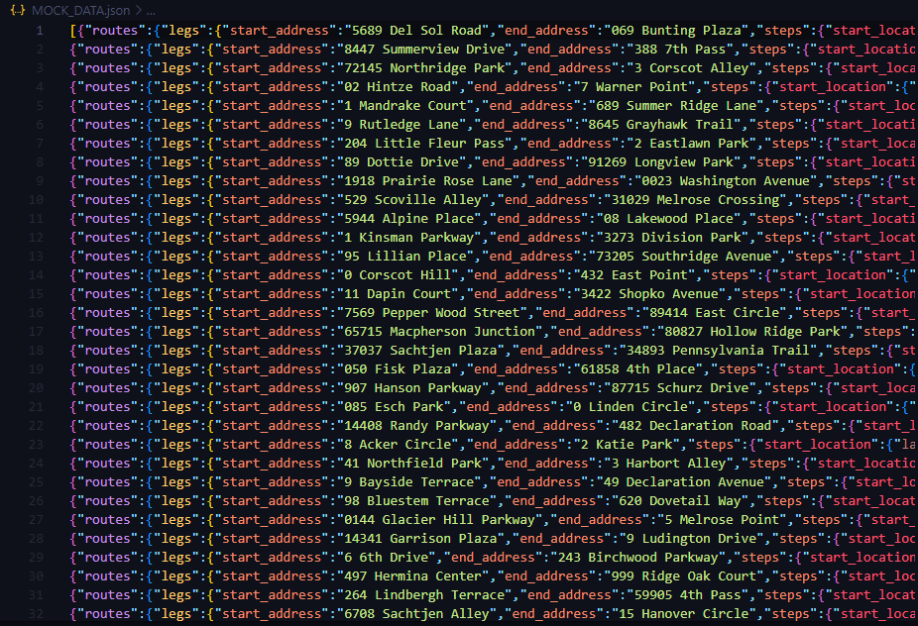

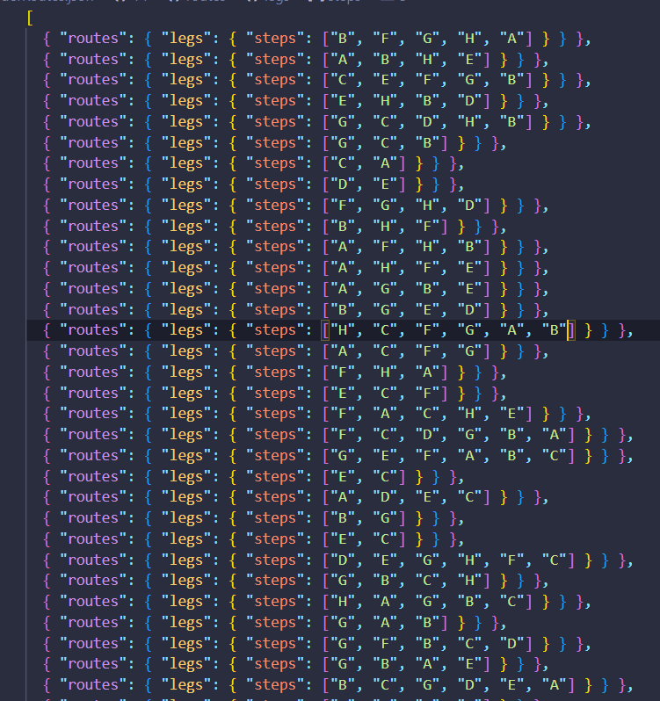

Figure 1. Rider Dataset

## Algorithm

**Clustering Analysis for Demand-Supply Matching**

### INPUTS:

* Riders' route data (supply)
* Passengers' route data (demand)
* Number of clusters (k)

### METHODOLOGY

Step 1: Start.

Step 2: Collect and preprocess rider’s and passengers’ route data.

Step 3: Apply Clustering Algorithm:

A. Initialize k centroids randomly.

B. Iterate until convergence or a defined number of iterations:

a. Assign each route to the nearest centroid based on distance metrics.

b. Calculate new centroids as the mean of assigned routes.

Step 4: Analyze Clusters:

A. Calculate cluster characteristics:

a. The average distance of routes within each cluster to its centroid.

b. Total passenger demand within each cluster.

B. Identify clusters with high demand and low rider presence.

C. Identify clusters with mismatches or unmet demand.

Step 5: Suggest Alternate Routes:

A. For clusters with high demand and low rider presence:

a. Analyze routes within the cluster.

b. Suggest alternate routes that can serve the demand while maintaining similar ride duration.

B. Generate a list of suggested alternate routes for riders.

Step 6: Output:

A. List of suggested alternate routes for riders.

Step 7: End

## Flowchart

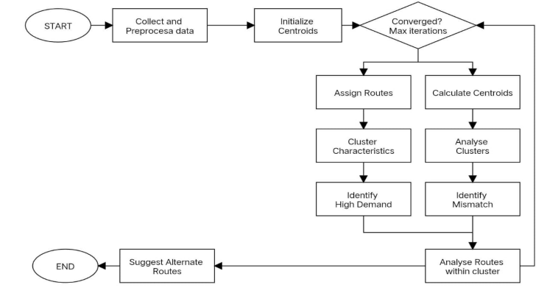

Figure 2.Workflow of the system

The proposed project entails gathering and preparing data as well as initializing the cluster centroids. This would be repeated until convergence or a certain number of iterations were reached. The centroid is computed for each route in rider and passenger data by computing distance metrics. Following that, the routes are assigned to the appropriate cluster. For each cluster, new centroids are calculated as the mean of routes inside the cluster. Each cluster's overall passenger demand is also computed. Clusters with a high and low presence of riders are detected. Along the way, the routes are added to a list. Figure 3.5.1 depicts this notion.

# Results And Discussion

This research aims to revolutionize urban transport by providing route ideas based on passenger demand to improve efficiency, cost-effectiveness, and sustainability. It addresses the frequent issue of solo commuting in metropolitan areas by attempting to seamlessly link riders and passengers via an innovative platform. This method decreases travel expenses for both parties while also helping to minimize the carbon footprint associated with urban transit. Congestion and environmental issues in today's urban scene necessitate efficient and sustainable transportation options. This research proposes a game-changing platform that uses technology to assure more sustainable and cost-effective mobility, imagining a future in which urban transit is both efficient and ecologically responsible. Modules for rider and passenger registration, locating riders, match-making, and route suggestions are among the project's components. It indicates the difficulty of operating several routes between the same beginning and terminating points with varied passenger demand. The suggested system includes demand forecasting based on Google Maps API data, allowing for the detection of routes with surplus demand and the recommendation of alternate routes for passengers without significantly affecting travel length. The database architecture for the study contains two core tables, "Riders Routes" and "Passenger Routes," which include vital data such as route specifics, user IDs, start and end locations, distance, time, and travel steps. The data's accuracy and quality are vital to the project's completion. The technique focuses on demand-supply matching clustering analysis, beginning with data collection and preprocessing and progressing to clustering methods. The research detects clusters with high demand but little rider presence, and different routes are proposed to handle extra demand while keeping equal commute lengths. The relevance of the initiative resides in its potential to transform urban transit by tackling lone commuting, high travel expenses, and carbon emissions. It provides competitive travel times, considerable cost savings, enhanced user happiness, and a large decrease in single-occupancy car use, all of which contribute to sustainability and fit with the project's environmental aims. In conclusion, the data-driven urban transportation optimization system provides a road to more cost-effective, sustainable, and comfortable urban commuting. It has the potential to revolutionize the way people travel inside cities by using technology, data analysis, and shared mobility, leading to a greener and more economically viable urban future.

## Requirements Specification

### System Requirements

#### Operating System:

#### Windows: Windows 7 or later

#### macOS: macOS 10.9 or later

#### Linux: Most modern Linux distributions

#### Processor:

#### Windows and Linux: Intel Pentium 4 processor or later with SSE2 support (or) AMD Athlon XP or AMD Athlon 64 processors

#### macOS: Intel processor

#### RAM: At least 2 GB of RAM (4 GB or more recommended)

### Software Requirements

The below-mentioned tools and technologies are required to process this system.

1. Software Requirements

|  |  |
| --- | --- |
| **Headings** | **Tools/Technology** |
| FRONT END TOOLS | React Native/ JS |
| BACK-END TOOLS | Python |
| MARKUP LANGUAGES | JSX |
| MIDDLEWARE  TECHNOLOGIES | Firebase, Google Maps API |
| SCRIPTING LANGUAGES | JavaScript, Python |
| PACKAGES NEEDED | Pandas, NumPy, Matplotlib, Scikit-learn, Random, OR-Tools, json |
| IDE | Visual Studio Code |

## Contribution to the Research Work

### The Optimization of Urban Transportation: The project takes a novel approach to urban transit by utilizing data analysis and internet connection to recommend routes depending on passenger demand. This helps optimize urban transport networks, making them more efficient and sustainable.

### Single-Occupancy Vehicle Reduction: One of the project's key aims is to minimize the predominance of single-occupancy cars and solo commuting. It supports shared mobility by linking riders and passengers, resulting in a significant reduction in single-occupancy car use. This has far-reaching consequences for transportation congestion and environmental impact reduction.

### Cost Savings: The analysis shows that recommended alternate routes frequently result in significant cost reductions for both riders and passengers. This financial gain helps the economic well-being of urban commuters, which is especially important in a society where transportation expenditures can be high.

### Environmental Longevity: The concept closely correlates with environmental sustainability aims by minimizing the usage of single-occupancy vehicles. It helps to reduce carbon emissions and the total environmental imprint of urban mobility, which is critical in light of rising environmental concerns.

### Efficiency and User Satisfaction: The study's technique improves urban transportation efficiency by better matching riders and passengers. This leads to faster travel times and more consumer satisfaction, resulting in a more convenient and appealing commuting experience.

## Comparison

Table 3 shows state of an art comparison of the proposed system and other systems.

1. State of n Art Comparision

|  |  |  |  |  |
| --- | --- | --- | --- | --- |
| **Research Work (Year)** | **Focus** | **Algorithm** | **Dataset** | **Limitations** |
| Proposed System | Demand prediction and Route optimization | Clustering Analysis for Demand-Supply Matching | Rider and passenger routes | Privacy Issues,  User Adoption |
| [3] Zhang et al. (2021) | Dynamic Node-Edge Attention Network | Dynamic Node-Edge Attention Network | Chengdu dataset, New York dataset. | Limited to urban areas, scalability issues |
| [4] Chen et al. (2020) | Multitask Learning and GCN-Based Prediction | GCN | Traffic and Taxi Demand Data | Reliant on historical data, need for real-time updates |
| [2] Sohani Liyanage et al. (2022) | AI-Based Neural Network Models | ANN | Smart Card Data | Limited to buses, may not cover all urban modes of transport |
| [8] Mariñas-Collado et al. (2022) | Clustering and Forecasting Bus Demand | Time Series Models with Clustering | Urban Bus Passenger Data | Limited to buses and clustering is based on historical patterns |
| [12] Abdi et al. (2021) | Travel and Arrival-Time Prediction | Various Prediction Models | Traffic Data | Limited to travel time predictions |
| [13] Halyal et al. (2022) | Forecasting Public Transit Demand | Neural Networks | Public Transit Demand Data | Primarily focused on public transit |

## Output

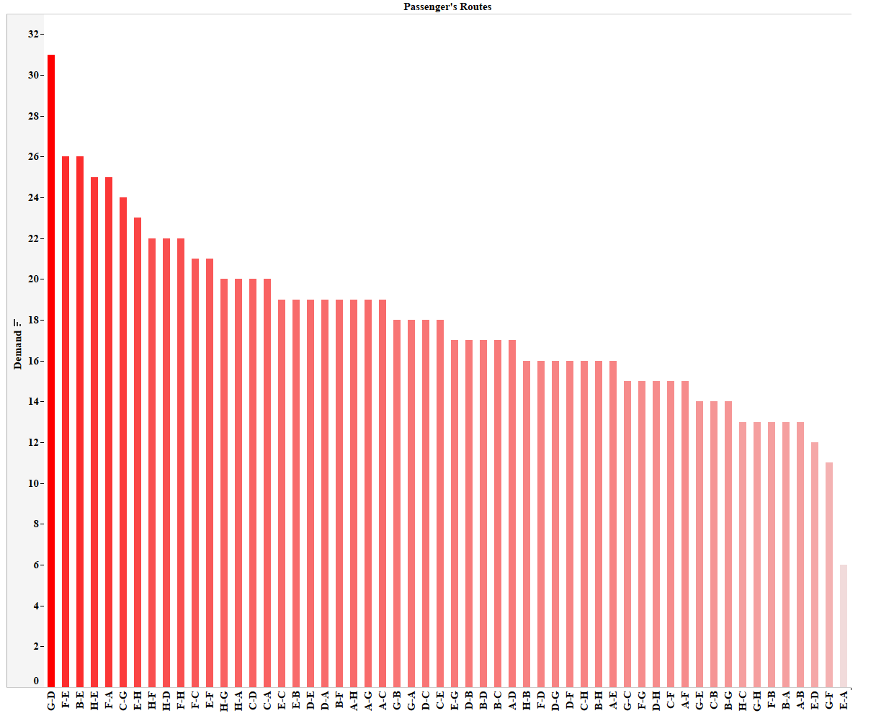Figure 11 shows the exact work of the proposed system. The system predicts the face shape as a round of the person and gets a recommendation of two glasses for their face shape.

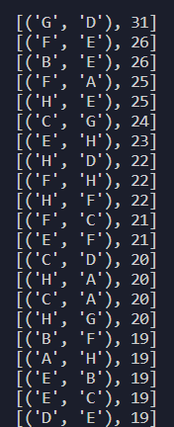 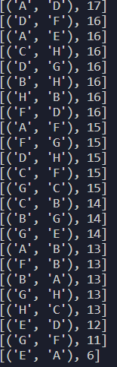

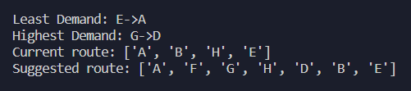

# Conclusion And Future Scope

To sum up, this research offers a data-driven approach to improving urban transportation by effectively matching passengers and riders. It provides a route to more affordable, environmentally friendly, and conveniently located urban commuting by addressing the issues of lone commuting, expensive travel expenses, and carbon emissions. The project shows how it might transform how people travel around cities and help create a more sustainable and prosperous urban future. To secure its long-term success, it is crucial to recognize its shortcomings and the requirement for ongoing development. This research is a big step in determining how urban mobility will develop in the future as transportation requirements and technology change.

## Limitation of the proposed system

### Data Reliance: Availability and accuracy of data, especially from the Google Maps API, are critical to the project's success. Incomplete or inaccurate data might impact service quality by resulting in inaccurate route recommendations.

### Privacy Issues: The platform's acquisition of user data gives rise to privacy problems. To guarantee the protection of user rights and data security, the project needs to solve these issues. It might be difficult to strike the correct balance between privacy and data acquisition.

### User Adoption: It might be difficult to persuade consumers to switch from their current modes of transportation to shared mobility. Some people can be suspicious of the advantages of the suggested system or resistant to change.

## Future Scope

Prospective research directions in ride-sharing and urban transportation optimization await further investigation. Using cutting-edge machine learning methods like deep learning and neural networks to provide more precise route recommendations is one of them. It is vital to include real-time data sources, comprehend commuter behavior, and optimize route recommendations according to user preferences. Furthermore, studies can examine how multimodal transportation alternatives integrate seamlessly, improve environmental impact assessment techniques, and examine cost-effectiveness, regulatory frameworks, and policy incentives. Future research must take user privacy and data security into account. These fields will advance urban mobility solutions in their ongoing progress.

##### References

1. Banerjee, N., Morton, A., Akartunalı, K. (2020). "Passenger demand forecasting in scheduled transportation." European Journal of Operational Research, Volume 286, Issue 3, pp. 797-810, ISSN 0377-2217.
2. Liyanage, S., Abduljabbar, R., Dia, H., Tsai, P-W. (2022). "AI-based neural network models for bus passenger demand forecasting using smart card data." Journal of Urban Management, Volume 11, Issue 3, pp. 365-380, ISSN 2226-5856.
3. Zhang, D., Xiao, F., Shen, M., Zhong, S. (2021). "DNEAT: A novel dynamic node-edge attention network for origin-destination demand prediction." Transportation Research Part C: Emerging Technologies, Volume 122, pp. 102851, ISSN 0968-090X.
4. Chen, Z., Zhao, B., Wang, Y., Duan, Z., & Zhao, X. (2020). "Multitask learning and GCN-based taxi demand prediction for a traffic road network." Sensors, Volume 20(13), pp.3776.
5. Cyril, A., Mulangi, R. H., George, V. (2018). "Modelling and Forecasting Bus Passenger Demand using Time Series Method." In 2018 7th International Conference on Reliability, Infocom Technologies, and Optimization (Trends and Future Directions) (ICRITO), Noida, India, pp. 460-466.
6. Faridai, S., Juraeva, R.S., Darovskikh, S.N., Qodirov, Sh.Sh. (2021). "Neural Network Model for Predicting Passenger Congestion to Optimize Traffic Management for Urban Public Transport." Вестник ЮУрГУ. Серия: Компьютерные технологии, управление, радиоэлектроника, 2021.
7. Ke, J., Qin, X., Yang, H., Zheng, Z., Zhu, Z., & Ye, J. (2021). "Predicting origin-destination ride-sourcing demand with a spatio-temporal encoder-decoder residual multi-graph convolutional network." Transportation Research Part C: Emerging Technologies, 122, 102858.
8. Mariñas-Collado, I., Sipols, A.E., Santos-Martín, M.T., Frutos-Bernal, E. (2022). "Clustering and Forecasting Urban Bus Passenger Demand with a Combination of Time Series Models." Mathematics, Volume 10, pp.2670.
9. Yadav, R. K., Kishor, G., Himanshu, K., Kashyap, K. (2020). "Comparative Analysis of Route Planning Algorithms on Road Networks." In 2020 5th International Conference on Communication and Electronics Systems (ICCES), Coimbatore, India, pp. 401-406.
10. Zhang, P., Ma, W., Qian, S. (2022). "Cluster analysis of day-to-day traffic data in networks." Transportation Research Part C: Emerging Technologies, Volume 144, pp. 103882, ISSN 0968-090X. 37
11. Bazant, M., Akhtar, M., Moridpour, S. (2021). "A Review of Traffic Congestion Prediction Using Artificial Intelligence." Journal of Advanced Transportation, Volume 2021, SP - 8878011, ISSN 0197-6729.
12. Abdi, A., Amrit, C. (2021). "A review of travel and arrival-time prediction methods on road networks: classification, challenges and opportunities." PeerJ Comput Sci, 7, e689. doi: 10.7717/peerj-cs.689.
13. Halyal, S., Mulangi, R. H., Harsha, M.M. (2022). "Forecasting public transit passenger demand: With neural networks using APC data." Case Studies on Transport Policy, Volume 10, Issue 2, pp. 965-975, ISSN 2213-624X.
14. Zhong, C., Wu, P., Zhang, Q., Ma, Z. (2023). "Online prediction of network-level public transport demand based on principle component analysis." Communications in Transportation Research, Volume 3, 100093, ISSN 2772-4247.
15. Halvorsen, A., Koutsopoulos, H.N., Ma, Z., et al. (2020). “Demand management of congested public transport systems: a conceptual framework and application using smart card data." Transportation, 47, 2337–2365.
16. Jiang, W., Ma, Z., Koutsopoulos, H.N. (2022). "Deep learning for short-term origin–destination passenger flow prediction under partial observability in urban railway systems." Neural Comput & Applic, 34, 4813–4830.
17. Tedjopurnomo, D.A., Bao, Z., Zheng, B., Choudhury, F.M., Qin, A.K. (2020). "A survey on modern deep neural network for traffic prediction: Trends, methods, and challenges." IEEE Transactions on Knowledge and Data Engineering, 34(4), 1544-1561.
18. Xie, Z., Lv, W., Huang, S., Lu, Z., Du, B., Huang, R. (2020). "Sequential Graph Neural Network for Urban Road Traffic Speed Prediction." IEEE Access, 8, 63349-63358.