# Google Search Engine

### A MINI PROJECT REPORT

#### Submitted by

#### Group: G22

#### Team No: 5

**Devesh Sharma 2210990265,**

**Dharuv Singla 2210990268,**

**Dhruv Aggarwal 2210990270,**

**Devneet Singh chahal 2210990266,**

#### in partial fulfillment for the award of the degree of

## BACHELEOR OF ENGINEERING

***in***

COMPUTER SCIENCE & ENGINEERING

**CHITKARA UNIVERSITY**

**CHANDIGARH-PATIALA NATIONAL HIGHWAY**

**RAJPURA (PATIALA) PUNJAB-140401 (INDIA)**

##### MAY, 2023

**Project Report**

**Executive Summary:**

The Google search engine aims to create a webpage that closely resembles the Google search page. The webpage allows users to enter search queries, displays search suggestions, and performs searches based on user input. This report provides an overview of the project, including its objectives, scope, technologies used, project structure, and functionality.

**Introduction:**

The internet is an essential part of our lives, and search engines play a crucial role in helping users find information quickly and efficiently. The Google Search Engine aims to replicate the functionality and design of the Google search page, providing users with a familiar and user-friendly search experience.

**Project Objectives:**

The main objectives of the project are as follows:

1. Create a webpage that closely resembles the Google search page.
2. Implement a search box that allows users to enter search queries.
3. Display search suggestions as users type in the search box.
4. Perform searches based on user input and display the search results.
5. Enhance the user experience by providing a clean and intuitive interface.

**Project Scope:**

The scope of the project includes the following aspects:

Designing and implementing the HTML structure of the webpage.

Styling the webpage using CSS to achieve a similar appearance to the Google search page.

Adding JavaScript functionality to handle search queries, suggestions, and search result navigation.

Testing the functionality and ensuring a smooth user experience.

Deploying the webpage on a web server for public access.

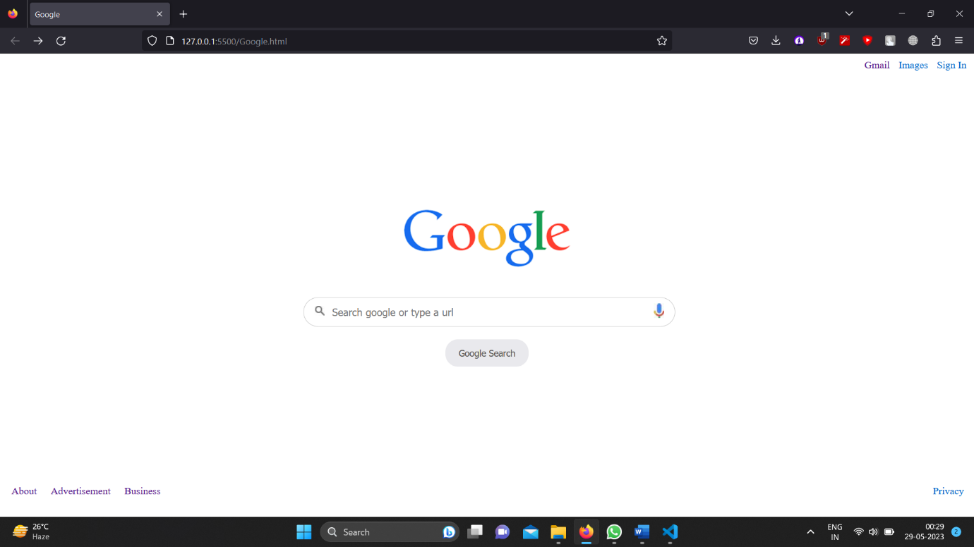

Technologies Used:

The following technologies were used in the project:

HTML: Used to structure the webpage and define its elements.

CSS: Applied to style the webpage and achieve the desired layout and appearance.

JavaScript: Used to add interactivity and handle search functionality.

Web browser: The project was developed and tested using modern web browsers.

**Project Structure:**

The project consists of the following files and directories:

google.html: Contains the HTML structure of the webpage.

google.css: Contains the CSS styling rules for the webpage.

google.js: Contains the JavaScript code for the search functionality.

**HTML Structure:**

The HTML structure of the webpage follows the standard format, consisting of the <html>, <head>, and <body> elements. The <nav> element contains navigation links, the search box is defined within the <section> element, and the footer contains relevant links.

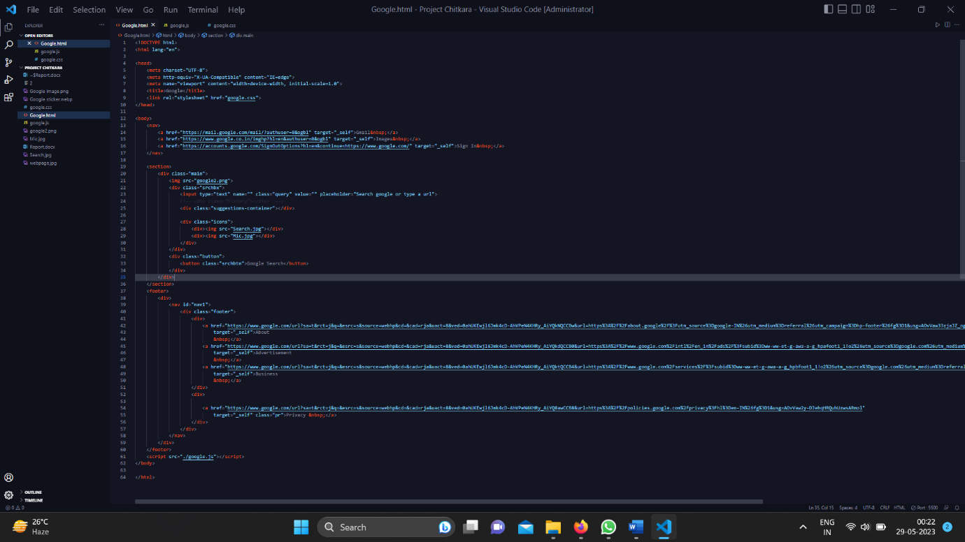

**CSS Styling:**

CSS styles were applied to various elements to achieve the desired layout and appearance. The <nav> element was styled to align navigation links to the right, and the search box and button were styled to match the Google search page design. Additionally, the footer section was styled to display navigation links in a horizontal layout

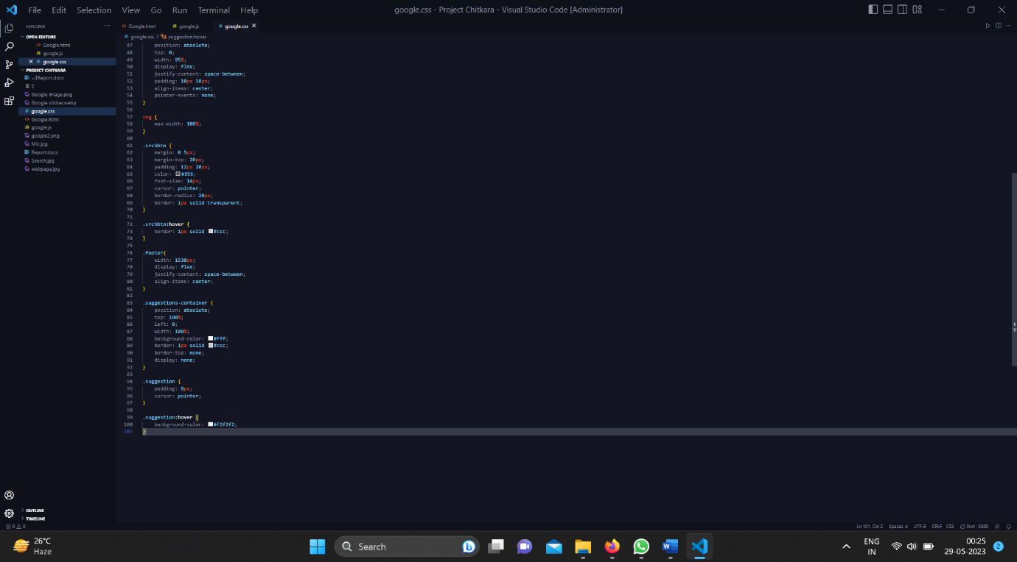

**JavaScript Functionality:**

JavaScript was used to add dynamic functionality to the webpage. The code interacts with HTML elements to handle user input, search queries, and search suggestions. It includes event listeners for the search button click and input changes in the search box. Suggestions are displayed as the user types, and search functionality is implemented to perform searches based on user input.

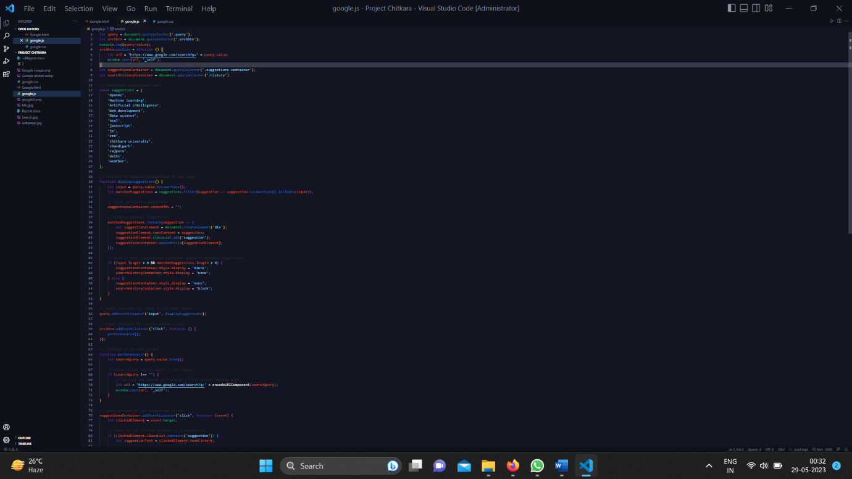

**Testing and Quality Assurance:**

Thorough testing was conducted to ensure the functionality of the webpage. Unit testing, integration testing, and cross-browser compatibility testing were performed. Quality assurance processes were followed to identify and fix any bugs or issues. User feedback and usability testing were also taken into consideration to improve the user experience.

**Deployment:**

The webpage was deployed on a web server for public access. It can be accessed using a web browser by navigating to the appropriate URL.

**Project Management:**

Throughout the project, a structured project management approach was followed. Tasks were defined, assigned, and tracked using project management tools. Regular team meetings were held to discuss progress, challenges, and next steps. Agile methodologies were employed to ensure flexibility and adaptability to changing requirements.

**Conclusion:**

The Google Search engine successfully created a webpage that closely resembles the Google search page. It provides users with an intuitive and familiar search experience. The implementation of search suggestions and search functionality enhances usability. Thorough testing and quality assurance measures were taken to ensure a robust and reliable application.

**Future Enhancements:**

While the project has achieved its objectives, there are opportunities for future enhancements, including:

1. Integration with backend services to provide more accurate search results.
2. Personalization features, such as user preferences and search history.
3. Optimization for mobile devices and responsive design.
4. Integration with external APIs to provide additional functionality.
5. Implementation of accessibility standards to ensure inclusivity.

**References:**

1. W3schools.com
2. GeeksforGeeks

**TLDR:**

This report provides an overview of the Google Search Engine, its objectives, implementation details, and future enhancements. The project successfully created a Google-like search page with interactive functionality. The team worked collaboratively, following best practices in project management and software development. The project demonstrates the team's skills in web development, HTML, CSS, and JavaScript. With future enhancements, the project has the potential to further improve the search experience for users.

**[End of Report]**