AEGIE : A Research Framework for Adaptive Agentic AI-Based Voice Interview Evaluation

Dhaslim N  M.Tech Data Science  Rajalakshmi Engineering College  Chennai, Tamil Nadu, India  dhaslim3103@gmail.com | Dr. S. Chandramohan  Professor, Department of IT  Rajalakshmi Engineering College  Chennai, Tamil Nadu, India  Chandramohan.s@rajalakshmi.edu.in | Dr. Ganesa Ramachandran Arunachalam  L&T EduTech, Chennai  grcchem@gmail.com

Abstract—This study develops AEGIE, a voice-based interview evaluation framework in which spoken answers are processed as both speech and technical content. In the implemented prototype, NVIDIA Parakeet converts each recorded response into text, while response duration, speaking rate, filler usage, and pauses are retained as separate delivery measurements. The transcript is then analysed with MiniLM at whole-answer, sentence, and concept levels so that different forms of semantic evidence can be examined independently. Three agents are used in the workflow: the Evaluation Agent collects the available evidence, the Adaptive Agent selects the difficulty of the following question, and the Feedback Agent presents the result to the user. The current experiment consists of five development questions and uses a rule-based combination of whole-answer and concept-level similarity for adaptation. The experiment is intended to verify the operation of the complete pipeline rather than to establish candidate competency. Therefore, the present similarity values and difficulty levels are treated as prototype evidence only. A later study will collect responses from real participants and compare the generated evidence with independent expert assessments before the framework is calibrated for broader evaluation.
Keywords—Adaptive interviewing, agentic AI, automatic speech recognition, MiniLM, NVIDIA Parakeet, semantic similarity, technical interview evaluation, voice analysis.
- INTRODUCTION
Technical interviews are commonly used to understand how candidates apply technical knowledge, explain concepts, and respond to problem-solving questions. In most cases, these qualities are judged directly by an interviewer. Human assessment is important because the same technical idea can be expressed in different ways. However, when a large number of interviews must be conducted, maintaining a consistent evaluation process can become difficult and time-consuming.
A spoken interview response contains information about both content and delivery. Automatic speech recognition can convert the candidate’s voice into text, while features such as speaking rate, filler words, and pauses can be measured from the recorded response. These speech measurements describe how the answer is delivered, but they do not indicate whether the expected technical concepts were actually discussed. For this reason, analysis of the transcribed content is also required.
AEGIE was developed as an adaptive agentic AI framework for studying voice-based technical interview evaluation. NVIDIA Parakeet is used for speech transcription, and observable speech features are extracted from each response. MiniLM is then used to compare the candidate’s transcript with reference knowledge at whole-answer, sentence, and concept levels. Keeping these semantic measurements separate makes it possible to inspect different parts of the response instead of reducing the answer immediately to one value.
The framework is coordinated through three agents. The Evaluation Agent organizes the speech and semantic evidence, the Adaptive Agent selects the difficulty of the next question, and the Feedback Agent presents the available evidence in an interpretable form. In the current prototype, adaptation is controlled by explicit development rules rather than a learned decision model.
The present work focuses on demonstrating the complete processing pipeline and examining the evidence produced by it. The generated semantic similarities and speech measurements are not treated as validated competency scores or hiring decisions. The next stage of the research will use real participant responses and independent expert annotations to support calibration and validation of the framework.
- RELATED WORK
Automated interview assessment has been studied using speech, linguistic, visual, and behavioural information. Rao et al. [1] examined communication-skill assessment using lexical, acoustic, and visual features, while Rasipuram and Jayagopi [2] investigated verbal and non-verbal information in interview interactions. Nguyen et al. [3] studied computational analysis of hirability from non-verbal behaviour, and related work extended this type of analysis to online video resumes [4]. Suen et al. [5] also used human interviewer ratings as reference information when studying automated communication and personality assessment.
Recent interview-support systems have combined speech recognition, natural language processing, automated questioning, and feedback. The systems reported in [6] and [7] illustrate how AI components can be integrated into mock-interview environments. Multimodal analysis of interview performance has also been explored in [8]. These studies show that interview responses can be analysed computationally, but they also indicate that automated measurements need careful interpretation.
Work on sentence representation is relevant to the semantic-analysis component of AEGIE. Sentence representations are useful in AEGIE because the system needs to compare a candidate response with expected technical content. Sentence-BERT [9] provides an efficient way to measure semantic similarity between sentences. MiniLM [10] and MiniLMv2 [11] reduce the computational cost of Transformer representations, which makes them practical for systems with limited computing resources. Similar Transformer approaches have also been investigated for automatic short-answer assessment [12]–[14], where the objective is to compare freely written responses with reference information.
Research on AI-supported interviews has also considered the experience of the applicant. Studies [15]–[18] examined how candidates respond to asynchronous interviews and algorithm-based assessment. More recent work has discussed the use of generative AI during interview tasks [19] and possible fairness issues in algorithmic hiring systems [20].
AEGIE brings several of these ideas into one development framework. The prototype combines local speech transcription, measurable delivery information, semantic comparison at different levels, and adaptive question selection. Human expert assessment is planned as a later calibration stage. For this reason, the evidence produced by the current prototype is used to study system behaviour and is not treated as an automatic hiring or competency decision.
- PROPOSED AEGIE FRAMEWORK
AEGIE processes each interview answer in a sequence of connected steps. The candidate first records a spoken response through the interview interface. NVIDIA Parakeet converts the audio into a transcript. At the same time, the system keeps separate delivery measurements, including response duration, speaking rate, filler occurrences, and pauses.
The transcript is then passed to MiniLM for semantic comparison. Three views are retained. Whole-answer similarity gives a broad comparison between the complete response and the reference answer. Sentence-level comparison looks at smaller parts of the response. Concept-level analysis checks how closely each expected technical concept is represented in the candidate’s sentences. For every expected concept, the strongest matching sentence is stored as supporting evidence.
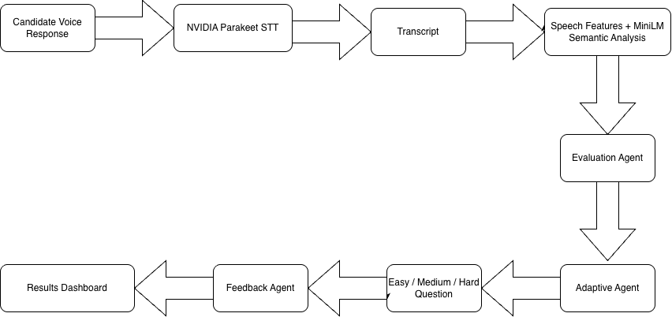
Fig. 1. Overall architecture of the proposed AEGIE framework.
After these measurements are produced, the Evaluation Agent gathers the speech and semantic information for the current answer. The Adaptive Agent uses this evidence when selecting the difficulty of the next question. The Feedback Agent then sends the processed information to the results interface.
The question bank contains Easy, Medium, and Hard questions. In the current prototype, movement between these levels follows fixed development rules. A learned adaptive model is not used at this stage, which makes the question-selection logic easier to inspect during testing.
Speech measurements and semantic similarities are intentionally kept as separate evidence. For example, a high MiniLM similarity does not by itself establish technical correctness, and values such as WPM or pause count are not treated as competency scores. The present framework therefore uses these measurements to support analysis and adaptive question control without producing an automatic hiring or pass/fail decision.
- RESEARCH METHODOLOGY AND DATA COLLECTION
The methodology used in AEGIE follows four stages: collecting the interview response, processing the recorded speech, extracting semantic evidence from the transcript, and preparing the framework for later human calibration. The present prototype implements the automated stages. Participant-based validation and expert annotation are planned as the next phase of the study.
A. Interview Data Acquisition
Each interview answer is collected through a microphone-based interface. Along with the audio response, the system can retain the participant ID, question ID, difficulty level, generated transcript, and the evidence produced from that response. Keeping these items together helps trace every measurement back to the exact answer from which it was obtained.
B. Speech Processing and Feature Extraction
After recording, NVIDIA Parakeet converts the spoken answer into text. The system also records basic delivery information from the response, including duration, number of spoken words, speaking rate, filler occurrences, and pauses. Words per minute are calculated as

WPM = (Number of spoken words / Response duration in seconds) × 60. (1)

These values are used only to describe how the answer was delivered. They are not used on their own to judge candidate ability or technical performance.
C. Semantic Evidence Extraction
MiniLM is used to generate semantic representations of the candidate transcript and the corresponding reference content. Similarity is calculated using cosine similarity,

Similarity(A,R) = (A · R) / (||A|| ||R||), (2)

where A represents the candidate-answer embedding and R represents the reference embedding. Whole-answer, sentence-level, and concept-level evidence are retained separately. For concept analysis, each expected concept is compared with the candidate sentences, and the strongest matching sentence is stored as evidence.
D. Human Annotation and Calibration
Independent experts will later review real participant responses using dimensions such as technical correctness, relevance, concept coverage, and communication clarity. Their assessments will provide an external reference for studying how the automated evidence relates to human judgment. Calibration data will be kept separate from later evaluation data so that the resulting approach can also be examined on previously unseen responses.
- ENVIRONMENTAL SETUP
The AEGIE prototype was implemented as a web-based application using Python and Flask. The current system supports voice recording, NVIDIA Parakeet transcription, speech-feature extraction, MiniLM semantic analysis, adaptive question selection, and evidence display through a results dashboard. A five-question development interview was used to verify whether these components operate together from voice input to final evidence generation.
A. Development Interview Configuration
Questions are grouped into Easy, Medium, and Hard levels. Each question includes reference content and a set of expected technical concepts. After a response is processed, the Adaptive Agent uses evidence from the previous answer to determine the difficulty of the next question.
B. Prototype Evidence and Adaptation
For the current development experiment, concept-level evidence and whole-answer similarity are combined as

E = 0.60C + 0.40W, (3)

where C is the mean concept-level similarity and W is the whole-answer MiniLM similarity.
The development prototype interprets evidence values below 0.45 as Beginner, values from 0.45 to below 0.65 as Intermediate, and values of 0.65 or above as Advanced. These boundaries are used only to test the adaptive workflow and have not yet been calibrated using independent expert assessments.
C. Recorded Measures
For every response, AEGIE records response duration, word count, WPM, filler count, pause count, whole-answer similarity, sentence-level similarity, concept-level evidence, and processing-time information. Keeping these measurements separately provides a trace of how each response moves through the pipeline and supports later comparison with human expert annotations.
- RESULTS AND EVALUATION
The five-question development interview was used to examine the end-to-end operation of AEGIE. The experiment covered voice transcription, speech-feature extraction, MiniLM semantic processing, adaptive question control, and evidence display. The reported values describe the behaviour of the current prototype and are not results from a completed participant study.
A. Speech Analysis Results
Across the five responses, the average speaking rate was 117.33 words per minute. The system detected 1 filler occurrence and 10 pauses in total. These measurements show that observable delivery information can be collected together with the transcript and retained for later analysis.
B. Semantic Evidence Results
The mean whole-answer MiniLM similarity across the five responses was 0.6522. Concept-level analysis examined 20 reference concepts and produced a mean best similarity of 0.4994. The whole-answer, sentence-level, and concept-level values did not follow the same pattern for every response, which supports keeping these measurements separate during development.
TABLE I QUESTION-WISE SEMANTIC AND SPEECH EVIDENCE
Question | Whole MiniLM | Sentence  MiniLM | Concept Mean | Total  Process  Time
Q1.DS_E03 | 0.8460 | 0.6899 | 0.6937 | 8.211 s
Q2.DS_M02 | 0.8741 | 0.6437 | 0.5189 | 9.706 s
Q3.DS_H01 | 0.4366 | 0.4760 | 0.6089 | 8.339 s
Q4.DS_H02 | 0.6169 | 0.5300 | 0.4516 | 7.511 s
Q5.DS_H04 | 0.4874 | 0.3942 | 0.2237 | 7.959 s

C. Provisional Semantic Evidence Level
Using the prototype formulation in (3), the five responses produced an overall evidence value of 0.5605. Under the current development boundaries, this falls within the Intermediate range. This label describes only the operation of the prototype rule and should not be interpreted as a validated competency level, interview grade, hiring recommendation, or pass/fail decision.
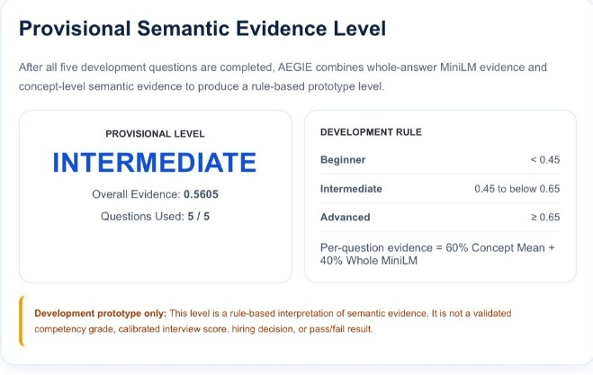
Fig. 2. Provisional semantic evidence level generated by the AEGIE development prototype.

D. Processing Latency
During the development run, NVIDIA Parakeet required an average of 4.717 seconds for speech-to-text processing. The Evaluation Agent and MiniLM semantic pipeline required an average of 0.096 seconds, while the average complete server-side processing time was 8.345 seconds per response. These values describe the current development environment and are not universal runtime guarantees.
TABLE II QUESTION-WISE PROCESSING LATENCY OF THE AEGIE PROTOTYPE
Question | Parakeet STT | Agent / MiniLM
Q1. DS_E03 | 4.579 sec | 0.079 sec
Q2. DS_M02 | 5.709 sec | 0.124 sec
Q3. DS_H01 | 4.737 sec | 0.085 sec
Q4. DS_H02 | 4.138 sec | 0.109 sec
Q5. DS_H04 | - c | - c

- DISCUSSION AND LIMITATION
The development experiment shows that the main components of AEGIE can operate together within a single voice-interview workflow. Spoken responses were transcribed, measurable speech characteristics were extracted, and semantic evidence was generated at whole-answer, sentence, and concept levels. The different semantic measurements did not always follow the same pattern, which supports keeping them separate instead of depending on one similarity value.
Concept-level analysis provides a more detailed view by identifying the candidate sentence that has the strongest semantic relationship with each expected technical concept. However, semantic similarity alone does not prove that a concept is technically correct or fully explained. The values should therefore be treated as supporting evidence rather than final competency scores.
The current study is limited to a five-question development interview, so the reported values cannot be generalized to a wider candidate population. The Beginner, Intermediate, and Advanced boundaries are prototype settings and have not yet been calibrated using independent expert assessments. Speech-recognition errors may also affect later semantic analysis because MiniLM operates on the generated transcript.
For these reasons, the present version of AEGIE does not claim validated interview scores, hiring decisions, or pass/fail outcomes. A larger participant study, independent expert annotation, calibration, and evaluation on unseen responses are required before stronger conclusions can be made.
- CONCLUSION AND FUTURE WORK
This work presented AEGIE as an adaptive agentic AI framework for analysing spoken technical interview responses. The prototype combines NVIDIA Parakeet speech recognition, speech-feature extraction, MiniLM-based semantic analysis, adaptive question selection, and evidence-based feedback within one workflow. Instead of producing only a single evaluation value, the framework retains whole-answer, sentence-level, and concept-level semantic evidence together with measurable speech characteristics.
The five-question development experiment confirmed that the complete pipeline can operate from voice input to transcription, semantic analysis, adaptive questioning, and result presentation. The experiment produced an average speaking rate of 117.33 WPM, a mean whole-answer similarity of 0.6522, and a mean concept-level best similarity of 0.4994. Using the current prototype rule, the overall evidence value was 0.5605, which falls within the provisional Intermediate range.
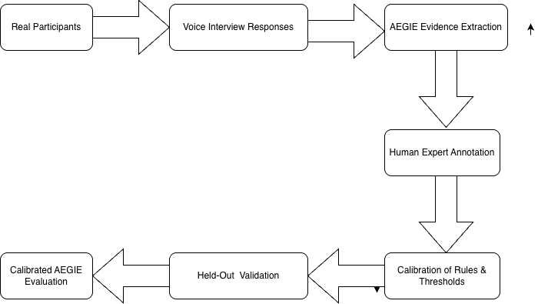
Fig. 3. Human annotation, calibration, and validation workflow for AEGIE.
These results describe the behaviour of the current prototype and are not presented as validated measures of candidate ability. Future work will focus on collecting responses from real participants and obtaining independent expert annotations for technical correctness, relevance, concept coverage, and communication clarity. These annotations will be used for calibration and evaluation on responses that are kept separate from the calibration process. Future experiments can investigate how transcription errors influence the later semantic analysis, test the framework with a broader question set, and study the processing time of individual components. It will also be useful to examine how much each semantic evidence level contributes to the final interpretation.
AEGIE is intended to assist the interview process rather than act as an independent decision maker. Its role is to present traceable evidence from the candidate response so that the final assessment can remain with the human interviewer.

REFERENCES
[1] P. Rao S. B., S. Rasipuram, R. Das, and D. B. Jayagopi, “Automatic assessment of communication skill in non-conventional interview settings: A comparative study,” in Proc. ACM ICMI, 2017, doi: 10.1145/3136755.3136756.
[2] S. Rasipuram and D. B. Jayagopi, “Automatic assessment of communication skill in interview-based interactions,” Multimedia Tools Appl., vol. 77, pp. 18709–18739, 2018, doi: 10.1007/s11042-018-5654-9.
[3] L. S. Nguyen, D. Frauendorfer, M. S. Mast, and D. Gatica-Perez, “Hire me: Computational inference of hirability in employment interviews based on nonverbal behavior,” IEEE Trans. Multimedia, vol. 16, no. 4, pp. 1018–1031, 2014, doi: 10.1109/TMM.2014.2307169.
[4] L. S. Nguyen and D. Gatica-Perez, “Hirability in the wild: Analysis of online conversational video resumes,” IEEE Trans. Multimedia, vol. 18, no. 7, pp. 1422–1437, 2016, doi: 10.1109/TMM.2016.2557058.
[5] H.-Y. Suen, K.-E. Hung, and C.-L. Lin, “Intelligent video interview agent used to predict communication skill and perceived personality traits,” Human-centric Comput. Inf. Sci., vol. 10, Art. no. 3, 2020, doi: 10.1186/s13673-020-0208-3.
[6] “AI Based Mock Interview System Using Natural Language Processing,” in Proc. Int. Conf. Advanced Computing Technologies (ICoACT), 2025, doi: 10.1109/ICoACT63339.2025.11005032.
[7] N. Amarasena et al., “Enhancing Employability Through an Advanced Mock Interview Platform for Fresh IT Graduates,” in Proc. ISRITI, pp. 540–545, 2024, doi: 10.1109/ISRITI64779.2024.10963436.
[8] I. Naim, M. I. Tanveer, D. Gildea, and M. E. Hoque, “Automated Analysis and Prediction of Job Interview Performance,” IEEE Trans. Affect. Comput., vol. 9, no. 2, pp. 191–204, 2018, doi: 10.1109/TAFFC.2016.2614299.
[9] N. Reimers and I. Gurevych, “Sentence-BERT: Sentence Embeddings Using Siamese BERT-Networks,” in Proc. EMNLP-IJCNLP, pp. 3982–3992, 2019, doi: 10.18653/v1/D19-1410.
[10] W. Wang et al., “MiniLM: Deep Self-Attention Distillation for Task-Agnostic Compression of Pre-Trained Transformers,” Adv. Neural Inf. Process. Syst., vol. 33, 2020.
[11] W. Wang, H. Bao, S. Huang, L. Dong, and F. Wei, “MiniLMv2: Multi-Head Self-Attention Relation Distillation for Compressing Pretrained Transformers,” Findings ACL-IJCNLP, pp. 2140–2151, 2021, doi: 10.18653/v1/2021.findings-acl.188.
[12] L. Camus and A. Filighera, “Investigating Transformers for Automatic Short Answer Grading,” in Artificial Intelligence in Education, vol. 12164, pp. 43–48, 2020, doi: 10.1007/978-3-030-52240-7_8.
[13] X. Zhu, H. Wu, and L. Zhang, “Automatic Short-Answer Grading via BERT-Based Deep Neural Networks,” IEEE Trans. Learn. Technol., vol. 15, no. 3, pp. 364–375, 2022, doi: 10.1109/TLT.2022.3175537.
[14] R. Agarwal et al., “Multi-Relational Graph Transformer for Automatic Short Answer Grading,” in Proc. NAACL-HLT, 2022, doi: 10.18653/v1/2022.naacl-main.146.
[15] T. Luo, “Speech Production Under Uncertainty: How Do Job Applicants Experience and Communicate with an AI Interviewer?,” J. Comput.-Mediat. Commun., vol. 28, no. 4, 2023, doi: 10.1093/jcmc/zmad028.
[16] N. Niemitz, L. Rietheimer, C. J. König, and M. Langer, “The (Null) Effects of Video Questions on Applicant Reactions in Asynchronous Video Interviews,” Int. J. Sel. Assess., vol. 32, pp. 421–428, 2024, doi: 10.1111/ijsa.12470.
[17] O. Tilston, F. Krings, N. Roulin, J. S. Bourdage, and M. Fetzer, “Reactions to Asynchronous Video Interviews: The Role of Design Decisions and Applicant Age and Gender,” Hum. Resour. Manage., vol. 63, no. 2, pp. 313–332, 2024, doi: 10.1002/hrm.22202.
[18] J. K. Oostrom et al., “Applicant Reactions to Algorithm- Versus Recruiter-Based Evaluations of an Asynchronous Video Interview and a Personality Inventory,” J. Occup. Organ. Psychol., vol. 97, no. 1, pp. 160–189, 2024.
[19] D. Canagasuriam and E.-R. Lukacik, “ChatGPT, Can You Take My Job Interview? Examining Artificial Intelligence Cheating in the Asynchronous Video Interview,” Int. J. Sel. Assess., vol. 33, 2025, doi: 10.1111/ijsa.12491.
[20] A. Fabris et al., “Fairness and Bias in Algorithmic Hiring: A Multidisciplinary Survey,” ACM Trans. Intell. Syst. Technol., vol. 16, no. 1, Art. no. 16, pp. 1–54, 2025, doi: 10.1145/3696457.

