SonarQube Dashboard – Screen Flow

# Contents

1. Home Page

2. Project Overview

2.1 Part 1

2.2 Part 2

3. Issues Tab

4. Security Hotspots Tab

5. Code Tab

6. Measures Tab

7. Activity Tab

8. Navigation Bar Tabs

- Issues

- Rules

- Quality Profiles

- Quality Gates

- Administration

- More

9. My Account

- Profile

- Security

- Notifications

10. Projects Tab

11. Help & Search

# 1. Home Page

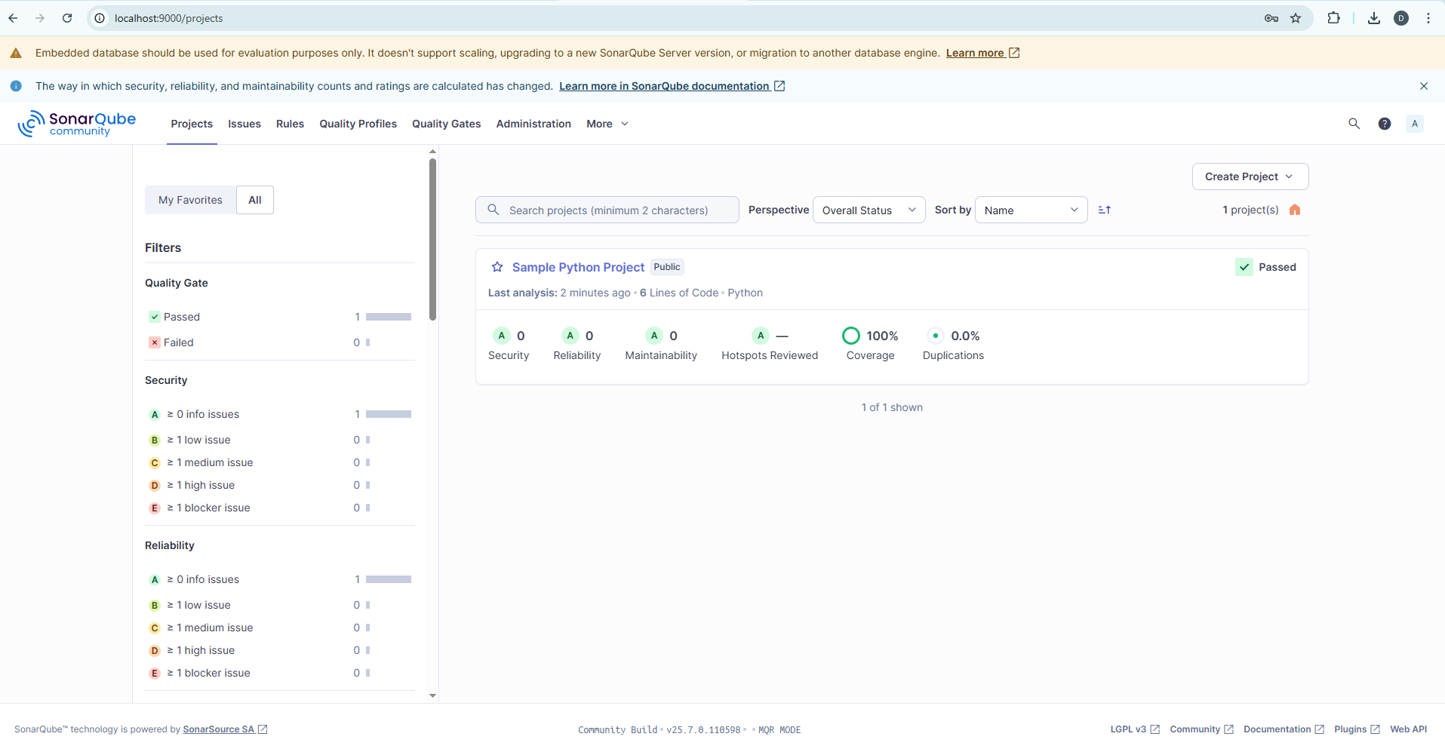

# 2. Project Overview

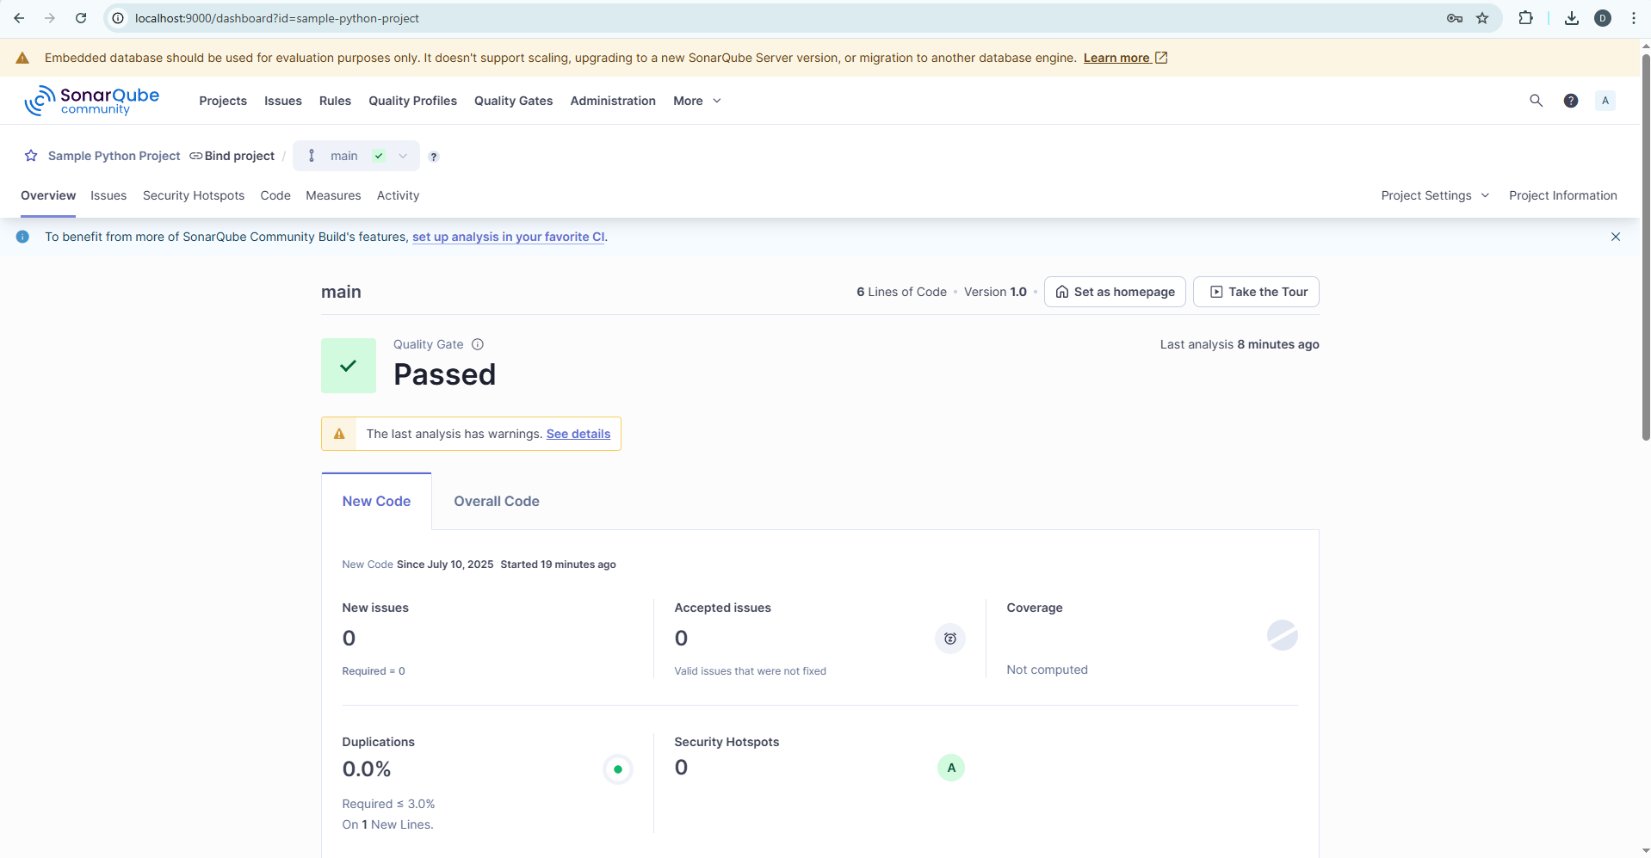

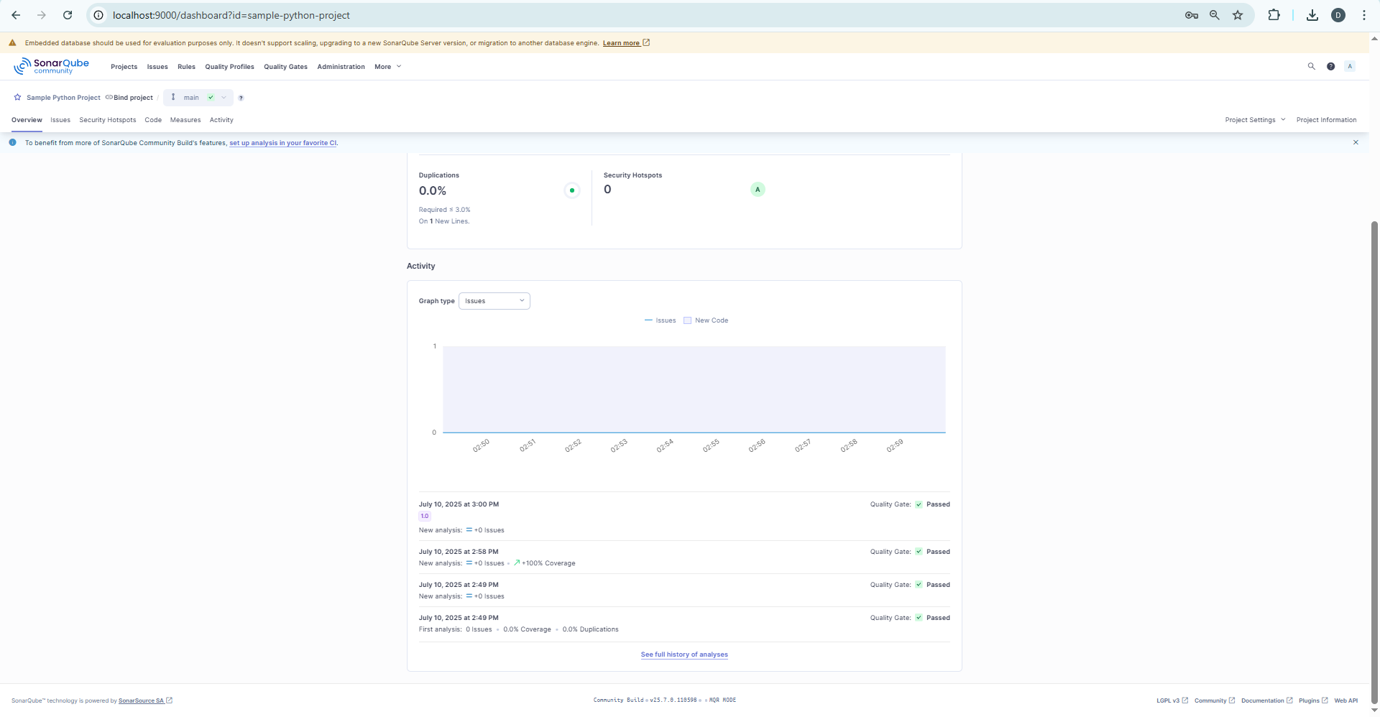

# 5. ISSUES TAB

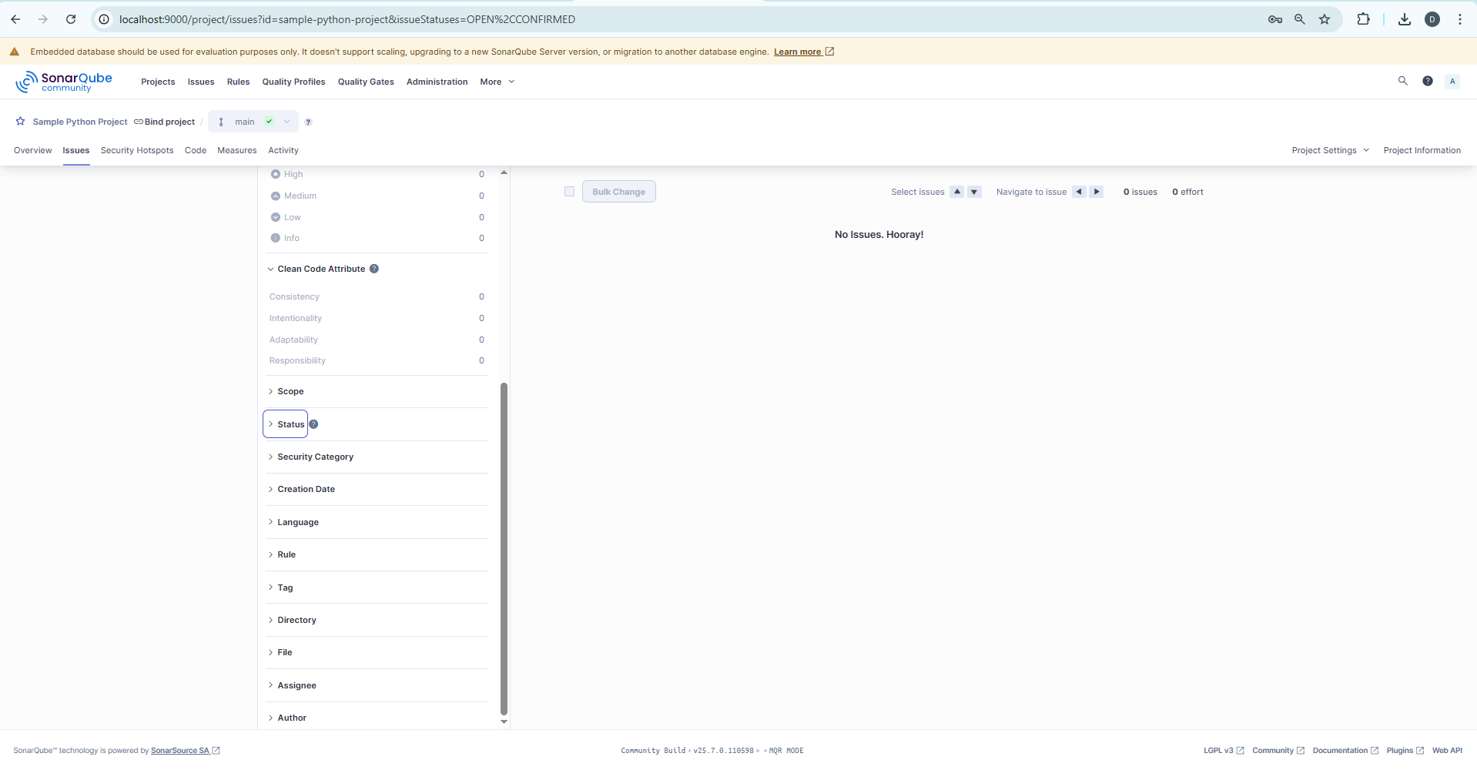

# 6. SECURITY HOTSPOTS TAB

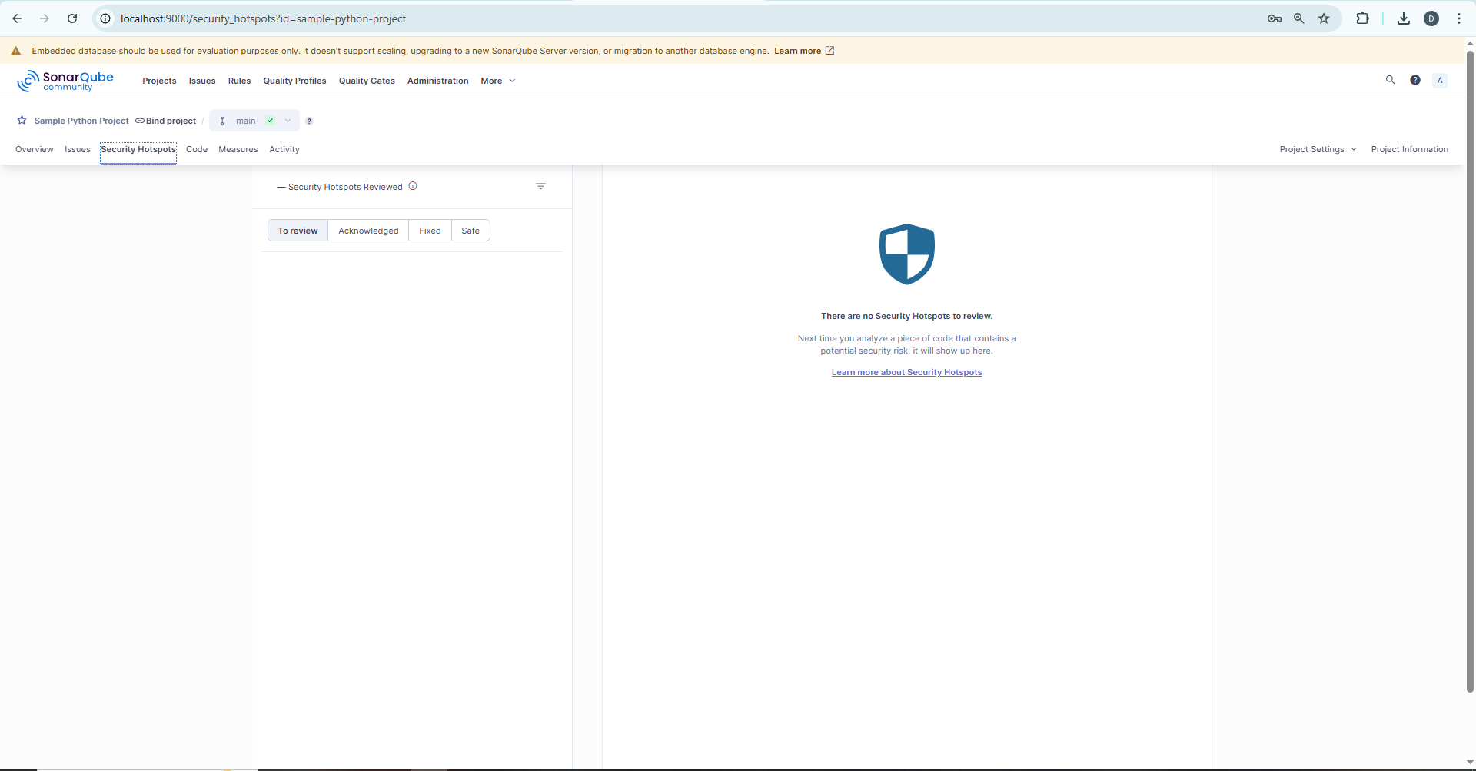

# 7. CODE TAB

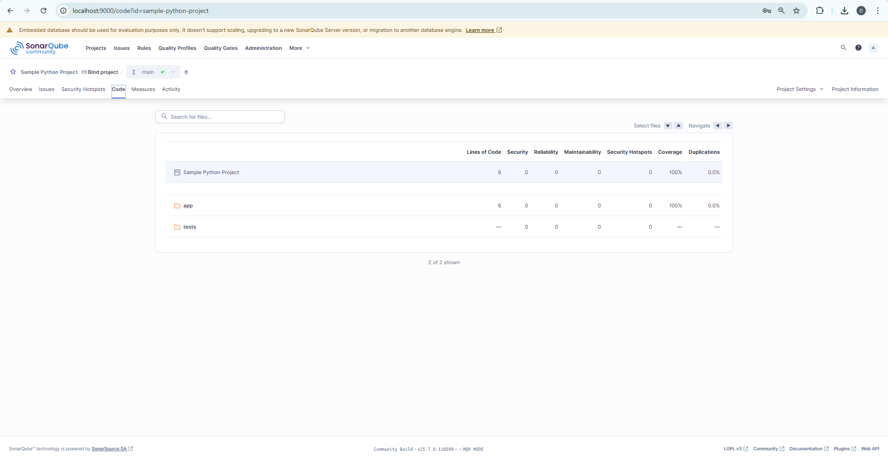

# 8. MEASURES TAB

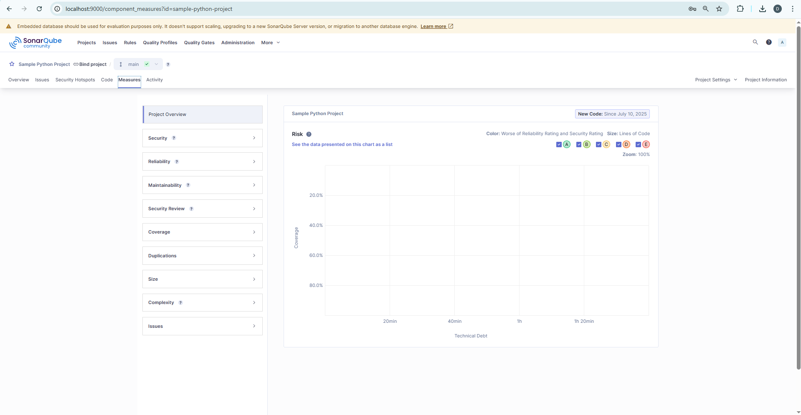

# 9. ACTIVITY TAB

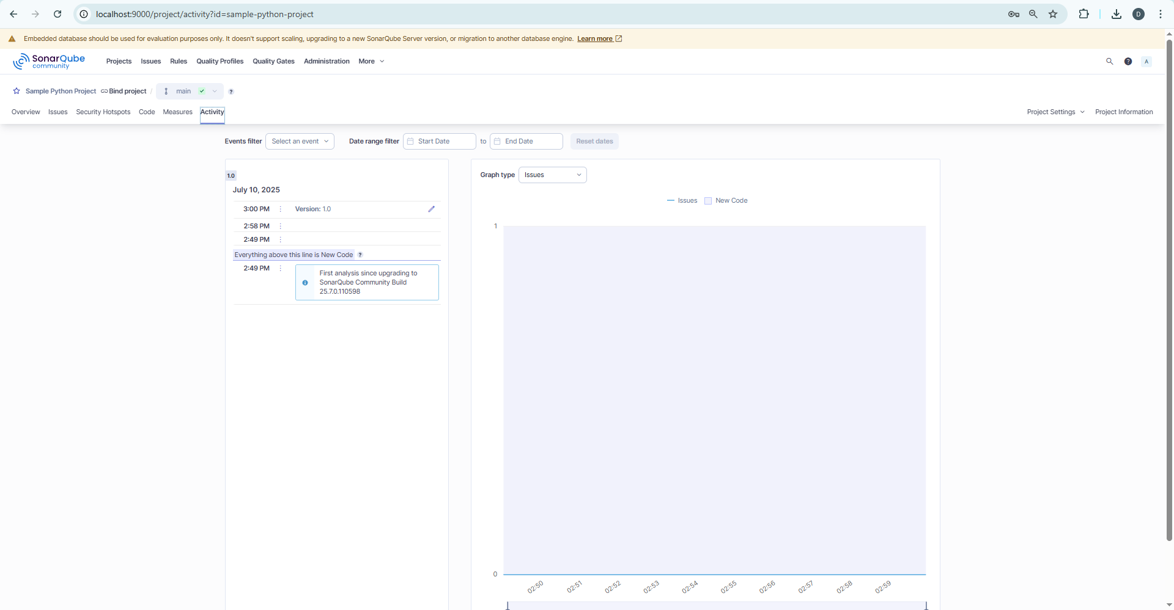

# NAV BAR SCREENS

# 11. ISSUES TAB

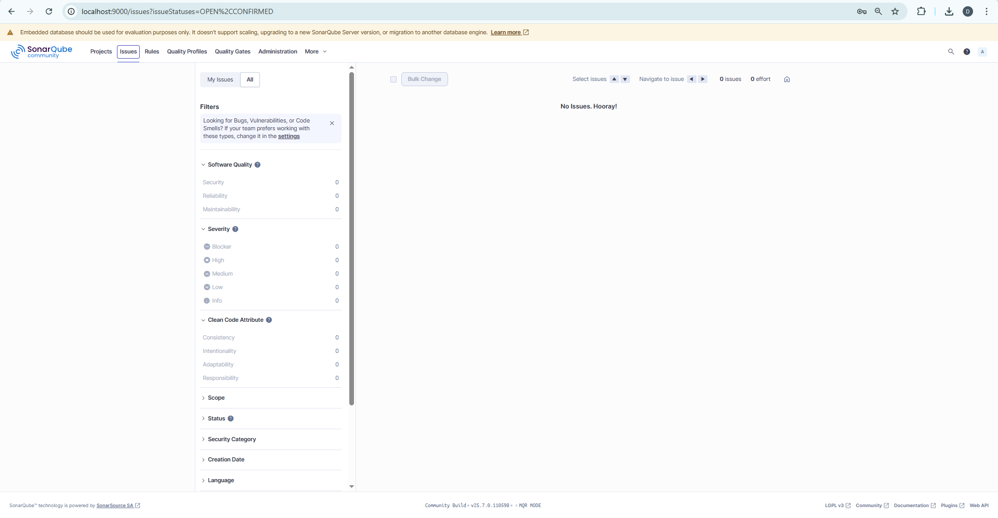

# 12. Rules Tab

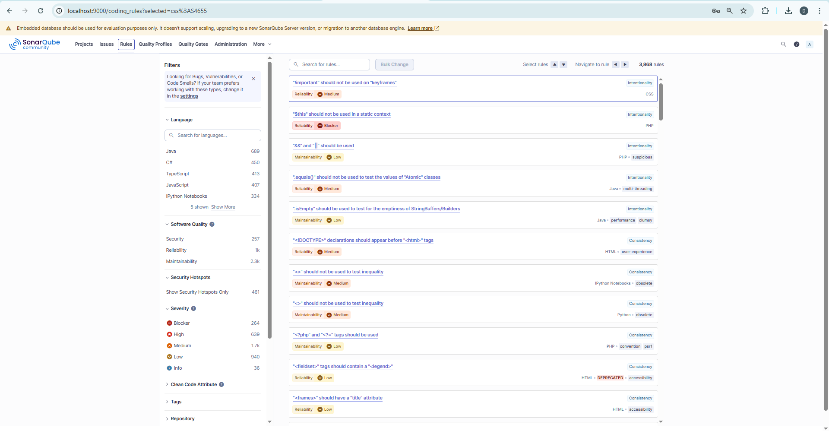

# 13. Quality Profiles

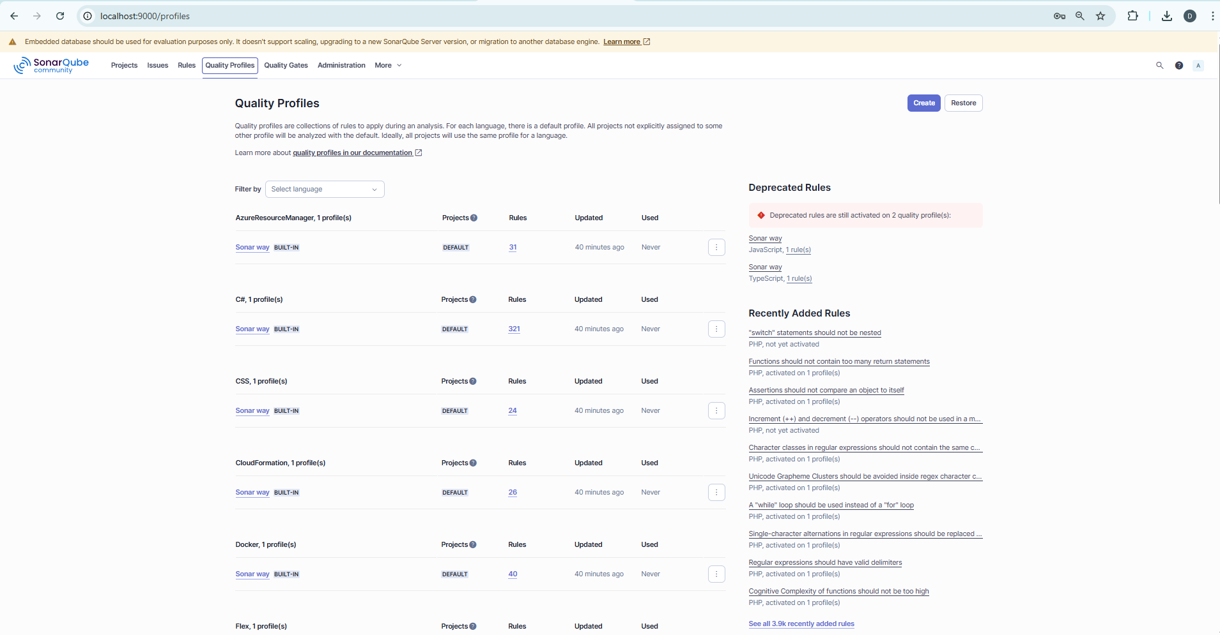

# 14. QUALITY GATES

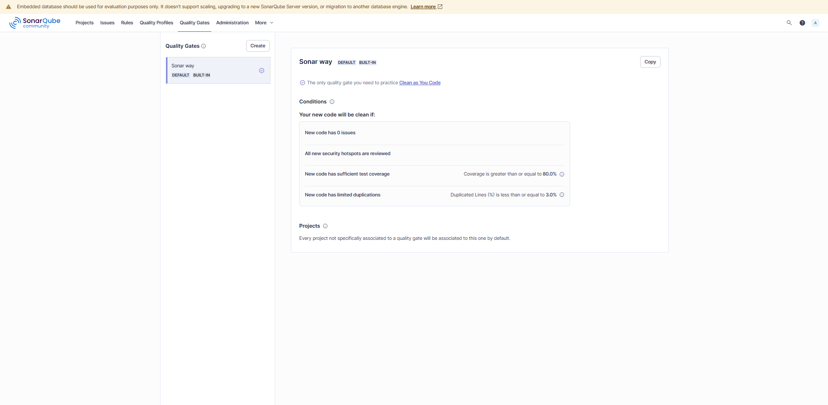

# 15. ADMINISTRATIONS

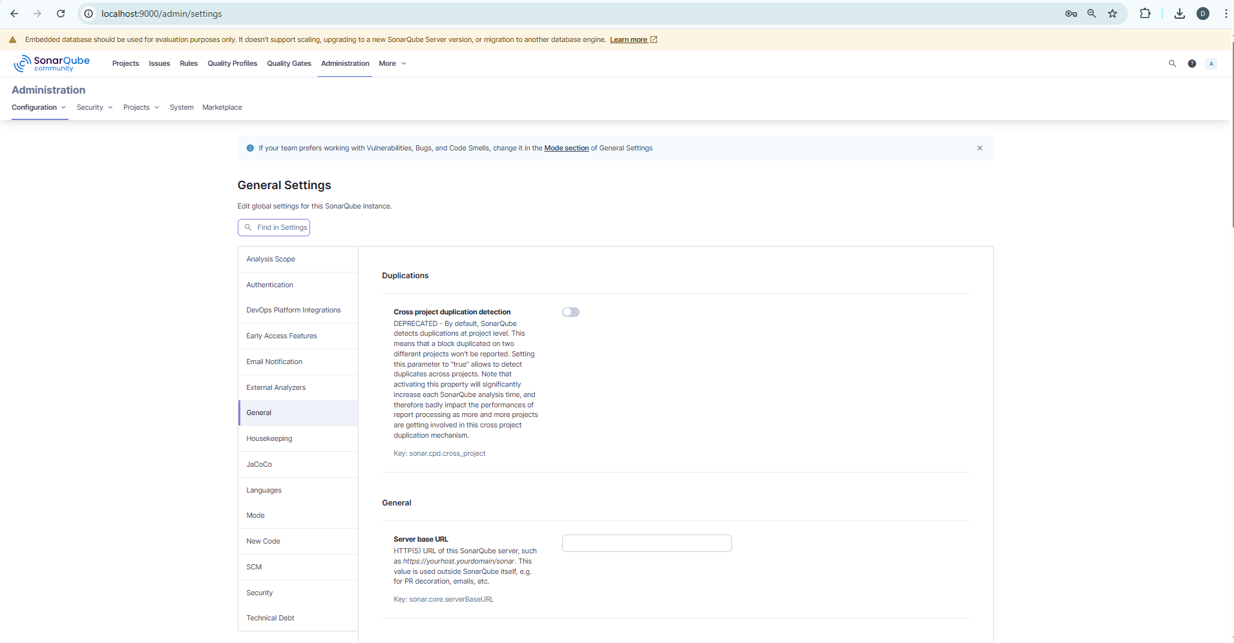

# 16. MORE Tab

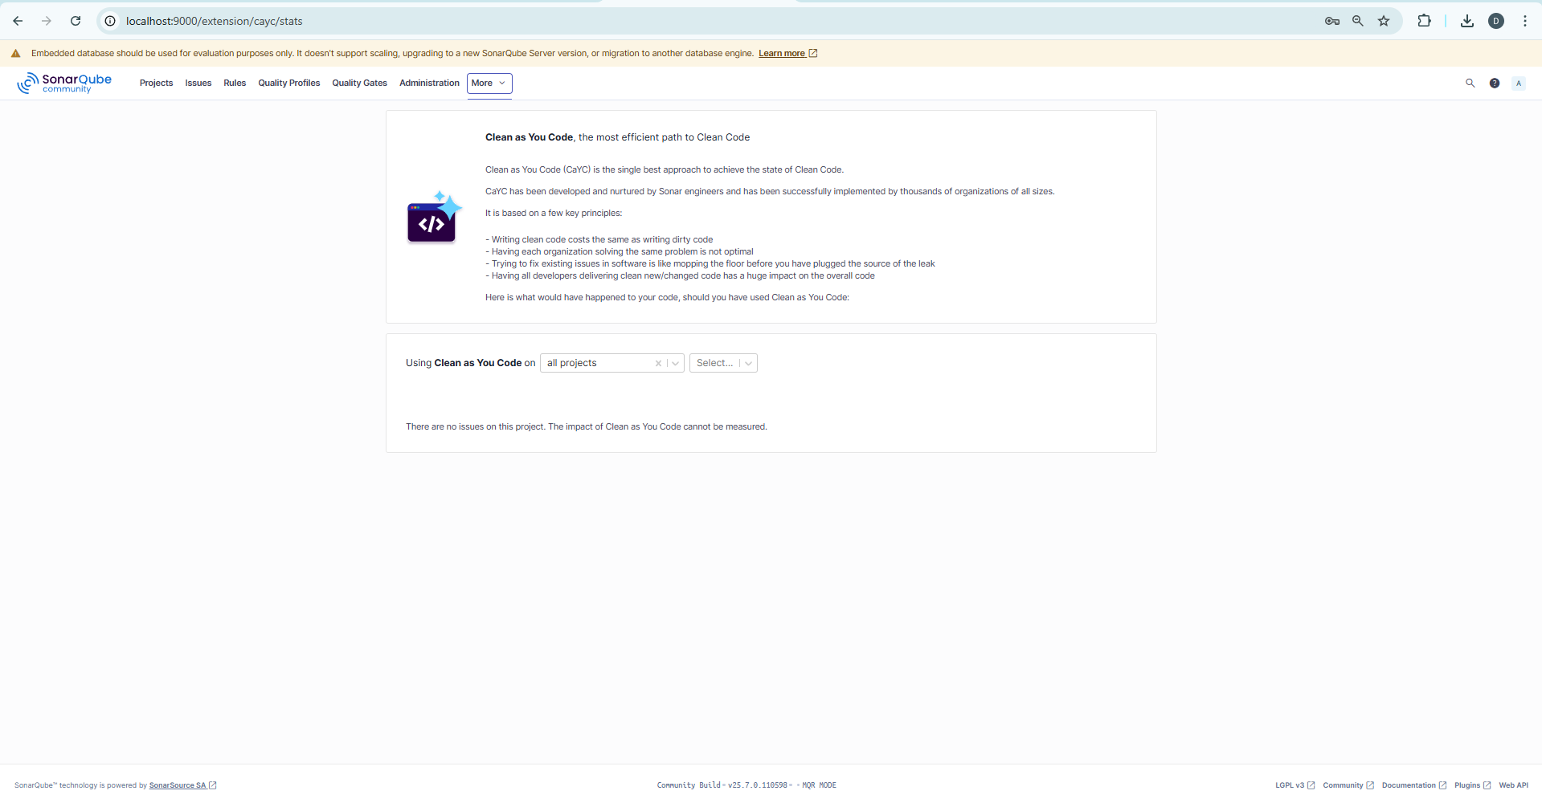

# NAV right side

# 17. Search option

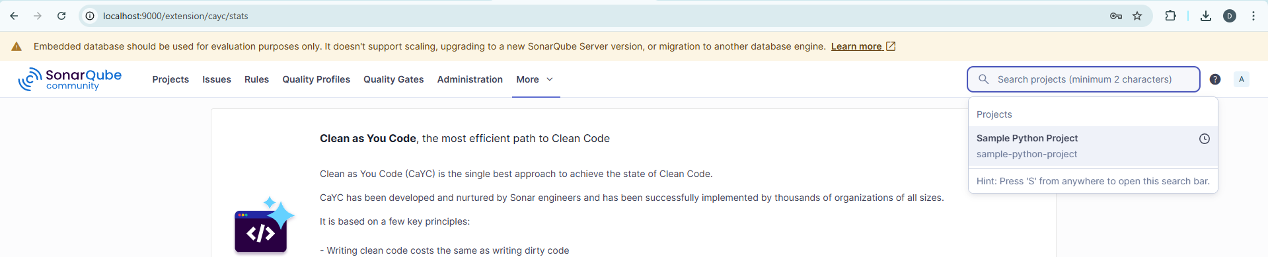

# 19. HELP OPTIONS

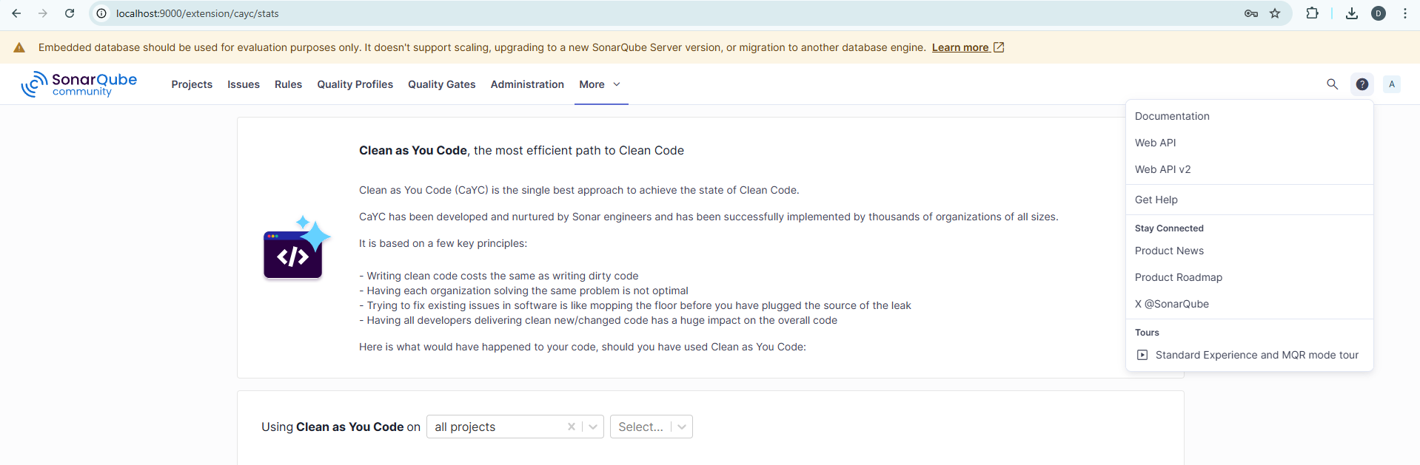

**MY ACCOUNT PAGE**

# 20. Profile Tab

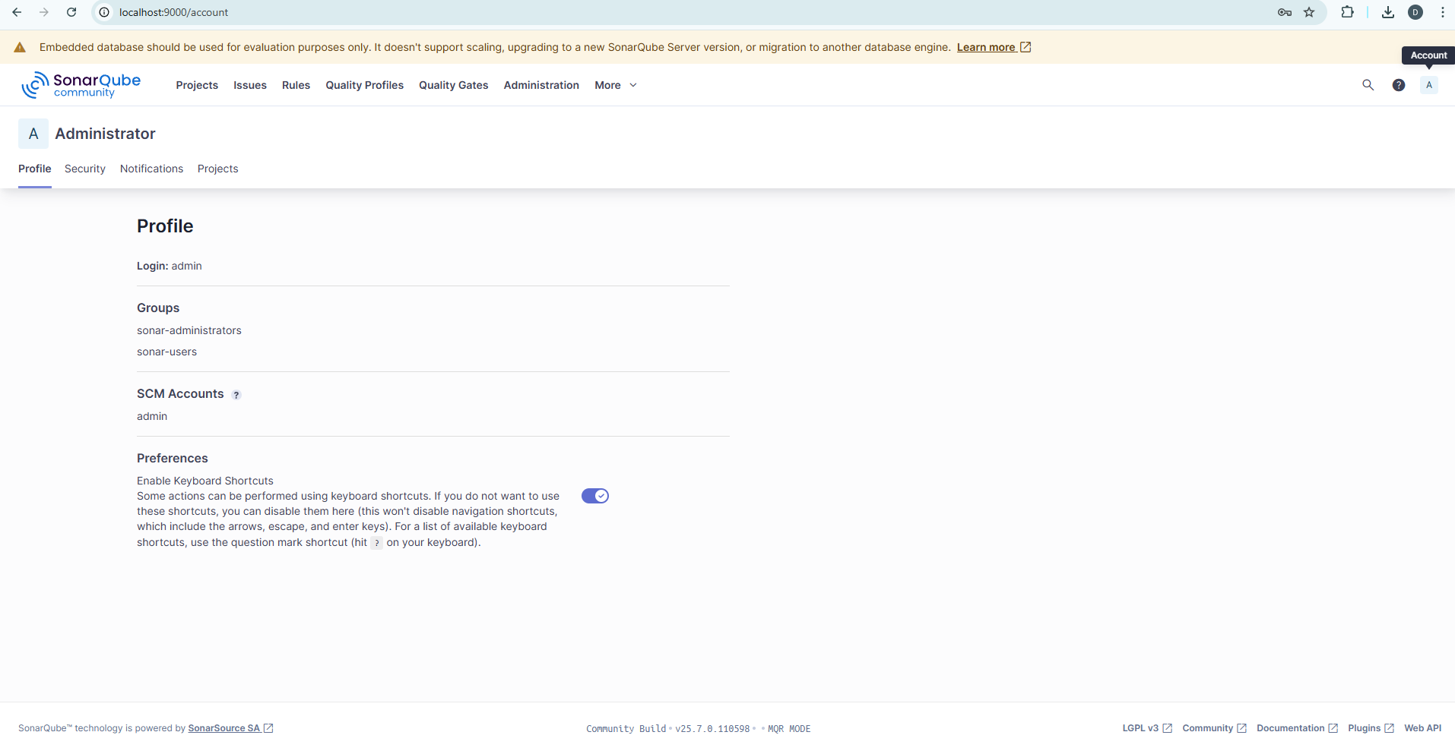

# 21. Security TAB

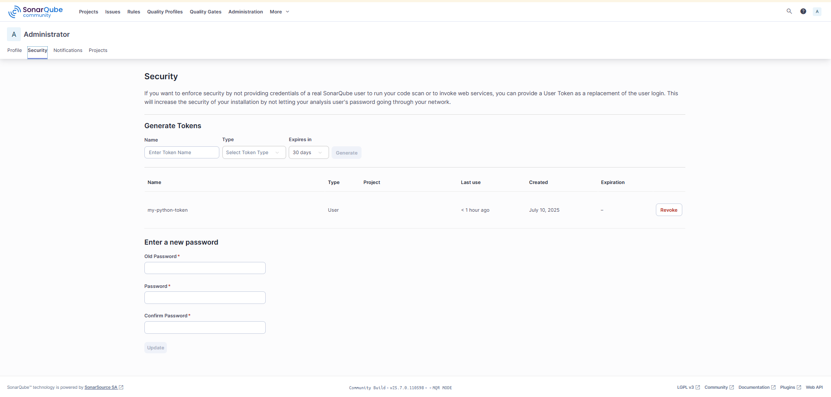

# 22. Notifications Tab

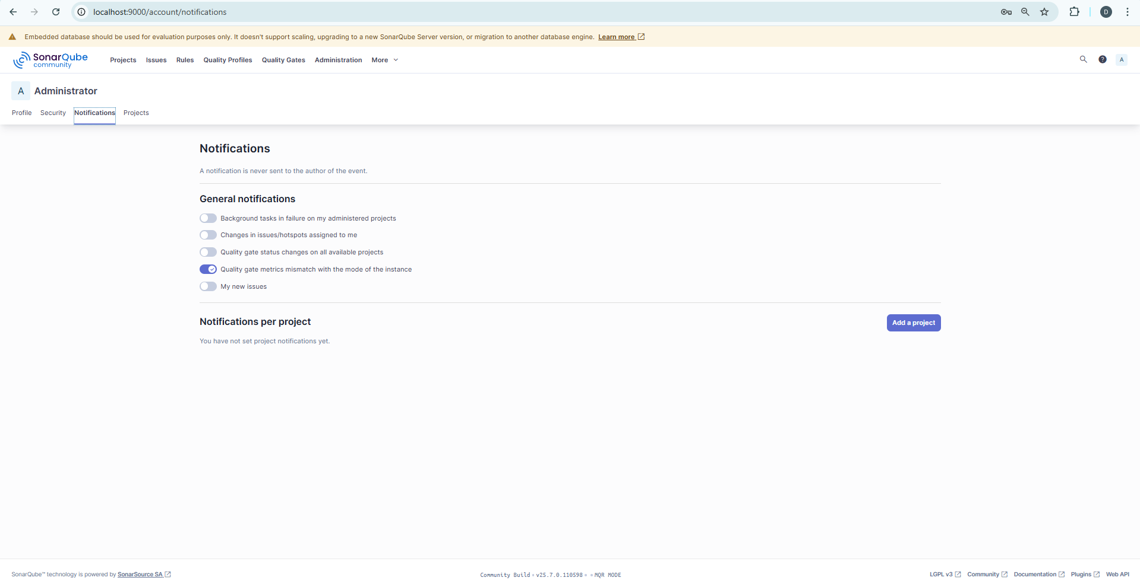

# 23. Projects Tab

