SKILL – 01

Encapsulation Builder: Analyze the overhead introduced by protocol headers and determine how encapsulation affects network efficiency.
Aim: To capture network packets and understand how Ethernet, IP, and TCP/UDP headers are added during data transmission.
Whenever data travels through a computer network, each protocol layer adds its own header to the data. These headers introduce overhead. Using Wireshark, we will capture real network packets, examine Ethernet, IP and TCP/UDP headers, calculate the total overhead, and determine how efficiently the network carries application data.
WireShark
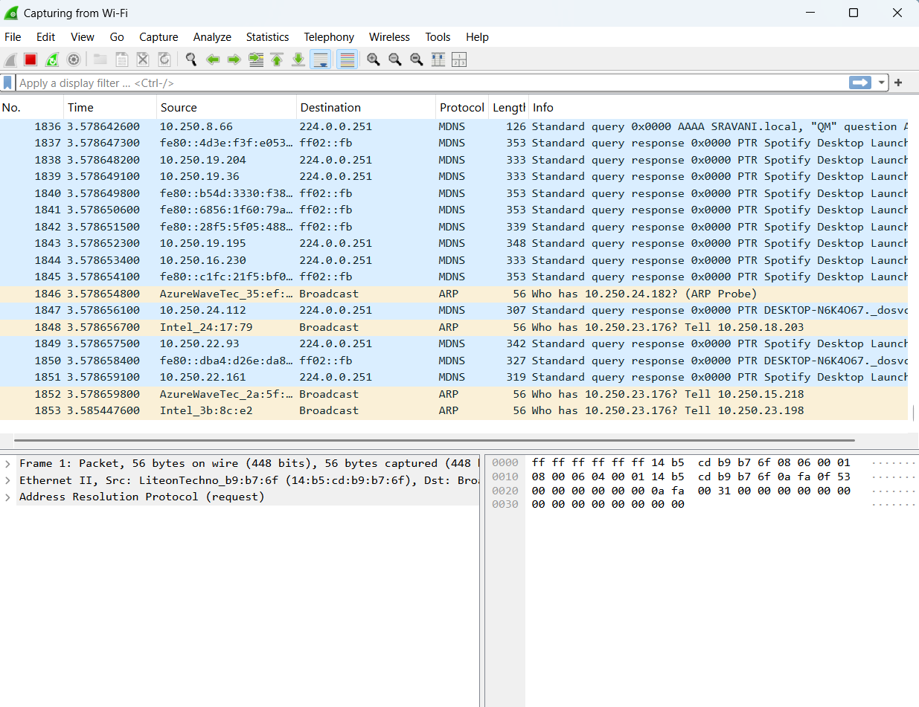
Web Browsers

After Browsing
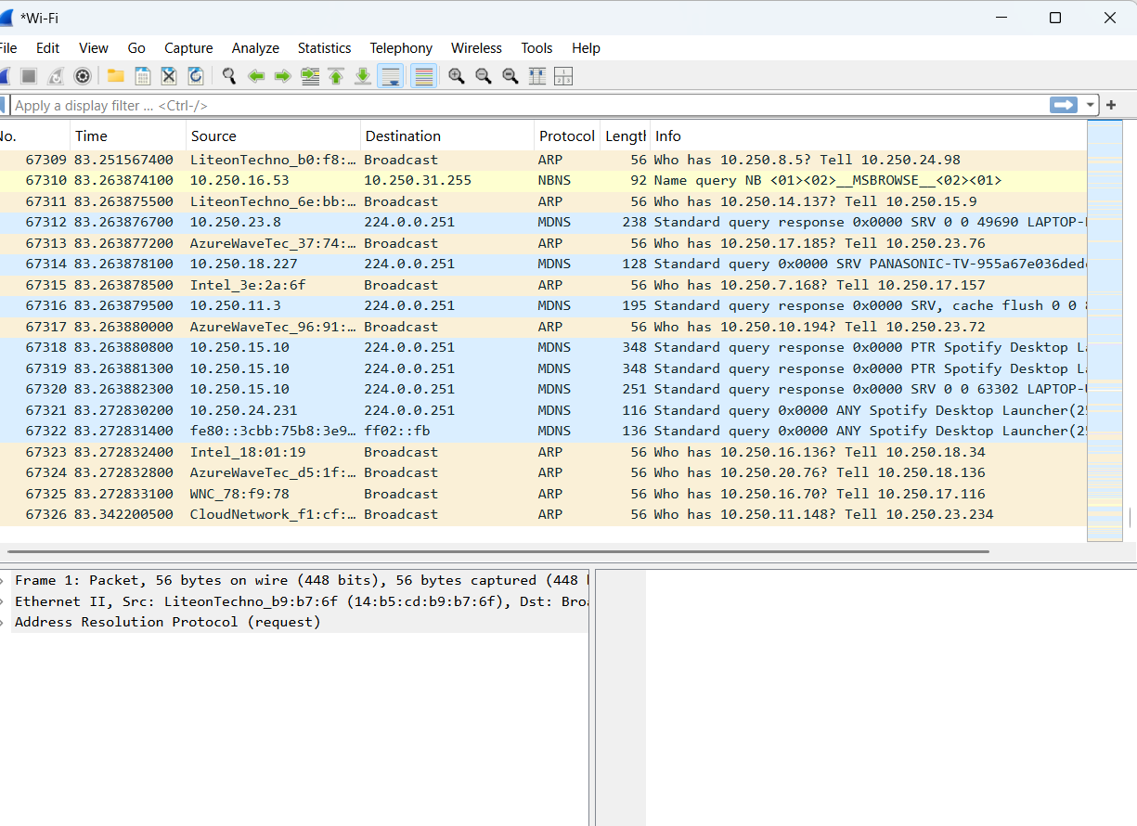

TCP
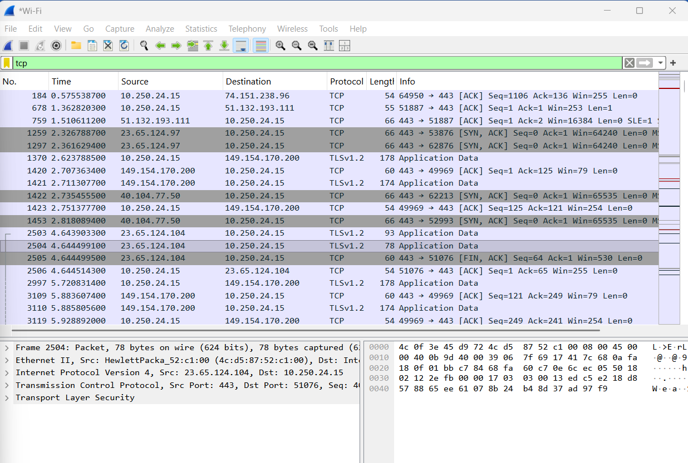
UDP
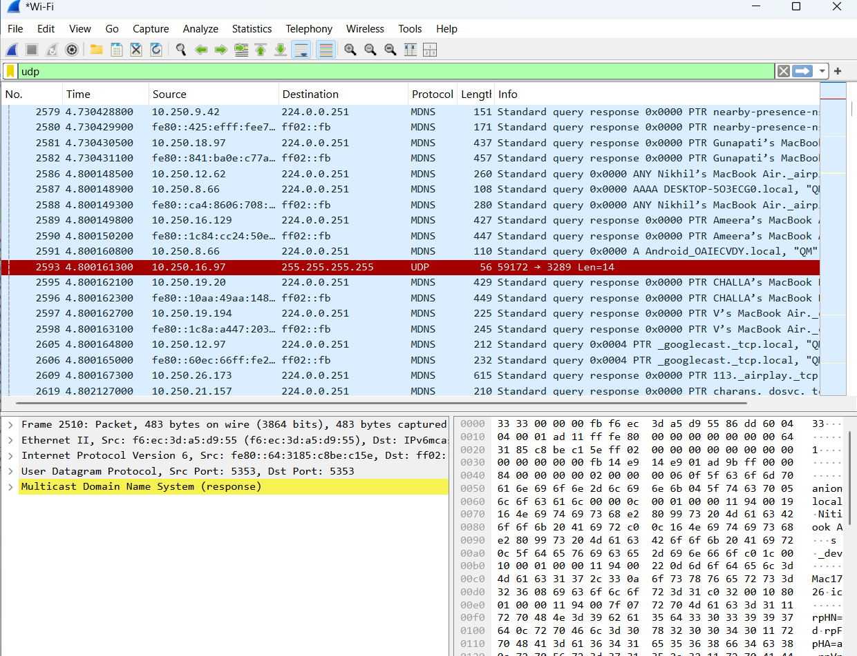

Records
Parameter | TCP Packet | UDP Packet
Frame Length | 66 Bytes | 87 Bytes
Ethernet Header Length | 14 Bytes | 14 Bytes
IP Header Length | 20 Bytes | 20 Bytes
Transport Header Length | 32 Bytes | 8 Bytes
IP Total Length | 52 Bytes | 73 Bytes
Transport Header Length | 0 Bytes | 53 Bytes
Payload Length | 0 Bytes | 45 Bytes

