A governed Knowledge Graph turns siloed SAP data into a reusable, explainable semantic layer, letting AI agents' reason deterministically across business objects like suppliers, materials, plants, and contracts
Enterprise AI cannot be trusted for decision-critical processes until it moves beyond probabilistic retrieval toward governed, deterministic reasoning over structured business relationships.
01 THE GAP
Today's AI limitation
▲ RAG is probabilistic
Retrieval accuracy degrades on complex enterprise
data no consistent or repeatable answers.
▲ No multi-hop reasoning
Cannot traverse dependencies across business objects
e.g. suppliers, materials, plants, and contracts.
▲ Limited governance and traceability
Source attribution is possible, but tracing business
relationships and decision paths remains challenging.
Probabilistic retrieval no deterministic path, no
explainable audit trail
02 THE SHIFT
What we propose
◆ Governed semantic layer
• Acts as an Enterprise Architecture context layer,
connecting business capabilities, processes,
applications, and organizational knowledge into a
unified semantic model.
• Provides a semantic abstraction layer, for the data
from different enterprise systems (SAP & Non-SAP),
that enables graph reasoning for Agentic Solutions
leveraging SAP Business Data Cloud.
• AI agents traverse relationship chains
deterministically, traceable across all business
contexts brining in multi-hop reasoning.
Deterministic reasoning over relationships every
inference is traceable and explainable
03 THE OUTCOME
Business value delivered
● Trusted, explainable AI
Every agent decision is grounded in governed data with
a clear reasoning path for audit and compliance.
● Unified data fabric
Hybrid model bridges structured SAP data and
unstructured sources into one semantic layer.
● Reusable knowledge layer
One graph powers multiple AI agents improving
accuracy, reducing risk, and scaling automation.
One graph powering multiple agents' accuracy,
risk reduction, and automation compound
A Knowledge Graph (KG) is a semantic data model that represents real-world entities — such as people, products, suppliers, events — as entities and meaningful relationships between them.
Context-Aware AI & Reasoning: Knowledge Graphs
connect business entities and relationships, enabling AI
access to the institutional context that governs how the
decisions are made.
• Unified Enterprise Data Fabric: Works on structured and
unstructured data across relational, graph, vector, JSON,
and document systems into a connected platform.
• Improved Decision Making: Explicit semantic
relationships provide better dependency analysis,
operational visibility, and more reliable business decisions.
• Autonomous Process Orchestration: Joule and AI agents
use Knowledge Graph relationships to automate workflows
across Supply Chain, Finance, Procurement, and HR.
• Intelligent Data Applications: Process both unstructured
data (documents, contracts) and tabular data through KG
Engine, with LLM integration via SAP GenAI Hub, Azure
OpenAI & AWS Bedrock
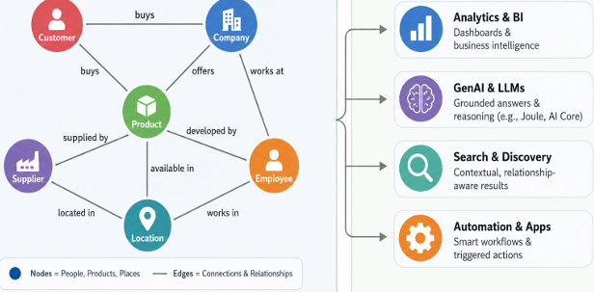
Native RDF Triples Store: Efficiently stores and
manages semantic triples representing entities,
properties, and relationships
• SPARQL Query Engine: Supports all SPARQL
query forms and updates for complex graph
traversals
• SQL-SPARQL Interoperability: Enables federated
queries between SQL and Knowledge Graph
engines
• Multi-model Integration: Works seamlessly with
vector, spatial, JSON, and relational engines
• LLM-Based Answer Synthesis: Converts graph
query results into natural language with ranked
recommendations and explanations
• Real-Time Graph Updates (Delta Handling):
Supports incremental updates without
rebuilding the entire graph
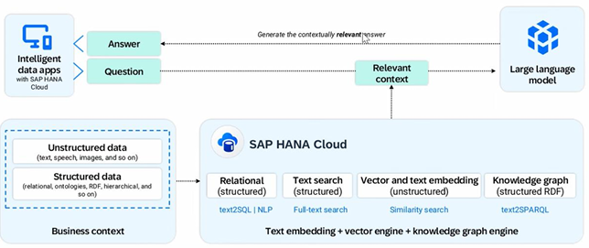

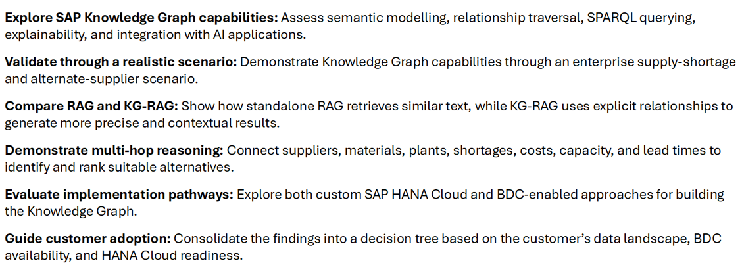
During a material shortage event by ACME Supplier at a Plant DE01, the system identifies and ranks alternate suppliers for the affected material Steel
Coil using Knowledge Graph relationships. Suppliers are evaluated based on reliability, cost, lead time, and capacity to ensure uninterrupted supply
continuity. Process is as goes below.
1. Shortage Detection & Supplier Identification
The system identifies the active shortage event and determines the supplier
linked to the disruption using Knowledge Graph relationships.
2. Alternate Supplier Discovery
The graph traverses Supplier offer relationships to find alternate suppliers for
the same material and plant while excluding the failing supplier.
3. Attribute Retrieval & Ranking
Supplier attributes; reliability, cost, lead time, and capacity are retrieved and
ranked using business prioritization logic.
4. AI Recommendation & Response
The AI agent synthesizes the ranked results into a plain-English
recommendation and returns the best alternatives to the procurement
manager

RAG does not retrieve any information
Retrieves semantically similar text chunks around "Steel Coil," "Plant_DE01," and suppliers, then asks the LLM to synthesize an answer. Because retrieval is based on text similarity rather than relationships, filters, supplier status, and lead-time comparisons are missed when information is spread across multiple chunks. Result quality depends heavily on chunking and retrieval accuracy.
Inherent Limitation: Relational data distributed across chunks cannot be reliably joined at query time
No structural filter: Supplier status, lead times, and plant codes require relational joins RAG cannot perform

Knowledge Graph retrieves complete information
Traverse explicit relationships between suppliers, materials, plants, and lead times. Filters out failing suppliers, compares delivery windows, and returns precise results via deterministic multi-hop traversal. Retrieval is based on connected data structure, not semantic similarity ensuring nothing structural is missed
Graphical Trait: Multi-hop graph traversal deterministically resolves cross-entity relationships
Precise structured output: Returns only qualified, active suppliers with verified delivery times for DE01

The key difference is that RAG retrieves relevant text, while Knowledge Graphs retrieve connected relationships. By explicitly modeling relationships, Knowledge Graphs can answer complex queries with greater efficiency, reducing prompt complexity, token consumption, and overall operational costs

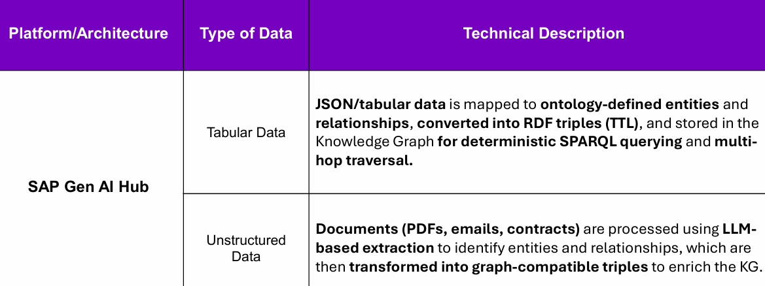

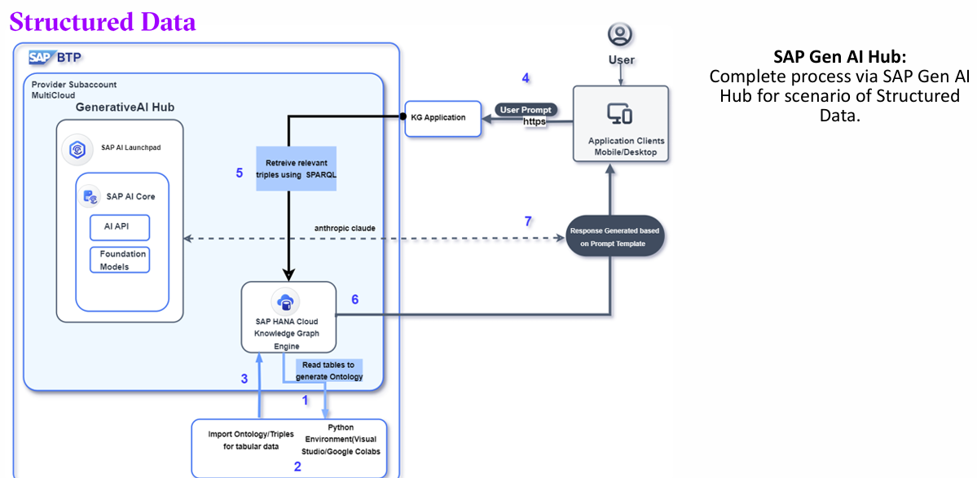
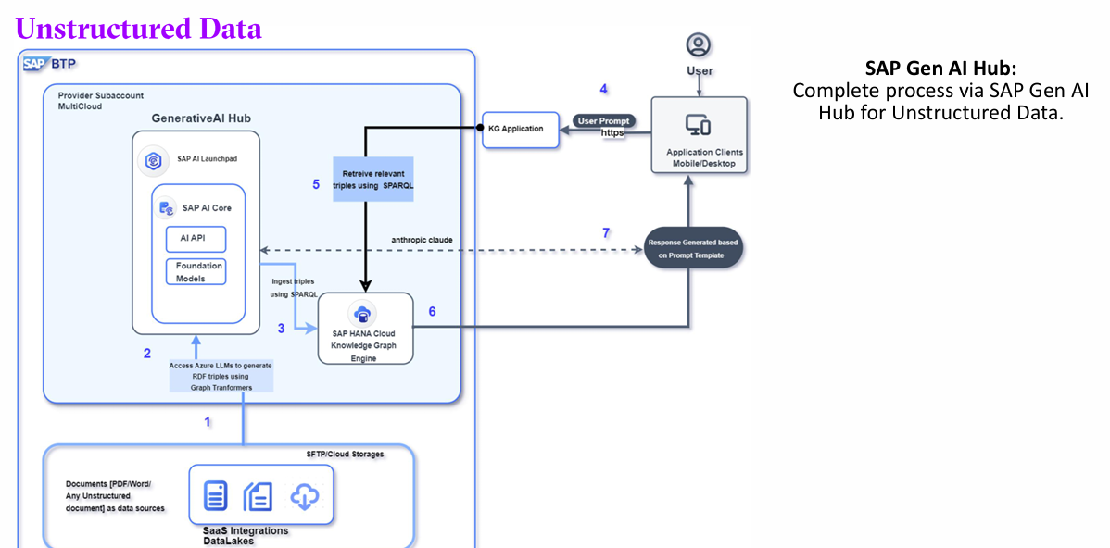
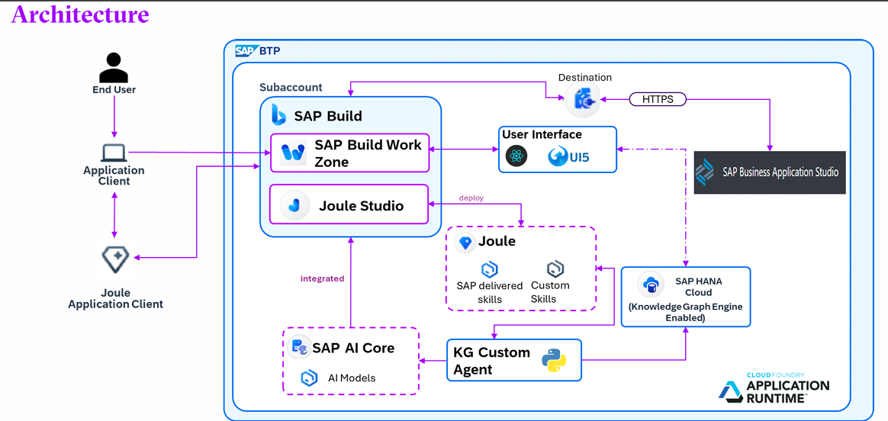
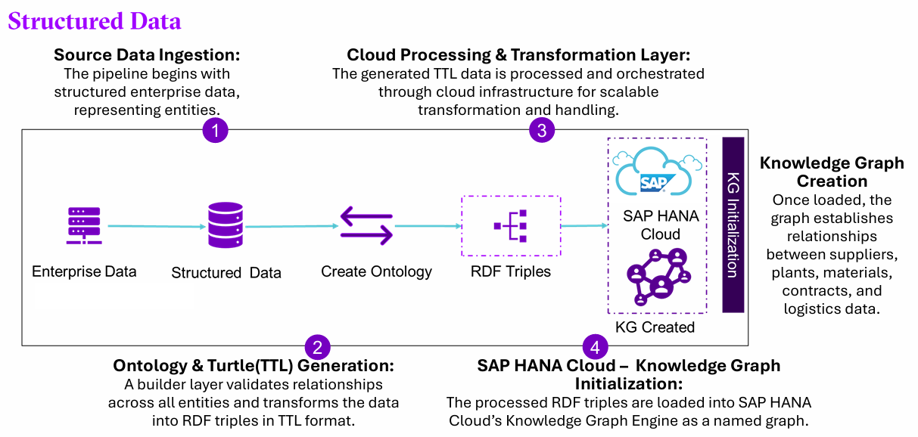
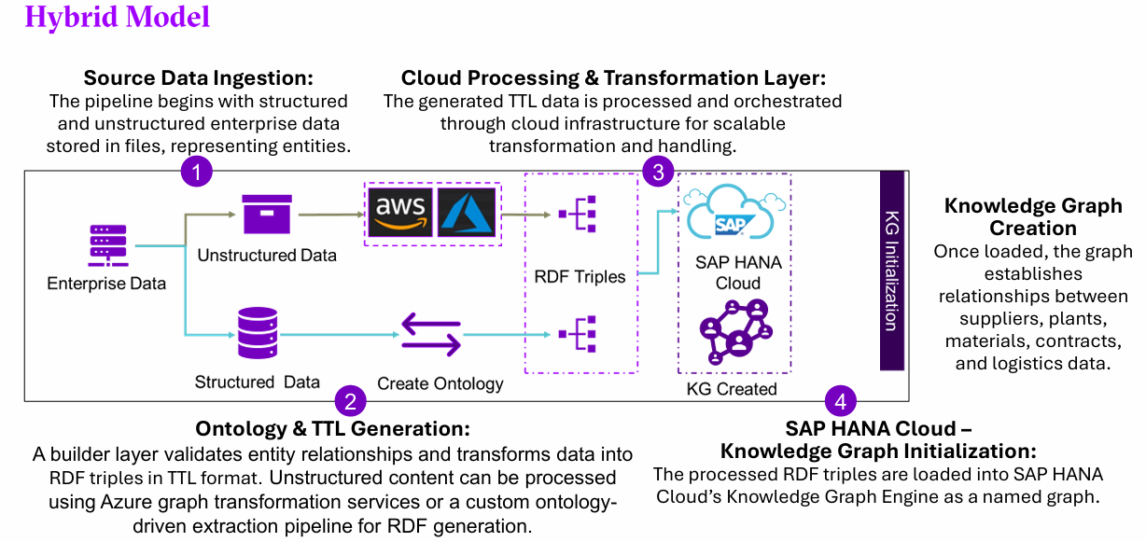
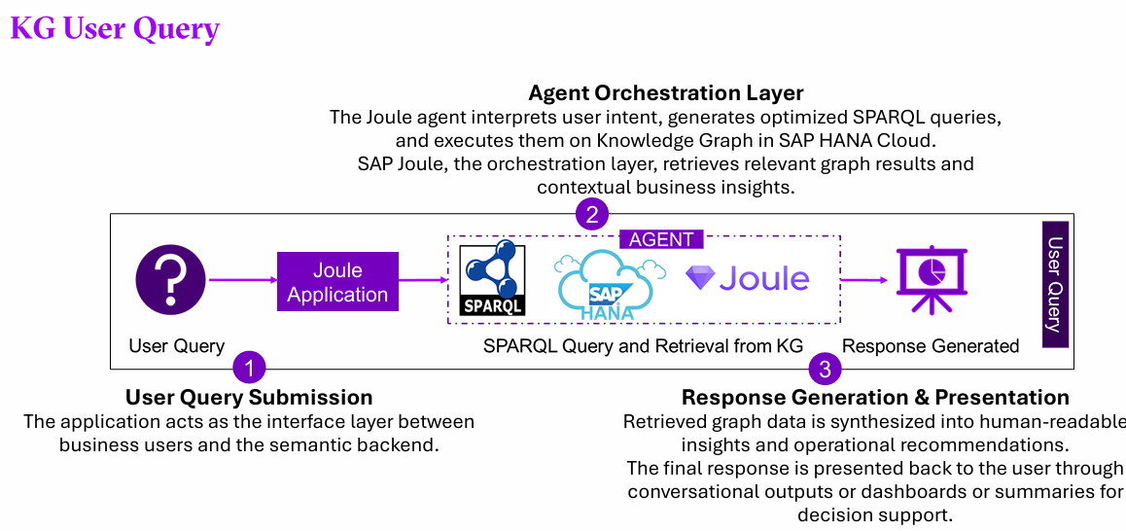

BDC – KG
Use BDC as the governed business data source, ingest the data into SAP HANA Cloud, transform it into Property Graphs, convert it to RDF Knowledge Graphs, and build a reusable semantic layer for AI-powered reasoning and explainability.
1 CURRENT SITUATION
KG generation from not available in standard SAP
As of now SAP does not provide the feature to generate
Knowledge Graph. However, SAP did indicate that this feature
could be a part of future releases.
High Ontology effort
When Knowledge Graph is generated from scratch in
HANA cloud, the ontology efforts are very high.
Data Products in BDC help reduce these efforts by
providing Property Graph generation which then can be
converted to Knowledge Graph.
2 THE APPROACH
Semantic foundation for agents
BDC-Data Products provide the semantic base for the creation of
knowledge graph. Data products provides governed, reusable,
business-ready dataset for property graph.
Bridge approach
Instead of generating Ontology from scratch, the property graph
is converted to Knowledge Graph with the help of HANA
Procedure RDF_GRAPH_FROM_GRAPH_WORKSPACE available
in HANA Cloud.
Prove the conversion path
Validated the creation of Knowledge Graph from Property Graph
by using the visualization layer built and as well as consuming in
an Agent.
3 Key Differentiators over KG from
Scratch
Property Graph
Property Graphs handle operational traversal which defines what
data is connected to what which forms the base for Knowledge
Graph to define what those connections mean and enables AI to
reason over them.
Property Graph to Knowledge Graph
SAP HANA Cloud provides Procedures to generate Knowledge
Graph from property graph reducing the efforts considerably.
BDC enables faster implementation of Knowledge Graph by providing Property Graph to generate Ontology using HANA Procedures, reducing the efforts invested to create RDF Triples.
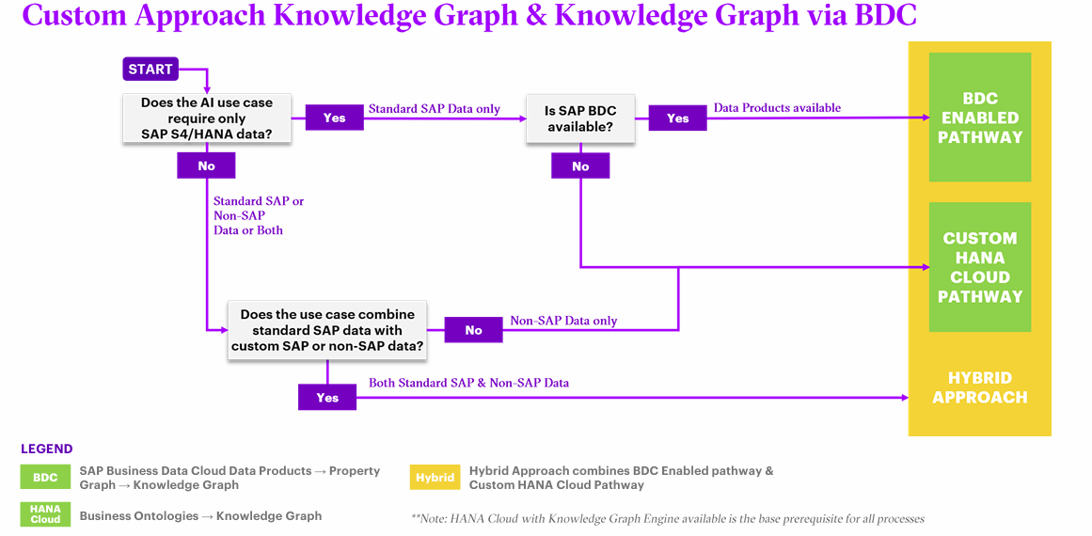
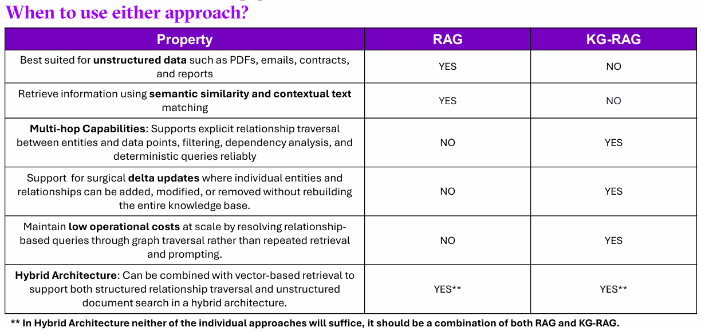
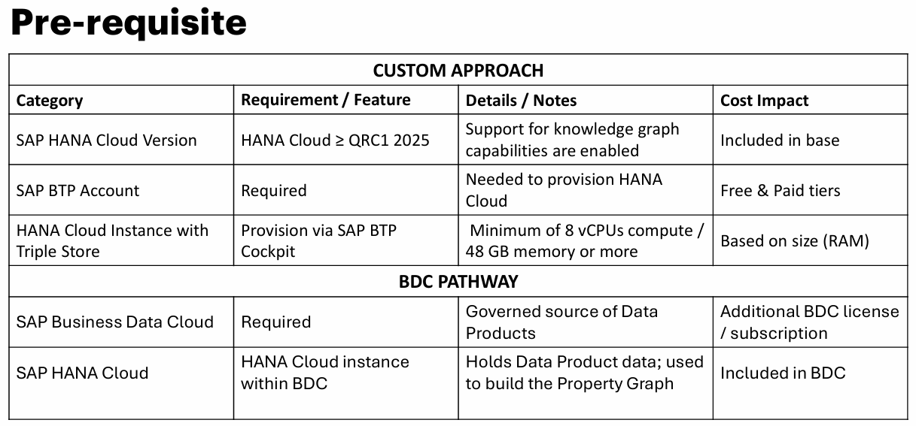
To find details about memory consumption and sizing, check the link: Memory Consumption and Sizing Considerations | SAP Help Portal
To find details about the version, check the link: SAP Road Map Explorer
To determine the HANA DB Size, make use of the calculator link: SAP HANA Cloud Capacity Unit Estimator

SAP HANA Cloud includes a built-in graph viewer that enables users to visualize entities and relationships directly from the Knowledge Graph. It supports basic graph exploration, relationship discovery, and validation of connected data structures.
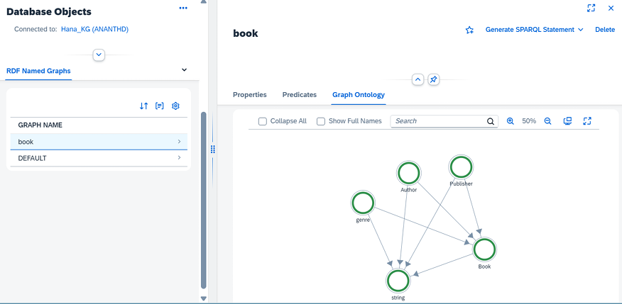

Road map
