My Soccer Music

Hausman
Vanderiblt School of Engineering
Vanderbilt University
Nashville, United States
andew.d.hausman@vanderbilt.edu

Abstract — As an avid user of Spotify and someone who appreciates music in the right mood, I want to revolve my project around automated creation of Spotify playlists based on information from the cloud. I want to take into consideration two factors to predict the mood of the user and automate a playlist that perfectly matches. One factor is the weather conditions at the user’s chosen location, which I could access through an accurate weather API, and then use that information to make pairings between different weather types and different music genres. Secondly, my project will consider mood based on the successes or failures of a chosen English Premier League team by the user. Based on the user’s location, the chosen soccer team, and what the team’s record is, I can determine if the user is in a happier or sadder mood. From here, I will use Spotify’s API to match the user’s mood to Spotify seed genres and “danceability,” which will match to the user’s weather and soccer team’s record, respectively. With this information, a custom-made playlist can be created and put into the user’s profile (provided the user offers their Spotify username).

Introduction
The first, and foremost, reason I chose this project was Spotify. The application has a fantastic interface and one that I love and use every day. Moreover, the application has a beautiful way of recommending songs to its users through something called seeds. These “seeds” can be anything from seed artists, songs, and genres to song danceability, energy, and duration. With these parameters, someone can tailor the contents of a playlist however they want. This provided a unique opportunity to experiment with playlist creation and identify new songs based off of what inputs I decided. Generating new playlists would also allow me and others to find new artists, songs, and genres we may have never heard before.
Aside from Spotify, I chose this project due to my passion for Soccer and love for climatology. I constantly watch soccer, and specifically the English Premier League, whenever possible. The science that is weather has also always been an interest of mine. Weather always has an effect on people’s mood, and I wanted to be able to show the mood a person might be in through songs. Thus, I figured utilizing Spotify with Weather and Soccer application programming interface’s would allow me to create something truly magical.
Lastly, I have never created a website before. I wanted real-world (i.e. outside the classroom) experience with Amazon Web Services and other programming languages like HTML, CSS, and Python [3]. Moreover, I have never really created a computer science-oriented project outside the classroom (or job), so I wanted to see what I could do on my own without anyone else’s help.

Design and Architecture

Website versus Application
While local applications are certainly nice, they lack a few key aspects compared to websites. To start, only one user (the person using my laptop) could take advantage of my project. On the other hand, any person with an internet connection can access my website and be rewarded with a Spotify playlist because of that fact. Moreover, this also allowed me to send my website’s URL to friends and family. While it was certainly nice to see their faces light up when they found a new playlist in their Spotify accounts, the real reason I was pleased was because this allowed me to have over twenty different people test and give feedback on my work. Had I just created an application on my laptop (like I was initially planning to), twenty different people would have come over to my house and put in their favorite soccer team, city, etc.; this also wasn’t an option given the global pandemic.
Furthermore, I gained a deeper understanding of “front-end” and “back-end,” and what those terms actually mean. The separation of web architecture from the actual program allowed me to build a truly unique solution.
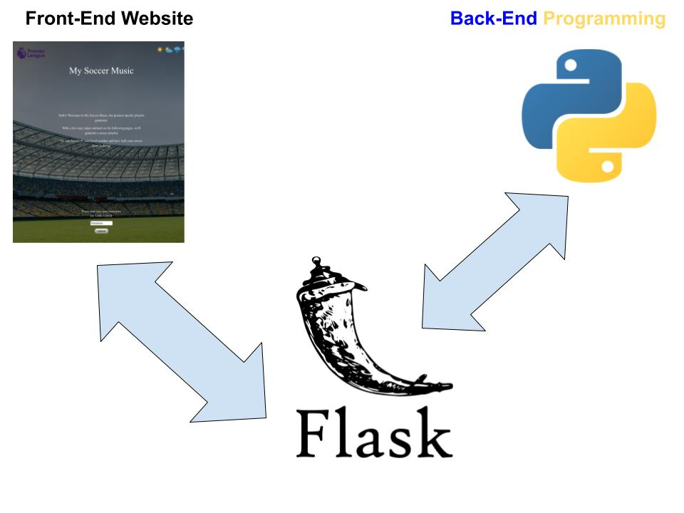
Fig. 1. Front-end vs. back-end

Lastly, as I previously stated, I have never made a website before and wanted to see if I could do it. While this experience was challenging and grueling at times, I also found it all the more rewarding and fulfilling. Gaining a deeper understanding of Amazon Web Services, along with HTML and CSS, will no doubt help me out in my future computer science related endeavors.

Spotify is the Premier Music Streaming Service
There are multitudes of music streaming services on the web and many of them have high-end, well thought out application programming interfaces. That said, Spotify’s is clearly the best one out there.
Vanderbilt School of Engineering
To start, Spotify makes it incredibly easy to use “seeds,” as described earlier. Making a unique playlist from a given set of parameters is not too difficult. Moreover, it is very easy to get the playlist from your backend code to the user’s Spotify profile through “get” and “post” requests. To start, I identified key parameters (danceability and genre) and sent a get request to Spotify for songs that meet those parameters. Then Spotify sends back a list of songs that meet those parameters. I then send two more post requests (one to create the playlist and another to dump the songs into that playlist). In return, I get a URL to this new Spotify playlist, which is also in the user’s account. Spotify’s API was critical in giving me the ability to easily find the direct URL to the new playlist, allowing me to directly output it to the final results page on my website (where the user can easily copy and paste it into their web browser).
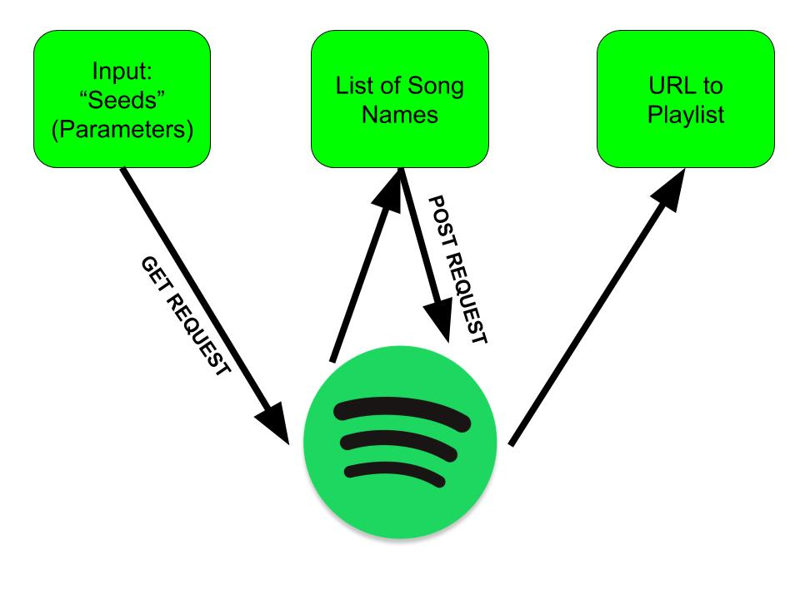
Fig. 2. How Spotify input parameters are turned into a URL for a playlist

Other music streaming API’s on the web (ex. Apple Music) are much more rigid. It is significantly harder to create and then send playlists to a given user’s account. More importantly, I know very few people (including myself) that use Apple, SoundCloud, etc. compared to Spotify. This would make it much harder for me to find people to test my website, and, more importantly, it would mean my website is less important to people (since less people could use it).
In the end, Spotify’s easy to use interface allowed me to make and send the playlists to users’ accounts. And with more people using Spotify than ever before, I gained a larger audience to test and give feedback on my website.

Flask as a Web Framework
As previously stated, I had never built a website before this project. I had zero experience in HTML, CSS, or JavaScript [3]. Thus, I went on a manhunt for an easy way to deploy my website through a language I knew (e.g., Python). This is when I realized Flask was the answer I had been looking for. Unlike Django and many other Python-based web frameworks, Flask is extremely to use and “pick-up” for beginners [2].

Implementation
The implementation of my solution is grounded in a front-end website (using HTML and CSS) with back-end programming in python and Flask Servers. The entire website is hosted on Amazon Web Services.

User Inputs
After typing http://3.23.131.227:8080/ into a search browser and hitting search, users will find them welcomed to a page asking them to insert their favorite English Premier League team’s name.
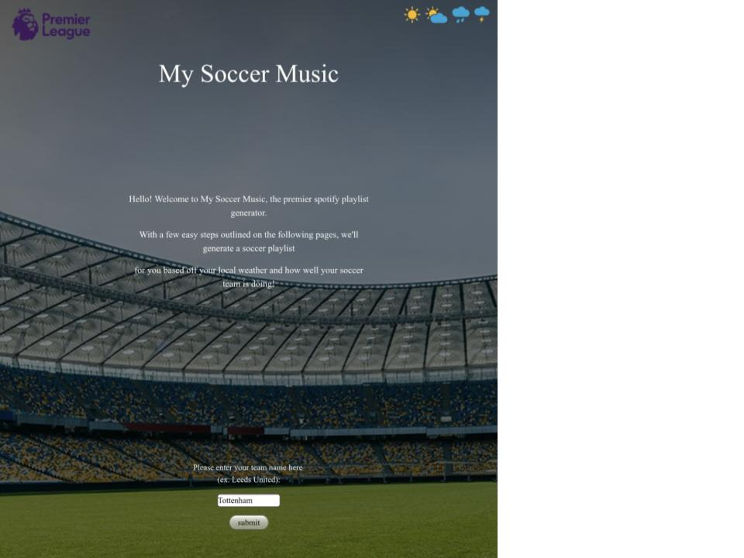
Fig. 3. Home page for website

Following the home page, the user’s will then be asked to submit a Spotify “token.” The next screen gives instructions for how to easily access the token (takes less than a minute) and input in the appropriate space on the website. The token is necessary for creating the playlist, as it allows the back-end program to access and modify a person’s Spotify account (temporarily).
Following the submission of a Spotify token, the website then asks for the user’s Spotify username, city, and country (as an abbreviation in the case of the United States.
These five inputs together form the backbone of generating the necessary Spotify seeds for the custom-made playlist.

Spotify Seeds
With the five inputs (team name, Spotify token, Spotify username, city, and country), we are now able to generate the Spotify seeds to make the playlist.
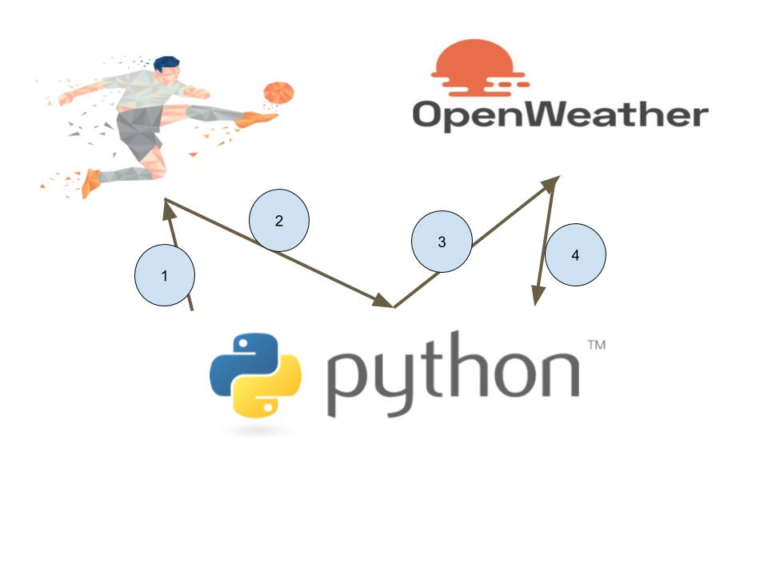

Fig. 4. Get requests sent to weather and soccer API’s

The Diagram above helps illustrate how this happens. Step one involves sending a get request to API-Football, a sports API which has up to date information for the English Premier League teams. Step two returns this information to the back-end python program which takes it and parses the returned string for the record of the team the user inputted. Another, separate get request (step three) is sent to OpenWeather, an API which has up to date information for cities around the world. Step four is taking the returned string from OpenWeather and parsing it for the current weather of the city the user inputted. At last, we have the soccer team’s record (number of wins, draws, and losses the team has) and the weather of the city the user gave the website.
The back-end program continues by calculating a “soccer score.” This equation for the score is as follows (note it is rounded to the nearest integer):

Score = 100 * [(wins*3) + draws] / [3 * (wins + draws + losses)] (1)

This score essentially calculates how well a team is doing, where the scale is 0 to 100 (it is almost like a grade in school). How high (or low) this school is then corresponds to the “danceability” Spotify seed, which the company defines as follows: danceability describes how suitable a track is for dancing based on a combination of musical elements including tempo, rhythm stability, beat strength, and overall regularity. A value of 0.0 is least danceable and 1.0 is most danceable. For example, Tottenham has a record of 7 wins, 3 draws and 1 loss (as of December 11th, 2020). This corresponds to a score of 80, which (according to the back-end program I built) gives a very high danceability of 0.97. On the other hand, teams like West Brom and Sheffield United (who are at the bottom of the English Premier League table) would receive a danceability of just 0.10.
But danceability is just one of two seeds for the playlist generation; the other is genre. The genre seed will come from the weather data taken from the OpenWeather API: sky description (ex. clear, rain, snow, etc.), wind in miles per hour, and temperature in Fahrenheit. The sky description part matches “clear” to the “happy” genre, “snow” to the “holidays” genre, and many others. A high temperature will also give a “summer” genre, while a low one will add a “study” genre. Finally, high wind will add a “rock-n-roll” genre (or a “chill” genre if not). Therefore, in total, three seed genres are sent to the Spotify API for processing.

Calling Spotify and User Outputs
As stated earlier in the design and architecture section, the two seeds (genre and danceability) are sent to Spotify through a get request. The information on 30 songs (title, artist, etc.) are returned to the back-end Python program. Then two post requests are made to the user’s Spotify account (one for creating the playlist and the next for adding the songs to it). In between the first and second post request, the URL for the new Spotify playlist can be extracted.

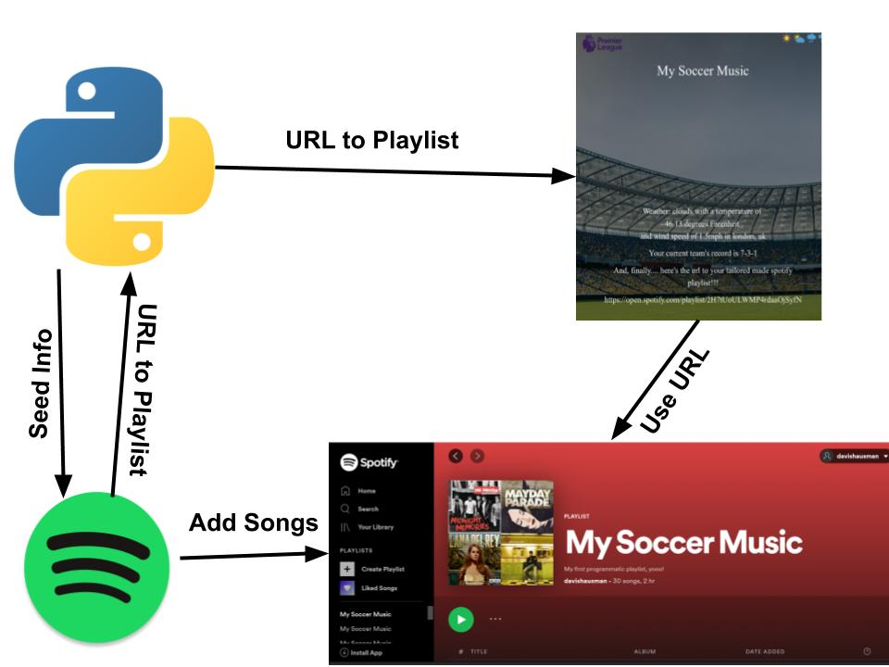

Fig. 5. How the User gets their output
With the URL extracted and placed in the back-end Python program, we can then send it to the website’s interface (coded in HTML and CSS) through the running Flask server for the user to easily access. Along with the URL to the playlist, the
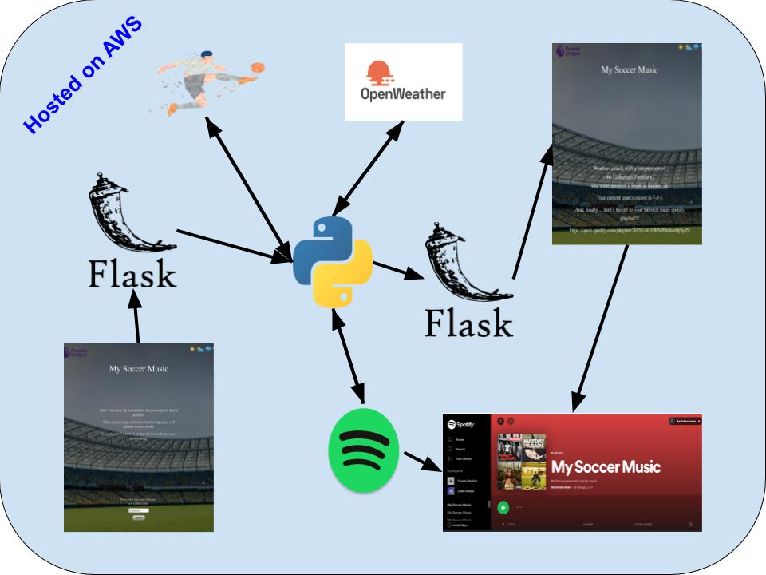

Fig. 6. Final layout of the website. Note that in order to actually start up the website I had to run “Foreground.py” in an AWS virtual machine.

soccer team’s record and the user’s city’s weather are displayed.
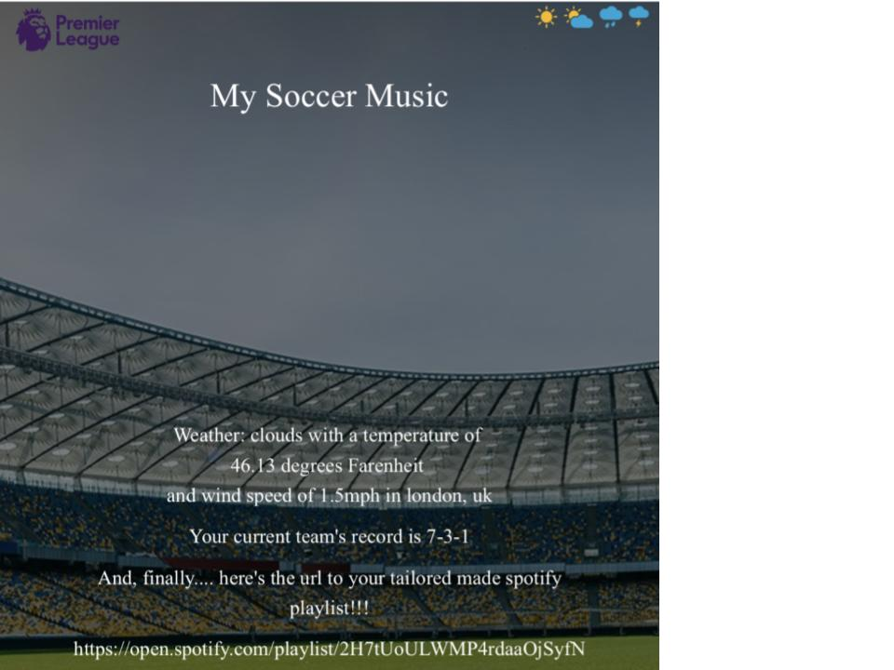
Fig. 7. Zoomed in version of results page on website

Flask Servers
In order to actually start up my website, I had to run the file “Foreground.py” in an AWS virtual machine, which runs a Flask server[2]. Flask played a unique role in my solution, which I have only just begun to understand.
In the beginning of my project, I create a website through HTML and CSS, along with the python-based back-end solution that I ran through my local terminal. Flask, in essence, allowed me to connect these two things. Flask was essentially the middle-man. For example, when I wanted to send the URL back to the website for the user to see, I sent it first through a flask method (called “finalOutput”). Then flask sent the results to the HTML through a method called “render_template.” Moreover, Flask also gave me a way to access my website on Chrome with an interface, and not just have it be a local application through terminal.
In all, choosing to use Flask was a great decision and really let my project come together.

Amazon Web Services
Until this project, I’ve never actually used Amazon Web Services before. While it was slightly more challenging than expected, it was indeed well worth it.
I followed a guide from Twilio that conveniently explained to me how to get my Flask application up-and-running on the internet through AWS. The beginning portion was mostly setting up an AWS instance and security groups (very similar to Chameleon). Similar to in-class assignments, I used ssh to get into the AWS create virtual machine. A “tmux” command was actually used to create a new session, where I actually ran the Flask application.

Teamwork
Due to my former partner and I splitting up, I did this project all on my own. While it was a bit much at times, I found it to be all the more rewarding and fulfilling to successfully build a website on my own. It’s, not only refreshing, but useful to know that should I ever need to build a website, use Flask, or deploy an AWS instance again I will be able to do just that.
Most of my unit testing was done by

Conclusion
My solution (in this case website) takes in the following inputs: an English Premier League soccer team, Spotify username, Spotify token, city, and country (or country’s abbreviation). Using these inputs, my (back-end) program builds a custom-made Spotify playlist with thirty unique songs based on the user inputs. The playlist is then sent to the user’s Spotify account where they can see it and start using it. The final or resulting webpage also has a link to this playlist, along with the record of the inputted soccer team and the weather data for the city that the user gave.
I was unsuccessful in error handling for this website for all five inputs. For example, if the Spotify token is outdated or off by a letter or two, then the website will crash and the playlist won’t be sent to the user’s account.
Error handling is the first thing I would like to continue in terms of future work. Other future work may include using a person’s location and to output that country’s music. For example, if a person lists “Spain” as their country, I would add Reggaeton to the seed genres.
The github link for all my work can be found here: https://github.com/dhausman16/CCFinalProject

Acknowledgment
YouTube channels like “Tech with Tim” were critical in helping me understand Flask, as well as CSS and HTML[2,3]. Moreover, I would not have been able to deploy an AWS instance with help from a guideline that can be found on Twilio[1].

References
- AWS:https://www.twilio.com/blog/deploy-flask-python-app-aws
- Flask:https://www.youtube.com/watch?v=mqhxxeeTbu0&list=PLzMcBGfZo4-n4vJJybUVV3Un_NFS5EOgX&ab_channel=TechWithTim
- CSS/HTML: https://www.youtube.com/watch?v=uyaV_EWWRmo&ab_channel=Webdev
- Spotifyseeds:https://developer.spotify.com/documentation/web-api/reference/browse/get-recommendations/

