# Image Processing - Lab02

Aim: Perform arithmetic and logical operation on image and enhance image by log transformation and power law transformation.

Arithmetic Operation:

We can perform add, subtract, multiply operation on image by simply as we do with numeric values.

Suppose we have image im1 and im2 then following operation can be done.

* Addition: im3 = im1 + im2
* Subtraction: im3 = im1 – im2
* Multiplication: im3 = im1. *im2

Logical Operation:

We can perform and, or, not operation on image by using inbuilt function.

Suppose we have image im1 and im2 then following operation can be done.

* And: and (im1, im2)
* Or: or (im1, im2)
* Not: not (im1)

Log transformation:

* s = c(1+log(r))

where c = constant, r=input image, s=output image

Power law transformation:

* s = c*r^gamma

where c=constant, r=input image, s =output image, gamma = constant

Assignment

1). In a surveillance system, two frames of the captured videos are given as image '1.jpg' and '2.jpg' Apply image subtraction to locate the foreground.

Code:

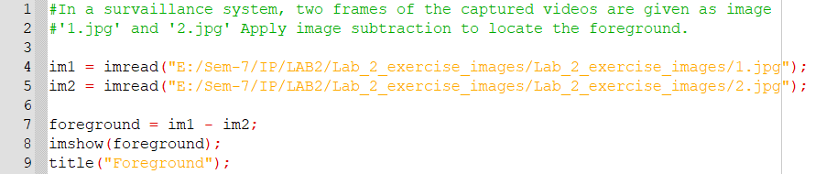

Output:

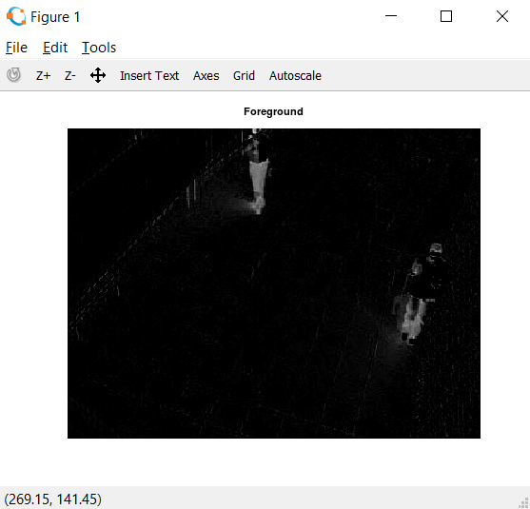

2). Take your own **black and white** photo. Resize it to 256x256. Also consider given

image 3.jpg. Demonstrate the logical operations like 'and', 'or', 'not' using these

two images. Justify the results.

Code:

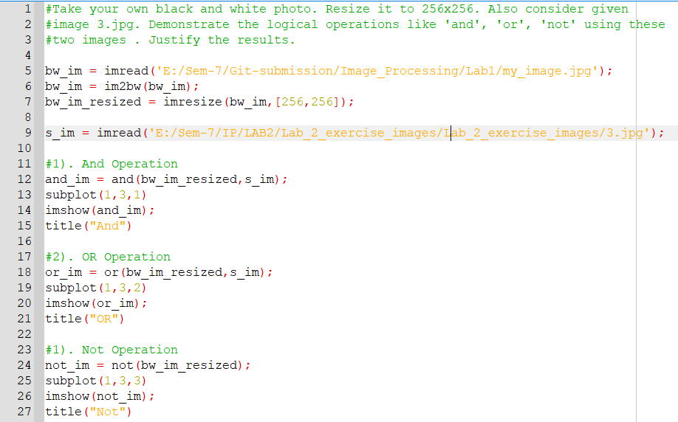

Output:

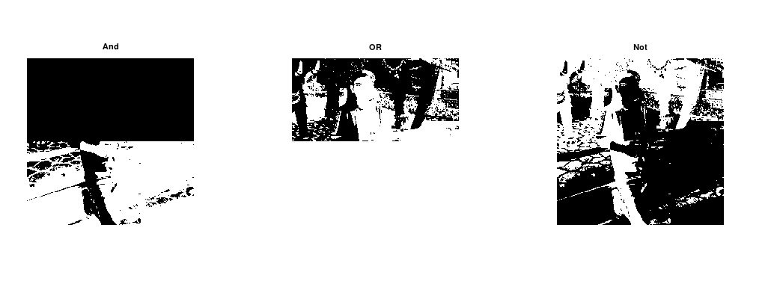

3). Consider image 4.jpg, 5.jpg and 6.jpg as input and apply arithmetic operations on

input image to generate 7.jpg as output image.

Code:

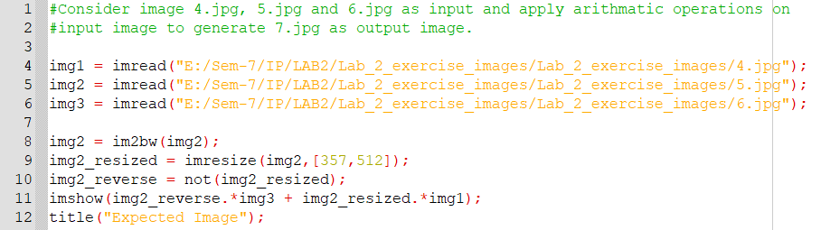

Output:

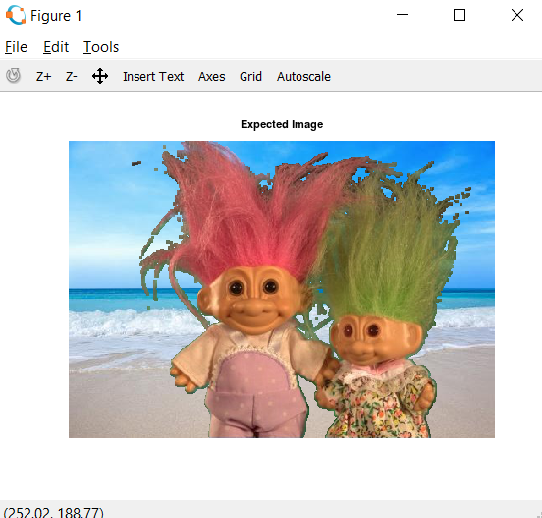

4). Take your own **grayscale** photo and apply 'negative' transformation.

Code:

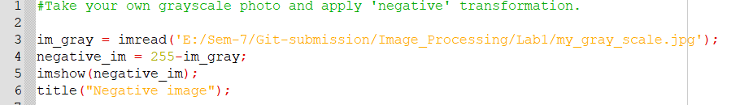

Output:

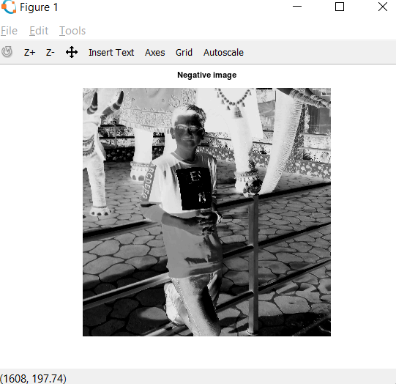

5). Consider image 8.jpg. Enhance the image by applying the log transformation.

Code:

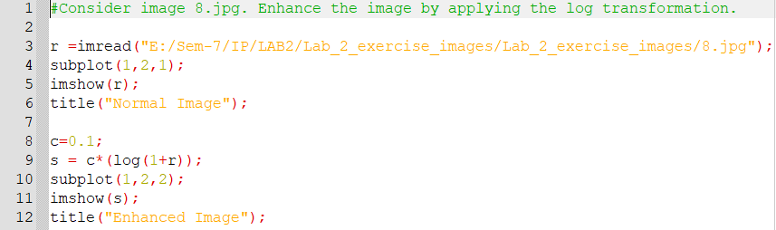

Output:

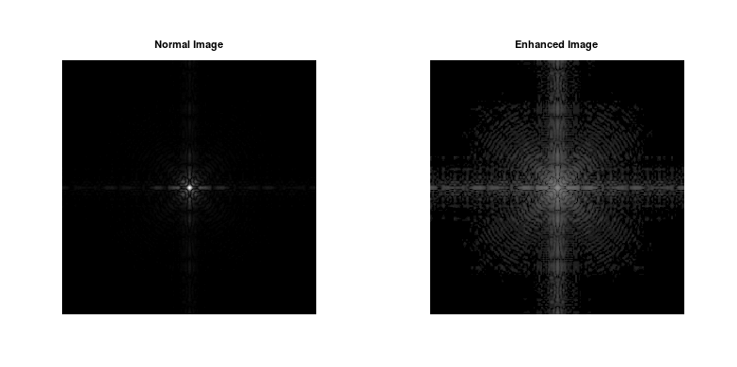

6). Consider image 9.jpg and 10.jpg and enhance them with power law

transformation.

Code:

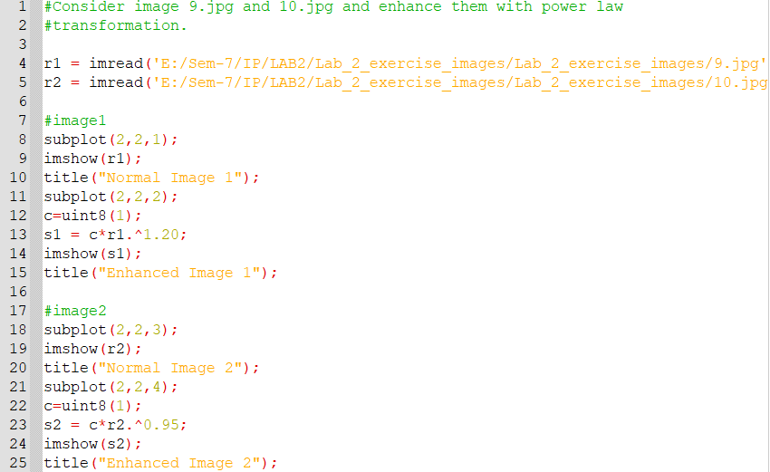

Output:

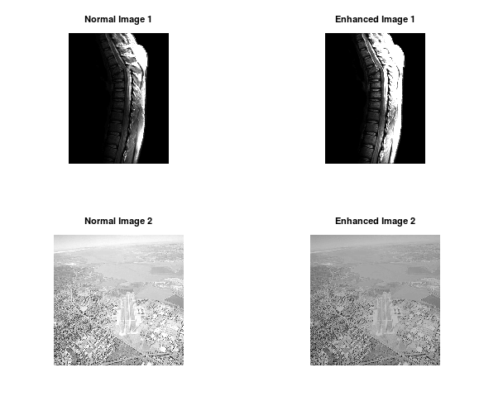

7). Consider your **over exposed photo (that you generated for assignment 1)** and enhance it by power law transformation. Specify the value of gamma which is suitable for this enhancement.

Code:

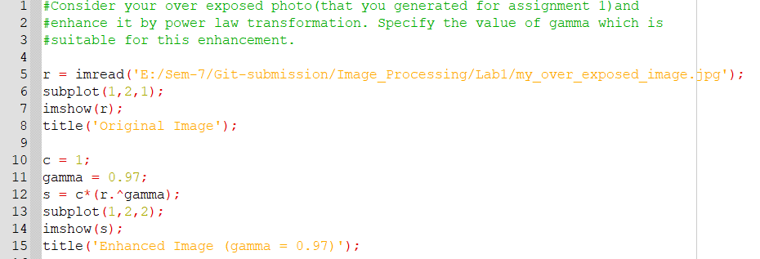

Output:

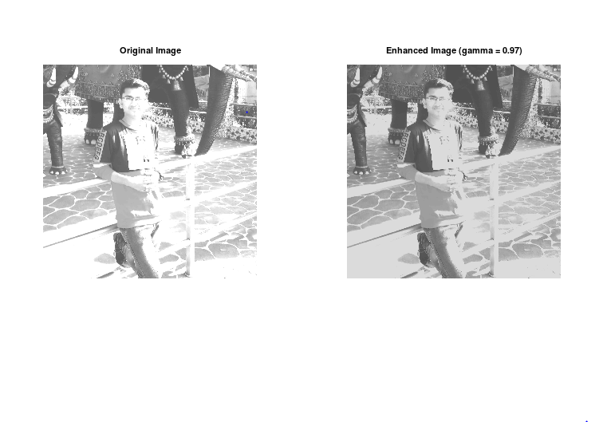

8). Consider your **under exposed photo (that you generated for assignment 1)** and

enhance it by power law transformation. Specify the value of gamma which is

suitable for this enhancement.

Code:

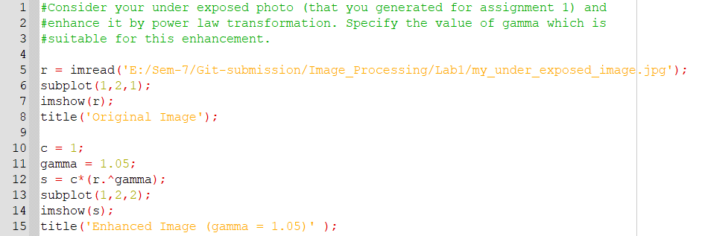

Output:

