**Lab_Assignment_3**

**1.  
**

3.   
  
4.  
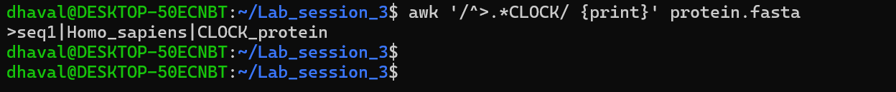  
  
5.  


6.  
  
Note: For this I ask help from chat gpt for syntax writing   
Given prompt-how to write syntax in awk for finding number of single character in whole file  
Ans- awk '{count += gsub(/A/, "A")} END {print count}' filename  
  
7. 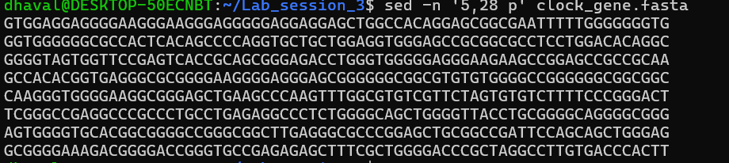

8.

Chat gpt promot- awk -F" " '/^>/ {print substr($1,2)}' file name

9.  
  
  
**10.  
  
11.**

**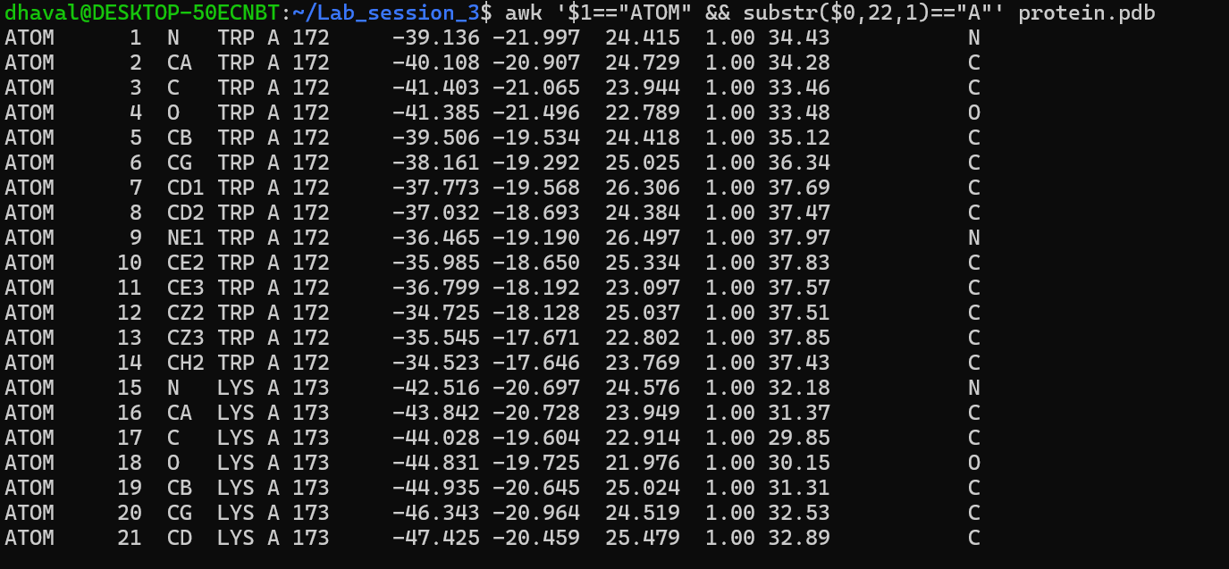  
  
  
  
12.  
**I took help from **ChatGPT** to understand how to write code using substr and **field** $n in awk.  
  
13.   
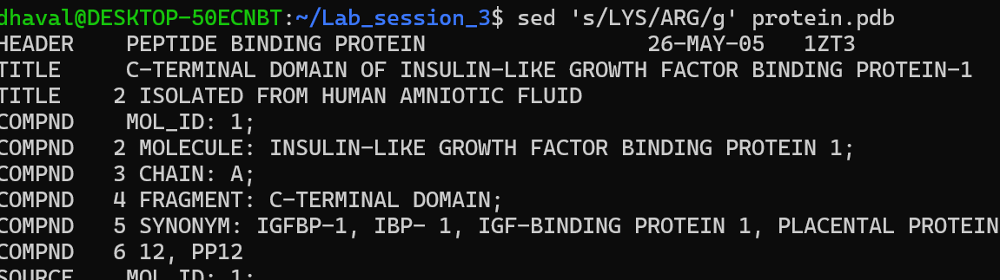  
  
15.  
  
  
17.   
  
20. 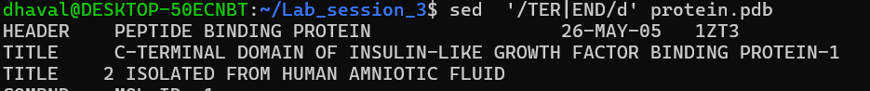  
  
22.  
I took help from Perplexity AI to understand how to find the frequency of each residue (molecule) in a PDB file.

awk '$1 == "ATOM" && $5 == "A" {residues[$4]++} END {for (res in residues) print res, residues[res]}' filename  
  
23.  
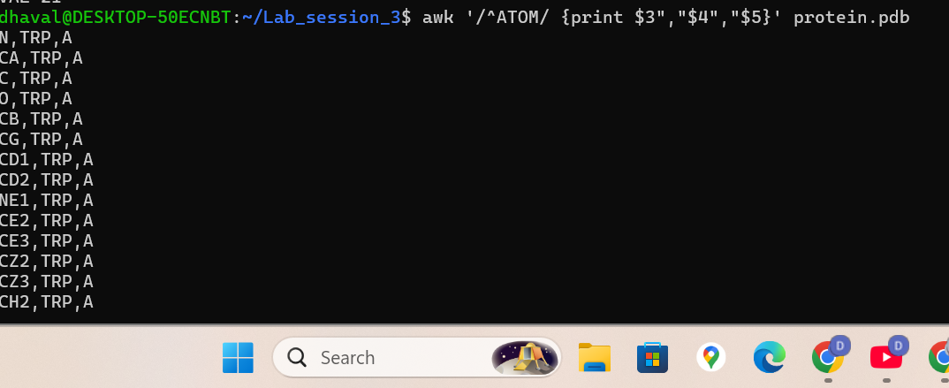  
  
25.   
  
  
  
  
26. 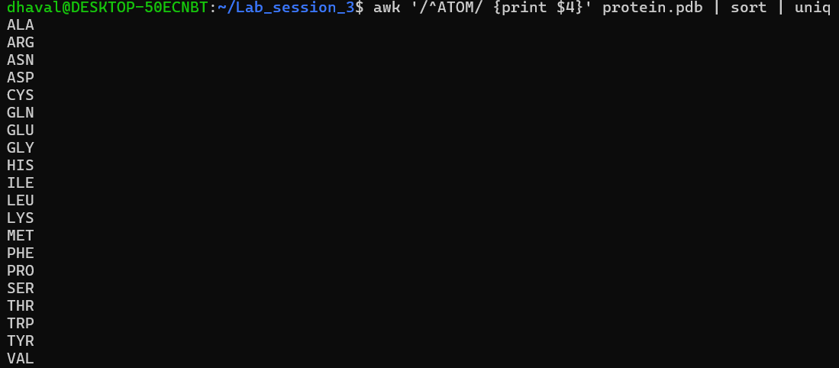  
  
27.   
  
28.  
  
  
Note: I used Perplexity AI to assist with understanding questions 26 and 28, and for guidance on interpreting PDB data. In question 28, I did not fully understand the solution.