**select name from** instructors **where CWID**=98763

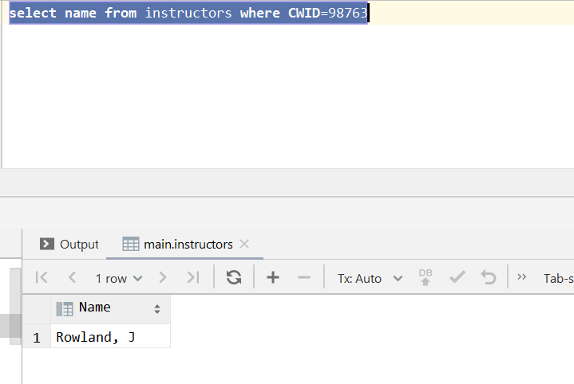

**select** instructors.**Dept**, *count*(*\**) **as** InstructorCount **from** instructors  
**group by Dept**

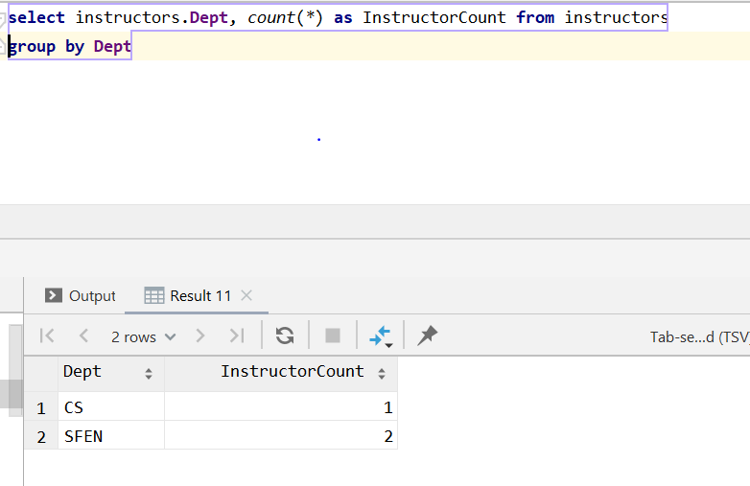

**select** students.**CWID**, students.**Name**, students.**Major**, **Course**, **Grade from** students  
 **join** grades **on CWID**=**StudentCWID**

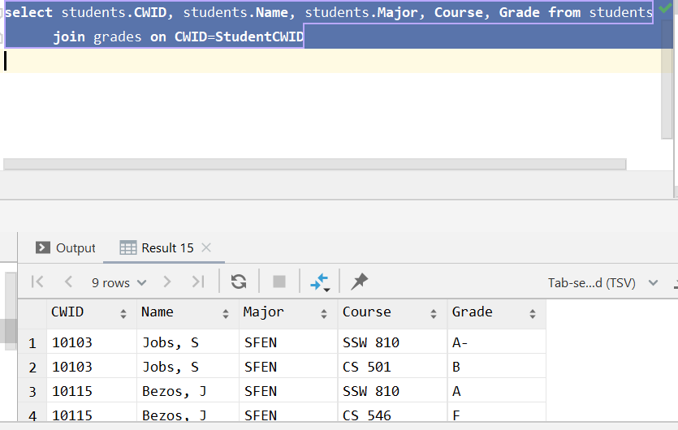

**select** grades.**Grade**, *count*(grades.**Grade**) **as** occurence **from** grades  
 **group by Grade order by** occurence **desc limit** 1

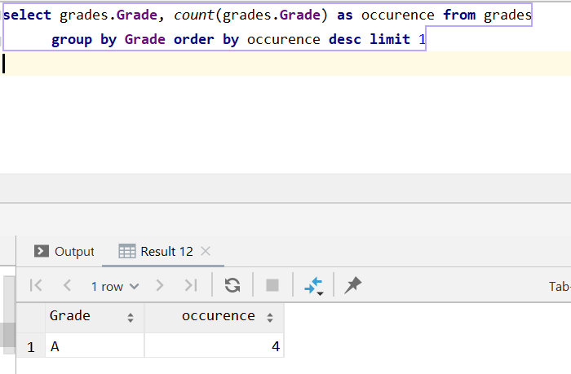

**select** students.**CWID**, students.**Name**, students.**Major**, **Course**, **Grade from** students  
 **join** grades **on CWID**=**StudentCWID where course**=**'SSW 810'**

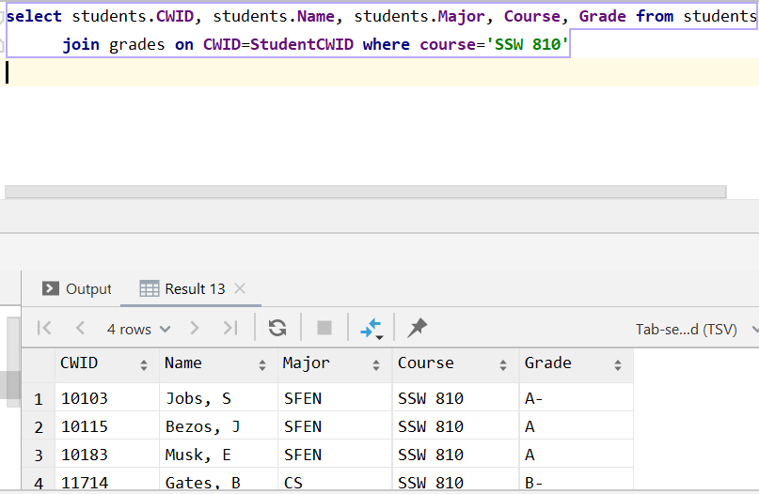

**select** instructors.**CWID**, instructors.**Name**, instructors.**Dept**, grades.**Course from** instructors **join** grades **on InstructorCWID**=**CWID group by CWID**

