Contents

Project management Terms 2

Project Management Principles 8

Project Management Performance Domains 10

Predictive Project Management Terms 12

Processes to Manage a Traditional / Predictive Project 21

Initiating 21

Planning 23

Critical Path Method 47

Point to revisit before Exam 47

Questions 47

## Project management Terms

#### What is Project?

* A temporary endeavor that produces a **unique** product, service or result
* ***Temporary*** in nature and has a definite beginning & ending
* Can be **part of large program or portfolio**
* **Progressively Eloborated**

#### What is Project Management (people management should call)?

Application of knowledge, skills, tools and techniques to satisfy project requirements.

* Preparing business cases to **justify the investment**.
* Estimate resources and times
* Developing & implementing a management plan for project
* ***Leading & motivating the project delivery team (Most important)***
* *Managing the risks, issues & changes on the project*
* *Monitoring progress against project plan*
* Closing the project in controlled fashion when appropriate.

#### What is Program Management?

A group of related projects managed in coordinated way to obtain benefits and control not available from managing them individually.

* Must be some ***value add*** in *managing them together* as a program
* A project may or may not have a program, but program will always have projects.
* Focus on the projects interdependencies and help to determine the optimal approach for managing them.

#### Project Management Office?

**Organizational structure** that standardizes the processes and facilities the sharing of **resources, methodologies, tools, and techniques**.

Types:

* **Supportive:** supports the project manager, such as **providing templates, training or lessons learned from other projects.**
* **Controlling:** Determines the **framework** for **methodology and use of specific forms**.
* **Directive:** Controls the project. **PM will be assigned** and **report to the PMO**.

#### What is Portfolio Management?

A portfolio is a collection of projects, programs, subsidiary portfolios, and operations managed as a group to achieve strategic objectives.

* Collections of projects, programs, subsidiarity portfolios
* Achieve strategic (long term) objectives

#### What is Operation Management

* Deals with ongoing production of goods and/or services
* Considering the acquisition, development, and utilization of resources, firms need to deliver the goods and services

#### What is the value of Project?

* What value will this project bring to the company upon completion?
* Why should we undertake this project?
* Money, brand reputation, customer service, new or change product or service.

#### Project enable changes

* Project can be a vehicle for change in an organization.
* Takes a company from a ***current state to the desired state***.

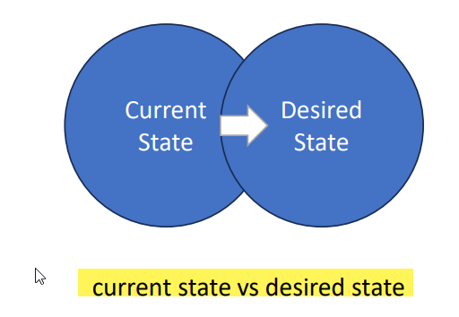

#### Phases and Deliverables

* A phase is collection of logical related project activities that culminates in the completion of one or more deliverables.
  + The number of the phases depends on the industry type and size and complexity of the project.
* A deliverables is any unique and verifiable product, service or result.
  + May be tangible or intangible
  + Must be accepted by the customer or sponsor for the phase

#### Project Life Cycle

* A representation of the phases that a project typically goes through from start to finish
* Can be either predictive or adaptive

#### Project Governance

Project Governance

* Framework within which project decisions are made
* Three pillars:
* Structure: Unique structure for every organization.
* People: Project Managers
* Information: Flow information to take correct decision

#### Stakeholders

Individuals, group, or organization that may affect, be affected, or perceive to be affected by the project.

**Key Stakeholders**

* **Project manager** – manages the project
* **Customer** – uses the project deliverable
* **Project team** – the collection of individuals completing the project work
* **Project Sponsor** – Provides resources and support
* **Functional manager** – department manager, i.e manager of engineering, vice president of marketing, director of IT, generally controls resources.

#### Project Manager Role

* Initiator : someone to initiate
* Negotiator: negotiate for mutually agreeable solution
* Listener: pay attention to other’s idea
* Coach: PM is coach not dictator, guide & support individuals or teams
* Working member: sometimes you can be working member
* Facilitator: PM is always a facilitator who manage group processes.

#### Milestone vs Task Duration

* Milestone: significant achievement in project.
* Task Duration: Task Duration refers to the amount of time it takes to complete a specific task

#### Project Bosses

* Sponsor
  + Internal or External
  + Project champion
  + Funding the project
  + Maybe used to resolve conflict in the project
* Program Manager
  + Senior to project manager
  + Maybe responsible for several projects executing at the same time
  + Maybe used to resolve conflicts in the project.

#### Product Management Vs Project Management

* Product management: Production management is having a complete life cycle of product.
* Project management: During the life cycle of product. There will be many projects. (design, marketing, development, etc.)

#### Area of a Project

* Scope: work to be done
* Schedule: Time to get the work done
* Cost: Budget of the work
* Quality: Customer satisfaction of work
* Resources: Managing the people and material resources
* Communication: All stakeholders get the correct information at the right time
* Stakeholders’ engagement: keeping all stakeholders active and alert on the project
* Risk: identifying and responding to risk over the lifecycle of the project
* Procurement: Acquiring resources from outside the project team

#### Project Management Approaches

Predictive Approach (waterfall approach)

* Involve detail planning
* Sequential execution
* Limited flexibility, limited changes with well define change control process

Adaptive Approach (Agile approach)

* Embraces change throughout the project
* Iterative and incremental development
* Customer collaboration
* Self-organizing team
* Commonly used in agile methodologies like scrum or kanban

#### Organizational Structure

* Functional Organizational Structure:
  + Structure that group staff members according to their expertise (sales, marketing, etc.) staff report to functional manager.
  + PM has less/no power
* Matrix Organizational Structure:
  + Can be weak, balanced, strong projectized.
* Project oriented organizational (Projectized):
  + Structure where PM has greatest amount of power, The project team is assigned to the project on full-time basis.
* Hybrid: Blended type

#### Issues, Risks, Assumptions & Constraints

* Risk: are potential events risks on project success
* Issues: Project or challenges that arise in project. They are typically negative events.
* Assumptions: statement or beliefs that are considered to be true/valid for the purpose of planning and decision-making.
* Constraints: are limitations or restriction that affect project planning and execution.

#### Project Constraints

* Scope
* Schedule
* Cost
* Risk
* Quality
* Resources

#### Emotional Intelligence

* Ability to recognize, understand & manage emotions, both oneself and in others.
* Being aware of one’s own emotions, effectively handling them, empathizing others and using emotions to guide thinking and behavior.
* In project management, EQ plays a significant role
* Relationship building
* Communication and conflict management
* Motivation and influence
* Leadership and Decision Making
* Stakeholders Management

#### Leadership vs. Management

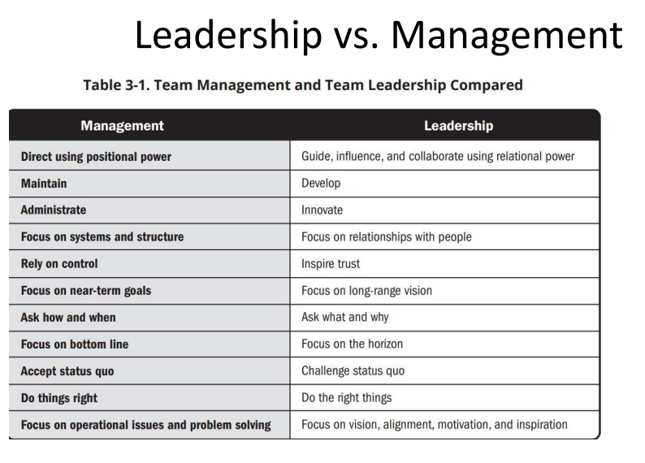

## Project Management Principles

#### PMI code of Ethics and Professional Conduct

PMI is based on 4 values

* Responsibility
* Respect
* Fairness
* Honesty

#### Project vs General Management Principles

Principles of project management can also have areas of overlap with general management principles

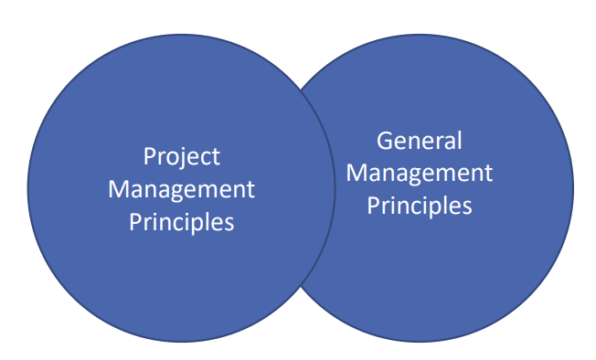

#### 12 Principles of project management

1. Be a diligent, respectful, and caring **steward**
   1. STEWARDSHIP: “The act of taking care of or managing something, for example property, an organization, money or valuable objects.”
2. Create a collaborative **project team** environment
   1. Project teams are made up of people who have diverse skills, knowledge, and experience.
   2. Project teams that work collaboratively can finish a shared objective more effectively and efficiently than individuals working on their own.
3. Effectively engage with **stakeholders**
   1. Engage stakeholders proactively and to the point needed to contribute to project success and customer satisfaction.
   2. Stakeholders impact projects, performance, and outcomes.
4. Focus on **value**
   1. Continually evaluate and adjust project alignment to business objectives and intended benefits and value.
   2. Value is the ultimate indicator of project success.
5. Recognize, evaluate, and respond to **system interactions**
6. Demonstrate **leadership** behaviors
   1. Demonstrate and adapt leadership behaviors to support individual and team needs. Effective leadership promotes project success and contributes to positive project outcomes. Any project team member can demonstrate leadership behaviors. Leadership is different than authority.
7. **Tailor based on context** 
   1. Each project is unique. Design the project development methods based on the needs of the project and its objectives, stakeholders, governance, and the environment. Using “just enough” process to accomplish the desired outcome while maximizing value, managing cost, and enhancing speed. Project success is based on adapting to the unique context of the project Tailoring the method is iterative, and therefore is a continuous process throughout the project.
8. **Build quality** into **processes** and **deliverables**
   1. Quality is about meeting the acceptance criteria for deliverables. Project quality is about satisfying stakeholders’ expectations and fulfilling project and product requirements. Stakeholders will have to maintain a focus on quality that produces deliverables that meet project objectives and align to the needs set forth by stakeholders.
9. Navigate **complexity**
   1. Complexity is the outcome of human behavior, system interactions, uncertainty, and ambiguity. Complexity can arise at any point during the project.Constantly evaluate and navigate project complexity so that approaches and plans enable the project team to successfully navigate the entire project. Complexity can be introduced by events or conditions
10. Optimize **risk** **responses**
    1. A risk is an uncertain event or condition that, if it occurs, can have a positive or negative effect on one or more objectives.Risks can be positive (opportunities) or negative (threats). Project teams seek to maximize positive risks (opportunities) and decrease exposure to negative risks (threats).
11. Embrace **adaptability** and **resiliency**
    1. Adaptability is the ability to respond to changing conditions. Resiliency is the ability to absorb impacts and to recover quickly from a setback or failure. Build adaptability and resiliency into the organization’s and project team’s approaches A focus on outcomes rather than outputs facilitates adaptability.
12. Enable **change** to achieve the envisioned future state
    1. Prepare those impacted for the acceptance to go from the current state to the intended future state created by the project output. A structured approach will helps individuals, groups, and the organization transition from the current state to a future desired state. Change can originate from internal influences or external sources. Enabling change can be challenging as not all stakeholders embrace change. Attempting too much change in a short time can lead to change fatigue and/or resistance. Stakeholder engagement and motivational approaches assist in change adoption.

## Project Management Performance Domains

Principles and performance domain Introduction

**Domain** are group of ***related activities*** that are critical for the effective delivery of project outcomes.

There are 3 different Project Performance Domain.

1. **Stakeholder** Performance Domain
2. **Team** Performance Domain
   1. Deals with activities and functions associated with the people who are responsible for creating project deliverables that realize business outcomes.
3. **Development Approach & Life Cycle** Performance Domain
   1. Determine approach Agile, Traditional Water fall or Hybrid
   2. Deals with activities and functions associated with the development approach, cadence, and life cycle phases of the project.
   3. Delivery cadence refers to the timing and frequency of project deliverables.
4. **Planning** Performance Domain
   1. Deals with activities and functions associated with the initial, ongoing, and evolving organization and coordination necessary for delivering project deliverables and outcomes.
   2. The purpose of planning is to proactively develop an approach to create the project deliverables.
5. **Project Work** Performance Domain
   1. Deals with activities and functions associated with establishing project processes, managing physical resources, and fostering a learning environment.
   2. Project work is connected with establishing the processes and performing the work done by the project team to deliver the expected deliverables and outcomes.
6. **Delivery** Performance Domain (High Quality Deliverable)
   1. Deals with activities and functions associated with delivering the scope and quality that the project was undertaken to achieve.
7. **Measurement** Performance Domain
   1. Deals with activities and functions associated with assessing/measuring project performance and taking appropriate actions to maintain acceptable performance.
8. **Uncertainty** Performance Domain (Risk)
   1. Deals with activities and functions associated with risk and uncertainty.

## Predictive Project Management Terms

#### Traditional Project

* Also called ‘Waterfall’ project management.
* It is better when customer needs are well defined, standards to follow are clear, and changes are not expected.
* Project manager is in control of the project at all the times.
* All planning is done upfront.
* Objective is to complete the set scop in as little time as possible and reduce cost.

#### Process Groups & Knowledge Areas Table

Process Groups: A practice guide provides an overview of project and development life cycles in the introduction, with a focus on predictive life cycles throughout, and describes the 49 processes within these five process groups along with the inputs, tools and techniques, and outputs associated with those processes.

This practice guide identifies the processes that are ***considered*** good practices on most projects, most of the time. Project management should be tailored to fit the needs of the project. ***There is no requirement that any particular process or practice be performed.*** The processes should be tailored for specific project and/or organization. Specific methodology recommendations are outside the scope of this practice guide.

1. Initiating
   1. Used to define a project or phase of an existing project.
   2. Done to authorize the start of the project and assign the project manager.
2. Planning
   1. Done to establish the scope of the project, define the course of action required to attain the objectives.
3. Execution
   1. Done to complete the word defined in project management plan.
4. Monitoring & Controlling
   1. Done to track, review, and regulate the progress and performance of the project.
   2. Looks for any areas in which changes to the plan are required and initiate the corresponding changes.
5. Closing
   1. Done to formally complete or close the project, phase, or contract.

#### Process

Input, Outputs and Toot/techniques combined to execute a specific purpose on the project

* Input
  + Starting point for the process, the raw materials to bigin the execution
    - Coud be the output of a previous process
* Tools and techniques
  + The actions or methods that are used to transform the raw materials into the output
* Output
  + The end result of our efforts. The raw materials into a polished stone
    - Maybe the input into another process

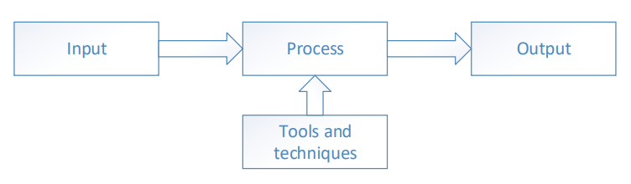

#### Enterprise Environment Factor (EEF) (also known as Organization Culture)

* Things that impact the project but are not part of the project itself
* Influence the organization, the project, and its outcome
* It is essential to consider these internal and external factors while planning the project to determine their influence
* Can enhance or constrain project management options and may have negative or positive influences on the outcomes

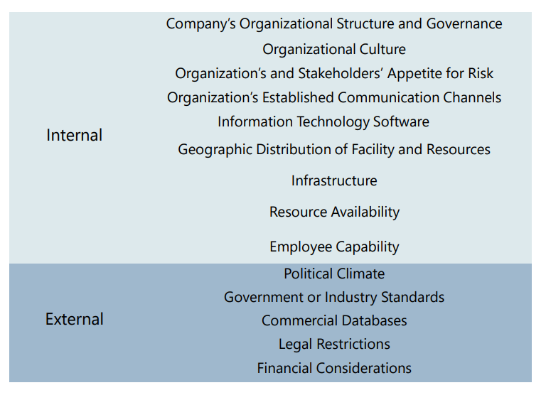

#### Organization Process Assets (OPA)

* OPA also know as existing templet provided by PMO
* Organizations have assets such as information, policies, procedures, documents, or knowledge bases which are called Organizational Process Assets (OPA) to help them in achieving their objectives
* Kept in some central repository so that they can be used whenever required
* These elements affect several aspects of the project
* Project team members update and add to the Organizational Process Assets throughout the project
  + Examples:
    - Project templates
    - Software tool
    - Historical information
    - Project closure guidelines
    - Risk control procedures
    - Change control procedures
    - Issue and defect management procedures\

#### Project Documents

* Any documents that are related to the project
* Project documents are additional documents that are created and used throughout the 49 processes that are not part of the project management plan
* “include but are not limited to.”

#### Project Management Plan

* Defines how the project is executed, monitored and controlled, and closed
* 18 components, 14 plans and 4 baselines
* “include but are not limited to.”

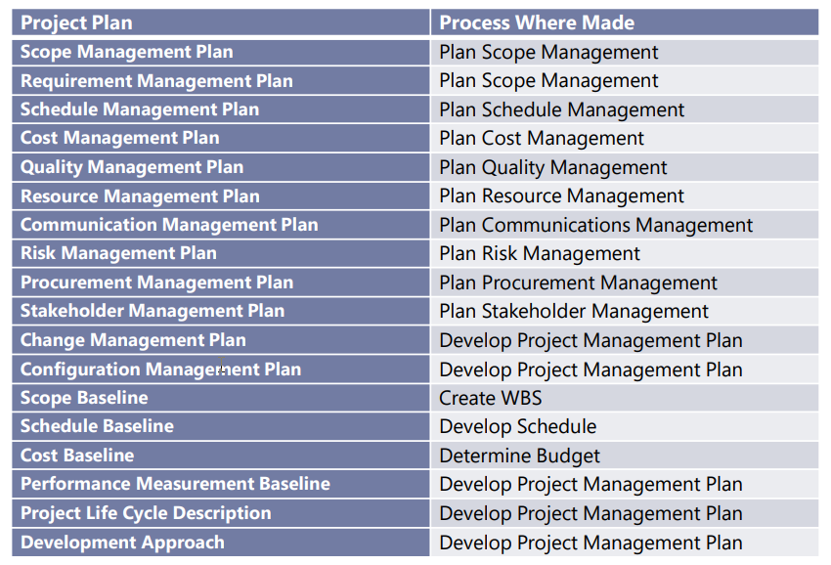

#### Expert Judgement

* One of the most common tools in the planning process
* Includes hiring an expert or subject matter expert (SME) to help you to plan a process or conduct a process
* People with specialized knowledge or training in a particular process, industry, or technology

#### Data Gathering, Data Analysis, Data Representation, Decision Making

Data Gathering

* Methods:
  + Brainstorming: Brainstorming is when you bring together a group of stakeholders to get ideas and analyze them. Brainstorming sessions are generally facilitated by the project manager.
  + Interviews: Any time you want to gather data from a particular stakeholders, one of the best methods is to just interview them. Ask them a series of questions and talk with them about their thoughts and views.
  + Focus groups: A focus group is when you bring together subject matter experts to understand their perspectives and how they would go about solving problems.
  + Checklist: A checklist is generally created by the organization and then given to potential stakeholders on a project for them to identify items they may want on a project, things they may not want on the project, and some success criteria they may have for the project.
  + Questionnaires and surveys: Questionnaires and surveys can be given to stakeholders to better understand what they may be looking for on a project and to better understand their needs.

Data Analysis

* Methods:
  + Alternative analysis: Alternative analysis involves looking at different options or ways to accomplish something.
  + Root cause analysis (RCA): A root cause analysis is used to identify the main underlining reason for particular event.
  + Variance analysis: Variance analysis is used quite often to find the exact differences between different things.
  + Trend analysis: Trend analysis involves looking at data over a period of time to see if a particular trend is forming.

Data Representation

* Illustrate different ways that a data could be shown to stakeholders
* Methods generally include the use of charts, matrixes, and different types of diagrams
* Examples: Flowcharts, Fishbone diagrams, Histograms

Decision Making

* Have to make a decision on what to do with that data
* Methods:
  + Voting: Voting is used by a group to determine whether to proceed, change, or reject something. Voting can be: majority wins, unanimity, where everyone agrees; or plurality, where a majority is not obtained but that decision is chosen.
  + Multicriteria decision analysis: This is when you make a table (matrix) that lists different types of criteria, and then evaluate an idea based on those criteria.
  + Autocratic decision making: This is when one person makes a decision for the entire team.

#### Interpersonal and Team Skills

* All project managers need to have good interpersonal and team skills in order to manage the different stakeholders that will be on the project
* most important tool in real-life project management
* Methods:
  + Active listening: Active listening is understanding, acknowledging, and clarifying what others are saying to you.
  + Conflict management: Anytime you bring a team together, bound to have conflicts on that team.
  + Facilitation: Facilitation is the art of managing a group. This can include bringing the group together, generating ideas, solving problems, and dissipating the team.
  + Meeting management: Meeting management generally includes having an agenda, inviting the right stakeholders, setting a time limit, and following up with meeting minutes and action items.

#### Meetings

* Meetings can be done face-to-face or virtually.
* Have an agenda and distribute it to all attendees before the meeting.
* Meetings must be timed, including having set start and finish times for topics and the entire meeting.
* Make sure that the meeting always stays on topic and does not go off topic.
* Ensure that all attendees have input to the topics.
* Distribute detailed meeting minutes once the meeting is complete.

#### Project Management Information System (PMIS)

* Automated system that is used to help the project manager optimize the schedule or keep track of all the documents and the deliverables
* Usually the computer system that a given organization uses to manage its projects
* It should include all the software and hardware tools that we need to manage the project from start to finish
* Includes the work authorization system and the configuration management system

#### Change Request

* Proposal to change a document, deliverable, or baseline
* Can include a request to add or remove work from the scope, finish the project faster, or complete the project more cheaply
* Implements
  + Corrective action: is something that’s taken to ensure that the project gets back on track.
  + Preventive action: is something you put in place to ensure the project stays on track.
  + Defect repair is done to fix a broken component on a project, such as if network switch memory fails on a network upgrade project.

Work Performance Data, Information, Report

Work Performance Data

* Work performance data is simply raw data
* It is the status of the work that was done but does not have any analysis applied to it.
* It is not useful by itself.
* Usually outputs of executing processes

Work Performance Information

* Information of the work that was performed compared to the plan
* It gives you actual status about the deliverables
* Work performance information is usually the output of most monitoring and controlling processes

Work Performance Report

* overall status report of the actual project
* It takes all the work performance information and puts it together into one comprehensive document
* You take the work performance data and compare it against the plan to come up with the work performance information. Then you take all the work performance information and create the work performance reports. In short, data feeds info and all the info creates reports.

#### Updates

* Updates is a catchall term
* Updates can include project documents, the project management plan, OPA and EEF updates
* Expect to see this output many times throughout the book

## Processes to Manage a Traditional / Predictive Project

### Initiating

#### Develop Project Charter

* The process of developing a document to formally authorize a project or a phase
* Outlines the project objectives, Defines the authority of the project manager. Provides the project manager with the authority to put the resources together to project activities.
  + Input: Contain specific information as to why a project should be initiated. There are two main documents
    - Business Case: Necessary information that determines whether or not the project is worth the required investment
    - Project Benefits Management Plan: Describes the main benefits that the project will produce once it is completed and how to measure the benefits. The project benefit could be the product, service, or result.
* Agreements: Service Level Agreements (SLA), Letters of intent, Contract between internal and external customer, Work required to be performed for Payment

|  |  |  |
| --- | --- | --- |
| Input | Tool Technologies | Output |
| Business Documents  Agreements  Enterprise Environmental Factors  Organizational Process Assets | Expert Judgment  Data Gathering  Interpersonal and Team Skills  Meetings | Project Charter  Assumption Log |

Output:

* Project Charter:
* Formally authorizes the existence of the project and it assigns the Project Manager and their Authority Level
* Signed by the organization Senior Management
* High Level requirements & risks
* Preliminary Project Budget and Schedule
* Project Purpose or justification
* Assumption Log:
* A list of things that you perceive to be true (assumptions) and things that might constrain the project.

#### Identify Stakeholders

* Identifying project stakeholders regularly.
* Analyzing and recording relevant information regarding their interests and involvement.
* It enables the project team to identify the appropriate focus for engagement of each stakeholder or group of stakeholders

|  |  |  |
| --- | --- | --- |
| Input | Tool Technologies | Output |
| Project Charter  Business Documents Project Management Plan Project Documents Agreements  Enterprise Environmental Factors  Organizational Process Assets | Expert Judgment  Data Gathering  Data Analysis  Data Representation  Meetings | Stakeholder Register  Change Requests  Project Management Plan Updates Project Documents Updates |

* Tools - Data Analysis
  + Stakeholder Analysis
  + analyzes who your stakeholders are and how they feel about the project
  + What would be the stakeholder’s role such as a team member, sponsor, or functional manger etc.?
  + How would the project affect them, either in a positive or negative way?
  + Would they be active stakeholders, such as team members who work on the deliverable, or passive, such as customers who watch the project work get done?
  + What is their power authority, such as sponsors who will be paying for the project.
* Tools – Data Representation – Stakeholder
  + Mapping/Representation - Method to categorize stakeholders.
    - Power/interest grid, power/influence grid, or impact/influence grid
    - Stakeholder cube
      * A three-dimensional methodology to support the mapping of a stakeholder’s interest, power, and influence
    - Salience model:
      * Power: Level of authority
      * Urgency: Immediate attention
      * Legitimacy: How appropriate is their involvement
    - Directions of Influence:
      * Upward: Senior management
      * Downward: Team members
      * Outward: Vendors, government, public, end-users
      * Sideward: peers such as other project managers
    - Prioritization
* Output – Stakeholder Register
  + Should contain:
    - Contact information
    - Role on the project, such as, sponsor or functional manager
    - Communication requirements
    - Expectations of the project
    - How are they affected by the project
    - Power influence level on the project
* Output – Change Requests
* Output – Project Management Plan Updates
  + Requirements Management Plan
  + Communications Management Plan
  + Risk Management Plan
  + Stakeholder Engagement Plan
* Output – Project Documents Updates
  + Assumption Log
  + Issue Log
  + Risk Register

### Planning

#### Develop Project Management Plan

* Process of defining, preparing, and coordinating all plan components and consolidating them into an integrated project management plan
* Comprehensive document that outlines the basis of all project work and how the work will be performed
* Either summary or detailed
* Contains baselines and plans
  + Baseline means what?
  + Management plan means how to do/manage/meature/etc.?

|  |  |  |
| --- | --- | --- |
| Input | Tool Technologies | Output |
| Project Charter Outputs from other Processes Enterprise Environmental Factors Organizational Process Assets | Expert Judgment Data Gathering Interpersonal and Team Skills Meetings | Project Management Plan |

* Output – Project Management Plan
  + Outlines how the project is executed, monitored and controlled, and closed.
  + 4 Baselines
    - Scope, Schedule, Cost, Performance Measurement
  + 14 Subsidiary plans
  + Approved by either the Project Manager, Sponsor, Functional Manager, Program Manager, or in rare instances Senior Management
  + Provides Guidance on project execution
  + Formal Written piece of communication
  + Only changed when a change request is generated and approved by the change control board or sponsors

#### Plan Scope Management

* Process of creating a scope management plan that documents how the project and product scope will be defined, validated, and controlled.
* Guidance and direction on how scope will be managed throughout the project
* Scope Terms
  + **Product Scope** - features and functions that characterize a product, service, or result
  + **Project Scope** - the work that is needed to be accomplished to deliver a product, service, or result with specified features and functions.
  + Prevent **Gold Plating**, which is doing extra work not in the scope.
  + Prevent **Scope creep**, which are unauthorized work added to the scope.

|  |  |  |
| --- | --- | --- |
| Input | Tool Technologies | Output |
| Project Charter  Project Management Plan Enterprise Environmental Factors  Organizational Process Assets | Expert Judgment Data  Analysis Meetings | Scope Management Plan  Requirements Management Plan |

* Output – Scope Management Plan
  + How the scope will be defined, developed, monitored, controlled and verified
    - Process for preparing & maintaining Scope Statement, WBS
    - How changes request to the scope statement will be process
  + Requirement Management Plan
    - How the requirements will be analyzed, documented and managed.
    - Traceability structure to reflect which requirements need to be captured on the traceability matrix

#### Collect Requirement

* Process of determining, documenting, and managing stakeholder needs and requirements to meet objectives.
* Process plays a significant role in the success of the overall project since project schedule, budget, risk factors, quality specifications, and resource planning are closely linked to the requirements

|  |  |  |
| --- | --- | --- |
| Input | Tool Technologies | Output |
| Project Charter  Project Management Plan  Project Documents  Business Documents  Agreements Enterprise  Environmental Factors  Organizational Process  Assets | Expert Judgment  Data Gathering  Data Analysis  Decision Making  Data Representation  Interpersonal and Team Skills  Context Diagram  Prototypes | Requirements Documentation  Requirements Traceability Matrix |

* Tools – Data Gathering
  + Benchmarking
* Tools – Data Analysis
  + Analyzing documents, agreements, policies, proposals, or business plans
* Tool - Data Representation
  + Idea / Mind Mapping - Ideas gather through brainstorming are map together to discover new considerations and conception variations
  + Affinity Diagram - Large ideas that are grouped and sorted together for further review and analysis.

* Tool - Interpersonal and Team Skills
  + Observations/Conversations-Job shadowing, viewing personalities in their environment and work place. Recording how jobs, chores and tasks are executed.
* Tool - Context Diagrams
  + Used to visually show how a business process, other systems, and people interact.
* Tool - Prototypes
  + A working model of a product that stakeholders can interact with and provide feedback how they might want to change it to better meet their requirements. This gives the stakeholders a great view and feel of what the final product will be when the project is finished.
* Output - Requirement Documentation
  + How individual requirements are to be performed and why each requirement is important to the project.
    - Components may include:
      * Stakeholder and business requirements
      * Acceptance criteria
      * Quality requirements
      * Project objectives
      * Organizational impacts
      * Legal or ethical compliance
      * Requirements assumptions and constraints
* Output - Requirement Traceability Matrix
  + Once a requirement is created, a table is created that will link the requirement back to it source. This is used to help manage changes to the project scope.
  + The table is created to track, but not limited to:
    - Who is the original stakeholder that provided the requirement
    - Why was the requirement added
    - Description of the requirement
    - Current status of the requirement, completed, in progress, delayed, cancelled, etc…

#### Define Scop

* Developing a detailed description of the project and product.
* A detailed project scope statement is critical to project success and builds upon the major deliverables, assumptions, and constraints that are documented during project initiation.

|  |  |  |
| --- | --- | --- |
| Input | Tool Technologies | Output |
| Project Charter  Project Management Plan Project Documents Enterprise Environmental Factors  Organizational Process Assets | Expert Judgment  Data Analysis  Decision Making  Interpersonal and Team Skills  Product Analysis | Project Scope Statement  Project Documents Updates |

* Tool - Product Analysis
  + Detailed understanding of the project’s product, service, or result, with the commitment to improve the team’s focus, it’s knowledge base, the correct interpretation of requirements,
  + Some tools used are
    - Product breakdown
    - System analysis
    - System requirements
* Tool - Project Scope Statement
  + Describes in detail the project deliverables, and the work that is required to produce those deliverables. The greater the detail level of the scope allows the team the better understanding on how to reach the end state of the project successfully. The less detail of the scope statement creates a great chance of project risk, as well as offering the possibility of greater scope creep.
  + Details should include, but not limited to:
    - Product description, Goals of the project
    - Identified risks
    - Project/Product acceptance criteria
    - Project constraints/exclusions

#### Create WBS (work breakdown structure, also known as structure breakdown work (SBW))

* Subdividing project deliverables and project work into smaller, more manageable components.
* Breakdown of the project deliverables from the scope statement
* *Add Structure*

|  |  |  |
| --- | --- | --- |
| *Input* | *Tool Technologies* | *Output* |
| Project Management Plan  Project Documents  Enterprise Environmental Factors  Organizational Process Assets | Decomposition Expert Judgment | Scope Baseline Project Documents Updates |

* Input - Project Management Plan
  + Scope Management Plan
* Input - Project Documents
  + Project Scope Statement
  + Requirement Documentation
* Input - Enterprise Environmental Factors
* Input - Organizational Process Assets
* Tool - Expert Judgment
* Decomposition
  + It comprises of breaking down each of the project deliverables into smaller components. The basic work package should be able to estimated its basic time, cost and effort.
* Output - Scope Baseline (3 Components)
  + Project Scope Statement
  + WBS
  + WBS Dictionary
* Project Documents Updates
  + Assumption Log
  + Requirements Documentation
* Create WBS
  + WBS
    - It is essential to the success of the project, if it is not in the WBS, it is not part of the project
    - Defines responsibilities of the team
    - A communication tool
    - It is created by the PM, SME’s, the Project team, and it a great tool for team building
    - A deliverable-oriented ranked decomposition of the work to be executed by the project team.
    - Each node must have a unique identifying number. This is used to help locate and arrange each node. They can not be any gaps and any overlap of work packages. Nothing is eliminated and nothing is duplicated.
  + WBS Dictionary
    - A document that details the contents of the WBS
    - It provides detailed information on each node of the WBS
    - It captures additional qualities about each Work Package in a separate document
    - It should include team member assigned to it, time estimate, cost estimate, account information, work package ID, quality requirements, contract information, Scheduled Milestone, plus detail overall of the task at hand
    - A screenshot of a computer

      AI-generated content may be incorrect.

#### Plan Schedule Management

* Establishing the policies, procedures, and documentation for planning, developing, managing, executing, and controlling the project schedule.
* Provides guidance and direction on how the project schedule will be managed throughout the project.

|  |  |  |
| --- | --- | --- |
| *Input* | *Tool Technologies* | *Output* |
| Project Charter  Project Management Plan  Enterprise Environmental Factors  Organizational Process Assets | Expert Judgment  Data Analysis  Meetings | Schedule Management Plan |

* Output - Schedule Management Plan
  + how the project schedule will be planned, developed, managed, executed, and controlled throughout the phase or project
  + It may establish the following:
    - Levels of Accuracy
    - Rules of Performance Measurement
    - Reporting formats
    - Release and Iteration Length
    - Project Schedule Model Development

#### Define Activities

* Process of identifying and documenting the specific actions to be performed to produce the project deliverables.
* Decomposes work packages into schedule activities that provide a basis for estimating, scheduling, executing, monitoring, and controlling the project work.

|  |  |  |
| --- | --- | --- |
| *Input* | *Tool Technologies* | *Output* |
| Project Management Plan  Enterprise Environmental Factors  Organizational Process Assets | Expert Judgment  Decomposition  Rolling Wave Planning Meetings | Activity List  Activity Attributes  Milestone List  Change Requests  Project Management Plan Updates |

* Tool – decomposition: breaking down the work in smaller activities.
* Tool - Rolling Wave Planning
  + A form of Progressive Elaboration. Near term work packages are able to be defined in a much great detail. Long term work packages may not be able to be defined in any detail, a place holder maybe created for later date.
  + As the project moves along to completion, long term place holders will be removed and then allowed to be decomposed into work packages as more details become available.
  + This planning must always be revisited throughout the life cycle of the project when long term work pages can not be clearly define

* Output - Activity List
  + A complete list of all scheduled activities that is required to be perform on the project.
  + It should include a sufficient work description as well as an activity identifier. This is recommended so all stakeholders have better understanding of all work that is needed to be perform on the project
  + Work packages are Scope determined deliverable based,
  + Activity are focused in the work that needs to be executed the work packages
  + Schedule focused, not WBS focused
  + Each activity should map back to one and only one work package(work package could have many activities
* Output - Activity Attributes
  + Any additional information required to execute the Activity list
    - Point of contact, location of work being performed
    - Used for scheduling development
* Output - Milestone List
  + Key dates of the projects
  + Mandatory, optional, contractual, % complete

#### Sequence Activities

* Is the process of identifying and documenting relationships among the project activities.
* It defines the logical sequence of work to obtain the greatest efficiency given all project constraints.
* Taking the activity list defined earlier and arranging the activities in the order they must be performed
* Sequencing can be performed by using project management software or by using manual or automated techniques.

|  |  |  |
| --- | --- | --- |
| *Input* | *Tool Technologies* | *Output* |
| Project Management Plan  Project Documents  Enterprise Environmental Factors  Organizational Process Assets | Precedence Diagramming Method  Dependency Determination and Integration  Leads and Lags  Project Management Information System | Project Schedule Network Diagrams  Project Documents Updates |

* Tool - Precedence Diagramming Method, (PDM)
  + Graphical representation of all work that is needed to be perform on the project. This represents the flow of the project. What work packages tie into another work packages, in order as well as durations. Simply stated it is work packages relationships to each other.
    - A diagram of a diagram

      AI-generated content may be incorrect.
* Tool - Relationships
  + Finish to Start (The most commonly used )
    - The start of the successor’s work package depends upon the completion of its predecessor work package
  + Finish to Finish
    - The completion of the successor work package depends on the completion of the predecessor work package
  + Start to Start
    - The start of the successor’s work package depends upon the start of its predecessor work package
  + Start to Finish (Very rarely used)
    - The completion of the successor work package depends upon the start of its predecessor work package
* Tool - Dependency Determination
  + Mandatory Dependencies (Hard Logic)
    - They are tangible limitations of work packages that are tie together. One work package MUST be completed prior to the subsequent work package beginning.
      * Foundation of the house erected prior to the house being built
      * Purchasing the paint prior to painting the walls
  + Discretionary Dependencies (Soft Logic)
    - Work packages that are tied together, but do not have physical limitations. Work packages may work in unison or tandem.
      * Painting the walls of a room, &laying carpet at the same time
      * Cooking both Dinner & Dessert at the same time in the oven
* Tool - External Dependencies
  + Work package relationship between project and non-project activities. Non-project Activities are usually outside the control of the project team.
    - The gas station receiving Gas prior to you filling up the Bulldozer gas tank
    - The Home Improvement store down stocking the paint prior to you buying it
* Tool - Internal Dependencies
  + Project Activities are within control of the team
    - How to test computer software after you installed it
    - Who does what tasks on a project
* Tool - Leads and Lags
  + The management team during the planning of activates will determine the order of work packages upon completion. During this phase of this process, work packages leads and lags must be processed.
    - A lead is the amount of time a successor activity can be advanced with respect to a predecessor activity
      * i.e. The windows maybe scheduled to be installed in the house up to 3 weeks prior to the siding being installed.
    - A lag directs the delay in the successor work package or activity
      * i.e. The windows can not be scheduled to be installed in the house until the external walls have been installed
* Output - Project Schedule Network Diagrams
  + These are system wide drawings which shows the entire project work packages/activities from start to finish. It shows logical relationships as well.
* Output - Project Document Updates

#### Estimate Activity Durations

* Estimating the number of work periods needed to complete individual activities with estimated resources.
* It provides the amount of time each activity will take to complete.
* It should be calculated by the individual most familiar with the nature of work in the specific activity.
* Uses information from the scope of work, required resource types or skill levels, estimated resource quantities, and resource calendars.

|  |  |  |
| --- | --- | --- |
| *Input* | *Tool Technologies* | *Output* |
| Project Management Plan  Project Documents  Enterprise Environmental Factors  Organizational Process Assets | Expert Judgment  Analogous Estimating  Parametric Estimating  Three-Point Estimates  Bottom-Up Estimating  Data Analysis  Decision Making  Meeting | 1.Duration Estimates  2.Basis of Estimates  3.Project Documents Updates |

* Tool - Analogous Estimating(top-down estimating)
  + This relies on historical information to predict estimates, (i.e. Time, Budget, Difficulty), for current projects. Often used when there is limited amount of information available. Cost less in Time and Money to uses, but it gives the least accuracy when it comes to estimating.
* Tool - Parametric
  + A technique that uses a statistical relationship between historical data and other variables (for example, square footage in construction, lines of code in software development) to calculate an estimate for activity parameters, such as scope, cost, budget, and duration.
* Tool - Three Point Estimate
  + Calculates an expected duration using a weighted average of 3 estimated, Optimistic, Pessimistic, Most Likely. (O+P+4M)/6.
    - If the Optimistic is 8 days, Pessimistic is 14 days, and Most likely is 10 days, Pert is 10.333.
      * ((8+14+4*10)/6)
      * (22+40)/6
      * 62/6
      * 10.33
* Tool Bottom-Up Estimating
  + The work has to be very detailed for this type of estimation to take place.
  + Takes a very long time to complete, but highly accurate.
  + You break down the work to the lowest levels and then aggregating the work back up to find an overall duration.
* Tool - Data Analysis
  + Reserve Analysis
    - Often call Slack Time, or Contingency Reserve, Time Reserves. Buffer
    - Maybe a percentage or a set determined time allowance
    - Usually added because of Risk Factors
* Tool - Decision Making
* Output - Duration Estimates
  + The likely number of work periods required to completed an activity or a work package. It does not have any leads or lags assigned to it. It is just a number. i.e. Painting room 6 with take at least 36 man hours, to a maximum of 42 man hours
  + May include some indication of the range of possible results
* Output - Basis of Estimates
  + How the estimates were developed and their ranges.
  + It can also include all assumptions and constraints made to create the estimate

#### 3 – Point Estimate (PERT) (VIMP)

* PERT(Program (or Project) Evaluation and Review Technique )
  + Three-Point Estimate
  + A scheduling tool that uses a weighted average formula to predict the length of activities and the project.
* Beta Distribution
  + Specifically, the PERT formula is (O+R(4)+P)/6

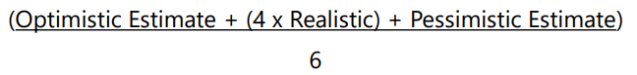

* Standard Deviation (P-O)/6
* Triangle Distribution
  + The Triangle Distribution formula is (O+R+P)/3

#### Develop Schedule

* Analyzing activity sequences, durations, resource requirements, and schedule constraints to create a schedule model for project execution and monitoring and controlling.
* It generates a schedule model with planned dates for completing project activities.
* Entering the activities, durations and resources into the scheduling tool will generates a schedule with planned dates for completing the project activities.

|  |  |  |
| --- | --- | --- |
| *Input* | *Tool Technologies* | *Output* |
| Project Management Plan  Project Documents  Agreements  Enterprise Environmental Factors  Organizational Process Assets | Schedule Network Analysis  Critical Path Method  Resource Optimization Data Analysis  Schedule Compression  Project Management Information System  Agile Release Planning | Schedule Baseline  Project Schedule  Schedule Data  Project Calendars  Change Requests  Project Management Plan Updates  Project Documents Updates |

* Tool - Schedule Network Analysis
  + It employs several different techniques, (Critical path, Critical Chain, What-if analysis, and resource optimization techniques) to determine the length of the schedule. It is used to calculate the early start and early finish dates, late start and late finish dates.
* Tool - Resource Optimization Techniques
  + A method to flatten the schedule when resources are over-allocated or allocated unevenly. Resource leveling can be applied in different methods to accomplish different goals. One of the most common methods is to ensure that workers are not overextended on activities.
* Tool - Critical Path Method
  + Calculate the early start (ES), early finish (EF), late start (LS) and late finish (LF) dates, without require for any resource limitations. It is used to help determined Lags, Leads, activity relationships, schedule constraints
* Tool - Critical Chain Method
  + A method of planning and managing projects that puts more emphasis on the resources required to execute project tasks developed
* Tool - Data Analysis
  + What If Scenarios (Monte Carlo)
  + Simulations
* Tool - Leads and Lags
* Tool - Schedule Compression
  + Crashing(Adding resources to a project activity)
    - Always adds cost
    - May add additional Risk
  + Fast Tracking( Activates performed in parallel)
    - May not always add cost
    - May increase risk due to project rework
* Tool - PMIS
* Tool - Agile Release Planning
  + The schedule will be broken up into smaller iterations, verses to a traditional project where the schedule is for the entire product release. Smaller increments allows the customers an opportunity to give feedback on the product with a quicker turnaround
  + Iteration plan is a plan that will be used to create a single iteration for part of the product.
  + Release plan is a set of iterations that will help to create a product that would be given to the customers for feedback
* Output - Project Schedule
  + Project start and end date. Each activity start & end date. The project schedule maybe a high level document, or as detail as having each activities resourced assign to it. Most often showed as a graphically presentation.
    - Project Network Diagrams
    - Bar charts
      * Activities represented by horizontal bars on a horizontal axis that represents the calendar.
    - Milestone Chart
      * ♦A list of only key dates in the project. A very high level detail of the status of the project.
* Output - Schedule Baseline
  + Original Schedule baseline with any approved changes to the schedule
* Output - Schedule data
  + Schedule templates that the team used to calculate durations, assumptions, constraints or resource requirements
* Project Calendars
  + Identifies Project shifts and workdays

#### Plan Cost Management

* Defining how the project costs will be estimated, budgeted, managed, monitored, and controlled.
* It provides guidance and direction on how the project costs will be managed throughout the project.
* ***Value Engineering***
  + Aka, value analysis is finding a less costly way of doing work. It will look how to achieve a goal/scope the less costly way

|  |  |  |
| --- | --- | --- |
| *Input* | *Tool Technologies* | *Output* |
| Project Charter  Project Management Plan  Enterprise Environmental Factors  Organizational Process Assets | Expert Judgment  Data Analysis  Meetings | Cost Management Plan |

* Output – Cost Management Plan
  + How costs will be planned, structured and controlled
  + Units of measure
  + Level of accuracy
  + Reporting formats
  + Control thresholds

#### Estimate Costs

* Developing an approximation of the cost of resources needed to complete project work.
* Usually expressed in some from of currency, $, Euro, Yen, Won, etc..
* Accuracy of a project estimate will increase as the project progresses through the project life cycle
* Costs are estimated for all resources that will be charged to the project including but is not limited to labor, materials, equipment, services, and facilities, as well as special categories such as an inflation allowance, cost of financing, or contingency costs.
* Definitive Estimates: –5% to +10%
* Budget Estimates: –10% to +25%
* Rough Order of Magnitude Estimates: –25% to +75%

|  |  |  |
| --- | --- | --- |
| *Input* | *Tool Technologies* | *Output* |
| Project Management Plan  Project Documents Enterprise Environmental Factors  Organizational Process Assets | Expert Judgment  Analogous Estimating  Parametric Estimating  Bottom-up Estimating  Three-Point Estimating  Data Analysis  Project Management Information System  Decision Making | Cost Estimates  Basis of Estimates  Project Documents Updates |

* Tool – Estimate Cost
  + Expert Judgment
  + Analogous Estimating
    - Top down, Pasted projects, Not very detailed
  + Parametric Estimating
    - Statistical relationships between historical data and variables
      * 8 hour work period, lay 50 cubic feet of concrete
      * 1 hour work period, paint 32 square feet of drywall
  + Bottom-up Estimating
    - Separate estimate for each activity and aggregated up to summary nodes on WBS
    - Greatest Level of specified detail
    - Highly accurate, labor intensive
  + Pert, Three point Estimating (Covered in Schedule Management)
  + Data Analysis
    - Reserve Analysis (Money set aside for Risk)
    - Cost of Quality
      * Failure
        + Internal caused, (may need to rework, scrap)
        + External caused, (Warranty work, Lost of business)
        + Leads to rework and increasing spend rate
      * Success
        + Training, proper equipment, inspections
  + PMIS
  + Decision Making
* Output – Estimate Costs
  + Cost Estimates
    - Costs associated with each activity. This includes labor, materials, equipment, facilities, inflation, services, etc…
  + Basis of Estimates
    - Range of possible estimates
    - Confidence level of estimates
    - How estimates were developed and by whom
  + Project Document Updates

#### Determines Budget

* Process of aggregating the estimated costs of individual activities or work packages to establish an authorized cost baseline.
* It determines the cost baseline against which project performance can be monitored and controlled.

|  |  |  |
| --- | --- | --- |
| *Input* | *Tool Technologies* | *Output* |
| Project Management Plan  Project Documents  Business Documents  Agreements  Enterprise Environmental Factors  Organizational Process Assets | Expert Judgment  Cost Aggregation  Data Analysis  Historical Information Review  Funding Limit Reconciliation  Financing | Cost Baseline  Project Funding Requirements  Project Documents Updates |

* Tool – Cost Aggregation
  + Details on what each schedule activity is scheduled to cost. These will be rolled up to each parent work package to determined total cost and budgetary requirements
* Data Analysis
  + Reserve Analysis, Possible Contingency reserves for the project
    - **Contingency Reserves:** The PM determines, manages, and controls the contingency reserves, which will address the cost impact of the remaining or known/unknown risks
    - **Management Reserve:** The management determines the funds to cover unknown/ unknown risks to the project
  + Designed for possible risk obstacles to the Baselines
* Historical Information Review
  + Parametric or Analogous estimates based off historical projects
  + Best used when project are very similar in nature
* Tool - Funding Limit Reconciliations
  + Projects current run rate vs. what was planned over the life cycle of the project. Sections of the project may need to be reschedule due to budget limitations
* Tool - Financing
  + Acquiring money for the project from an external source
* Output - Cost Baseline
  + Includes the cost of all the activities, that are aggregated to work packages. The work packages and the contingency reserves are aggregated into control account. The sum of all control account is the cost baseline.
  + Typically displayed in a S-Curve graph.

* + The cost baseline represents the project cost, which includes the contingency reserves. The project budget is the cost baseline + management reserves.
* Output - Project Funding Requirements
  + What gets funded when and by how much. Is there a trigger point, Milestone point, etc..
* Project Document Updates

#### Plan Quality management

* “The standard of something as measured against other things of a similar kind; the degree of excellence of something.”
* Identifying quality requirements and/or standards for the project and its deliverables, and documenting how the project will demonstrate compliance with quality requirements and/or standards.
* Guidance and direction on how quality will be managed and verified throughout the project.
* Identifies what the quality specifications are for this project and how these specifications will be met
* **How To Ensure Effective Quality Management**
  + Always cost more if the customers find the defects. Prevent defects from going to the customers
  + Build quality into the planning and design of a project
  + Build a culture in the organization that wants to produce quality work.

|  |  |  |
| --- | --- | --- |
| *Input* | *Tool Technologies* | *Output* |
| Project Charter  Project Management Plan  Project Documents Enterprise Environmental Factors  Organizational Process Assets | Expert Judgment  Data Gathering  Data Analysis  Decision Making  Data Representation  Test and Inspection Planning  Meetings | Quality Management Plan  Quality Metrics  Project Management Plan Updates  Project Documents Updates |

* Tool - Data Analysis
  + Cost Benefit Analysis
    - Does the activities, work packages performed cost more then the expected results. The benefits must out weigh their costs.
  + Cost of Quality, (COQ)
    - All costs incurred over the life of the product ensuring it meets quality of the product
    - Conformance, Prevention costs, Appraisal costs
    - Non-Conformance, Internal and external failure costs
* Tool - Test and Inspection Planning
  + PM and team determine how to test or inspect the project output to ensure it meets the stakeholders needs and expectations.
* Tool - Data Representation
  + Logical Data Model
    - A visual representation of the data and you can then use it to identify the best methods to sort and organize it
  + Matrix Diagram
    - The relationship between two or more groups within the project
  + Mind Mapping
    - Visually organize data
  + Flowcharts
    - A graphical representation of the process and any room for improvements

* Output - Quality Management Plan
  + Quality standards that will be used by the project
  + Quality control and management activities for the project
  + Quality tools that will be used
  + How to continually improve our processes
* Quality Metrics
  + Specifications on how quality will be measure during the control quality process. Such as, error per line of code

#### Plan Resource Management

* Describing how to estimate, acquire, manage, and use team and physical resources.
* Team resources are the people working on the project to build the deliverables
* Physical resources such as supplies, materials, services, facilities, and equipment will be measured, acquired, managed, and used in the project

|  |  |  |
| --- | --- | --- |
| *Input* | *Tool Technologies* | *Output* |
| Project Charter  Project Management Plan  Project Documents Enterprise Environmental Factors  Organizational Process Assets | Expert Judgment  Data Representation  Organizational Theory  Meetings | Resource Management Plan  Team Charter  Project Documents Updates |

* Tool - Data Representation
  + Organization Charts and Positions Descriptions
    - 3 Types
      * Hierarchical
        + Graphic, Top-Down Format, (similar format to the WBS)

* + - * Matrix-Based Chart
        + Responsibility Assignment Matrix, (RAM). RACI Charts
      * Text-Oriented Format
        + Detail description of roles, qualifications, responsibilities, etc.
  + Tool - RACI = R = responsible , A = Accountable, C=consulted, I = Inform

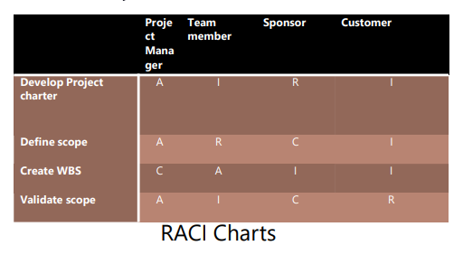

* Output - Resource Management Plan
  + part of the project management plan and is used to manage both physical and team resources
  + It will guide the remaining five resource management processes
  + Contains the roles and responsibilities, the organization chart, and project team resource management.
* Output - Team Charter
  + Document that outlines what will be acceptable behavior within the project.
  + Should include things like the general rules of conduct for meetings, decision making, and one-on-one conversations

#### Estimate Activity Resources

* Where you look at each individual activity and determine what and how many resources are needed to accomplish that activity
* Resources are not just people, but also include equipment, machines, and different types of supplies needed to finish the activity

|  |  |  |
| --- | --- | --- |
| *Input* | *Tool Technologies* | *Output* |
| Project Management Plan  Project Documents  Enterprise Environmental Factors  Organizational Process Assets | Expert Judgment  Bottom-up Estimating  Analogous Estimating  Parametric Estimating  Data Analysis  Project Management Information System  Meetings | Resource Requirements  Basis of Estimates  Resource Breakdown Structure  Project Documents Updates |

* Tool - Bottom-Up Estimating
  + Break down the activities in more detail until you can assign the resources. You can then aggregate them back up to the full activity
* Tool - Analogous Estimating
  + Also known as top-down estimation. Analogous estimation relies on historical information to assign the current duration to the activities. It is based on a limited amount of information.
* Tool - Parametric Estimating
  + Uses a math algorithm to calculate cost or duration
* Output - Resource Requirements
  + will document the number and types of resources needed to complete each activity. This should be very detailed.
* Resource Breakdown Structure
  + Hierarchical breakdown of resources by their categories and types.
* Basis of Estimates
  + How the estimates were created.

#### Plan Communication Management

* Developing an appropriate approach and plan for project communications activities ϒ Based on the information needs of the project stakeholders
* Documented approach to effectively and efficiently engage stakeholders

|  |  |  |
| --- | --- | --- |
| *Input* | *Tool Technologies* | *Output* |
| Project Charter  Project Management Plan  Project Documents Enterprise Environmental Factors  Organizational Process Assets | Expert Judgment  Communication Requirements Analysis  Communication Technology  Communication Models  Communication Methods  Interpersonal and Team Skills  Data Representation  Meetings | Communications Management Plan  Project Management Plan Updates  Project Documents Update |

* Tool - Expert Judgement
* Tool - Communication Requirements Analysis
  + Analyzing the communications needs of the stakeholders
  + Lack of communication leads to failure
  + Communications Channels
    - Channels = n(n-1)/2
      * N=The number of people on the project
      * 4 Team Members= 6 lines of communication
      * 4(4-1)/2=x } 6=x
    - There are 10 stakeholders on a project, how many channels will the project manager need to analyze?
      * 10(10-1)/2 = 45

* Tool - Communication Technology
  + Method of communication
    - Technology, Email, phone, fax, Web page, in-person
    - Level of Urgency
    - Ease of use
    - Sensitivity and confidentiality of the information
* Communication Methods
  + Informal Written
    - Email, Memorandums
  + Formal Written
    - Contracts, Project Documents, Legal Notices
  + Informal Verbal
    - Phone calls, random discussions
  + Formal Verbal
    - Presentations, Speeches
  + Push- Email Blast
  + Pull-Download information
  + Interactive- Joint Discussions
* Tool - Communication Models
  + Sender - The person or group sending the message to the receiver.
  + Encoder - The device or technology that encodes the message to travel over the medium. (Sender EMAIL server)
  + Decoder - This is the inverse of the encoder. (Receiver EMAIL server)
  + Receiver - This is of course the recipient of the message.
  + Paralingual - The pitch, tone, & inflections in the sender’s voice affect the message being sent.
  + Nonverbal – (expression, hand gesture, etc.)
  + Communication Blocker
* Tool - Interpersonal and Team Skills
  + Communication styles assessment
    - Technique to determine the ideal communication method, format, and substance for planned communication
  + Political awareness
    - Achieved through a good perception of strategies, hidden agenda, and power structure and relationship within and around the project
  + Cultural awareness
    - Understanding the differences among individuals, groups, and organizations and adjusting the project’s communication to these differences.
* Tool - Communications Management Plan
  + Who should receive project communications
  + What communications they should receive
  + Who should send the communication
  + How the communication will be sent
  + How often it will be updated
  + Definitions so that everyone has a common understanding of terms.

#### Plan Risk Management

#### Identify Risk

#### Perform Qualitative Risk Analysis

* Output - Project Documents Updates
  + Risk Register : throughout the project risk priority are keep changing since project phase and internal & external environment.
  + Risk Report

#### Perform Quantitative Risk Analysis

EMV = Estimated Monetary Value

#### Plan Risk Responses

#### Plan Procurement Management

#### Plan Stakeholder Engagement

### Critical Path Method

#### Calculate Critical Path

#### Calculate Slack & Float

#### Forward Pass

#### Free Float

#### CPM Practice 1

#### CPM Practice 2

## Point to revisit before Exam

* Stakeholder
* Team
* Team vs Stakeholder
* Conflict
* Change
* Focus on Values
* 49 processes of predictive project management.

## Questions

Do we need to create Plan document for each project in organization? Or do we get provided by PMO team? I believe we need to develop only baseline documents.