**QoS based Optimal Route Discovery**

**Using OpenFlow**

Dhaval Sonawane (dsonawa)

Vaibhav Rajadhyaksha (vrajadh)

Elson Serrao (eserrao)

Chethan Nannivala Thipperudrappa (cnanniv)

North Carolina State University

CSC/ECE-573-002: Internet Protocols

Final Report

*2nd December, 2015*

**1 Introduction**

Routing algorithms traditionally route packets using greedy approach to datagram delivery. Algorithms are broadly classified into Distance Vector and Link State algorithms. The primary metrics used by these algorithms to calculate shortest path is number of hops or the link-cost defined based on the bandwidth. Essentially when a new shortest path is identified, all the traffic is routed in that direction. Nowhere in this technique do we take the QoS requirements of the traffic into consideration. There may exist cases where a new path is calculated and the traffic is routed to it, even though the old path could still be satisfying the QoS requirements.

In our project we design a routing scheme based on the QoS requirements of the traffic.

We take into consideration link latency, bandwidth and queue/port drops as the QoS metrics to calculate the shortest path based on the service requirement (ToS/DSCP). These metrics are fed to a cost function based on which the shortest path is calculated based on the service requirements.

**2 Components**

**2.1 Platforms for Project**

**OpenFlow**: It is a Software Defined Networking (SDN) paradigm that provides centralized control functions by decoupling control and data forwarding layers of routing.

**Mininet**: Mininet creates a realistic virtual network, running real kernel, switch and application code, on a single machine.

**POX**: It is an OpenFlow controller development framework in Python. It provides various OpenFlow APIs that can be used to interact with switches, fetch statistical information from the switches, and write control information to the switches.

**Open vSwitch**: Open vSwitch is a production quality, multilayer virtual switch licensed under the open source Apache 2.0 license.  It is designed to enable massive network automation through programmatic extension, while still supporting standard management interfaces and protocols.

**2.2 Major Components**

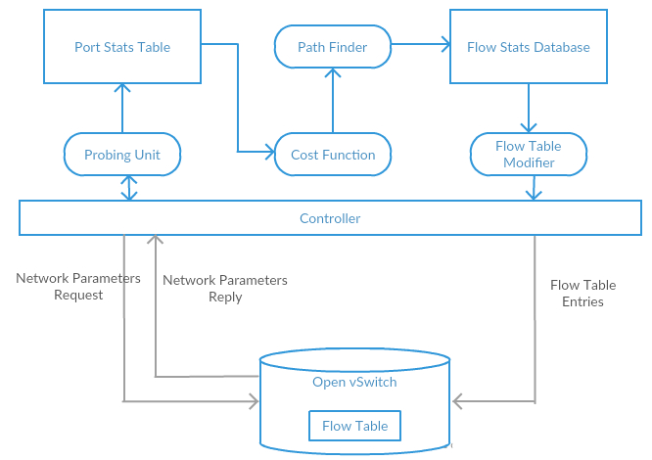

              Figure 1: Flow Diagram

**2.2.1 Control Units**

**Probing Unit**:  This unit is used to query the switches to obtain the network parameters. These parameters are stored as a part of the port stats table. They are then used by the cost function unit to calculate the link costs. It is also responsible for sending the latency packets used to calculate the link latencies. The link latency is calculated periodically.

**Calculated Network Parameters:**

**Bandwidth**: The maximum data transfer rate or throughput for the various links in the network.

**Packet Drops**: The number of packets being dropped from the tail of the queue in the switches. This depicts congestion in the network. Hence it becomes an important parameter to take into consideration while calculating the costs for the links. Delay intolerant traffic can’t be sent on such links with high number of packet drops.

**Link Latency and Calculation:** Network latency is an expression of how much time it takes for a [packet](http://searchnetworking.techtarget.com/definition/packet) of data to get from one designated point to another. In our project we calculate the link latency i.e. delays experienced by packets at the input/output queues of switches.

We are using the method described in the paper ‘Monitoring latency with Open-

Flow’. Accordingly we send a special probe packet from a controller and back while measuring the amount of time it took to do so. The special packet is identified by (0x07c3) as the Ethernet-type. The payload consists of the switch’s mac-address, port it is to be sent out from and time-stamp of its creation (T1).

Initially, when the switches come up the controller writes flow table entries to direct them to forward packets with Ethernet-type 0x07c3 back to the controller. Once the controller receives the packet back it measures the current time (T2). The latency calculation is done as follows:

*Tlink(s1,s2) = Ttotal - [(Ts1 +Ts2)/2]*

Where,

Ttotal- the total time

Ts1- the RTT between the controller and s1

Ts2- the RTT between the controller and s2

The RTT between the controller and the switches is calculated by sending latency packets to be sent out from controller facing interface of the switches.

**QOS Index Calculator:**

QOS Index Calculator uses a cost function uses a cost function using the link parameters saved in the LSDB to calculate the QOS index for a particular link. This information is fed to the path finder to determine the optimal path.

*QosIndexCalculator = K1 * Bandwidth utilization + n (K2 Latency + K3 QueueDrops)*

QosIndexCalculator calculates the cost each link by giving different weights of K1, K2, and K3 for each type of traffic class.

Voice traffic: Voice traffic is sensitive to delay and less tolerant to data loss. K2 has higher weightage and K3 has less weightage.

Video traffic: Video traffic is not very sensitive to latency or data loss. Thus K2 and K3 will have a medium weightage.

Critical traffic: Business traffic is intolerant to delay but highly sensitive to data loss. Thus we have a higher weightage for data loss (K3) and lesser weightage for latency while calculating the cost of the link.

K1= 100, the value for this constant is same for best effort and media traffic.

K2= [0.01, 0.1], Voice=0.1, Video=0.07, Critical=0.01, Best effort=0 (latency is not considered for calculating the cost of the link for best effort traffic).

K3: [0.001, 0.01], Voice= 0.003, Video= 0.007, Critical=0.01, Best effort=0 (Again queue drops are not considered for calculating the cost of the link for best effort traffic).

**Path Finder**

This module runs the Floyd-Warshall algorithm to find minimal cost from a source to destination. Unlike traditional routing the cost used here is a function of bandwidth, latency and queue-drops. Thus based on the ToS value of the traffic differential treatment is provided for different kinds of traffic. Optimal route is calculated based on the level of tolerance of the traffic towards latency and data loss.

**Flow Writer**

This component writes the flow table entries in the switches based on the updated values in the path_map. Flows are written incrementally i.e. only when there are updates that happen on the flow entries in the path_map.

**2.2.2 Dictionary Tables**

We have used dictionaries in python to store statistics and adjacency information.

**Switch Adjacency Table:**

This table can be considered to be in a form of matrix where the rows are the switches while the ports are the columns. The corresponding switches to which the ports are connected are the values.

Below is the format and example adjacency table.

**{switch :{ports:switch}**

{1: {2: 2, 3: 3, 4: 4},

2: {2: 1, 3: 3, 4: 4},

3: {2: 1, 3: 2, 4: 4},

4: {2: 1, 3: 2, 4: 3}}

**Port Statistics Table:**

This dictionary is used to store the link parameter values required for cost calculation. The key is the dpid of the switches while the values are also dictionaries with ports as keys and corresponding parameters as values.

Below is the format and example of the port statistics table.

ports = {'**switch**': { **port** : [latency, bandwidth_util, prev_tx_drops, tx_drops, mac-address]}}

{**'00-00-00-00-00-01**':

{**1:** [0.0, 100, 0, 0, '5e:2d:92:32:01:42'],

**2:** [0.0, 100, 0, 0, '22:bd:d6:2e:19:01'],

**3:** [0.0, 100, 0, 0, 'ba:66:fb:bc:d8:03'],

**4:** [0.0, 100, 0, 0, '6e:59:d1:20:39:c3'],

**65534:** [0.0, 100, 0, 0, 'f6:88:35:90:eb:43']}

**3. Testing and Validation**

**3.1 Test Environment Details**

Figure 2 shows the network topology we are using for the test cases.

Table 1 shows the DPID’s of the switches

Table 2 shows the hosts and their ip addresses.

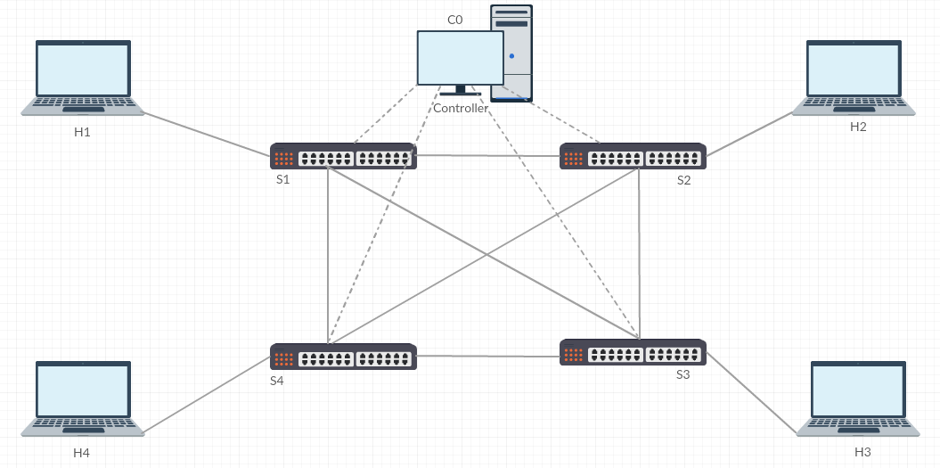

Figure 2: Topology Diagram

|  |  |
| --- | --- |
| **Switch** | **DPID(String)** |
| Switch-1 | 00-00-00-00-00-01 |
| Switch-2 | 00-00-00-00-00-02 |
| Switch-3 | 00-00-00-00-00-03 |
| Switch-4 | 00-00-00-00-00-04 |

Table 1: Switches

|  |  |
| --- | --- |
| **Hosts** | **IP Address** |
| Host-1 | 10.0.0.1 |
| Host-2 | 10.0.0.2 |
| Host-3 | 10.0.0.2 |
| Host-4 | 10.0.0.3 |

Table 2:Hosts

**3.2 Unit Testing**

**Test Case 3.2.1- Switch Connectivity**

1. Start POX controller module on the controller node using the command "./pox.py log.level --ERROR QoSOptRouting"
2. Start mininet module using the command “sudo mn --custom customtopo.py --topo mytopo --link tc --controller remote”
3. Open Terminal on a Switch using the command “xterm s2” on the mininet console.
4. Verify switches are connected to the controller using “ovs-vsctl show” on the switch terminal.
5. Verify controller log to verify it’s connected to the switches.

Switch :

# ovs-vsctl show

03defa20-a00b-494d-9bda-95804c3ea877  
   Bridge "s2"  
       Controller "ptcp:6635"  
       Controller "tcp:127.0.0.1:6633"  
           is_connected: true  
       fail_mode: secure  
       Port "s2-eth3"  
           Interface "s2-eth3"  
       Port "s2-eth4"  
           Interface "s2-eth4"  
       Port "s2"  
           Interface "s2"  
               type: internal  
       Port "s2-eth1"  
           Interface "s2-eth1"  
       Port "s2-eth2"  
        Interface "s2-eth2"

Controller:

POX 0.3.0 (dart) / Copyright 2011-2014 James McCauley, et al.

QoS Based Optimal Routing using OpenFlow

Connected to switch 00-00-00-00-00-04

Connected to switch 00-00-00-00-00-03

Connected to switch 00-00-00-00-00-02

Connected to switch 00-00-00-00-00-01

**Test Case 3.2.2 - Controller Handling Packets**

1. Start POX controller module on the controller node using the command "./pox.py log.level --ERROR QoSOptRouting"

2. Start mininet module using the command “sudo mn --custom customtopo.py --topo mytopo --link tc --controller remote”

3. Use ping utility to send packets between hosts on the mininet console using the command “h1 ping h2 -c 4”.

4. Check the switch logs for successful ICMP replies.

Switch :

mininet> h1 ping h2 -c 4

PING 10.0.0.2 (10.0.0.2) 56(84) bytes of data.

64 bytes from 10.0.0.2: icmp_seq=1 ttl=64 time=2000 ms

64 bytes from 10.0.0.2: icmp_seq=2 ttl=64 time=2000 ms

64 bytes from 10.0.0.2: icmp_seq=3 ttl=64 time=2000 ms

64 bytes from 10.0.0.2: icmp_seq=4 ttl=64 time=2000 ms

--- 10.0.0.2 ping statistics ---

4 packets transmitted, 4 received, 0% packet loss, time 3019ms

rtt min/avg/max/mdev = 2000.180/2000.326/2000.700/0.216 ms, pipe 2

**Test Case 3.2.3 - Switch Adjacency Table**

1. Start POX controller module on the controller node using the command "./pox.py log.level --ERROR QoSOptRouting"

2. Start mininet module using the command “sudo mn --custom customtopo.py --topo mytopo --link tc --controller remote”

3. Controller runs discovery on connecting to the switches.

4. Verify that the adjacency matrix is correctly populated.

Adjacency Table Syntax

{Switch : {Port : Switch}}

{**1**: {2: 2, 3: 3, 4: 4},

**2**: {2: 1, 3: 3, 4: 4},

**3**: {2: 1, 3: 2, 4: 4},

**4**: {2: 1, 3: 2, 4: 3}}

**Test Case 3.2.4 - Statistics Calculation**

1. Start POX controller module on the controller node using the command "./pox.py log.level --ERROR QoSOptRouting"

2. Start mininet module using the command “sudo mn --custom customtopo.py --topo mytopo --link tc --controller remote”

3. Check that the port_stats table is being populated with the calculated statistics on the controller output.

Statistics Table Syntax

{'**switch**':

{ **port** : [latency, bandwidth_util, prev_tx_drops, tx_drops, mac-address]}}

Initial Statistics Table (For Switch 1)

{**'00-00-00-00-00-01'**:

{**1**: [0.0, 100, 0, 0, 'de:ab:18:79:59:05'],

**2**: [0.0, 100, 0, 0, '4e:c6:49:a4:9f:86'],

**3**: [0.0, 100, 0, 0, 'ba:f7:75:c8:0b:37'],

**4**: [0.0, 100, 0, 0, 'fe:88:5d:76:7f:8c'],

**65534**:[0.0,100,0, 0,'56:be:9b:82:37:4a']}}

After Receiving Statistics:

{**'00-00-00-00-00-01'**:

{**1**: [0.0, 8, 0, 0, 'de:ab:18:79:59:05'],

**2**:[1061.4784,5,0,0,'4e:c6:49:a4:9f:86'],

**3**:[48.62, 6, 0, 0, 'ba:f7:75:c8:0b:37'],

**4**:[48.0624, 7, 0, 0, 'fe:88:5d:76:7f:8c'],

**65534**:[0.0, 0,77,77,'56:be:9b:82:37:4a']}}

**Test Case 3.2.5 - Link Down Event**

1.Start POX controller module on the controller node using the command "./pox.py log.level --ERROR QoSOptRouting"

2. Start mininet module using the command “sudo mn --custom customtopo.py --topo mytopo --link tc --controller remote”

3. Run the command “link s1 s2 down” on the mininet console to take down the link between s1 and s2.

4. Verify in the controller output that the link is being removed.

Switch

mininet> link s1 s2 down

Controller

Link removed 00-00-00-00-00-02.2 -> 00-00-00-00-00-01.2

Link removed 00-00-00-00-00-01.2 -> 00-00-00-00-00-02.2

**Test Case 3.2.6 - Cost Function Calculation Verification**

1. Start POX controller module on the controller node using the command "./pox.py log.level --ERROR QoSOptRouting"

2. Start mininet module using the command “sudo mn --custom customtopo.py --topo mytopo --link tc --controller remote”

3.Verify controller logs to check that the cost function matrix is being printed appropriately.

Cost Matrix Syntax

{**Switch** : {Port : Cost} }

Controller:

----- Traffic Received with **ToS** ----- **160**  || **Traffic Type =  voice**

----- Costs for given ToS -----

{**1**: {2: 102.7531, 3: 3.8454, 4: 3.5638},

**2**: {1: 103.8211, 3: 3.8072, 4: 3.5666},

**3**: {1: 3.8379, 2: 3.7490, 4: 2.6284},

**4**: {1: 3.6821, 2: 3.5927, 3: 3.7510} }

**Test Case 3.2.7 - Verifying Path Finder module**

1. Start POX controller module on the controller node using the command "./pox.py log.level --ERROR QoSOptRouting"

2. Start mininet module using the command “sudo mn --custom customtopo.py --topo mytopo --link tc --controller remote”

3. Start Terminals for Host 1 and Host 2 using “xterm h1” and “xterm h2” on the mininet console.

4. Set node h2 as receiver by running the command “ITGRecv” on the Host 1 terminal.

5. Set node h1 as sender and run Voice traffic using the following commands -

Best Effort: ITGSend -a 10.0.0.2 -rp 10001 -b 0

Voice: ITGSend -a 10.0.0.2 -rp 10001 -b 160

Video: ITGSend -a 10.0.0.2 -rp 10001 -b 120

Business Critical: ITGSend -a 10.0.0.2 -rp 10001 -b 88

6. Verify controller logs to check that the path is getting printed properly.

7. Start Terminal for Switch 1 using “xterm s1” on the mininet console.

8. Verify switch dump-flows using “ovs-ofctl dump-flows s1” to check that the path has been installed properly.

Path Syntax on Controller

[( Switch, Input port, Output port )]

Controller:

Voice Traffic :-

----- Traffic Received with ToS ----- 160  || Traffic Type =  voice

----- Costs for given ToS -----

{1: {2: 103.6173, 3: 6.117, 4: 6.0949},

2: {1: 103.7688, 3: 6.0872, 4: 6.0647},

3: {1: 6.0540, 2: 5.8113, 4: 6.0350},

4: {1: 7.1174, 2: 6.8743, 3: 7.1423}}

**-----Printing path-----**

**[(00-00-00-00-00-01, 1, 3),**

**(00-00-00-00-00-03, 2, 3),**

**(00-00-00-00-00-02, 3, 1)]**

Best Effort Traffic:-

----- Traffic Received with ToS ----- 0  || Traffic Type =  best_effort

----- Costs for given ToS -----

{1: {2: 600.0, 3: 600.0, 4: 500.0},

2: {1: 600.0, 3: 600.0, 4: 600.0},

3: {1: 500.0, 2: 600.0, 4: 600.0},

4: {1: 600.0, 2: 600.0, 3: 600.0}}

**-----Printing path-----**

**[(00-00-00-00-00-01, 1, 2),**

**(00-00-00-00-00-02, 2, 1)]**

Switch:

# ovs-ofctl dump-flows s1

NXST_FLOW reply (xid=0x4):

cookie=0x0, duration=5.518s, table=0, n_packets=5043, n_bytes=2793822, idle_timeout=10, idle_age=0, priority=65535, udp, in_port=1, vlan_tci=0x0000, dl_src=66:bf:9b:d2:82:55, dl_dst=16:95:47:d7:4a:d4, **nw_src=10.0.0.1,** **nw_dst=10.0.0.2**, **nw_tos=160**, tp_src=36177, tp_dst=10002 **actions=output:3**

cookie=0x0, duration=11.608s, table=0, n_packets=9, n_bytes=638, idle_timeout=10, idle_age=5, priority=65535, tcp, in_port=1, vlan_tci=0x0000, dl_src=66:bf:9b:d2:82:55, dl_dst=16:95:47:d7:4a:d4, **nw_src=10.0.0.1, nw_dst=10.0.0.2, nw_tos=0,** tp_src=51684, tp_dst=9000 **actions=output:2**