 

**DESIGN AND DEVELOPMENT OF WIRELESS FLEXIBLE ELECTRONICS NASAL WIFLEN MASK FOR RESPIRATORY BREATHING ASSESSMENTS**

**Ref No: TDP/DRISHTI CPS/L2M-2.0/SL/2023-24/0002**

**Current Status of the work:**

* **Data Acquisition**: Data collection with Prototype 3 is complete, encompassing different scenarios such as Normal Breathing, Deep Breathing, Breathing while Walking, Stairs Climbing, and Shallow Breathing.
* **Patent Filing**: Utility Patent filing for **MP-WIFLEN** is under process.
* **Mobile Application** A mobile app has been developed to retrieve real-time data from the prototype and deliver analytical insights.
* **Prototype Fabrication**:
  + - * Prototype 3 has been sent for fabrication, with an expected delivery date of September 25, 2024.
      * Prototype 4 has been received, and the programming of the board is now underway.
* **Papers Submitted**: Based on the acquired data, a series of papers have been submitted. These papers include detailed analyses Developing ML and DL models and visualizations.

|  |  |  |
| --- | --- | --- |
| **Paper** | **Journal/Conference** | **Status** |
| WIRELESS FLEXIBLE ELECTRONICS NASAL  (WIFLEN) MASK:A FASDEN-CNN MODEL  BASED RECOGNITION OF BREATHING  PATTERNS | **IEEE-EMBS International Conference on Biomedical and Health Informatics (BHI’24)** | Under Review |
| Performance Evaluation Of Wearable Nasal Sensor For Respiratory Assessments  Using A NOVEL EDRS-LSTM Deep Learning Model | **IEEE TENCON 2024** | Accepted |
| AN INTEGRATED WEARABLE NASAL HUMIDITY SENSOR WITH DEEP AI FOR CONTINUOUS RESPIRATORY ASSESSMENT | **International Conference on Biomedical Engineering & Health Sciences (2nd ICBMEHS)** | Accepted |

**WIRELESS FLEXIBLE ELECTRONICS NASAL (WIFLEN) MASK:A FASDEN-CNN MODEL BASED RECOGNITION OF BREATHINGPATTERNS**

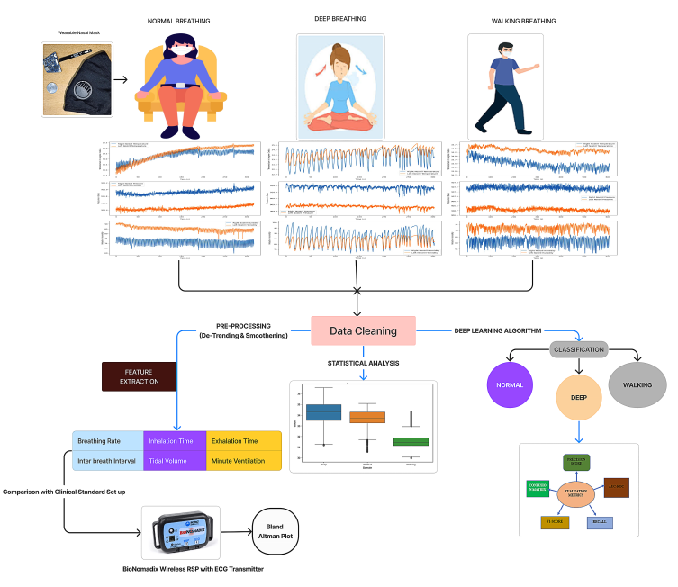

The proposed Wireless Flexible Electronic Nasal (WIFLEN) sensor with the fast dense (FASDEN-CNN) towards recognition of breathing patterns. The data collection was performed using a WIFLEN sensor that is capable of capturing the variations in temperature, pressure, and humidity at the right and left nostrils during breathing. The data was recorded for capturing breathing patterns during normal breathing, deep breathing, and walking. To eliminate outliers and non-integer values, the raw data was cleaned. Three procedures were applied to the cleansed data. 1.feature extraction 2. Statistical analysis 3. Creation of a deep AI model to categorize respiratory patterns. The cleaned data was detrended using quadratic detrending technique and was smoothened using the Savgol filter. Baseline onset and offsets were detected to track the inhalation and exhalation points. Further, Inhalation and exhalation points were identified which were used for the calculation of respiratory vitals namely breathing rate, inter-breath interval, inhalation time, exhalation time, tidal volume, and minute ventilation. The results were validated by comparing the obtained results with the output of the clinical standard chest based respiratory assessment device. Statistical analysis was performed to understand the suitability of recorded breathing pattern for possible pattern classification. The effect of left as well as right nostrils-based temperature, pressure and humidity variations were found to show distinguishable median difference for the three activities. In order to exploit the frequency variations of the recorded breathing patterns, Hilbert transform was applied and the resultant data were converted into 2D spectrogram. The Fast dense (FASDEN) CNN , being a 2D CNN model was deployed on the resultant spectrogram for training and testing to perform binary classification.

**Performance Evaluation Of Wearable Nasal Sensor For Respiratory AssessmentsUsing A NOVEL EDRS-LSTM Deep Learning Model**

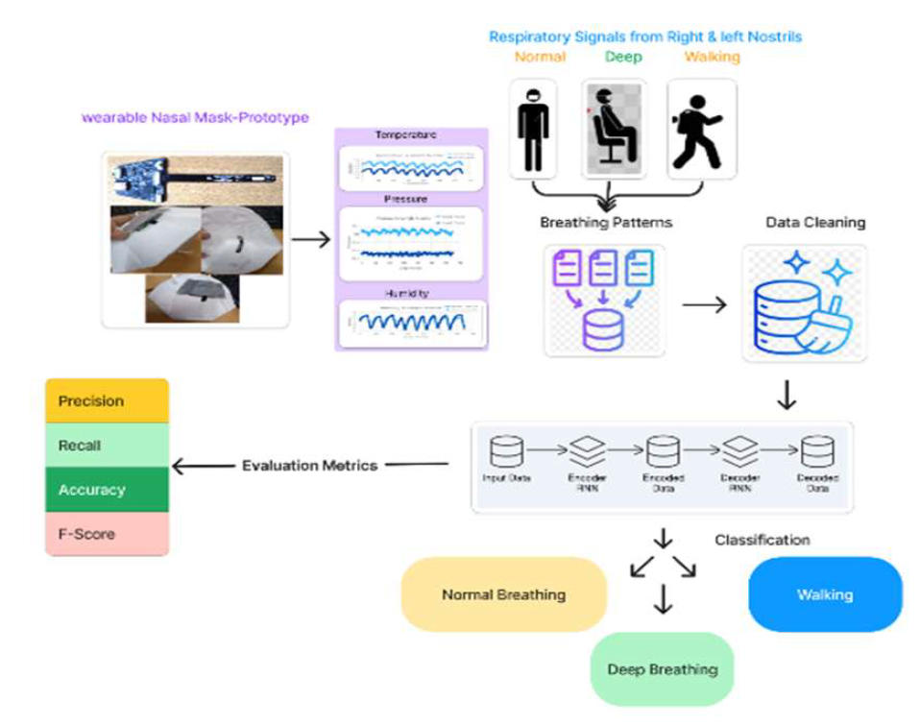

The overall schematic flow/ framework towards the data collection/ recording and assessment of respiratory signals during Normal breathing , Deep breathing, and breathing while walking. Unlike the traditional chest/diaphragm/inductance thoracic based sensing mechanism breathing variations were picked up by placing wearable nasal mask which comprises of nasal sensor that collects temperature, pressure and humidity variations from left as well as right nostrils. Data cleansing was deployed to ensure the recorded signals were suitable for analysis. A hamming segmentation of window length of 10sec with 50% overlap was used. The segments from the cleaned data were normalized and given to the EDRS-LSTM deep learning model. Three breathing changes normal, deep and walking were taken into consideration for assessment. The performance of the proposed integrated framework was evaluated in terms of precision, recall, ROC, accuracy as well as F1 score.

**AN INTEGRATED WEARABLE NASAL HUMIDITY SENSOR WITH DEEP AI FOR CONTINUOUS RESPIRATORY ASSESSMENT**

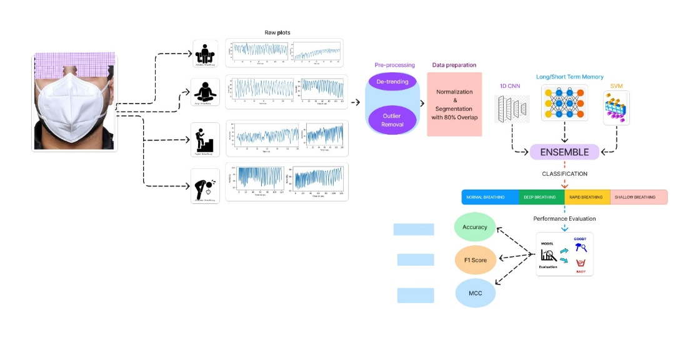

The general structure for evaluating respiratory signals with the following breathing patterns: normal breathing, deep breathing, rapid breathing and shallow breathing during recuperation. By inserting a wearable nasal mask with humidity sensors beneath the nostrils, the humidity fluctuations indicating the breathing patterns from the right and left nostrils were detected. In order to prepare the raw data for future analysis, baseline drift was removed using a detrending mechanism, and outliers were eliminated using IQR (Inter Quartile Range) techniques. In order to handle the non-stationary nature of the biomedical signals recorded, the data was normalized and divided into segments with 80% overlap. To evaluate and categorize the prepared data, an ensemble model comprising 1D-CNN, LSTM, and SVM classifiers was applied. The performance of the proposed integrated framework was evaluated in terms of accuracy, F1- score and MCC values.

**Future Work:**

* Data Acquisition with prototype 3 and prototype 4.
* Cloud Sourcing for Deployment of Mobile Application
* Journal / Conference Publications