1. **Project Definition**
   * Abstract
   * Introduction
   * Proposed System
   * System Scope
   1. **Abstract:**

The website is all about purchasing and selling laptop. The users need to initially register themselves on the website and further they can purchase product. Client also search the any company product. The admin user can upload the product and information about them as well as they can delete their products.

From the admin side initially the admin needs to login in the website and then they can furthermore do operation such as:

* Manage the upload done by users(Submit & delete the product)
* Can add and also can delete new categories.
* Can aslo delete the registered users as per the requirement.
* Can delete the “ Feedback ” part of the user.

**1.2 Introduction:**

This website helps customer to find types of laptop, their features. The website will help in easy maintain and updating products in the website for the administarator. Also quick and easy comparison of different products for the customers. Customer aslo can feedback.

* This project is in PHP with MySql
* Shopping : This entails interaction between the customer and the shopkeeper dealing with buying, selling of commodities.
* Product : An commodities that is being given to a customer.
* Customer : Fulfill the customer requirement.
* We supply following company’s Product
* Dell
* Apple
* Sony
* Lenovo
* Hp

**1.3 Proposed System:**

Laptop offering is a system to connect the customers and sellers in market. In industries and businesses where products have been the standard means of conducting transactions, online systems have sped up and generalized the process. In general, the internet products has become a popular way to enhance the mode of handling transactions whether between individuals or businesses.

The main objective of the new proposed system is to have all the required features, which would really help to the members.

The typical reason to go online with an products includes:

* Advertising, reaching a broader audience and removing geographical limitations.
* Tracking for buyers and sellers.
* Security of transactions
* Automate customers checking and purchasing
* Efficient managing and recording of products transactions
* Ease of modifying products rule

Product selling is probably the most effective negotiation tool available today. Most business activity on the internet is limited to publicizing the business opportunity and catalog based sales, but it will rapidly expand to include the negotiations conducted to settle the price of the goods or commodities being traded.

Trading on the internet allows a business to reach a larger number of potential customers and suppliers in a shorter time and a lower cost than possible by other modes of communications, and to settle business transactions with lower cost overhead in a shorter time. Hence the rapid emergence of internet based trading applications.

**1.4 System Scope:**

Online transation provide in feature by our system and also purchase multiple product.

1. **Project Analysis**

* Preliminary Investigation
* Feasibility Study
* Fact finding Techniques
* System specification
* Linear sequential model
  1. **Preliminary Investigation:**

Following are major steps that we have followed during the analyses of the whole system.

* In first phase we have understood the project definition in detail from our project guide.
* After the detailed discussion, we have noted down the lots of queries regarding the exact output.
* As we have followed prototype model in development, we have conducted various meeting regarding the development tool we should use such that it fulfill all the functionalities of web based implementation.
* We have spent enough time to gather requirements of employees and deciding development tools in Analyses phase.

**2.2 Feasibility Study:**

* Feasibility study is a process to check possibilities of system devlopment.
* Economical Feasibility
* Technical Feasibility
* Operational Feasibility
* Resource Feasibility

**[1] Economical Feasibility:**

In economical feasibility ,analysis of the cost of the system is carried out.The system should be only developed if it is going to give return.In any educational orgenization or for parents it is headache to find question and generate test which is different each time.

**[2] Technical Feasibility:**

It is basically used to see existing computer ,hardware and software etc, weather it is sufficient or additional equipment’s are required ?Minimum system Requirement is such that it can be affordable. So system is fully technically feasible.

**[3] Operational Feasibility:**

Once the system is disigned there must be trained and expert operatr. If they are not trained they should give training according to the needs of the system. From the user’s perspective our system is very easy to use as it just requires some knowledge of computers.

**[4] Resource Feasibility:**

* Required Resource are as follows :
* Environmental Resources:

One personal computer,platform with xampp server,Local area connection. The application server is needed to deploy the project are also freely downloadable.

* Human Resources:

As taking in the consideration of time durational feasibility available human resource were enough.

* 1. **Fact finding Techniques:**

**[1] Interview:**

Interviews were conducted at Company Sitevisit with MaulikSir & DrashanSir on regular based to know the requirements and confirm if it is any changes are required in the present system. Interviews are essential to ensure that the developer and customer have the same perception of the system.

**List of Questions & Answer were condceted in Interviews**

Q.1 How your manual system works?

This site is work in manually are laptop purchase in site.

Q.2 What types of Reports do you Need?

Online transaction provide in feature by our system and also purchase multiple product.

Q.3 How many types User Access to you system(website)?

1) Guest/visitors

2) Authenticate Users (Registered Users)

3) Operator (if any)

4) Admin

Q.4 How to Collect Information ?

Laptop information in specification are define the hard disk, ram, processor, graphics, price etc.

Q.5 How many types of product ?

Shop in product various type like hp, apple, Sony, dell laptop.

**[2] Record Review:**

Reviewing records, were carried out along with the interview as the interview was carried out at the place of their work and hence when there was any doubt or if more information was needed. Record reviews are to get the information in any available form in front of us for further consideration.

* Bill Book
* Visiting Card
* Catlogs
* Price List

**Visited shop:**

Smart Computer Shop

Rajkot 360002

**[3] Observation:**

Observation was also carried out during the interview. as how the various information can be carry out from the other section of existing system.

* How the manually purchase laptop are bill & pay now.
* Observation in site view to related in graphic design, & site module design.
* System analysis are define the easy to use customer.
  1. **System specification:**

The proposed computerized system should give them the following features:

* Elimination of clumsy paper work
* The maintenance and retrieval of the old records should be fast and easy.
* The system should be flexible enough for further modification and enhancement.
* The system should be user friendly.

USER INTERFACE FEATURES:

* All data capture screens are presented in consistent, standardized user friendly GUI format.
* Validations related to data capture are carried out instantaneously and error if any, flagged there and then. Only error free data is accepted by the system.

Extensive online help facility will be provided.

* 1. **Linear sequential model:**

1. **System Design**
   * Process Specification
   * Design Strategies
   * Data Dictionary
   * Data Flow Diagram
   * E-R Diagram
   * Time-Line Chart
   1. **Process Specification:**

* **Client Side:**
* Login:

The field is login are username & password. If the username and password are correct then it directed to next page.

* User Registration:

In the case of buying a loptop at time, if the user is not registred then register and login after purchase it.

* Manage Product:

This module has information regarding the laptop such as is name, model, price information, its features etc.

* **Admin Side:**
* Insert:

In this module is insert product, administrator, companies all inforemation stores in the database in our system.

* Update:

In this module is update product, administrator, companies all inforemation stores in the database in our system.

* Delete:

In this module is delete product, administrator, companies all inforemation stores in the database in our system.

* 1. **Design Strategies:**
* **SOFTWARE ENGINEERING APPROACH:**

Software design process involves developing several models of the system at a different level of abstraction as the design is decomposed error and omissions in earlier stages are discovered.

The two design strategies are widely accepted as follows:

* **FUNCTION ORIENTED DESIGNING:**

The system is designed from a functional viewpoint starign with a high level view and progressively refining this into a more detailed design. The system state is centralized and shared between functions operating on the state.

As our system is process oriented we have work accordingly considering the functional designing.

* **OBJECT ORIENTED DESIGNING:**

The system is viewed as a collection of objects rather than as function. Object oriented technology lead to reuse and reuse leads to faster development and higher quality programs. It is also easier to maintain.

* 1. **Data Dictionary:**

|  |  |  |
| --- | --- | --- |
| **Field** | **Type** | **Description** |
| a_id | int | Display admin id |
| name | varchar | Display admin name |
| eid | varchar | Display admin email id |
| pwd | varchar | Display admin password |

Table : admin_login

Description: Display admin details

|  |  |  |
| --- | --- | --- |
| **Field** | **Type** | **Description** |
| pro_id | int | Display product id |
| company_id | int | Display company id |
| model_nm | varchar | Display modal name |
| pro_img | text | Display product img path |
| price | int | Display product price |
| Processor | varchar | Display laptop processor |
| ram | varchar | Display laptop ram |
| harddisk | varchar | Display laptop harddisk |
| os | varchar | Display laptop operating system |
| web_camera | varchar | Display laptop camera |
| screen_size | varchar | Display product screen size |
| graphics | varchar | Display product graphics |
| Warranty | varchar | Display product warranty |
| information | text | Display product other information |

Table :product

Description: Display product details

|  |  |  |
| --- | --- | --- |
| **Field** | **Type** | **Description** |
| cid | int | Display company id |
| |  |  | | --- | --- | | cnm |  | | varchar | Display company name |

Table :company

Description:Display company details

|  |  |  |
| --- | --- | --- |
| **Field** | **Type** | **Description** |
| user_id | int | Display feedbacks userid |
| user_nm | varchar | Display feedbacks username |
| eid | varchar | Display feedbacks emil id |
| comment | varchar | Display feedbacks comment |

Table :feedback

Description:Display feedback details

|  |  |  |
| --- | --- | --- |
| **Field** | **Type** | **Description** |
| order_id | int | Display order id |
| user_id | varchar | Display user id |
| pro_id | int | Display product id |
| quantity | int | Display quantity |
| total_amount | int | Display order total amount |

Table :order

Description:Display order details

|  |  |  |
| --- | --- | --- |
| **Field** | **Type** | **Description** |
| user_id | int | Display register user id |
| user_nm | varchar | Diplay register user name |
| user_fnm | varchar | Display register user first name |
| user_lnm | varchar | Display register user last name |
| eid | varchar | Display register user email id |
| Pwd | varchar | Display register user password |
| contect_no | varchar | Display register user contect no |
| |  | | --- | |  |   address | text | Display register user address |
| city | varchar | Display register user city |
| Pincode | int | Display register user pincode |
| profile_picture | text | Display register user profile image |

Table :register_user

Description:Display register_user details

* 1. **Data Flow Diagram:**

System DFD:

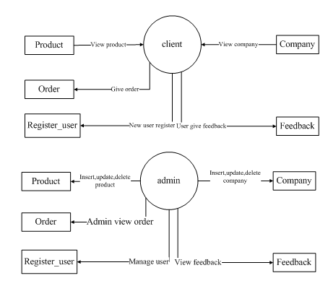

**Admin Usecase DFD:**

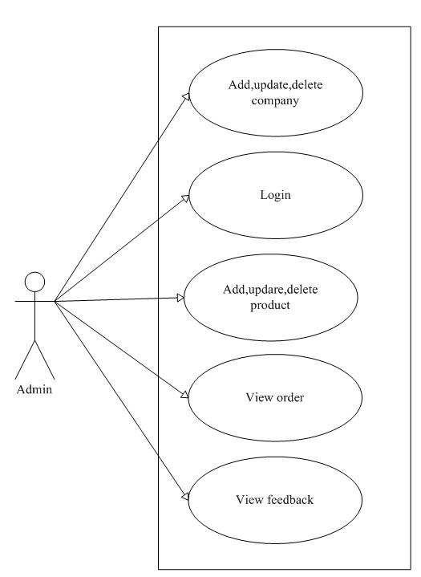

**Client usecase DFD:**