1. **Project Definition**
   * Abstract
   * Introduction
   * Proposed System
   * System Scope
   1. **Abstract:**

The website is all about purchasing and selling laptop. The users need to initially register themselves on the website and further they can purchase product. Client also search the any company product. The admin user can upload the product and information about them as well as they can delete their products.

From the admin side initially the admin needs to login in the website and then they can furthermore do operation such as:

* Manage the upload done by users(Submit & delete the product)
* Can add and also can delete new categories.
* Can aslo delete the registered users as per the requirement.
* Can delete the “ Feedback ” part of the user.

**1.2 Introduction:**

This website helps customer to find types of laptop, their features. The website will help in easy maintain and updating products in the website for the administarator. Also quick and easy comparison of different products for the customers. Customer aslo can feedback.

* This project is in PHP with MySql
* Shopping : This entails interaction between the customer and the shopkeeper dealing with buying, selling of commodities.
* Product : An commodities that is being given to a customer.
* Customer : Fulfill the customer requirement.
* We supply following company’s Product
* Dell
* Apple
* Sony
* Lenovo
* Hp

**1.3 Proposed System:**

Laptop offering is a system to connect the customers and sellers in market. In industries and businesses where products have been the standard means of conducting transactions, online systems have sped up and generalized the process. In general, the internet products has become a popular way to enhance the mode of handling transactions whether between individuals or businesses.

The main objective of the new proposed system is to have all the required features, which would really help to the members.

The typical reason to go online with an products includes:

* Advertising, reaching a broader audience and removing geographical limitations.
* Tracking for buyers and sellers.
* Security of transactions
* Automate customers checking and purchasing
* Efficient managing and recording of products transactions
* Ease of modifying products rule

Product selling is probably the most effective negotiation tool available today. Most business activity on the internet is limited to publicizing the business opportunity and catalog based sales, but it will rapidly expand to include the negotiations conducted to settle the price of the goods or commodities being traded.

Trading on the internet allows a business to reach a larger number of potential customers and suppliers in a shorter time and a lower cost than possible by other modes of communications, and to settle business transactions with lower cost overhead in a shorter time. Hence the rapid emergence of internet based trading applications.

**1.4 System Scope:**

Online transation provide in feature by our system and also purchase multiple product.

1. **Project Analysis**

* Preliminary Investigation
* Feasibility Study
* Fact finding Techniques
* System specification
* Waterfall model
  1. **Preliminary Investigation:**

Following are major steps that we have followed during the analyses of the whole system.

* In first phase we have understood the project definition in detail from our project guide.
* After the detailed discussion, we have noted down the lots of queries regarding the exact output.
* As we have followed prototype model in development, we have conducted various meeting regarding the development tool we should use such that it fulfill all the functionalities of web based implementation.
* We have spent enough time to gather requirements of employees and deciding development tools in Analyses phase.

**2.2 Feasibility Study:**

* Feasibility study is a process to check possibilities of system devlopment.
* Economical Feasibility
* Technical Feasibility
* Operational Feasibility
* Resource Feasibility

**[1] Economical Feasibility:**

In economical feasibility ,analysis of the cost of the system is carried out.The system should be only developed if it is going to give return.In any educational orgenization or for parents it is headache to find question and generate test which is different each time.

**[2] Technical Feasibility:**

It is basically used to see existing computer ,hardware and software etc, weather it is sufficient or additional equipment’s are required ?Minimum system Requirement is such that it can be affordable. So system is fully technically feasible.

**[3] Operational Feasibility:**

Once the system is disigned there must be trained and expert operatr. If they are not trained they should give training according to the needs of the system. From the user’s perspective our system is very easy to use as it just requires some knowledge of computers.

**[4] Resource Feasibility:**

* Required Resource are as follows :
* Environmental Resources:

One personal computer,platform with xampp server,Local area connection. The application server is needed to deploy the project are also freely downloadable.

* Human Resources:

As taking in the consideration of time durational feasibility available human resource were enough.

**2.3 Fact finding Techniques:**

**[1] Interview:**

Interviews were conducted at Company Sitevisit with MaulikSir & DrashanSir on regular based to know the requirements and confirm if it is any changes are required in the present system. Interviews are essential to ensure that the developer and customer have the same perception of the system.

**List of Questions & Answer were condceted in Interviews**

Q.1 How your manual system works?

This site is work in manually are laptop purchase in site.

Q.2 What types of Reports do you Need?

Online transaction provide in feature by our system and also purchase multiple product.

Q.3 How many types User Access to you system(website)?

1) Guest/visitors

2) Authenticate Users (Registered Users)

3) Operator (if any)

4) Admin

Q.4 How to Collect Information ?

Laptop information in specification are define the hard disk, ram, processor, graphics, price etc.

Q.5 How many types of product ?

Shop in product various type like hp, apple, Sony, dell laptop.

**[2] Record Review:**

Reviewing records, were carried out along with the interview as the interview was carried out at the place of their work and hence when there was any doubt or if more information was needed. Record reviews are to get the information in any available form in front of us for further consideration.

* Bill Book
* Visiting Card
* Catlogs
* Price List

**Visited shop:**

Smart Computer Shop

Rajkot 360002

**[3] Observation:**

Observation was also carried out during the interview. as how the various information can be carry out from the other section of existing system.

* How the manually purchase laptop are bill & pay now.
* Observation in site view to related in graphic design, & site module design.
* System analysis are define the easy to use customer.

**2.4 System specification:**

The proposed computerized system should give them the following features:

* Elimination of clumsy paper work
* The maintenance and retrieval of the old records should be fast and easy.
* The system should be flexible enough for further modification and enhancement.
* The system should be user friendly.

USER INTERFACE FEATURES:

* All data capture screens are presented in consistent, standardized user friendly GUI format.
* Validations related to data capture are carried out instantaneously and error if any, flagged there and then. Only error free data is accepted by the system.

Extensive online help facility will be provided.

**2.5 WaterFall model:**

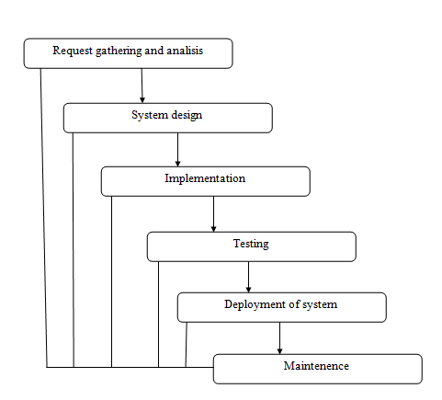

1. **System Design**
   * Process Specification
   * Design Strategies
   * Data Dictionary
   * Data Flow Diagram
   * E-R Diagram
   * Usecase Diagram
   1. **Process Specification:**

* **Client Side:**
* Login:

The field is login are username & password. If the username and password are correct then it directed to next page.

* User Registration:

In the case of buying a loptop at time, if the user is not registred then register and login after purchase it.

* Manage Product:

This module has information regarding the laptop such as is name, model, price information, its features etc.

* **Admin Side:**
* Insert:

In this module is insert product, administrator, companies all inforemation stores in the database in our system.

* Update:

In this module is update product, administrator, companies all inforemation stores in the database in our system.

* Delete:

In this module is delete product, administrator, companies all inforemation stores in the database in our system.

* 1. **Design Strategies:**
* **SOFTWARE ENGINEERING APPROACH:**

Software design process involves developing several models of the system at a different level of abstraction as the design is decomposed error and omissions in earlier stages are discovered.

The two design strategies are widely accepted as follows:

* **FUNCTION ORIENTED DESIGNING:**

The system is designed from a functional viewpoint starign with a high level view and progressively refining this into a more detailed design. The system state is centralized and shared between functions operating on the state.

As our system is process oriented we have work accordingly considering the functional designing.

* **OBJECT ORIENTED DESIGNING:**

The system is viewed as a collection of objects rather than as function. Object oriented technology lead to reuse and reuse leads to faster development and higher quality programs. It is also easier to maintain.

* 1. **Data Dictionary:**

|  |  |  |
| --- | --- | --- |
| **Field** | **Type** | **Description** |
| a_id | int | Display admin id |
| name | varchar | Display admin name |
| eid | varchar | Display admin email id |
| pwd | varchar | Display admin password |

Table : admin_login

Description: Display admin details

|  |  |  |
| --- | --- | --- |
| **Field** | **Type** | **Description** |
| pro_id | int | Display product id |
| company_id | int | Display company id |
| model_nm | varchar | Display modal name |
| pro_img | text | Display product img path |
| price | int | Display product price |
| Processor | varchar | Display laptop processor |
| ram | varchar | Display laptop ram |
| harddisk | varchar | Display laptop harddisk |
| os | varchar | Display laptop operating system |
| web_camera | varchar | Display laptop camera |
| screen_size | varchar | Display product screen size |
| graphics | varchar | Display product graphics |
| Warranty | varchar | Display product warranty |
| information | text | Display product other information |

Table :product

Description: Display product details

|  |  |  |
| --- | --- | --- |
| **Field** | **Type** | **Description** |
| cid | int | Display company id |
| |  |  | | --- | --- | | cnm |  | | varchar | Display company name |

Table :company

Description: Display company details

|  |  |  |
| --- | --- | --- |
| **Field** | **Type** | **Description** |
| user_id | int | Display feedbacks userid |
| user_nm | varchar | Display feedbacks username |
| eid | varchar | Display feedbacks emil id |
| comment | varchar | Display feedbacks comment |

Table :feedback

Description: Display feedback details

|  |  |  |
| --- | --- | --- |
| **Field** | **Type** | **Description** |
| order_id | int | Display order id |
| user_id | varchar | Display user id |
| pro_id | int | Display product id |
| quantity | int | Display quantity |
| total_amount | int | Display order total amount |

Table :order

Description:Display order details

|  |  |  |
| --- | --- | --- |
| **Field** | **Type** | **Description** |
| user_id | int | Display register user id |
| user_nm | varchar | Diplay register user name |
| user_fnm | varchar | Display register user first name |
| user_lnm | varchar | Display register user last name |
| eid | varchar | Display register user email id |
| Pwd | varchar | Display register user password |
| contect_no | varchar | Display register user contect no |
| |  | | --- | |  |   address | text | Display register user address |
| city | varchar | Display register user city |
| Pincode | int | Display register user pincode |
| profile_picture | text | Display register user profile image |

Table :register_user

Description:Display register_user details

* 1. **Data Flow Diagram:**

**System DFD:**

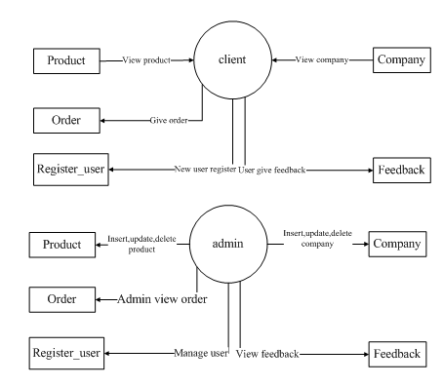

**Login DFD:**

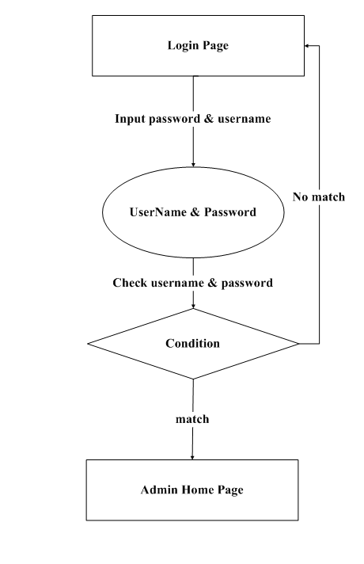

* 1. **E-R Diagram:**

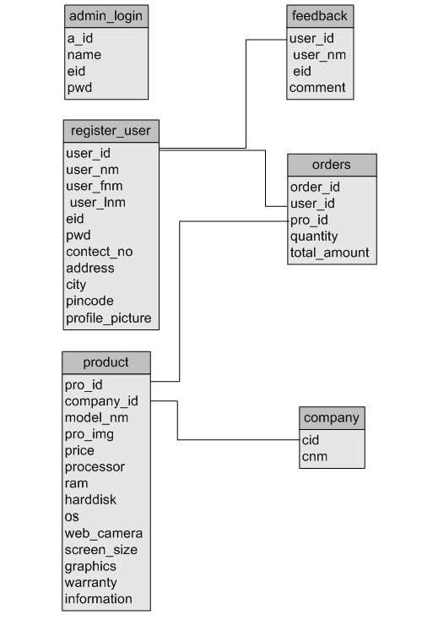

* 1. **Usecase Diagram:**

**Admin Usecase:**

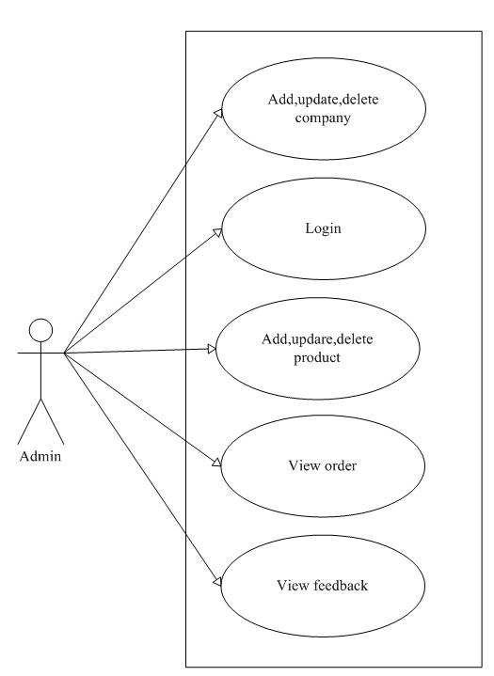

**Client usecase:**

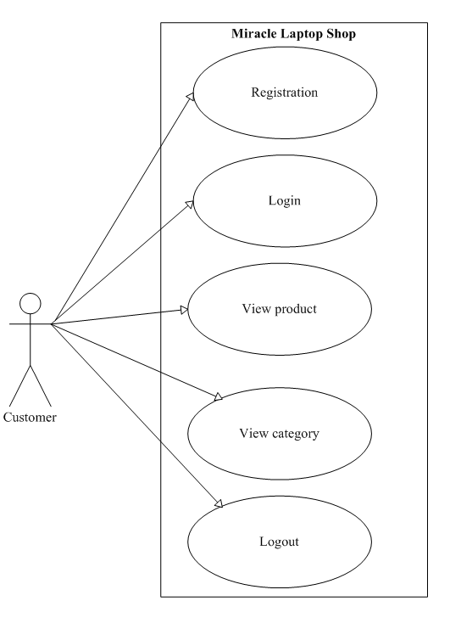

1. **Tools & Technology**
   * Web Architecture
   * Technology used

Apache web server

About database

About MYSQL

* + Language

About HTML

About JavaScript

About php

About CSS

* 1. **Web Architecture :**

**PROPOSED SYSTEM**

A Web Server is a computer that runs the Web server software, which Responds to page requests. It is also called host. The two main types of web Server are HTTP Server that follows the HTTP protocol, and FTP Servers that follow the FTP protocol.

A Web Client sends requests for data to a web server. When the web server processes the request and sends the requested page to the client (remember the browser is used to view these pages and send requests.)

* 1. **Technology used:**
     1. **Apache web server:**
     2. **About database:**
* **Database:**

A Database is similar to a data file in that it storage place for data. Like a Data file, a database does not present information directly to a user; the user runs an application that fetch data from the database and presents it to the user in an understandable format.

Database Systems are more powerful than data files. In well-designed database, there is no duplicate value of data that the user or application must update at the same time. Related pieces of data are grouped together in a single structure.

A Database typically has two main parts: first, the file holding the physical database and second, the database management system (DBMS) software that applications use to fetch and store data. The DBMS is responsible for the Database structure including:

**Maintaining relationships between data in the Database**.

* **Relational Database:**

There are different ways to organize data in different ways in database; relational databases are one of the most effective. Relational database systems are an application of mathematical set Theory to the problem of effectively organizing data. In a relation database, data is collected into tables.

A table represents some class of objects that are important to an organization. For example, a company may have a database with a table for employees, another table for customer, and another for stores. Each table is built of columns and rows. Each column represents some attribute of the object represented by the table. For example, an Employee table that have a column such as First Name, Last Name, EmpId, Department, and Job title.

**A database system comprises two components:**

* Programs that provide an interface for client-based users to access data.
* The database structure that manages and stores the data on the server.

For example, if you use Microsoft Access to create a checking account application, you must set up a database structure to manage the account transaction data and an a Data Types.

My SQL, like other database-management systems, requires you to specify the type Of data that each field holds.

You can choose among the following data types

* Text holds up to 255 characters, including letters, numbers, and special characters.
* Memo holds text up you 65000 characters. Unlike text fields, memo field are available length you do not specify a maximum size of them.
* Number holds number actually used in calculations. The type of number it can hold and accuracy of calculation depends on the size you
* Give to the number field. Some number fields hold many decimal with many decimal places.
* Date/time holds dates and times. Whether you can enter a date or a time depends on the format you give to the field.
  + 1. **About MYSQL:**
* **MYSQL DATABASE MANAGEMENT SYSTEM:**

MySQL, the most popular Open Source SQL database management system, is developed, distributed, and supported by MySQL AB.

MySQL AB is a commercial company, founded by the MySQL developers. It is a second generation Open Source Company that unites Open Source values and methodology with a successful business model.

The MySQL Web site (<http://www.mysql.com/>) provides the latest information about MySQL software and MySQL AB.

The official way to pronounce “MySQL” is “My Ess Que Ell” (not “my sequel”), but we don't mind if you pronounce it as “my sequel” or in some other localized way.

* **MYSQL FEATURES:**
  + MySQL is a database management system.
  + MySQL is a relational database management system.
  + MySQL software is Open Source.
  + The MySQL Database Server is very fast, reliable, and easy to use.
  + MySQL Server works in client/server or embedded systems.
  + A large amount of contributed MySQL software is available.
  1. **Language:**
     1. **About HTML:**
* HTML was originated by Tim Berners-Lee
* HTML developed a few years ago as a subset of SGML (Standard Generalized Mark-up Language), which is a higher-level mark-up language that has long been a favorite of the Department of Defense.
* Any HTML document is also valid for SGML
* HTML is a Hyper Text Markup Language that is used to develop web pages
* HTML is not a programming language like C, C++ and Java etc.
* It is a cross platform markup language that is design to be flexible enough to display text and other elements like graphical on a variety of views.
* The HTML documents consist of special Tags that are embedded in an ASCII document.
* Web browser like Internet Explorer, Netscape Navigator etc, interprets these Tags.
  + 1. **About JavaScript:**
* JavaScript was designed to add interactivity to HTML pages.
* JavaScript is a scripting language (a scripting language is a lightweight programming language)
* A JavaScript consists of lines of executable computer code
* A JavaScript is usually embedded directly into HTML pages
* JavaScript is an interpreted language (means that scripts execute without preliminary compilation)
* Everyone can use JavaScript without purchasing a license.
  + 1. **About php:**
* The full form of PHP is “Hypertext Preprocessor”. Its original name was “Personal Home Page”.
* Rasmus Lerdorf software engineer, Apache team member is the creator and original driving force behind PHP. The first part of PHP was developed for his personal use in late 1994.
* By the middle of 1997, PHP was being used on approximately 50,000 sites worldwide.
* PHP is server-side scripting language, which can be embedded in HTML or used as a stand-alone.
* PHP doesn’t do anything about what a page looks and sounds like. In fact, most of what PHP does is invisible to the end user.
* Someone looking at a PHP page will not necessarily be able to tell that it was not written purely in HTML, because usually the result of PHP is HTML.
* PHP is an official module of Apache HTTP Server.
* PHP is fully cross-platform, meaning it runs native on several flavors of UNIX, as well as on Windows and now on Mac OS X.
* **Advantages of php**
* ***Cost*:** PHP costs you nothing. It is open source software and doesn’t need to purchase it for development.
* ***Ease of Use*:** PHP is easy to learn, compared to the others. A lot of Ready-made PHP scripts are freely available in market so, you can use them in your project or get some help from them.
* ***HTML Support:*** PHP is embedded within HTML. In other words, PHP pages are ordinary HTML pages that escape into PHP mode only when necessary. When a client requests this page, the web server preprocesses it. This means it goes through the page from top to bottom, looking for sections of PHP, which it will try to resolve.
* ***Cross-platform compatibility*:** MySQL run native on every popular flavor of UNIX and windows. A huge percentage PHP and of the world’s HTTP servers run on one of these two classes of operating system.
* ***PHP is compatible with the three leading Web servers:*** Apache HTTP Server for UNIX and Windows, Microsoft Internet Information Server, and Netscape Enterprise Server. It also works with several lesser-known servers, including Alex Blits’ fhttpd, Microsoft’s Personal Web Server, AOL Server and Omnicentrix’s Omni server application server.
* ***Stability:*** The word stable means two different things in this context:
* The server doesn’t need to be rebooted often
  + - The software doesn’t change radically and incompatibly from release to release.

**To our advantage, both of these apply to both MySQL and PHP.**

* **Speed:** PHP is pleasingly zippy in its execution, especially when compiled as an Apache module on the UNIX side. Although it takes a slight performance hit by being interpreted rather than compiled, this is far outweighed by the benefits PHP drives from its status as a Web server module.
  + 1. **About CSS:**

Cascading Style Sheets (CSS) is a collection of formatting rules that control the appearance of content in a web page. Using CSS styles to format a page separates content from presentation. The content of your page—the HTML code—resides in the HTML file, and the CSS rules defining the presentation of the code reside in another file (an external style sheet) or in another part of the HTML document (usually the head section).

Separating content from presentation makes it much easier to maintain the appearance of your site from a central location because you don’t need to update every property on every page whenever you want to make a change. Separating content from presentation also results in simpler and cleaner HTML code, which provides shorter browser loading times, and simplifies navigation for people with accessibility issues (for example, those using screen readers).

CSS gives you great flexibility and control over the exact appearance of your page. With CSS you can control many text properties including specific fonts and font sizes; bold, italics, underlining, and text shadows; text color and background color; link color and link underlining; and much more. By using CSS to control your fonts, you can also ensure a more consistent treatment of your page layout and appearance in multiple browsers.

1. **Screen Layouts**
   * User Panel
   * Admin Panel
   1. **User Panel:**

* **Home page:**

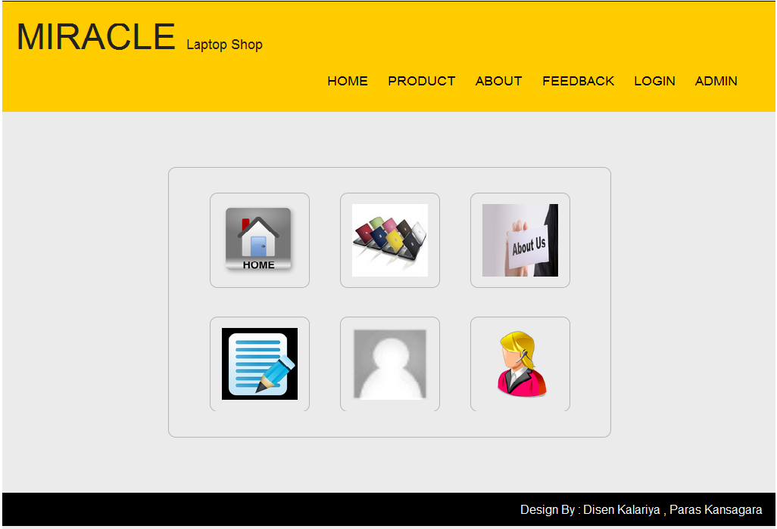

* **Product page:**

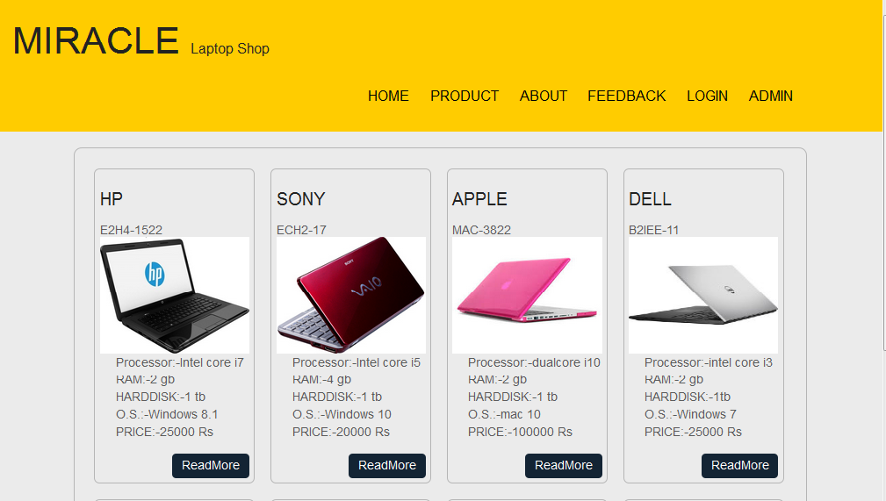

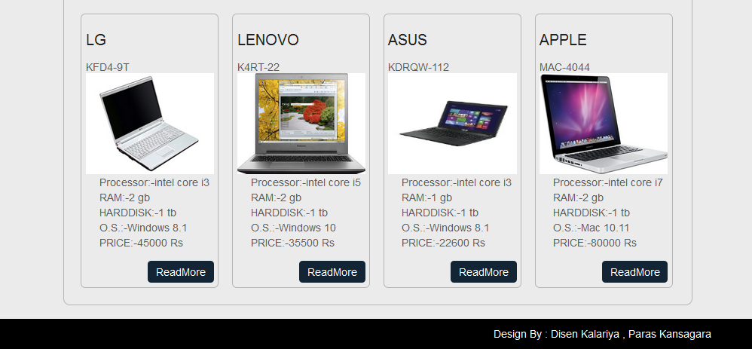

* **Login page:**

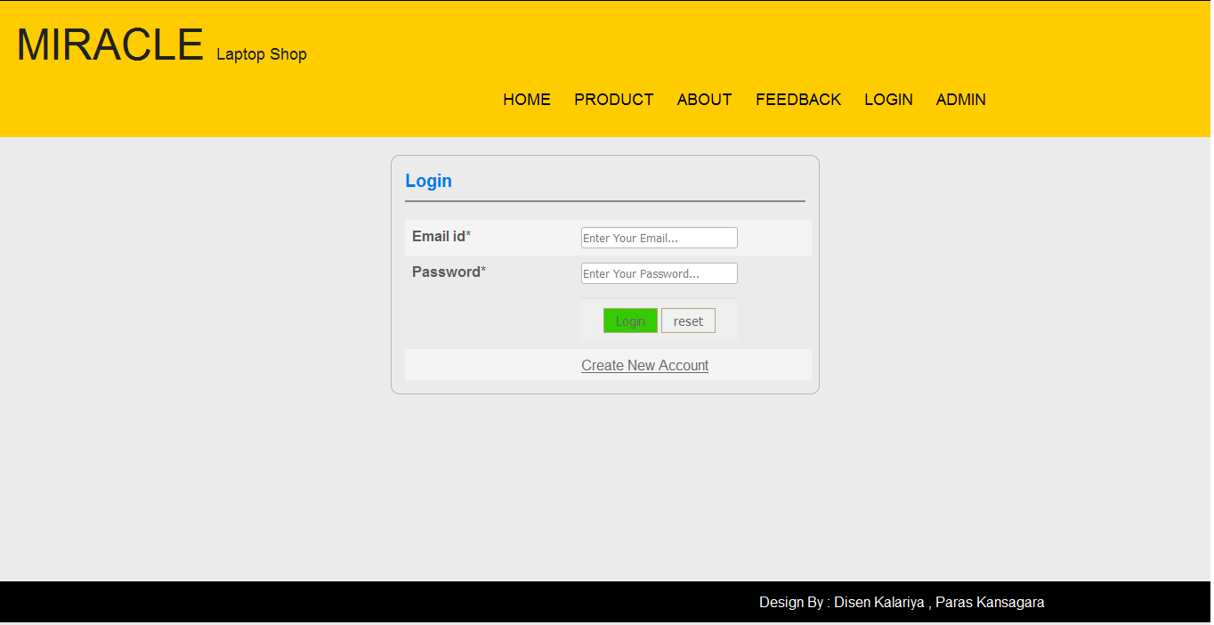

* **Feedback page:**

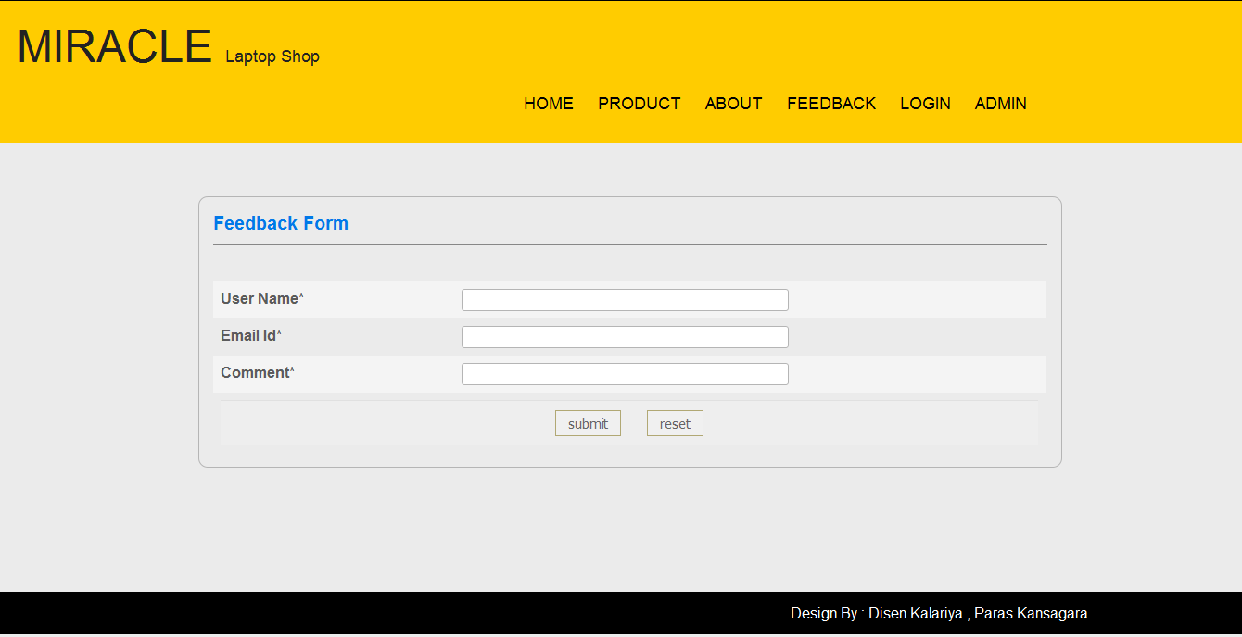

* **ProductInfo page:**

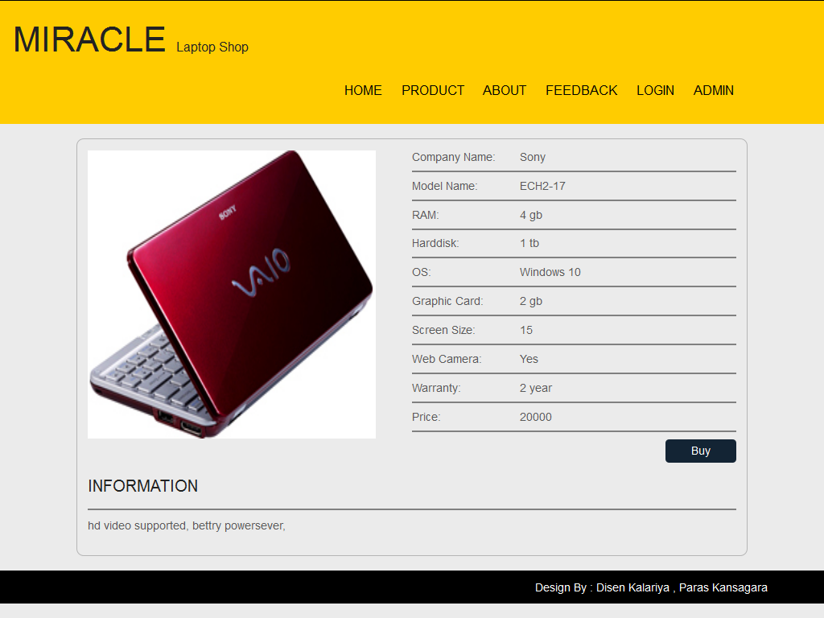

* **Buynow page:**

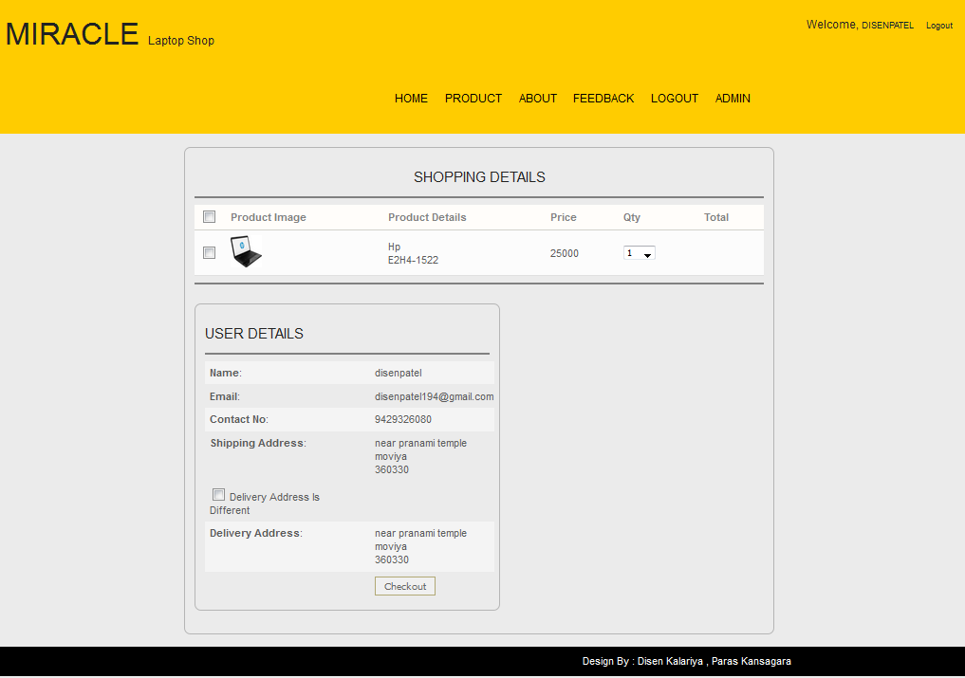

* **RegisterUser page:**

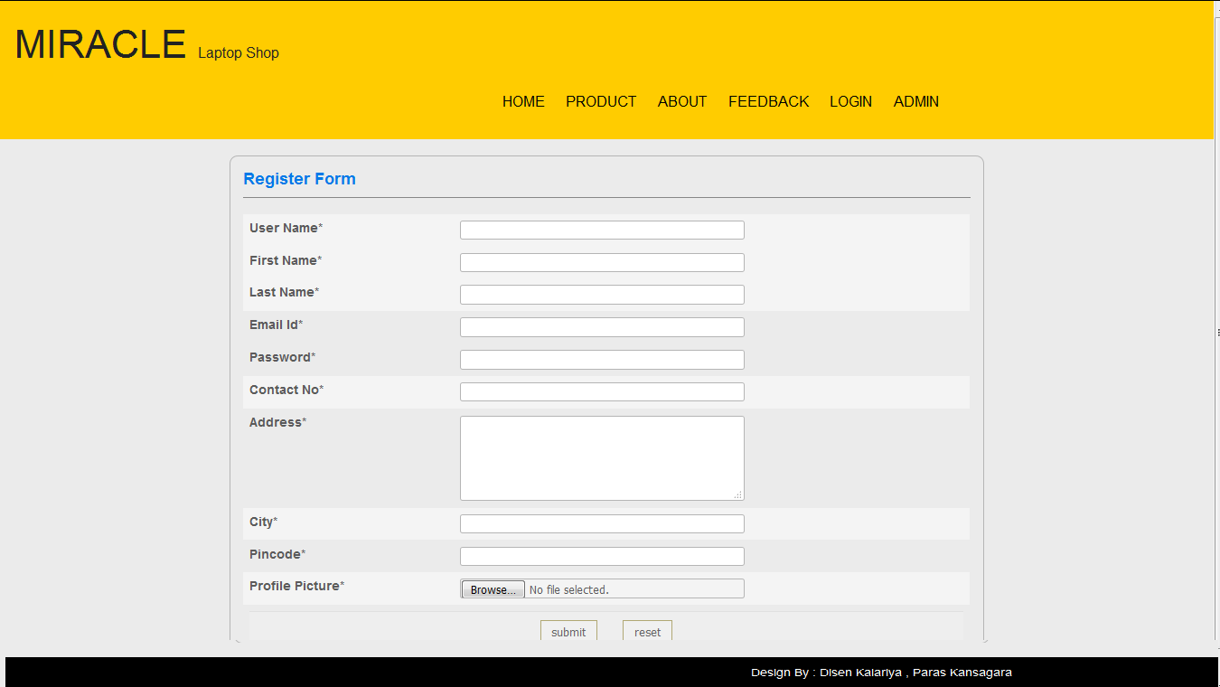

* 1. **Admin Panel:**
* **Home page:**

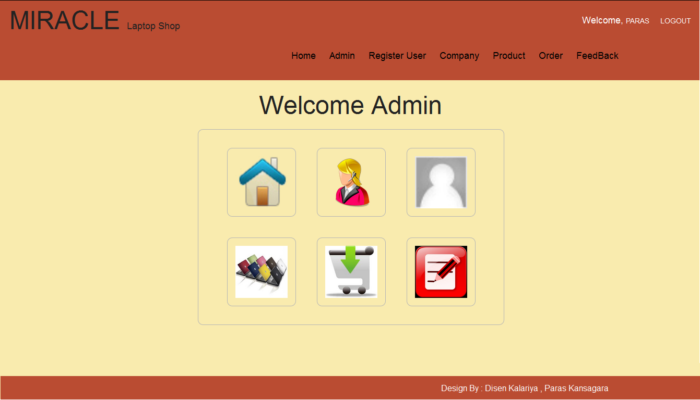

* **Registeruser page:**

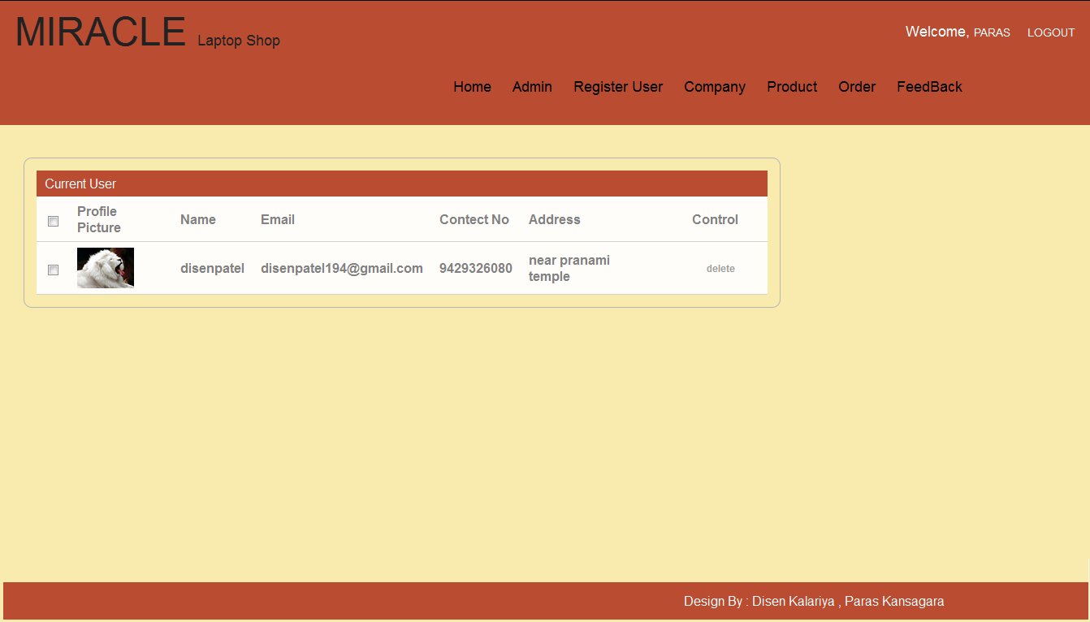

* **Company page:**

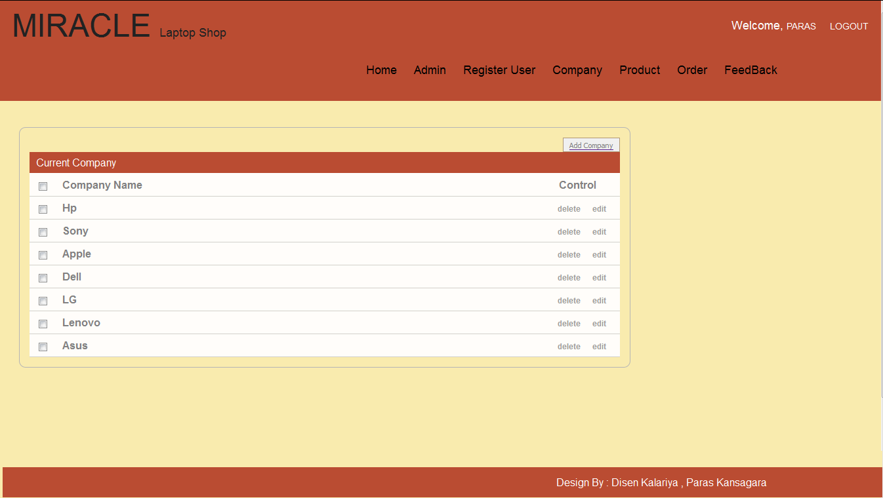

* **AddCompany page:**

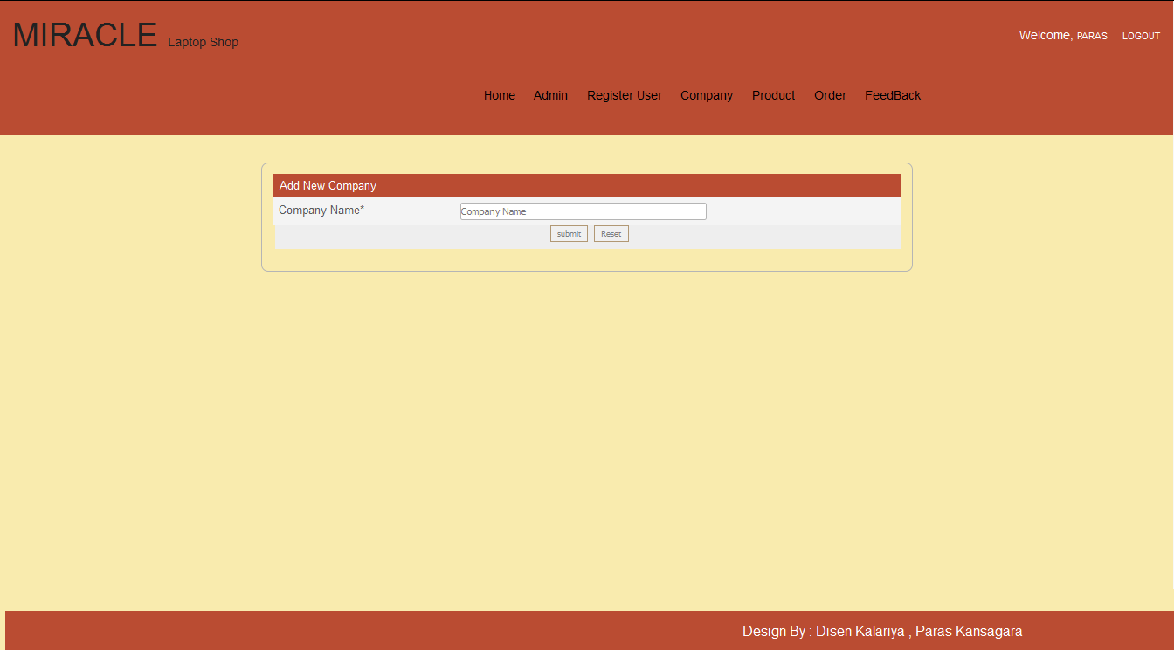

* **Product page:**

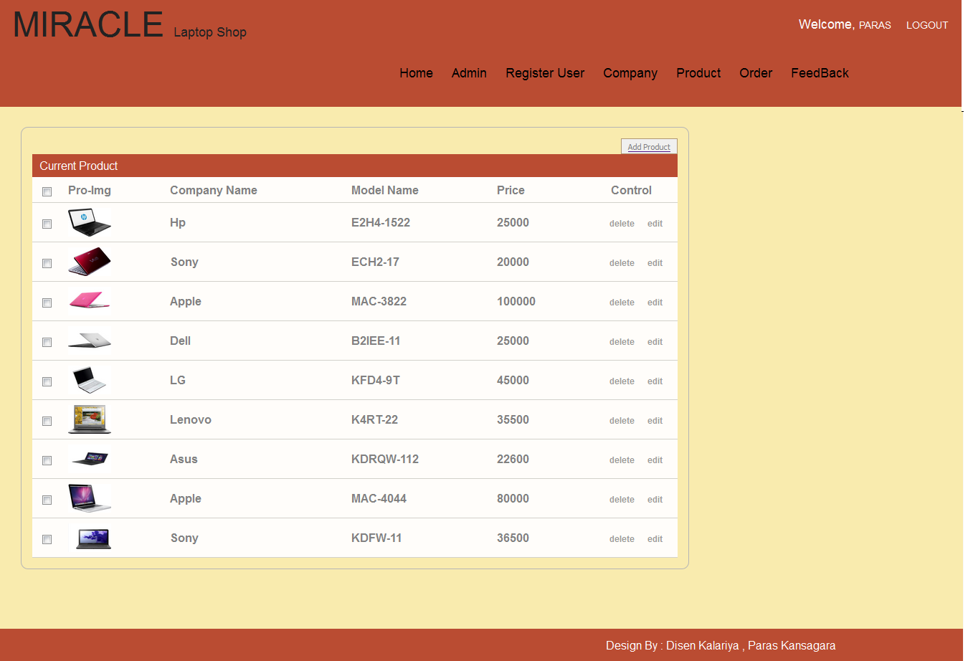

* **AddProducrt page:**

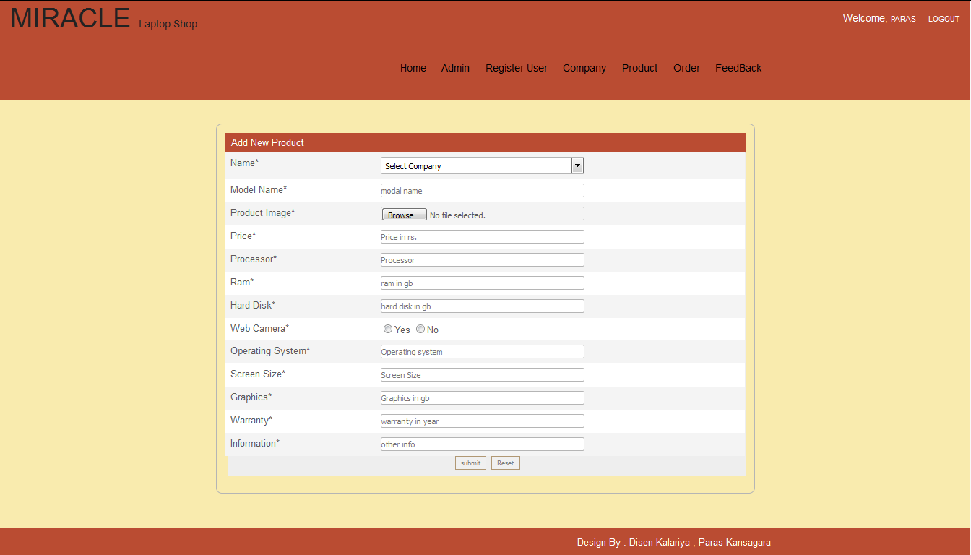

* **Order page:**

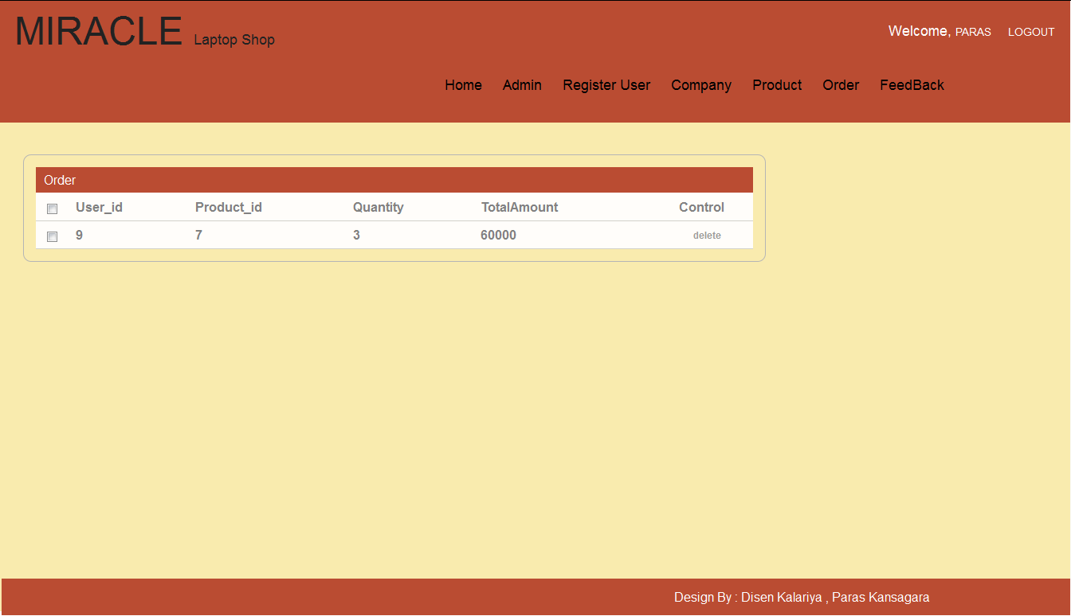

* **Feedback page:**

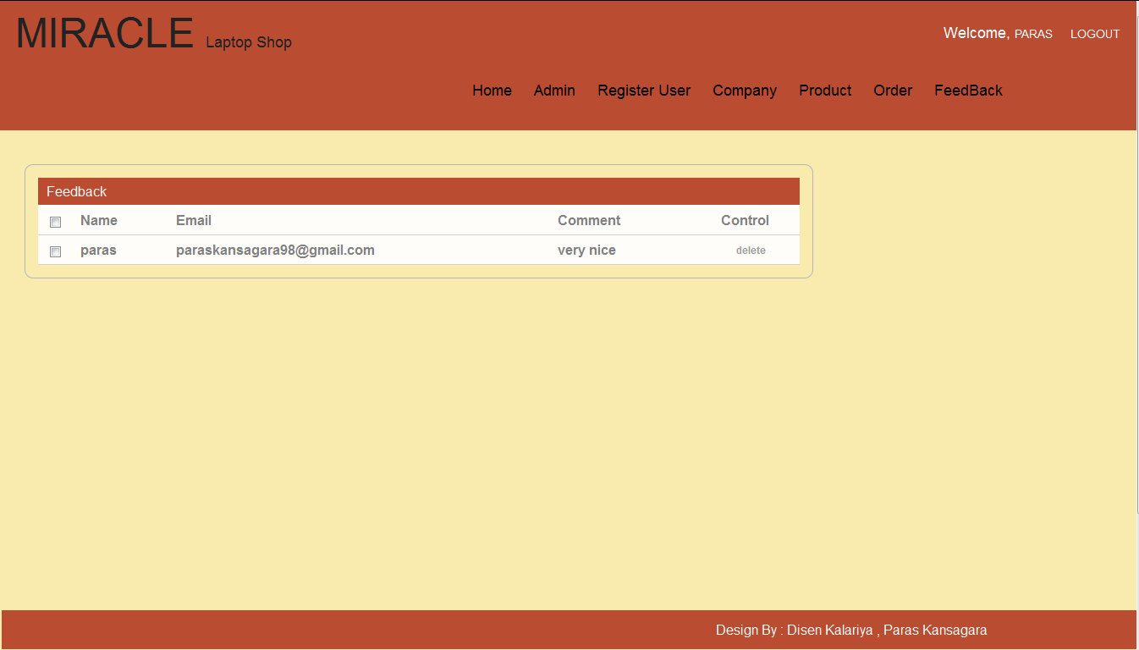

1. **Testing & Debugging** 
   * Testing Methodology
   * Unit testing
   * Test Case
   * System Testing
   1. **Testing Methodology:**

* Black-box Testing:

Black box testing is also referred as behavior testing.

It focuses on the functional requirment of the software.

Black-box testing treats the software as a “black-box” without any knowledge of internal implementation.

* Black-box tasting methods:
* Equivalense partitioning
* Model-based testing
* Specification-based testing
* Black-box testing finds the error in following categories:
  + Incorrect or missing funcation.
  + Utilization & termination error.
  + Behavior & performance error etc.
* White Box testing:
* White box testing is also known as glassbox trsting.
* It is a test case design philosophy that uses the control structure describe as part of component-level design.
* White-box testing method deals will the internal logic & structure of the code.
* In order to deal with white box technique the tester has no deal with the code hence he must have the knowledge of coding logic.
  1. **Unit Testing:**

Testing of individual software components or modules.typically done by the programmer and not by tester os it require detailed knowledge of the internal program design and code may require devloping iest driver modules or test hurness.

* 1. **Test Cases:**

|  |  |  |
| --- | --- | --- |
| Field | Value | Succesfully login |
| eid | abc |
| password | abc |

|  |  |  |
| --- | --- | --- |
| Field | Value | Unsuccesfully login |
| eid | abc |
| password | xyz |

* 1. **System Testing:**

Entire system is tested as per the requirements black-box type testing that is based on overall requirements specification covers all combined parts of a system.

1. **Conclusion** 
   * Work Experience
   * Future Enhancement
   * Bibliography
   1. **Work Experience:**

* The past two months have proved to be a great learning experience and have made us aware of the hardships an organization has to deal with while building a software project.
* We also came across various methods and conventions that an organization follows in order to develop a project.
* Our project guide was always eager to lend a helping hand during the course of developing our project but made sure that we try solving our difficulties by ourselves first and then only ask him for his help thereby made us self-reliant.
* He also made sure that we understood every single aspect of the project. We would conclude this by saying that we gained a lot from this training and this knowledge surely will help us in the coming future.
  1. **Future Enhancement:**
* The system that was to be built in the organization need to have some creative concept that can help the user in the real manner and the next important thing is that it should give the most interactive and automated solution to the user.
* As the prior application were not providing the userinteraction,the new application should be created for the intranet website and mobile device so that user can access the application efficiently.
* The new application also gives the user the liberty to know and use the application from the web through the web modules which gives complete information of the application.
  1. **Bibliography:**
* www.W3school.com site in use to project help.