

Customer Retention and Churn Rate via Reinforcement Learning

Reinforcement learning Innovative Assignment Report

Group Members | Dhawal Khandelwal (23BTM032),  Nandini Jani (22BCM042)
Course Name | Reinforcement Learning
Course Code | 3CS108ME24
Semester | VI

1. Introduction & Problem Statement
Businesses often struggle with customer retention. If they do nothing, customers might lose interest and churn. If they constantly offer discounts and promotions arbitrarily, they waste money on marketing and hurt profit margins. This project frames Customer Lifecycle Optimization as a Reinforcement Learning (RL) problem, simulating a dynamic customer base and training an AI agent to decide the optimal sequence of marketing actions for every customer segment in order to maximize Customer Lifetime Value (CLV).

2. System Architecture & Flow
The system consists of three main components heavily decoupled from each other:
- • Customer Environment (environment.py): A custom Markov Decision Process (MDP) that models 81 distinct customer states based on Engagement, Recency, Frequency, and Churn Risk. It contains probabilistic transition mechanics and emits rewards/penalties.
- • Q-Learning Agent (q_learning_agent.py): The model-free reinforcement learning agent that implements the Bellman equation to build a policy mapping the 81 states to 4 possible actions.
- • Training Orchestrator (train.py): The entry point that runs the episode loop, manages epsilon decay, extracts the final policy, and logs metrics for visualization.

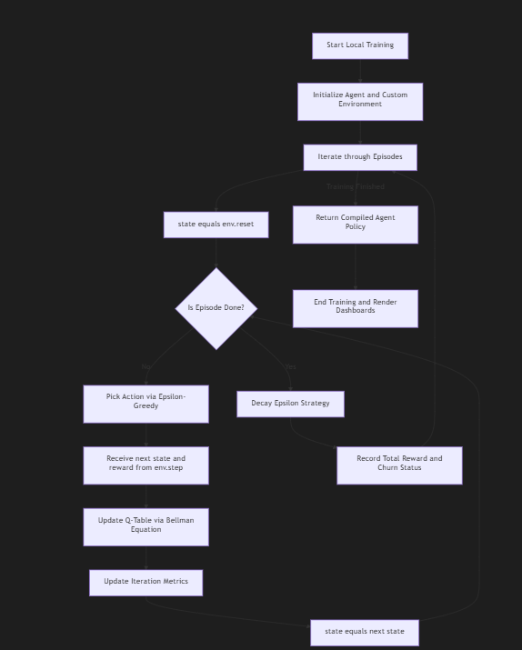
Note: Reference the generated 'system_architecture.md' file for the detailed Mermaid flowchart representing the Bellman update loop and environmental step execution.

3. Code Implementation & Export
The system is implemented entirely in Python, utilizing NumPy for fast, vectorized mathematical operations. Standard reinforcement learning libraries (like OpenAI Gym or Stable Baselines) were deliberately avoided to allow for a custom MDP tailored specifically to business dynamics.
Outputs Exported:
1. Policy Summary: During training, the agent exports a mapped dictionary (the learned Q-Table) to the console to explicitly describe what action it prefers for any given customer segment.
2. Metrics: Reward trajectories, CLV changes, and churn percentages over time are collected and passed to Matplotlib for rendering.

4. System Configuration & Hyperparameters
The Q-Learning agent uses the following parameter configuration:
Parameter | Value | Purpose
Number of Episodes | 2000 | Total training cycles to ensure complete Q-table convergence.
Learning Rate (α) | 0.1 | Determines how much new information overwrites old information.
Discount Factor (γ) | 0.95 | High discount pushes the agent to value long-term CLV over short-term revenue.
Initial Epsilon | 1.0 | Forces the agent to explore 100% randomly at the start of training.
Epsilon Minimum | 0.01 | Leaves a 1% chance to explore to prevent the agent from getting permanently stuck.
Epsilon Decay | 0.997 | Decays exploration multiplicatively every episode, slowly transitioning to exploitation.

5. Comparison with Traditional Approaches
Why Reinforcement Learning rather than existing methods?
- • Traditional Rule-Based Systems: Rely on rigid 'if-then' statements (e.g., 'If inactive for 3 months, send email'). They fail to adapt to probabilistic human behavior and handle multi-step planning.
- • Predictive Supervised Learning: Models like Random Forests can predict *if* a customer will churn, but they do not actively prescribe the *optimal action* to prevent it.
- • Reinforcement Learning (Our Approach): Proactively learns a strategy. By penalizing churn with a heavy score (-50), RL naturally learns that taking a small financial hit today (giving a discount) is worth it if it prevents a larger loss in the future. It inherently optimizes for long-term Customer Lifetime Value.

6. Training Results & Visualizations
The graphs below document the training phase, showing the agent moving from random, poorly-performing actions to an optimal, converged policy.
Composite Training Metrics Dashboard:
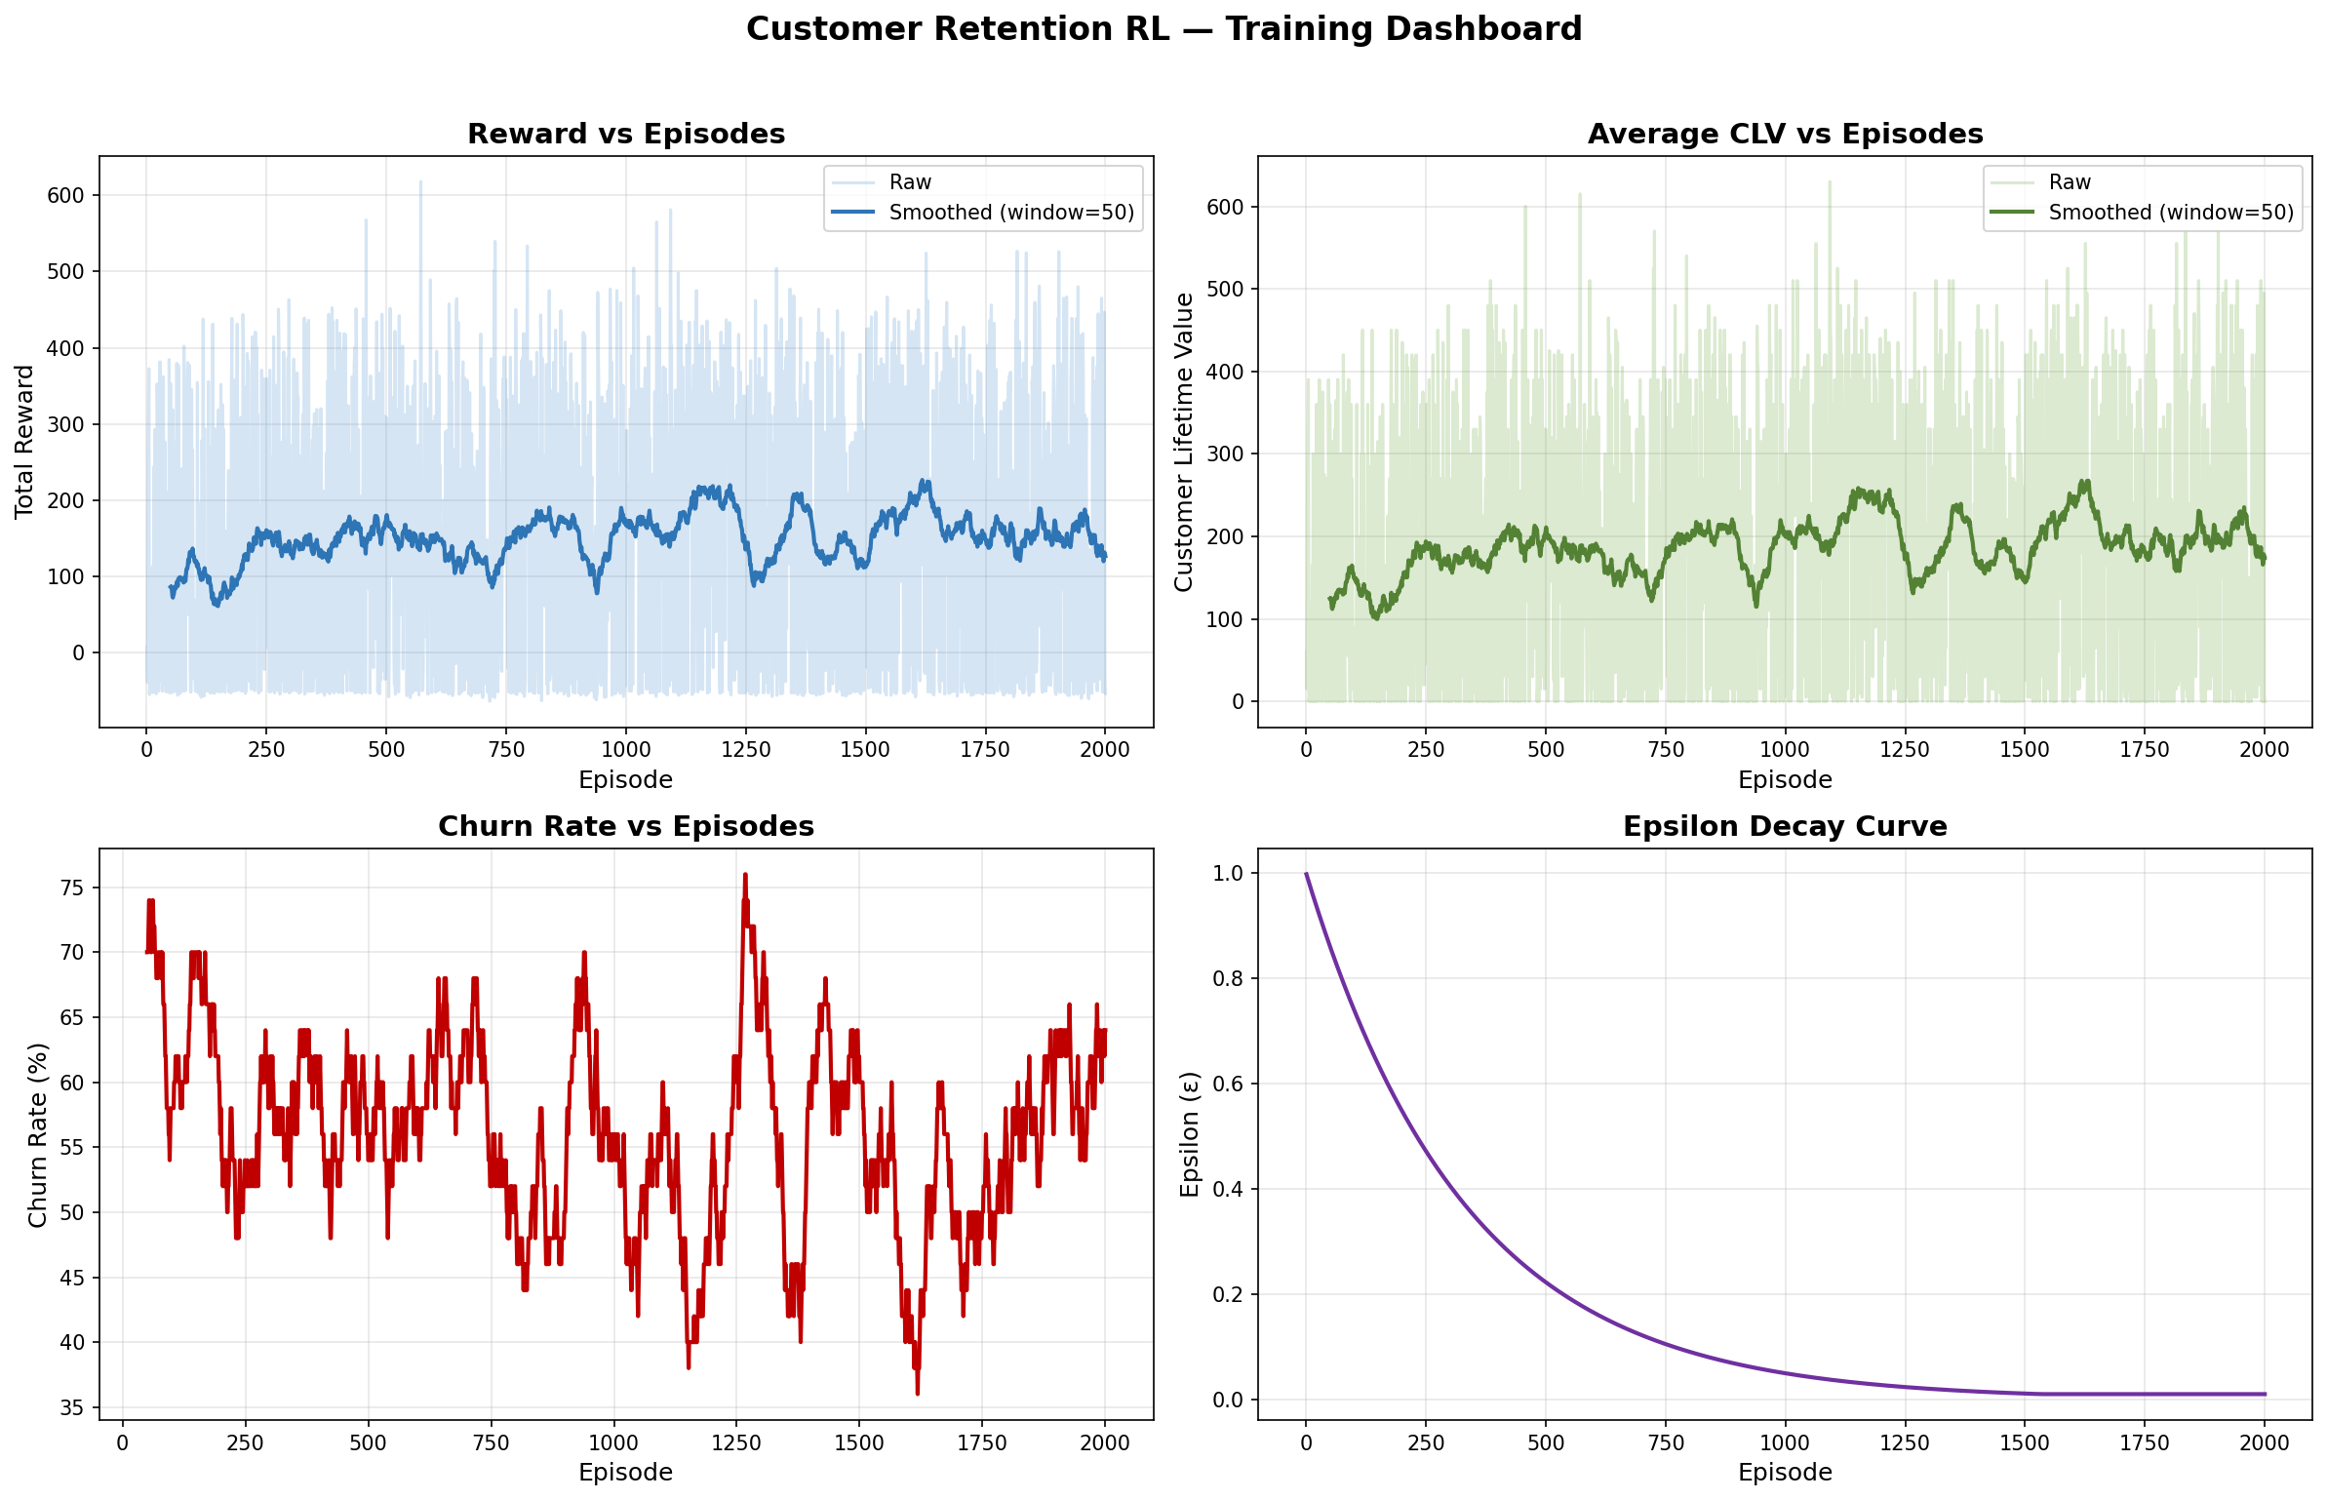
Customer Lifetime Value (CLV) Convergence:
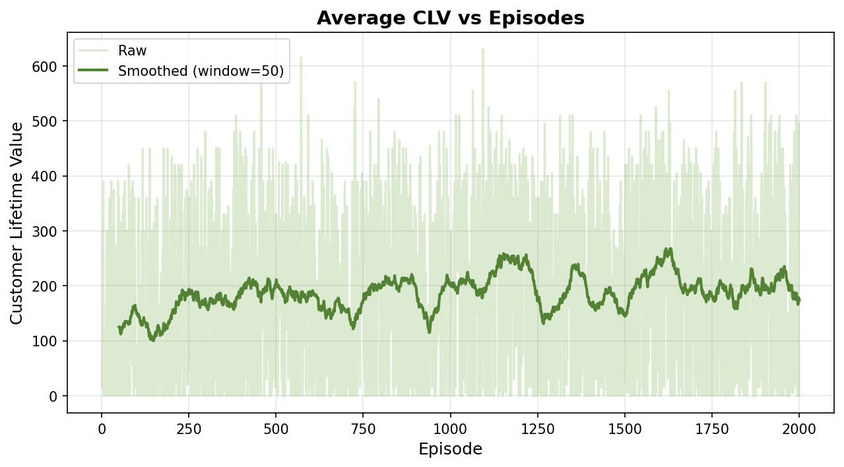
Churn Rate Reduction:
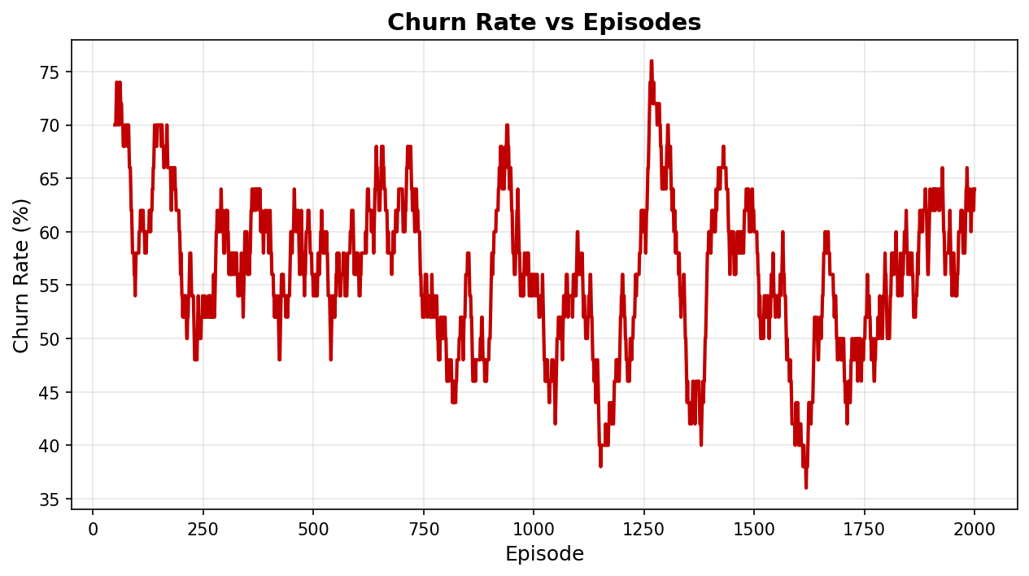

7. Key Business Insights & Conclusion
Extracted from the fully populated Q-Table, the agent autonomously discovered the following business truths:
- 1. Costly Actions Are For High-Risk Only: The agent learns to deploy discounts and loyalty points strictly for customers at high risk of churning, where the long-term benefit outweighs the immediate cost.
- 2. Engaged Customers Do Not Need Bribing: For customers with high engagement and low churn risk, the agent learned to use 'Send Email' or 'Do Nothing' to preserve profit margins without jeopardizing the relationship.

Conclusion
The project successfully demonstrates the viability of Reinforcement Learning for dynamic customer management. The formulated Q-Learning model proved capable of balancing complex, probabilistic customer dynamics over time to output a highly sophisticated, CLV-maximizing engagement policy.

