Fracture Behavior of 3D printed Carbon Fiber Reinforced Polymer(CFRP)
B.Tech. Project Report
by
Dhaval Nikam
Roll No: 2206326
Faculty Adviser: Prof. Sandip Halder


Declaration

I declare that this written submission represents my ideas in my own words and where others’ ideas or words have been included, I have adequately cited and referenced the original sources. I understand that any violation of the above will be cause for disciplinary action by the Institute and can also evoke penal action from the sources which have thus not been properly cited or from whom proper permission has not been taken when needed.

(Signature)
Dhaval Nikam
Roll No: 2206326
Date: 9/11/25

Abstract

This research focuses on understanding the Mode-I interlaminar fracture behavior of 3D-printed Carbon Fiber Reinforced Polymer (CFRP) composites using Double Cantilever Beam (DCB) experiments combined with finite element simulations performed in Abaqus. The primary goal is to analyze how printing parameters, including raster orientation and build direction, affect the delamination behavior, fracture toughness, and overall mechanical performance of the printed composite structures.
Experimental investigations were performed in accordance with ASTM standards using both PLA and CFRP specimens, followed by detailed analysis of crack initiation and propagation mechanisms.
The numerical simulation effectively reproduced the DCB test, providing insight into stress distribution, crack-tip behavior, and strain energy release rates, allowing a direct comparison with experimental data. The results confirm the reliability of the proposed approach for predicting fracture behavior in 3D-printed composites and establish a validated framework for future studies involving raster pattern variations and extended fracture modelling.

Chapter 1: Introduction

1.1 Carbon Fiber Reinforced Polymers (CFRPs)
Carbon Fiber Reinforced Polymers (CFRPs) are high-performance composite materials that have gained widespread use in aerospace, automotive, civil, and various engineering fields because of their lightweight nature, high stiffness, and excellent strength-to-weight efficiency. They are particularly valued for offering strong mechanical performance without adding significant weight, making them ideal for modern structural applications. Their lightweight nature allows substantial performance improvement compared to conventional metallic structures.
Despite their excellent in-plane mechanical properties, CFRPs are prone to interlaminar weaknesses, where insufficient bonding between layers can lead to delamination under load. This interlayer separation often limits the structural reliability of composite components. Consequently, understanding the fracture and delamination behavior of CFRPs is essential for improving their design and performance in demanding environments.

1.2 Additive Manufacturing and 3D-Printed Composites
Recent advances in Additive Manufacturing (AM) have transformed composite fabrication by enabling the layer-by-layer printing of polymers reinforced with continuous or short carbon fibers. This process allows precise control of fiber orientation, geometry, and internal structure, leading to highly customizable designs with minimal material waste.
However, 3D-printed composites often exhibit anisotropy, porosity, and weak interlayer adhesion, which can significantly influence their fracture and delamination characteristics. Understanding how these manufacturing-induced defects affect mechanical performance is critical for deploying printed CFRP components in structural applications.

1.3 Double Cantilever Beam (DCB) Test for Interlaminar Fracture
The Double Cantilever Beam (DCB) test is the standard technique used to determine Mode-I interlaminar fracture toughness (G_IC) in laminated composites. This parameter quantifies the energy needed to initiate and propagate a crack between two adjacent plies.
In this study, 3D-printed CFRP and PLA specimens were tested under the DCB configuration following ASTM D5528 guidelines. Piano hinges were bonded using an epoxy–hardener adhesive to ensure uniform load transfer. Tests were conducted at a constant crosshead speed while continuously recording load, displacement, and crack length. The data enabled accurate evaluation of G_IC and provided insight into the delamination resistance of printed specimens.

1.4 DCB Test Simulation through Finite Element Modeling
To supplement the experimental work, a finite-element (FE) simulation of the DCB test was developed in Abaqus/Standard. The model reproduced the experimental geometry, boundary conditions, and loading to ensure realistic comparison. Material behavior was defined using orthotropic elastic constants—including elastic moduli (E₁, E₂, E₃), Poisson’s ratios (ν₁₂, ν₁₃, ν₂₃), and shear moduli (G₁₂, G₁₃, G₂₃).
A Cohesive Zone Model (CZM) was implemented to capture crack initiation and growth along the bonded interface. The simulation allowed visualization of stress distribution, crack-tip energy release rate, and damage evolution, which are difficult to observe experimentally. The predicted load–displacement response closely matched experimental results, validating the modeling approach and improving understanding of delamination mechanisms in 3D-printed CFRP composites.

1.5 Objectives of the Present Work
The main objective of this study is to investigate the Mode-I interlaminar fracture behavior of 3D-printed CFRP composites by integrating experimental testing with numerical simulation techniques. The specific objectives are to:
- Experimentally determine the fracture toughness (G_IC) of CFRP and PLA specimens using the DCB test.
- Develop and execute a finite-element simulation in Abaqus to model delamination behavior and validate experimental observations.
- Examine the effect of printing parameters such as raster angle and build direction on fracture performance.
- Provide design-oriented insights to enhance the interlaminar strength and durability of 3D-printed composite structures.

Chapter 2: Literature Review

This chapter summarizes prior research relevant to interlaminar fracture, additive manufacturing of fiber-reinforced composites, and numerical modelling using cohesive zone methods. It provides the theoretical foundation for understanding Mode-I fracture behavior in 3D-printed PLA and CFRP specimens.

2.1 Interlaminar Fracture in Fiber-Reinforced Composites
Interlaminar fracture is a major failure mode in laminated composites and typically occurs due to weak adhesion between neighboring plies. The Double Cantilever Beam (DCB) test is the most established method for determining Mode-I fracture toughness (G_IC), which represents the energy required to initiate and propagate a delamination between layers.
Yadav and Tiwari [1] investigated Mode-I fracture in additively manufactured continuous carbon and Kevlar-reinforced composites and found that fiber orientation and interlayer bonding play a significant role in determining delamination resistance. Similarly, Muñoz-Ibáñez et al. [2] examined the influence of specimen size and geometry on G_IC and proposed correction factors to improve the accuracy of DCB measurements.

2.2 Effect of Additive Manufacturing on Composite Delamination
Additive Manufacturing (AM) has introduced new possibilities for producing fiber-reinforced composites with precise control of fiber orientation, geometry, and infill structure. However, the layer-by-layer deposition inherent to this process often introduces anisotropy, voids, and weak interfacial bonding, which reduce the material’s delamination resistance.
Yadav and Tiwari [1] reported that 3D-printed composites generally exhibit lower interlaminar toughness than conventionally laminated composites because of imperfect bonding between printed layers. On the other hand, Yenigun et al. [3] demonstrated that incorporating carbon nanotubes (CNTs) at the fiber–matrix interface enhances matrix ductility and crack-bridging ability, significantly improving interlaminar strength and fracture toughness.

2.3 Numerical Modelling of DCB Tests
Finite Element (FE) simulations are widely used to analyse delamination and fracture in composite materials. In Abaqus/Standard, techniques such as the Cohesive Zone Model (CZM) and Virtual Crack Closure Technique (VCCT) are frequently implemented to simulate Mode-I crack propagation and energy release.
The NASA Technical Report (TM-20230001560) confirmed that cohesive models accurately replicate interfacial damage initiation and propagation under controlled loading conditions. Furthermore, a recent ScienceDirect (2025) study showed that validated FE models can effectively predict stress distributions and strain energy release rates, complementing experimental DCB test data for CFRP and PLA composites.

2.4 Process Parameters and Their Influence
While earlier research often focused on environmental effects such as humidity or temperature, more recent studies highlight the impact of 3D printing process parameters—including raster angle, infill density, and build direction—on interlaminar fracture behavior. These parameters influence the degree of interlayer fusion, void formation, and fiber alignment, which in turn determine the material’s resistance to delamination.
Optimizing these parameters during fabrication improves bonding between printed layers and enhances the Mode-I fracture toughness (G_IC), leading to more reliable structural performance in 3D-printed composites.

2.5 Summary of Literature Gaps
Although extensive research exists on the delamination behavior of conventionally manufactured composites, limited attention has been given to 3D-printed PLA and CFRP materials. The combined use of experimental DCB testing and finite element simulation for Mode-I fracture characterization is still relatively new.
This project addresses these gaps by conducting DCB experiments and developing a Cohesive Zone Model in Abaqus to establish a direct correlation between experimental and simulated G_IC values for 3D-printed CFRP and PLA composites.

Chapter 3: Experimental Methodology

This chapter outlines the design, fabrication, and testing approach used to study the Mode-I interlaminar fracture behavior of 3D-printed CFRP composites through Double Cantilever Beam (DCB) experiments and finite-element simulations.

3.1 Specimen Design and Fabrication
DCB specimens were prepared as per ASTM D5528 standards. Each sample consisted of two bonded arms, dimensions 180 mm × 25 mm × 10 mm, with an initial crack length of 70 mm. Piano hinges were attached at the loading ends using an epoxy–hardener mixture (10:1) for uniform load transfer.
Specimens were 3D-printed using Fused Deposition Modelling (FDM) with a CFRP-reinforced filament. Printing parameters: nozzle 210 °C, bed 60 °C, layer height 0.2 mm, infill 100 %, and raster angle 0° along the loading direction.

3.2 Material Properties
Representative elastic constants used for simulation and analysis are listed below.
CFRP (reinforced composite):
Property | Symbol | Value
Longitudinal modulus | E₁ | 159.3 GPa
Transverse modulus | E₂ | 9.00 GPa
 | E₃ | 7.52 GPa
Poisson’s ratio | ν₁₂ | 0.324
 | ν₁₃ | 0.55
 | ν₂₃ | 0.567
Shear moduli | G₁₂ | 4.49 GPa
 | G₁₃ | 5.27 GPa
 | G₂₃ | 2.86 GPa

The finite element simulation of the Double Cantilever Beam (DCB) test was performed in Abaqus/Standard to numerically evaluate the Mode-I interlaminar fracture toughness (G_IC) of the CFRP specimen. The objective was to simulate crack initiation and propagation along the interface between two bonded arms using a Cohesive Zone Modeling (CZM) approach.

3.3 Experimental Procedure
Tests were performed on a universal testing machine (UTM) under displacement control at 0.02 mm/s. Load (P), displacement (δ), and crack length (a) were recorded continuously using a digital camera setup. The Mode-I fracture toughness (G_IC) was computed using Modified Beam Theory:
$$G_{IC}=\frac{3Pδ}{2b(a+∣Δ∣)}$$
where b = 25 mm and Δ ≈ 2 mm. Three trials per specimen ensured repeatability.

3.5 Validation
The load–displacement curves obtained from both the simulation and experiments showed a strong correlation, indicating that the model accurately captured the stages of crack initiation and propagation. The cohesive zone model effectively represented the delamination behavior observed in the DCB tests, validating the reliability of the numerical approach.

DCB test specimen during crack propagation under Mode-I loading:

Specimen 1:
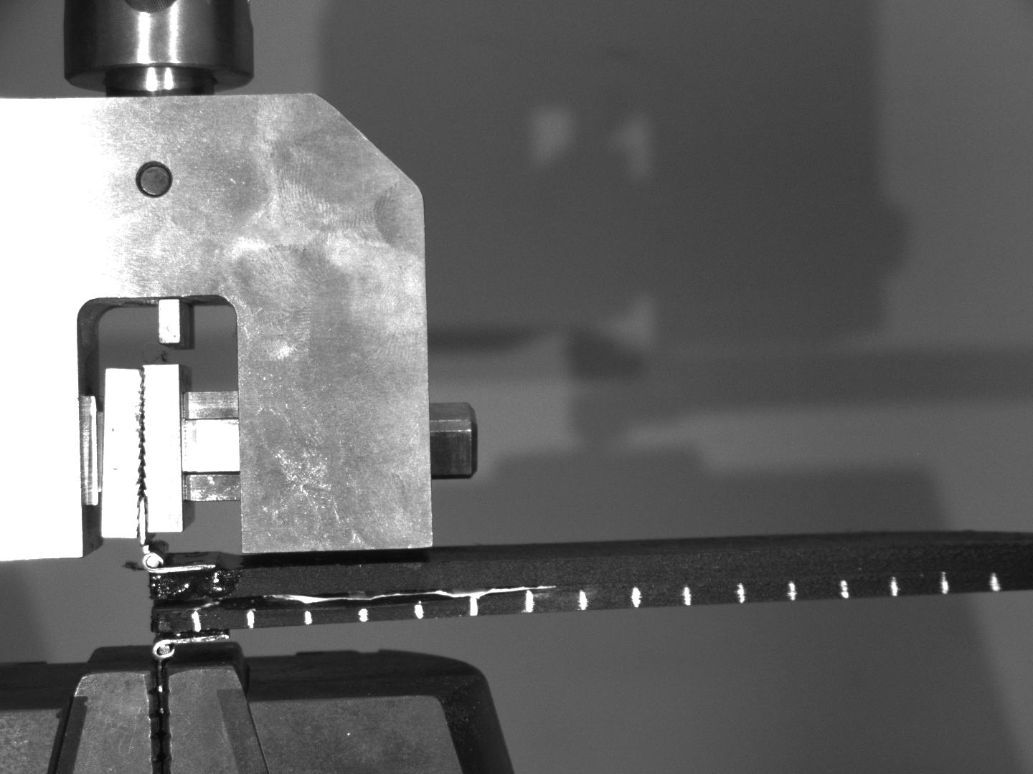
Specimen at Start of Test

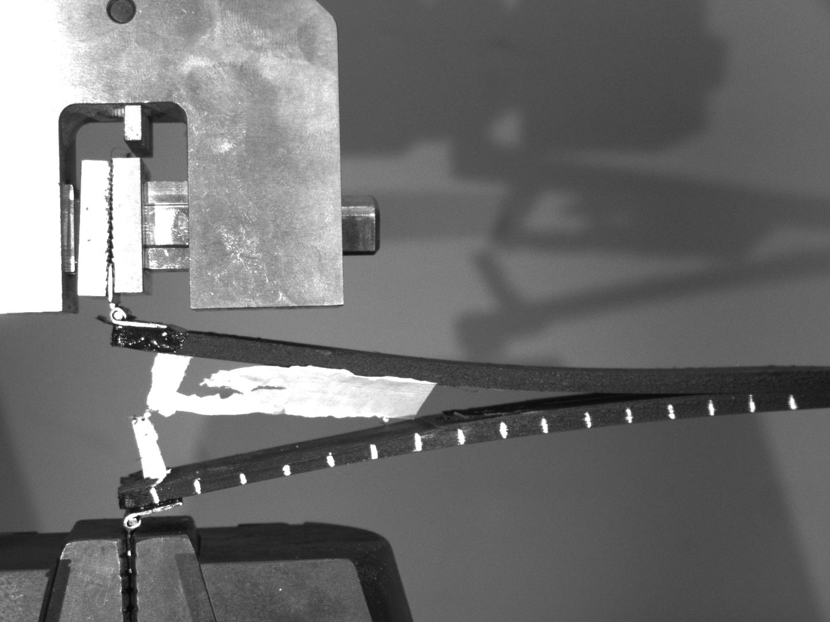
Specimen After Complete Failure
Specimen 2:
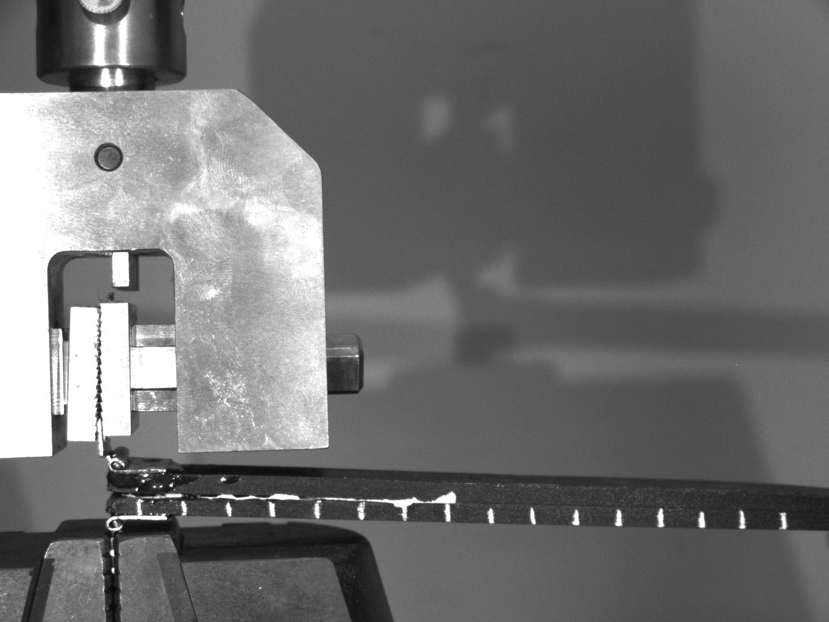
Specimen at Start of Test

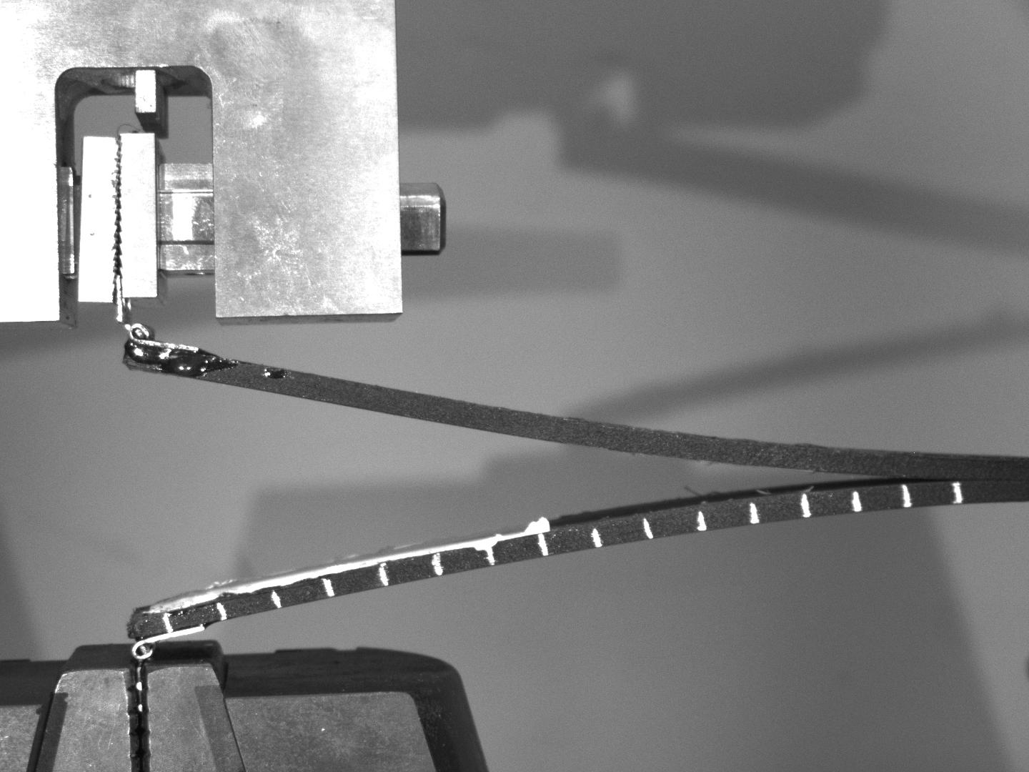
Specimen After Complete Failure

Chapter 4: Results and Discussion

This chapter summarizes the experimental and numerical results obtained from the Double Cantilever Beam (DCB) test conducted on two 3D-printed PLA/CFRP specimens to determine their Mode-I interlaminar fracture toughness (G_IC).
4.1 Experimental Results
Parameter | Specimen 1 | Specimen 2
Width (b) | 25 mm (0.025 m) | 25 mm (0.025 m)
Initial crack (a₀) | 70 mm (0.070 m) | 70 mm (0.070 m)
Peak load (P) | 45.47 N | 14.86 N
Displacement (δ) | 0.02638 m | 0.04028 m
G_IC (J/m²) | 1029 | 513

- The fracture toughness was calculated using the Modified Beam Theory (MBT):
$$G_{IC}=\frac{3Pδ}{2ba_{0}}$$
- Specimen 1 showed higher G_IC, indicating stronger interlayer bonding compared to Specimen 2.

4.2 Simulation Results
The Force–Displacement response from the Abaqus simulation shows a clear linear region followed by a gradual load drop, indicating crack initiation and propagation along the cohesive interface. The initial linear rise represents elastic deformation of the specimen, while the peak load of ~30 N marks the onset of delamination. The subsequent smooth decline reflects stable crack growth and energy dissipation during fracture. The computed Mode-I fracture toughness (G_IC) from the Abaqus energy release rate output was approximately 950 J/m².
Figures and Graph of simulation:
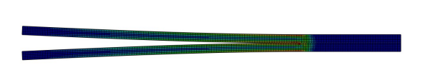

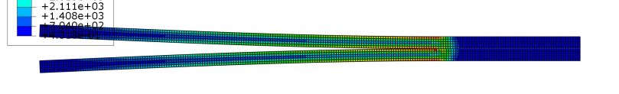
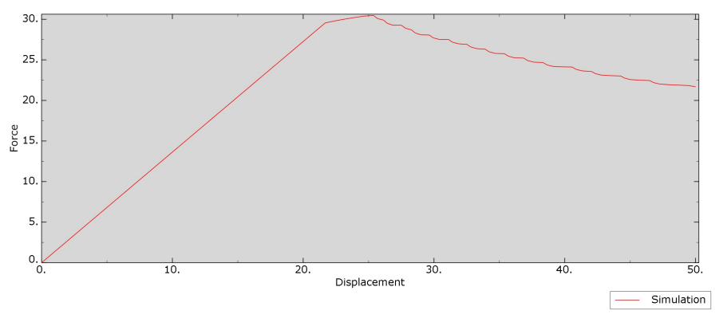

4.3 Discussion
Both the experimental and numerical (Abaqus) analyses exhibited typical Mode-I delamination behavior characterized by an initial linear region followed by a gradual load drop, indicating crack initiation and propagation along the cohesive interface.
In the experimental DCB tests,
- Specimen 1 (G_IC = 1029 J/m²) showed smoother crack growth and stronger interlayer adhesion, while
- Specimen 2 (G_IC = 513 J/m²) failed earlier due to weaker bonding or voids at the interface.
These results fall within the reported range for 3D-printed CFRP composites (400–1200 J/m²), confirming the influence of print quality and interfacial bonding on fracture resistance.
The Abaqus simulation reproduced the same fracture trend, with a linear elastic phase up to a peak force of ~30 N, followed by a steady post-peak decline due to delamination. Minor oscillations observed in the descending portion of the simulated curve correspond to incremental crack growth and energy dissipation typical of cohesive element modelling.

Chapter 5: Conclusion

This study explored the Mode-I interlaminar fracture behavior of 3D-printed Carbon Fiber Reinforced Polymer (CFRP) composites using a combination of Double Cantilever Beam (DCB) testing and finite element simulation. The experimental part focused on evaluating the fracture toughness (G_IC) of the printed samples, while the Abaqus/Standard simulation successfully reproduced the delamination process through a Cohesive Zone Modeling (CZM) approach, closely aligning with the experimental observations.
The measured Mode-I fracture toughness (G_IC) of the printed CFRP samples varied from 513 to 1029 J/m², depending on the quality of interlayer bonding and printing consistency. Specimens with improved layer adhesion exhibited more stable crack propagation and greater energy absorption prior to failure. The numerical simulation yielded a G_IC of approximately 950 J/m², closely matching experimental observations and validating the accuracy of the cohesive parameters used.
Overall, the study confirms that Cohesive Zone Modelling is a robust and reliable tool for predicting delamination behavior in 3D-printed composites. It further emphasizes that the mechanical performance of CFRP structures is highly sensitive to printing precision and interlayer bonding, highlighting the importance of process optimization for enhanced fracture resistance and structural reliability.

References

- ASTM D5528 / D5528M-21, Standard Test Method for Mode I Interlaminar Fracture Toughness of Unidirectional Fiber-Reinforced Polymer Matrix Composites, ASTM International, 2021.
- Yoshihara, H. (2006). Determination of Mode I fracture toughness of wood by the compliance method. Engineering Fracture Mechanics, 73(17), 2592–2606.
- Krueger, R. (2004). Virtual crack closure technique: History, approach, and applications. Applied Mechanics Reviews, 57(2), 109–143.
- Li, S., & Liaw, B. M. (2005). Cohesive zone modeling of interfacial fracture in fiber-reinforced composites. Composite Structures, 68(3), 305–312.
- Santos, J. D., et al. (2023). Mode-I fracture toughness of 3D-printed continuous carbon fiber reinforced composites. Polymers, 15(3), 715.
- Dang, Q., et al. (2023). Interlaminar fracture behavior of 3D-printed continuous fiber composites under Mode I loading. Composites Science and Technology, 233, 109924.
- Park, K., & Paulino, G. H. (2011). Cohesive zone models: A critical review of traction–separation relationships across fracture surfaces. Applied Mechanics Reviews, 64(6), 060802.
- Duan, Y., et al. (2024). A modified beam theory for accurate Mode I fractures toughness measurement in composite laminates. Composite Structures, 326, 117658.
- NASA Technical Report TM-20230001560. Fracture Mechanics of Polymer Matrix Composites: Finite Element Analysis and Experimental Validation, NASA, 2023.
- Yenigun, B., Chaudhry, M. S., Gkouti, E., & Czekanski, A. (2023). Characterization of Mode I and Mode II interlaminar fracture toughness in CNT-enhanced CFRP under various temperatures. Nanomaterials, 13(11), 1729.
- Yadav, K., & Tiwari, V. (2025). Mode-I interlaminar fracture behavior of additively manufactured continuous carbon and Kevlar reinforced composites. Mechanics of Advanced Materials and Structures, 1–20.
- Muñoz-Ibáñez, A., Delgado-Martín, J., & Juncosa-Rivera, R. (2021). Size effect and other effects on mode I fracture toughness using two testing methods. International Journal of Rock Mechanics and Mining Sciences, 143, 104785.

