**Practical - 1**

**Aim:** LED blink application

Interface LED with ESP8266 and code it to blink LED to indicate output of some computation process.

**Components:** LED, ESP 8266

**Procedure:**

* Connections for ESP8266:

LED’s -Ve to GND

LED’s +Ve to D7

* Code:

void setup() {

pinMode(D7, OUTPUT);

}

void loop() {

digitalWrite(D7, LOW); // LED is Off

delay(1000); // execution stops for 1 second

digitalWrite(D7, HIGH); // LED is On

delay(2000); // execution stops for 2 second

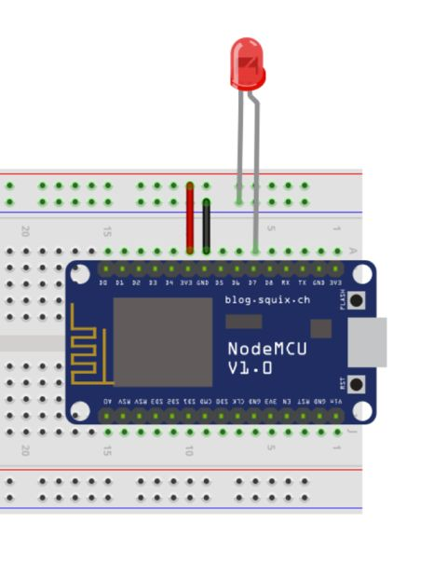}

* Implementation in diagram