**Practical - 6**

**Aim:**  Car reverse parking sensor

Develop reverse parking sensor for cars where if a obstacle is less than 10 meters, the LED/buzzer blinks. As distance to object decreases, frequency of blinking increases

**Components:** LED, Ultrasonic Sensor, 5V input power (Arduino board), Jumper wires, ESP 8266 NodeMCU

**Procedure:**

* 5V Power Supply to work with Ultra Sonic Sensor
* Note that Ultra Sonic sensor works well with 5v power supply. We used Arduino board to provide power supply to sensor
* Connections for ESP8266:

Sensor’s -Ve to GND

Sensor’s Triger pin to D1

Sensor’s Echo pin to D2

* Connections for Arduino board:

Sensor’s +Ve to 5V pin

* Implementation diagram

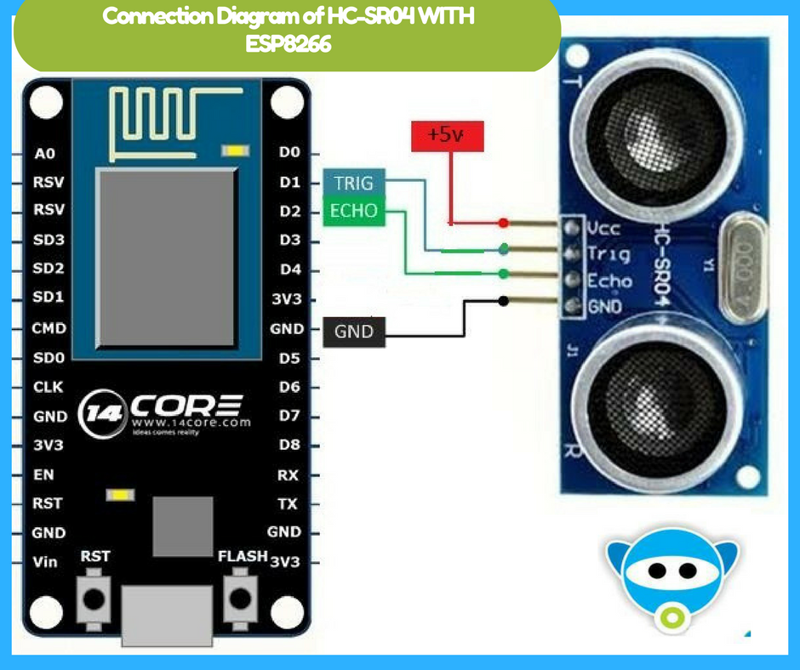

* Code:

In void loop() we provide distance of the echo received as blinking delay timing of the LED.

Using delay(10*distance) the led blinks according to the distance between sensor and obstacle.

Below code is used for measuring the distance

long duration, distance;

digitalWrite(TRIGGER, LOW); // The trigger pin is D1

delayMicroseconds(2);

digitalWrite(TRIGGER, HIGH);

delayMicroseconds(10);

digitalWrite(TRIGGER, LOW);

duration = pulseIn(ECHO, HIGH); // The echo pin is D2

distance = (duration/2) / 29.1; // due to speed of sound we use this formula

Now the duration is used for delay in blinking of led