**Practical - 7**

**Aim:**  Upload Temperature and Humidity Sensor Data to cloud platform

Use appropriate sensors to collect the temperature and humidity data and upload the same to selected cloud platform. Ensure that the data is stored in some standard format.

**Components:** LED, Temperature and Humidity sensor DHT11, Jumper wires, ESP 8266 NodeMCU

**Procedure:**

* Account on ThingSpeak:
* Firstly, we create account on <https://thingspeak.com/> so that we can put our sensor data on cloud.
* Create new channel and add two fields one for temperature and second for humidity sensor and then save the channel
* Now on the newly created channel go to the API keys and note down the api key through which we will access the cloud.
* Update method is used to upload sensor data on cloud.
* Connections for ESP8266:

Sensor’s -Ve to GND

Sensor’s +Ve to 3v3

Sensor’s output to D7 (pin 13)

* Output on thingspeak dashbaord

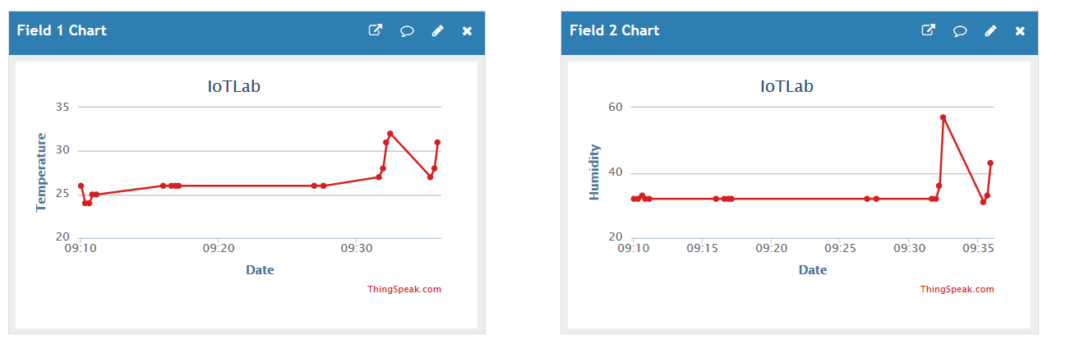

* Code:

We read humidity and temperature data from sensor and then we run update query so that the sensor data is updated on cloud.

client.print("GET https://api.thingspeak.com/update?api_key="+postStr);

here the putstr is API_KEY&field1=Temperature_data&field2=humidity_data

after running this above query, the data will get uploaded to cloud if there is internet connection available