**Practical - 9**

**Aim:**

Study of Contiki OS and Cooja Simulator

**Contiki OS:**

* Contiki is an open source operating system used for building complex wireless systems.
* Contiki supports fully standard IPv6 and IPv4, along with the recent low-power wireless standards: 6lowpan, RPL, CoAP.
* Contiki is designed to run on types of hardware devices that are severely constrained in memory, power, processing power, and communication bandwidth.

**Cooja Simulator:**

The below information is for how to simulate sensor motes

* Go to file->new simulator and create new simulator.
* Now, Go to Motes->Add Motes->New mote type-> select (sky mote or MicaZ mote)
* For selection of Contiki process/firmware

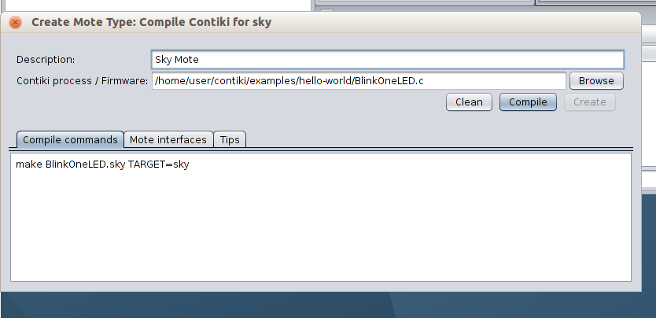we use BlinkOneLED.c file and run compile and then click on create button.

* 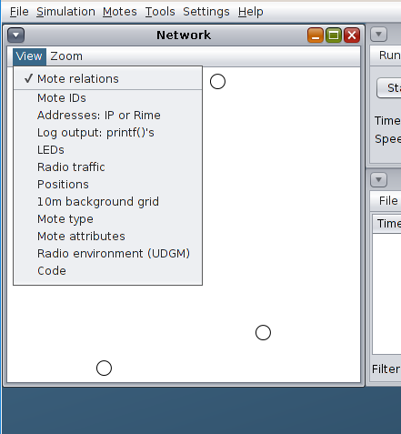There are various view options available to see how the network communicates. ( Log output, LEDs, Grid of 10m etc.)
* Here, we select the below view points and start the simulation

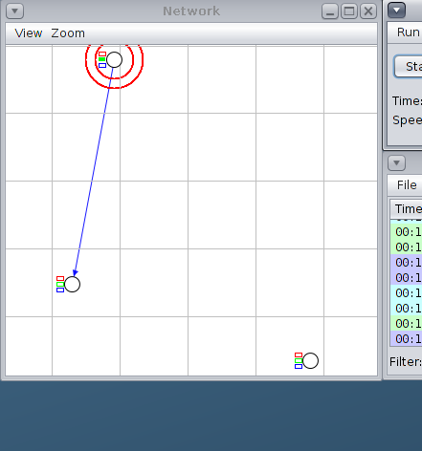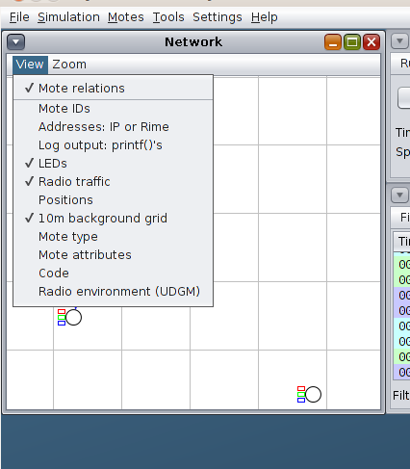

* 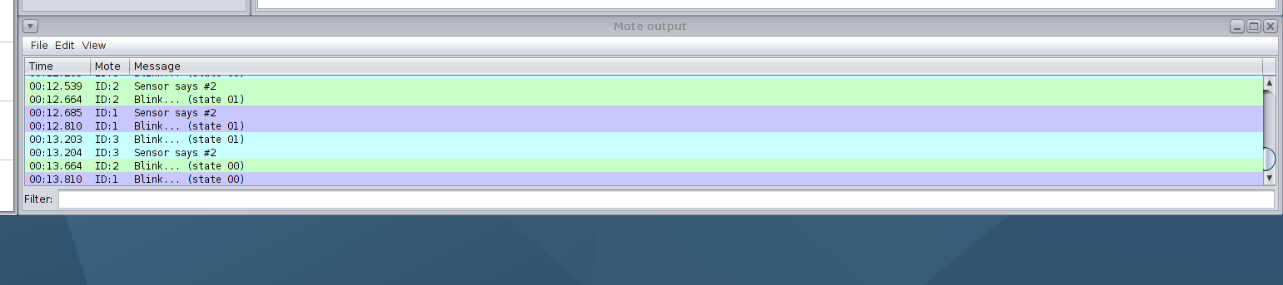The messages can be seen in output panel