**TWITTER SENTIMENT ANALYSIS**

**USING R Programming Language**

**Introduction**

From the Google search we get that Sentiment analysis is contextual mining of text which identifies and extracts subjective information in source material, and helping a business to understand the social sentiment of their brand, product or service while monitoring online conversations.

However, analysis of social media streams is usually restricted to just basic sentiment analysis and count based metrics. This is akin to just scratching the surface and missing out on those high value insights that are waiting to be discovered.

**RESULTS OF THE PROGRAM**

While running the sentiment analysis on the twitter account of Indian prime minister Narendra Modi on his recent 200 tweets these were the results

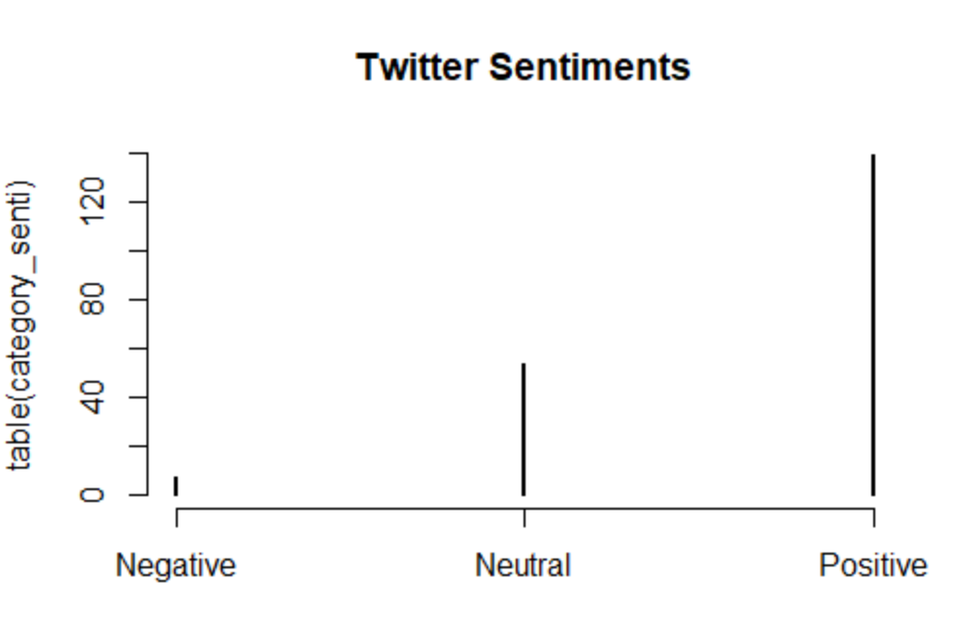

Negative Neutral Positive

7 53 139

**Analysis**

Thus we see that most of the tweets of Prime minister Narendra Modi were of positive sentiment. And the negative tweets were very less as compared to Neutral or Positive nature tweets.