QA Defect Analysis Assignment
Login / Sign-Up Testing — Paytm App
Prepared by: Dhaval Trivedi | Role: Manual / Functional Testing | Date: 17 August 2026

Q1. Five Defects Identified – Paytm Login / Sign-Up Flow
App tested: Paytm (Android), on the Login and Sign-Up screens. Each item below is written as a self-contained defect statement — what the screen does, versus what it should do.
ID | Screen / Module | Defect Statement
DEF-01 | Login – Mobile Number entry | The Mobile Number field on the Login screen accepts non-numeric characters and more than 10 digits, and does not display an inline validation error before the user taps “Send OTP”.
DEF-02 | OTP Verification (Login / Sign-Up) | The “Resend OTP” button remains enabled throughout the 30-second countdown timer, allowing the user to trigger multiple OTP requests before the original OTP expires.
DEF-03 | Login – Password / MPIN entry | The show/hide “eye” icon on the password field does not change its visual state (open vs. closed eye) after being tapped, even though the text masking itself toggles correctly, giving the user inconsistent visual feedback.
DEF-04 | Sign-Up – Create Account form | When the device is rotated to landscape orientation on certain Android phones, the “Create Account” button is pushed below the visible viewport and cannot be reached even after scrolling, blocking account creation in that orientation.
DEF-05 | Sign-Up – OTP screen | Tapping the device Back button on the OTP screen during Sign-Up navigates directly to the app’s Home/Dashboard instead of returning to the Mobile Number screen, silently discarding the in-progress sign-up.

Q2. Severity and Priority Classification
Severity measures how badly a defect damages the product or the user experience. Priority measures how urgently it needs to be fixed relative to other work in the queue. The two do not always move together, as shown below.
ID | Defect (short) | Severity | Priority | Justification
DEF-01 | 10-digit / numeric limit not enforced on mobile number | Major | High | Bad input reaches the OTP-request API; wrong OTPs are requested and users get stuck at the very first step of the funnel.
DEF-02 | “Resend OTP” active during countdown timer | Major | High | Enables OTP-request abuse, drives up SMS gateway cost, and risks tripping rate-limits for genuine users — needs a quick fix.
DEF-03 | Eye icon does not reflect show/hide state | Trivial | Low | Purely cosmetic icon-state bug; the security control (masking) itself works correctly, so there is no functional or data risk.
DEF-04 | “Create Account” button unreachable in landscape | Major | Low | Completely blocks sign-up when triggered (high severity) — but see the mismatch note below for why priority is still Low.
DEF-05 | Back button on OTP screen skips to Home, losing sign-up progress | Minor | Medium | Confusing and loses progress, but the user can simply restart sign-up, so it is inconvenient rather than blocking.
Where Severity and Priority Diverge – DEF-04
DEF-04 (Create Account button unreachable in landscape) is rated Major severity because, when it occurs, it fully blocks the core function of the screen — the user cannot complete sign-up at all. However, it is rated Low priority because the trigger condition is narrow: it only appears in landscape orientation, on a subset of Android devices, and mobile users overwhelmingly sign up in portrait mode. A simple workaround also exists — rotating back to portrait. Compare this with DEF-01 and DEF-02, which are functionally less catastrophic on their own but affect every single user on every device on the very first screen of the funnel, and therefore need to be fixed sooner (High priority) even though their severity rating is the same. This is the classic illustration that severity is about damage, while priority is about scheduling.

Q3. Bug Life Cycle Diagram
The diagram below shows how a defect moves from being logged to closure, including the three “no-fix” exit paths (Rejected, Duplicate, Not a Bug), the Deferred path for postponed fixes, and the Retest → Reopened loop when a fix does not hold.
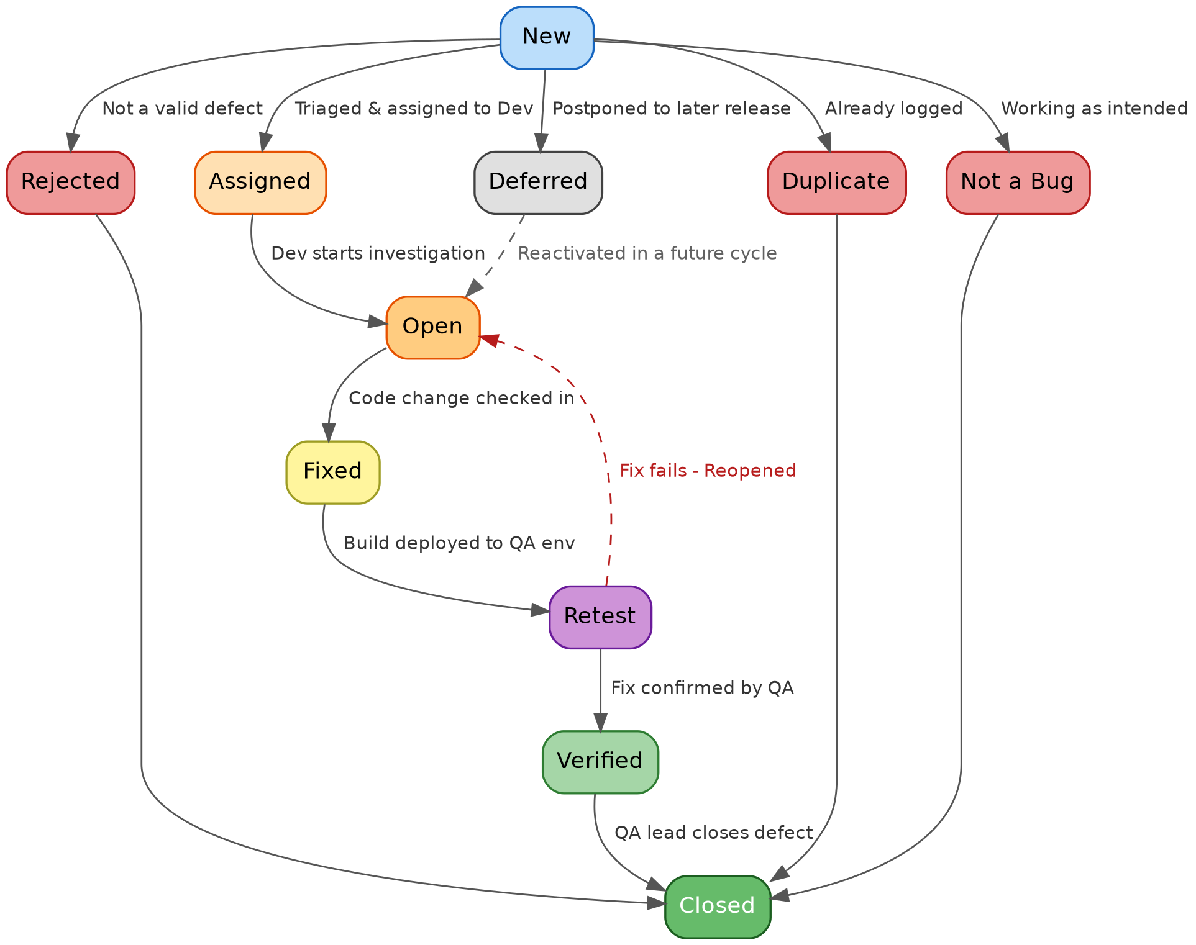
State summary:
- New → Assigned → Open → Fixed → Retest → Verified → Closed is the standard happy path.
- From New, a defect can instead be marked Rejected, Duplicate, Deferred, or Not a Bug — all of which are eventually Closed without a code fix (Deferred can also re-enter as Open in a later release).
- If Retest fails, the defect is Reopened and routed back to Open for another fix attempt.

Q4. Scenario – A UPI Defect Found After Go-Live
During a festive-sale campaign, a defect in Paytm’s UPI payment module caused the app to show “Payment Failed” to the user even when the bank had actually debited the amount and credited the merchant. Because the reconciliation check only ran once nightly, the mismatch stayed invisible until customer-support tickets and social media complaints began piling up two days after the release — by which point thousands of live transactions across real bank accounts had been affected.
Had this same defect been caught during development — say, in a functional or integration test that verified the UI status against the actual bank response — it would have been a single ticket, fixed and retested within the sprint, with zero customer impact and no money at risk. Found in production instead, it becomes a P1 incident: an emergency hotfix, manual reconciliation and refunds for every affected user, incident reports to the payment partner and possibly the regulator, and a hit to user trust in the app for handling money. The table below summarizes the difference.
Aspect | Found during Development / Testing | Found after Go-Live (Production)
Cost to fix | Low — a code change, unit test and one round of QA regression | High — hotfix, emergency release, war-room, and full regression across payment flows
Impact scope | Contained to the build in QA; no real users or real money affected | Live, real-money transactions; potentially thousands of users affected before rollback
Business impact | None visible to customers or leadership | Failed/duplicate debits, refund processing, customer complaints, App Store reviews, regulatory scrutiny (RBI/NPCI for UPI)
Trust & brand | No impact | Erodes user trust in the app for financial transactions — hard to win back

