**AIM: Learn about UI & UX with answering the following questions**

1. **What is UI & UX?**
   1. **UI:** UI refers to the screens, buttons, toggles, icons, and other visual elements that you interact with when using a website, app, or other electronic device.
   2. **UX:** UX refers to the entire interaction you have with a product, including how you feel about the interaction.
2. **Comparison of UI & UX.**

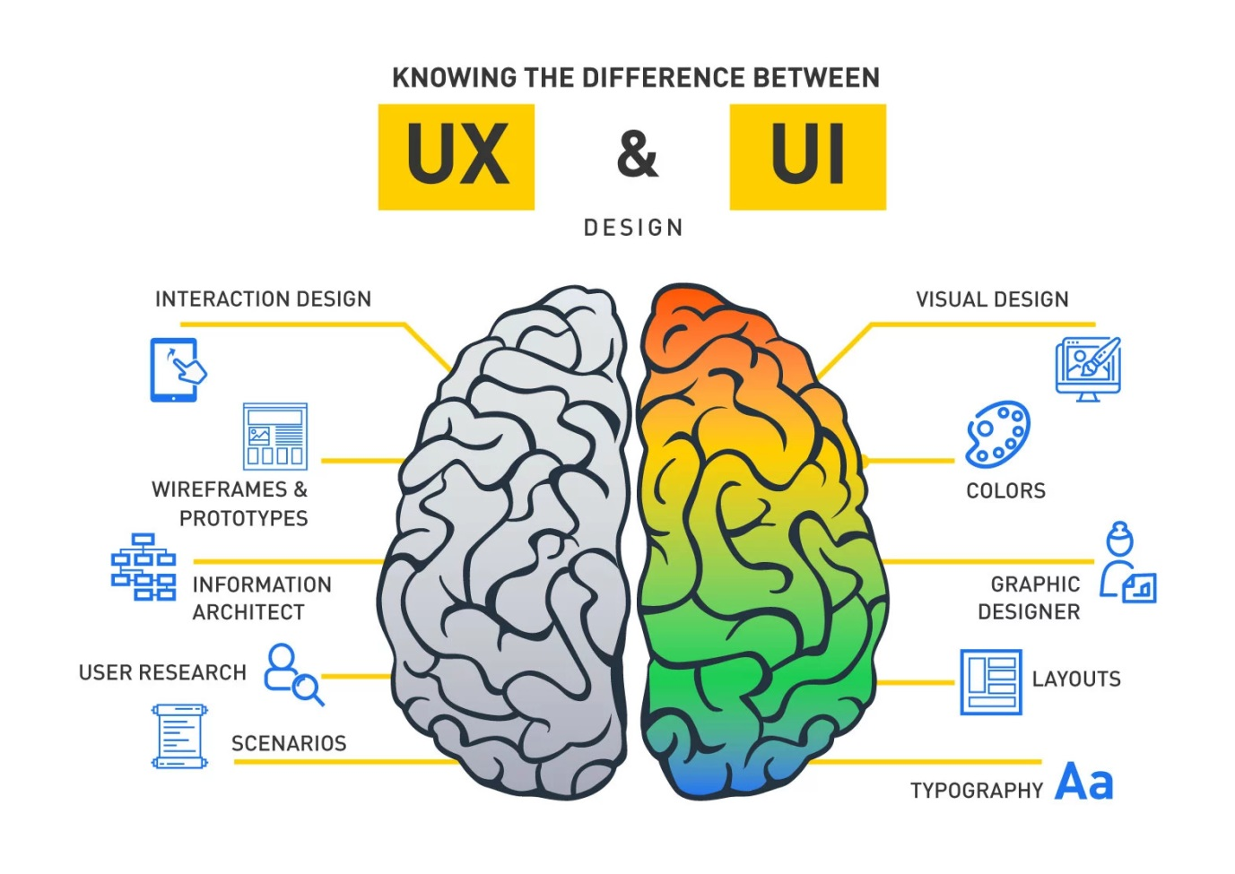

1. **List out qualities of UIUX design and demonstrate with an Example.**

|  |  |  |
| --- | --- | --- |
| **Key Points** | **Flipkart** | **Amazon** |
| * Displaying categories | **✓** | **✗** |
| * Search with options | **✗** | **✓** |
| * Image wrap in background | **✗** | **✓** |
|  |  |  |
|  |  |  |