**Project 3:- KungfuMaster**

|  |  |
| --- | --- |
| Name | Student ID |
| Siddharthkumar Patel | 104887749 |
| Dhavan Mehta | 104893409 |
| Prince Patel | 104827934 |

**Developed By:-**

**Steps to run system:-**

* extract the zip of the project which is provided.
* install intellij J IDE then click on the file tab then click on open, select the folder sourcecode->kungfu-master_services which you extracted it will open your project.
* select springbootapplication.java file then you will see a green symbol in front of the main method declaration just click it and we are done our project will start, we don't setup any server over here as tomcat is embedded in the application so it will automatically started while starting the application.
* TO run GUI part open folder sourcecode->Kungfu-Club-master.there is one kungfumaster.sql file import it in phpmyadmin.
* Copy the Kungfu-Club-master folder in www folder of wamp server.
* Activate the wamp server and type 127.0.0.1/Kungfu-Club-master in addressbar of the browser.

**UML Diagram:-**

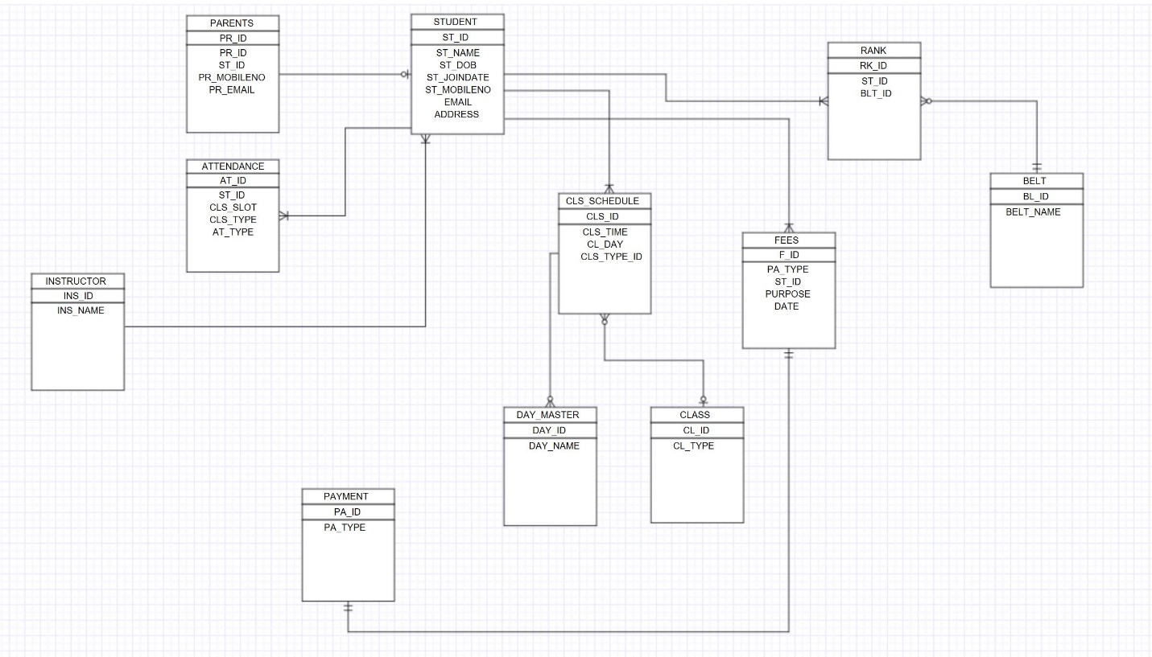

Crow’s Foot UML Diagram

**Dependency Diagram:-**

