In this web application we have two flows.

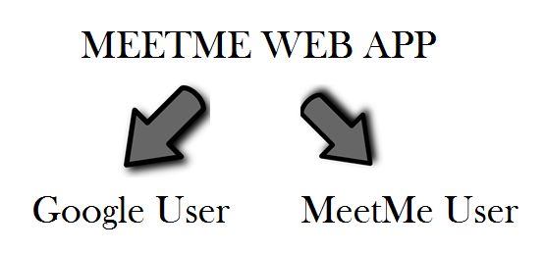

1. **Google User:-**

**Step 1:-**

Click on Sign in with Google button of homepage.

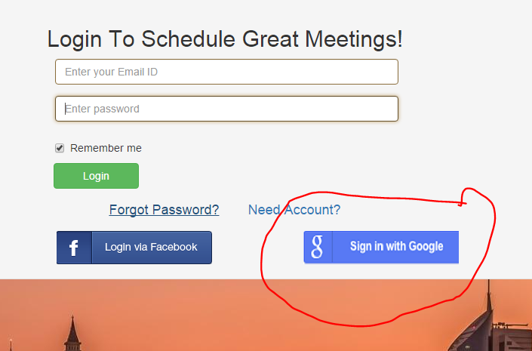

**Step 2:-**

Enter your Google email id and password.

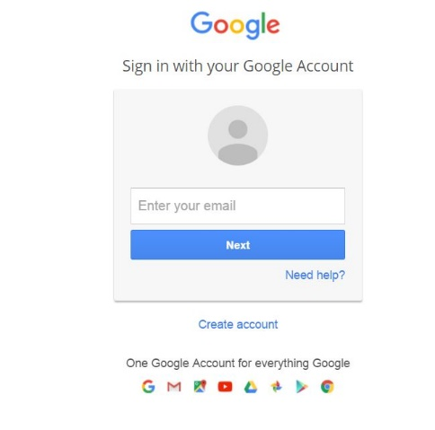

**Step 3:-**

Click on Allow to allow access to your Google Calendar

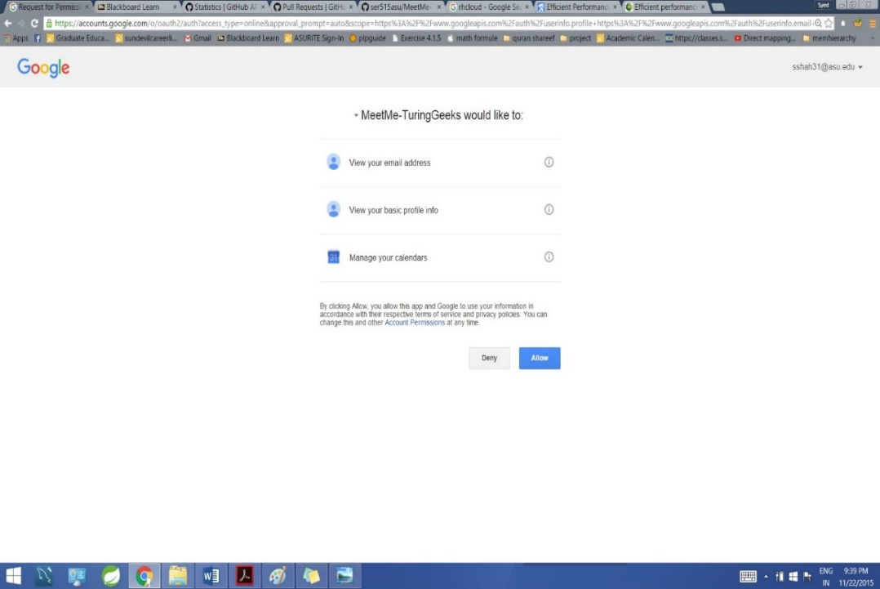

**Step 4:-**

The calendar dashboard along with the events is displayed.

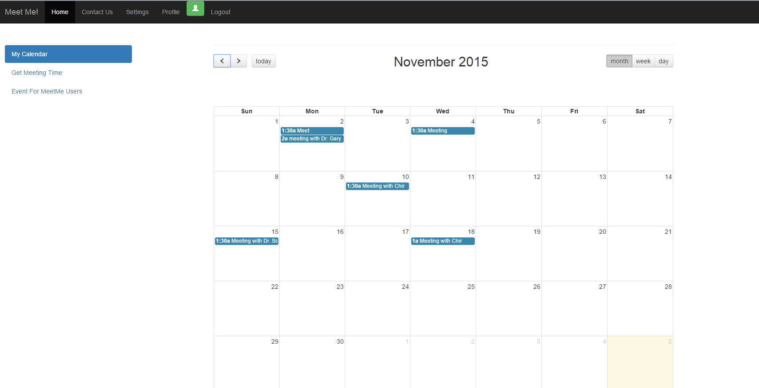

**Step 5:**

Schedule an event by clicking on event for Meetme users and then create an event.

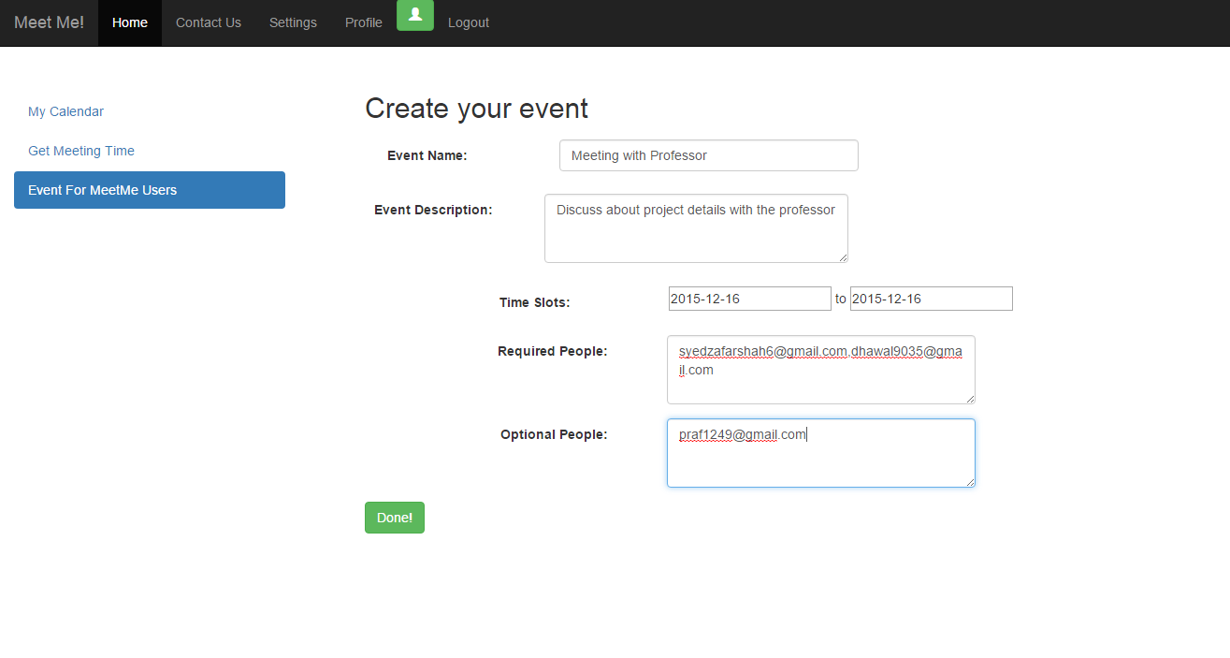

**Step 6:-**

View scheduled meetings by clicking on “Get Meeting time” 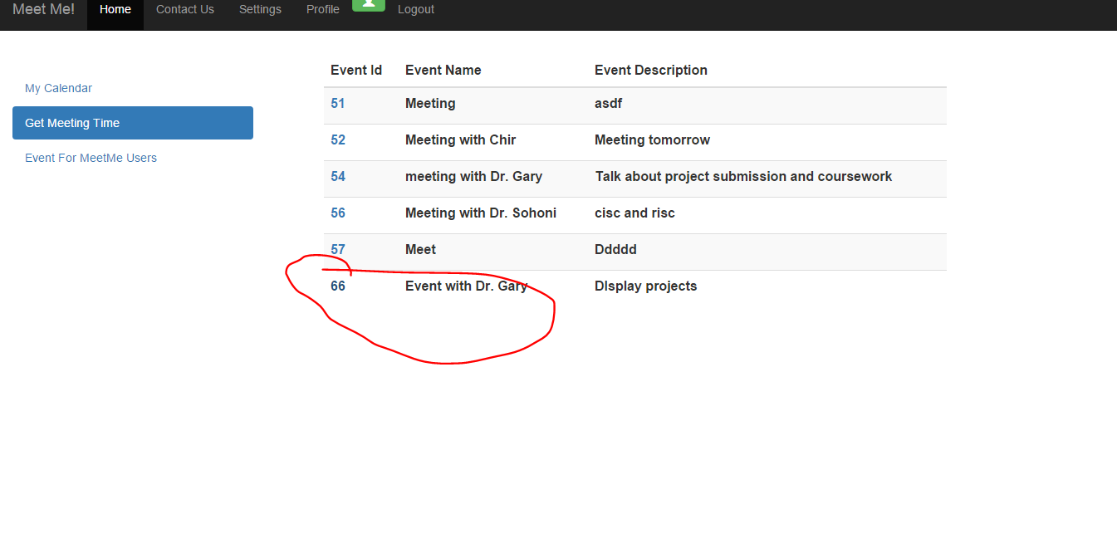

**Step 7:-**

Output at the scheduled users are seen in this way.

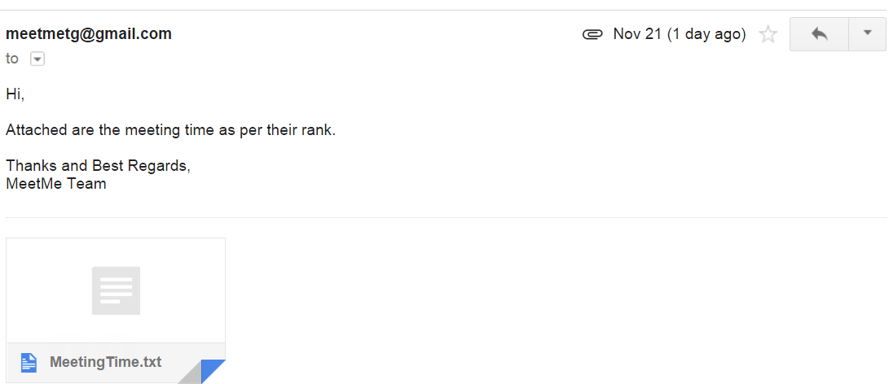

1. **MeetMe Users**

**Step 1:-**

Create an account with MeetMe by first clicking on Need Account and then entering all the details properly in the right format

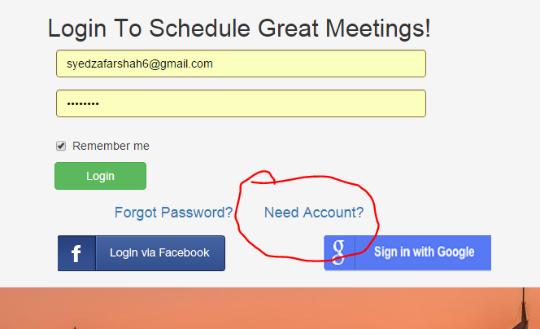

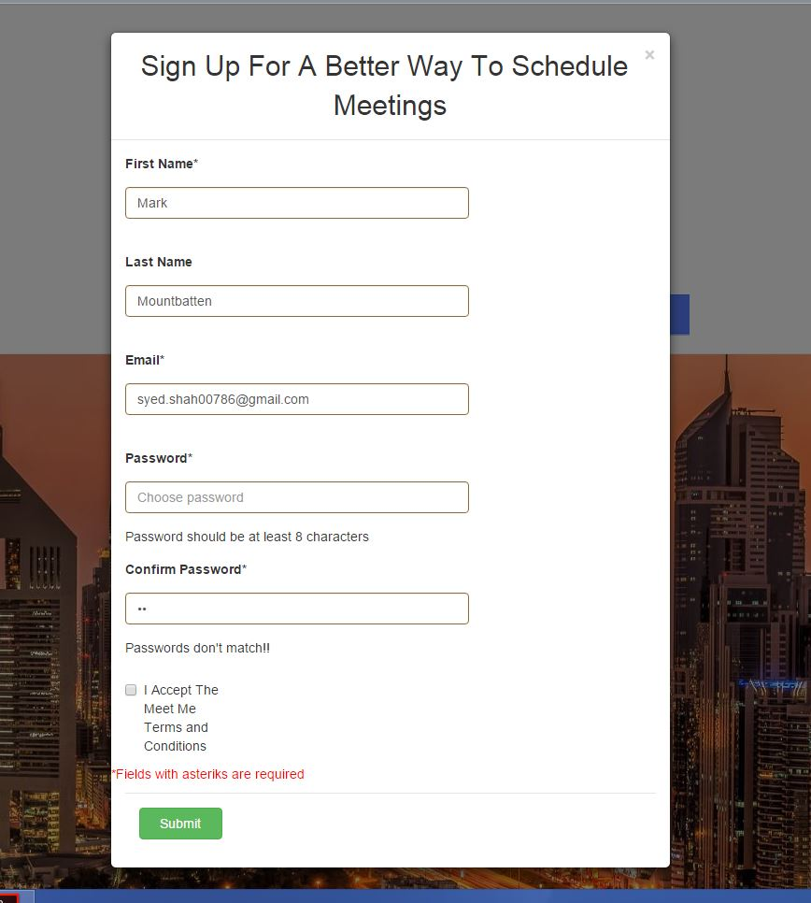

**Step 2:-**

Enter login details to sign in to MeetMe application 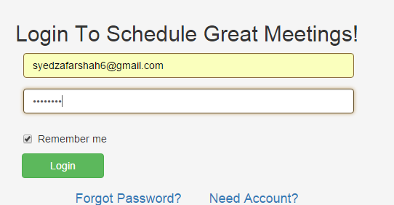

**Step 3:-**

If you forgot password then click on forgot password and you need to enter your login email. Click on the link provided in the email.

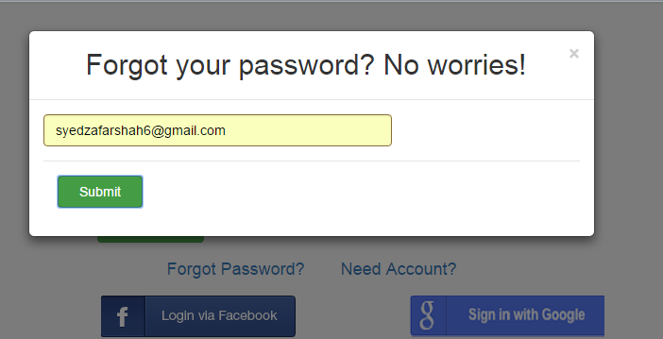

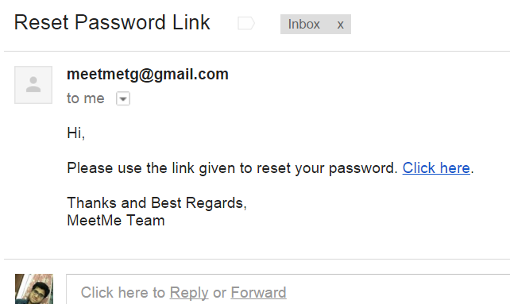

1. **Step 4:-**

After successful login you will be directed to calendar dashboard page where you can see your scheduled events.

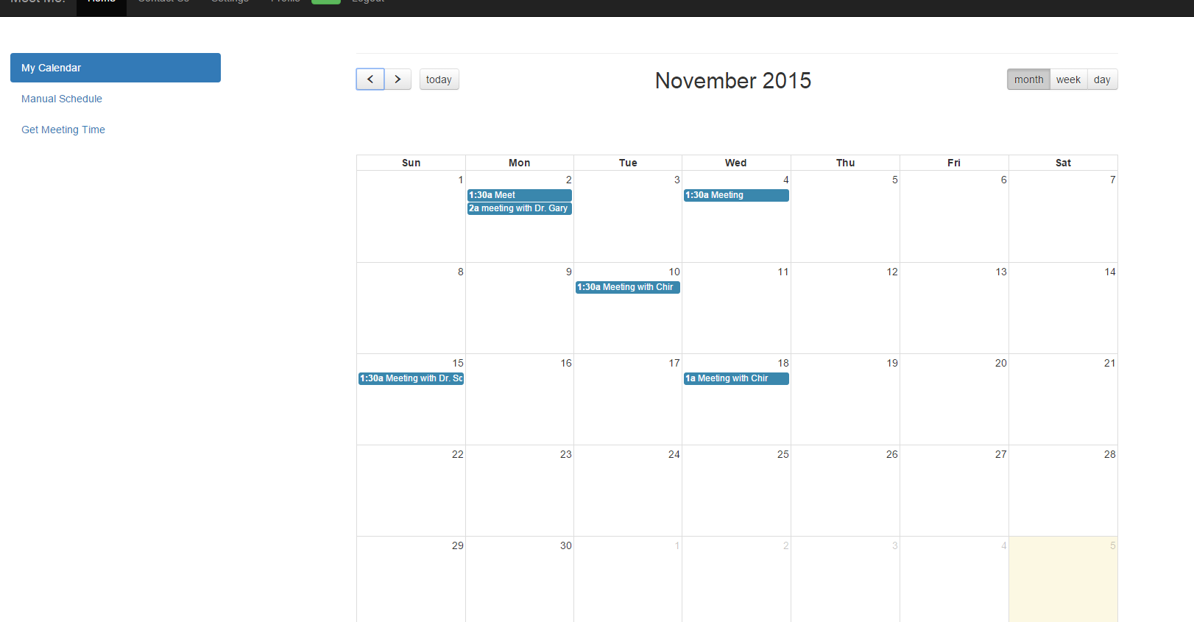

1. **Step 5:-**

Click on Manual schedule to schedule an event.Once all the details are entered the event is scheduled and event details are sent to all the event invitees. Click on OK when the alert is generated.

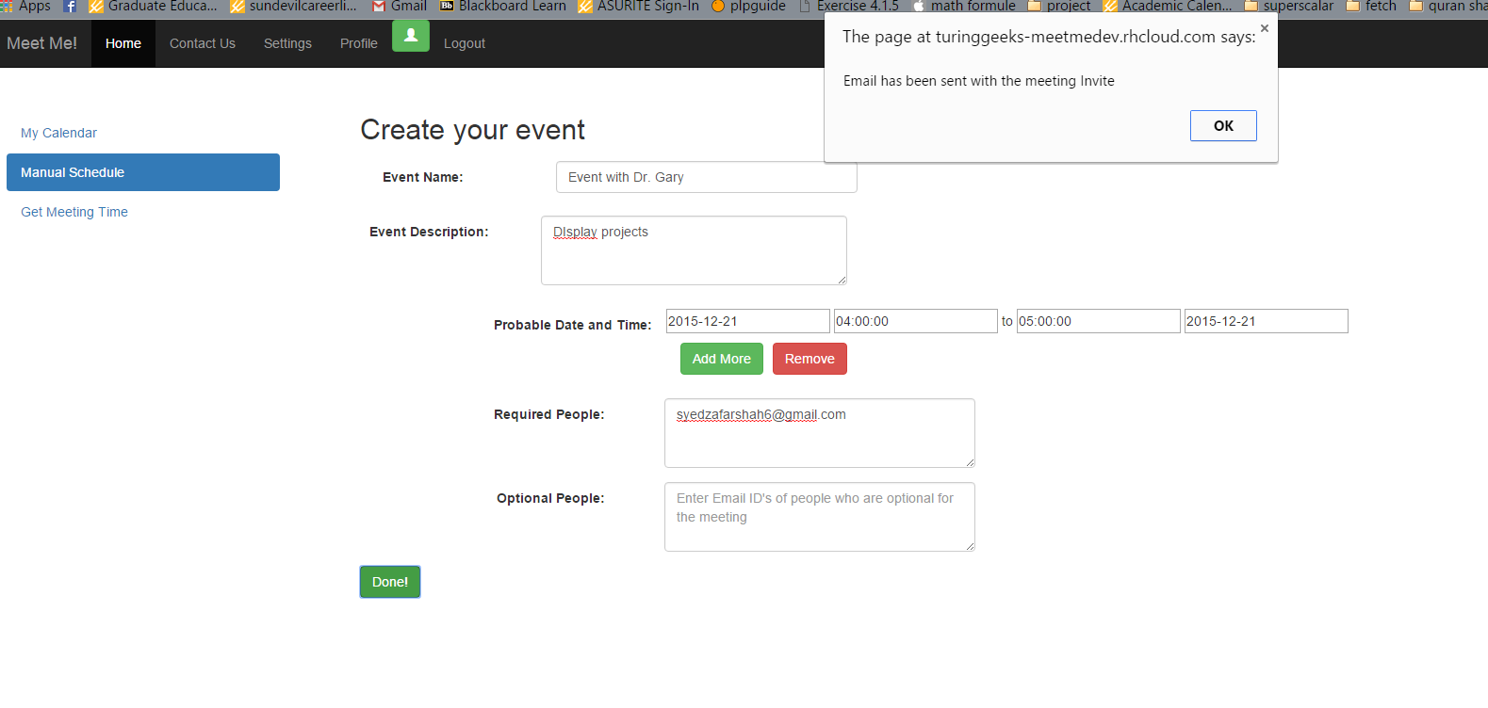**Step 6:**

Click on Get Meeting time and when clicked on the scheduled event you get the following alert

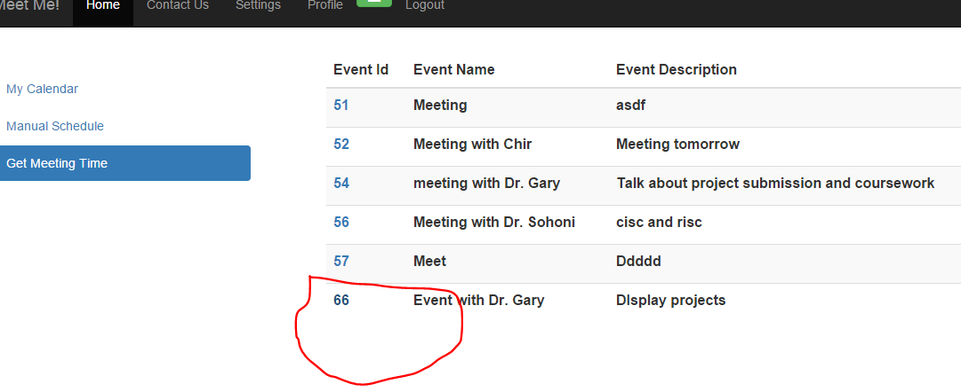

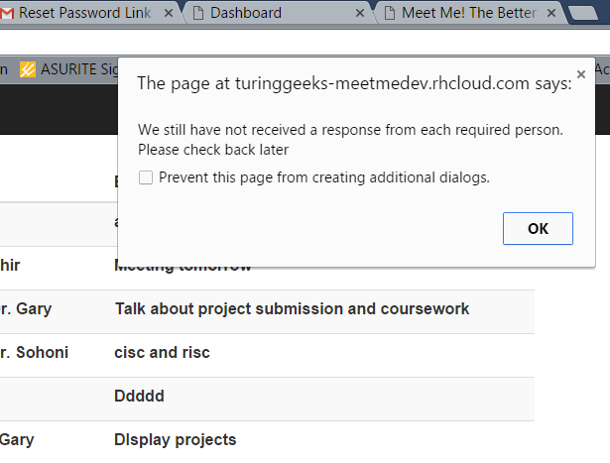

**Step 7:-** Click on the link and you will be asked to give your ranked meeting time of all the probable meeting times.

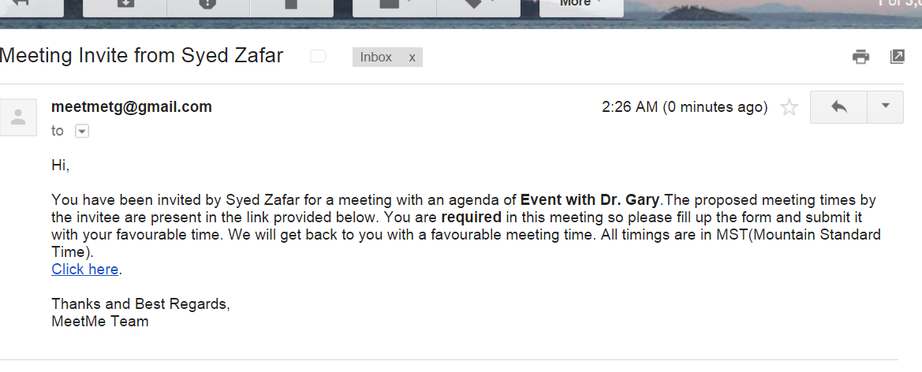

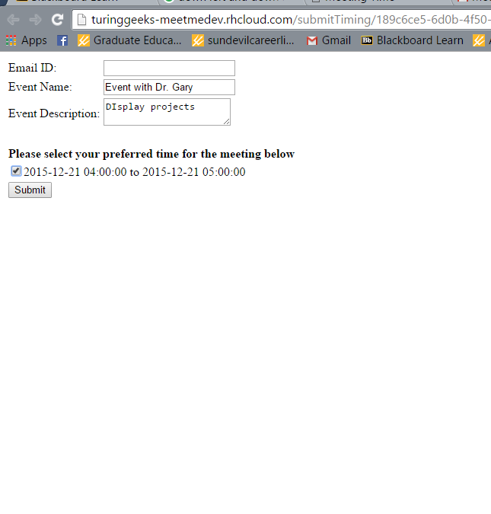

**Step 8:-**

After clicking on submit you get the response as

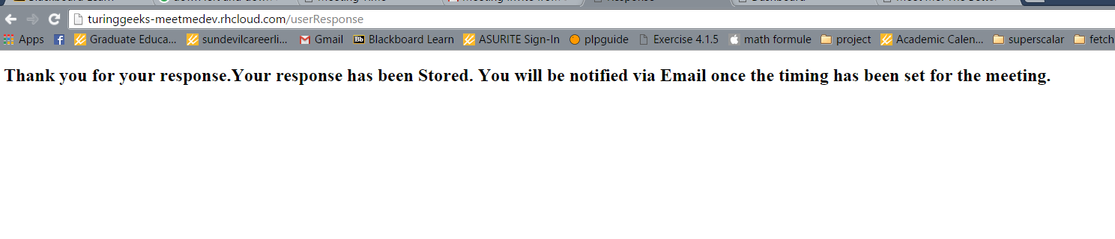

**Step 9:-** Click on Get Meeting time and then on event Id to view the ranking of time slots

