# Multiple Stocks:

Screenshot of Year 2014

# 

Year 2014

Screenshot of Year 2015

# 

Year 2015

Screenshot of Year 2016

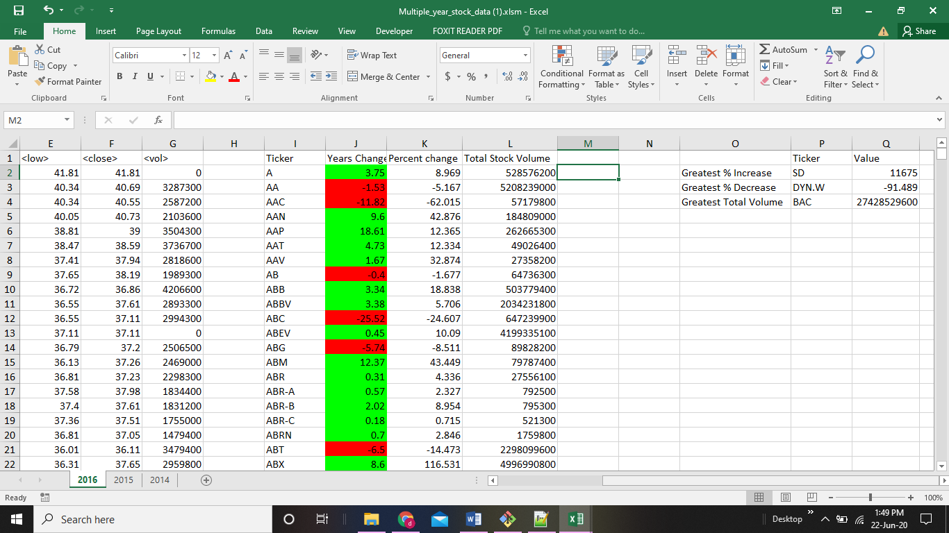

Year 2016

Note: The VBA scripts for the test data (Alphabetical testing) & Stocks data (Multiple Stocks) are attached as TestData.bas & StockData.bas .

References:

How to find last row or column in excel:

<https://www.excelcampus.com/vba/find-last-row-column-cell/>

How to find the max or min value in a column:

<https://www.mrexcel.com/board/threads/why-doesnt-vba-have-a-min-max-function.1055344/>

Color Index:

<https://www.excel-easy.com/vba/examples/background-colors.html>