# **UFO –LEVEL -1**

Overview of the page with the table loaded.

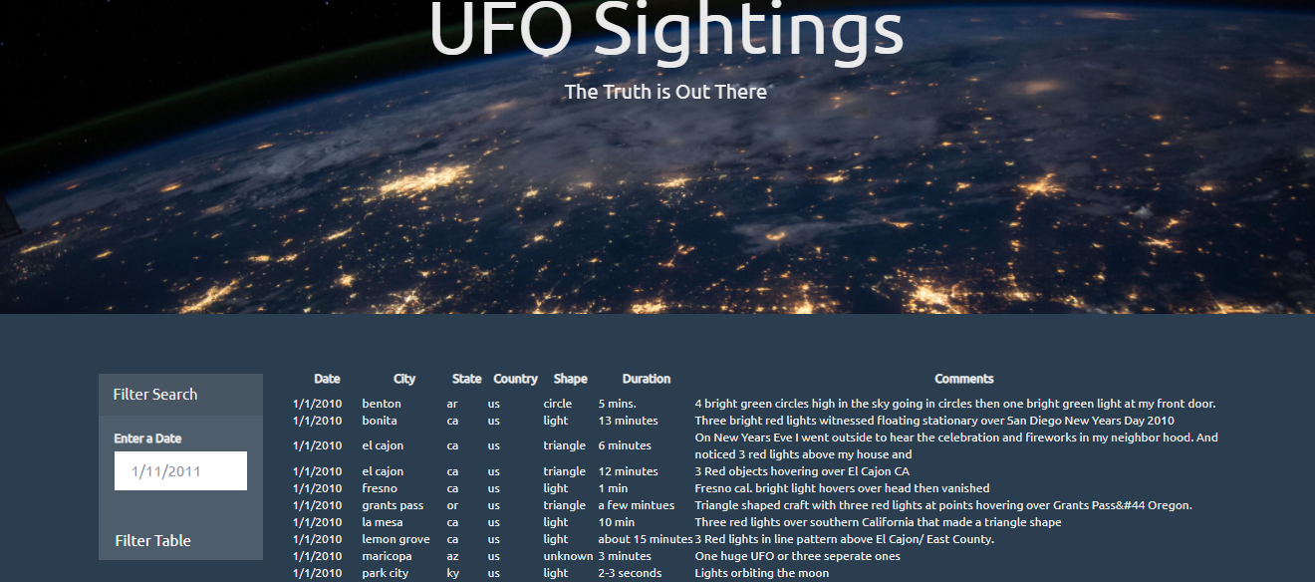

On click of the Date field a calendar will be loaded to select the date in mm/dd/yy format.

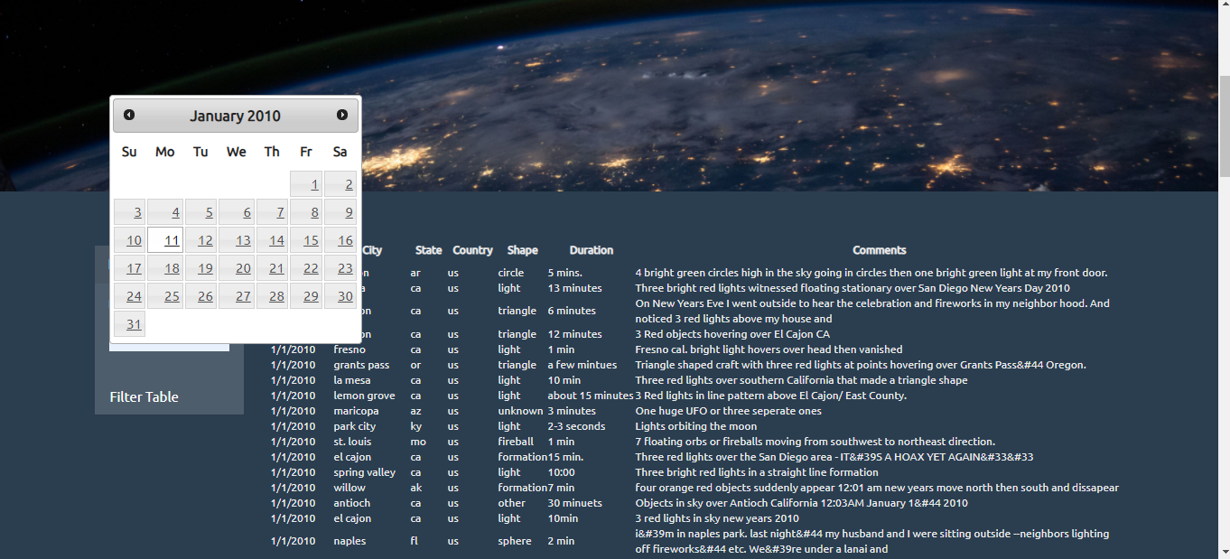

After applying the date filter.

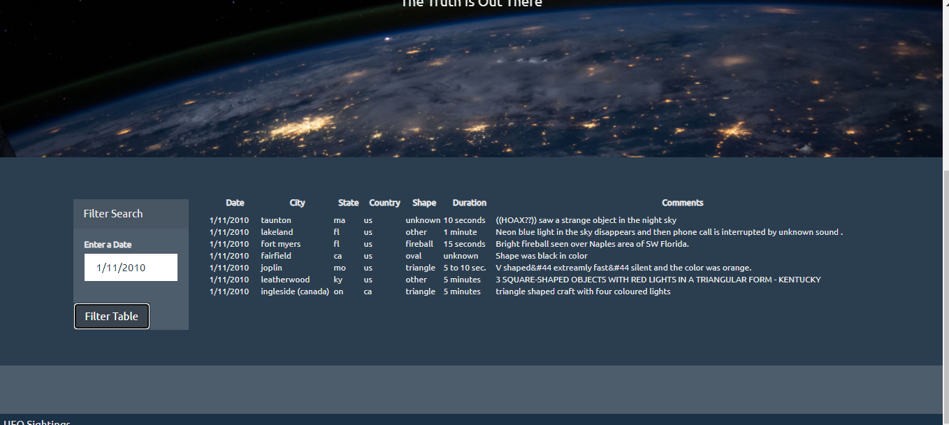

# **UFO –LEVEL 2**

Added the dropdown options to the filter table button for user to select.

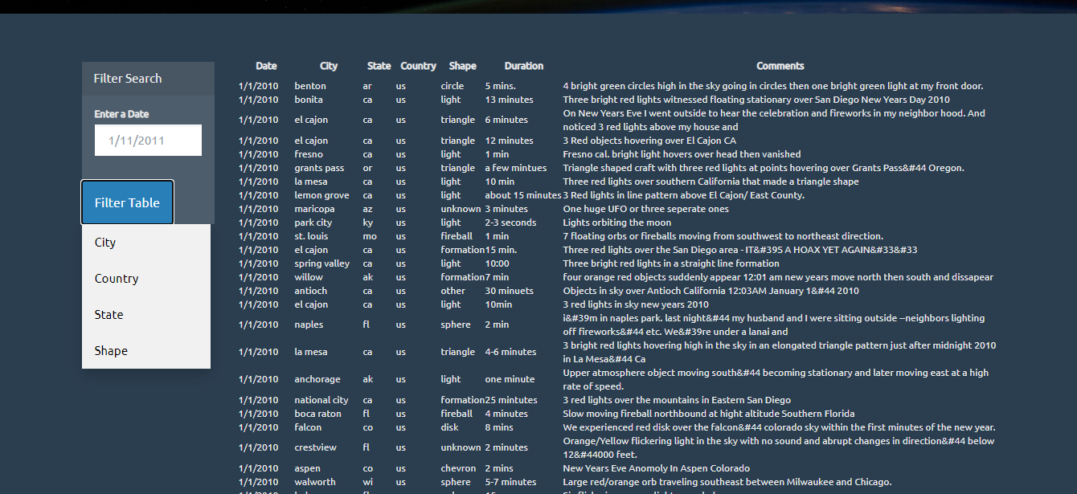

New empty input fields will be created with the placeholders for the reference every time the user will select the filter options. User can input the values and find the data they want.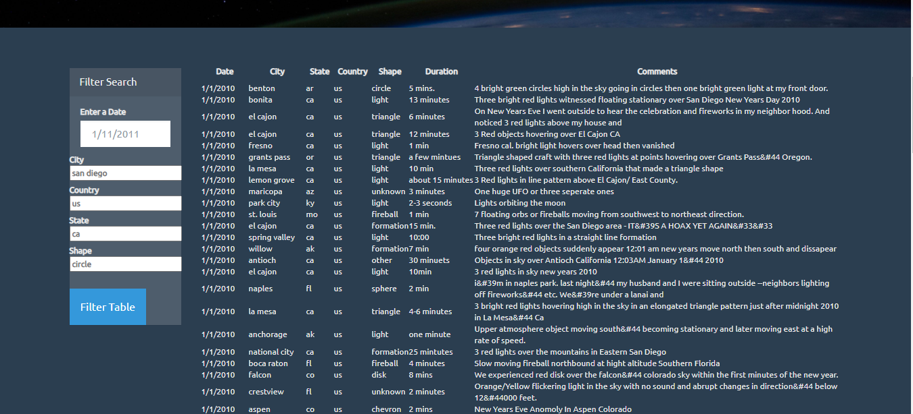

When filtered by only date.

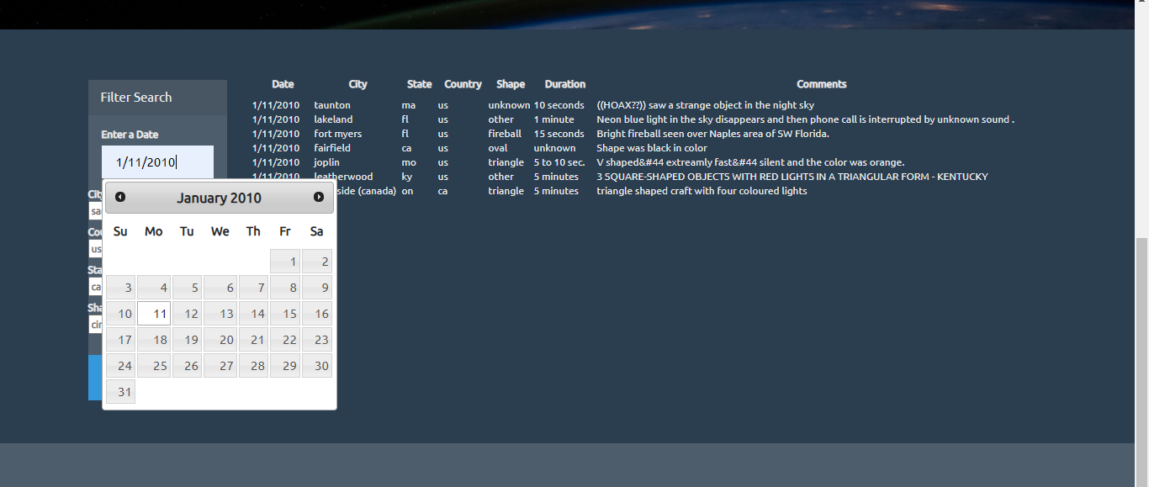

Upon giving multiple filters.

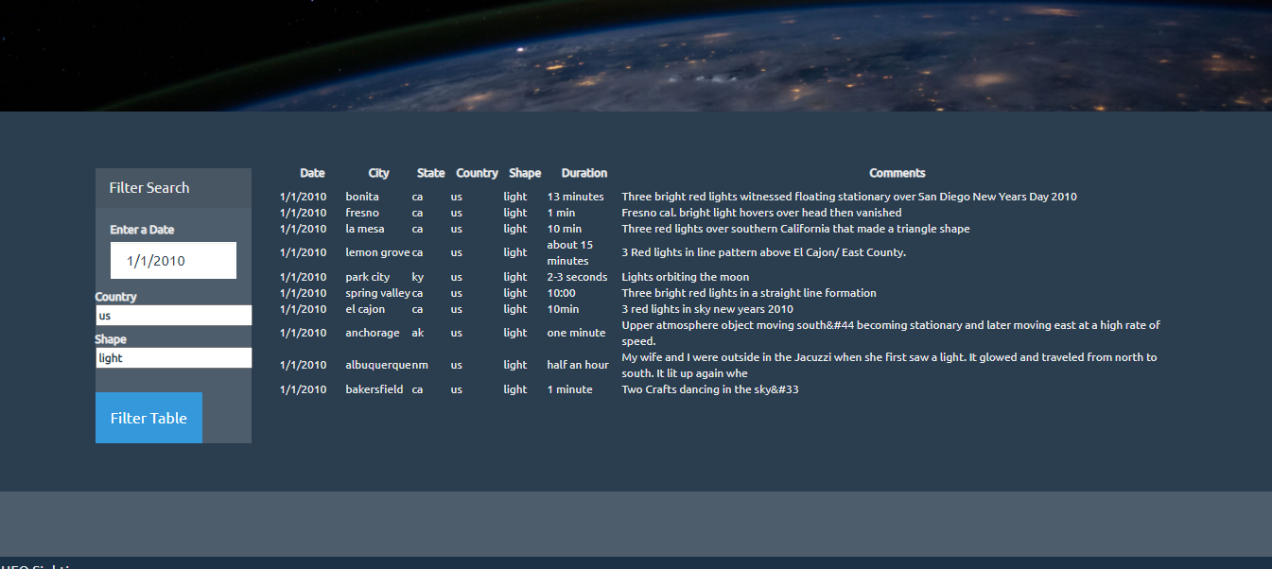

User can choose as many filters as they want and get their data.

