process lcfs transport data
Dave Hawkey
2025-03-20
transport_codes <- read.xlsx("C:/Users/DavidHawkey/R projects/Energy and climate/lcfs_transport/transport_codes_processed.xlsx") %>% tibble()
other_variables <- c(
"a124", # Cars and vans in household
"weighta", #Annual weight
"weightq", # Quarterly weight
"a040", # Number of children children-age under 2
"a041", # Number of children children-age 2 but un
"a042", # Number of children children-age 5 but un
"a0423", # Number of children completing a diary
"a043", # Number of adults-age under 45
"a044", # Number of adults-age 45 but under 60
"a045", # Number of adults-age 60 but under 65
"a046", # Number of adults-age 65 but under 70
"a047", # Number of adults-age 70 and over
"a049", # Number of persons in household
"a053", # Households with married women (econ active)
"a054", # Number of workers in household
"a055", # Sampling month
"a056", # Number of persons economically active
"a057", # Men 65+ women 60+ economically active
"a058", # Others - not economically active
"a060", # Gross normal income of HRP by range
"a062", # Composition of Household
"EqIncDOp", # Equivalised income (OECD Scale) - anonymised dvhh Yes
"a069p", # Type of household - Anonymised
"case", # case number anonymised
"gorx" # Government Office Region modified"
)
lcfs_year <- c(2019,2021,2022)
lcfs <- load_lcf(
year = lcfs_year,
col_select = c(paste0("^", transport_codes$variable, "$"), other_variables),
force_lower_case = TRUE
) %>%
mutate(incomeVar = eqincdop) # So we can change to tbm output later if we want
## Warning: `..1$a062` and `..2$a062` have conflicting value labels.
## ℹ Labels for these values will be taken from `..1$a062`.
## ✖ Values: 1, 2, 3, 4, 5, 6, 7, 8, …, 29, and 30
## Warning: `..1$gorx` and `..2$gorx` have conflicting value labels.
## ℹ Labels for these values will be taken from `..1$gorx`.
## ✖ Values: 2
## Warning: `..1$a053` and `..2$a053` have conflicting value labels.
## ℹ Labels for these values will be taken from `..1$a053`.
## ✖ Values: 1, 2, 3, 4, 5, 6, 7, 8, …, 13, and 14
## Warning: `..1$a062` and `..2$a062` have conflicting value labels.
## ℹ Labels for these values will be taken from `..1$a062`.
## ✖ Values: 1, 2, 3, 4, 5, 6, 7, 8, …, 29, and 30
## Warning: `..1$a060` and `..2$a060` have conflicting value labels.
## ℹ Labels for these values will be taken from `..1$a060`.
## ✖ Values: 1, 2, 3, 4, 5, 6, 7, 8, …, 49, and 50
## Warning: `..1$gorx` and `..2$gorx` have conflicting value labels.
## ℹ Labels for these values will be taken from `..1$gorx`.
## ✖ Values: 2
## Warning: `..1$a053` and `..2$a053` have conflicting value labels.
## ℹ Labels for these values will be taken from `..1$a053`.
## ✖ Values: 1, 2, 3, 4, 5, 6, 7, 8, …, 13, and 14
## Warning: `..1$a069p` and `..2$a069p` have conflicting value labels.
## ℹ Labels for these values will be taken from `..1$a069p`.
## ✖ Values: 1, 2, and 3
# This checks out fine
setdiff(transport_codes$variable, names(lcfs))
## character(0)
setdiff(other_variables, names(lcfs))
## [1] "EqIncDOp"
setdiff(names(lcfs), c(transport_codes$variable, other_variables))
## [1] "eqincdop" "my_year" "incomeVar"
lcfs_transport <- lcfs %>%
pivot_longer(cols = matches(transport_codes$variable), names_to = "transport_code") %>%
left_join(
transport_codes %>% select(c(variable, pub_priv, active, taxi, surface)),
by = c("transport_code" = "variable")
) %>%
group_by(across(-c("transport_code", "value", "pub_priv", "active", "taxi", "surface"))) %>%
summarise(
all_transport = sum(value),
public = sum((pub_priv == "public") * value),
private = sum((pub_priv == "private") * value),
active = sum((active == "active") * value),
private_excl_taxi = sum((pub_priv == "private" & taxi == "not_taxi") * value),
air = sum((surface == "air") * value),
.groups = "drop"
)

By income decile
lcfs_transport <- lcfs_transport %>%
group_by(my_year) %>%
arrange(incomeVar) %>%
mutate(
pos = (cumsum(weighta) - weighta / 2) / sum(weighta),
incomeDecile = ceiling(pos * 10)
)
transport_boxplot <- lcfs_transport %>%
ggplot(
aes(
x = as_factor(incomeDecile),
weight = weighta
)
) +
geom_boxplot() +
coord_cartesian(ylim = c(0,250)) +
scale_y_continuous(name = "Weekly spend", labels = scales::label_dollar(prefix = "£"))
transport_boxplot + aes(y = all_transport) + labs(title = "All transport")
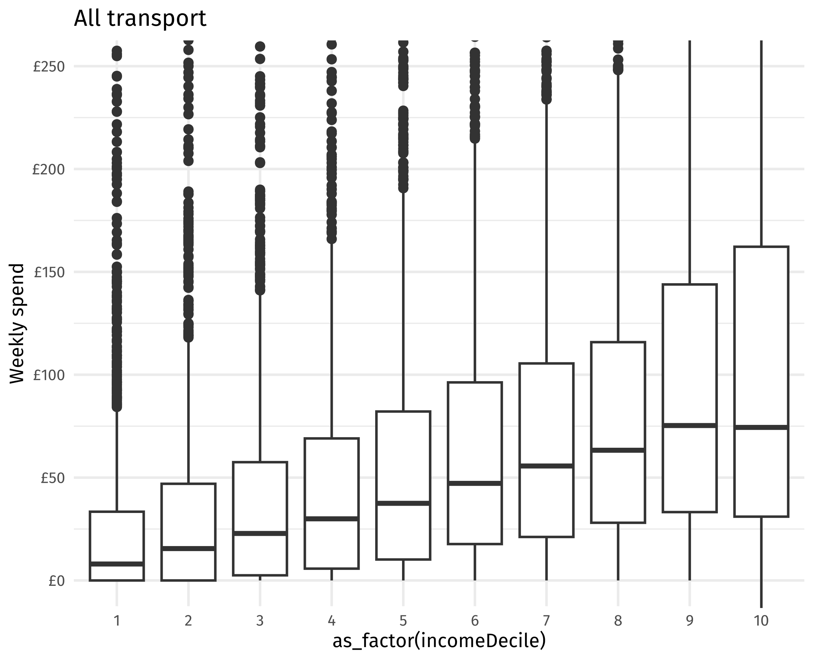
transport_boxplot + aes(y = private) + labs(title = "Private transport")
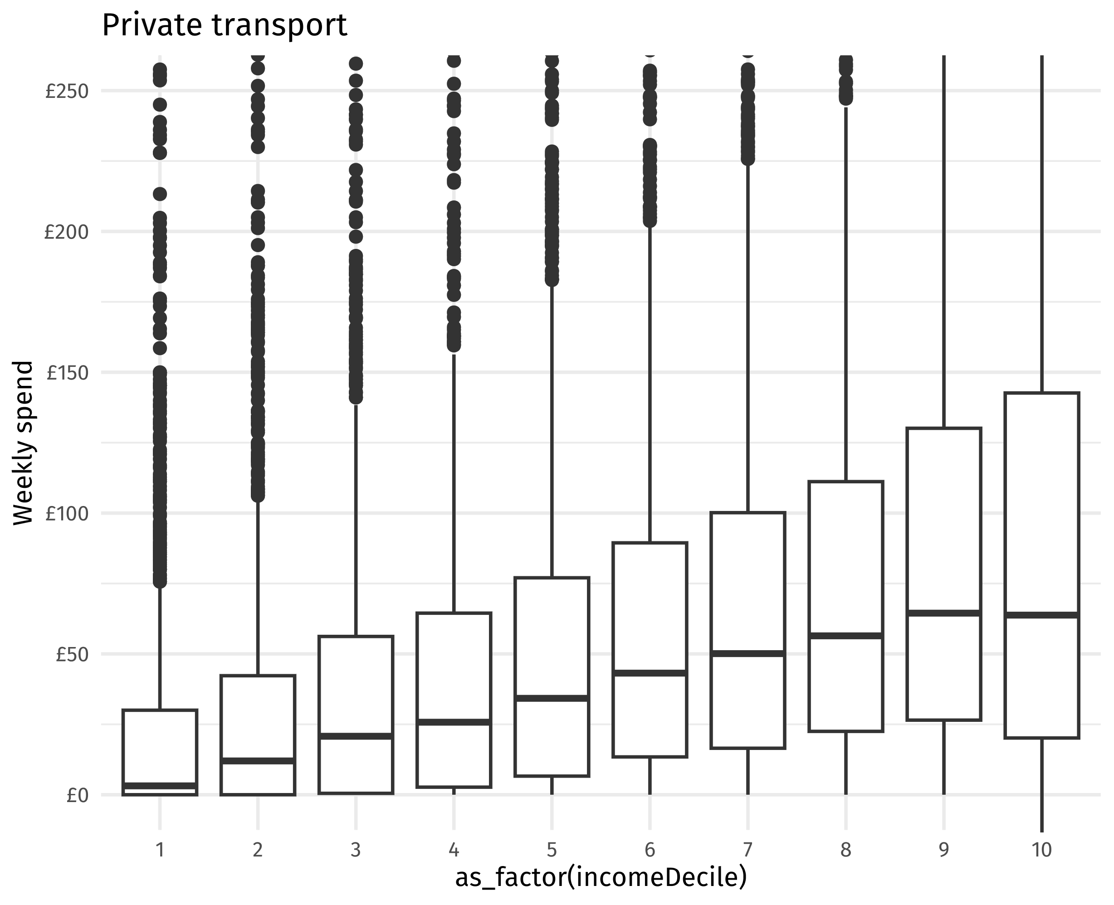
transport_boxplot + aes(y = public) + labs(title = "Public transport") + coord_cartesian(ylim = c(0,25))
## Coordinate system already present. Adding new coordinate system, which will
## replace the existing one.
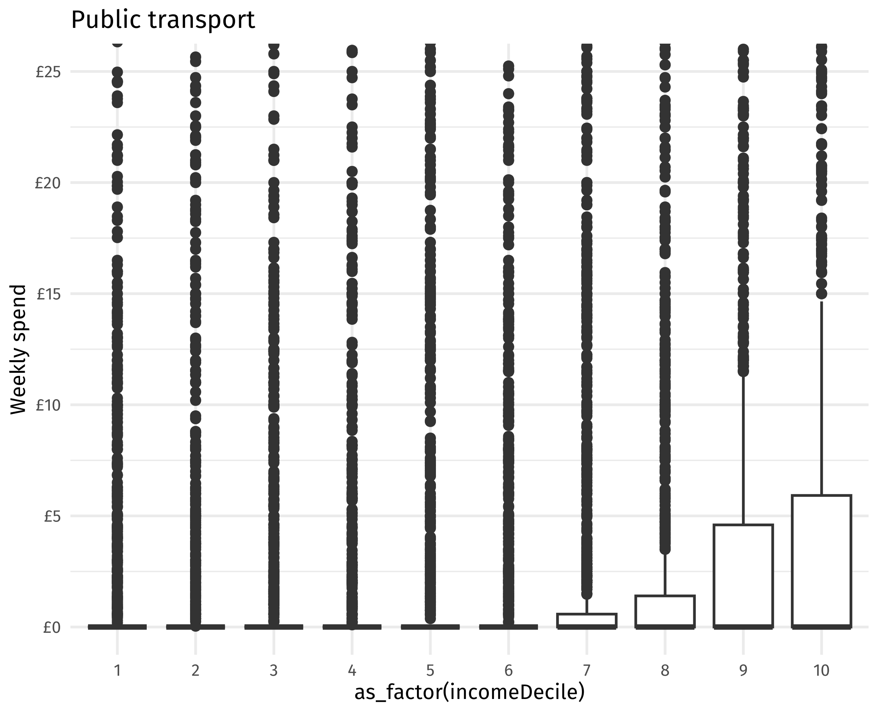
transport_boxplot + aes(y = private_excl_taxi) + labs(title = "Private transport excluding taxis")
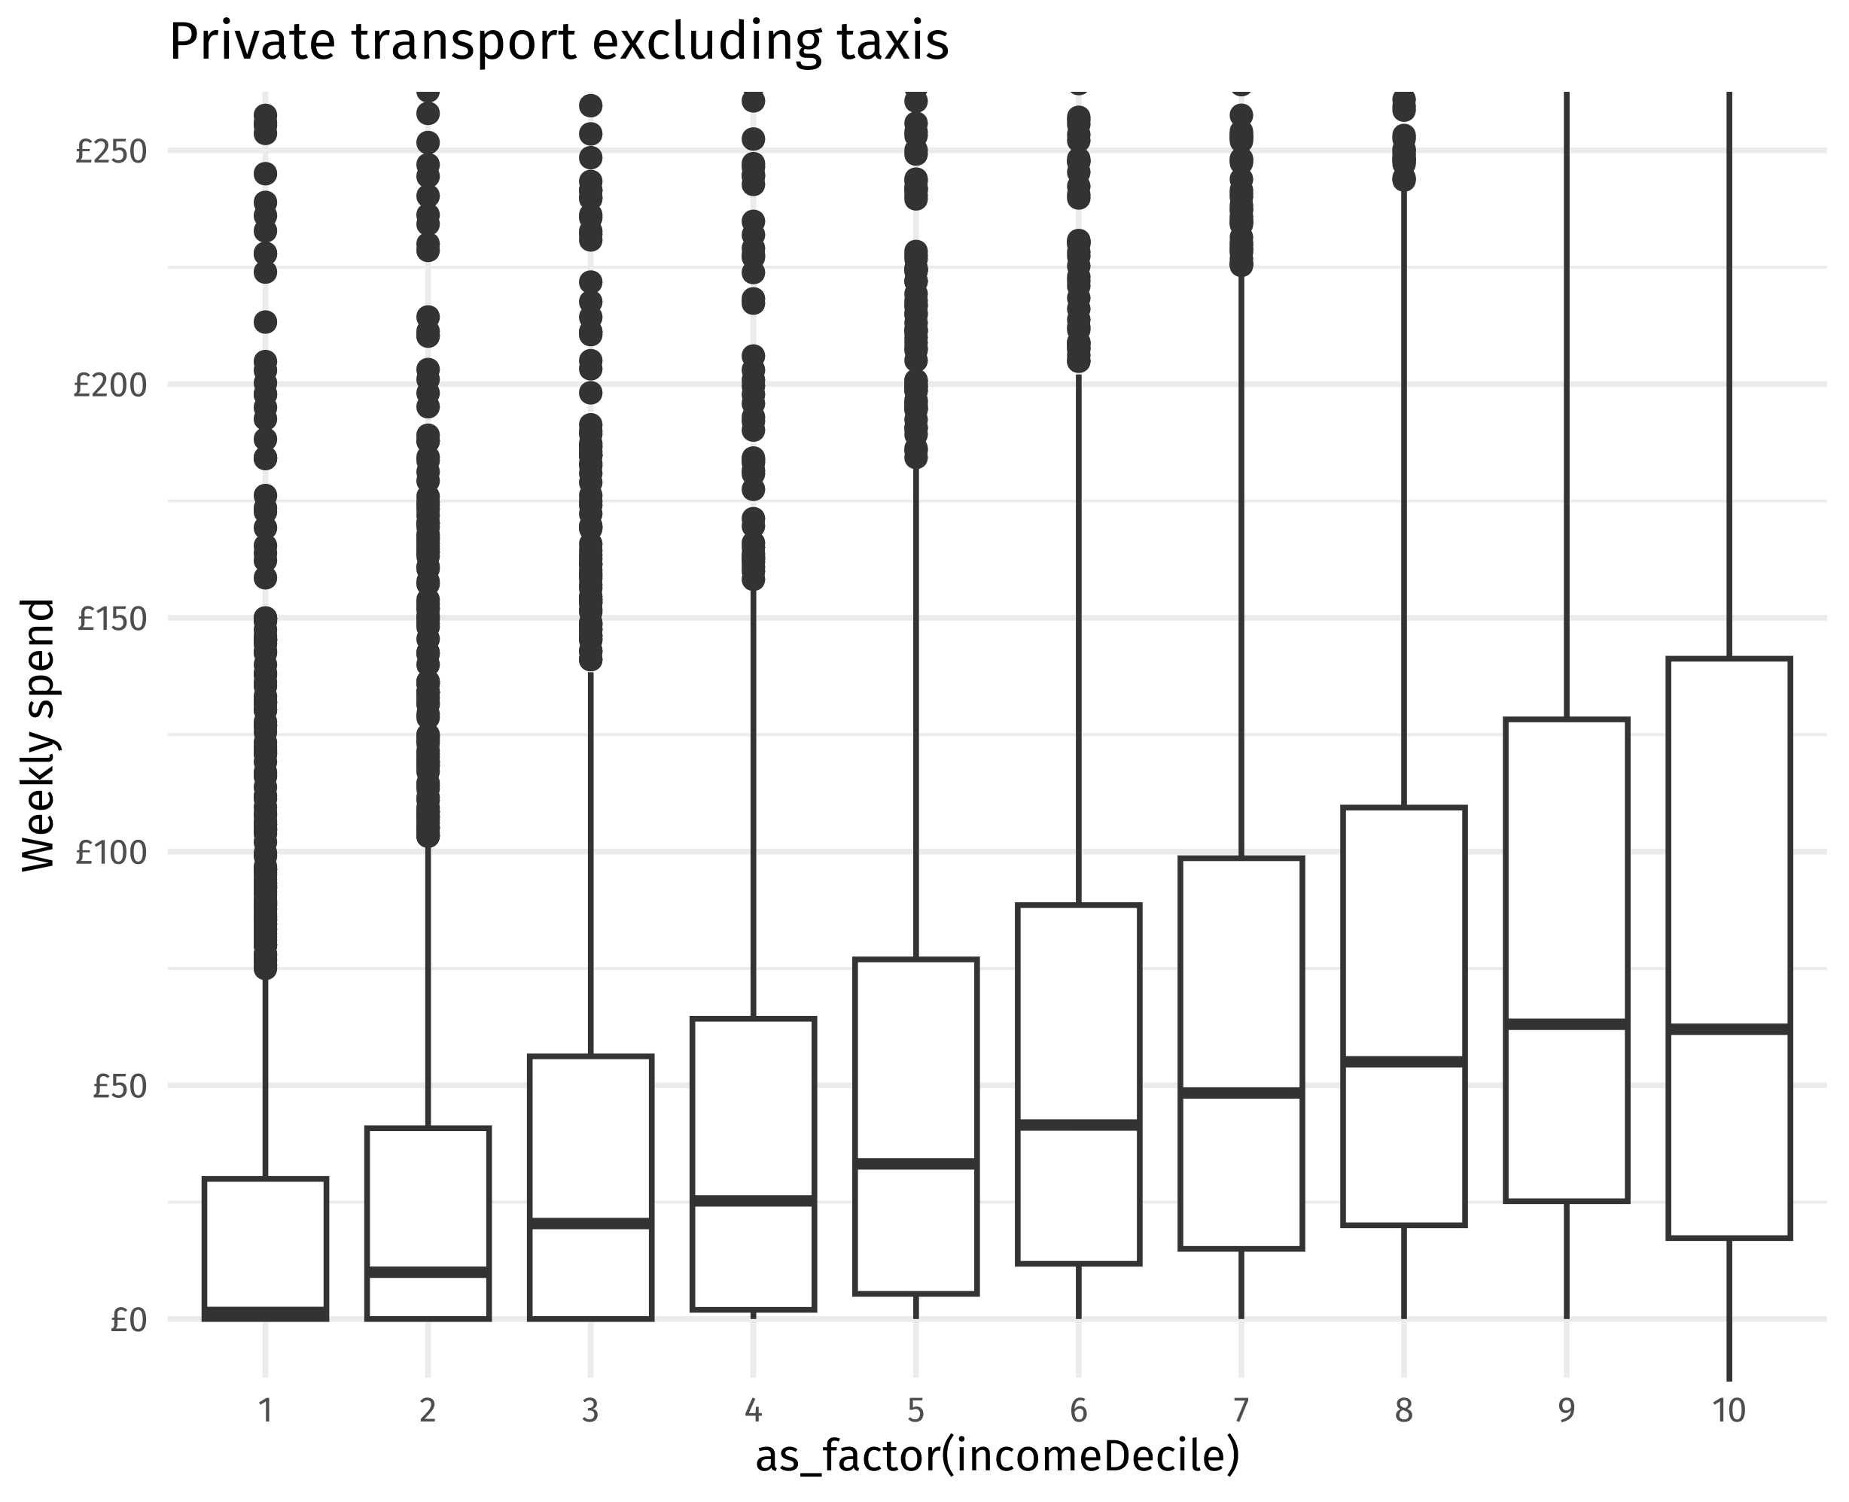
transport_boxplot + aes(y = air) + labs(title = "Air")
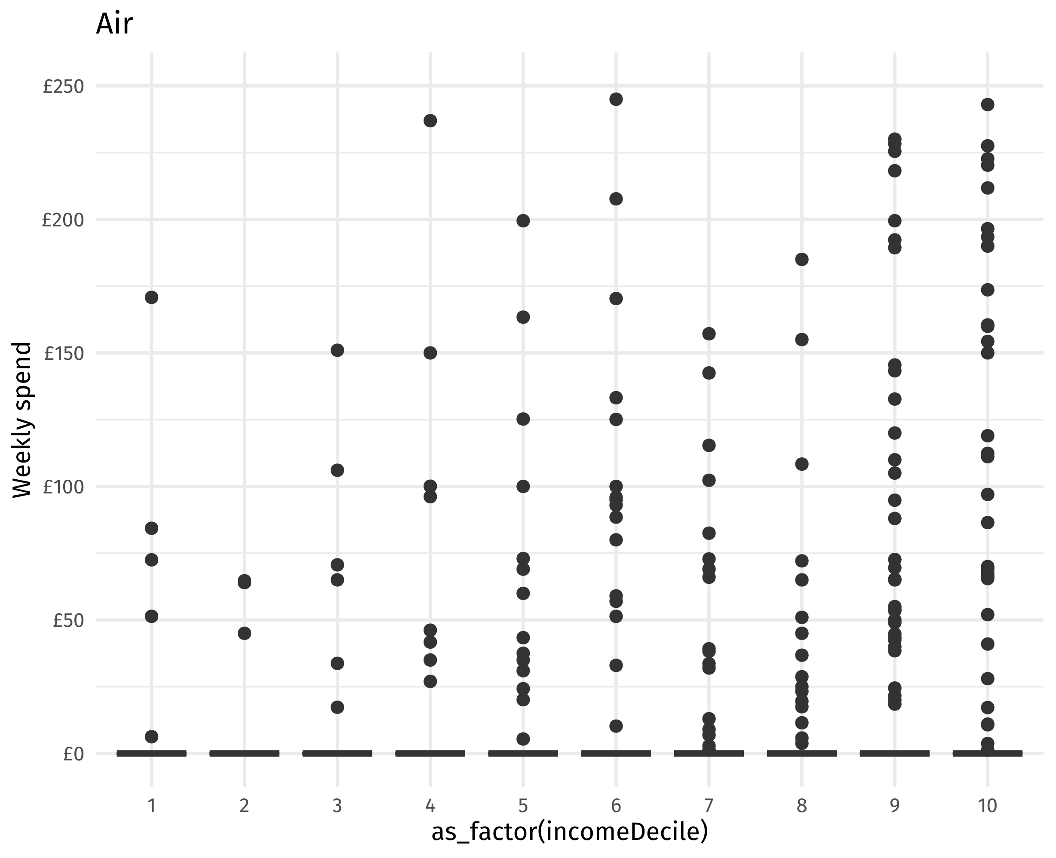
transport_boxplot + aes(y = active) + labs(title = "Active travel")
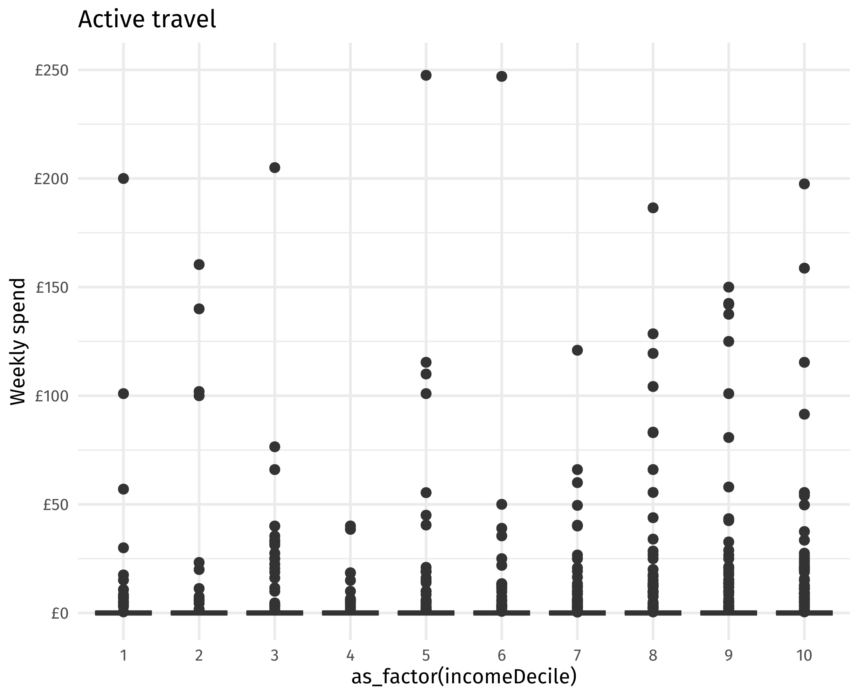
transport_plot <- function(data, title, ylim = c(0,200)){
data %>%
ggplot(
aes(
x = as_factor(x_var),
y = target_var,
weight = weighta
)
) +
geom_boxplot() +
coord_cartesian(ylim = ylim) +
scale_y_continuous(name = "Weekly spend", labels = scales::label_dollar(prefix = "£")) +
labs(title = title)
}
excl_zero_plot <- function(data, ...) {
data %>% transport_plot(...)
}
lcfs_transport %>% mutate(target_var = air, x_var = incomeDecile) %>% excl_zero_plot(title = "Air excluding zeros", ylim = c(0,300))
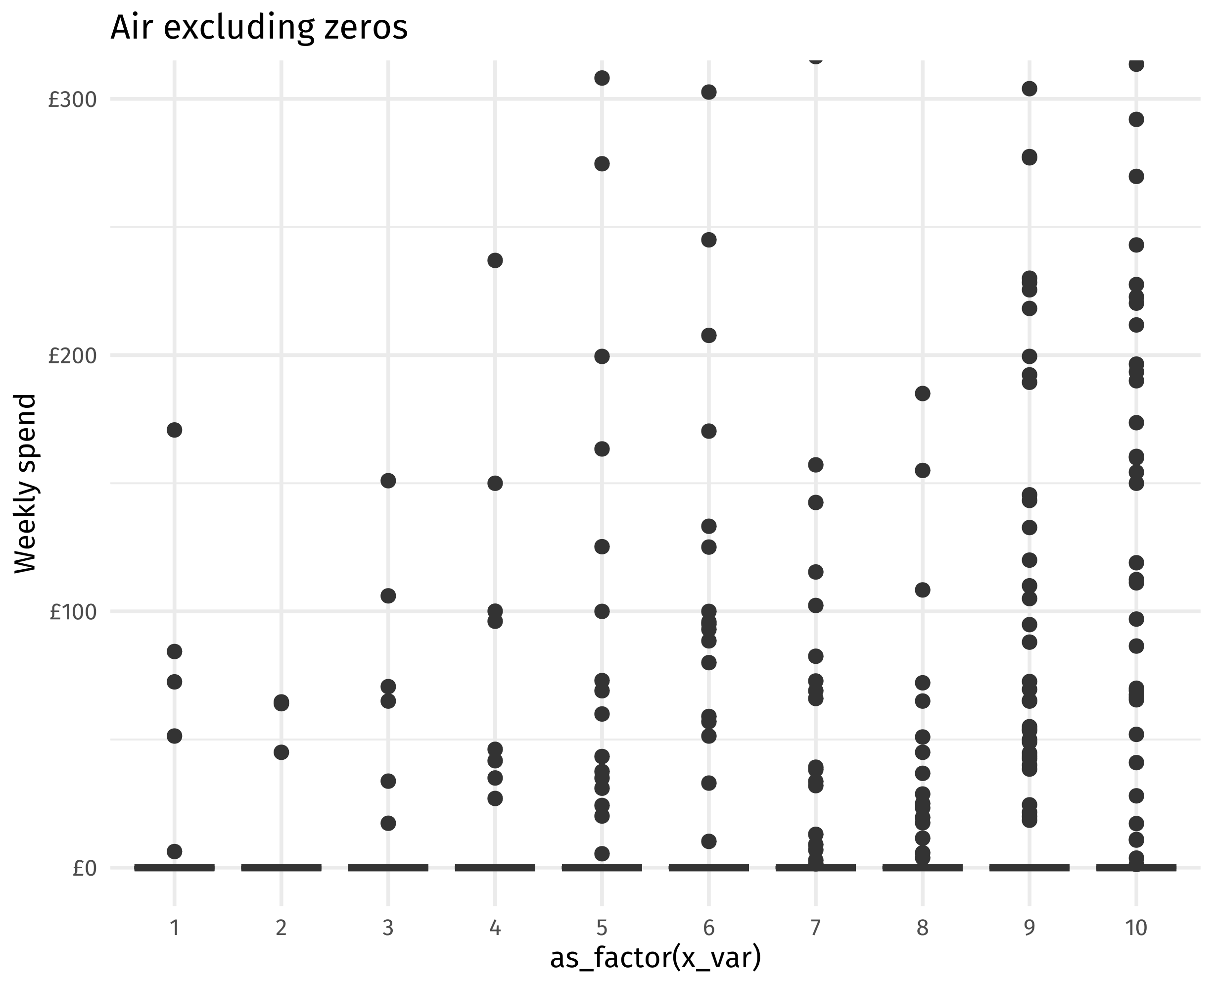
lcfs_transport %>% mutate(target_var = public, x_var = incomeDecile) %>% excl_zero_plot(title = "Public excluding zeros", ylim = c(0,100))
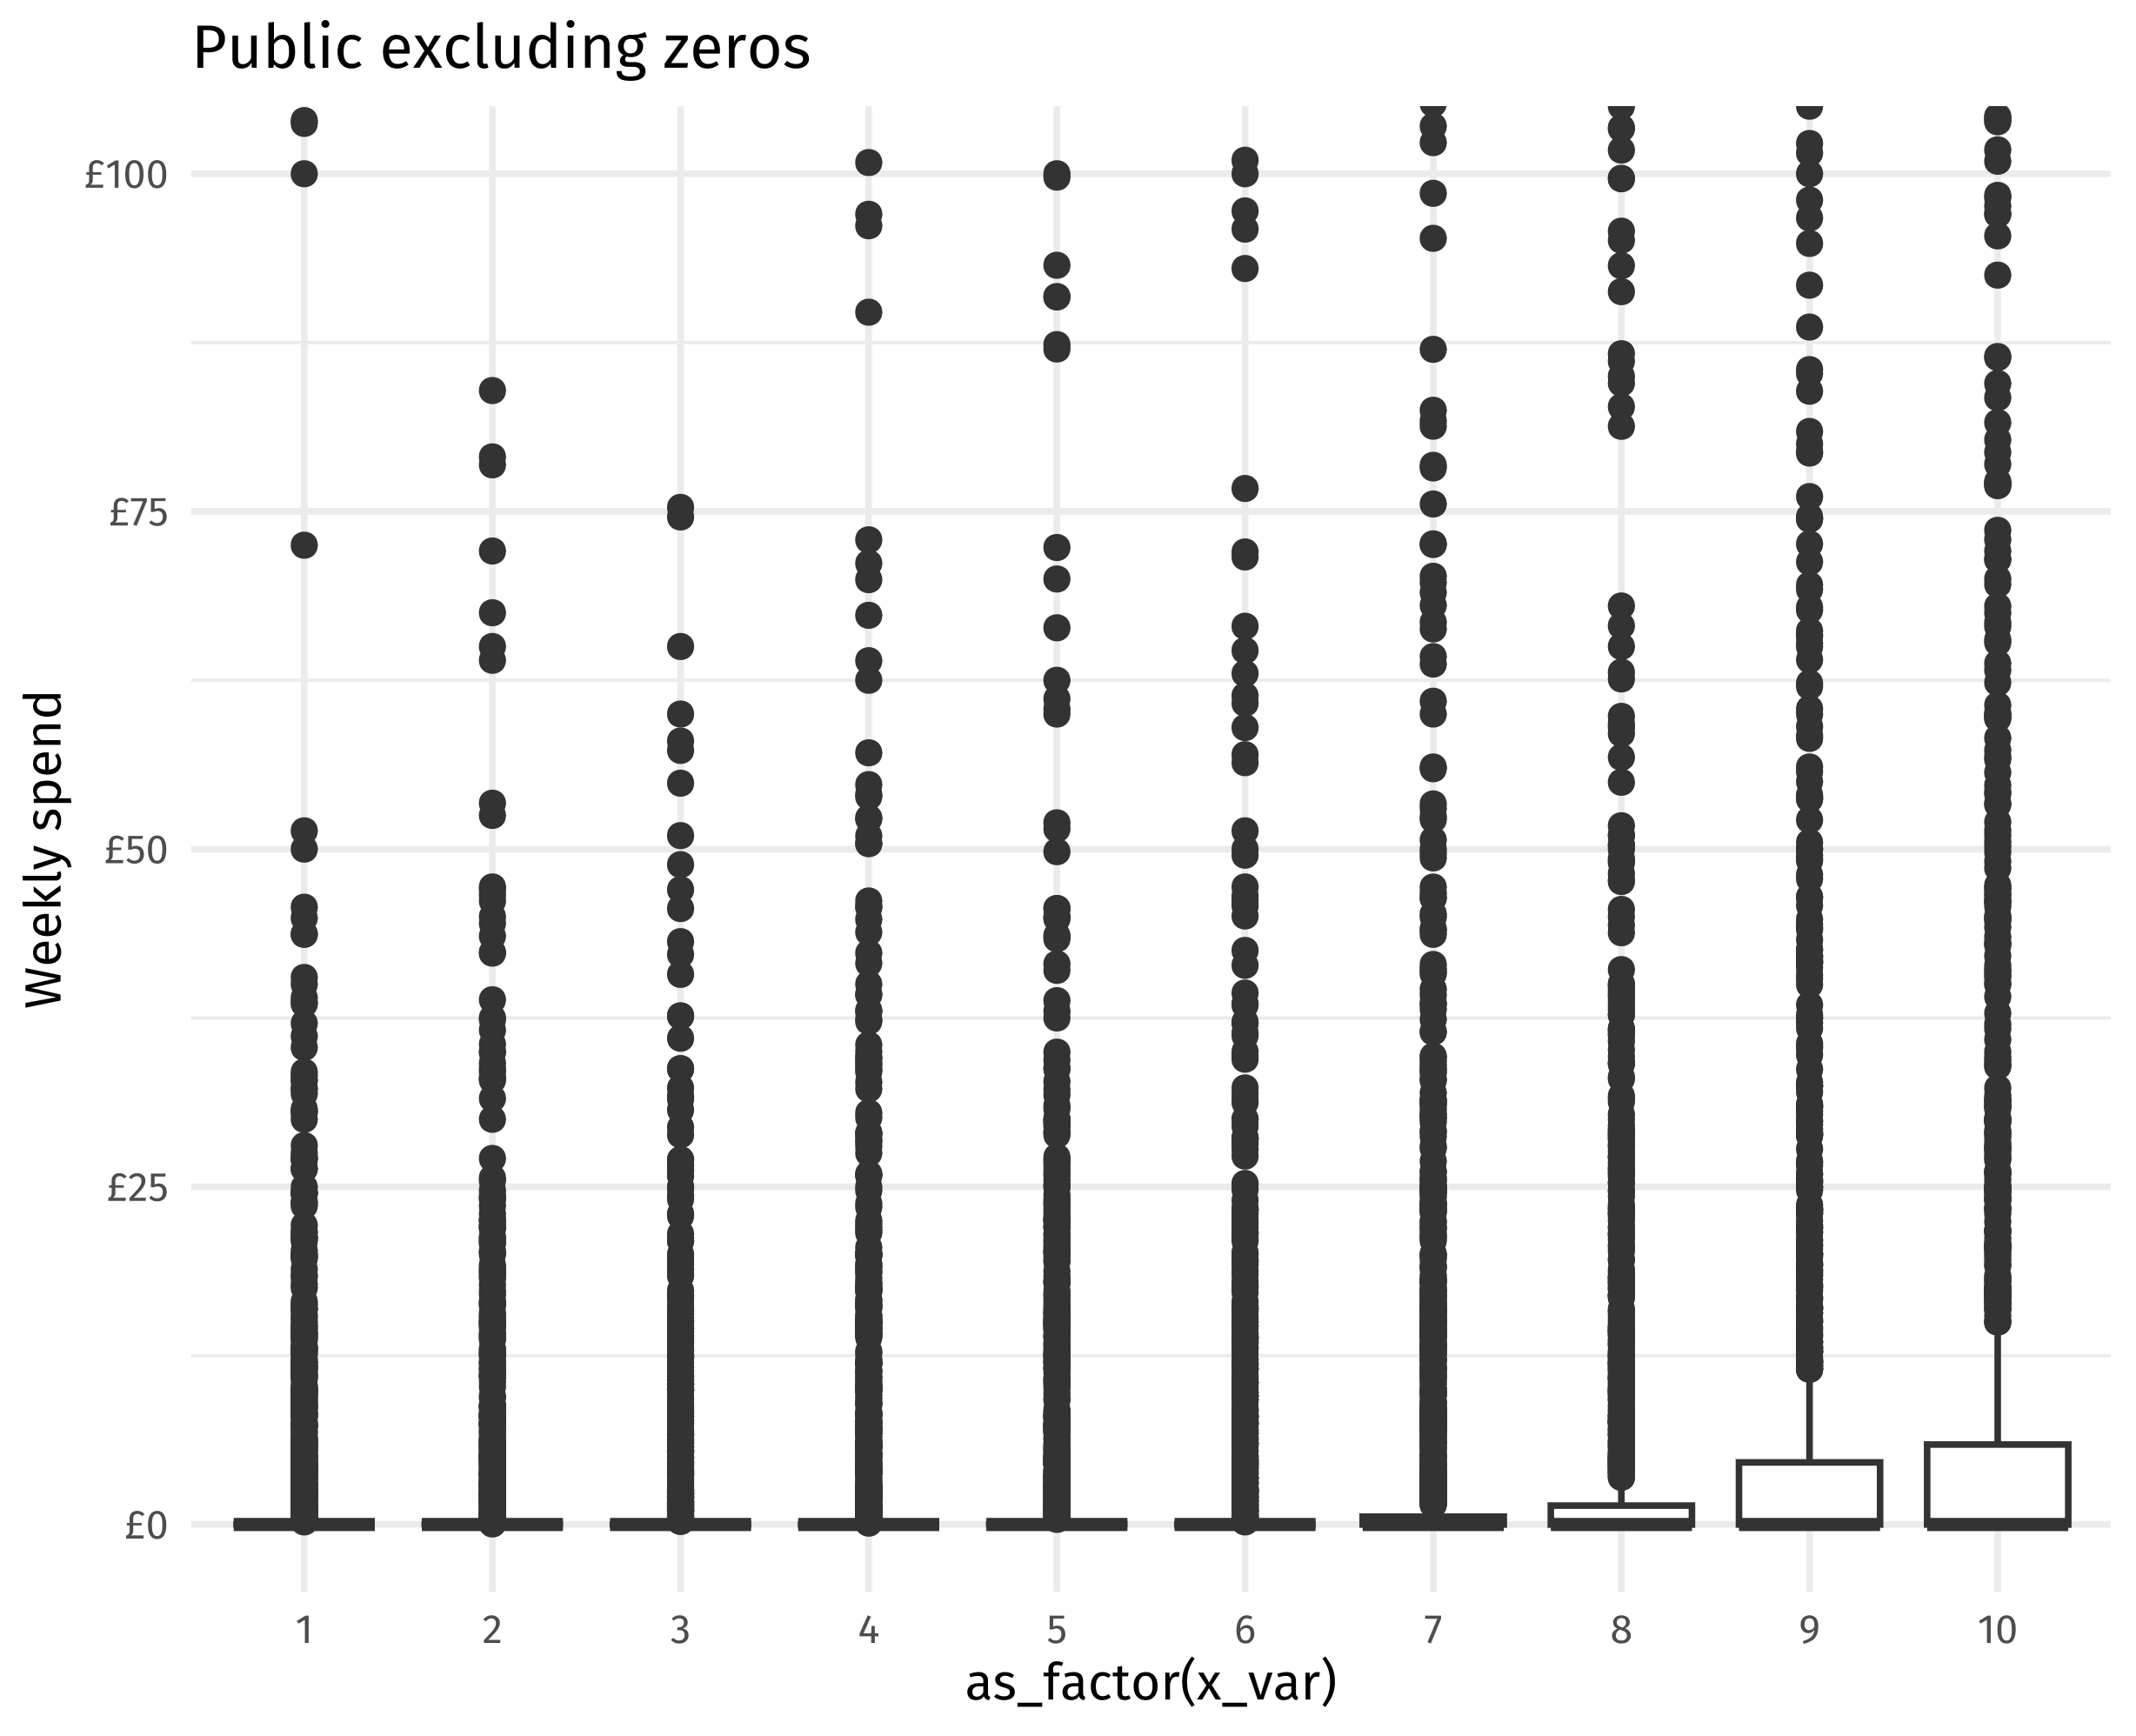
lcfs_transport %>% mutate(target_var = active, x_var = incomeDecile) %>% excl_zero_plot(title = "Active excluding zeros", ylim = c(0,300))
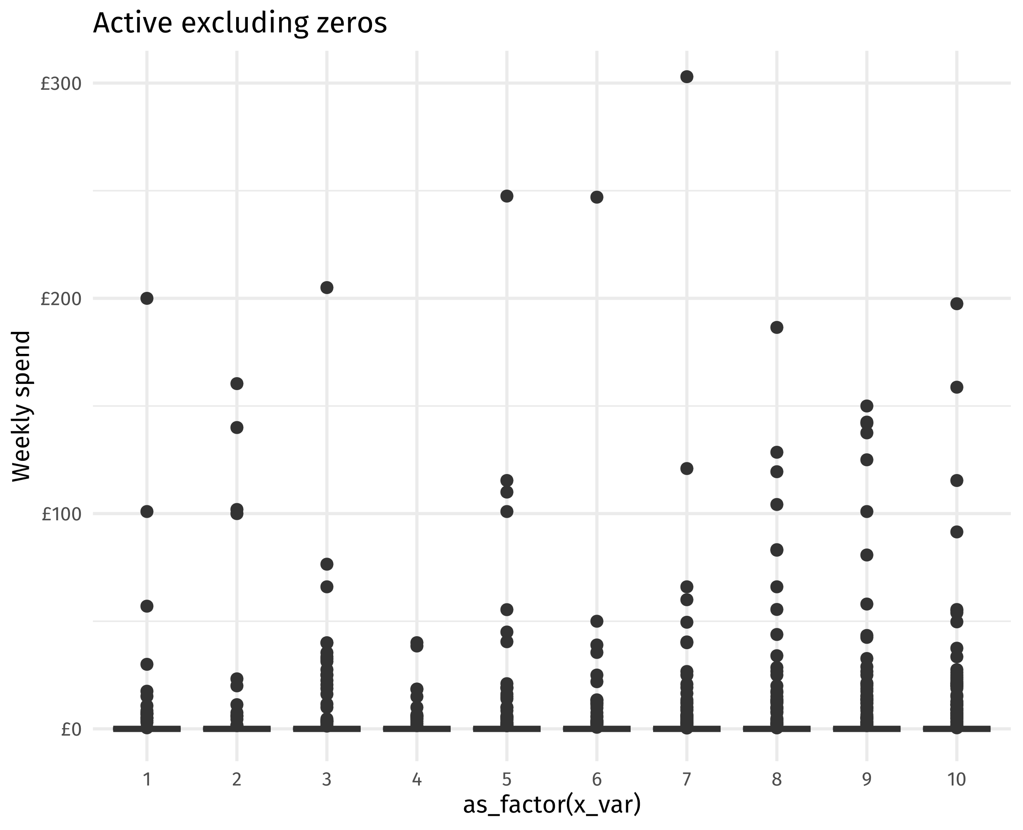
lcfs_transport %>%
group_by(my_year, incomeDecile) %>%
summarise(
across(
c(all_transport, public, private, private_excl_taxi, active, air),
.fns = list(
median = ~wtd.quantile(.x, q = 0.5, weight = weighta),
p75 = ~wtd.quantile(.x, q = 0.75, weight = weighta),
p25 = ~wtd.quantile(.x, q = 0.25, weight = weighta)
)),
.groups = "drop"
)
## # A tibble: 30 × 20
## my_year incomeDecile all_transport_median all_transport_p75 all_transport_p25
## <dbl> <dbl> <dbl> <dbl> <dbl>
## 1 2019 1 7.95 33.8 0
## 2 2019 2 16.2 44.7 0
## 3 2019 3 22.9 59.9 3.46
## 4 2019 4 35.2 72.3 12
## 5 2019 5 39.8 82.1 12.2
## 6 2019 6 49.9 96.7 22.9
## 7 2019 7 65.2 105. 27.1
## 8 2019 8 74.7 130. 34.8
## 9 2019 9 91.9 160. 41.6
## 10 2019 10 84.3 167. 41.6
## # ℹ 20 more rows
## # ℹ 15 more variables: public_median <dbl>, public_p75 <dbl>, public_p25 <dbl>,
## # private_median <dbl>, private_p75 <dbl>, private_p25 <dbl>,
## # private_excl_taxi_median <dbl>, private_excl_taxi_p75 <dbl>,
## # private_excl_taxi_p25 <dbl>, active_median <dbl>, active_p75 <dbl>,
## # active_p25 <dbl>, air_median <dbl>, air_p75 <dbl>, air_p25 <dbl>

By region
transport_boxplot <- lcfs_transport %>%
ggplot(
aes(
x = as_factor(gorx),
weight = weighta
)
) +
geom_boxplot() +
coord_cartesian(ylim = c(0,250)) +
scale_y_continuous(name = "Weekly spend", labels = scales::label_dollar(prefix = "£")) +
theme(axis.text.x = element_text(angle = 90, hjust = 1, vjust = 0.5))
transport_boxplot + aes(y = all_transport) + labs(title = "All transport")
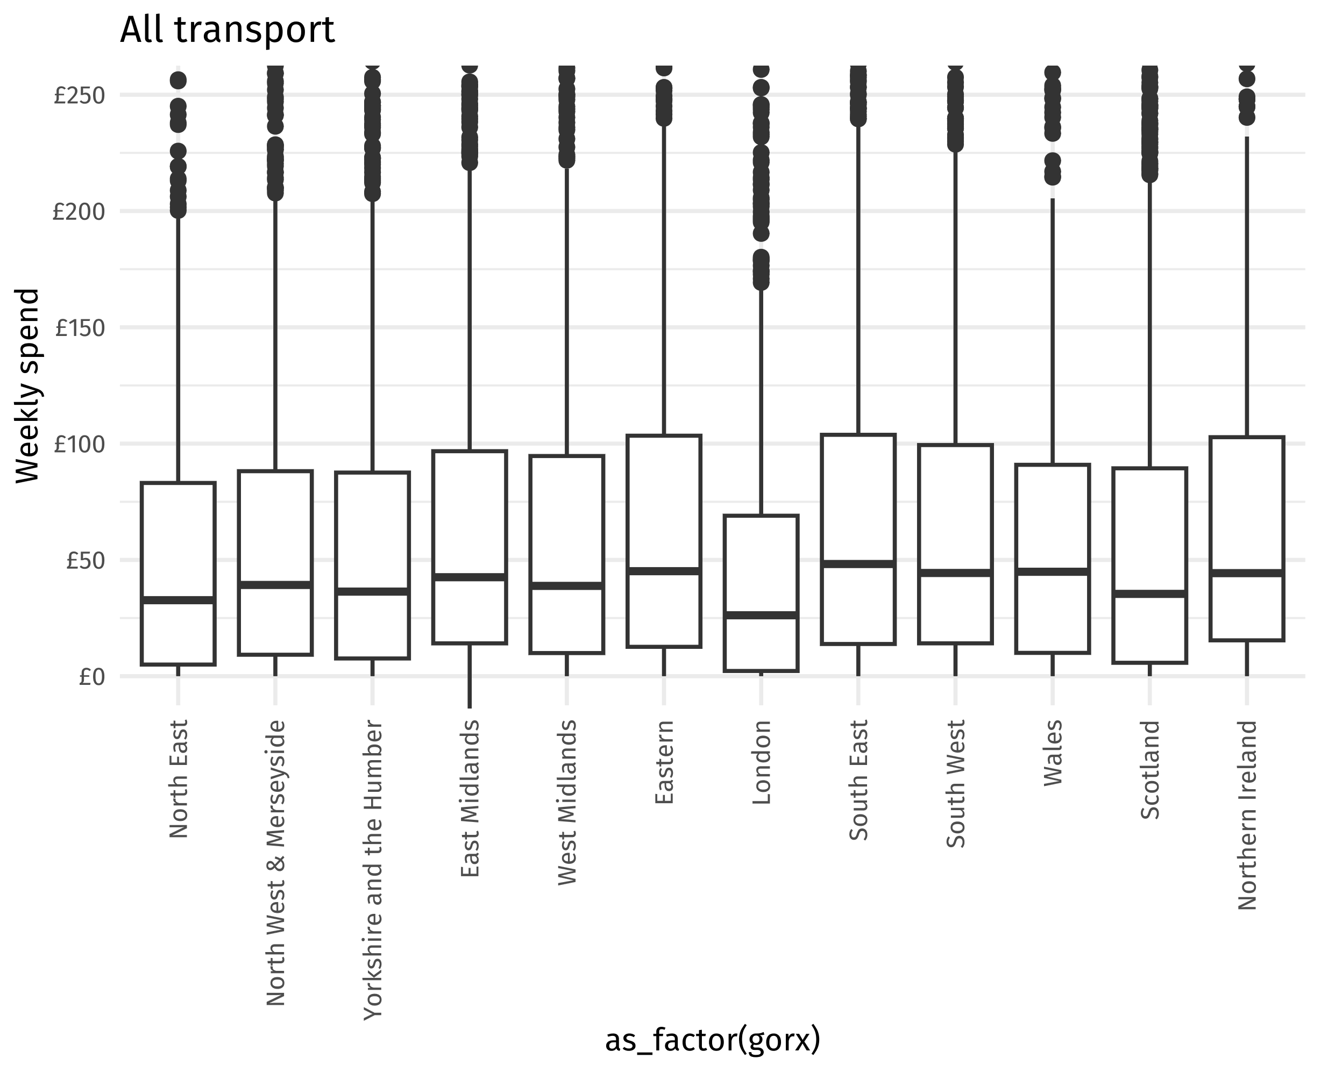
transport_boxplot + aes(y = private) + labs(title = "Private transport")
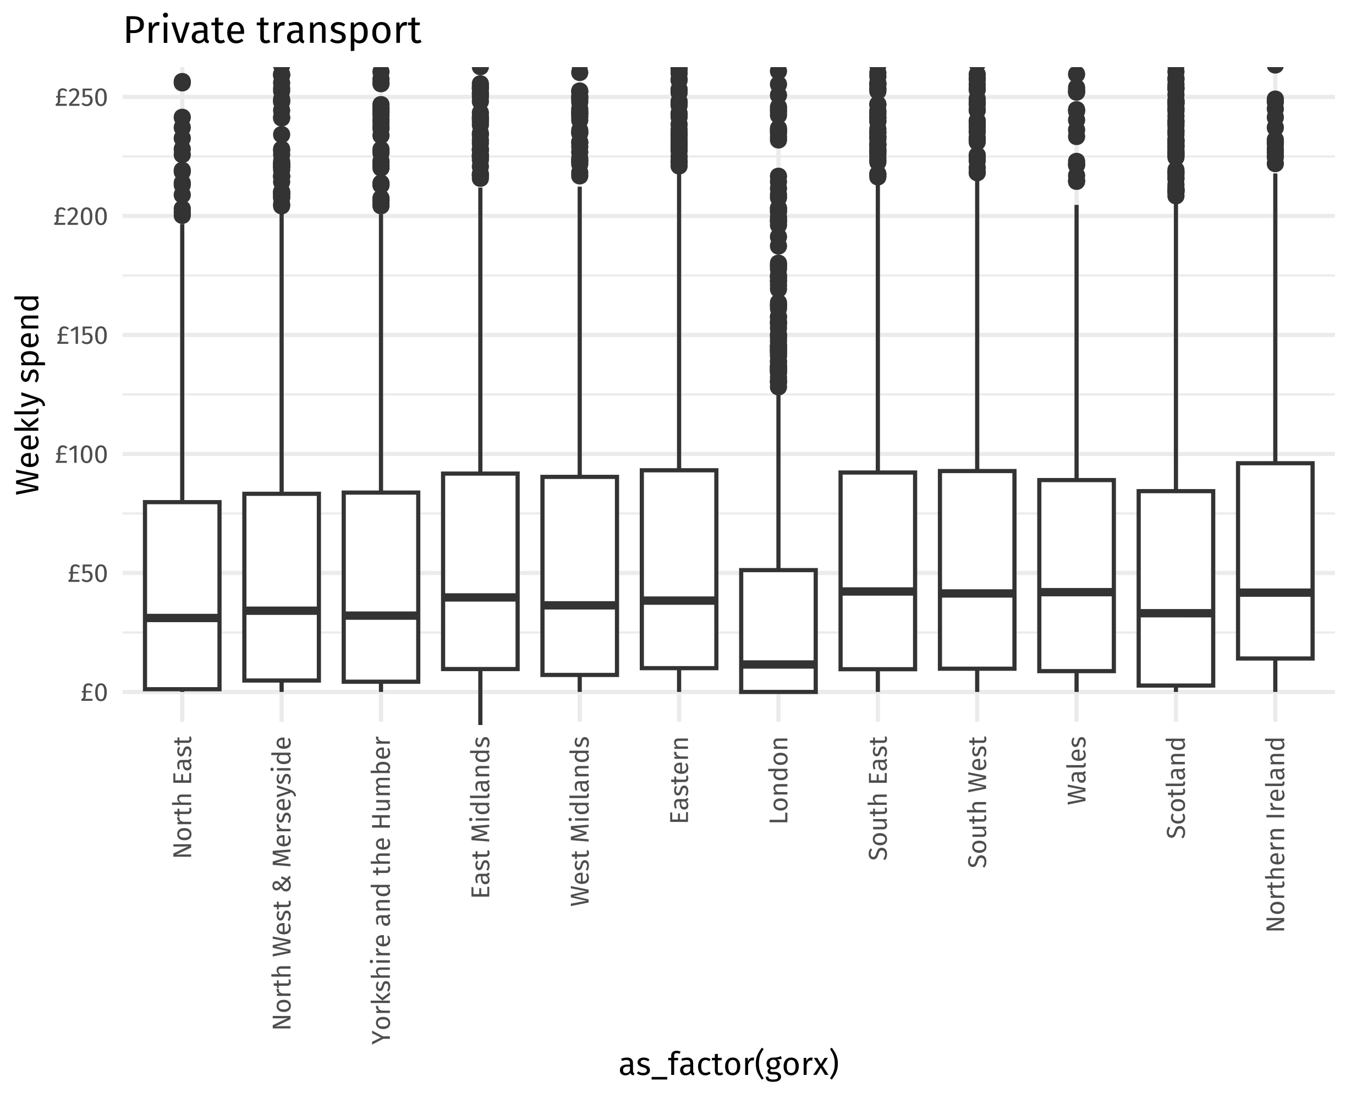
transport_boxplot + aes(y = public) + labs(title = "Public transport") + coord_cartesian(ylim = c(0,25))
## Coordinate system already present. Adding new coordinate system, which will
## replace the existing one.
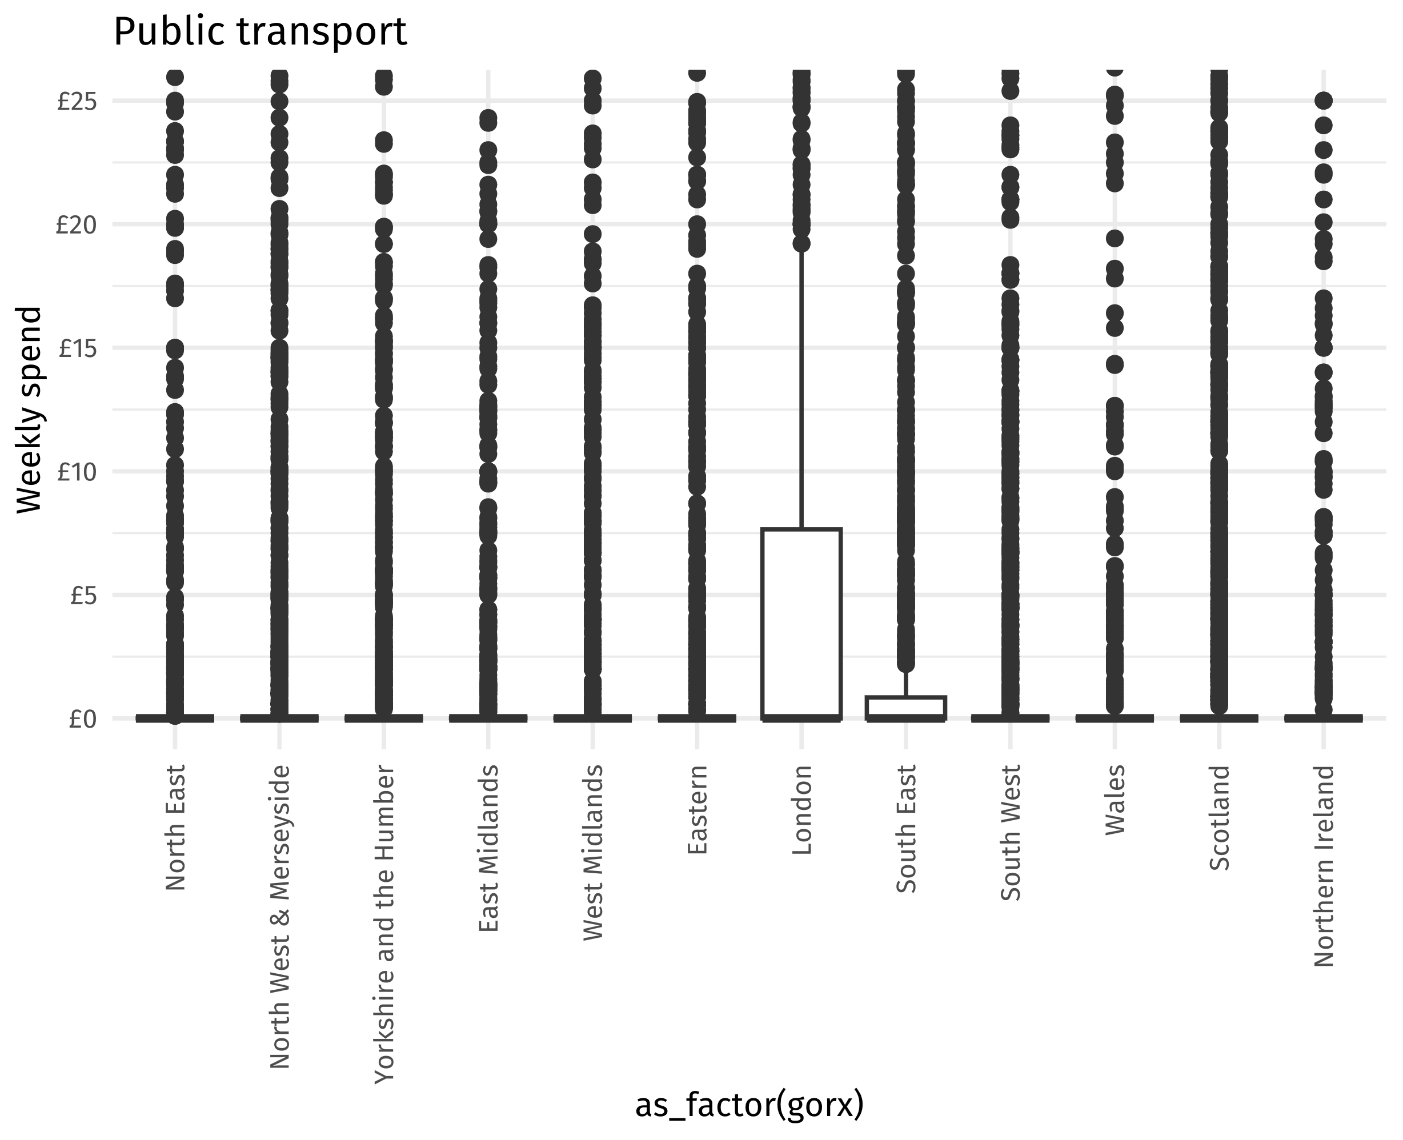

Region excluding zeros
lcfs_transport %>% mutate(target_var = air, x_var = gorx) %>% excl_zero_plot(title = "Air excluding zeros", ylim = c(0,300))
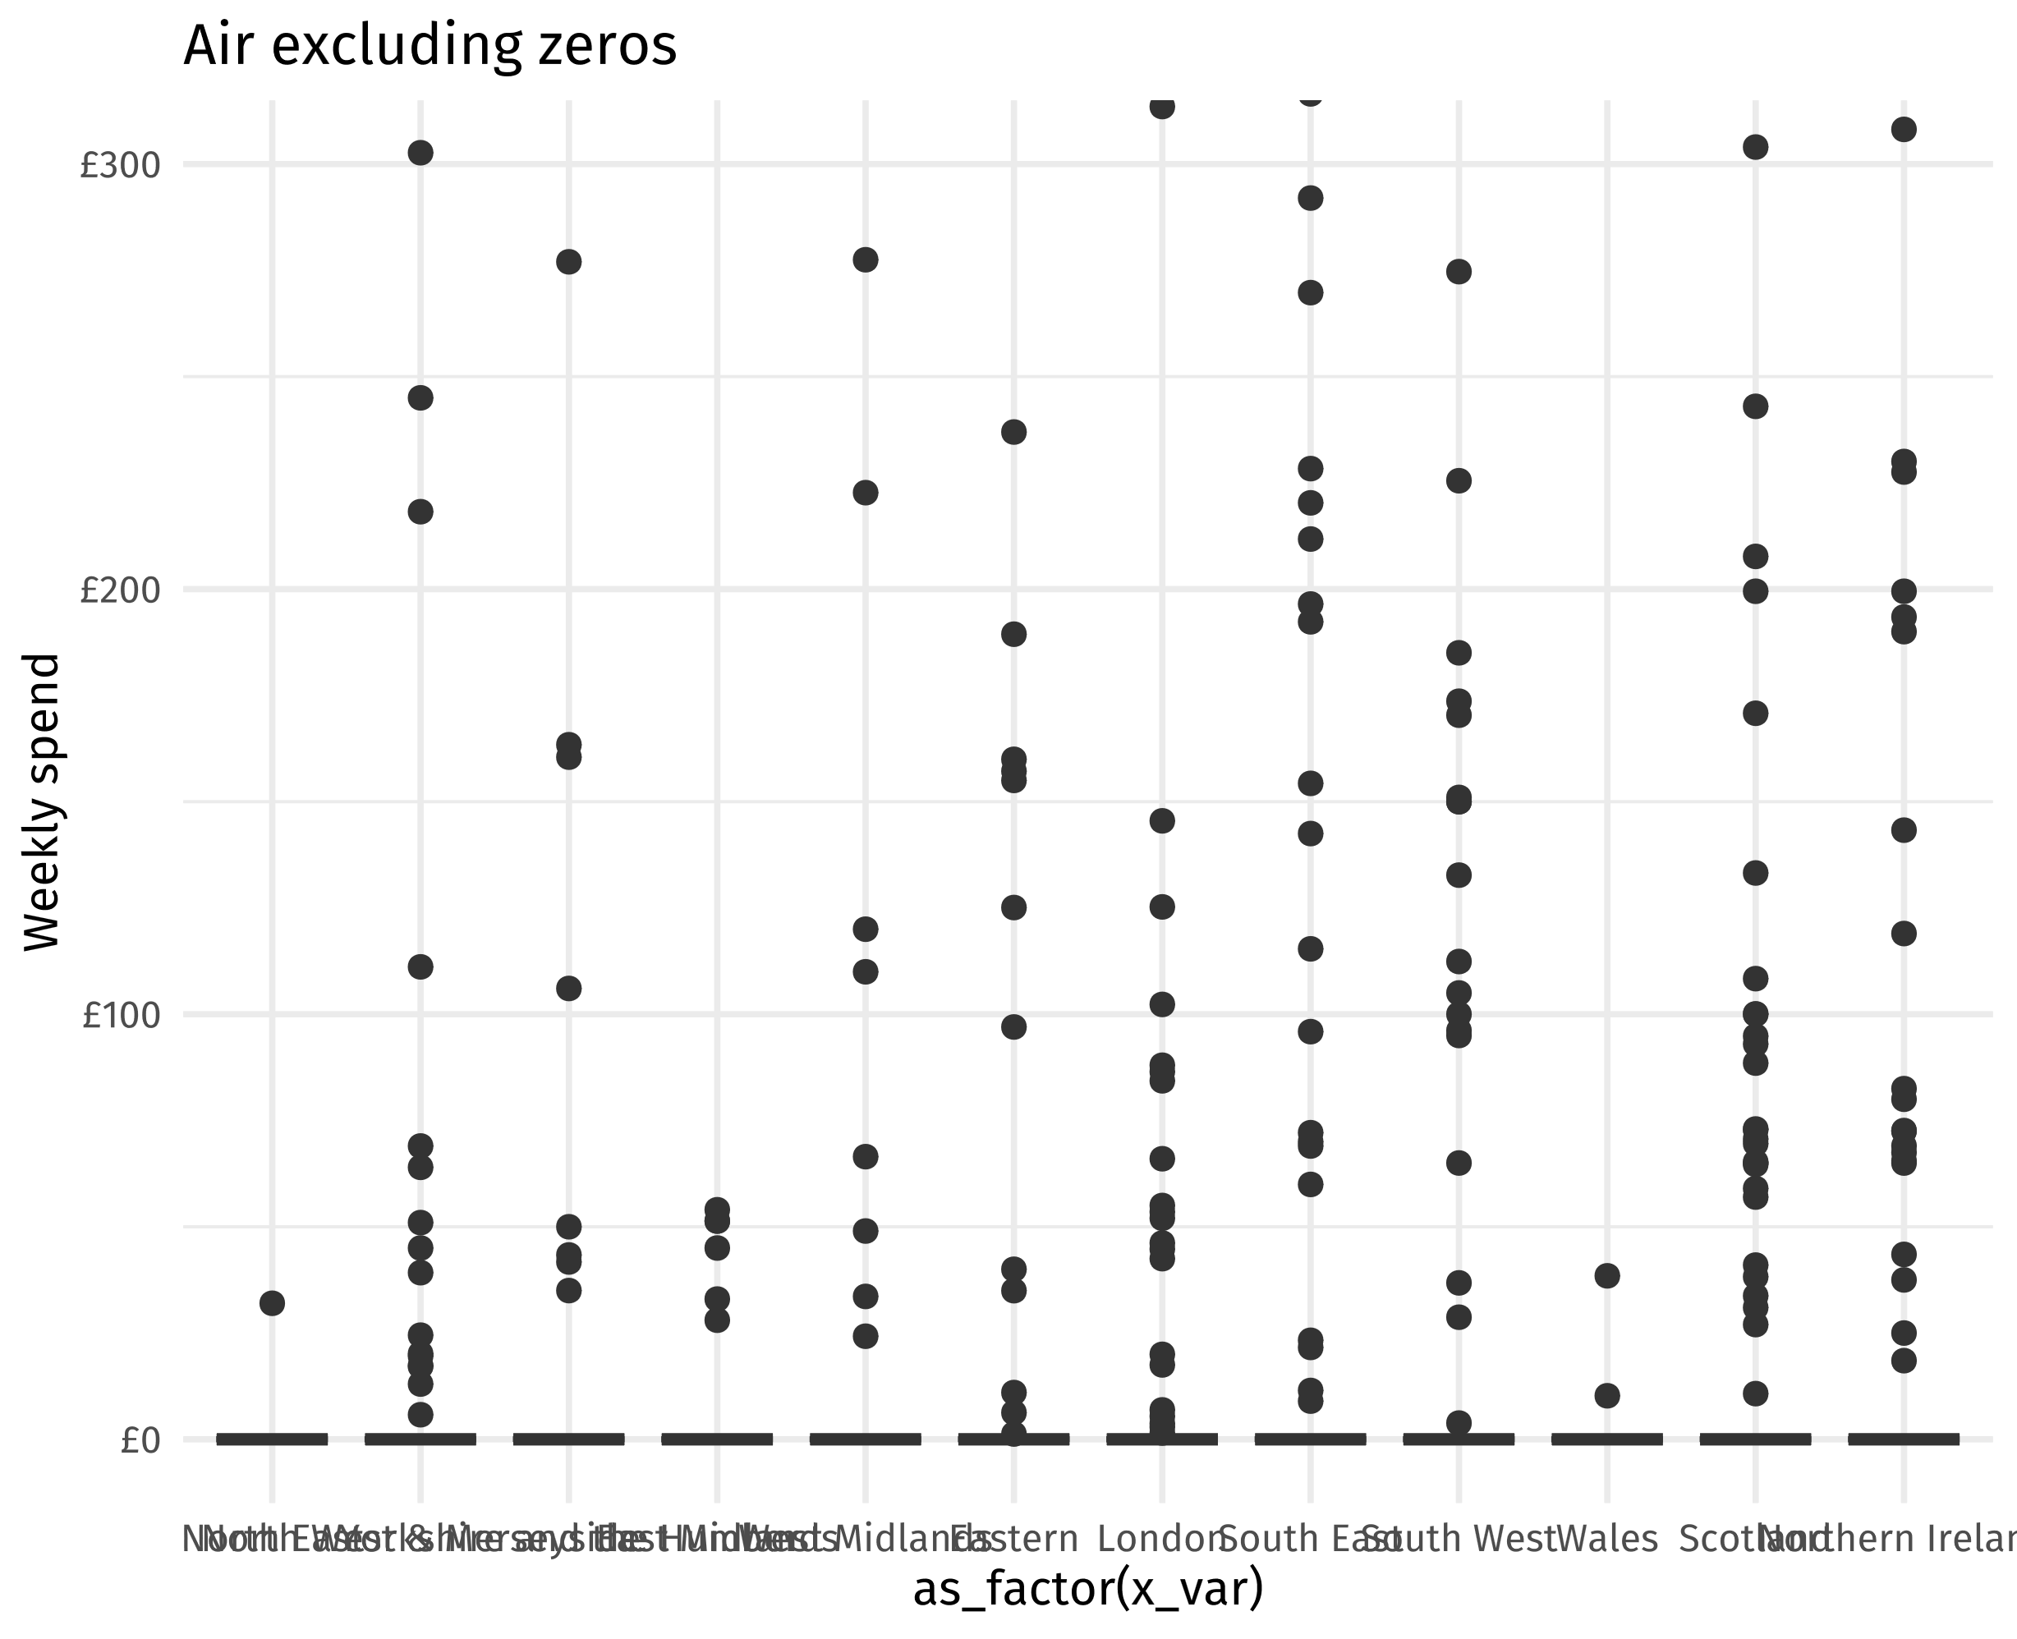
lcfs_transport %>% mutate(target_var = public, x_var = gorx) %>% excl_zero_plot(title = "Public excluding zeros", ylim = c(0,100))
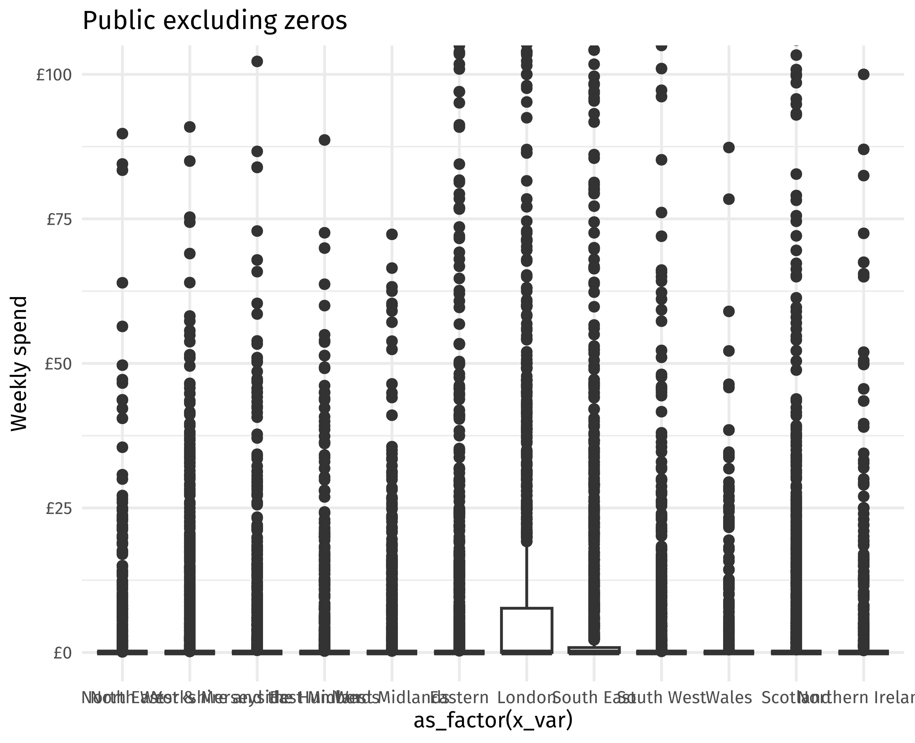
lcfs_transport %>% mutate(target_var = active, x_var = gorx) %>% excl_zero_plot(title = "Active excluding zeros", ylim = c(0,300))
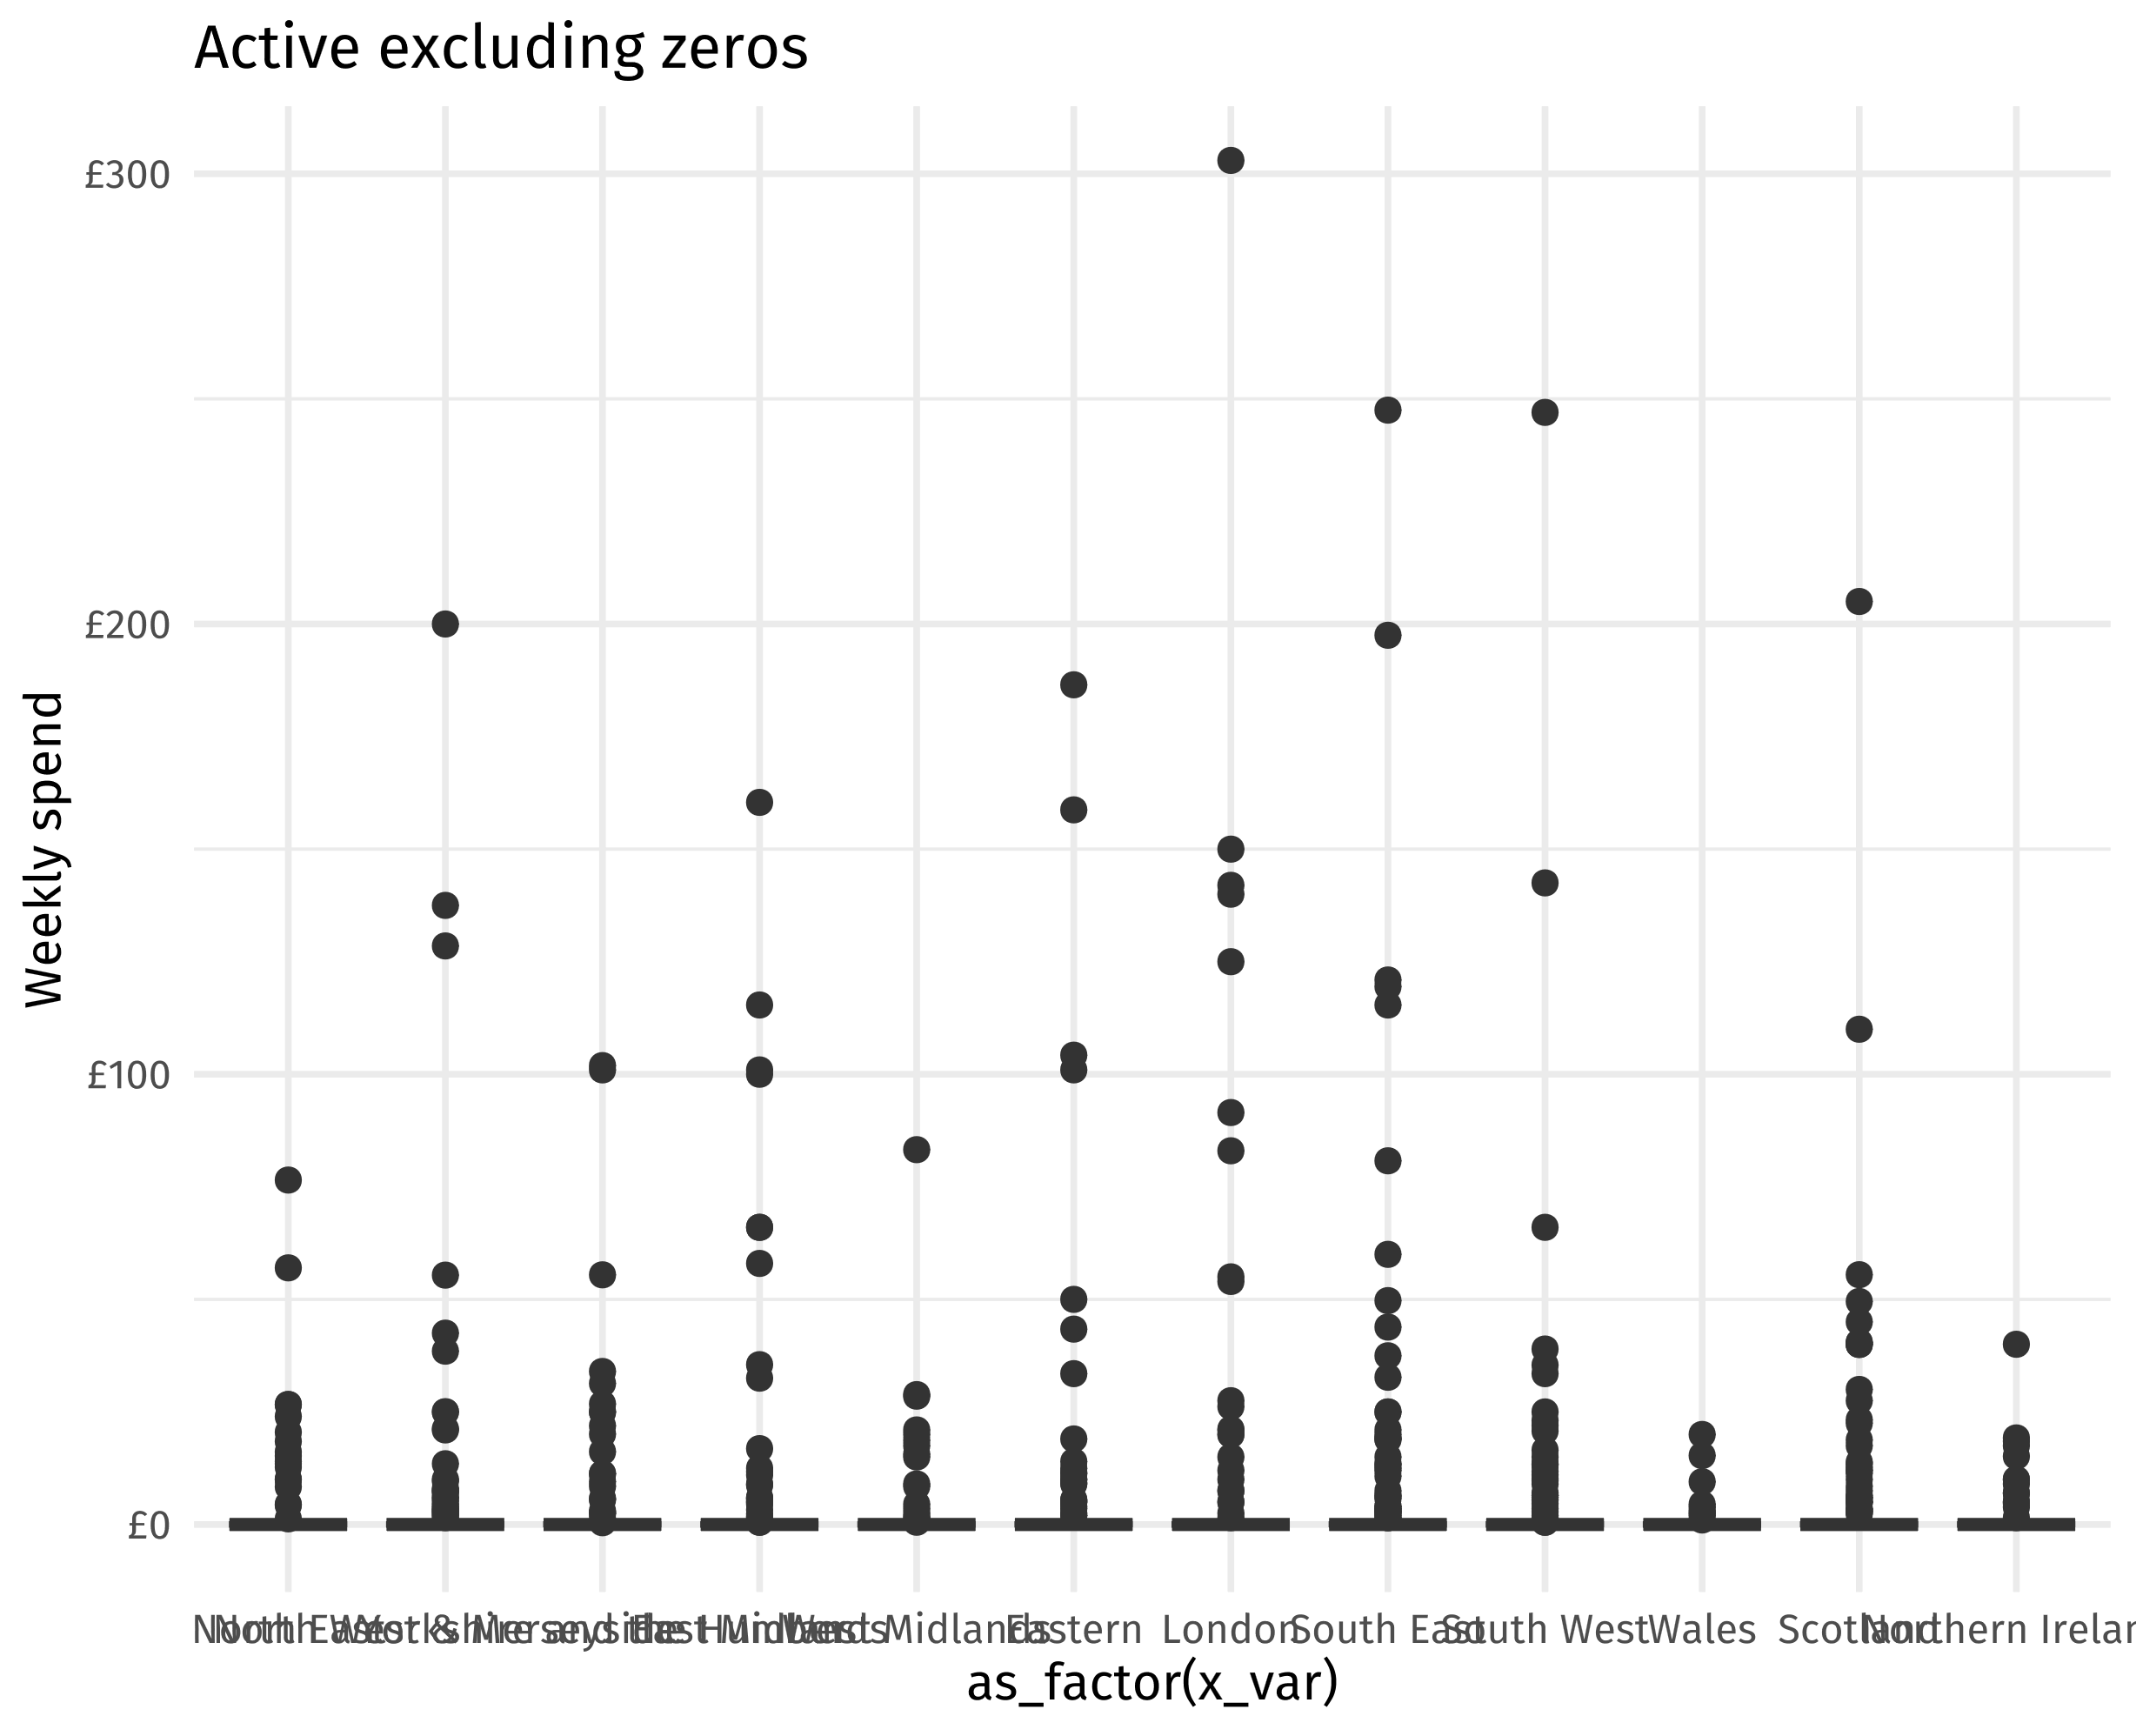

By number of vans / cars
lcfs_transport %>%
mutate(target_var = all_transport, x_var = a124) %>%
transport_plot(title = "All transport", ylim = c(0,500)) +
theme(axis.text.x = element_text(angle = 90, hjust = 1, vjust = 0.5)) +
xlab("Number of cars / vans")
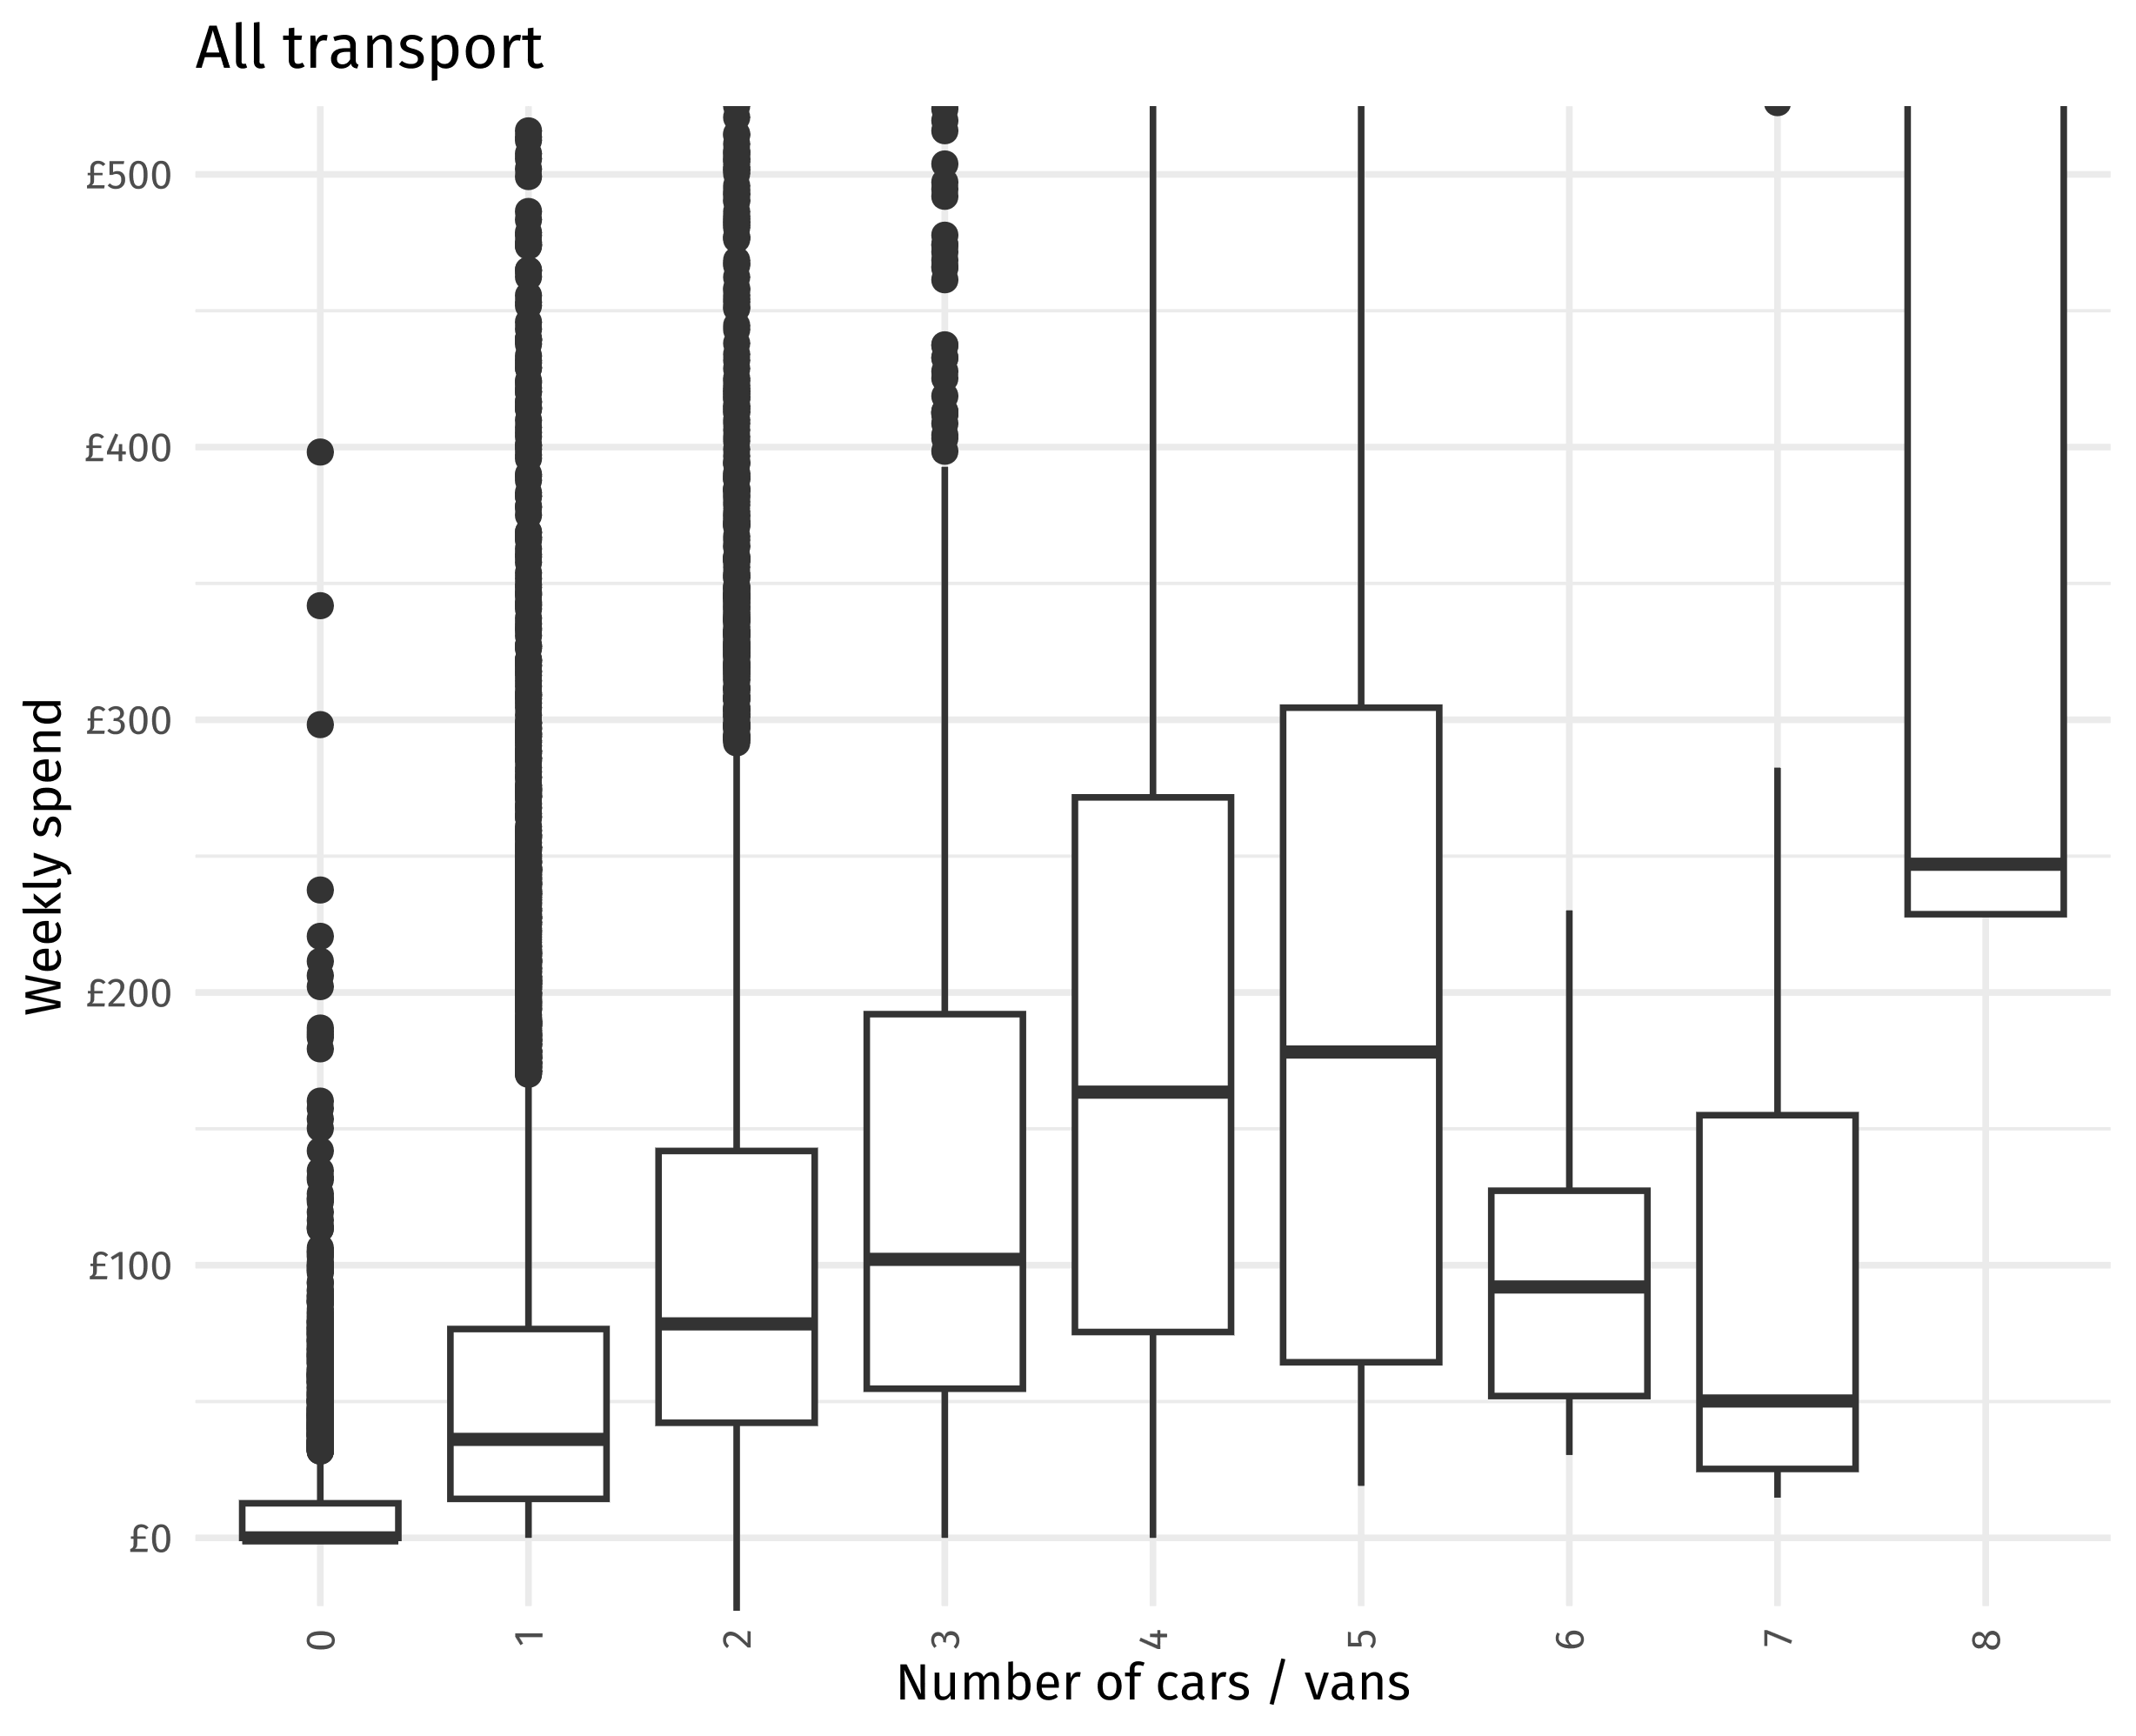
lcfs_transport %>%
mutate(target_var = private, x_var = a124) %>%
transport_plot(title = "Private transport", ylim = c(0,500)) +
theme(axis.text.x = element_text(angle = 90, hjust = 1, vjust = 0.5)) +
xlab("Number of cars / vans")
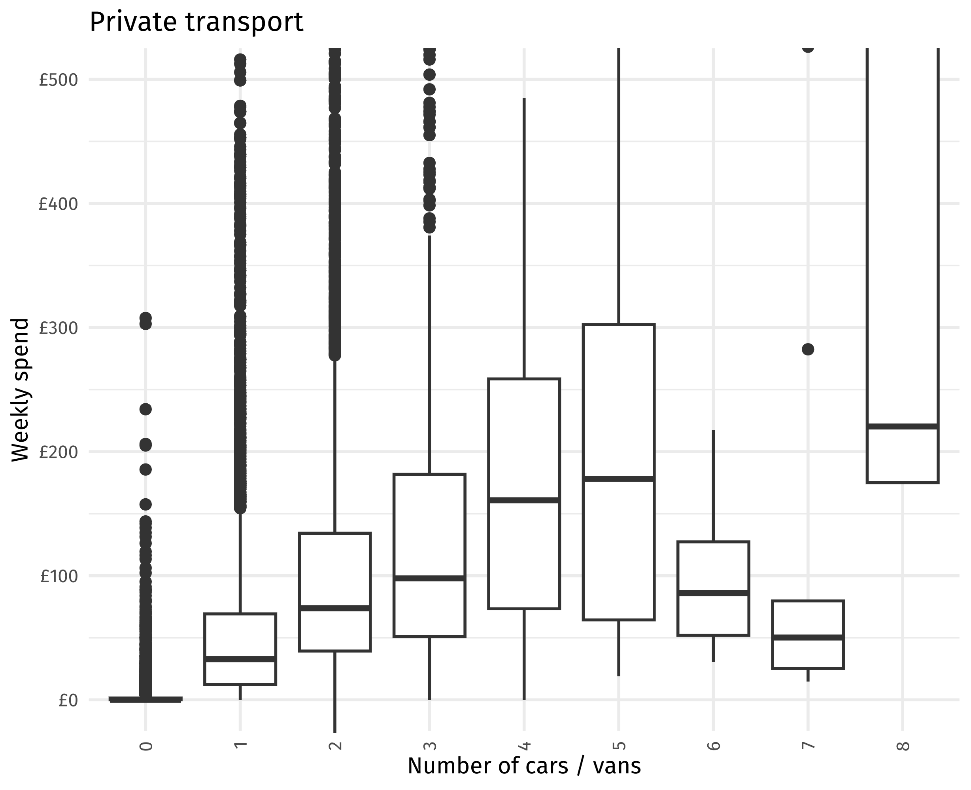
lcfs_transport %>%
mutate(target_var = public, x_var = a124) %>%
transport_plot(title = "Public transport", ylim = c(0,500)) +
theme(axis.text.x = element_text(angle = 90, hjust = 1, vjust = 0.5)) +
xlab("Number of cars / vans")
