
A PROJECT REPORT
ON
“RepoVitals: An Agentic RAG-Based Dependency Health Advisor for Node.js/npm and Python/PyPI Projects”
A project report submitted in partial fulfillment of the requirements for the degree of
BACHELOR OF TECHNOLOGY
IN
COMPUTER SCIENCE & ENGINEERING
Submitted By
Abhirami Nair — 23070122012
Anindita Bandopadhyaya — 23070122068
Astha Kumari — 23070122059
Spandan Dhawse — 23070122085
UNDER THE GUIDANCE OF
Dr. Ankur Goyal
Professor, Computer Science & Engineering
DEPARTMENT OF COMPUTER SCIENCE & ENGINEERING
SYMBIOSIS INSTITUTE OF TECHNOLOGY, PUNE
Symbiosis International (Deemed University)
AY 2026–27
Pune – 412115, Maharashtra, India

CERTIFICATE
This is to certify that the project work entitled “RepoVitals: An Agentic RAG-Based Dependency Health Advisor for Node.js/npm and Python/PyPI Projects” has been carried out by the following students of Bachelor of Technology in Computer Science & Engineering, Symbiosis Institute of Technology, Pune, during the academic year 2026–2027, in partial fulfillment of the requirements for the degree of Bachelor of Technology.
Table 1. Project group members
Student name | PRN
Abhirami Nair | 23070122012
Anindita Bandopadhyaya | 23070122068
Astha Kumari | 23070122059
Spandan Dhawse | 23070122085

The work described in this report is submitted for academic evaluation. The guide and institute shall verify the project status, contribution statements, final implementation, and attached institutional forms before signing.
Guide: Dr. Ankur Goyal
Co-guide (if applicable): ____________________________________
Date: ____________________
Place: Pune
Guide signature: ______________________________ Head of Department: ______________________________

DECLARATION
We hereby declare that the project report entitled “RepoVitals: An Agentic RAG-Based Dependency Health Advisor for Node.js/npm and Python/PyPI Projects”, submitted to Symbiosis Institute of Technology, a constituent of Symbiosis International (Deemed University), Pune, for the award of the degree of Bachelor of Technology in Computer Science & Engineering, describes work undertaken by our project group. This report has not previously been submitted, in whole or in part, to another university or institute for the award of a degree or diploma.
We have identified source material and technical artefacts supplied for this report and have cited them in the text and references. The final authors must review this document, confirm the factual statements, insert approved institutional reports, and sign this declaration before submission.
Degree: Bachelor of Technology in Computer Science & Engineering
Academic year: 2026–2027
Project title: RepoVitals: An Agentic RAG-Based Dependency Health Advisor for Node.js/npm and Python/PyPI Projects
Signatures of all group members:
Abhirami Nair (23070122012): __________________________________________
Anindita Bandopadhyaya (23070122068): __________________________________________
Astha Kumari (23070122059): __________________________________________
Spandan Dhawse (23070122085): __________________________________________
Date: ____________________ Place: Pune

ACKNOWLEDGEMENT
We express our sincere gratitude to our project guide, Dr. Ankur Goyal, for guidance and review throughout the development of RepoVitals. The project required coordinated work across repository scanning, scoring, retrieval-grounded reporting, research instrumentation, testing, and documentation; the feedback received during project reviews helped us keep the system’s claims aligned with its evidence.
We thank the Department of Computer Science & Engineering and Symbiosis Institute of Technology, Pune, for providing the academic setting and facilities in which this project was undertaken.
We also acknowledge the open-source communities and public services on which the prototype depends, including GitHub, npm, PyPI, OSV.dev, Django, React, LangGraph, Chroma, and the maintainers of the package ecosystems examined by the system. Their public interfaces and documentation make reproducible dependency analysis possible.
Finally, we thank our families, classmates, and peers for their encouragement and the constructive discussions that supported the completion of the project work.

ABSTRACT
Open-source packages are assembled into dependency trees that change continuously. A repository may depend on packages that are vulnerable, deprecated, or stale, while a warning from a conventional scanner still leaves the developer to interpret the package’s history and decide what action is justified. RepoVitals is a web-based dependency-health advisor for GitHub repositories using Node.js/npm and Python/PyPI. It validates repository access and supported manifests, reads dependencies from manifests and supported lockfiles, obtains registry and vulnerability signals, and computes an explainable 0–100 score with a deterministic, versioned formula. Its repository-level score is produced by aggregating occurrence-level penalties, while a separate flag rule identifies dependencies that merit human review. The score is not generated by a language model. On demand, the application produces a combined triage report or a per-dependency remediation report. The latter retrieves package documentation, applies a deterministic grounding gate, and generates a cited report whose retrieved evidence and execution trace remain inspectable. The system does not write to users’ repositories or create pull requests.
The checked project snapshot documents a deployed prototype with registration, scanning, npm and PyPI adapters, deterministic scoring, drill-down explanations, reports, project grouping, trend history, and a research corpus toolchain. The Review 3 material reports 11 of 14 implementation phases complete. A separate 17-repository research pilot recorded 410 dependency occurrences, of which 239 were flagged and one was unassessable; three pilot scores matched product scans exactly. These are preliminary engineering results, not a completed validation study. Formal scoring validation and the planned retrieval-grounding experiment remain pending in the supplied review record. The report describes the design, implementation, evidence, limitations, and next steps without treating planned experiments as completed findings.
Keywords: software supply-chain security; dependency health; deterministic scoring; retrieval-augmented generation; LangGraph; npm; PyPI; explainability.

TABLE OF CONTENTS
CHAPTER 1 · INTRODUCTION 1
1.1 Introduction 1
1.2 Background and project context 2
1.3 Problem statement 2
1.4 Aim and objectives 3
1.5 Scope and delimitations 4
1.6 Significance and motivation 5
1.7 Sustainable Development Goals 6
1.8 Program-outcome alignment 7
1.9 Organization of the report 8
CHAPTER 2 · LITERATURE REVIEW 9
2.1 Background 9
2.2 Review of related studies 9
2.3 Cross-study synthesis 21
2.4 Research and technology gaps 22
2.5 Research questions and contribution 23
2.6 Project novelty and positioning 24
2.7 Chapter summary 25
CHAPTER 3 · SOFTWARE REQUIREMENTS SPECIFICATION 26
3.1 Product perspective and user classes 26
3.2 Functional requirements 26
3.3 Non-functional requirements 30
3.4 External interface requirements 32
3.5 Software platform and technology stack 33
3.6 Hardware requirements and environment 34
3.7 Work breakdown structure 35
3.8 Cost estimation 36
3.9 Feasibility and constraints 37
3.10 Chapter summary 38
CHAPTER 4 · METHODOLOGY 39
4.1 Development methodology 39
4.2 System architecture 39
4.3 System context and actors 40
4.4 Repository validation and scan flow 41
4.5 Dependency adapter design 42
4.6 Data model 44
4.7 State and asynchronous processing 45
4.8 Deterministic scoring methodology 46
4.9 Retrieval-grounded remediation workflow 48
4.10 User interface and interaction design 49
4.11 Security and privacy design 50
4.12 Deployment design 51
4.13 Chapter summary 52
CHAPTER 5 · RESULTS AND DISCUSSION 53
5.1 Results scope and evidence sources 53
5.2 Implemented product outcomes 53
5.3 Corpus pilot results 54
5.4 Interpretation and formula caveats 56
5.5 Testing and debugging 57
5.6 Interface evidence 60
5.7 Project schedule status 61
5.8 Outcome mapping 62
5.9 Limitations and threats to validity 63
5.10 Chapter summary 64
CHAPTER 6 · CONCLUSION AND FUTURE SCOPE 65
6.1 Conclusion 65
6.2 Project contributions 66
6.3 Future work 66
6.4 Final conclusion 68
REFERENCES 69
APPENDICES 73
Appendix A · Project plan and review snapshot 73
Appendix B · Team work distribution 73
Appendix C · Representative test catalogue 74
Appendix D · Scoring example for oral examination 75
Appendix E · AIC report (mandatory institutional form) 76
Appendix F · Similarity report 76
Appendix G · AI plagiarism / AI writing report 77
Appendix H · Project outcome certificates 77
Appendix I · Source repository and implementation map 78

LIST OF TABLES
Table 1. Project group members i
Table 2. Abbreviations used in this report x
Table 3. Scope boundaries 4
Table 4. SDG mapping and limits 6
Table 5. Program-outcome mapping 7
Table 6. Thematic synthesis of the supplied literature 21
Table 7. Research questions and status 24
Table 8. Functional requirements 26
Table 9. Non-functional requirements 30
Table 10. External interfaces 32
Table 11. Technology stack and project use 33
Table 12. Environment requirements 34
Table 13. Fourteen-phase work breakdown and reported status 35
Table 14. Cost and resource assumptions 36
Table 15. Principal entities 44
Table 16. Implemented v1 weights in the checked repository snapshot 47
Table 17. Threat model and current mitigations 50
Table 18. Implemented outcomes and evidence limits 53
Table 19. Pilot score distribution by ecosystem (17 repositories total) 55
Table 20. Engineering results from the pilot run 55
Table 21. Representative test and acceptance matrix 58
Table 22. Outcomes against documented evidence 62
Table 23. Prioritized future work 66
Table B.1. Role distribution from the supplied collaboration slide 73
Table C.1. Test-suite groupings 75
Table F.1. Similarity appendix completion fields 77
Table G.1. AI report completion fields 77
Table I.1. Repository map for viva and maintenance 78

LIST OF FIGURES
Figure 1. Layered RepoVitals architecture and external data exchanges 40
Figure 2. System context showing the user and external services 41
Figure 3. Activity sequence from repository submission to explained score 42
Figure 4. Level-0 data-flow diagram for scans, reports, data stores, and external sources 42
Figure 5. Adapter class boundary and the common scan–score–report flow 43
Figure 6. Conceptual ERD: operational records and permanent history are separated 45
Figure 7. Simplified state transitions for scans, reports, and guarded rescans 46
Figure 8. Two-level deterministic score and independent flag/classification decisions 48
Figure 9. LangGraph steps for a per-dependency report; combined triage bypasses retrieval 49
Figure 10. Repository drill-down illustration from the supplied Review 3 presentation (sample data) 50
Figure 11. Demo deployment topology and trust boundaries 52
Figure 12. Repository drill-down user interface as illustrated in Review 3; data is sample data 61
Figure 13. Review 3 schedule snapshot, with phases 1–11 complete and later work pending 62
Figure A.1. Week-level project plan as recorded in Review 3 73

LIST OF ABBREVIATIONS
Table 2. Abbreviations used in this report
Abbreviation | Expansion / meaning
AHP | Analytic Hierarchy Process
API | Application Programming Interface
BOLA | Broken Object-Level Authorization
CI | Continuous Integration
CVE | Common Vulnerabilities and Exposures
CVSS | Common Vulnerability Scoring System
DFD | Data-Flow Diagram
DRF | Django REST Framework
EPSS | Exploit Prediction Scoring System
ERD | Entity-Relationship Diagram
HTTP(S) | Hypertext Transfer Protocol (Secure)
LLM | Large Language Model
MCDM | Multi-Criteria Decision-Making
MVP | Minimum Viable Product
NFR | Non-Functional Requirement
npm | Node Package Manager
OSV | Open Source Vulnerabilities
OWASP | Open Worldwide Application Security Project
PEP | Python Enhancement Proposal
PyPI | Python Package Index
RAG | Retrieval-Augmented Generation
REST | Representational State Transfer
SDG | Sustainable Development Goal
SIT | Symbiosis Institute of Technology
SPA | Single-Page Application
SSRF | Server-Side Request Forgery
UI | User Interface
UX | User Experience
WP | Work Package

CHAPTER 1

INTRODUCTION

1.1 Introduction
Modern software is rarely assembled only from code written inside one repository. Applications depend on external libraries that supply web frameworks, data structures, parsers, authentication, networking, build tooling, and many other capabilities. This reuse accelerates development, but it also means that a change in the state of a dependency can affect the security and maintainability of the application that consumes it.
A dependency may become vulnerable after a public advisory is released; its maintainer may deprecate it or recommend a replacement; or releases may stop while the surrounding ecosystem continues to evolve. These conditions are not equivalent. A known vulnerability is evidence of a disclosed weakness, deprecation is a maintainer signal, and staleness is a proxy whose meaning depends on the package’s release pattern and context. A useful assessment tool should therefore retain the underlying signals and explain how each affected the final result.
RepoVitals combines repository-level dependency scanning with a deterministic scoring engine and an optional retrieval-grounded remediation workflow. It supports Node.js/npm and Python/PyPI. The scanner reads supported manifests from the repository tree, consults package metadata and OSV.dev, and stores the observations used in scoring. The UI presents a repository score and a dependency-level explanation. When requested, a report agent can retrieve a package changelog or README and provide a cited summary; generation is deliberately separate from scoring.

1.2 Background and project context
Dependency maintenance is an information-integration problem as much as a detection problem. The version written in a manifest may be a range rather than the version resolved by a package manager. A repository may have several manifests in a monorepo. A vulnerability feed may report multiple advisories for one package, with some advisories lacking a CVSS value. Package registries expose different metadata, and a package that is unavailable on a public registry may be a private, local, or Git-based dependency rather than a clean package.
The project is framed as an advisor, not an automated repair bot. It reads a repository and external metadata, shows a score and its component signals, and proposes possible next actions. It does not modify source code, push commits, or open pull requests. This boundary lowers the risk of an incorrect recommendation being applied without review and makes the report an aid to engineering judgment.
The supplied proposal used the working name DepScan-AI in some early material. The public code repository, review presentation, and current project identity use RepoVitals; this report therefore uses RepoVitals consistently. The system snapshot used here is the public repository at commit e95ae63 dated 24 September 2026, supplemented by the supplied Review 3 presentation and project documents.

1.3 Problem statement
Developers lack a single lightweight view that combines repository-level dependency health signals, a reproducible risk score, and an evidence-backed explanation of remediation options across the npm and PyPI ecosystems. Existing warning-oriented workflows can identify a problem, but developers still have to locate relevant changelogs or migration notes and judge whether a proposed update is appropriate. RepoVitals addresses the gap by assessing declared dependencies in context, making the score traceable to stored inputs, and presenting on-demand recommendations alongside the source text used to ground them.

1.4 Aim and objectives
Aim: to design, implement, and evaluate a web-based system that turns dependency manifests from eligible GitHub repositories into an interpretable dependency-health assessment and a cautious, evidence-linked remediation report.
- Provide GitHub-based sign-in and server-side session handling for the web application.
- Validate repository reachability, user access eligibility, duplicate registration, and supported manifest presence before accepting a repository.
- Discover supported npm and PyPI manifests across repository trees and parse them through a common adapter interface.
- Resolve versions using supported lockfiles where available and explicitly retain dependencies that cannot be assessed.
- Collect deprecation, vulnerability, version, and release-age signals from registries and OSV.dev.
- Compute deterministic per-occurrence penalties and a repository-level score with a versioned, explainable formula.
- Expose flagged dependencies and their signal-level reasons through a repository drill-down interface.
- Offer combined triage and per-dependency retrieval-grounded reports with citations, a confidence indicator, stored outputs, and export options.
- Enforce object-level authorization, restrict outbound network destinations, protect tokens, and ensure the operational code path does not write to GitHub.
- Retain scan and dependency history and agent traces so later controlled evaluations can be conducted without rebuilding the product pipeline.

1.5 Scope and delimitations
The implemented product covers npm and PyPI, manually registered repositories, manual rescans, supported manifests and lockfiles, deterministic scoring, repository detail, projects and trends, and on-demand reports. The review snapshot reports the first eleven of fourteen implementation phases complete. Corpus collection and scanning form a separate research workflow and are designed to write only to a separate research database; they must not contaminate the product’s live history.
The system does not continuously monitor pushes, apply fixes, create pull requests, parse every lockfile format, or claim production-scale multi-tenant reliability. It does not fully understand application call sites or cross-service behavioral contracts. A public issue-search retrieval utility is restricted to research commands rather than exposed to normal report requests, because issue text is user-generated and carries a different prompt-injection risk from reviewed package documentation.
Table 3. Scope boundaries
Included in the product snapshot | Outside MVP / limitation
npm and PyPI dependency scanning through shared adapters | Additional ecosystems such as Maven, Go, and Rust
On-demand scans and persistent trend history | Push-triggered or continuous scanning
Deterministic score plus inspectable signal breakdown | A fully validated v2 weight set; validation remains pending
Cited per-dependency RAG report; combined triage report | Automatic patch application, pull requests, or guaranteed correctness
Manifest and supported lockfile parsing | All packaging formats and executable project metadata
Repository-level dependency evidence | Call-site, API-contract, and integration-level impact analysis

1.6 Significance and motivation
The motivation is not to replace mature vulnerability databases or commercial scanners. RepoVitals concentrates on a narrower workflow: make a dependency assessment comparable at repository level, explain the arithmetic, and make remediation advice inspectable. The supplied literature survey reports dependency amplification in npm projects and argues that transitive dependency chains increase the amount of software a developer may need to reason about. The project responds by surfacing direct manifest declarations and their observable metadata; it does not claim a complete dependency graph or transitive package inventory.
Separating the score from language-model generation is a central design choice. The same stored signal record and the same weights version should always produce the same score. Natural-language generation is used only for optional explanation and must show its evidence. This separation allows the project to test retrieval and generation without allowing model variability to silently alter a security score.
A second motivation is portability. npm and PyPI have different manifest conventions and release metadata. By keeping ecosystem-specific parsing behind an adapter interface, the project can test whether one scanner and scorer operate over multiple ecosystems without embedding ecosystem branches throughout every layer.

1.7 Sustainable Development Goals
The project team’s supplied SDG mapping associates RepoVitals with goals that relate to resilient digital infrastructure, productivity, trustworthy digital services, and collaboration across open-source infrastructure. These are contribution claims rather than measured social-impact outcomes.
Table 4. SDG mapping and limits
SDG | Goal | Project-level justification | Claim boundary
SDG 9 | Industry, Innovation and Infrastructure | Improves visibility into software dependencies used in digital infrastructure. | A prototype; no measured sector-wide security improvement.
SDG 8 | Decent Work and Economic Growth | Automates part of dependency triage and may reduce manual research effort. | Time savings and economic impact have not been experimentally measured.
SDG 16 | Peace, Justice and Strong Institutions | Supports software supply-chain transparency and reviewable security advice. | Does not certify software or prevent attacks on its own.
SDG 17 | Partnerships for the Goals | Uses public services and open-source ecosystems as shared infrastructure. | The system is an integration example, not a formal partnership.

1.8 Program-outcome alignment
Table 5. Program-outcome mapping
PO | Outcome area | Evidence from project work
PO1 | Engineering knowledge | Applies software engineering, web systems, data processing, scoring, and retrieval.
PO2 | Problem analysis | Frames repository health and explainable remediation as a distinct workflow.
PO3 | Design/development | Uses layered architecture and a shared adapter boundary.
PO4 | Investigation | Includes a corpus pilot and plans controlled scoring and RAG studies.
PO5 | Modern tools | Uses Django, React, GitHub APIs, OSV.dev, LangGraph, Chroma, and fastembed.
PO6 | Engineer and society | Considers software supply-chain exposure and repository-owner control.
PO7 | Environment and sustainability | Constrains the demo to free tiers and lightweight embedding/runtime choices.
PO8 | Ethics | Separates suggestions from writes and records evidence and confidence.
PO9 | Individual and team work | Divides implementation, research-data, documentation, and review deliverables.
PO10 | Communication | Provides explainable score details, citations, report exports, and this report.
PO11 | Project management | Uses 14 phases, work packages, review gates, and a week-level schedule.
PO12 | Life-long learning | Engages with current work on software security, RAG, and dependency ecosystems.

1.9 Organization of the report
Chapter 1 introduces the problem, objectives, scope, and SDG/PO mapping. Chapter 2 reviews the supplied research literature and derives the project gaps. Chapter 3 records the software requirements, tools, constraints, and work plan. Chapter 4 explains the system design and implementation methodology. Chapter 5 reports implementation status, test coverage, and the documented pilot results while separating pending evaluation from achieved outcomes. Chapter 6 presents the conclusion and future work. References and appendices follow.

CHAPTER 2

LITERATURE REVIEW

2.1 Background
The reviewed work spans four related areas: software vulnerabilities and supply-chain risk; dependency lifecycle and migration; retrieval-augmented generation for software tasks; and methods for making multi-signal scores or AI outputs more interpretable. These topics overlap, but no single source in the supplied literature survey is described as combining all of them in one repository-level tool.
The review below is a critical synthesis of the summaries supplied with the project materials. It identifies what each source contributes to the design argument and what it does not establish. Complete publication metadata—such as journal or conference, volume, pages, DOI, and stable publication URLs—was not included for most entries in the supplied survey. The reference list therefore preserves the known author, year, and title information and explicitly asks the group to verify the remaining bibliographic fields before final institutional submission.
The supplied survey’s narrative states that it synthesizes 22 papers, while its written summaries contain 23 distinct study titles. This draft retains all 23 distinct titles visible in the supplied material and flags the count discrepancy for the group to reconcile against the original bibliography.

2.2 Review of related studies
The sources are grouped conceptually rather than treated as interchangeable evidence. The first group concerns vulnerability and dependency ecosystems; the second concerns scoring and decision methods; the third concerns RAG, agent design, faithfulness, and traceability.

2.2.1 LLMs in Software Security: A Survey of Vulnerability Detection Techniques and Insights
Sheng et al. (2025): The supplied survey describes a synthesis of LLM-based vulnerability detection datasets, model architectures, evaluation methods, and research trends. It is relevant because it places language models within software-security workflows and distinguishes model-assisted reasoning from conventional static or rule-based checks.
Critical relevance and limitation: Its focus is vulnerability detection, not deterministic repository-level dependency scoring or evidence-grounded upgrade guidance. RepoVitals therefore uses this work as background for the AI component, not as evidence that an LLM should calculate the score.

2.2.2 Understanding Vulnerabilities in Software Supply Chains
Shen et al. (2025): This empirical study is summarized as examining vulnerability origin, propagation, localization, and repair across software supply chains. It supports the project’s premise that dependency risk is distributed across interconnected packages and that repository-level context matters.
Critical relevance and limitation: The supplied summary does not describe an end-to-end dependency advisor. RepoVitals narrows its own claim to manifest-based assessment and explicitly does not claim complete transitive-chain analysis.

2.2.3 Automating Dependency Updates in Practice: An Exploratory Study on GitHub Dependabot
He et al. (2023): The supplied review reports that this study evaluates Dependabot in real development settings. Its relevance is the practical distinction between detecting or proposing a version update and explaining the contextual reasoning a developer needs before accepting that update.
Critical relevance and limitation: The study is about an existing update bot, not a general risk score or RAG grounding experiment. RepoVitals positions itself as complementary decision support rather than a replacement for Dependabot.

2.2.4 Secure Supply Chain Management in DevOps: Addressing SBOM Risks
Seknametla (2025): The survey describes work on operationalizing Software Bills of Materials in DevOps and improving visibility and risk management. The topic supports the broader motivation for capturing dependency information as structured data.
Critical relevance and limitation: The work, as summarized, does not provide AI-based remediation or repository-level scoring. RepoVitals’ stored manifest and vulnerability observations are not represented as a full SBOM unless a separate export is implemented.

2.2.5 How Deep Does Your Dependency Tree Go? An Empirical Study of Dependency Amplification Across 10 Package Ecosystems
Arafat (2025): The supplied survey reports measurements across 500 projects and ten package ecosystems, including an npm average dependency-amplification factor of 4.32 and roughly 12% of projects above ten. These figures motivate attention to the scale of dependency exposure.
Critical relevance and limitation: The work is described as a measurement preprint, not a detection or remediation system, and its figures are quoted only as reported in the supplied survey. RepoVitals’ current scanner focuses on declared manifest occurrences rather than asserting a complete transitive tree.

2.2.6 Detecting and Characterizing Low and No Functionality Packages in the NPM Ecosystem
Tevarut et al. (2025): The survey summarizes static analysis for identifying trivial or low-functionality npm packages. This contributes a package-quality perspective beyond vulnerability advisories and illustrates that dependency risk signals may include lifecycle and package characteristics.
Critical relevance and limitation: The study is npm-specific and does not supply a cross-ecosystem scoring formula or grounded remediation workflow. Low-functionality analysis is not claimed as a RepoVitals signal in the current implementation.

2.2.7 A Comprehensive Study of the Lifecycle of Dormant npm Packages
Zerouali et al. (2026): This work is described as studying lifecycle characteristics of dormant npm packages. It makes package age and release inactivity plausible indicators for further analysis, while reminding the reader that dormancy is not the same thing as a known vulnerability.
Critical relevance and limitation: The supplied summary does not present an AI remediation system. RepoVitals includes release staleness as one normalized signal but treats it as a proxy, not a proof that a package is unsafe.

2.2.8 A Comprehensive Framework for Supplier Selection: Using Subjective, Objective, and Hybrid Multi-Criteria Decision-Making Techniques With Sensitivity Analysis
Boukrouh et al. (2025): The supplied survey describes comparison of AHP, entropy, and hybrid weighting methods, with sensitivity analysis. This provides methodological context for making a multi-signal score explicit and testing whether its weights are fragile.
Critical relevance and limitation: The application domain is supplier selection, not software dependencies. The analogy supports a method choice but cannot validate RepoVitals’ weights; that requires project-specific data and independent references.

2.2.9 Seven Failure Points When Engineering a Retrieval Augmented Generation System
Barnett et al. (2024): This source is summarized as identifying engineering challenges, trade-offs, and failure points in RAG system construction. It informs the need to handle retrieval, corpus construction, and evidence display as separate reliability concerns.
Critical relevance and limitation: The supplied summary does not study package remediation. RepoVitals applies general RAG engineering principles in a constrained single-pass setting and still requires a domain-specific faithfulness evaluation.

2.2.10 Applying Generative Artificial Intelligence for Vulnerability Fixing in a Proprietary Software Ecosystem
Costa et al. (2025): The supplied survey describes PSECO-SafePatch, an AI-assisted vulnerability-fixing framework with human validation. It demonstrates a relevant design principle: generated remediation should remain subject to review rather than being treated as an automatically safe patch.
Critical relevance and limitation: The work addresses a proprietary ecosystem and patching, while RepoVitals only recommends version or replacement actions and does not modify code. The two systems are therefore related but not directly comparable.

2.2.11 Retrieval Augmented Generation Evaluation in the Era of Large Language Models: A Comprehensive Survey
Gan et al. (2025): The supplied summary covers internal and external evaluation of RAG, including retrieval, generation, and faithfulness. It gives RepoVitals a useful vocabulary for separating whether relevant evidence is retrieved from whether a generated claim is actually supported.
Critical relevance and limitation: The survey is general-purpose and does not define dependency-remediation ground truth. RepoVitals’ planned study must construct a task-specific item set and disclose how its judge is validated.

2.2.12 RAP-RAG: A Retrieval-Augmented Generation Framework with Adaptive Retrieval Task Planning
Ji et al. (2025): RAP-RAG is described as selecting among vector, local, dual, or topology-enhanced retrieval strategies according to query complexity. It informs possible future retrieval escalation when the package changelog alone provides insufficient context.
Critical relevance and limitation: The project’s live agent does not implement the adaptive multi-source planner in the paper. Issue/discussion retrieval is restricted to internal research tooling, so this paper motivates a future question rather than describing an existing feature.

2.2.13 Self-Admitted Library Migrations in Java, JavaScript, and Python Packaging Ecosystems: A Comparative Study
Gu et al. (2023): The survey describes mining repository histories for self-admitted library migrations across Maven, npm, and PyPI. This cross-ecosystem perspective motivates an adapter-based design and provides context for studying dependency changes.
Critical relevance and limitation: Migration behavior is distinct from automated health scoring and remediation. RepoVitals does not mine repository history as part of its normal scan.

2.2.14 Creating Characteristically Auditable Agentic AI Systems
Phiri (2025): The supplied survey presents an auditability framework with properties such as integrity, coverage, verifiability, accessibility, and governance alignment. These concepts align with retaining retrieval chunks, scores, and generation traces.
Critical relevance and limitation: The framework is general rather than dependency-specific. Logging is an architectural mechanism; its presence alone does not demonstrate that a report is faithful or that a user can independently reproduce the result.

2.2.15 Benchmarking Retrieval Strategies for Biomedical Retrieval-Augmented Generation: A Controlled Empirical Study
Bal and Puhan (2026): The survey notes a controlled comparison of retrieval strategies with a no-context baseline and an ablation design. The methodological relevance is the value of comparing systems under matched inputs rather than comparing unrelated generations.
Critical relevance and limitation: The domain is biomedical question answering. RepoVitals adapts the experimental pattern to software dependencies and must not import the paper’s results as if they applied to code remediation.

2.2.16 Demystifying LLM-Based Software Engineering Agents
Xia et al. (2025): The supplied survey identifies Agentless as evidence that a carefully designed non-agentic pipeline can perform strongly on a software-engineering benchmark with lower complexity. It supports the project’s decision to keep the workflow bounded rather than maximize autonomy.
Critical relevance and limitation: The work concerns program repair benchmarks, not dependency health scoring. It motivates restraint but does not prove that RepoVitals’ particular graph is optimal.

2.2.17 Autonomous CI/CD Quality Assurance Using LangGraph Multi-Agent Orchestration and Risk-Proportionate HITL Control
Jadhav (2025): This practitioner-oriented source is described as using LangGraph and confidence-based human escalation in CI/CD quality assurance. Its relevance is architectural: system decisions can include a confidence signal and a point at which human judgment remains necessary.
Critical relevance and limitation: The supplied survey notes comparatively limited academic validation and a different application focus. It is used as contextual evidence, not as a verified benchmark result for RepoVitals.

2.2.18 Agentic AI for Autonomous Software Maintenance: A Retrieval-Augmented Multi-Agent Framework for Bug Localization, Patch Generation, and Regression Validation
Swathi et al. (2025): AutoMaint-RAG is summarized as combining retrieval with specialized agents for localization, patch generation, and validation. It illustrates a more autonomous maintenance architecture against which RepoVitals’ deliberately smaller single-pass agent can be contrasted.
Critical relevance and limitation: The work targets bug fixing, not package-level health. RepoVitals does not claim multi-agent patch generation or regression validation.

2.2.19 Hallucination Mitigation for Retrieval-Augmented Large Language Models: A Review
Zhang and Zhang (2025): The review is described as surveying mitigation strategies for hallucination in RAG systems. It supports the project’s emphasis on explicit source display and restrained responses when retrieved evidence is weak.
Critical relevance and limitation: The review is not specific to dependency upgrade recommendations. A deterministic confidence gate is only a proxy for evidence sufficiency and requires empirical validation.

2.2.20 Faithfulness-Aware Uncertainty Quantification for Fact-Checking the Output of RAG
Fadeeva et al. (2025): The survey identifies a confidence/uncertainty approach to estimating RAG faithfulness. This is conceptually close to RepoVitals’ deterministic gate based on retrieval similarity and retrieved text length.
Critical relevance and limitation: The current RepoVitals gate is not the same model and does not inherit its validity. Similarity and text length measure retrieval properties, not truth; the planned study must compare output claims against evidence.

2.2.21 GitHub Issue Mining to Enhance Developer Profiling
Caruccio et al. (2025): This work applies NLP to GitHub issues and is included in the survey as evidence that issue text can be analyzed as a source of software-related information. It motivates a research-only exploration of broader retrieval sources.
Critical relevance and limitation: Developer profiling is not dependency remediation, and public issue text may contain unreviewed instructions. RepoVitals therefore keeps issue/discussion search out of the live user-facing report path.

2.2.22 Traceability and Accountability in Role-Specialized Multi-Agent LLM Pipelines
Barrak (2025): The supplied summary reports that structured handoffs in a Planner–Executor–Critic pipeline can reduce error propagation. Its relevance is the importance of recording state and intermediate evidence rather than persisting only a final natural-language answer.
Critical relevance and limitation: RepoVitals’ production remediation graph is a single-pass pipeline, not a Planner–Executor–Critic multi-agent system. The source supports traceability as a principle, not a direct performance claim.

2.2.23 Grounded Generation for Enterprise Knowledge: Automated Documentation and Knowledge Extraction Using GenAI Agents
Menda (2022): The survey describes retrieval-grounded generation for documentation and knowledge extraction, motivated by reducing unsupported output. The basic evidence-first principle is shared with RepoVitals’ use of package documentation.
Critical relevance and limitation: The source is described as practitioner-oriented and without extensive empirical evaluation. It is not sufficient on its own to establish that package-specific remediation is faithful.

2.3 Cross-study synthesis
The literature supports several independent components of RepoVitals rather than one prior system that the project claims to reproduce. Supply-chain studies motivate visibility into the number and evolution of dependencies. Vulnerability research motivates structured vulnerability signals. Dependency-lifecycle work motivates using release age as a cautious risk indicator. MCDM literature motivates documenting how weights are derived. RAG evaluation work motivates measuring retrieval and faithfulness separately. Auditability research motivates retaining trace data. Together, these ideas support the architecture but do not substitute for local evaluation.
Table 6. Thematic synthesis of the supplied literature
Theme | Representative sources | Design implication | Evidence still required
Supply-chain exposure | Shen et al. (2025); Arafat (2025); Seknametla (2025) | Capture repository dependency observations and known advisories. | Coverage of transitive dependencies and external validity.
Dependency lifecycle | Tevarut et al. (2025); Zerouali et al. (2026); Gu et al. (2023) | Keep staleness and ecosystem information explicit. | Whether the chosen staleness threshold predicts actionable risk.
Multi-criteria scoring | Boukrouh et al. (2025) | Version weights, preserve formula provenance, inspect sensitivity. | Project-specific AHP/entropy validation and anchors.
RAG reliability | Barnett et al. (2024); Gan et al. (2025); Fadeeva et al. (2025) | Store retrieved evidence and assess grounding independently. | Claim-level labels and retrieval/generation metrics.
AI-assisted maintenance | Costa et al. (2025); Swathi et al. (2025); Xia et al. (2025) | Keep user review central; bound agent autonomy. | Controlled comparison against simpler baselines.
Auditability | Phiri (2025); Barrak (2025) | Persist the decision path, evidence, and generation metadata. | Whether users can verify and reproduce recommendations.

2.4 Research and technology gaps
Integrated workflow gap: The supplied studies generally focus on one of vulnerability detection, dependency lifecycle, or AI-assisted remediation. The project brings scanning, a repository score, dependency-level drill-down, and optional remediation into one workflow.
Explainability gap: A label such as outdated or vulnerable does not by itself show which raw signal and normalization rule produced an aggregate score. RepoVitals displays component contributions and preserves formula versions.
Deterministic-score gap: An LLM-generated risk number would complicate repeatability and audit. The system therefore derives numeric risk from stored signals and a deterministic function, reserving generation for optional reports.
Grounding gap: General RAG results do not establish whether a version recommendation is supported by the package’s own changelog or README. RepoVitals keeps retrieval evidence visible and exposes a deterministic low-evidence state.
Traceability gap: Many user-facing systems persist only final text. RepoVitals records retrieved chunks and generation details in separate trace records to support later inspection.
Ecosystem gap: Manifest formats and registry metadata differ. A shared adapter interface is used to keep ecosystem-specific reading separate from common scanning/scoring behavior.
Validation gap: The implementation’s existence does not show that its weights are well calibrated or that its reports are faithful. The supplied plan defines S1 and S3; the review record shows those studies are not yet complete.

2.5 Research questions and contribution
The implemented system is an engineering contribution; its research claims remain hypotheses until the planned validation gates are completed. The current research plan asks whether the deterministic score agrees with independent health references and remains stable under plausible weight perturbations, and whether evidence retrieval improves remediation correctness and faithfulness under matched conditions.
Table 7. Research questions and status
Question | Proposed comparison | Current state in supplied review
S1 · scoring validity | AHP weights versus entropy weights, independent Scorecard reference, anchors, and sensitivity analysis. | Validation results not complete; WP-2/WP-3 rework is required and WP-6 is a gate.
S3 · retrieval grounding | No retrieval vs fixed changelog RAG vs the production branching agent; ecosystem and case type considered. | Experiment harness/run plan is not complete in the review snapshot; WP-8/WP-9 materials remain pending.

2.6 Project novelty and positioning
The distinctive design decision is the boundary between the scanner/scorer and the generative report agent. The score remains deterministic and inspectable; report generation is optional and stored. The system does not claim to detect every vulnerability or outperform established vulnerability databases.
The adapter boundary is another architectural contribution. The review presentation reports that PyPI support was added without changes to the shared scanner, scoring engine, schema, or API. That is evidence for the implementation seam, not a statistical claim about detection quality.
Finally, the system treats uncertainty and non-assessability as first-class states. Registry failures and local/private/Git dependencies are not silently described as clean. A low-grounding report can acknowledge insufficient evidence rather than forcing a confident replacement recommendation.

2.7 Chapter summary
The literature gives a credible basis for combining dependency visibility, deterministic multi-signal scoring, source-grounded generation, and traceability. It also shows why evaluation must be explicit: borrowed findings from adjacent domains cannot validate the project’s own score or remediation outputs. The next chapter translates these design intentions into testable requirements.

CHAPTER 3

SOFTWARE REQUIREMENTS SPECIFICATION

3.1 Product perspective and user classes
RepoVitals is a browser-based application backed by a Django REST API and PostgreSQL. A developer signs in through GitHub, registers repositories the user owns or can write to, waits for a background scan, and inspects a score and dependency-level evidence. An on-demand report may be requested for a repository or a selected dependency. A maintainer/research operator can execute corpus and analysis commands in a separate research context; those commands are not part of the regular product interface.
The primary user is a repository owner or collaborator who needs a concise view of dependency risk. A secondary user is a project reviewer who needs to understand the scoring method, its limitations, and the evidence behind a recommendation. The report operator is a technical contributor responsible for maintaining research datasets and reproducing analysis artifacts.

3.2 Functional requirements
Table 8. Functional requirements
ID | Requirement | Description
FR-01 | Authentication | The system shall authenticate users through GitHub OAuth and establish an application-owned server-side session.
FR-02 | Token handling | GitHub access tokens shall be encrypted at rest, used only by the backend, and never placed in browser storage or logs.
FR-03 | Repository submission | An authenticated user shall be able to submit a GitHub repository identifier for registration.
FR-04 | Repository validation | The system shall verify reachability, eligibility, per-user duplicate status, and the presence of supported manifests before registration.
FR-05 | Manifest discovery | The scanner shall enumerate supported manifests across the repository tree and avoid treating vendored package trees as project declarations.
FR-06 | Adapter parsing | The scanner shall parse supported npm and PyPI manifests through a common DependencyAdapter interface.
FR-07 | Version resolution | The scanner shall prefer supported lockfile-resolved versions where available and record resolution provenance.
FR-08 | Unassessable dependencies | The scanner shall retain non-registry or unresolved declarations with an explicit reason rather than silently treating them as safe.
FR-09 | Signal collection | For assessable package occurrences, the system shall store release, deprecation, vulnerability, and version signals available from configured sources.
FR-10 | Risk scoring | The scoring engine shall calculate an occurrence score and repository score deterministically from stored signals and a selected formula version.
FR-11 | Classification | The repository score shall be classified as Safe, Medium, or High-Alert using configured thresholds.
FR-12 | Score explanation | The detail view shall expose dependency findings and the component contributions used by the scoring engine.
FR-13 | Background scans | Long-running scans shall be triggered asynchronously and expose a persisted status for polling.
FR-14 | Reports | The system shall support a repository-level combined report and a per-dependency report on demand.
FR-15 | Grounding | Per-dependency reports shall retrieve package documentation, calculate a non-LLM grounding gate, and preserve citations/evidence.
FR-16 | Report cache/export | Completed reports shall be stored and downloadable in human-readable and structured formats.
FR-17 | History | The system shall preserve scan and dependency history separately from short-lived current-scan records.
FR-18 | Projects and trends | Users shall be able to group owned repositories and view score history without exposing another user’s private dependencies.
FR-19 | Authorization | Every resource fetch shall be scoped to the authenticated owner; unauthorized cross-user access shall not disclose resource contents.
FR-20 | Research isolation | Corpus-building and corpus-scanning commands shall write to research tables/database contexts and shall not write operational product tables.
FR-21 | No-write behavior | The operational backend shall not issue write operations to GitHub or apply generated fixes.
FR-22 | Operational safeguards | Duplicate scans and report requests shall be guarded server-side; rescan confirmation shall protect generated reports from accidental deletion.

3.3 Non-functional requirements
Table 9. Non-functional requirements
ID | Quality attribute | Acceptance statement
NFR-01 | Determinism | Given identical stored signals and a fixed weight version, scoring returns the same result.
NFR-02 | Explainability | Each score contribution can be traced to a raw input, normalized value, and weight.
NFR-03 | Security | Use HTTPS, server-side sessions, object-level authorization, token encryption, and an outbound host allowlist.
NFR-04 | Privacy | Keep GitHub tokens server-side; avoid logging secrets; isolate research data from operational reads.
NFR-05 | Reliability | Background work has explicit status/error states and duplicate-work guards.
NFR-06 | Portability | Adding a dependency ecosystem should require an adapter implementation rather than changes to the core score pipeline.
NFR-07 | Resource use | The deployed demo must fit the stated free-tier memory and service constraints.
NFR-08 | Usability | Validation failures should be actionable; a user should see why a repository or dependency was not assessed.
NFR-09 | Auditability | Scans carry formula versions; remediation traces retain retrieval and generation evidence.
NFR-10 | Bounded generation | A user-triggered per-dependency generation follows a single bounded pass and does not apply changes.
NFR-11 | Maintainability | Backend tests, frontend tests, linting, migration checks, typechecking, and build checks run through CI.
NFR-12 | Availability boundary | Free-tier hosting is suitable for demonstration but may sleep when idle and is not a production uptime commitment.

3.4 External interface requirements
Table 10. External interfaces
Interface | Purpose | Direction / handling
GitHub OAuth | Identity and user-authorized repository reads. | Browser redirect; token held server-side and encrypted.
GitHub REST API | Repository metadata, recursive tree, and manifest/document reads. | Backend HTTPS GET requests only; hosts allowlisted.
npm Registry | Package version, release dates, and deprecation metadata. | Backend registry reads.
PyPI JSON API | Package release and yank/lifecycle information. | Backend registry reads.
OSV.dev | Advisory and affected-version data. | Batched backend queries.
Deps.dev / Scorecard | Independent reference for planned scoring validation. | Research pipeline; not a user score input.
Groq | On-demand report generation. | Single bounded request for per-dependency report; temperature 0, JSON response mode in current plan.
Vercel-to-Render proxy | Same-origin path for browser-to-API requests. | The browser sends /api/*; Vercel rewrites to backend.
PostgreSQL / Chroma | Persist application state and retrieve report evidence. | Application-owned database access; Chroma embedded in backend.

3.5 Software platform and technology stack
Table 11. Technology stack and project use
Layer | Technology | Use in RepoVitals
Frontend | React, Vite, TypeScript, Tailwind CSS | Dashboard, repository detail, reports, project grouping, history chart.
Backend | Python 3.12, Django, Django REST Framework | OAuth/session management, API, scanner, scoring, persistence, report services.
Relational data | PostgreSQL; Supabase for demo deployment | Operational and product-history records; research database is separate.
Agent orchestration | LangGraph / LangChain | Single-pass per-dependency remediation graph.
Vector retrieval | Chroma | Embedded per-scan corpus for package documentation.
Embeddings | fastembed, ONNX runtime, all-MiniLM-L6-v2 | Local embeddings within constrained memory budget.
Generation | Groq API, model configured by GROQ_MODEL | Generate report text and structured fix suggestions.
Security data | OSV.dev | Batched vulnerability/advisory queries.
Package registries | npm registry and PyPI JSON API | Version, release, deprecation/yank information.
Repository host | GitHub REST API and OAuth | Identity, repository validation, manifest and document reads.
Deployment | Vercel Hobby, Render free service, Supabase free database | Demo hosting constrained to free tiers.
Quality | pytest, Ruff, Vitest, React Testing Library, TypeScript | Backend and frontend regression checks and CI.

3.6 Hardware requirements and environment
The supplied material does not give a laboratory workstation model or required client hardware specification. The client requires a modern web browser and network access. Development requires Python 3.12+, Node.js 20+, and a local PostgreSQL environment for the product workflow; Docker Compose is included in the repository for local database services. The deployed backend is constrained by the free service’s 512 MB memory tier described in the review deck. The report does not infer a particular CPU or disk size that was not recorded.
Table 12. Environment requirements
Environment | Requirements evidenced in project material | Purpose
Developer workstation | Python 3.12+, Node 20+, Docker; actual per-member hardware not provided. | Local API, frontend, and database development.
Production demo | Render free web service, one gthread worker; Supabase PostgreSQL; Vercel Hobby. | Live demonstration.
Research environment | Separate research database; local commands and archived manifest data. | Corpus and experiment workflows, isolated from product data.

3.7 Work breakdown structure
Table 13. Fourteen-phase work breakdown and reported status
Phase | Work package | Deliverable / state in Review 3
P1 | Foundations | Authentication, application skeleton, deployment — complete.
P2 | Registration | Repository registration and pre-scan validation — complete.
P3 | Scanner + npm | Manifest scanning and npm adapter — complete.
P4 | Scoring engine | Versioned deterministic scoring — complete, v1 remains preliminary.
P5 | Repository drill-down | Finding explanations and detail view — complete.
P6 | PyPI adapter | Second ecosystem behind adapter seam — complete.
P7 | Combined report | Repository-level triage generation — complete.
P8 | RAG agent | Per-dependency RAG report — complete.
P9 | Hardening | Security, history, downloads, guardrails — complete.
P10 | Projects + trends | Project grouping and score history — complete.
P11 | Corpus tooling | Corpus builder and scanner — complete; pilot evidence recorded.
P12 | S1 validation | Weight/score validation — in progress / blocked by WP gates.
P13 | S3 experiments | Retrieval-grounding experiment — planned.
P14 | Replication package | Final hardening and v1.0 package — planned.

3.8 Cost estimation
The proposal and review material choose free or open-source tiers for the demonstration stack. No reliable monetary budget or actual API overage expenditure was supplied. The project cost estimate is therefore expressed as a resource/cost basis rather than a fabricated rupee total. Free-tier availability, model quotas, cold starts, and external provider policies can change and should be checked before a live evaluation.
Table 14. Cost and resource assumptions
Resource | Cost basis in project plan | Residual constraint
Vercel frontend | Hobby/free tier. | Suitable for a single project demo; account terms apply.
Render backend | Free Web Service tier. | Idle sleep/cold start; one service constrained by free allowance.
Supabase database | Free tier PostgreSQL. | Storage/connection limits; research data stays separate.
GitHub API | Public/free API access within rate limits. | Core and Search have different budgets.
npm, PyPI, OSV | Public APIs; no paid service planned. | Rate limiting, outage, and data freshness remain possible.
Groq inference | Free-tier or quota-limited usage for demo. | Rate and model availability are provider-controlled.
Python libraries | Open-source libraries. | Dependency compatibility and deployment memory must be managed.

3.9 Feasibility and constraints
Technical feasibility is supported by the completed user-facing product phases and the repository’s adapter implementations. The second ecosystem demonstrates that common scanner and scoring components can operate over distinct manifests. The deployed system is a demo-grade application; in-process background threads and free-tier service behavior are not equivalent to a durable, horizontally scalable job system.
Operational feasibility is constrained by rate limits, registry availability, token scope, model quotas, ephemeral hosting storage, and memory. The system addresses some constraints using batched vulnerability queries, one Gunicorn worker, local ONNX embeddings, polling, and an outbound host allowlist. These choices reduce the dependency on additional services but do not remove service-level failure modes.
Research feasibility is conditional. The code contains corpus and validation tooling, and a 17-repository pilot is documented. The supplied review record identifies incomplete anchor and AHP work packages and leaves S1 and S3 results open. Accordingly, the project can present research infrastructure and a pilot, but cannot report final accuracy, validity, or comparative RAG effectiveness yet.

3.10 Chapter summary
The requirements define RepoVitals as an authenticated, read-only dependency advisor with explainable deterministic scoring and optional evidence-grounded reporting. They also set a clear boundary between the live application and the research pipeline, and between implemented features and pending evaluation.

CHAPTER 4

METHODOLOGY

4.1 Development methodology
The repository’s governing implementation plan organizes work into fourteen ordered phases. Product phases form vertical slices that can be demonstrated and accepted before the next phase is started. Research phases add corpus building, formula validation, controlled remediation experiments, and a replication package after the live product pipeline has been instrumented.
The implementation follows an iterative engineering method: define a phase objective, implement the smallest complete slice, add regression tests, record a decision when a design choice changes, and review behavior against acceptance criteria. External HTTP calls are separated behind clients and mocked in most automated tests. Database migrations are additive, and history data is designed to survive changes to the live scan records.
The current report does not treat the project plan itself as proof that every phase has passed. The review presentation and decision log provide status and pilot evidence; formal work-package acceptance remains distinct from code availability. This distinction matters particularly for the weighting study and the RAG experiment.

4.2 System architecture
The architecture has a React/Vite client, a Django/DRF application, an AI/retrieval subsystem, PostgreSQL persistence, and external registry/security/repository services. The browser routes API traffic through a same-origin /api proxy. The backend owns GitHub OAuth token handling, data access, repository validation, scanning, scoring, report generation, and research commands. The relational database stores raw observations and user-visible outputs. Chroma is embedded within the backend and used on demand for a selected dependency’s package documents.
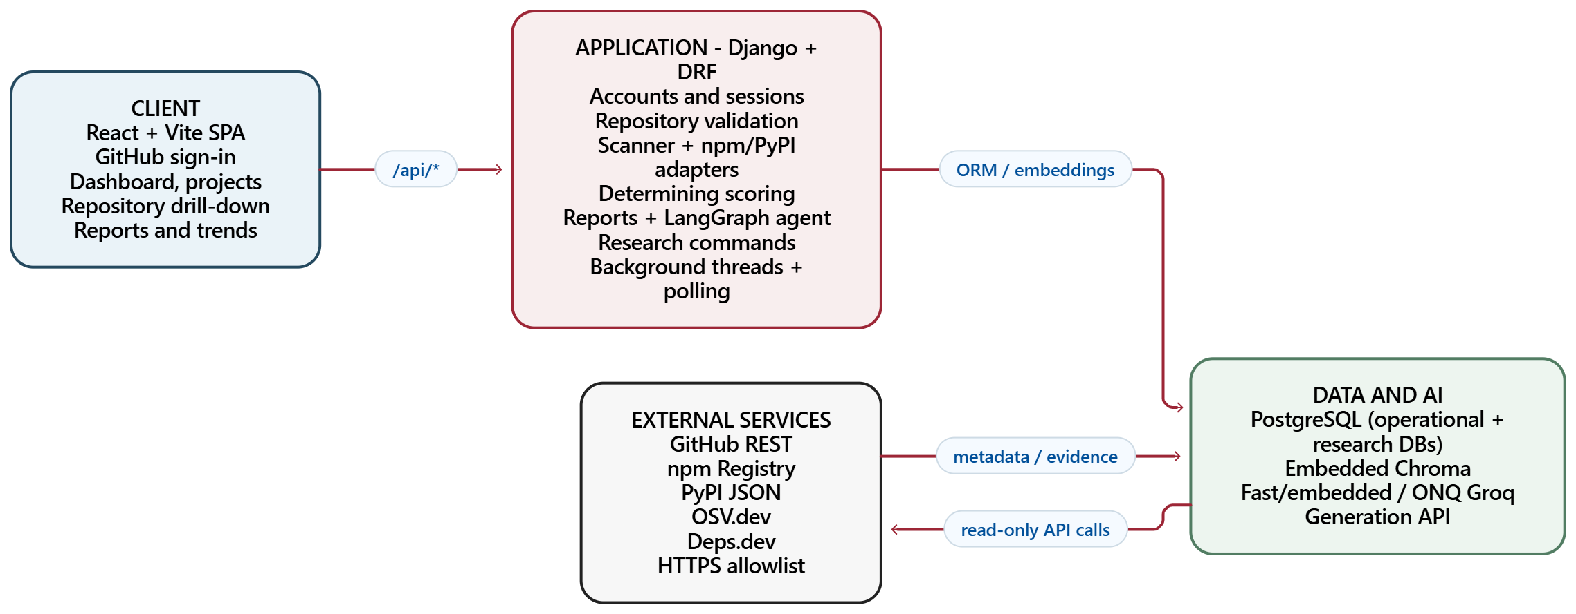
Figure 1. Layered RepoVitals architecture and external data exchanges.

4.3 System context and actors
The developer is the sole normal product actor. Registration and report-generation requests cross the application boundary only after authentication and authorization. GitHub supplies the identity and repository material; npm and PyPI supply package metadata; OSV.dev supplies vulnerability records; and Groq is contacted only for requested report generation. Deps.dev is used as an independent reference in the planned scoring-validation workflow, not as a live scoring input.
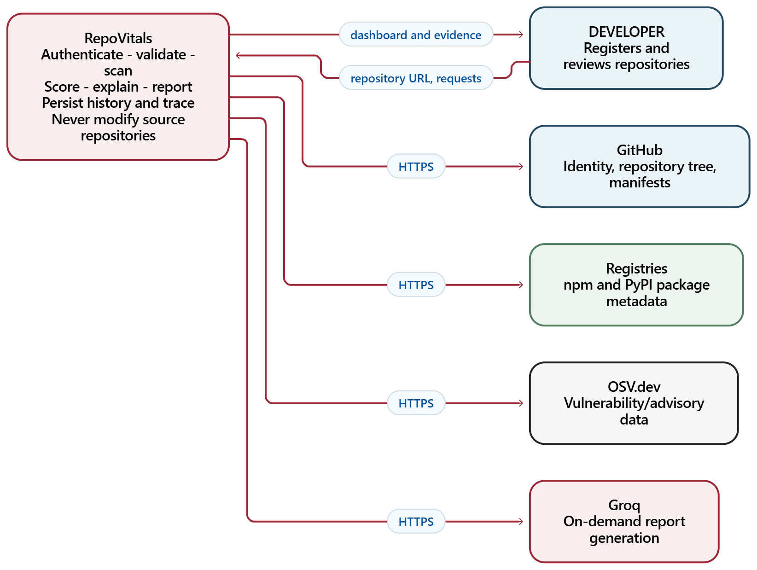
Figure 2. System context showing the user and external services.

4.4 Repository validation and scan flow
Before repository insertion, the backend parses a GitHub owner/repository identifier rather than fetching an arbitrary URL. It checks reachability and eligibility, prevents duplicate registration for the same user, and verifies that at least one supported dependency manifest exists in the repository tree. The request returns actionable errors for inaccessible, read-only, duplicate, empty, unsupported, and rate-limited cases.
After validation, registration triggers a background scan. The scanner searches the full tree for supported manifests, excludes common vendored directories, associates a supported lockfile with its manifest, parses declarations, and resolves version data. Each occurrence retains its manifest path and resolution provenance. The scanner collects registry facts and vulnerability results, stores raw signal values, and passes assessable occurrences to the deterministic scorer. Unassessable occurrences remain visible but are excluded from score calculations.
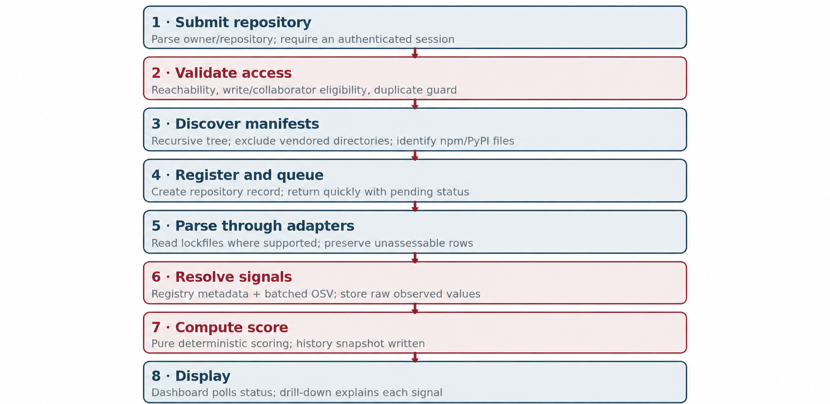
Figure 3. Activity sequence from repository submission to explained score.
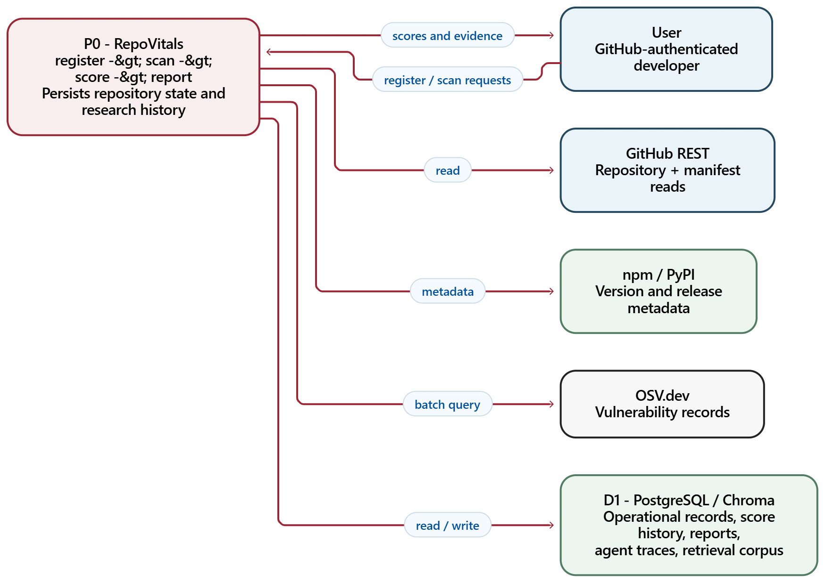
Figure 4. Level-0 data-flow diagram for scans, reports, data stores, and external sources.

4.5 Dependency adapter design
The DependencyAdapter is an abstract boundary between ecosystem-specific formats and the shared scanner. An adapter identifies the manifest paths it supports, parses bytes into common dependency specifications, and supplies the registry client appropriate to its ecosystem. It does not fetch GitHub files, calculate scores, or execute repository content. This boundary prevents parser-specific decisions from leaking into the common scoring function.
The npm adapter reads package.json declarations and supported npm lockfile information. The PyPI adapter supports requirements files, pyproject.toml, Pipfile/Pipfile.lock, poetry.lock, and static inspection of setup.py. Executable setup.py content is never run. Registry and version semantics differ between ecosystems, so raw metadata is normalized into common facts but the provenance remains explicit.
A dependency that points to a workspace, local path, Git URL, private package, or unavailable registry item is represented as unassessable with a reason. The system does not translate a failed lookup into a claim that the dependency is safe. Likewise, a package that has no measurable release history has missing staleness, not a zero-day staleness assertion.
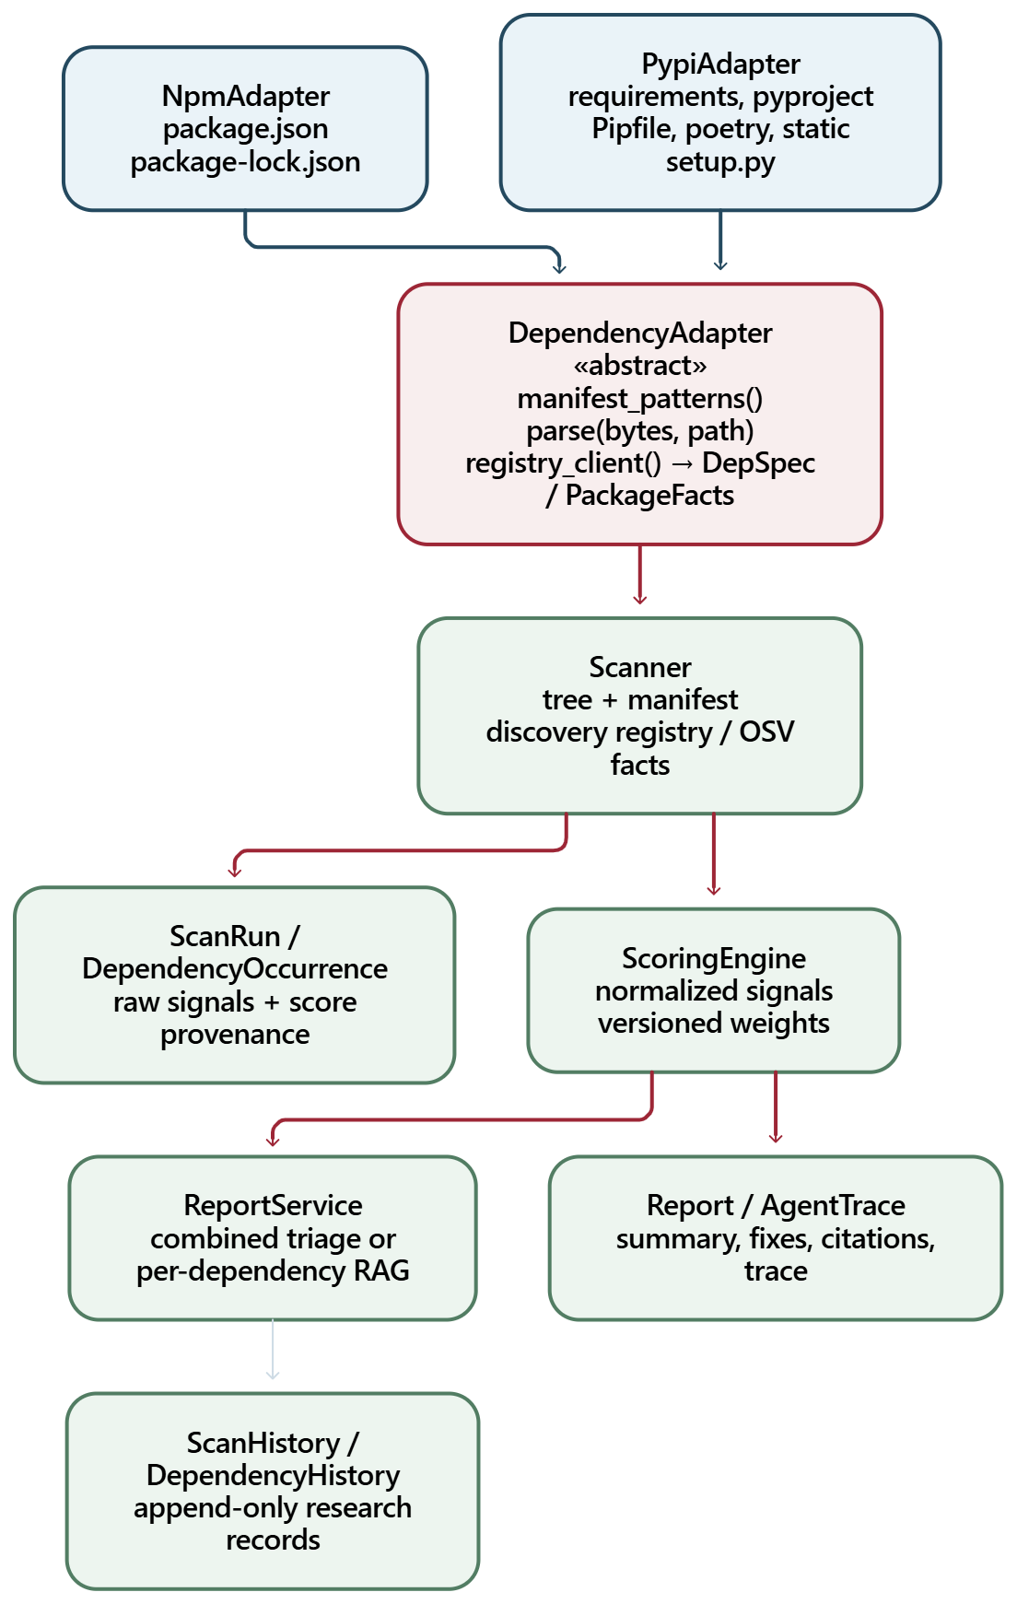
Figure 5. Adapter class boundary and the common scan–score–report flow.

4.6 Data model
The operational data model separates identity, repository, scan, manifest, dependency occurrence, package, vulnerability, report, project, and history concerns. ScanRun records the execution state and score provenance. ManifestFile records path and parser. DependencyOccurrence stores the version and raw indicators used by the score. DependencyVulnerability records advisory-specific details. Reports hold summaries, structured fixes, citations, retrieved chunks, and grounding state. Permanent scan/dependency history and agent traces are stored separately from the short-lived operational scan graph.
Table 15. Principal entities
Entity | Role | Relationship / note
User | GitHub-backed identity and encrypted token | Owns repositories and projects.
Project | Optional grouping of related repositories | Belongs to one user; contains that user’s repositories.
Repository | Registered GitHub repository | Belongs to user; may be grouped into a project.
ScanRun | One scan execution and score | Belongs to a repository; carries formula version/status.
ManifestFile | One manifest discovered in a scan | Belongs to a scan; stores path, ecosystem, parser.
DependencyOccurrence | One dependency declared in one manifest | Belongs to manifest/package; stores observed signals.
DependencyVulnerability | One advisory associated with an occurrence | Stores OSV/CVE identifiers and severity evidence.
Report | Cached output of a report request | Belongs to a scan; optional dependency for a per-dependency report.
ScanHistory / DependencyHistory | Append-only research snapshots | Denormalized; data source is tagged as live or corpus.
AgentTrace | Execution evidence for a per-dependency report | Stores branch, chunks, similarity and model metadata.

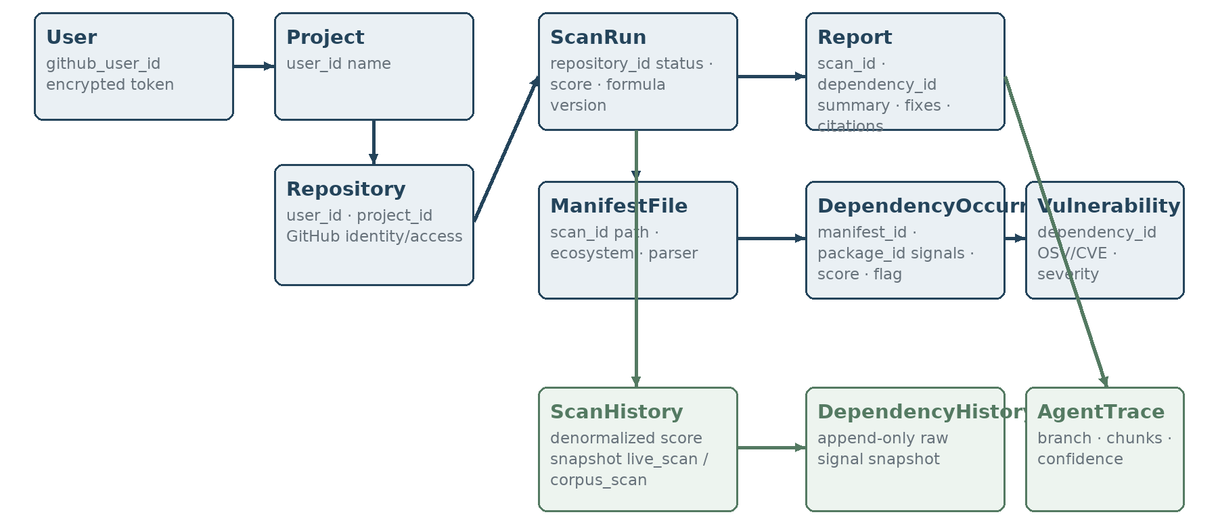
Figure 6. Conceptual ERD: operational records and permanent history are separated.

4.7 State and asynchronous processing
Scanning and report generation use persisted statuses with background processing. The user interface polls status rather than holding the registration request open while GitHub, registry, vulnerability, embedding, and generation calls complete. The deployed architecture uses in-process threads behind one gthread worker. Each worker thread manages its database connection lifecycle. This is a deliberate free-tier design; a process exit can interrupt work, which is why a durable external task queue remains a production extension.
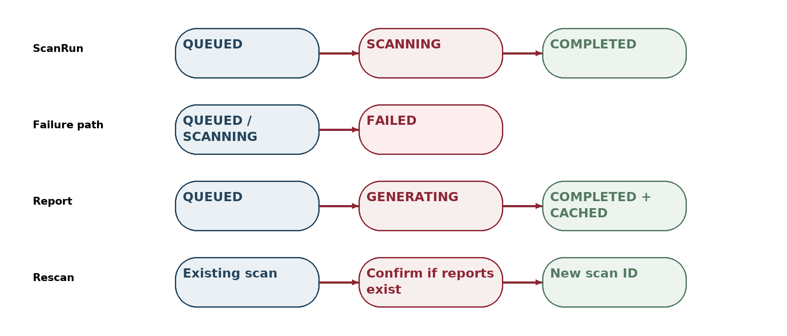
Figure 7. Simplified state transitions for scans, reports, and guarded rescans.

4.8 Deterministic scoring methodology
Scoring begins with raw observations: whether a package is deprecated or yanked, vulnerability count, maximum CVSS severity where known, and release staleness. Version distance is also collected for display/research but is not a Tier-1 formula term in the current governing implementation plan. EPSS is an optional research signal and is disabled in the v1 weights file.
For each assessable occurrence, deprecation is mapped to a binary value; severity is normalized to the CVSS 0–10 scale; advisory count is capped at ten and divided by ten; and staleness is capped at 1,095 days and divided by that cap. If an advisory has no CVSS score, the current normalization uses a 5.0 placeholder and records reduced confidence. If release history is missing, the staleness term is omitted and the remaining measured weights are proportionally redistributed.
The occurrence penalty is the weighted sum of normalized risk signals, expressed on a 0–100 scale; the occurrence score is 100 minus that penalty. The repository roll-up sorts assessable occurrence penalties from highest to lowest, sums up to twenty terms with geometric decay 0.5^rank, and subtracts the deduction from 100. This preserves the influence of the highest-risk items without allowing a large number of clean packages to erase the worst signals. The result is clamped to [0,100].
Flagging is intentionally separate from classification. An occurrence is flagged when it is deprecated, has at least one vulnerability, or meets the configured stale threshold of 730 days. Classification is based on the repository score: 80–100 Safe, 50–79 Medium, and below 50 High-Alert. A repository can have a flagged occurrence while its aggregate classification remains Safe; the drill-down communicates that distinction.
Table 16. Implemented v1 weights in the checked repository snapshot
Signal | npm v1 weight | PyPI v1 weight | Normalization / note
Deprecation | 0.46 | 0.32 | Binary signal; PyPI adapter includes yank/inactive metadata.
Maximum severity | 0.28 | 0.35 | CVSS / 10; a 5.0 placeholder is used if an advisory has no CVSS.
Vulnerability count | 0.16 | 0.16 | min(count, 10) / 10.
Staleness | 0.10 | 0.17 | min(days, 1,095) / 1,095; missing release history is not zero.

The v1 file is a preliminary, versioned configuration. The supplied Review 3 presentation notes a Consistency Ratio of 0.0115 inherited from the seed matrix and explicitly marks AHP consistency and known-bad anchors as requiring work. A low Consistency Ratio is a coherence check; it is not evidence that the weights predict dependency risk correctly. The final AHP/entropy comparison, calibration, external validity, and sensitivity results must not be claimed until WP-6 is accepted.
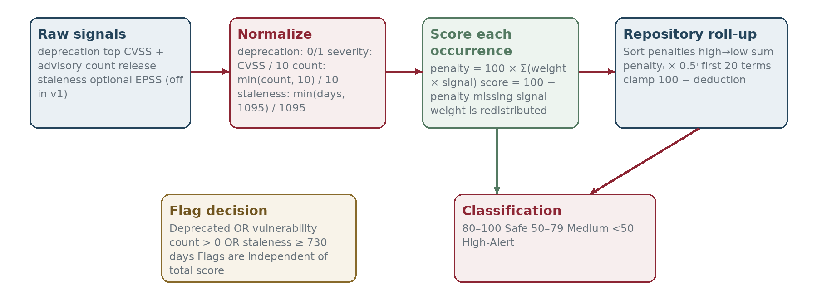
Figure 8. Two-level deterministic score and independent flag/classification decisions.

4.9 Retrieval-grounded remediation workflow
The per-dependency report is generated only after a user requests it. The agent loads scan and package context, obtains package changelog/README content, chunks and embeds it lazily, frames retrieval according to the available deprecation reason, and retrieves the top-k passages with similarity values. A deterministic grounding gate checks whether the best similarity is at least 0.30 and the retrieved text totals at least 400 characters. These constants are project thresholds, not calibrated probabilities.
The generator receives the evidence and grounding state and returns one structured response. It is instructed to say that information is insufficient rather than inventing a recommendation when the evidence is weak. Citations are restricted to retrieved passages; a fix referring to a different package is rejected. The report and full trace are persisted; successfully used dependency chunks are cleaned up. The workflow makes no source-code write and has no self-correction loop.
The combined report follows a separate, lighter path: it provides repository-wide triage from structured scan facts without the per-dependency retrieval pipeline. The report types should not be conflated. A combined summary is not a citation-backed RAG report merely because the same application also supports grounded per-dependency reports.
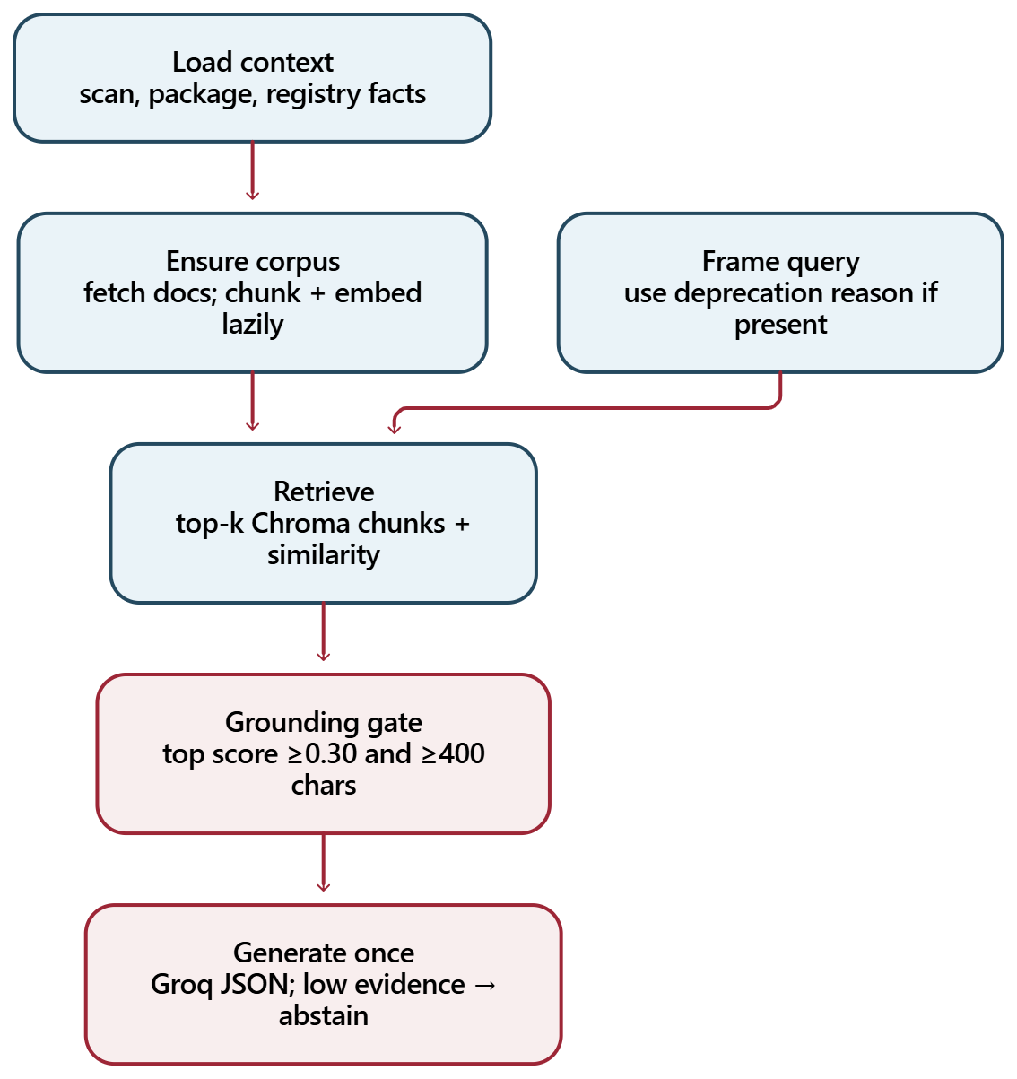
Figure 9. LangGraph steps for a per-dependency report; combined triage bypasses retrieval.

4.10 User interface and interaction design
The application provides sign-in, repository registration, a repository overview, a repository drill-down, projects, reports, downloads, and trend history. The drill-down supports score inspection and per-dependency “Why?” and “Remediate” actions. The screenshot below is reproduced from the supplied Review 3 slide and is labelled as sample data; it is not represented as a verified live production capture.
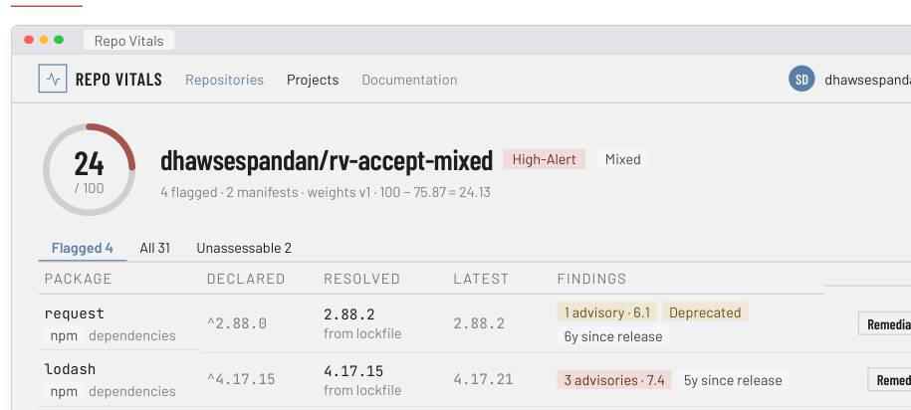
Figure 10. Repository drill-down illustration from the supplied Review 3 presentation (sample data).

4.11 Security and privacy design
Table 17. Threat model and current mitigations
Threat / risk | Design response | Residual consideration
SSRF through repository URL | Parse owner/name and construct allowlisted GitHub API requests; do not fetch arbitrary user URLs. | Tree API truncation remains a documented edge for extremely large repositories.
OAuth token exposure | Encrypt token at rest; decrypt transiently in the backend; never expose to browser or logs. | OAuth App scope is broader than read-only; code-level prohibition on GitHub writes is the mitigation.
Broken object-level authorization | Scope each resource query to authenticated owner and use shared authorization behavior. | Continue testing every new resource route against foreign-user access.
Prompt injection in retrieved text | Treat package documents as untrusted evidence, not instructions; expose no write-capable agent tool. | RAG grounding cannot guarantee a generated statement is correct.
Malicious manifest | Limit parsing size, handle parse failures, parse as data, never execute repository content. | Extremely unusual syntactic constructs may be reported as unsupported.
Outbound endpoint abuse | HTTPS allowlist and request construction for approved hosts. | Host allowlist and redirect behavior require ongoing review.
Rate exhaustion | Batch OSV queries, use rate budgets for research search, guard duplicate scans. | Free APIs can still impose transient rate limits or change quotas.
Concurrent Chroma access | Use a per-scan lock for chunk writes and create collections safely. | Single-process assumptions should be revisited before horizontal scaling.
Permanent research data | Separate denormalized history/trace records from cascading live data. | Future privacy requests require an explicit anonymization process.

4.12 Deployment design
The supplied Review 3 architecture describes a Vercel frontend, Render backend, and Supabase PostgreSQL database. Every browser API request uses the /api path rewritten to the backend, preserving the first-party session-cookie model. The backend uses one Gunicorn gthread worker to avoid loading multiple embedding-model copies. It runs in-process background threads rather than a separate task queue. Chroma is embedded and can rebuild per-scan collections on demand. Health and keepalive behavior is documented in the repository, but the project notes that GitHub scheduled workflows do not reliably keep the Render process warm.
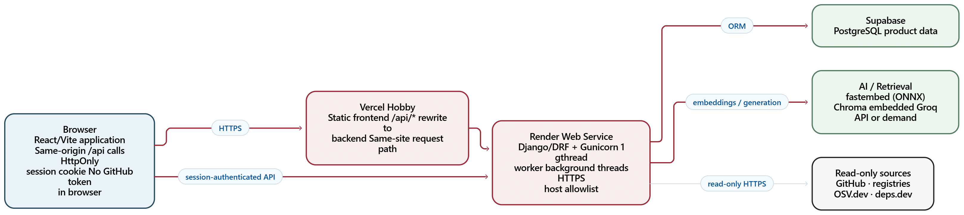
Figure 11. Demo deployment topology and trust boundaries.

4.13 Chapter summary
The design makes data provenance explicit from manifest through score and report. Ecosystem adapters isolate parsing, raw signals remain distinct from normalized values, the repository score is deterministic, RAG is on demand, and the research database is isolated. Security controls are proportionate to a read-only demo but do not transform it into a production-scale service.

CHAPTER 5

RESULTS AND DISCUSSION

5.1 Results scope and evidence sources
Results in this chapter are limited to evidence in the checked public repository, its decision log, the supplied Review 3 presentation, and the project planning documents. Product implementation status is reported as of the Review 3 snapshot dated 24 September 2026. Pilot measurements are reported from the project decision log. The supplied material does not contain a final S1 validation report, a completed S3 experiment, an official Turnitin similarity report, or an AI-plagiarism report.
The project has three different kinds of evidence: implementation evidence (modules and tests exist), deployment/acceptance evidence (selected behaviors were exercised on the demo), and research evidence (a pilot corpus was scanned). These should not be collapsed into one claim that the tool has been scientifically validated. The full scoring-validation and RAG-grounding studies remain future work in the supplied review record.

5.2 Implemented product outcomes
Table 18. Implemented outcomes and evidence limits
Capability | Outcome in the snapshot | Evidence boundary
GitHub authentication and session | Implemented with server-owned session handling. | Do not infer a particular institution-wide identity or security certification.
Pre-scan validation | Repository validation, eligibility, duplicate, and manifest checks implemented. | Behavior is documented in code/tests and review material.
npm + PyPI scanning | Two adapters process the supported ecosystem formats through shared infrastructure. | Does not imply every lockfile or all transitive dependencies are covered.
Explainable deterministic scoring | Versioned v1 scoring with per-signal breakdown and independent flags. | Weight validation remains open; v1 is preliminary.
Combined and per-dependency reports | On-demand outputs; per-dependency reports use RAG and preserve citations/evidence. | Generation quality has not yet been established by S3.
Projects and trends | Repository grouping and score-history visualization are implemented. | Trend history reflects rescans, not automatic continuous monitoring.
Security hardening | BOLA test suite, outbound allowlist, token encryption, no-write audit, and throttles are documented. | Not a third-party penetration test or formal security audit.
Research toolchain | Corpus builder/scanner and planned validation/experiment infrastructure exist. | Work-package sign-offs and full studies are not complete.

5.3 Corpus pilot results
A pilot run used a 20-repository target on a stale-project sampling frame. Seventeen of thirty-three candidates were admitted, a 52% admission rate. The admitted set comprised nine npm projects and eight PyPI projects, a 53/47 split. Thirteen candidates were rejected because they had no supported manifest; three lacked declared dependencies. The run was a pilot, not the intended roughly 1,000-repository corpus.
The scan processed 410 dependency occurrences, flagged 239, and retained one unassessable occurrence. Scores covered the three configured classification categories. The pilot’s npm scores ranged from 0.00 to 55.19, with median 0.00; its PyPI scores ranged from 31.13 to 99.24, with median 76.25. These distributions must not be interpreted as showing npm projects are less healthy: the sample was deliberately stale, the ecosystem sample sizes were small, and npm repositories had substantially larger declared dependency counts, which interact with the rank-decayed aggregation formula.
Three independently selected repositories were rescanned through the product pipeline and compared row by row with corpus results. The recorded score, classification, occurrence count, and fourteen signal columns matched exactly for all three cases. A hard-interruption/resume check completed the remaining pilot records without duplicate history rows. A fresh research database test also recorded zero writes to operational product tables. These are meaningful pipeline-isolation and reproducibility checks, but they do not establish population-level score validity.
Table 19. Pilot score distribution by ecosystem (17 repositories total)
Ecosystem | n | Minimum | Median | Maximum | Safe | Medium | High-Alert
npm | 9 | 0.00 | 0.00 | 55.19 | 0 | 2 | 7
PyPI | 8 | 31.13 | 76.25 | 99.24 | 3 | 3 | 2

Table 20. Engineering results from the pilot run
Pilot measure | Recorded result | Interpretation
Candidates inspected | 33 | Sampling frame pilot; not a random general-population sample.
Admitted | 17 / 33 (52%) | 9 npm and 8 PyPI; near the expected admission fraction.
Dependency occurrences | 410 | Manifest-level occurrences; duplicate package declarations may be separate occurrences.
Flagged occurrences | 239 | Flagged by independent deprecated/vulnerable/stale clauses.
Unassessable | 1 | Retained visibly rather than silently counted as clean.
Product/corpus agreement | 3 of 3 exact matches | Same scores, classes, occurrence counts, and signal columns in selected comparisons.
Resume test | 17 distinct repositories; 410 dependency-history rows | No duplicate history rows after forced interruption and resume.
Operational-table writes from corpus run | 0 | The research scan stayed isolated from product operational tables.

5.4 Interpretation and formula caveats
The 17-repository pilot demonstrates that the corpus pipeline can execute the same adapter and score implementation used by the product and that research records can be isolated. It does not show that the score correlates with real-world exploitation or that the class thresholds are optimal. A low score is a statement about the current formula applied to observed manifest data, not a probability of compromise.
The pilot exposed a confound between ecosystem and declared dependency count. npm samples contained much larger dependency sets than the small PyPI projects in this pilot. Because the repository roll-up uses rank-decayed penalties, a large set has more opportunities to contribute additional penalties. A valid ecosystem comparison therefore needs to control for dependency count and case mix rather than compare the raw medians alone.
The current v1 weights were accepted as an initial engineering configuration but do not have completed validation. The review presentation explicitly identifies a rebuild of the known-bad anchor set and a blind redo of the independent AHP judgments. A consistency score inherited from a seed matrix must not be presented as independent validation. Until WP-6 is complete and signed off, results are preliminary.

5.5 Testing and debugging
The repository contains extensive automated tests organized around authentication and session lifecycle, repository validation and authorization, npm/PyPI parsing, registry/OSV behavior, scoring determinism, scan lifecycle, RAG retrieval, report generation and caching, downloads, project ownership, history isolation, token encryption, outbound HTTP restrictions, log redaction, and memory smoke checks. The review presentation reports 791 backend tests and 202 frontend tests, with CI running lint/format/migration checks, backend pytest, frontend typecheck, Vitest, and build.
The rows below are a report-level mapping from user-visible requirements to the named test areas. Their test coverage is evidenced by the repository and review material; the table does not claim an independent CI run during preparation of this document.
Table 21. Representative test and acceptance matrix
Test ID | Scenario | Expected result | Evidence area
T-01 | OAuth login callback and session creation | Correct user session is created; token not sent to browser. | oauth_login / session_lifecycle
T-02 | Repository does not exist or cannot be read | Registration rejected with actionable result. | repository_validation
T-03 | Read-only collaborator / fork-only repository | Eligibility rule prevents monitoring. | repository_validation
T-04 | Duplicate registration by same user | Existing entry reused; no duplicate. | repository_validation
T-05 | Nested supported manifest | Full tree finds it and schedules scan. | scanner / validation
T-06 | Vendored package manifest | Vendor path is not treated as a project dependency source. | npm adapter / scanner
T-07 | Malformed manifest | Parser records/handles failure without executing content. | adapter and hardening tests
T-08 | npm lockfile resolution | Resolved version and its source are retained. | npm adapter / scanner
T-09 | PyPI requirements and pyproject formats | Supported declarations normalize through shared contract. | pypi adapter
T-10 | Workspace/local/Git dependency | Occurrence retained as unassessable with reason. | adapter / dependency API
T-11 | OSV advisory with CVSS value | Severity and advisory count are persisted and scored. | registry_and_osv / scoring
T-12 | Advisory with no CVSS | Fallback score is explicit and reduced-confidence state retained. | normalize / scoring
T-13 | Missing release history | Staleness omitted and measured weights redistributed. | scoring engine
T-14 | Same signal inputs and same weight version | Exactly repeatable score and explanation. | scoring determinism
T-15 | Cross-user request for repository/report | Foreign resource is not disclosed. | BOLA suite
T-16 | Non-GET request to GitHub client | Write is blocked before network socket opens. | no_write_calls / outbound_http
T-17 | Same report requested again for same scan key | Cached output served without second LLM call. | report_cache
T-18 | Rescan when report exists | Confirmation required before cascade invalidates report. | rescan_guard
T-19 | Cited fix references non-retrieved package/chunk | Unsupported citation or mismatched package is rejected. | agent_graph / report_generation
T-20 | Corpus pilot interruption and resume | Remaining corpus completes without duplicate history rows. | research decision log pilot
T-21 | Corpus run writes operational table | Isolation assertion fails if any product record is changed. | corpus_scan
T-22 | No token/secret in structured logs | Redaction assertion rejects secret leakage. | log_redaction

The supplied Review 3 slide records a production memory peak of approximately 274.5 MB on the 512 MB Render tier, with the local smoke-test series showing the embedding runtime and Chroma as the largest incremental loads. This is a measured point in one demo environment, not a capacity guarantee under concurrent workloads.

5.6 Interface evidence
The supplied review presentation contains a repository drill-down illustration showing a risk score, ecosystem label, flagged dependencies, resolved/latest versions, advisory counts, staleness, and “Why?”/“Remediate” actions. The slide states that it was recreated from the application components using sample data; it demonstrates intended presentation, not an actual finding for a user’s production repository.
Figure 12. Repository drill-down user interface as illustrated in Review 3; data is sample data.

5.7 Project schedule status
The review presentation labels phases 1–11 complete, phase 12 in progress, and phases 13–14 planned. The work-package review dated 24 September states that WP-1 had been accepted; WP-2 needed an anchor-set rebuild; WP-3 required a blind, timestamped redo; and the formal scoring and RAG study packages were not yet accepted. The timeline is therefore a project snapshot, not a promise that remaining research work has already been completed.
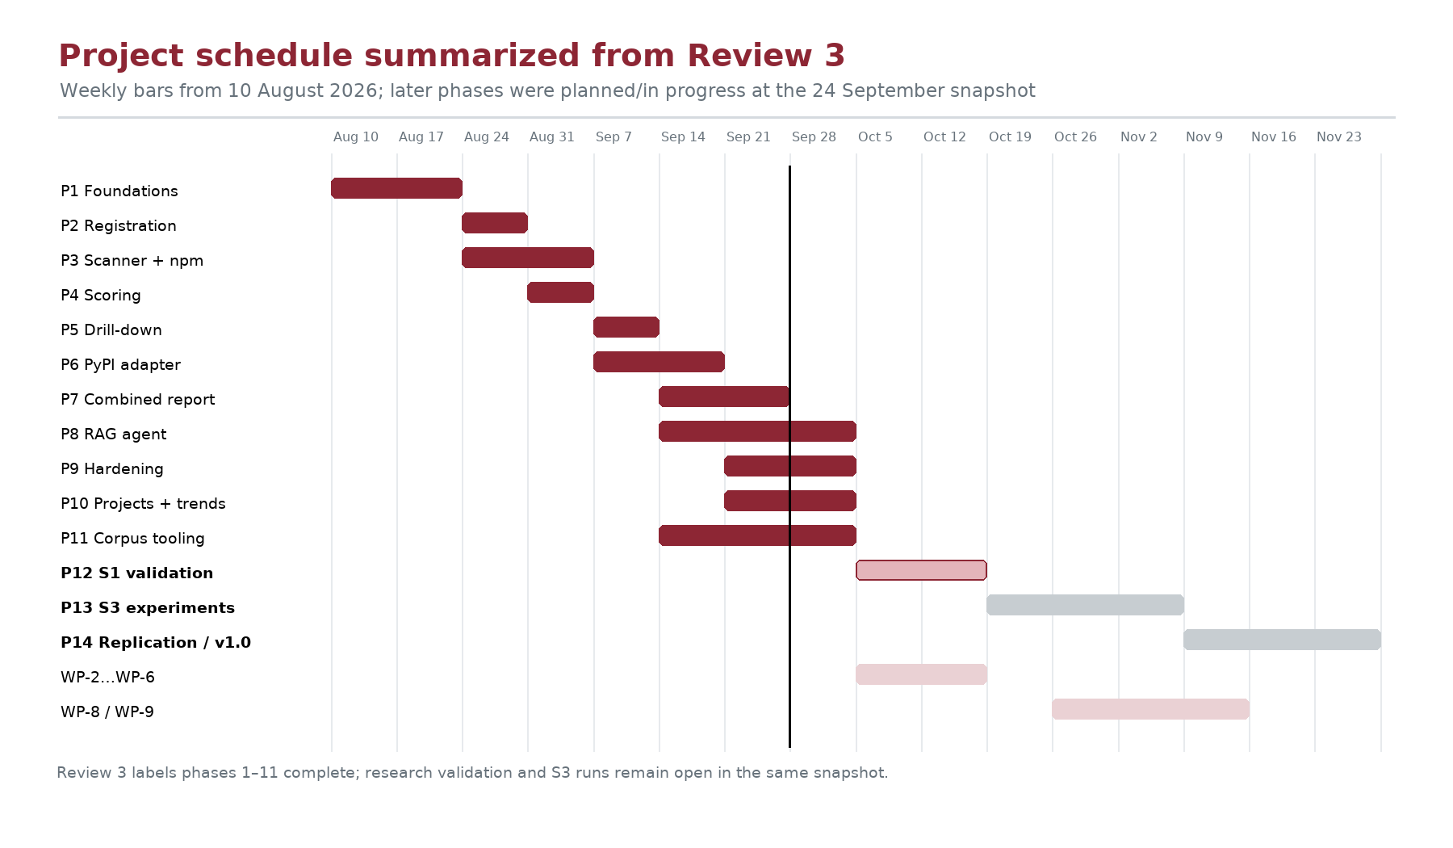
Figure 13. Review 3 schedule snapshot, with phases 1–11 complete and later work pending.

5.8 Outcome mapping
Table 22. Outcomes against documented evidence
Planned outcome | Achieved / current evidence | Status
A working dependency health application | Deployed client/API with npm and PyPI scanning and drill-down. | Achieved in review snapshot.
Deterministic and explainable repository score | V1 scoring and explanation components are implemented. | Implemented; validation is pending.
RAG-grounded per-dependency report | Single-pass agent, evidence pane, trace storage, and report exports are present. | Implemented; controlled faithfulness study is pending.
Cross-ecosystem adapter soundness | PyPI was added behind shared adapter and code paths. | Implementation evidence present; research study not a substitute.
Validated scoring formula | AHP/entropy harness planned; anchor/AHP work package needs rework. | Not achieved in supplied review state.
Controlled RAG experiment | Condition design and planned harness documented. | Not achieved in supplied review state.
AIC, similarity report, AI report, certificates | Not included in supplied attachments. | Insert official/current documents if required.

5.9 Limitations and threats to validity
Construct validity: The score is a composite of proxy signals. It is not ground-truth exploit probability, and staleness or deprecation does not by itself prove a vulnerability.
Weight validity: V1 weights are preliminary. The validation work is incomplete, including known-bad anchors and independent judgments.
Sample validity: The 17-project pilot uses a stale-strata frame and is too small for broad ecosystem claims.
Confounding: The pilot’s npm and PyPI dependency counts differ. Aggregation exposure may explain part of score distribution differences.
Coverage: The scanner covers supported manifests and version sources. Unsupported lockfiles, Git Trees truncation, dynamically generated setup.py metadata, transitive resolution, and private registries can limit coverage.
RAG faithfulness: A retrieval similarity/length gate is not a truth probability. Output quality and abstention calibration are not yet established by S3.
External services: GitHub, registries, OSV.dev, hosting providers, vector libraries, and the generation provider can change, fail, or rate-limit.
Operational scale: In-process threads and free-tier services are adequate for a demonstration, not proven for high concurrency or durable distributed jobs.
Privacy/research retention: Permanent research records are denormalized and do not cascade with account deletion. A privacy request requires an explicit anonymization policy and process.
Integration risk: Manifest-level analysis does not determine cross-service contracts, API behavior, runtime reachability, or whether a suggested update breaks application code.

5.10 Chapter summary
The implemented prototype demonstrates end-to-end operation, two ecosystem adapters, deterministic scoring, report generation, and research instrumentation. The documented pilot establishes useful engineering checks—pipeline identity, resumability, and data isolation—but the project’s scientific claims about weight validity and RAG faithfulness remain untested in the supplied final review state.

CHAPTER 6

CONCLUSION AND FUTURE SCOPE

6.1 Conclusion
RepoVitals addresses a practical software-maintenance problem: dependency warnings identify concern, but a developer also needs repository context and a reasoned next step. The project implements a web workflow in which an authenticated user registers an eligible GitHub repository, the system discovers supported npm and PyPI manifests, external metadata is collected, and a deterministic score and dependency-level explanation are presented.
The scoring and report-generation paths are deliberately separated. Numeric assessment uses stored signals and versioned weights; it is not delegated to an LLM. Per-dependency reports use a bounded retrieval-augmented workflow that presents citations and a deterministic grounding indicator. The application proposes actions rather than modifying source code. The adapter interface provides evidence that a second ecosystem can be integrated without rewriting the common scan and scoring pipeline.
The project has also invested in security and reproducibility: user-level access control, encrypted GitHub tokens, outbound host restrictions, no GitHub write calls, duplicate-work guards, permanent score history, and agent traces are documented in code and tests. Research tooling records corpus scans separately from live product data.
The 17-repository pilot provides preliminary results and verifies several engineering properties. It does not validate the risk formula or prove that RAG improves remediation quality. The supplied review material states that phases 1–11 are complete while formal S1 validation, S3 experiments, and the replication package remain open. This distinction is central to an accurate assessment of the project: the product is a functioning prototype, while the main empirical claims are still hypotheses.

6.2 Project contributions
- A layered web application for scanning npm and PyPI repositories and presenting dependency health.
- A shared adapter interface that separates ecosystem-specific manifests from common scanning and scoring logic.
- A deterministic, normalized and versioned scoring method with occurrence-level and repository-level calculations.
- An on-demand report workflow that distinguishes combined triage from per-dependency RAG and retains evidence.
- Security and reliability controls suited to a read-only free-tier demonstration.
- Research instrumentation, pilot corpus tooling, scan-history retention, and full trace persistence to support future validation.

6.3 Future work
Table 23. Prioritized future work
Priority | Future work | Reason / prerequisite
1 | Rebuild a verified anchor set and redo independent AHP judgments. | Required before trusting the score weights; WP-2/WP-3 were returned for rework.
2 | Complete S1 scoring validation and publish the validation report. | Compare AHP and entropy weights, check anchors, sensitivity, and external reference validity.
3 | Complete the controlled S3 retrieval experiment. | Measure correctness, faithfulness, and retrieval precision across matched conditions and ecosystems.
4 | Package and document reproducible research artifacts. | Complete Phase 14 only after research gates and work-package deliverables are accepted.
5 | Improve durable background execution for larger deployments. | Move from in-process threads to a task queue when service scale requires it.
6 | Add more package ecosystems. | Implement new adapters after verifying equivalent version and advisory semantics.
7 | Improve registry and document caching. | Reduce repeated network calls when traffic or corpus size grows.
8 | Add code-aware upgrade analysis. | Read relevant imports/call sites and assess breaking changes; requires more context and tests.
9 | Extend retrieval only after prompt-injection review. | Issue/discussion content is higher risk and currently restricted to research-only tooling.
10 | Review privacy and retention policy for permanent history/traces. | Define anonymization and data-removal handling before broader adoption.
11 | Consider GitHub App read-only permissions. | Reduce the breadth of OAuth token permissions where the extra lifecycle complexity is justified.
12 | Evaluate richer dependency graph and SBOM integration. | Improve transitive coverage without confusing manifest occurrence scores with full dependency resolution.

6.4 Final conclusion
RepoVitals provides a technically coherent base for transparent dependency assessment and evidence-aware remediation. Its strongest current evidence is architectural and engineering-oriented: the score is deterministic, the adapters are shared, the system retains traceable inputs, and a pilot run demonstrated exact agreement between product and corpus scoring for three selected repositories. The next step is not to claim success beyond this evidence; it is to finish the pre-specified validation work and report the results—including null or adverse results—with the same transparency as the implementation.

REFERENCES
Bibliographic note: the supplied literature survey provides author names, publication years, and paper titles for the sources below, but does not provide complete venue, volume, issue, page, DOI, or stable URL details for most research papers. The entries preserve only the metadata supplied; the group should verify the original sources and complete APA 7 details before printing the final copy.
Arafat. (2025). How Deep Does Your Dependency Tree Go? An Empirical Study of Dependency Amplification Across 10 Package Ecosystems. [Publication details not supplied in the project literature survey; verify and complete in APA 7 format].
Bal and Puhan. (2026). Benchmarking Retrieval Strategies for Biomedical Retrieval-Augmented Generation: A Controlled Empirical Study. [Publication details not supplied in the project literature survey; verify and complete in APA 7 format].
Barnett et al. (2024). Seven Failure Points When Engineering a Retrieval Augmented Generation System. [Publication details not supplied in the project literature survey; verify and complete in APA 7 format].
Barrak. (2025). Traceability and Accountability in Role-Specialized Multi-Agent LLM Pipelines. [Publication details not supplied in the project literature survey; verify and complete in APA 7 format].
Boukrouh et al. (2025). A Comprehensive Framework for Supplier Selection: Using Subjective, Objective, and Hybrid Multi-Criteria Decision-Making Techniques With Sensitivity Analysis. [Publication details not supplied in the project literature survey; verify and complete in APA 7 format].
Caruccio et al. (2025). GitHub Issue Mining to Enhance Developer Profiling. [Publication details not supplied in the project literature survey; verify and complete in APA 7 format].
Costa et al. (2025). Applying Generative Artificial Intelligence for Vulnerability Fixing in a Proprietary Software Ecosystem. [Publication details not supplied in the project literature survey; verify and complete in APA 7 format].
Fadeeva et al. (2025). Faithfulness-Aware Uncertainty Quantification for Fact-Checking the Output of RAG. [Publication details not supplied in the project literature survey; verify and complete in APA 7 format].
Gan et al. (2025). Retrieval Augmented Generation Evaluation in the Era of Large Language Models: A Comprehensive Survey. [Publication details not supplied in the project literature survey; verify and complete in APA 7 format].
Gu et al. (2023). Self-Admitted Library Migrations in Java, JavaScript, and Python Packaging Ecosystems: A Comparative Study. [Publication details not supplied in the project literature survey; verify and complete in APA 7 format].
He et al. (2023). Automating Dependency Updates in Practice: An Exploratory Study on GitHub Dependabot. [Publication details not supplied in the project literature survey; verify and complete in APA 7 format].
Jadhav. (2025). Autonomous CI/CD Quality Assurance Using LangGraph Multi-Agent Orchestration and Risk-Proportionate HITL Control. [Publication details not supplied in the project literature survey; verify and complete in APA 7 format].
Ji et al. (2025). RAP-RAG: A Retrieval-Augmented Generation Framework with Adaptive Retrieval Task Planning. [Publication details not supplied in the project literature survey; verify and complete in APA 7 format].
Menda. (2022). Grounded Generation for Enterprise Knowledge: Automated Documentation and Knowledge Extraction Using GenAI Agents. [Publication details not supplied in the project literature survey; verify and complete in APA 7 format].
Phiri. (2025). Creating Characteristically Auditable Agentic AI Systems. [Publication details not supplied in the project literature survey; verify and complete in APA 7 format].
Seknametla. (2025). Secure Supply Chain Management in DevOps: Addressing SBOM Risks. [Publication details not supplied in the project literature survey; verify and complete in APA 7 format].
Shen et al. (2025). Understanding Vulnerabilities in Software Supply Chains. [Publication details not supplied in the project literature survey; verify and complete in APA 7 format].
Sheng et al. (2025). LLMs in Software Security: A Survey of Vulnerability Detection Techniques and Insights. [Publication details not supplied in the project literature survey; verify and complete in APA 7 format].
Swathi et al. (2025). Agentic AI for Autonomous Software Maintenance: A Retrieval-Augmented Multi-Agent Framework for Bug Localization, Patch Generation, and Regression Validation. [Publication details not supplied in the project literature survey; verify and complete in APA 7 format].
Tevarut et al. (2025). Detecting and Characterizing Low and No Functionality Packages in the NPM Ecosystem. [Publication details not supplied in the project literature survey; verify and complete in APA 7 format].
Xia et al. (2025). Demystifying LLM-Based Software Engineering Agents. [Publication details not supplied in the project literature survey; verify and complete in APA 7 format].
Zerouali et al. (2026). A Comprehensive Study of the Lifecycle of Dormant npm Packages. [Publication details not supplied in the project literature survey; verify and complete in APA 7 format].
Zhang and Zhang. (2025). Hallucination Mitigation for Retrieval-Augmented Large Language Models: A Review. [Publication details not supplied in the project literature survey; verify and complete in APA 7 format].
Dhawse, S. (2026). RepoVitals [Computer software]. GitHub. https://github.com/dhawsespandan/repo-vitals (Repository snapshot checked: 24 September 2026, commit e95ae63).
Symbiosis Institute of Technology. (2026). Guidelines for BTech Black Book Report, AY 2026–27 [Unpublished institutional document supplied by the project group].
Symbiosis Institute of Technology. (2026). B.Tech Project Blackbook Report Format [Institutional report template supplied by the project group].
RepoVitals project group. (2026). Review 3 presentation, Group 10 [Presentation supplied by the project group, dated 24 September 2026].

APPENDICES

Appendix A · Project plan and review snapshot
The schedule below is reconstructed from the supplied Review 3 chart. Bars identify week-level spans and reported status; detailed daily timesheets were not supplied. Phase 1–11 completion and later-phase status reflect the presentation snapshot, not a new status update.
Figure A.1. Week-level project plan as recorded in Review 3.

Appendix B · Team work distribution
Table B.1. Role distribution from the supplied collaboration slide
Member | PRN | Contribution recorded in Review 3
Spandan Dhawse | 23070122085 | Implementation: backend, frontend, deployment, CI/tests, decision log, reviews, and implementation planning.
Astha Kumari | 23070122059 | Research data: work packages WP-1–WP-9, initial AHP weights, anchor/corpus work, and research guidance. Formal work-package acceptance remains subject to review.
Abhirami Nair | 23070122012 | Documentation and research: black-book sections, literature/methodology, research-paper drafting, and implementation planning.
Anindita Bandopadhyaya | 23070122068 | Reports and presentations: design/testing report sections, hackathon submissions, review presentations, and research-paper preparation.

The role statements reproduce the contribution categories in the Review 3 presentation. Each student should confirm that this allocation accurately describes the work completed before signing the declaration.

Appendix C · Representative test catalogue
The 22 representative test scenarios and mapped test areas are listed in Table 21. The repository’s project-wide test totals in the supplied presentation are 791 backend and 202 frontend tests. The following categories group that suite for viva discussion.
Table C.1. Test-suite groupings
Test family | Representative files / themes | Viva explanation
Authentication and sessions | OAuth login; session lifecycle; back-navigation guard | Identity belongs to GitHub; application session belongs to RepoVitals.
Validation and authorization | Repository validation; BOLA; project ownership | Every resource read must be scoped to the logged-in owner.
Adapters and scanner | npm/PyPI adapters; manifests; lockfiles; unassessables | Parser inputs remain data and never execute.
Scoring | Normalization; weight loader; deterministic engine; rescoring | Same raw evidence and versioned weights produce repeatable score.
Reports / retrieval | RAG retrieval; generation; cache; downloads; Chroma cleanup | Per-dependency report includes evidence and a trace; combined report is separate.
Security hardening | No GitHub writes; outbound HTTP; redaction; token cryptography | Reduce abuse paths and protect authorization material.
History and research | Live history filtering; corpus isolation; resume behavior | Corpus scans must not contaminate operational records.
UI behavior | Polling; reports tab; trend chart; project context; confirm dialogs | Progress and destructive operations are visible to the user.

Appendix D · Scoring example for oral examination
The formula is most easily explained at two levels. First, normalize the signals available for a single dependency. If the package has a CVSS value of 7.5, two advisories, and 365 days since its latest release, the normalized severity is 0.75, the capped count term is 0.20, and staleness is 365/1,095 ≈ 0.333. If it is not deprecated, the deprecation term is zero. With npm v1 weights and all terms measured, its penalty is approximately 0.46×0 + 0.28×0.75 + 0.16×0.20 + 0.10×0.333 = 0.266; the occurrence score is about 73.40. This is an illustrative arithmetic example, not an observed repository result.
Second, sort all assessable occurrence penalties in descending order. Apply 1.0 to the largest, 0.5 to the next, 0.25 to the third, and so on, keeping at most twenty terms; subtract the total deduction from 100. The score is then clamped and classified. A flagged dependency is not removed from view just because its repository aggregate is Safe.

Appendix E · AIC report (mandatory institutional form)
PLACEHOLDER — insert the completed AIC report/form supplied or approved by the department. No AIC form was present in the materials provided for this draft. This page is not the institutional AIC form and must be replaced before submission.
Project title: RepoVitals — An Agentic RAG-Based Dependency Health Advisor for Node.js/npm and Python/PyPI Projects
Group: 10 Academic year: 2026–27
Department copy / guide approval / group signatures: TO BE COMPLETED ON THE OFFICIAL FORM.

Appendix F · Similarity report
PLACEHOLDER — attach the official Turnitin similarity-report summary after guide review. The supplied guideline states that the summary must be below 10%. This draft has not been processed through Turnitin, and no similarity percentage is asserted here. Do not replace the official report with a manually typed number.
Table F.1. Similarity appendix completion fields
Required item | Final attachment
Turnitin similarity summary page | [Insert official report page]
Similarity percentage | [Insert value from official report after review]
Guide verification/sign-off | [Insert/complete as required by department]
Run date and report identifier | [Insert official report metadata]

Appendix G · AI plagiarism / AI writing report
PLACEHOLDER — attach the official AI-plagiarism/AI-writing report required by the department after guide review. No detector result was supplied, and this document does not generate or simulate one. The project group must follow the institute’s approved process and report its actual output.
Table G.1. AI report completion fields
Required item | Final attachment
Official AI report summary | [Insert official report page]
Tool and run date | [Insert official metadata]
Guide verification/sign-off | [Complete as required]

Appendix H · Project outcome certificates
No hackathon, competition, publication, conference, industry-collaboration, or other project-outcome certificates were included in the supplied files. If the group has qualifying outcomes, attach the certificate/evidence pages here. If there are no such outcomes, confirm with the guide whether this appendix may be removed or retained with this note.
Certificate / outcome 1: [Insert evidence if applicable]
Certificate / outcome 2: [Insert evidence if applicable]
Certificate / outcome 3: [Insert evidence if applicable]

Appendix I · Source repository and implementation map
Table I.1. Repository map for viva and maintenance
Repository area | Purpose
backend/apps/accounts | GitHub OAuth, user records, token encryption, sessions.
backend/apps/repositories | Repository registration, validation, projects.
backend/apps/scanning/adapters | Shared dependency adapter, npm and PyPI readers.
backend/apps/scanning | Manifest discovery, registry/OSV queries, scan lifecycle and history.
backend/apps/scoring | Signal normalization, versioned weight loading, deterministic formula.
backend/apps/reports/agent | LangGraph per-dependency graph.
backend/apps/reports/rag | Documentation fetch, chunking, embeddings, Chroma retrieval.
backend/apps/research | Corpus build/scan and validation/experiment instrumentation.
backend/tests | Backend regression and security tests.
frontend/src | React routes, views, report and score components, frontend tests.
docs/decisions.md | Chronological implementation decisions and selected live acceptance evidence.
plan/ | Implementation, parallel work-package, and research plans.

Repository: https://github.com/dhawsespandan/repo-vitals. Snapshot checked: commit e95ae63, dated 24 September 2026. The report must be reviewed against any later commit before final printing.

