DIGITAL ASSESSMENT 1
DATA STRUCTURES AND ALGORITHMS
NAME:A.DHAYALAKSHMI
REG. NO.: 24MIS0158
SLOT:B1
Course code :ISWE102P

1.USE ARRAYS TO SOLVE THE FOLLOWING PROBLEM

PROBLEM STATEMENT- 1
Encryption technique is simply a type of substitution cipher that is each letter of a given text is replaced by a letter with a fixed number of positions down the alphabet. One of such encryption type is called Caesar Cipher technique. For example with a shift of 2, A would be replaced by C, B would become D, and so on. The technique is apparently named after Julius Caesar, who apparently used it to communicate with his officials.
cipher text is given as (x+n)%26
CODE:
#include <stdio.h>
#include <string.h>
void caesarCipher(char text[], int shift) {
int I;
for (I = 0; text[i] != ‘\0’; i++) {
if (text[i] >= ‘A’ && text[i] <= ‘Z’) {
text[i] = ((text[i] – ‘A’ + shift) % 26) + ‘A’;
}
}
printf(“Encrypted Text: %s\n”, text);
}

int main() {
char text[100];
int shift;
printf(“Enter UPPERCASE text: “)
scanf(“%s”, text);
printf(“Enter shift (0-25): “);
scanf(“%d”, &shift);
caesarCipher(text, shift);
return 0;
}
OUTPUT:
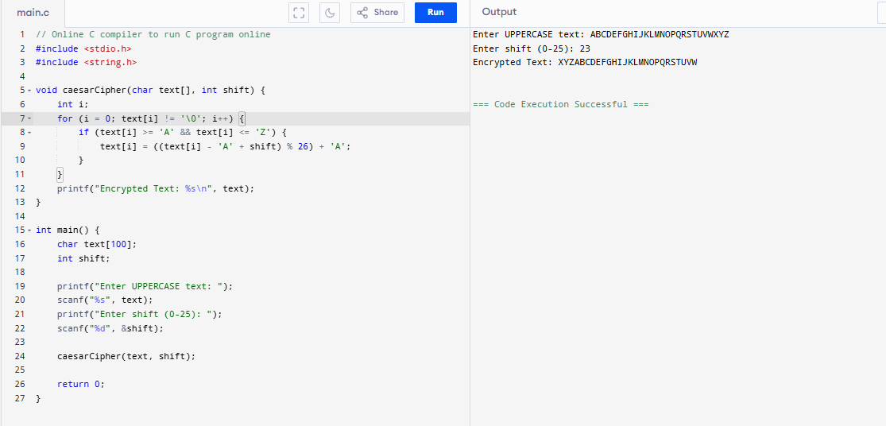
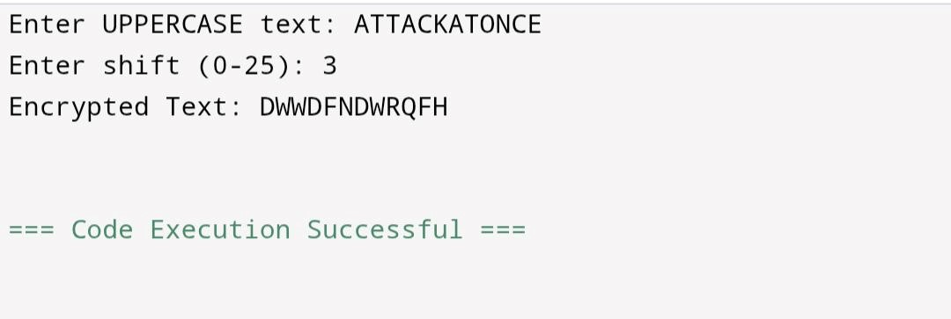
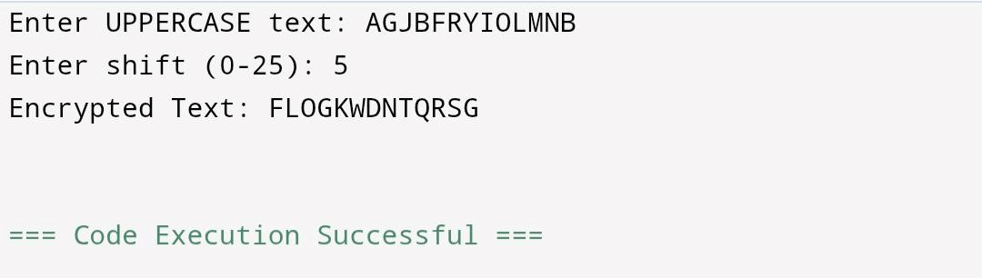
PROBLEM 2:
2.STACK SEQUENCE CHECK

Given two sequences pushed and popped with distinct values, write a program to return true if and only if this could have been the result of a sequence of push and pop operations on an initially empty stack.
Code:
#include <stdio.h>
#define SIZE 100

int validateStackSequences(int pushed[], int popped[], int n) {
int stack[SIZE], top = -1, i = 0, j = 0;
while (i < n) {
stack[++top] = pushed[i++]; // push element
while (top >= 0 && j < n && stack[top] == popped[j]) {
top--; // pop
j++;
}
}
return (top == -1); // stack empty means valid sequence
}
int main() {
int n, i;
printf("Enter size of arrays: ");
scanf("%d", &n);
int pushed[n], popped[n];
printf("Enter pushed sequence: ");
for (i = 0; i < n; i++) scanf("%d", &pushed[i]);
printf("Enter popped sequence: ");
for (i = 0; i < n; i++) scanf("%d", &popped[i]);
if (validateStackSequences(pushed, popped, n))
printf("Output: 1 (Valid Stack Sequence)\n");
else
printf("Output: 0 (Invalid Stack Sequence)\n");
return 0;
}
OUTPUT: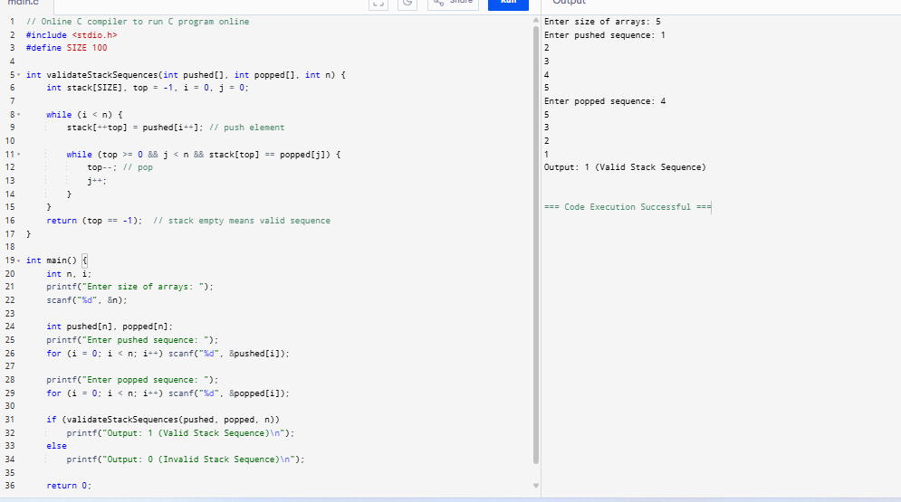
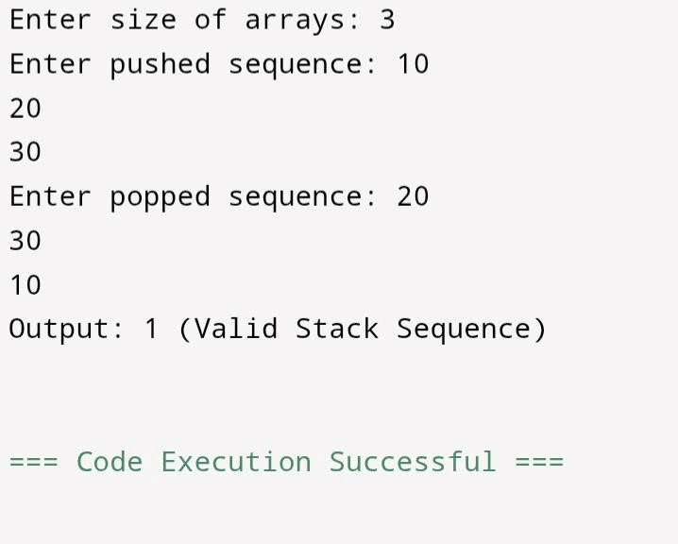
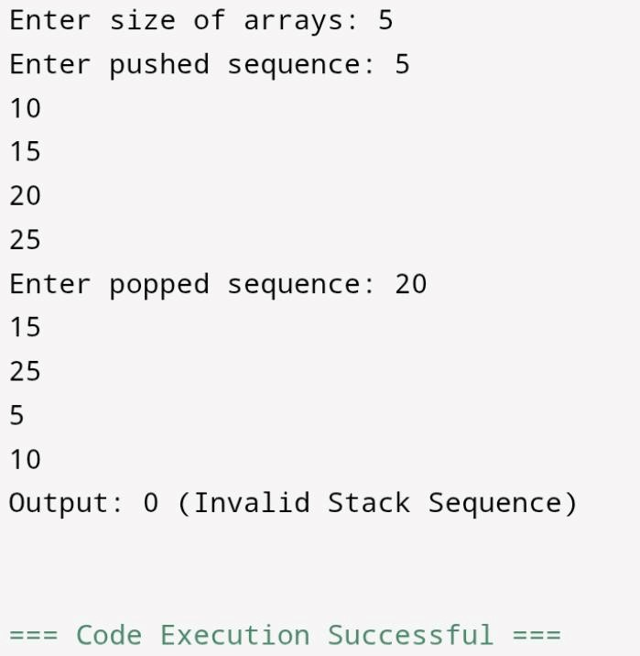
PROBLEM 3:
Checking Balanced Parenthesis in scripting code
<script>
document.getElementById("demo").innerHTML=”Hello JavaScripts!”;
</script>
document.getElementById("demo").style.fontSize = "25px"; document.getElementById("demo").style.color = "red"; document.getElementById("demo").style.backgroundColor = "yellow"; document.getElementById("image").src = "picture.gif";
<style>
Body{background-color:powderblue;}
H1{color:red;}
P{color:blue;}
</style>
Write a C program to read the above java script or part of the above code as a stream of input text and check the parenthesis like curly braces, regular parenthesis and angle brackets are rightly placed. Also count the total number of such pairs, if each category is less than five then print it as insufficient and between 5 and 10 then print it as moderate, and above 10 means then print it as sufficient.
Code:
#include <stdio.h>
#include <string.h>
#define SIZE 1000
int checkBalanced(char str[]) {
char stack[SIZE];
int top = -1, i, countParen = 0, countCurly = 0, countAngle = 0;
for (i = 0; str[i] != '\0'; i++) {
char c = str[i];
if (c == '(' || c == '{' || c == '<')
stack[++top] = c;
else if (c == ')' || c == '}' || c == '>') {
if (top == -1) return 0;
char last = stack[top--];
if ((c == ')' && last != '(') ||
(c == '}' && last != '{') ||
(c == '>' && last != '<'))
return 0;
if (c == ')') countParen++;
if (c == '}') countCurly++;
if (c == '>') countAngle++;
}
}
if (top != -1) return 0;
printf("Parenthesis count: %d\n", countParen);
printf("Curly braces count: %d\n", countCurly);
printf("Angle brackets count: %d\n", countAngle);
int total = countParen + countCurly + countAngle;
if (total < 5)
printf("Category: Insufficient\n");
else if (total >= 5 && total <= 10)
printf("Category: Moderate\n");
else
printf("Category: Sufficient\n");

return 1;
}
int main() {
char code[SIZE];
printf("Enter the code snippet:\n");
fgets(code, SIZE, stdin);
if (checkBalanced(code))
printf("Balanced Parentheses\n");
else
printf("Not Balanced\n");
return 0;
}
OUTPUT
