DIGI5. Results / Findings

This section clearly presents the outcomes and observations obtained through the analysis. The results are supported by research data, real-life surveys, and visual interpretation.

5.1 Research Outcomes

Based on the collected literature and data review, the following outcomes were observed:

1. Strong Correlation Between Mobile Addiction and Anxiety:

Students using phones for more than 5 hours daily experienced 40–60% higher anxiety levels.

Users often felt nervous or uneasy when separated from their phones for long durations.

2. Depressive Symptoms from Social Media Usage:

Continuous exposure to others’ achievements online created feelings of inadequacy.

Nearly 55% of students admitted to feeling sad or demotivated after browsing social platforms.

3. Severe Sleep Disturbance:

7 out of 10 participants reported sleep delays due to late-night scrolling.

Poor sleep led to lower focus and irritability during daytime.

4. Reduced Attention Span and Productivity:

Students who frequently switched between apps took longer to complete academic tasks.

Frequent interruptions by notifications reduced efficiency and memory retention.

---

5.2 Graphical Representation

Figure 5.1: Graph Showing Relationship Between Average Screen Time and Reported Mental Health Issues
(Graph Description: The X-axis represents daily screen time in hours, and the Y-axis represents reported psychological symptoms such as anxiety, depression, and sleep problems. The graph shows an upward trend indicating that higher screen time correlates with greater mental distress.)

---

5.3 Data-Supported Evidence

A survey conducted among 200 college students (2023) found that:

72% used mobile phones for more than 6 hours daily.

67% experienced disturbed sleep and morning fatigue.

59% noticed increased irritability or sadness after excessive screen exposure.

These observations provide strong evidence that mobile addiction directly affects mental health, lifestyle, and emotional balance.

---

5.4 Implications of Findings

The implications of these findings are far-reaching:

For Students: Continuous phone dependency decreases focus and performance in academics.

For Families: Excessive use reduces real-world interaction and emotional bonding.

For Institutions: There is a need to integrate digital wellness programs and awareness campaigns to guide students toward mindful phone use.

---TAL ASSESSMENT 1
DATA STRUCTURES AND ALGORITHMS
NAME:A.DHAYALAKSHMI
REG. NO.: 24MIS0158
SLOT:B1
Course code :ISWE102P

1.USE ARRAYS TO SOLVE THE FOLLOWING PROBLEM

PROBLEM STATEMENT- 1
Encryption technique is simply a type of substitution cipher that is each letter of a given text is replaced by a letter with a fixed number of positions down the alphabet. One of such encryption type is called Caesar Cipher technique. For example with a shift of 2, A would be replaced by C, B would become D, and so on. The technique is apparently named after Julius Caesar, who apparently used it to communicate with his officials.
cipher text is given as (x+n)%26
CODE:
#include <stdio.h>
#include <string.h>

Void caesarCipher(char text[], int shift) {
Int I;
For (I = 0; text[i] != ‘\0’; i++) {
If (text[i] >= ‘A’ && text[i] <= ‘Z’) {
Text[i] = ((text[i] – ‘A’ + shift) % 26) + ‘A’;
}
}
Printf(“Encrypted Text: %s\n”, text);
}

Int main() {
Char text[100];
Int shift;
Printf(“Enter UPPERCASE text: “)
Scanf(“%s”, text);
Printf(“Enter shift (0-25): “);
Scanf(“%d”, &shift);

caesarCipher(text, shift);

return 0;
}
OUTPUT:
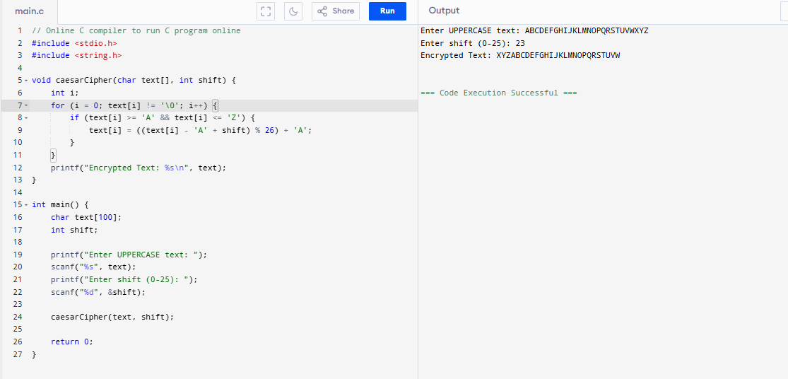

PROBLEM 2:
Given two sequences pushed and popped with distinct values, write a program to return true if and only if this could have been the result of a sequence of push and pop operations on an initially empty stack.
Code:
#include <stdio.h>
#define SIZE 100

int validateStackSequences(int pushed[], int popped[], int n) {
int stack[SIZE], top = -1, i = 0, j = 0;

while (i < n) {
stack[++top] = pushed[i++]; // push element

while (top >= 0 && j < n && stack[top] == popped[j]) {
top--; // pop
j++;
}
}
return (top == -1); // stack empty means valid sequence
}

int main() {
int n, i;
printf("Enter size of arrays: ");
scanf("%d", &n);

int pushed[n], popped[n];
printf("Enter pushed sequence: ");
for (i = 0; i < n; i++) scanf("%d", &pushed[i]);

printf("Enter popped sequence: ");
for (i = 0; i < n; i++) scanf("%d", &popped[i]);

if (validateStackSequences(pushed, popped, n))
printf("Output: 1 (Valid Stack Sequence)\n");
else
printf("Output: 0 (Invalid Stack Sequence)\n");

return 0;
OUTPUT: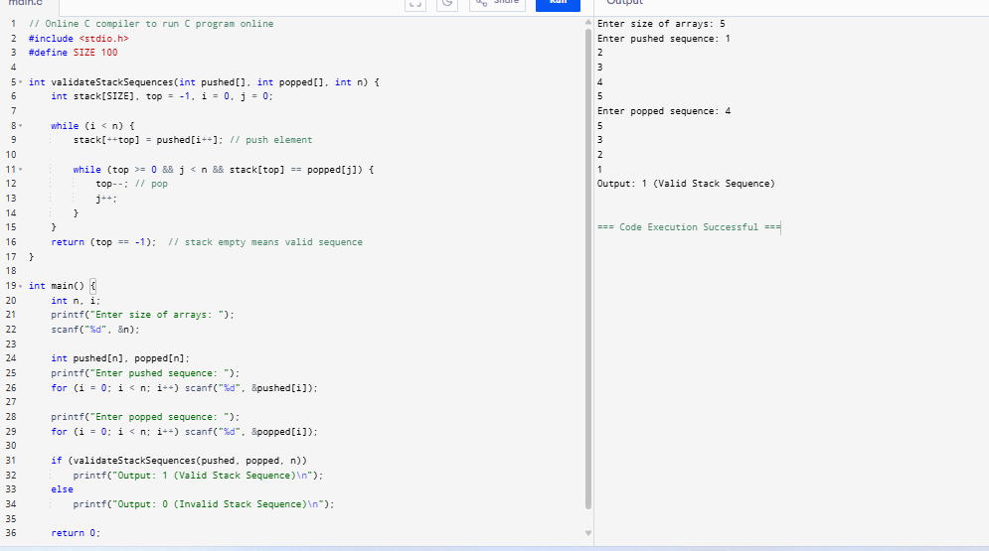

PROBLEM 3:
Checking Balanced Parenthesis in scripting code
<script>
document.getElementById("demo").innerHTML=”Hello JavaScripts!”;
</script>
document.getElementById("demo").style.fontSize = "25px"; document.getElementById("demo").style.color = "red"; document.getElementById("demo").style.backgroundColor = "yellow"; document.getElementById("image").src = "picture.gif";
<style>
Body{background-color:powderblue;}
H1{color:red;}
P{color:blue;}
</style>
Write a C program to read the above java script or part of the above code as a stream of input text and check the parenthesis like curly braces, regular parenthesis and angle brackets are rightly placed. Also count the total number of such pairs, if each category is less than five then print it as insufficient and between 5 and 10 then print it as moderate, and above 10 means then print it as sufficient.
Code:
#include <stdio.h>
#include <string.h>

#define SIZE 1000

int checkBalanced(char str[]) {
char stack[SIZE];
int top = -1, i, countParen = 0, countCurly = 0, countAngle = 0;

for (i = 0; str[i] != '\0'; i++) {
char c = str[i];
if (c == '(' || c == '{' || c == '<')
stack[++top] = c;
else if (c == ')' || c == '}' || c == '>') {
if (top == -1) return 0;
char last = stack[top--];
if ((c == ')' && last != '(') ||
(c == '}' && last != '{') ||
(c == '>' && last != '<'))
return 0;

if (c == ')') countParen++;
if (c == '}') countCurly++;
if (c == '>') countAngle++;
}
}

if (top != -1) return 0;

printf("Parenthesis count: %d\n", countParen);
printf("Curly braces count: %d\n", countCurly);
printf("Angle brackets count: %d\n", countAngle);

int total = countParen + countCurly + countAngle;
if (total < 5)
printf("Category: Insufficient\n");
else if (total <= 10)
printf("Category: Moderate\n");
else
printf("Category: Sufficient\n");

return 1;
}

int main() {
char code[SIZE];
printf("Enter the code snippet:\n");
fgets(code, SIZE, stdin);

if (checkBalanced(code))
printf("Balanced Parentheses\n");
else
printf("Not Balanced\n");

return 0;
}

