REG NO:24MIS0158.
NAME:A.DHAYALAKSHMI
PING:
Send N packets and stop
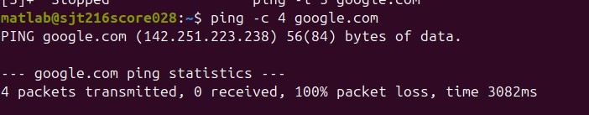
Increase or Decrease the Time Interval
Between Packets
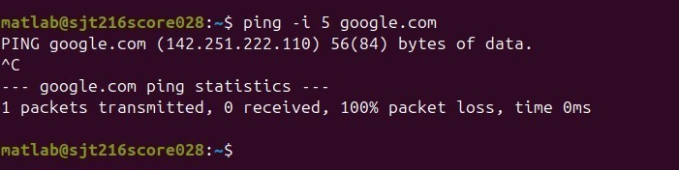
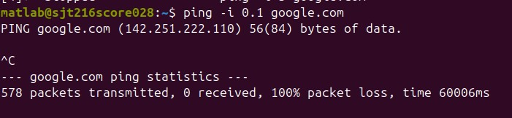
LOCALHOST
Flood the network
Change Ping Packet Siz e
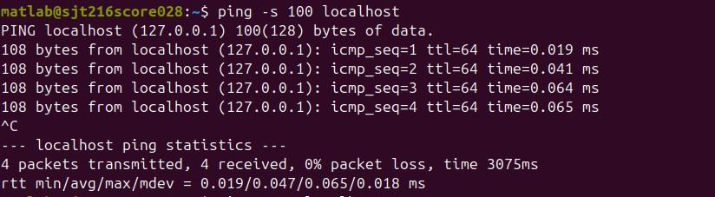

Timeout
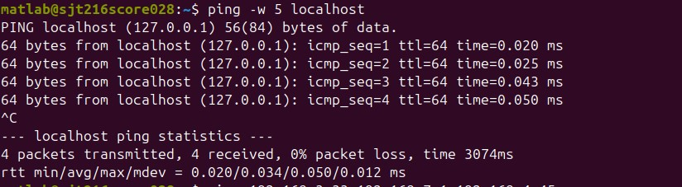
Ifconfig:
View All Network Setting
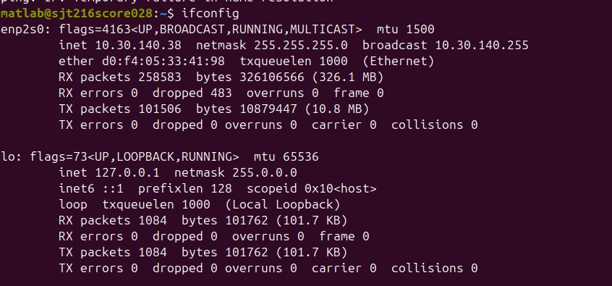

Display Information of All Network Interfaces using -a option
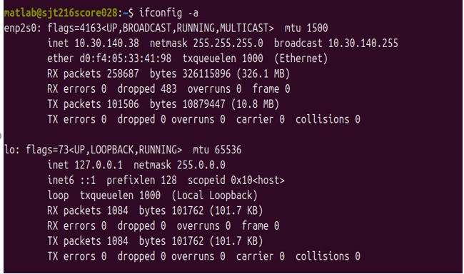

Nslookup
Query the MX Record using -query=mx
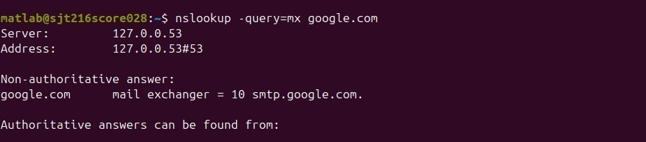
Looking up IP address to get the domainname.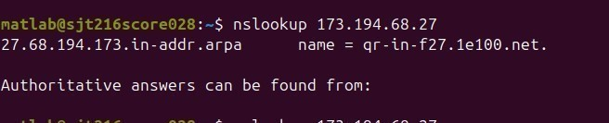
HOSTNAME.
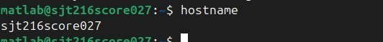

ARP
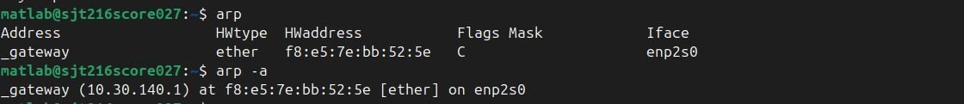

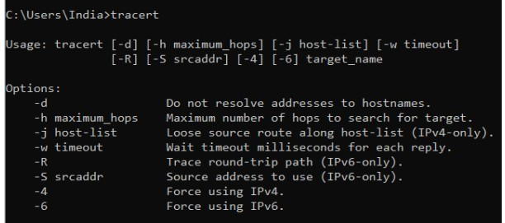
TRACERT

PROBLEM 1:
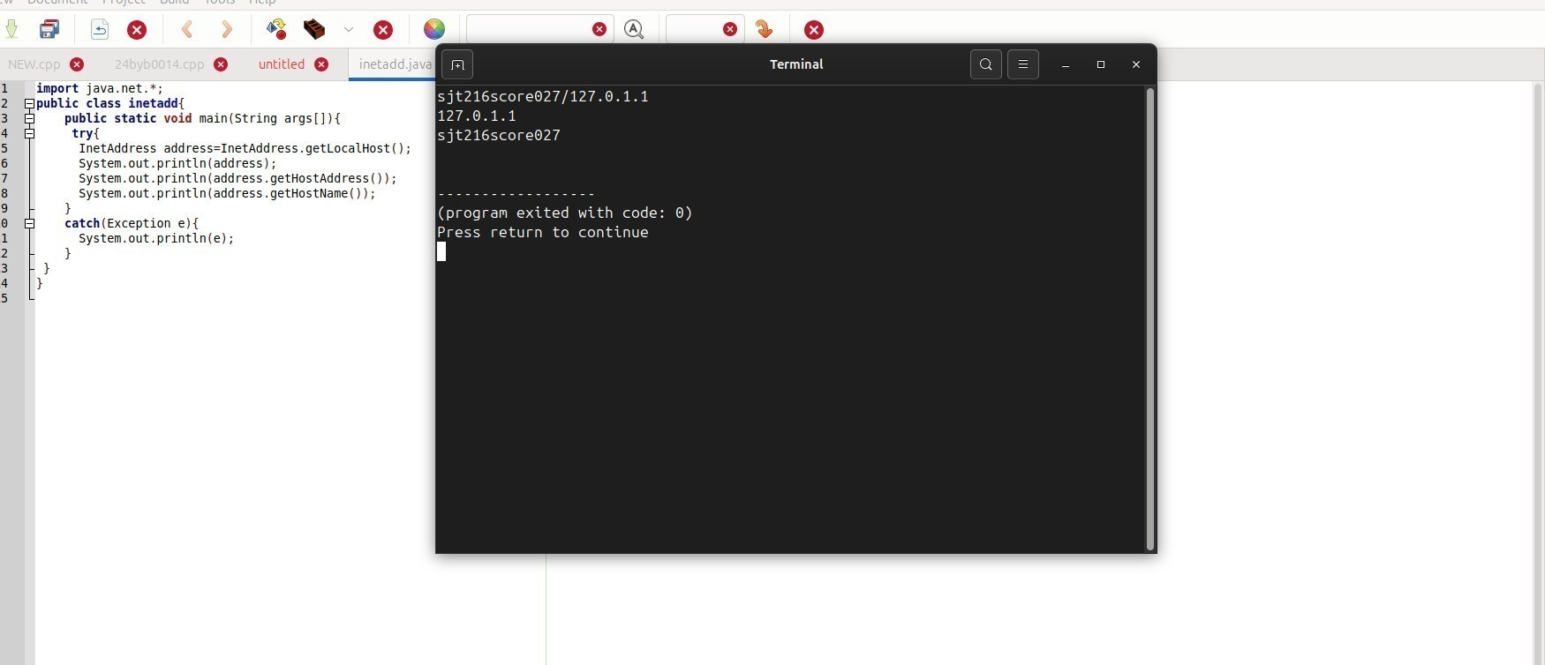
PROBLEM 2:

CODE:
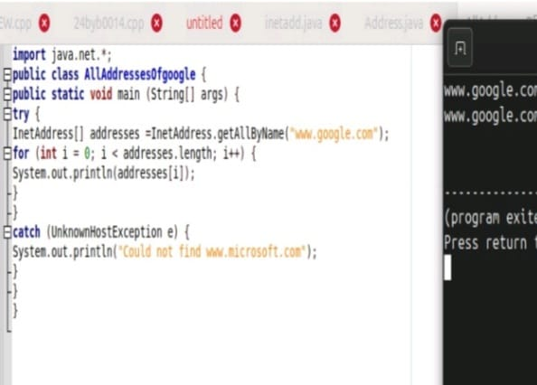
OUTPUT:
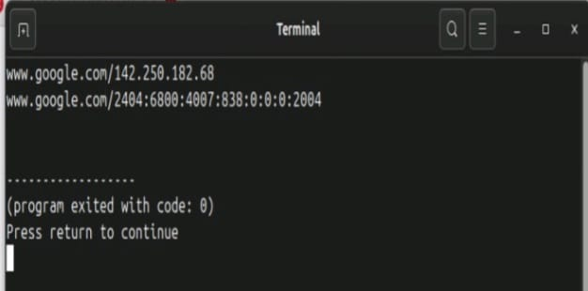
PROBLEM 3:
CODE:
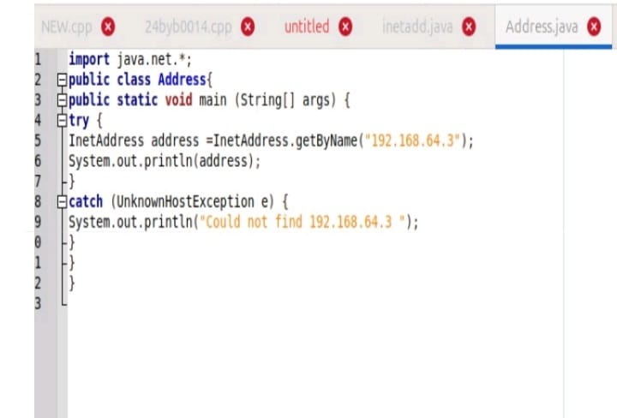
OUTPUT:

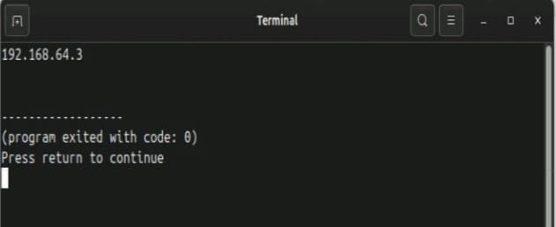
PROBLEM 4:
CODE:
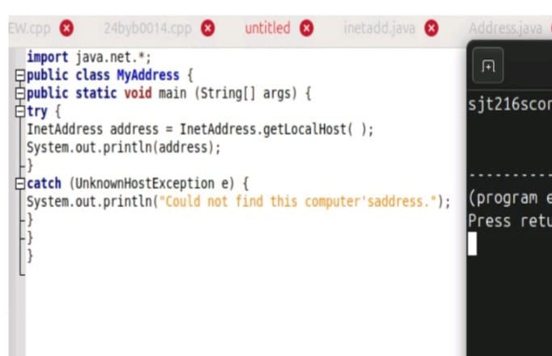
OUTPUT:
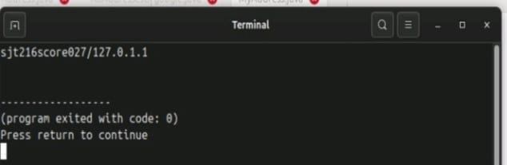
PROBLEM 5:
CODE:
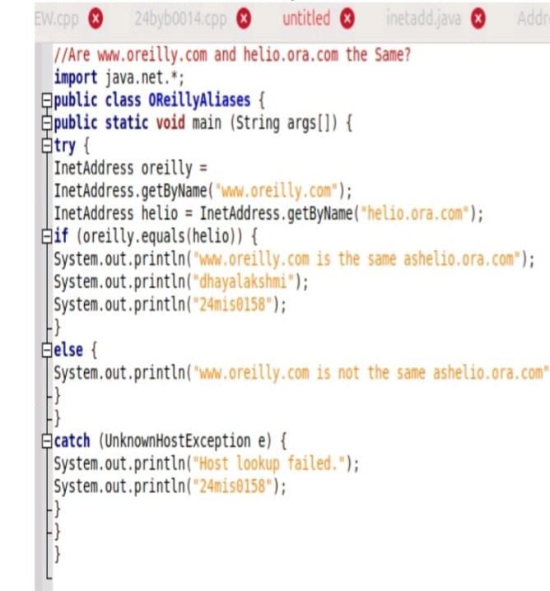
OUTPUT:

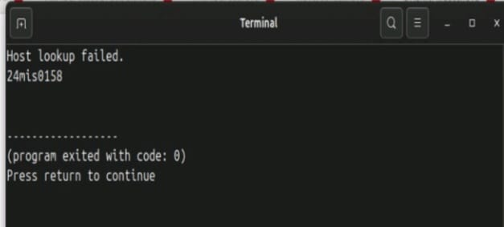
splitting url
CODE:
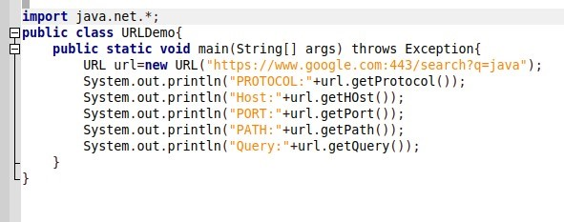
OUTPUT:
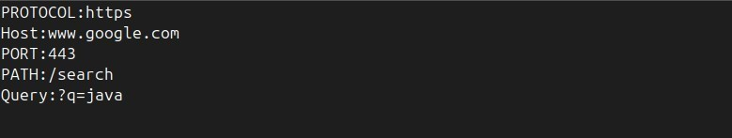
TCP:
PROBLEM:
SUM OF RANDOM NUMBERS
CODE:
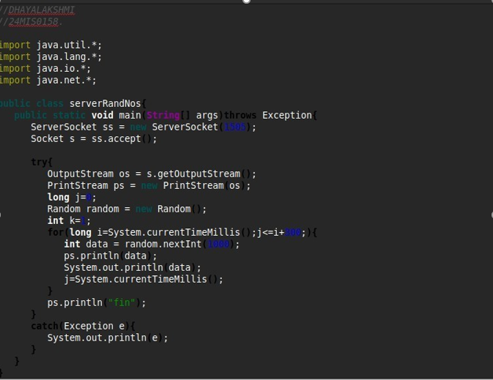

OUTPUT:
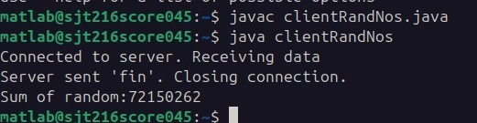
PROBLEM 2:
DATE&TIME SERVER
CODE:
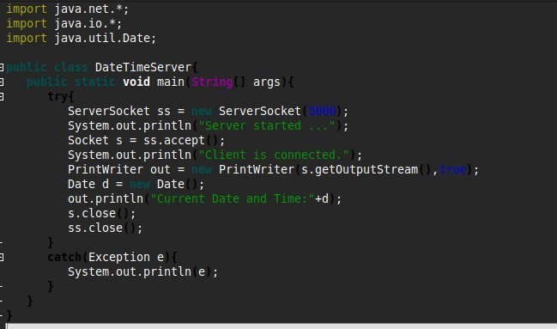
OUTPUT:
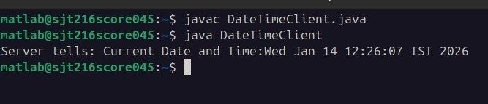
PROBLEM 3:
The message entered in the client is sent to the server and the server encodes the message and returns it to the client. Encoding is done by replacing a character by the character next to it i.e. a as b, b as c ...z as a. Write a Java program for the same using TCP socket.
CODE:
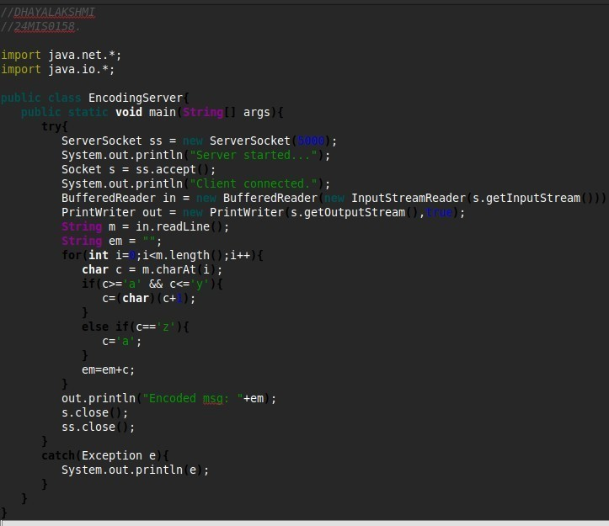
OUTPUT:
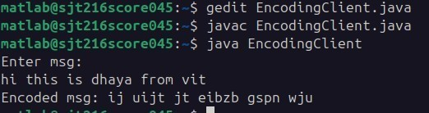
PROBLEM 4:
Program to implement a simple message transfer from client to server process using TCP/IP.
CODE:
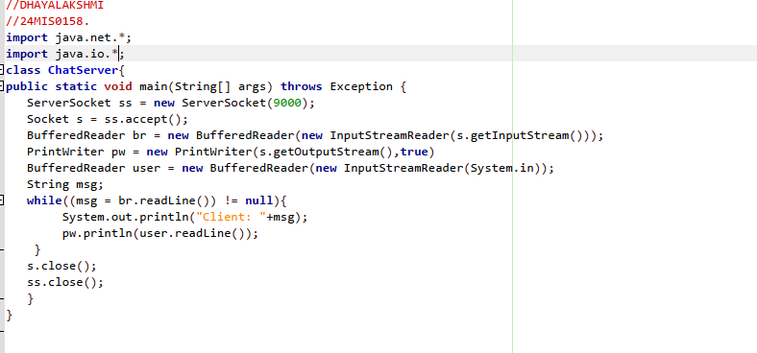
OUTPUT:

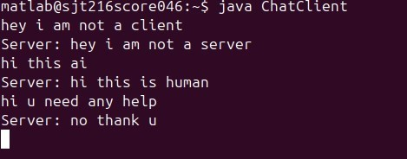
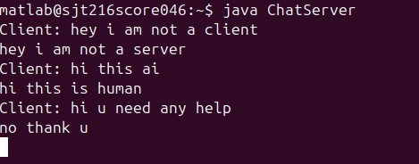
COMMANDS:
NETSTAT:
Listing TCP Ports connections
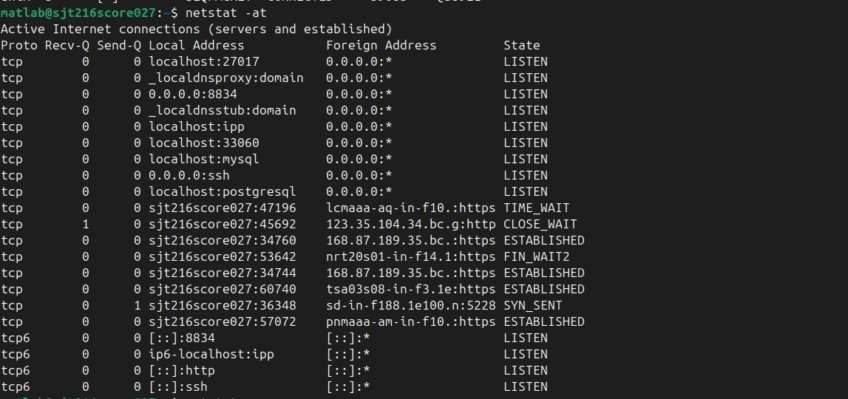
Listing all LISTENING Connection:
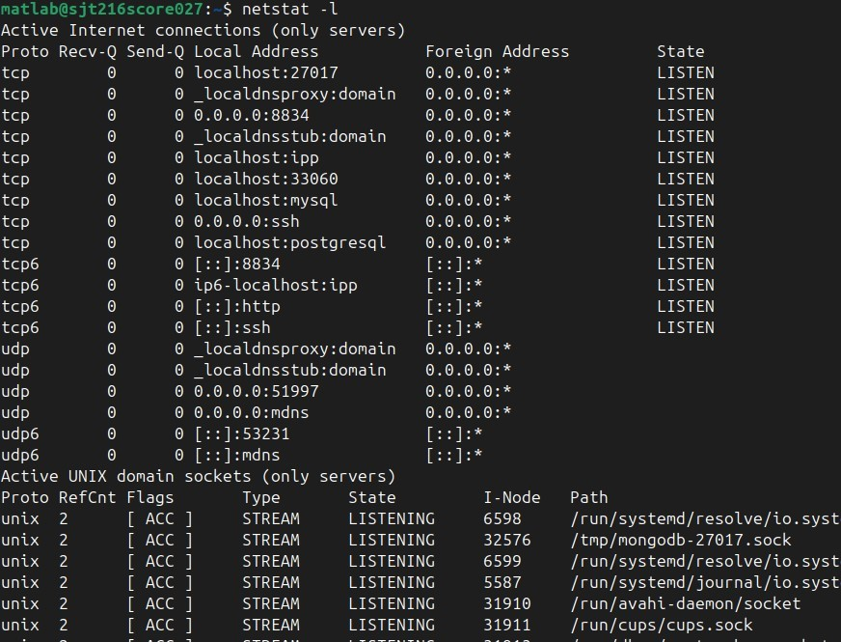
Display Kernel IP routing table:
