
School of Computer Science Engineering and Information Systems

(SCORE)
Winter Semester 2025-2026
Assessment-01

Name: DHAYALAKSHMI A
Reg. No: 24MIS0158
Faculty Name: Dr Gunasekaran G
Course Code: ISWE207P
Course Name: Object Oriented Analysis and Design Lab
Lab Slot: L39+L40

Problem Statement 01: Recipe Manager Software System (RMSS)
Build an app that allows users to add, edit, delete, and view their own recipes added by other users. Users can view recipes added by other users and give comments on their posts. For recipes, users can view Images and videos of recipes.
Building this application can help users understand data structure concepts such as LinkedList, Arrays, HashMap, and Array Lists along with CRUD operations.
Storing and retrieving recipe data helps developers in making network API calls. The following features should have in Recipe Manager software system as given below.
- Add recipes with ingredients and other details such as images and photos
- Categories recipes list with category-wise
- Search recipes with names or ingredients
- Edit and delete existing recipes
- Ability to rate, review, and share recipes

EXPERIMENT-1

SOFTWARE REQUIREMENT SPECIFICATION
AIM: The aim of the experiment is to prepare a Software Requirements Specification for the project recipe manager software system.
- Introduction
  - Purpose:
The purpose of this software Requirement Specification(SRS) document is to provide a clear and detailed description of the requirements for the Recipe Manager Software System[RMSS].This document explains the system’s functionality,requirements,and constraints.
1.2 Scope:
The Recipe Manager Software System is an application that helps users efficiently manage their cooking recipes in a digital format. Instead of maintaining recipes on paper or scattered notes, user can store all their recipes in one place. The system allows users to add, update, delete, search and view recipes based on the different criteria such as recipe name, ingredients, or category. The application is suitable for home cooks, students, and small food businesses.
1.3 Definition, Acronyms and Abbreviations:
UI – User Interface
DB – Database
CRUD – Create, Read, Update and Delete
UML-Unified Modeling Language.

  - Reference:
This document is prepared based on OOAD laboratory guidelines and standard SRS documentation format.
  - Overview:
This document is divided into three major sections. The Introduction provides the purpose and scope of the system. The Overall Description gives a general view of the system features and users. The specific Requirements section describes the functional and non- functional requirements in detail.
- Overall Description
  - Product Perspective:
The Recipe Manager Software System is designed as a standalone application that helps users organize and manage their cooking recipes digitally. Traditionally, recipes are written in notebooks or stored across different platforms, which can be difficult to maintain. This system provides a centralized and structured way to store a recipes in one place. This application can be developed either as a desktop-based or web-based system depending or requirements.
2.1.1 System Interfaces:
The system communicates with the backend database that store and retrieve recipe information. If implemented as a web application, the system may also interact with cloud service for backup and synchronization purposes.
2.2.2 User Interfaces:
The user interfaces is designed to be simple,clean,and easy to understand,even for first time users.the system provides forms for adding and editing recipes easily,and a user dashboard where users can view their stored recipes.
2.1.3 Hardware Interfaces:
The system can run on standard hardware such as desktops, laptops, tablets, or smartphones. Users interact with the system using basic input devices like keyboard, mouse or touchscreen.
2.1.4 Software Interfaces:
The Recipe Manager Software System can operate on commonly used Operating systems such as windows, linux, or macOS.It connect database management system like MySQL OR SQLite to store data.For web-base versions,a web browser is required to access application..
2.1.5 Communication Interfaces:
For a web-based implementation,the system uses standard communication protocols such as HTTP OR HTTPS to transfer data securely between the client and the server.
2.1.6 Memory Interfaces:
All recipes and user information is stored permanently in a database.This ensures that data is not lost when the system is closed and can be accessed whenever the user logs in again.
2.1.7 Operations:
The normal operation of the system includes user login,adding new recipes,updating existing recipes,deleting unwanted recipes,and searching for recipes based on different criteria. This operations are designed to be straightforward and user-friendly.
2.1.8 Site Adaptation Requirements:
The system should adapt to different screen sizes and devices without affecting functionality.
  - Product Functions:
The Recipe Management Software System provides several useful functions to assist users in managing recipes efficiently.Users can create and maintain their own recipe collection, organize recipes in into categories, search for recipes quickly, and view detailed cooking instructions whenever needed.
  - User Characteristics:
The system is designed for users with basic computer or smartphone knowledge. No technical background is required to use the application.
  - Constraints:
The system may require an internet connection for proper functioning. There is limited storage space for images and videos.Performance depends on system hardware and database capacity.
2.4 Assumptions and Dependencies:
It is assumed that users will enter correct and complete recipe information . The system depends on the availability of the database and proper functioning of the underlying Operating system and hardware. Any failure in these components may affect system performance
3.Specific Requirements
  - External Interface Requirements
This section explains how the Recipe Manager Software System interacts with users and other systems.
    - User Interfaces:
The system provides a simple and user-friendly interface that allow users to log in, manage recipes,and search for recipes easily. All screen are designed to be clear and easy to understand.
    - Hardware Interfaces:
The system does not requires any special hardware. Users can access the system using standard devices such as Camera and storage access are needed for uploading media files.
    - Software Interfaces:
The system interact with a database and authentication module for data storage and user verification.
    - Communication Interfaces:
For web- based operation,the system used standard protocols such as HTTP or HTTPS for Secure data communication .
3.2 Software Product Features:
Users can add recipes along with ingredients, images and videos. Existing recipes can be edited or deleted by the owner. The system allows users to search recipes, view them category, and also support rating, reviewing and sharing recipes.
  - Performance Requirements:
The system should respond quickly when users perform action like searching or loading recipes.It should work smoothly even when a large number of recipes are stored.within a reasonable time for all user actions.
  - Design Constraints:
Only registered and logged –in users are allowed to manage recipes. The system design should be simple and should work properly on commonly used devices and platforms.
  - Software System Attributes:
The system should be reliable, secure and easy to use. User data(or)information should kept secure, and privacy must be maintained.
  - Logical Database Requirements:
The database stores details related to users, recipes, categories, ratings and reviews. Each recipe should be uniquely identified and linked to the user who created it.
  - Other Requirements:
The system should provide backup and recovery options to avoid data loss. It should allow future improvements without major changes.
RESULT:
The Software Requirements Specification for the project recipe manager software system has been analyzed and documented successfully.

EXPERIMENT-2
USE CASE MODELING: Recipe Manager Software System (RMSS)
AIM: The aim of the experiment is to Identify actors involved in recipe manager software system, draw use case model and describe scenarios using use case template for the project.
2.1 ACTORS:
The actors involved in the Recipe Manager Software System are:
- User:
The user is the main person who uses the recipe manager application. The user can add new recipes,search for recipes, view recipe details, edit recipes, delete recipes .
- Admin:
The admin manages the system.the admin is responsible for managing users and deleting unwanted or incorrect recipes from the system.
  - USE CASE:
Scenario  Starts when | Actor | Trace | Action | Output
Scenario  Starts when | User | Login | Users enters valid login credentials. | Login  Successful
Scenario  Starts when | User | search Recipe | Users searches for recipes by name. | Recipe list displayed.
Scenario  Starts when | User | View Recipe | User selects a recipe from the list. | Recipe details displayed.
Scenario  Starts when | User | Add  Recipe | User enters recipe details. | Recipe submitted successfully.
Scenario  Starts when | Admin | Approve Recipe | Admin review and approve recipe | Recipe published.
Ends | User Logout Users logs out Session ended

  - USE CASE MODEL
      - The Use Case Model shows how different actors interact with the Recipe Manager Software System.
      - The system supports two actors namely User and Admin.
      - Users can create and manage their own recipes. users can view, search, rate and review recipes shared by others.
      - The admin monitors system activities and manages users and recipes.
      - This model helps in understanding the functional flow of the system clearly.

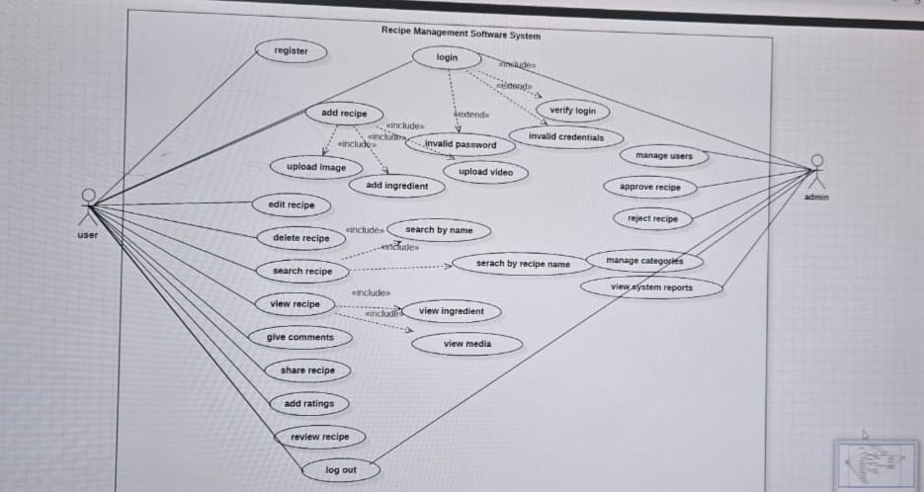

2.4 USE CASE DOCUMENT
    - Name:
Add Recipe
    - Brief Description:
This use case describes the process by which a registered user adds a new recipe to the Recipe Management Software System. The recipe is reviewed by the admin before it is approved and made available to other users.
    - Actors:
1.User
2.Admin
2.4.4 Preconditions:
      - The user must be registered and logged into the system.
2. The system must be operational
2.4.5 Basic Flow:
      - The user logs into the system using valid credential.
      - The user selects the Add Recipe option and enters the recipe details, including ingredients and media files.
      - The system validates the entered information and submits the recipe for admin review.
      - The admin reviews the recipe and approves it.
      - The system publishes the approved recipe for other users to view.
2.4.6 Alternate Flows:
      - If the user decides to save the recipe as a draft, the system stores the recipe without submitting it for admin approval.
      - If the admin requests minor modifications instead of rejecting the recipe, the system notifies the user to update the recipe and resubmit it for approval.
2.4.7 Exception Flows:
      - If the user enters incomplete or invalid recipe details, the system displays an error message and requests correction.
      - If media upload fails due to format or size issues, the system asks the user to re-upload valid files
      - If the admin rejects the recipe during review, the system notifies the user and the recipe is not published.
2.4.8 Post Conditions:
      - The recipe is successfully stored in the system after approval.
      - The user receives confirmation regarding the recipe status.
RESULT:
Thus, the use case diagram and documentation for the recipe manager software system designed using StarUML software, has been successfully completed.

EXPERIMENT-3
AIM: To identify the entity class, boundary class, control class relationships, attributes, operations and draw class diagram for the project recipe manager software system.
3.1 Identify the Classes
- Entity Classes
    - User
    - Recipe
    - Category
    - Review
    - Media
- Boundary Classes
    - LoginUI
    - RecipeUI
    - AdminUI
- Control Classes
    - SearchManager
    - ShareManager
  - Define Attributes:
1.User
userId :int
      - userName :string
      - email : string
      - password : string
2.Recipe
recipeId : int
recipeName : String
ingredients:String
instruction : String
rating : float
3.Category
categoryId : int
categoryName : String
description : String
recipeList : String
4. Review
reviewId : int
userId : int
recipeId : int
rating : float
comments : String
5.Media
mediaId : int
recipeId : int
mediaType : String
6.ShareManager
shareId : int
userId : int
recipeId : int
platform : String
shareLink : String

7. SearchManager
recipeList : String
ingredientList : String
searchResult : String

  - Define Methods
1.User
register()
login()
addRecipe()
editRecipe()
deleteRecipe()
2.Recipe
addRecipe()
updateRecipe()
deleteRecipe()
viewRecipe()
calculateRating()
3.Category
addCategory()
updateCategory()
deleteCategory()
addRecipe()
viewRecipe()
4. Review
addReview()
updateReview()
deleteReview()
viewReview()
approveReview()
5.Media
uploadImage()
uploadVideo()
deleteMedia()
updateMedia()
viewMedia()
ShareManager
shareRecipe()
generateLink()
trackShare()
deleteShare()
SearchManager
searchByName()
searchByIngredient()
searchByCategory()
displayResults()
clearSearch()

  - Identify Relationships:
- A User can create multiple Recipes (One-to-Many)
- A Recipe can contain multiple Ingredients (One-to-Many)
- Many reviews are written for one recipe.(Many-to-One)
- One recipe can have multiple media files(One-to-Many).
- One category contains many recipes(One-to-Many).
- A user can share multiple recipes(One-to-Many).
- A recipe can be shared multiple times(One-to-Many).
- SearchManager accesses recipe data
3.5 Draw the Class Diagram
The class diagram includes:
- Entity classes: User, Recipe, Category, Review, Media
- Boundary classes: LoginUI, RecipeUI, AdminUI
- Control classes: ShareManager,SearchManager.

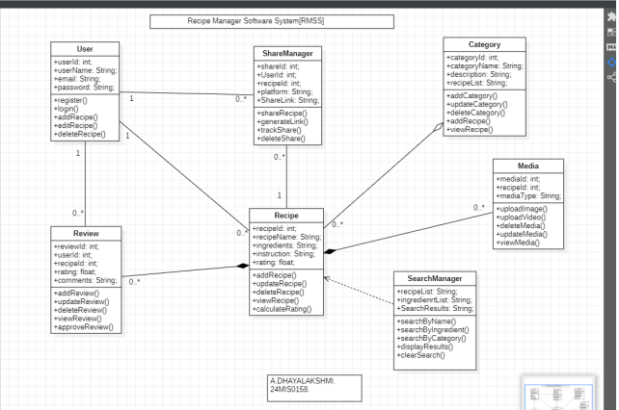

RESULT:
Thus, the class diagram for the recipe manager software system was successfully designed using StarUML by identifying classes, attributes, methods, and relationships.

