

NAME : DHAYALAKSHMI A
REG.NO : 24MIS0158
SUBJECT CODE : ISWE103P
SUBJECT LAB. : DATABASE SYSTEM LAB
LAB SLOT : L33 +L34
GUIDED BY : PROF. BHUVANA S

1.Create the following tables:
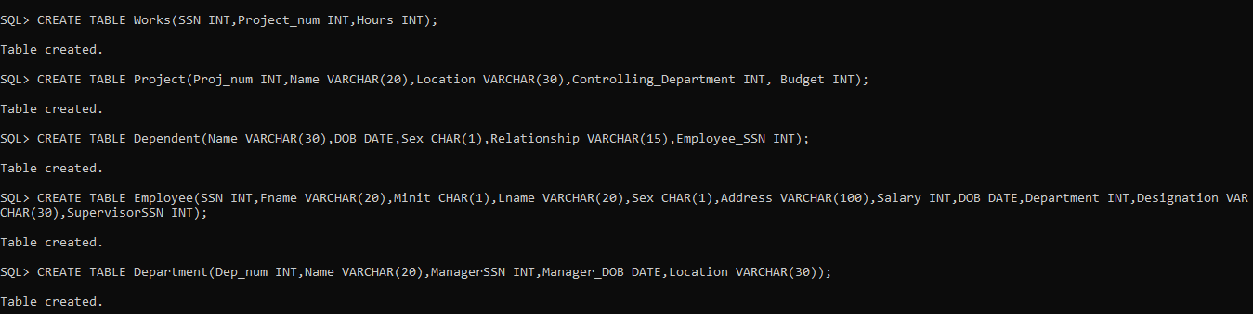
a)Identify the appropriate primary keys for the tables. It is self-explanator
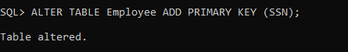
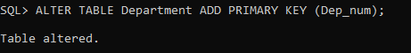
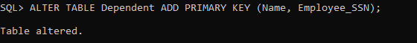
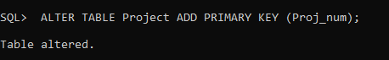
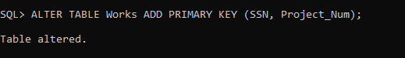
c) Set the following Constraints to the above tables:
1) Department number should be in the range 1000 to 2000.
2) Relationship of the dependents to an employee should be only Spouse, Son, Daughter, and Parent.
3) Name of the project doesn't exceed 4 characters 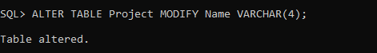
4) Employee salary should be above 1000 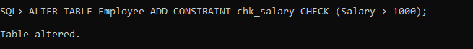
5) The location of the project is mandatory 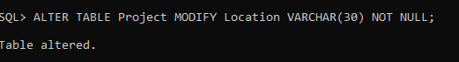
6) The minimum hour of a project is 20 hours and maximum 120 hours.
7) The department names can be 'IT', 'HR', 'Sales',
'Manufacturing' and 'Production'.

b) Insert at least 10 rows to each table. (Apply Interactive insertion.
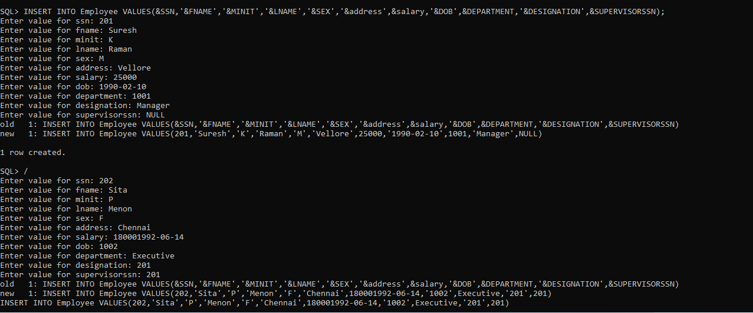
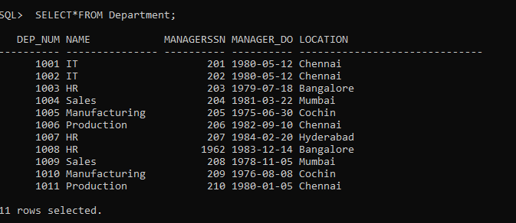

Select*from Works;
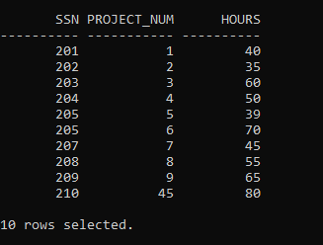
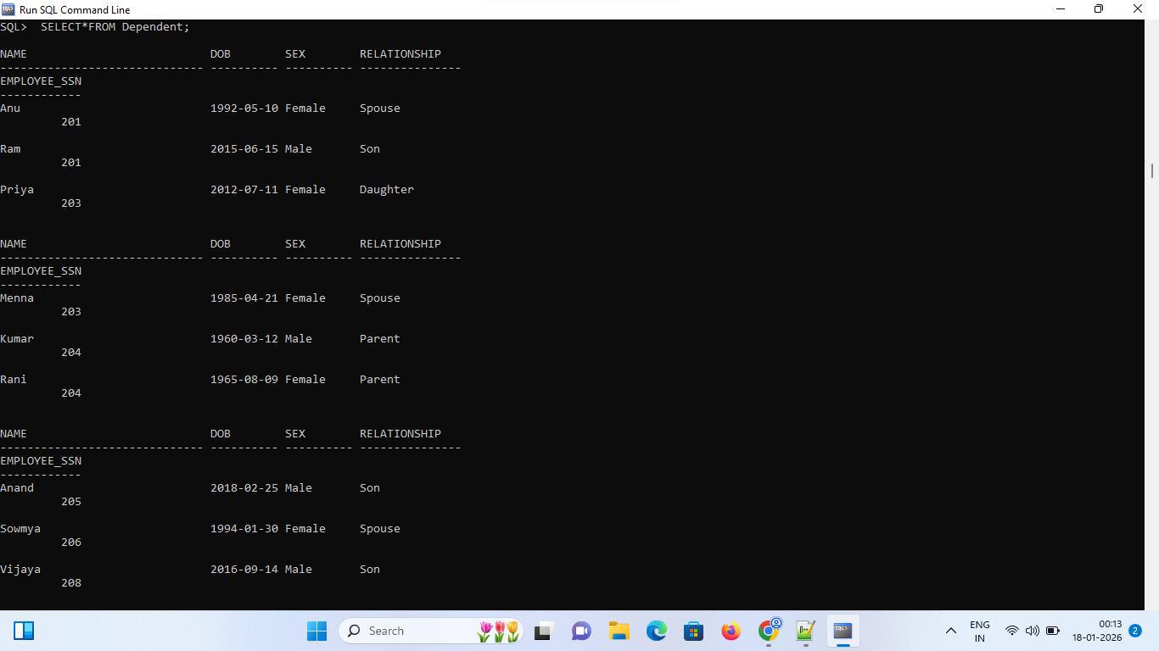
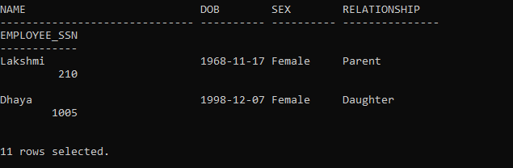
d) Query the Database:
1) Display all the employee details of the employee table.
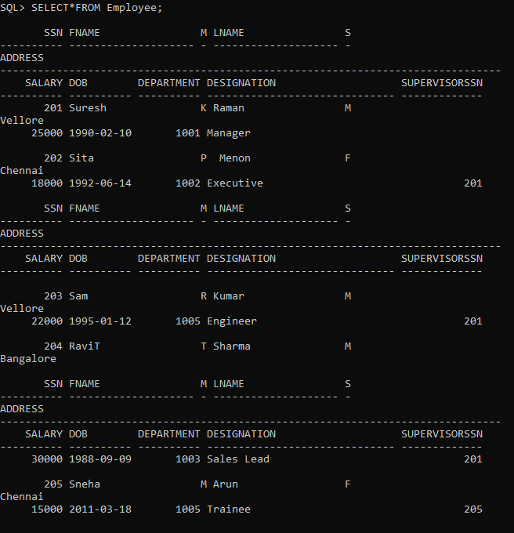

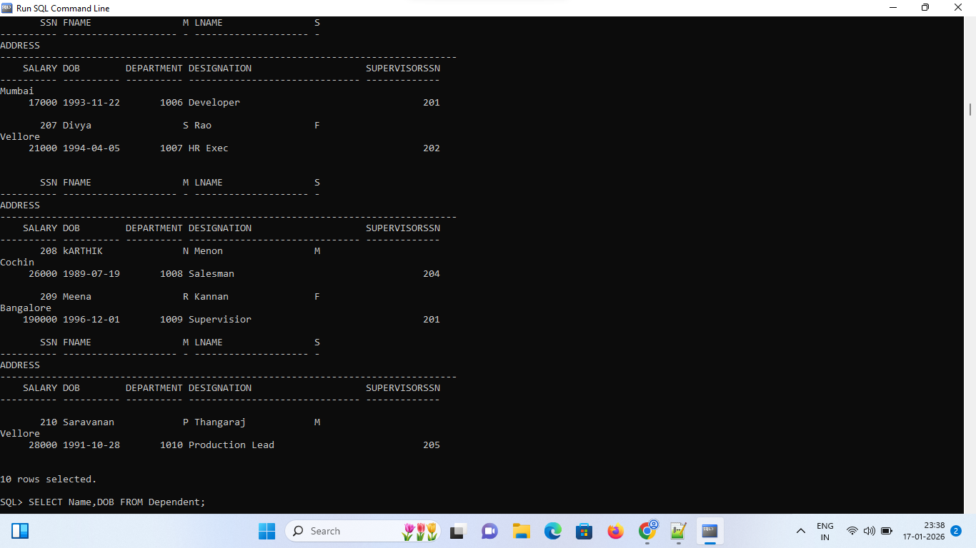2)Project only Name and DOB of dependent table.
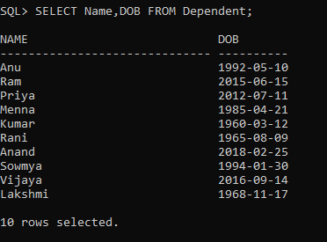

3) Select the records of employee whose name start with "S".
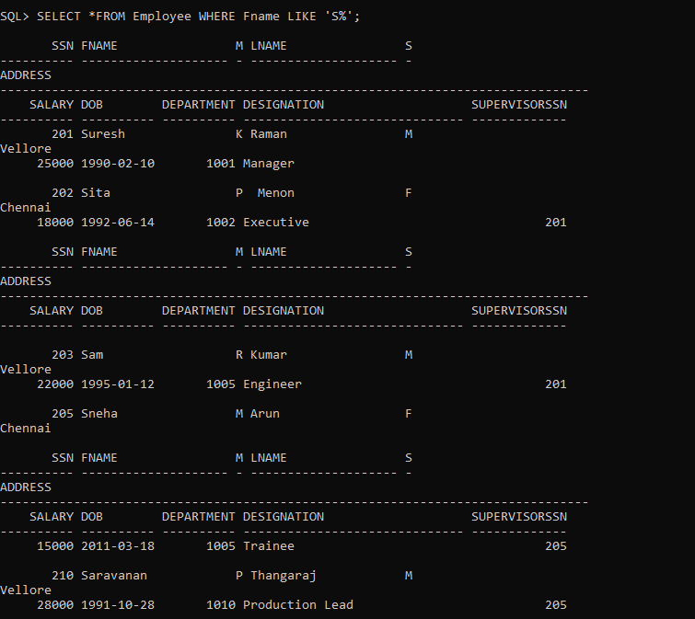
4) List the employee names who work for department no 1005.
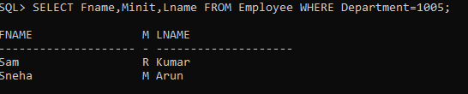
5) Dependent names that are females and related to Employee no 1005.
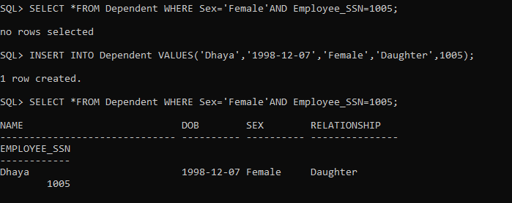
6) Find the details of the projects that have been operating in the location 'Chennai".
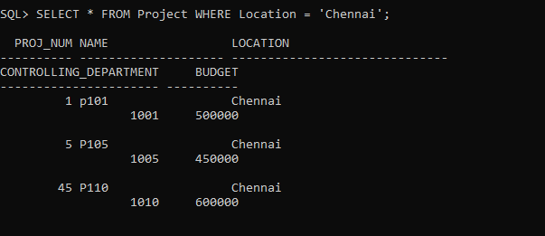

7) Find the employee who does not have a supervisor.
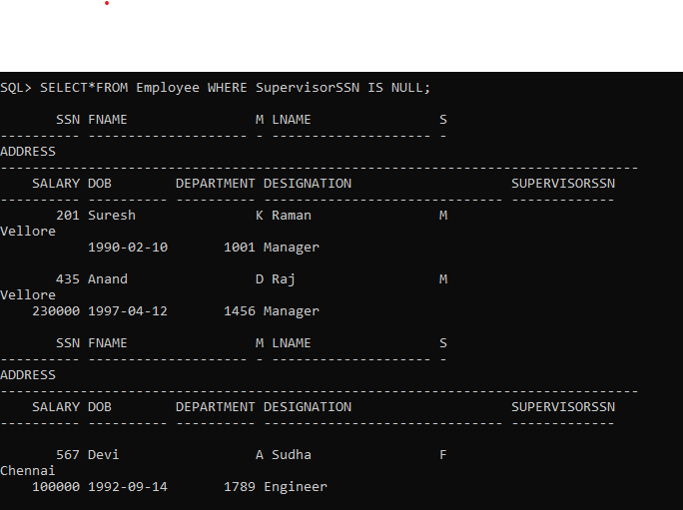
8)Display the Department details which has a manager.
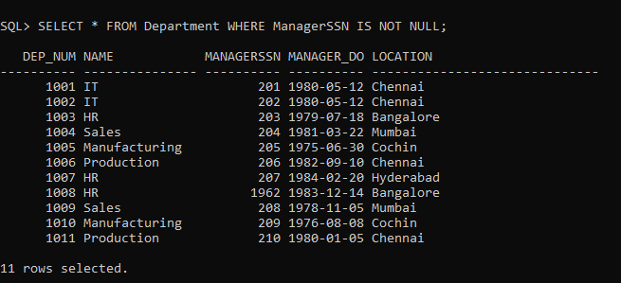
9)A project name whose location is "Tidal Park" or department is 1006.
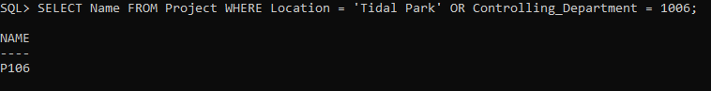
10)Select the employees who were born after 2010.
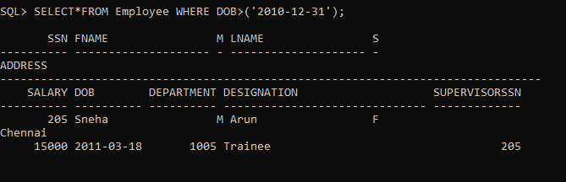
11) Display the employee names who salary is in the range 12000 to 30000. 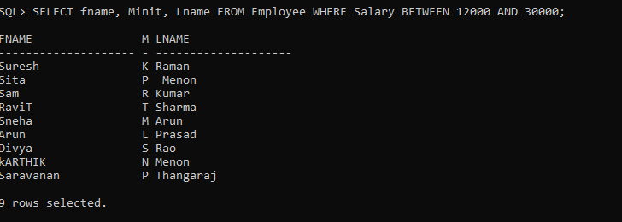
12)Find the employees who work for the project numbers 1, 3, and 45.
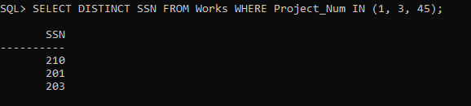

13)Maximum salary withdrawn by an employee.
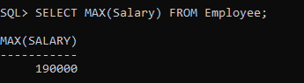
14)List the number of dependents for an employee.
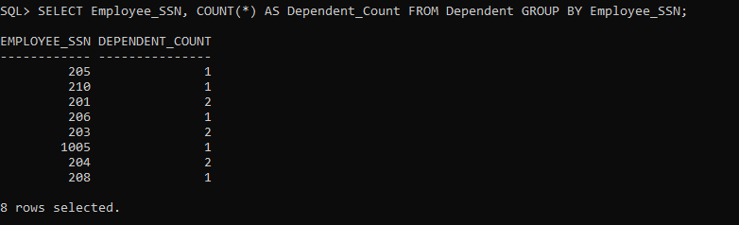
15) Print the total salary amount sanctioned in department no 4.
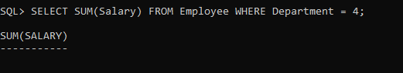
16) Count the number of projects for any SSN.
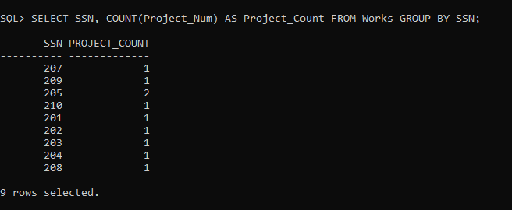

17) Find that how many employees come from the city "Vellore'.
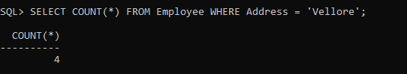
18) List out how many male employees working in the company.
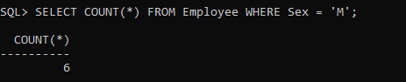
e) Alter the tables to:
1)Make name of Project as Unique and sex of employee as not null
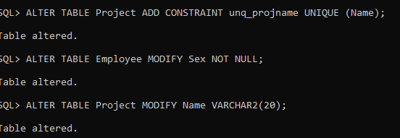
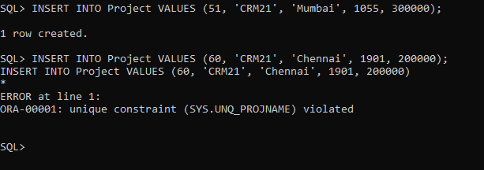
2)Increase the size of project name. 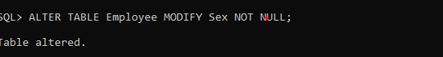
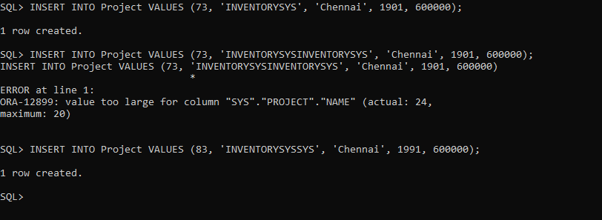
3)Make salary of employee to accept real values.

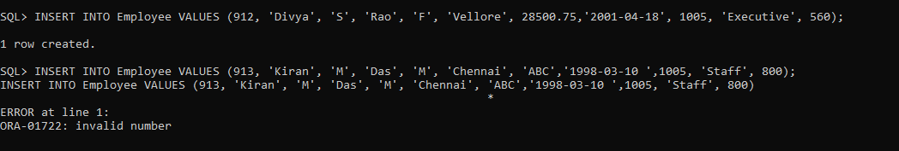
4)Decrease the size of department name.

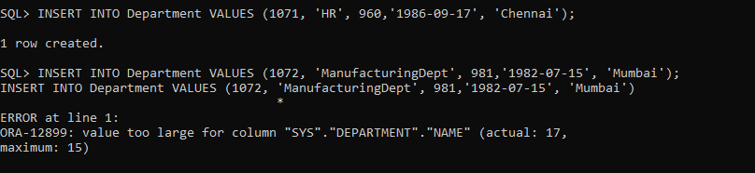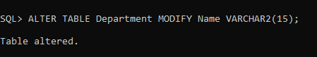

5)Ensure that the location of the project can only be from 'Chennai, 'Hyderabad', 'Cochin', 'Bangalore' and 'Mumbai".

