

NAME : GOPIKA S
REG.NO : 24MIS0026
SUBJECT CODE : IMAT202P
SUBJECT TITLE : PROBABILITY AND STATISTICS LAB
LAB SLOT : L45+L46
GUIDED BY : Prof. UDHAYAKUMAR R

- Create the following tables:
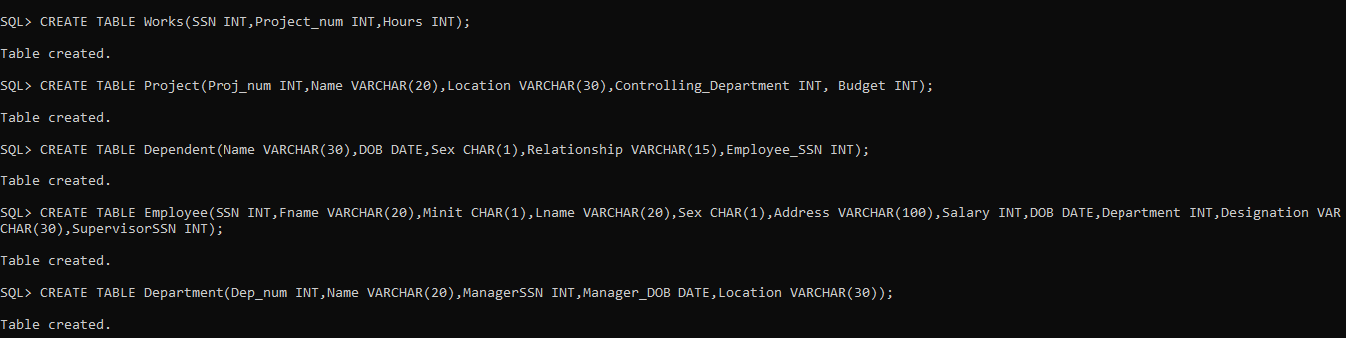
a)Identify the appropriate primary keys for the tables. It is self-explanator
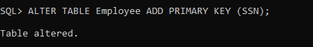
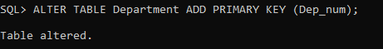
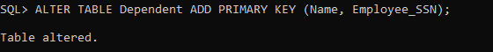
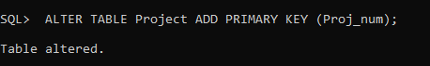
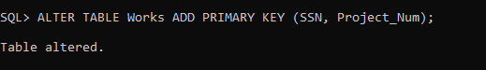
c) Set the following Constraints to the above tables:
1) Department number should be in the range 1000 to 2000.
2) Relationship of the dependents to an employee should be only Spouse, Son, Daughter, and Parent.
3) Name of the project doesn't exceed 4 characters
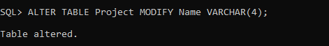
4)
b) Insert at least 10 rows to each table. (Apply Interactive insertion.

