Drift-Triggered Evidence Switching Suppresses Stale Priors in Cold-Start Interactive Recommendation

Dhayanidhi Rajasekaran^{1*} Rajalakshmi N.R.²

¹Research Scholar, Department of Computer Science and Engineering, Vel Tech Rangarajan Dr Sagunthala R&D Institute of Science and Technology, Chennai, India
²Professor, Department of Computer Science and Engineering, Vel Tech Rangarajan Dr Sagunthala R&D Institute of Science and Technology, Chennai, India
* Corresponding author’s Email: dhayanidhi.r@gmail.com

Abstract: A demographic prior serves a new user well at first and turns harmful once taste drifts, because a warm linear bandit keeps conditioning on stale rows. DES-UCB is a contextual bandit that holds a prior-driven source P and a sliding-window feedback source F, picks one each round with EXP3 on a clipped generalisation gain, and on a Page-Hinkley firing halves the window, purges old feedback, resets the credit of P and forces F for a burn-in. Eight claims were preregistered and five are supported. On abrupt drift with a stale prior the dynamic regret is 50.4 against 65.1 without suppression, paired difference -14.7 with 95% CI [-16.0, -13.5]. Passive decay of the prior is not worse, the method costs 6.86 times the regret of warm LinUCB without drift, and MovieLens-1M shows no precision gain. The contribution is a mechanism, two diagnostics and a preregistered protocol, not a regret win.
Keywords: Contextual bandits, concept drift, cold start, interactive recommendation, non-stationary environments, preregistration

1. Introduction
Cold-start recommendation has a standard remedy. Borrow a prior from users who look alike and let the bandit start from it. Warm LinUCB does this well when the prior is close to the truth and the truth does not move. Interactive settings break the second condition. Sessions change topic, seasons change taste, and the cohort a user was assigned to at sign-up stops being informative.
The natural repair is forgetting. Sliding-window UCB drops old rows [1]. Discounted LinUCB down-weights them [2]. Change-point restarts throw everything away when a detector fires [3]. Bandit-over-Bandit (BOB) tunes the window on the fly [4]. Each of these treats all evidence the same. None of them distinguishes rows that came from a prior population from rows that came from the user, and none of them can tell the estimator to stop trusting one of these two sources while keeping the other.
DES-UCB makes that distinction explicit. It keeps a prior estimator P and a feedback estimator F side by side. A meta-controller decides which one scores the candidates in each round. A drift detector watches the active source. On a firing, the agent removes feedback that predates the new window, wipes the meta-controller’s credit for P and runs F alone for $B$ rounds. The window itself is chosen by a BOB layer.
The article reports the method and its evaluation as they were run, including the parts that did not work. Eight claims were written into a registry before the confirmatory five-seed run, each with a threshold. A paper-text gate then releases only the sentences whose claim is supported. Five claims pass and three fail. The failures rule out the strongest readings of the idea. Purge, reset and burn-in are not shown to beat a simple halving of the prior weight. With no drift at all the switching layer costs 6.86 times the regret of warm LinUCB. On MovieLens-1M the method does not raise precision. The paper therefore frames its contribution as follows.
Contributions
(i) A two-source contextual bandit whose meta-controller is paid a clipped, scale-free generalisation gain and whose drift response acts on the sources rather than on the whole model. (ii) Two diagnostics for non-stationary bandits. The staleness ratio measures how often the agent conditions on the prior after the change. The phase diagram maps the drift magnitude and prior size at which suppression pays off. (iii) A preregistered evaluation protocol with a claim registry, a text gate and three separate metric namespaces for synthetic regret, rated offline regret and replay reward. (iv) An honest report of five supported and three unsupported claims, with a statement of what a decisive test would need.
Section 2 places the method against sliding-window, discounted, restart and BOB bandits. Sections 3 and 4 give the formulation and the equations as implemented in des_ucb_core.py. Sections 5 to 7 describe the environments, the protocol and the results. Sections 8 and 9 discuss what the numbers do and do not show.
2. Related Work
Linear contextual bandits
LinUCB [5] and OFUL [6] fit a ridge estimator and add an exploration width proportional to the estimator’s uncertainty. The estimator in this article is the same and the arm selection rule is the same. Warm starts from a demographic or population prior are the standard cold-start device [5], [7].
Forgetting
Sliding-window UCB [1] keeps only the last $w$ rows. Discounted UCB down-weights rows geometrically [1], [2]. Both are borrowed here. F is a sliding-window ridge estimator and baseline B5 is discounted LinUCB. What is new is that the window applies to F only. The prior rows in P are never forgotten by a window. They are switched off by the meta-controller and their credit is reset on drift.
Change-point restarts
Detecting a change and restarting the estimator is well studied [3], [8], [9]. Page-Hinkley [10] and ADWIN [11] are two standard detectors and both are implemented. Baseline B6 is a Page-Hinkley restart of warm LinUCB. The difference in DES-UCB is that a firing does not restart the model. It halves the window, purges the feedback rows that fall outside it, resets the credit of P and forces F for a burn-in. The prior estimator itself is untouched and can be selected again once the burn-in ends.
Bandit-over-Bandit
Cheung, Simchi-Levi and Zhu [4] run EXP3 over a set of window lengths and credit the chosen window with the block reward. This layer is borrowed as is. Baseline B4 is BOB alone. In DES-UCB the drift response can shorten the window in the middle of a block and the block credit is then discarded to keep the attribution clean.
Meta-controllers over experts
EXP3 [12] and its variants for mixing experts or policies are standard. The evidence switch is EXP3 over two sources with a clipped relative-error gain. Corralling bandits [13] and model-selection bandits [14] combine base learners with a master, but the master there is paid the observed reward. Here it is paid a held-out comparison between the two sources on the same observation, which makes the gain scale-free.
Position of this work
Three ideas are borrowed unchanged. Sliding-window forgetting, BOB window selection and change-point triggering. Four are new in combination. Two evidence sources with separate estimators, gain-based switching between them, a drift-triggered purge that touches only F and a credit reset of P with a forced F-only burn-in. The article also borrows the idea of a preregistered claim registry from confirmatory research practice [15].
3. Problem Formulation
Interaction protocol
A single user interacts for $T$ rounds. At round $t∈\{0,…,T−1\}$ the environment shows a candidate set $X_{t}∈R^{K×d}$ with rows $x_{t,a}$. The agent picks an index $a_{t}$ and observes a reward $r_{t}$. In the synthetic environment the reward is
$r_{t}=x_{t,a_{t}}^{⊤}θ_{t}+ε_{t}, ε_{t}∼N(0,σ^{2}),$ (1)
where $θ_{t}$ is a time-varying parameter. Before the first round the agent receives a set of prior rows $D_{prior}=(X_{P},r_{P})$ with $n_{P}$ rows drawn from a prior parameter $θ_{prior}$ that may or may not equal $θ_{0}$.
Dynamic regret
Performance on synthetic data is measured by dynamic regret against the per-round best candidate under the noise-free mean,
$R_{T}=\sum_{t=0}^{T−1}{\left(\max_{a}x_{t,a}^{⊤}θ_{t}−x_{t,a_{t}}^{⊤}θ_{t}\right)}.$ (2)
The oracle B9 picks the maximiser in every round and has $R_{T}=0$ by construction. The claim sanity_oracle checks this in every round of every run.
Offline regret and replay reward
Rated datasets have no $θ_{t}$. There the candidate set is a sample of items the user actually rated, the reward is the rating turned into a hit indicator and the best available reward in the candidate set plays the role of the oracle,
$R_{T}^{off}=\sum_{t=0}^{T−1}{\left(\max_{a}r_{t,a}−r_{t,a_{t}}\right)}.$ (3)
Logged randomised exposure data (Yahoo R6, KuaiRand) would be scored by replay reward [16], the mean reward over rounds where the logged arm equals the chosen arm. Three metric namespaces result. dynamic for (2), offline for (3) and replay. The code raises an error when a metric function is called on the wrong namespace and no number in this article compares two namespaces.
Notation
Table 1 lists the symbols used below.
Table 1. Notation.
Symbol | Meaning
$d$ | feature dimension
$K$ | candidate items per round
$T$ | rounds per user
$x_{t,a}$ | feature vector of candidate $a$ at round $t$
$θ_{t}$ | true parameter at round $t$ (synthetic only)
$D_{prior}$ | prior rows $(X_{P},r_{P})$, $n_{P}$ of them
$λ,β,S$ | ridge weight, exploration width, norm clip
$V_{m},b_{m},{\hat{θ}}_{m}$ | ridge statistics of source $m∈\{P,F\}$
$w,w_{0},w_{min}$ | active window, its initial value, its floor
$W$ | candidate windows for BOB
$H$ | BOB block length
$γ$ | EXP3 exploration rate (switch and BOB)
$G$ | gain clip
$g_{t}$ | clipped generalisation gain at round $t$
$m_{t}$ | source selected at round $t$
$B$ | burn-in length after a firing
$δ,λ_{PH},α$ | Page-Hinkley drift, threshold, forgetting
$δ_{AD}$ | ADWIN confidence
$N_{fired}$ | number of detector firings
$Δ_{max}$ | largest per-round regret

4. Method
Fig. 1 shows the components. The equations below are read off des_ucb_core.py and use its variable names where practical.

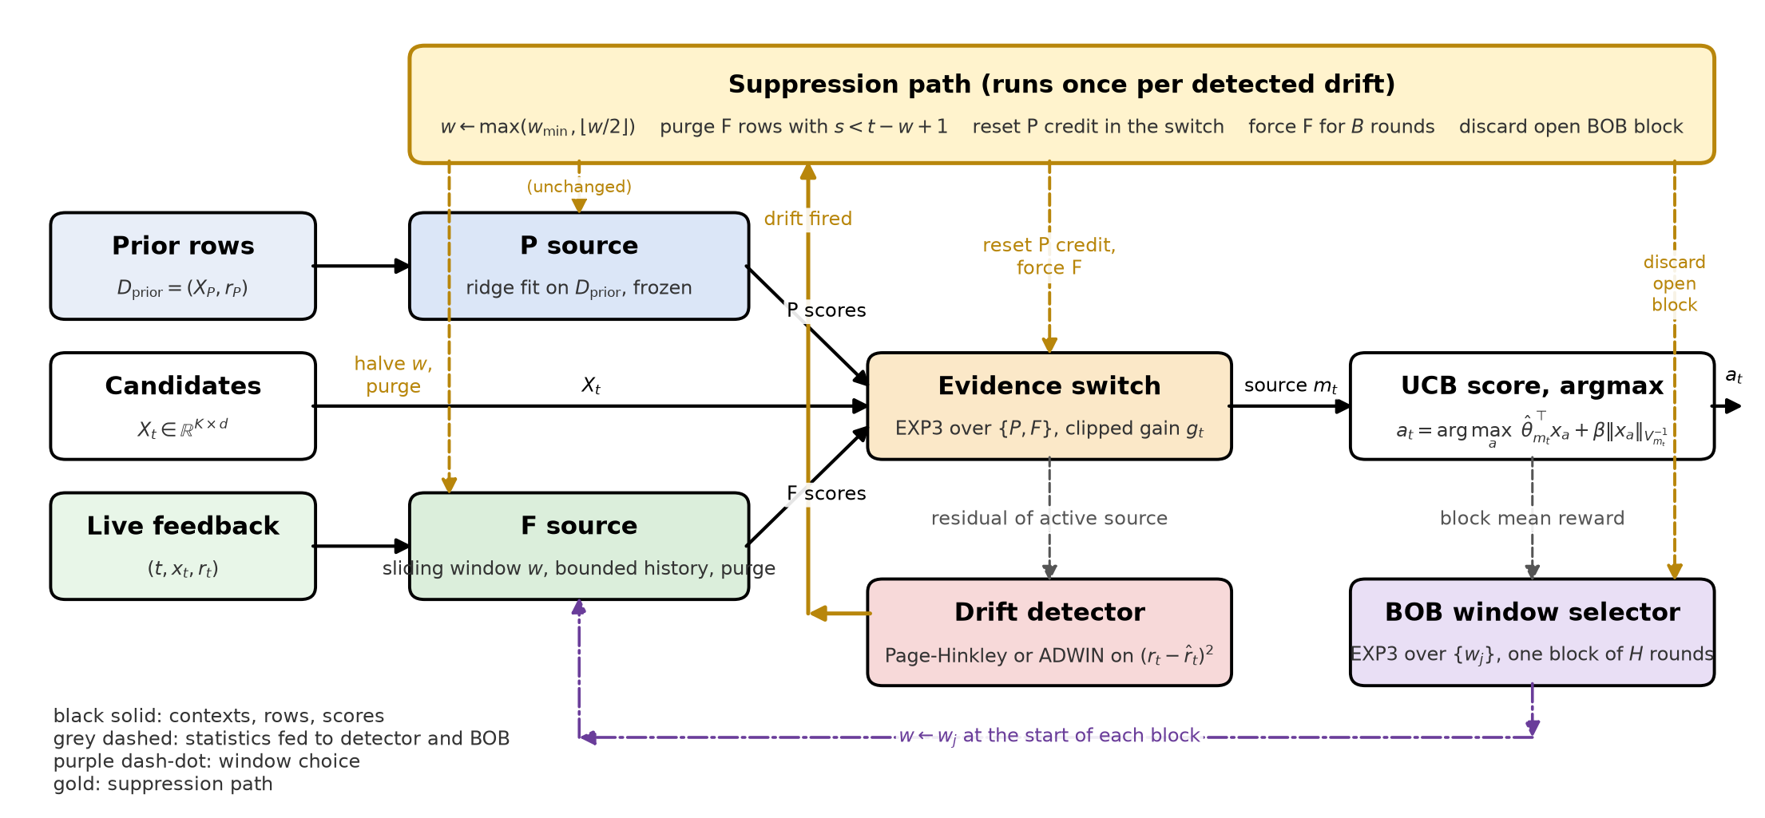
Figure. 1 Block diagram of DES-UCB. Prior rows feed source P and live feedback feeds source F. The evidence switch chooses which source scores the candidates. The active source’s squared residual drives the drift detector. The block mean reward drives the BOB window selector. The gold path is taken once per detected drift. It halves the window, purges F rows with $s<t−w+1$, resets the credit of P, forces F for $B$ rounds and discards an open BOB block if the window changed.

4.1. Ridge-UCB Estimator
Both sources are instances of one estimator. For a source $m$ with weighted rows $\{(x_{i},r_{i},c_{i})\}$,
Vm=λId+i​ci xixi⊤, bm=i​ci ri xi,θm=ΠSVm−1bm, ΠS(θ)=θ min​1,S∥θ∥2. (4)–(5)
The inverse is kept by Sherman-Morrison updates. The UCB score and the arm choice are
$\begin{aligned}u_{m}(x)={\hat{θ}}_{m}^{⊤}x+β \sqrt{x^{⊤}V_{m}^{−1}x}, \\ a_{t}={arg max}_{a} u_{m_{t}}(x_{t,a}).\end{aligned}$ (6)–(7)
Ties resolve to the first index.
4.2. Prior Source P
P is (4)–(5) fitted once on $D_{prior}$ with unit weights. A mixing weight $α≥0$ allows live rows to be added to P with weight $α$ when P is the active source. All experiments here use $α=0$, so P never changes after the fit. P is therefore a frozen summary of what the population, or the user’s own past, said before interaction began.
4.3. Feedback Source F
F is (4)–(5) on the user’s own rows $(s,x_{s},r_{s})$ with timestamp $s$. Its ridge state covers exactly the active rows
$A_{t}(w)=\{(s,x_{s},r_{s}) : s≥t−w+1\}.$ (8)
Rows that leave the window are kept in a bounded history of the most recent $max(w_{max},\left|A_{t}\right|)$ rows. When the window grows later, (8) is rebuilt from that history, so a window change is exact rather than approximate. The purge
$purge(t_{0})=\text{drop every row with }s<t_{0}$ (9)
acts on the history and the ridge state together and is irreversible. After a purge no later window growth can bring the dropped rows back.
4.4. Evidence Switch
The switch is EXP3 [12] over $\{P,F\}$ with log-weights $ℓ=(ℓ_{P},ℓ_{F})$ and exploration $γ$,
pt(m)=(1−γ) eℓmm′​eℓm′+γ2. (10)
Round $t$ samples $m_{t}∼p_{t}$, except in three forced cases. During a burn-in the source is F. Before F holds $min(d,w_{min})$ rows the source is P. In ablation A1 a fixed schedule replaces the sampler. Forced rounds are not credited.
After the reward is seen the agent computes the held-out squared errors of both sources, before either is updated,
$\begin{aligned}e_{m}={\left({\hat{θ}}_{m}^{⊤}x_{t,a_{t}}−r_{t}\right)}^{2}, e_{o}={\left({\hat{θ}}_{o}^{⊤}x_{t,a_{t}}−r_{t}\right)}^{2}, \\ g_{t}=\frac{e_{o}−e_{m}}{e_{o}+e_{m}+{10}^{−12}}∈[−1,1],\end{aligned}$ (11)
where $o$ is the source not selected. The gain is the relative squared-error reduction from having conditioned on $m_{t}$ rather than on the alternative. It is scale-free and already bounded, and it is clipped to $[−G,G]$ and mapped to $[0,1]$ before the EXP3 update,
$\begin{aligned}{\tilde{g}}_{t}=\frac{clip(g_{t},−G,G)+G}{2G}, \\ ℓ_{m_{t}}←ℓ_{m_{t}}+\frac{γ}{2} \frac{{\tilde{g}}_{t}}{p_{t}(m_{t})}, ℓ←ℓ−\max_{m}ℓ_{m}.\end{aligned}$ (12)–(13)
Ablation A6 replaces (11) by the relative reduction in UCB width $(ω_{o}−ω_{m})/(ω_{o}+ω_{m})$ with $ω_{m}=\sqrt{x^{⊤}V_{m}^{−1}x}$. Ablation A7 replaces EXP3 by UCB1 over the two sources with the same gain.
4.5. Drift Detectors
The detector input is the squared residual of the active source’s point prediction,
$ϵ_{t}={\left(r_{t}−{\hat{θ}}_{m_{t}}^{⊤}x_{t,a_{t}}\right)}^{2}.$ (14)
The default detector is Page-Hinkley [10] with forgetting factor $α$,
$\begin{aligned}{\overset{‾}{ϵ}}_{n}={\overset{‾}{ϵ}}_{n−1}+\frac{ϵ_{t}−{\overset{‾}{ϵ}}_{n−1}}{n}, \\ M_{n}=αM_{n−1}+(ϵ_{t}−{\overset{‾}{ϵ}}_{n}−δ), m_{n}=min(m_{n−1},M_{n}), \\ \text{fire}⇔n≥n_{min} \text{and} M_{n}−m_{n}>λ_{PH}.\end{aligned}$ (15)
The statistics reset after a firing. The alternative detector is ADWIN [11]. It holds a window of recent $ϵ$ values and, for every split into a head of $n_{0}$ and a tail of $n_{1}$ values, compares means against
$\begin{aligned}ϵ_{cut}=\sqrt{\frac{2{\hat{σ}}^{2}}{m}ln\frac{2}{δ^{′}}}+\frac{2}{3m}ln\frac{2}{δ^{′}}, \\ m=\frac{1}{1/n_{0}+1/n_{1}}, δ^{′}=\frac{δ_{AD}}{n},\end{aligned}$ (16)
and drops the head when $\left|{\hat{μ}}_{0}−{\hat{μ}}_{1}\right|>ϵ_{cut}$.
4.6. BOB Window Selector
Rounds are grouped into blocks $\left[kH,(k+1)H\right)$. At the start of a block the selector samples a window $w∈W$ from an EXP3 distribution of the form (10) over $\left|W\right|$ arms and F is set to that window through (8). At the last round of the block the mean reward of the block is mapped to $[0,1]$ and credited to the window that was active,
$ℓ_{w}←ℓ_{w}+\frac{γ}{\left|W\right|} \frac{clip({\overset{‾}{r}}_{block},0,1)}{p(w)}.$ (17)
Credit is block-level, never per round, so a window is judged by what it delivered over the whole block it governed.
4.7. Drift Suppression
When the detector fires at round $t$ the agent runs the following sequence.
$\begin{aligned}w←max\left(w_{min},⌊w/2⌋\right), \\ \text{set F to window }w\text{ and apply }purge(t−w+1), \\ ℓ_{P}←min(ℓ_{P},ℓ_{F}), \\ \text{force }m_{t^{′}}=F\text{ for }t^{′}=t+1,…,t+B.\end{aligned}$ (18)–(21)
The purge cutoff in (19) equals the active-window boundary in (8). Every row F would still use survives and every row outside the new window is gone for good. Step (20) moves the log-weight of P down to that of F, which makes the switch indifferent between the sources once the burn-in ends and removes any credit P had built on the pre-drift regime. If (18) changed the window in the middle of a BOB block, the open block is discarded so that no window is credited with rewards earned under another window. A block that is exactly complete at $t$, or a firing that leaves $w$ unchanged, keeps its credit. Ablation A2 skips all four steps. Ablation A5 replaces them by a passive decay that halves a mixing weight on P, so that P’s predictions become $ρ {\hat{θ}}_{P}^{⊤}x+(1−ρ) {\hat{θ}}_{F}^{⊤}x$ with $ρ←ρ/2$ at each firing.
4.8. Regret Bound as an Obligation
The intended guarantee is
$\begin{aligned}R_{T}(\text{DES-UCB})≤​R_{T}(\text{SW-UCB/BOB}) \\ +O(\sqrt{T})+N_{fired}BΔ_{max}.\end{aligned}$ (22)
The first term is what the F source alone would incur. The second is the EXP3 cost of switching between two experts. The third charges every burn-in at the worst per-round regret. This inequality is stated as a proof obligation. It is not proved in this article and no result below relies on it. The empirical rate check in Section 7 is a consistency check, not a substitute for a proof.
4.9. Baselines and Ablations
Table 2 lists the agents. All share $λ$, $β$ and $S$ with DES-UCB. B3 uses a fixed window equal to $w_{0}$. B5 uses discount $0.995$. B6 restarts warm LinUCB on a Page-Hinkley firing with the same detector settings as DES-UCB. B9 is the noise-free oracle and exists only to check (2).
Table 2. Agents. B are baselines, A are ablations of DES-UCB.
Id | Agent
B1 | LinUCB, cold start [5]
B2 | LinUCB, warm start from $D_{prior}$
B3 | Sliding-window UCB, fixed $w=w_{0}$ [1]
B4 | Bandit-over-Bandit over $W$ [4]
B5 | Discounted LinUCB [2]
B6 | Warm LinUCB with Page-Hinkley restart [3]
B7 | Prior only, P never updated
B8 | Uniform random
B9 | Oracle, per-round best mean
A1 | no switch, fixed P-then-F schedule
A2 | no suppression, detector fires but does nothing
A3 | no detector
A4 | no BOB, fixed $w=w_{0}$
A5 | passive decay of P instead of purge, reset, burn-in
A6 | uncertainty gain instead of (11)
A7 | UCB1 switch instead of EXP3

4.10. Metrics and Statistics
Dynamic and offline regret
Regret is summed per unit, where a unit is one (seed, user) pair, then averaged over units. Standard deviations in tables are over units.
Staleness ratio
For an agent with source trace $m_{t}$ and first true change $t_{c}$,
SR=1T−tct≥tc​1[mt=P]. (23)
It measures how often the agent still conditions on the prior after the world has moved.
Recovery time
The number of rounds after $t_{c}$ until the 20-round moving average of per-round regret returns within 10% of its pre-change level.
Rate slope
With cumulative regret $R(T_{j})$ at checkpoints $T_{j}$, the slope is the least-squares fit of $lnR(T_{j})$ on $lnT_{j}$. A stationary linear bandit has slope near $0.5$. Under sinusoidal drift the slope measures how fast the regret keeps growing.
Precision and recall
On rated data, cumulative precision at $k$ is the mean over units of hits in the first $k$ rounds divided by $k$. Cumulative recall at $T$ is hits in $T$ rounds divided by the user’s number of relevant items in the test split, matched by the user’s ordinal identifier.
Replay reward
On logged randomised data, the mean reward over rounds where the logged arm equals the chosen arm, with the number of matched rounds reported alongside.
Confidence intervals
Every difference between two agents is a paired difference over units. Its 95% interval is a percentile bootstrap with 2000 resamples of the unit-level differences, seed 0. No other hypothesis test is used. A claim with a directional threshold passes when the whole interval lies on the required side.
5. Environments and Data
5.1. Synthetic Environments
Items are $N$ unit-norm Gaussian vectors in $R^{d}$. Each user belongs to one of $K_{c}$ cohorts with prototype $μ_{k}$ and has $θ_{0}$ equal to a noisy unit-norm copy of its prototype. The candidate set at each round is $K$ items drawn uniformly. Six drift types set $θ_{t}$.
none. $θ_{t}=θ_{0}$.
abrupt. $θ_{t}$ jumps at each change point to a new target at distance $∥θ_{1}−θ_{0}∥$ equal to the magnitude.
gradual. The same targets, reached by linear interpolation over $G$ rounds.
recurring. $θ_{t}$ alternates between $θ_{0}$ and $θ_{1}$ every $P$ rounds.
incremental. A random walk with unit-norm steps of size $ϵ$.
sinusoidal. $θ_{t}=θ_{0}+\text{mag}⋅sin(2πt/\text{per}) u$ with $u$ the unit direction from $θ_{0}$ to $θ_{1}$.
The prior rows are $n_{P}$ items scored by $θ_{prior}$ plus Gaussian noise $σ_{prior}$. The flag sets $θ_{prior}=θ_{0}$, so the prior is right before the change and stale after it. Otherwise $θ_{prior}=μ_{k}$, a population prior. With probability $p_{mis}$ the prior is instead drawn from a different cohort’s prototype, which models a misspecified prior. Table 3 gives the values used.
Table 3. Default configuration from configs/default.yaml.
Setting | Value
$d$, $N$, $K$ | 16, 500, 20
$λ$, $β$, $S$ | 1, 0.5, 5
$w_{0}$, $w_{min}$, $W$ | 400, 50, {50, 100, 200, 400, 800}
$H$, BOB $γ$ | 100, 0.1
switch $γ$, $G$ | 0.1, 1
$B$ | 30
PH $δ$, $λ_{PH}$, $α$, $n_{min}$ | 0.005, 1, 0.999, 30
$K_{c}$, $n_{P}$, $σ_{prior}$ | 8, 200, 0.1
change points, magnitude, $σ$ | {600, 1300}, 1, 0.1
$G$ (gradual), $P$ (recurring) | 300, 500
$ϵ$ (incremental), period (sinusoidal) | 0.01, 500
B3 window, B5 discount | 400, 0.995

5.2. Rated Datasets
MovieLens-1M and MovieLens-100K [17] are used with a user-disjoint 85/5/10 split, users with at least 100 ratings and a hit defined as rating $≥4$. Item features are $16$ SVD factors plus genre indicators, $d=34$ in total. Each test user runs $T=40$ rounds with $K=20$ candidates drawn from the user’s own rated items, following the interactive collaborative filtering protocol [18], [19]. The prior for a test user is $n_{P}=200$ rows from training users of the same gender and age cohort. When the exact cohort has no training rows the loader falls back to the cohorts that are available, so some priors are less specific than intended. Three protocols are run. Protocol A is plain cold start. Protocol B splits the user’s ratings chronologically, builds the prior from the cohort rows plus the user’s own early half and shows early-half items before the midpoint and late-half items after it. This induces a drift with a prior that is exact for the first half and stale for the second. Protocol C draws the cohort prior from a different demographic cohort with probability 0.5. Window settings are scaled down to $w_{0}=20$, $w_{min}=5$, $W=\{5,10,20,40\}$, $H=10$ and $B=5$. At most 300 test users are used and one seed is run.
MIND-small [20] is used chronologically with $T=20$, users with at least 20 impressions and $32$ SVD factors of the title TF-IDF as item features. The reward is a click, which is a proxy for relevance and not a rating. Windows are $H=5$ and $B=3$.
5.3. Replay Datasets
The loaders for Yahoo R6 and KuaiRand exist and the replay-reward metric is implemented. Neither dataset was configured in the reported run. Yahoo R6 requires a Webscope licence and is not fetched by the program. The replay section of the notebook therefore reports that these metrics were not computed. No replay number appears in this article.
6. Experimental Setup
Scales
The pilot uses 1 seed, 20 users, $T=1000$ and a single change point at 500. The drift grid uses 2 seeds and 30 users at $T=2000$. The ablation uses 2 seeds and 30 users. The staleness sweep and the phase diagram use 2 seeds, 20 users and $T=1500$. The rate check uses 3 seeds, 20 users and $T=4000$ with checkpoints {250, 500, 1000, 2000, 4000}. The claim registry, which is the confirmatory run, uses 5 seeds and 100 users at $T=2000$, giving 500 units per claim. These scales are set in configs/default.yaml and the grid, ablation and sweep numbers below are exploratory at these sizes.
Preregistration and gate
Eight claims were written down with a criterion before the confirmatory run. Table 11 lists them with the verdicts. A text gate reads the verdicts and emits only the result sentences whose claim is supported. Sentences for unsupported claims are printed as unsupported and appear in this article only as such.
Pilot decision
The pilot was run first with a Page-Hinkley threshold of 50, the value in the original specification. The detector did not fire on any of the 20 units. The preregistered decision table had a branch for this case, labelled detection failure, which allows the threshold to be retuned and the pilot repeated. The threshold was set to 1 and the pilot was rerun. Table 4 shows the rerun. This is a tuned hyperparameter, chosen on the pilot, and not a result. The confirmatory run used the retuned value.
Reproducibility
All randomness derives from the seed, the user index and a fixed CRC of the agent name. The environment is reset before each agent so that agents see identical candidate streams. One notebook produces every CSV, JSON and figure used here and scripts/build_paper_tables.py turns them into the tables and macros of this article without manual entry.
7. Results
7.1. Pilot
Table 4 gives the pilot after retuning. The detector fired on every unit with a mean delay of 21.1 rounds, which is below $B=30$, and with 0.00 false alarms before the change. DES-UCB had -12.5 less regret than A2 and -6.3 less than B4 on this small run. The pilot verdict was to proceed to the confirmatory run.

Table 4. Pilot after threshold retuning. Regret is mean $±$ standard deviation over 20 units, abrupt drift at round 500, $T=1000$. Delay is in rounds after the true change.
Agent | regret | detected | missed | mean delay | firings
DES-UCB | 22.6 $±$ 4.8 | 20/20 | 0 | 21.1 | 22
A2 no suppression | 35.1 $±$ 13.5 | 20/20 | 0 | 25.1 | 25
B4 BOB | 29.0 $±$ 10.7 | 0/20 | 20 | – | 0

7.2. Drift Grid
Table 5 and Fig. 2 give dynamic regret for every agent on the six drift types. Bold marks the best non-oracle agent per column. DES-UCB is not the best agent in any column. Warm LinUCB (B2) wins with no drift at 1.6 against 11.3 for DES-UCB. The Page-Hinkley restart (B6) wins on abrupt, recurring and sinusoidal drift. Discounted LinUCB (B5) wins on gradual and incremental drift. On abrupt, gradual, recurring and sinusoidal drift DES-UCB sits between the forgetting baselines and the warm start. On incremental drift the warm start is ahead of DES-UCB as well, at 18.4 against 22.3. Fig. 3 zooms on the first change point of the abrupt run. The moving-average panel shows DES-UCB returning to its pre-change level faster than A2. Recovery times, in rounds, are 154 for DES-UCB, 126 for B4, 116 for B6 and 971 for B2 under abrupt drift.

Table 5. Dynamic regret on the drift grid, mean $±$ standard deviation over units (2 seeds, 30 users, $T=2000$). Bold is the lowest regret per column among non-oracle agents.
Agent | none | abrupt | gradual | recurring | incremental | sinusoidal
DES-UCB | 11.3 $±$ 3.2 | 50.6 $±$ 11.0 | 41.0 $±$ 9.5 | 56.0 $±$ 15.0 | 22.3 $±$ 4.5 | 147.4 $±$ 26.6
B1 LinUCB | 8.0 $±$ 1.6 | 130.9 $±$ 39.7 | 117.0 $±$ 37.1 | 91.8 $±$ 26.2 | 21.6 $±$ 4.7 | 198.6 $±$ 22.4
B2 LinUCB warm | 1.6 $±$ 0.4 | 145.7 $±$ 45.5 | 128.9 $±$ 40.7 | 96.4 $±$ 27.4 | 18.4 $±$ 5.5 | 187.5 $±$ 20.7
B3 SW-UCB | 10.4 $±$ 1.8 | 49.3 $±$ 10.0 | 34.5 $±$ 7.1 | 79.8 $±$ 19.9 | 15.3 $±$ 2.1 | 272.6 $±$ 28.3
B4 BOB | 20.0 $±$ 4.4 | 49.4 $±$ 13.0 | 37.5 $±$ 9.0 | 66.9 $±$ 20.0 | 23.9 $±$ 3.6 | 166.2 $±$ 30.4
B5 D-LinUCB | 11.1 $±$ 1.9 | 40.9 $±$ 9.0 | 29.7 $±$ 6.8 | 57.3 $±$ 14.0 | 14.9 $±$ 2.1 | 168.3 $±$ 15.8
B6 PH-restart | 8.0 $±$ 1.6 | 30.7 $±$ 4.6 | 33.9 $±$ 4.5 | 39.6 $±$ 5.3 | 23.1 $±$ 4.8 | 98.3 $±$ 9.9
B7 Prior-only | 6.6 $±$ 3.1 | 370.1 $±$ 89.6 | 304.9 $±$ 72.6 | 189.0 $±$ 39.8 | 47.6 $±$ 16.0 | 188.7 $±$ 20.7
B8 Random | 912.4 $±$ 32.8 | 1248.9 $±$ 135.0 | 1186.3 $±$ 123.0 | 1074.0 $±$ 95.6 | 942.4 $±$ 69.1 | 1095.1 $±$ 37.3
B9 Oracle | 0.0 $±$ 0.0 | 0.0 $±$ 0.0 | 0.0 $±$ 0.0 | 0.0 $±$ 0.0 | 0.0 $±$ 0.0 | 0.0 $±$ 0.0

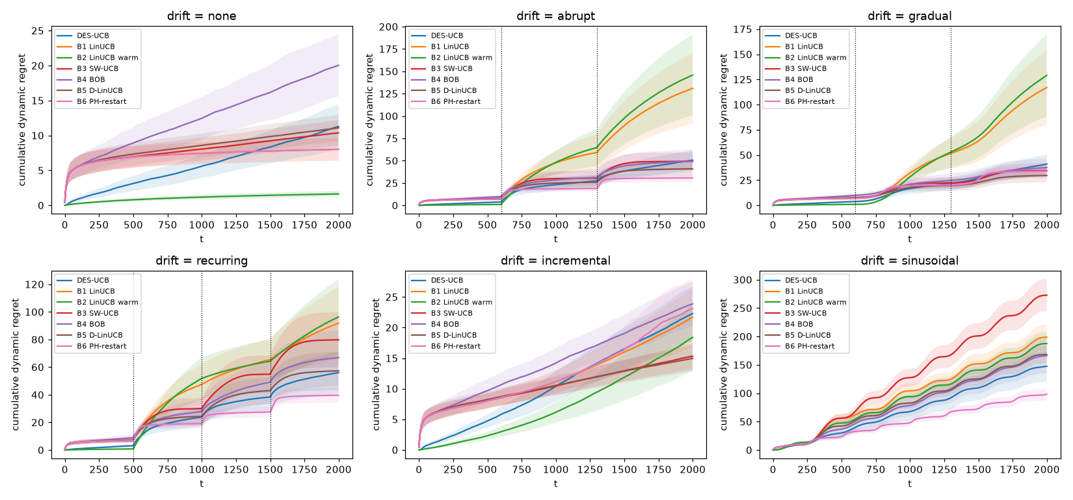
Figure. 2 Cumulative dynamic regret on the six drift types. Each panel is one drift type and each line is one agent, averaged over units.

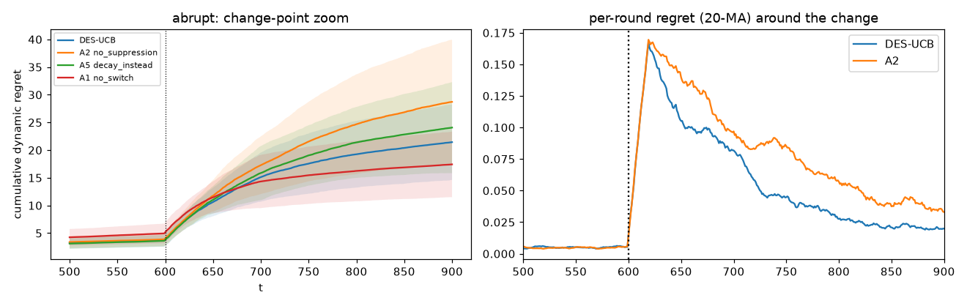
Figure. 3 Left, cumulative dynamic regret around the first change point of the abrupt run for DES-UCB and three ablations, with one standard deviation bands. Right, 20-round moving average of per-round regret for DES-UCB and A2. The dotted line is the true change.

7.3. Mechanism Traces
Fig. 4 shows the source trace of every user in one seed and the mean window length. Before the first change the switch spends many rounds on P. After the first firing the trace is almost entirely F and the mean window drops sharply at each change point before BOB grows it back. Fig. 5 shows the detector firings around the true changes. Firings cluster within a few dozen rounds after each change, with a tail of isolated later firings that are false alarms.

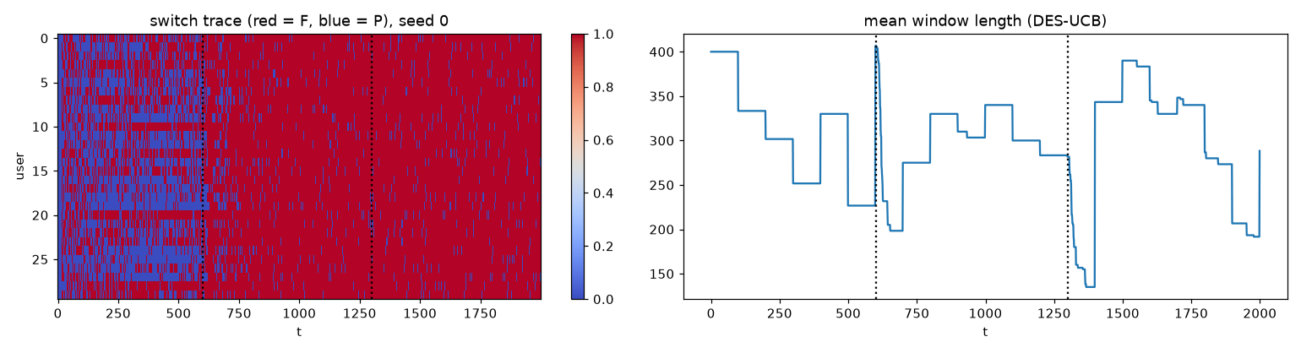
Figure. 4 Left, source selected per round for each user in seed 0 on abrupt drift (red is F, blue is P). Right, mean active window length of DES-UCB over users. Dotted lines are the true change points.

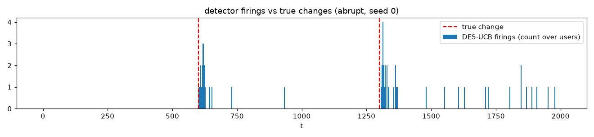
Figure. 5 Rounds at which the Page-Hinkley detector fired, counted over users in seed 0 on abrupt drift. Dashed lines are the true change points.

7.4. Ablations
Table 6 and Fig. 6 remove one component at a time on abrupt and gradual drift. The difference $Δ$ is DES-UCB minus the ablation, so a negative value means the full method has lower regret. Two components matter as intended. Against no suppression (A2) the difference is -16.4 on abrupt drift. Against no detector (A3) it is -15.6. Two components hurt at this scale. Against no switch (A1) the difference is 17.6 and against no BOB (A4) it is 2.6, both in favour of the ablation. Passive decay (A5) is within noise of the full method on abrupt drift, 1.4 with interval [-2.2, 5.0], and is better on gradual drift with 3.9 and interval [1.5, 6.2]. The two alternative switch designs are much worse. Against the uncertainty gain (A6) the difference is -79.5 and against the UCB1 switch (A7) it is -46.9.

Table 6. Ablations. Regret is dynamic regret over units (2 seeds, 30 users). $Δ$ is DES-UCB minus the ablation with a paired bootstrap 95% interval. Negative $Δ$ means the full method is better.
Variant | abrupt |  | gradual
 | regret | $Δ$ [95% CI] | regret | $Δ$ [95% CI]
DES-UCB | 50.6 | – | 41.0 | –
A1 no switch | 33.0 | 17.6 [14.1, 20.9] | 27.2 | 13.7 [11.1, 16.3]
A2 no suppression | 67.0 | -16.4 [-20.2, -12.9] | 52.7 | -11.7 [-15.3, -8.4]
A3 no detector | 66.2 | -15.6 [-19.7, -11.9] | 50.1 | -9.1 [-12.1, -6.6]
A4 no BOB | 48.0 | 2.6 [0.4, 4.8] | 34.8 | 6.2 [4.3, 8.0]
A5 decay instead | 49.2 | 1.4 [-2.2, 5.0] | 37.1 | 3.9 [1.5, 6.2]
A6 uncertainty gain | 130.1 | -79.5 [-89.1, -70.3] | 101.0 | -60.0 [-67.5, -52.8]
A7 UCB1 switch | 97.5 | -46.9 [-56.2, -37.9] | 68.1 | -27.1 [-34.5, -20.6]

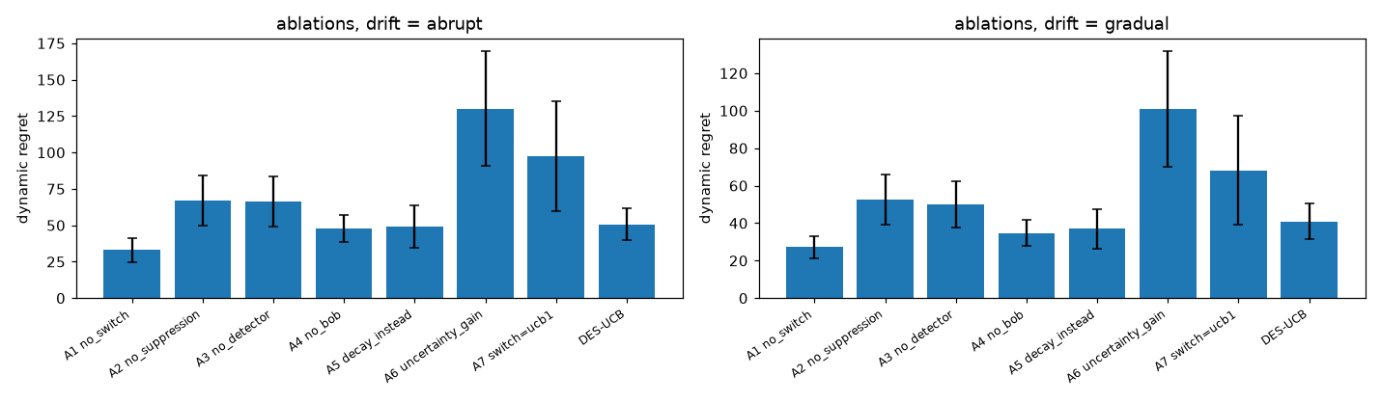
Figure. 6 Ablation dynamic regret on abrupt and gradual drift. Bars are means over units and whiskers are one standard deviation.

7.5. Staleness Sweep and Phase Diagram
Table 7 sweeps one knob at a time and reports DES-UCB against A2 with the paired interval. Of 25 rows, 21 have an interval entirely below zero. The advantage of suppression over no suppression grows with the drift magnitude, from 1.2 at magnitude 0.25, where the interval covers zero, to -45.0 at magnitude 2. It grows with the burn-in length from -9.3 at $B=0$ to -13.8 at $B=100$. It persists across prior noise levels, reaching -10.8 at $σ_{prior}=1$ with upper bound -7.5. It grows with the mismatch probability.
Table 8 and Fig. 7 give the phase diagram of DES-UCB minus A2 over drift magnitude and prior size. Of 20 cells, 13 favour suppression. The cells that do not are all at magnitude 0.25 and two at magnitude 0.5. The largest gain is -52.5 at magnitude 2 with $n_{P}=400$. The largest loss is 1.2 at magnitude 0.25 with $n_{P}=200$. Suppression pays when the change is large enough that the stale prior is far from the truth, and it costs a little when the change is small enough that the prior is still close.

Table 7. Staleness sweep, one knob at a time (2 seeds, 20 users, $T=1500$). Dynamic regret per agent and paired DES-UCB minus A2 with 95% bootstrap interval. Rows marked pop. use a population prior instead of the pre-drift prior.
Knob | value | DES-UCB | A2 | B2 | B4 | DES$−$A2 [95% CI]
p_mismatch | 0 | 58.2 | 66.9 | 131.6 | 42.9 | -8.7 [-12.6, -5.2]
p_mismatch | 0.2 | 66.4 | 76.0 | 148.9 | 42.9 | -9.6 [-12.9, -6.3]
p_mismatch | 0.5 | 70.8 | 81.8 | 157.7 | 42.9 | -11.0 [-14.5, -7.5]
p_mismatch | 0.8 | 80.0 | 93.5 | 175.1 | 42.9 | -13.4 [-17.5, -9.4]
magnitude | 0.25 (pop.) | 34.7 | 35.3 | 44.1 | 18.6 | -0.6 [-2.4, 1.2]
magnitude | 0.5 (pop.) | 41.7 | 43.4 | 65.8 | 24.9 | -1.6 [-3.5, 0.2]
magnitude | 1 (pop.) | 58.2 | 66.9 | 131.6 | 42.9 | -8.7 [-12.6, -5.2]
magnitude | 2 (pop.) | 91.1 | 122.7 | 259.1 | 84.2 | -31.6 [-42.3, -22.3]
magnitude | 0.25 | 15.3 | 14.1 | 9.3 | 18.6 | 1.2 [0.1, 2.3]
magnitude | 0.5 | 22.9 | 24.9 | 31.4 | 24.9 | -2.0 [-4.4, 0.1]
magnitude | 1 | 39.9 | 52.1 | 99.0 | 42.9 | -12.2 [-16.8, -8.3]
magnitude | 2 | 75.8 | 120.8 | 228.2 | 84.2 | -45.0 [-57.0, -34.3]
sigma_prior | 0.05 | 39.5 | 53.0 | 98.6 | 42.9 | -13.5 [-17.5, -9.9]
sigma_prior | 0.1 | 39.9 | 52.1 | 99.0 | 42.9 | -12.2 [-16.8, -8.3]
sigma_prior | 0.3 | 43.4 | 52.2 | 104.0 | 42.9 | -8.8 [-12.7, -5.4]
sigma_prior | 1 | 54.2 | 65.0 | 137.9 | 42.9 | -10.8 [-14.3, -7.5]
burn_in_B | 0 | 42.8 | 52.1 | 99.0 | 42.9 | -9.3 [-13.9, -5.5]
burn_in_B | 10 | 42.1 | 52.1 | 99.0 | 42.9 | -10.1 [-14.6, -6.1]
burn_in_B | 30 | 39.9 | 52.1 | 99.0 | 42.9 | -12.2 [-16.8, -8.3]
burn_in_B | 100 | 38.3 | 52.1 | 99.0 | 42.9 | -13.8 [-18.5, -9.6]
beta | 0.1 | 40.2 | 52.4 | 100.9 | 42.9 | -12.2 [-16.2, -8.3]
beta | 0.25 | 38.9 | 51.4 | 100.3 | 42.5 | -12.5 [-16.5, -8.7]
beta | 0.5 | 39.9 | 52.1 | 99.0 | 42.9 | -12.2 [-16.8, -8.3]
beta | 1 | 45.3 | 57.6 | 97.5 | 47.9 | -12.3 [-17.0, -8.3]
beta | 2 | 67.2 | 77.0 | 94.5 | 71.9 | -9.8 [-14.8, -5.2]

Table 8. Phase diagram. Entries are DES-UCB minus A2 dynamic regret over drift magnitude (rows) and number of prior rows (columns). Negative favours suppression.
$∥θ_{1}−θ_{0}∥$ | $n_{P}=25$ | $n_{P}=50$ | $n_{P}=100$ | $n_{P}=200$ | $n_{P}=400$
0.25 | 0.1 | 0.4 | 0.4 | 1.2 | 0.6
0.5 | -1.1 | 0.2 | 0.5 | -2.0 | -3.0
1 | -8.0 | -7.5 | -7.6 | -12.2 | -15.1
2 | -29.4 | -28.3 | -30.8 | -45.0 | -52.5

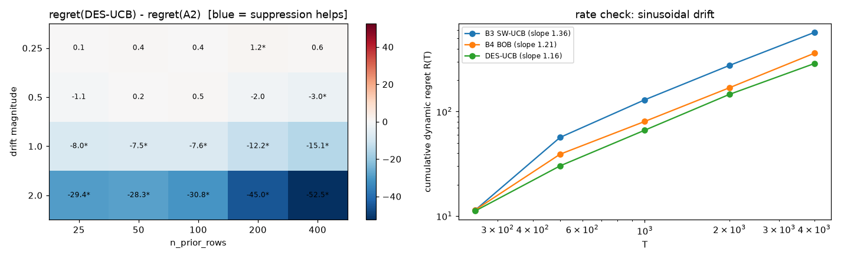
Figure. 7 Left, phase diagram of DES-UCB minus A2 over drift magnitude and prior size. Right, log-log cumulative regret at the rate checkpoints under sinusoidal drift.

7.6. Rate Check
Table 9 and the right panel of Fig. 7 give cumulative regret at the checkpoints under sinusoidal drift and the fitted slope. DES-UCB has slope 1.164, B4 has 1.207 and B3 has 1.357. All three exceed one, which is expected under drift that never stops. The registered criterion was that the slope of DES-UCB does not exceed that of B4 by more than 0.05, and it holds.

Table 9. Log-log regret slope and cumulative regret at checkpoints under sinusoidal drift (3 seeds, 20 users, $T=4000$).
Agent | slope | $R(250)$ | $R(500)$ | $R(1000)$ | $R(2000)$ | $R(4000)$
DES-UCB | 1.164 | 11.2 | 30.2 | 66.3 | 146.1 | 287.5
B4 BOB | 1.207 | 11.5 | 39.0 | 80.4 | 169.0 | 360.9
B3 SW-UCB | 1.357 | 11.4 | 56.5 | 129.5 | 276.3 | 570.8

7.7. Rated Data
Table 10 gives offline regret, cumulative precision and cumulative recall on MovieLens-100K, MovieLens-1M and MIND-small. Fig. 8 plots precision and Fig. 9 plots offline regret under protocol B. These are offline numbers and are not comparable to the synthetic regret above. Under protocol B on MovieLens-1M, which is the registered real-data test, DES-UCB reaches precision at 40 of 0.719 while B2 reaches 0.750 over 295 users. The paired difference is -0.031 with interval [-0.036, -0.026]. The prior-only agent B7 is close to B2. The agents that start from the prior, B2, B7 and DES-UCB, all dominate the cold-start agents B1 and B4 on protocols A and B, and the gap narrows under protocol C where the prior is misspecified with probability 0.5. On MIND-small precision at 10 ranges from 0.111 for B7 to 0.136 for B4, and the random agent B8 at 0.112 sits inside that range. 295 MovieLens-1M users, 37 MovieLens-100K users and 94 MIND users met the filters.

Table 10. Rated datasets. Cumulative precision at $k$, offline regret (3) and cumulative recall at $T$. Protocols A, B and C are defined in Section 5. MIND rewards are click proxies. One seed per dataset.
Data | prot. | agent | P@5 | P@10 | P@20 | P@40 | off. regret | recall@T
ml-100k | A | DES-UCB | 0.697 | 0.686 | 0.670 | 0.641 | 14.027 | 0.243
 |  | A2 no suppression | 0.697 | 0.665 | 0.669 | 0.645 | 13.946 | 0.245
 |  | B1 LinUCB | 0.708 | 0.670 | 0.658 | 0.642 | 14.324 | 0.243
 |  | B2 LinUCB warm | 0.703 | 0.686 | 0.655 | 0.650 | 14.000 | 0.247
 |  | B4 BOB | 0.708 | 0.670 | 0.662 | 0.632 | 14.703 | 0.238
 |  | B7 Prior-only | 0.697 | 0.673 | 0.657 | 0.633 | 14.676 | 0.241
 |  | B8 Random | 0.589 | 0.597 | 0.585 | 0.575 | 17.000 | 0.218
ml-100k | B | DES-UCB | 0.914 | 0.838 | 0.753 | 0.694 | 12.243 | 0.265
 |  | A2 no suppression | 0.914 | 0.830 | 0.766 | 0.701 | 11.946 | 0.268
 |  | B1 LinUCB | 0.708 | 0.695 | 0.680 | 0.645 | 14.216 | 0.246
 |  | B2 LinUCB warm | 0.914 | 0.859 | 0.808 | 0.727 | 10.865 | 0.280
 |  | B4 BOB | 0.708 | 0.695 | 0.669 | 0.634 | 14.622 | 0.240
 |  | B7 Prior-only | 0.914 | 0.862 | 0.812 | 0.729 | 10.811 | 0.283
 |  | B8 Random | 0.584 | 0.616 | 0.607 | 0.570 | 17.216 | 0.216
ml-100k | C | DES-UCB | 0.697 | 0.670 | 0.657 | 0.636 | 14.216 | 0.240
 |  | A2 no suppression | 0.697 | 0.654 | 0.661 | 0.637 | 14.270 | 0.242
 |  | B1 LinUCB | 0.708 | 0.670 | 0.658 | 0.642 | 14.324 | 0.243
 |  | B2 LinUCB warm | 0.692 | 0.673 | 0.657 | 0.643 | 14.297 | 0.244
 |  | B4 BOB | 0.708 | 0.670 | 0.662 | 0.632 | 14.703 | 0.238
 |  | B7 Prior-only | 0.697 | 0.673 | 0.653 | 0.627 | 14.919 | 0.239
 |  | B8 Random | 0.589 | 0.597 | 0.585 | 0.575 | 17.000 | 0.218
ml-1m | A | DES-UCB | 0.756 | 0.720 | 0.698 | 0.674 | 12.990 | 0.225
 |  | A2 no suppression | 0.756 | 0.718 | 0.698 | 0.679 | 12.769 | 0.227
 |  | B1 LinUCB | 0.693 | 0.688 | 0.686 | 0.676 | 12.925 | 0.226
 |  | B2 LinUCB warm | 0.763 | 0.736 | 0.708 | 0.690 | 12.329 | 0.230
 |  | B4 BOB | 0.693 | 0.688 | 0.679 | 0.666 | 13.271 | 0.222
 |  | B7 Prior-only | 0.756 | 0.727 | 0.701 | 0.679 | 12.810 | 0.226
 |  | B8 Random | 0.612 | 0.623 | 0.615 | 0.615 | 15.410 | 0.204
ml-1m | B | DES-UCB | 0.883 | 0.818 | 0.767 | 0.719 | 10.986 | 0.241
 |  | A2 no suppression | 0.883 | 0.815 | 0.771 | 0.722 | 10.847 | 0.243
 |  | B1 LinUCB | 0.713 | 0.706 | 0.708 | 0.684 | 12.502 | 0.229
 |  | B2 LinUCB warm | 0.883 | 0.842 | 0.805 | 0.750 | 9.664 | 0.251
 |  | B4 BOB | 0.713 | 0.706 | 0.703 | 0.675 | 12.844 | 0.226
 |  | B7 Prior-only | 0.883 | 0.844 | 0.805 | 0.746 | 9.786 | 0.250
 |  | B8 Random | 0.641 | 0.637 | 0.637 | 0.607 | 15.641 | 0.201
ml-1m | C | DES-UCB | 0.751 | 0.721 | 0.695 | 0.675 | 12.919 | 0.226
 |  | A2 no suppression | 0.751 | 0.718 | 0.698 | 0.678 | 12.790 | 0.226
 |  | B1 LinUCB | 0.693 | 0.688 | 0.686 | 0.676 | 12.925 | 0.226
 |  | B2 LinUCB warm | 0.751 | 0.737 | 0.705 | 0.687 | 12.414 | 0.229
 |  | B4 BOB | 0.693 | 0.688 | 0.679 | 0.666 | 13.271 | 0.222
 |  | B7 Prior-only | 0.751 | 0.728 | 0.699 | 0.675 | 12.875 | 0.225
 |  | B8 Random | 0.612 | 0.623 | 0.615 | 0.615 | 15.410 | 0.204
mind | chrono | DES-UCB | 0.117 | 0.129 | 0.127 | – | 17.468 | –
 |  | A2 no suppression | 0.115 | 0.120 | 0.123 | – | 17.543 | –
 |  | B1 LinUCB | 0.117 | 0.134 | 0.138 | – | 17.245 | –
 |  | B2 LinUCB warm | 0.121 | 0.128 | 0.130 | – | 17.404 | –
 |  | B4 BOB | 0.117 | 0.136 | 0.127 | – | 17.457 | –
 |  | B7 Prior-only | 0.102 | 0.111 | 0.114 | – | 17.713 | –
 |  | B8 Random | 0.119 | 0.112 | 0.114 | – | 17.713 | –

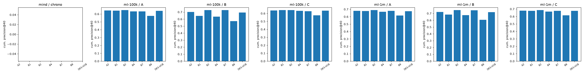
Figure. 8 Cumulative precision at 40 on the rated datasets by protocol. The MIND panel is empty because MIND runs $T=20$ rounds and precision at 40 is undefined there.

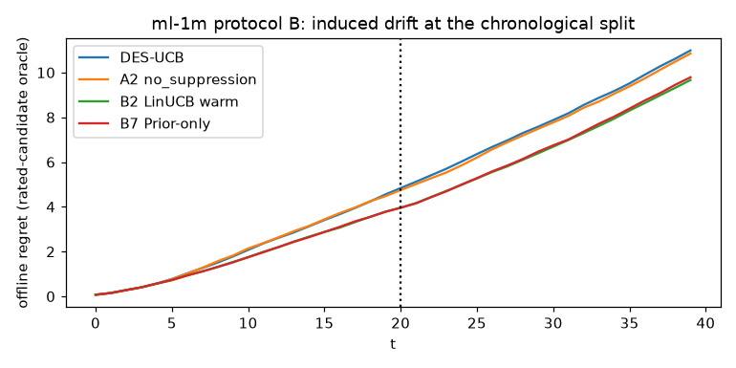
Figure. 9 Cumulative offline regret under protocol B on MovieLens-1M. The dotted line is the induced switch round at $T/2$.
7.8. Claim Registry
Table 11 gives the eight preregistered claims and their verdicts on the confirmatory run of 5 seeds and 100 users. 5 are supported and 3 are not.

Table 11. Preregistered claims and verdicts from results/claims.json. Intervals are paired bootstrap 95% intervals over 500 units.
Claim | Verdict | Test | Key statistic
sanity_oracle | supported | oracle expected reward $≥$ every agent’s expected reward, every round | min regret 0.00
suppression | supported | dyn_regret[DES] < dyn_regret[A2 no_suppression] on abrupt drift with a stale (pre-drift) prior | $Δ$ -14.7 [-16.0, -13.5]
stale_ratio | supported | post-change rounds conditioned on P: DES < A2 | $Δ$ -0.028 [-0.032, -0.025]
not_redundant | not supported | purge+reset+burn-in beats passive decay of the prior (A5) | $Δ$ 3.1 [1.8, 4.3]
suppression_mis | supported | same as suppression under p_mismatch=0.2 with a population (not pre-drift) prior | $Δ$ -14.7 [-16.0, -13.4]
no_harm | not supported | dyn_regret[DES] ≤ 1.10 * dyn_regret[B2 warm LinUCB] with no drift | ratio 6.86
rate | supported | log-log regret slope on sinusoidal drift: DES ≤ B4 + 0.05 | slopes 1.164 vs 1.207
real_precision | not supported | ML-1M protocol B: cum_precision@ 40[DES] $≥$ cum_precision@ 40[B2] | $Δ$ -0.031 [-0.036, -0.026]

Supported
sanity_oracle holds in every round. suppression holds. On abrupt drift with a stale pre-drift prior, DES-UCB has dynamic regret 50.4 against 65.1 for A2, a paired difference of -14.7 with interval [-16.0, -13.5]. The detector fired on 99.7% of units with a mean delay of 22.7 rounds. suppression_mis holds. With a population prior and $p_{mis}=0.2$ the regret is 78.6 against 93.3, a difference of -14.7 with interval [-16.0, -13.4]. stale_ratio holds. The share of post-change rounds spent on P is 0.070 for DES-UCB and 0.099 for A2, a difference of -0.028 with interval [-0.032, -0.025]. rate holds with slopes 1.164 against 1.207.
Not supported
not_redundant fails. The passive-decay ablation A5 has regret 47.3 against 50.4 for the full method, so the full method is worse by 3.1 with interval [1.8, 4.3]. Purge, credit reset and burn-in are not shown to add anything over halving the prior weight. no_harm fails. With no drift, DES-UCB has regret 11.14 against 1.62 for warm LinUCB, a ratio of 6.86, and it spends 52% of rounds on F even though P is correct throughout. The registered threshold was a ratio of 1.10. real_precision fails. Under protocol B on MovieLens-1M, precision at 40 is 0.719 for DES-UCB and 0.750 for B2, and the interval [-0.036, -0.026] excludes zero on the wrong side.
8. Discussion
What the mechanism does
The supported claims show that the suppression path behaves as designed. When a stale or misspecified prior meets an abrupt change, the detector fires within the burn-in length on almost every unit, the agent stops conditioning on P for most of the remaining rounds, and regret falls relative to the same agent with the path disabled. The sweep shows that the effect scales with the magnitude of the change and with the burn-in length, and that it survives noisy priors. The phase diagram locates the regime. Large changes with a confident prior are where suppression helps most.
What it does not show
The unsupported claims are informative. First, the comparison that matters for novelty is not against no suppression but against the simplest possible suppression, and there A5 wins by a small but significant margin. Halving the weight of P on a firing already stops the stale prior from dominating, without discarding any feedback rows. The purge and the forced burn-in remove information that a passive decay keeps, and at this scale that information was worth more than the cleaner state. Second, the switching layer has a cost that does not go away when nothing changes. Half the rounds go to F even when P is exact, because EXP3 keeps exploring and because F wins the gain in (11) on rounds where its window happens to fit the noise. A ratio of 6.86 against warm LinUCB is not a small price. Third, on MovieLens-1M under an induced drift the warm start still wins on precision, and the prior-only agent is nearly as good, which suggests that the second half of a user’s ratings is not far from the first half in that dataset. The induced drift is not strong enough to make suppression useful.
Comparison to restarts and discounting
On the grid the Page-Hinkley restart B6 beats DES-UCB on the abrupt, recurring and sinusoidal columns and discounted LinUCB B5 beats it on gradual and incremental drift. Both are single-source agents with no switching cost. This says that at the tested settings the two-source design is paying for flexibility it does not use. The switch does add value in one place. Removing it in A1 lowers regret at this scale, but A1 has a hard-coded schedule that already knows F should take over at $w_{min}$ rows, and that knowledge would not transfer to a setting where the prior stays good.
What a decisive test would need
Four changes to the protocol would separate the mechanism from its alternatives. Priors that are misleading rather than noisy, so that a decayed prior still points the wrong way and a purge is the only way out. Frequent or recurring drift, so that a passive decay never finishes forgetting before the next change. Short cold-start phases, so that stale feedback rows are a larger share of the window at the time of the change. A fix for the stationary cost, for example gating the switch on disagreement between the sources or lowering the exploration rate when the sources agree, so that the no_harm threshold of 1.10 becomes reachable. These conditions were not preregistered for this run and are stated as the next test, not as a result.
The protocol as a contribution
The registry and gate did what they were meant to do. The unsupported claims are printed as unsupported. The threshold retuning is recorded as a decision taken on the pilot, in a branch that was written before the pilot ran. The three metric namespaces made it impossible to place a synthetic regret next to an offline regret in one table. None of this makes the method better. It does make the report of the method checkable.
9. Threats to Validity
Construct
The Page-Hinkley threshold was retuned from 50 to 1 after the pilot showed no firings. The retuned value was then used in the confirmatory run. This is a tuned hyperparameter and the confirmatory results depend on it. The regret bound (22) is stated and not proved, and no result here depends on it. The rate slope is a descriptive fit on five checkpoints. MIND rewards are clicks and not relevance judgements. Precision on rated data counts a hit only among items the user rated, which is the standard offline protocol and not a measure of live performance.
Internal
Baselines share $λ$, $β$ and $S$ with DES-UCB and were not tuned separately. B3 uses a fixed window equal to $w_{0}$ and B5 uses a single discount. Better-tuned baselines could widen the gaps against DES-UCB. The passive-decay ablation A5 uses a halving factor that was not tuned either. Real-data cohort priors fall back to available demographic cohorts when the exact gender-and-age cohort has no training rows, so some priors are less specific than the protocol intends. Real-data runs use one seed and at most 300 users per dataset.
Statistical
The grid, ablation, sweep and phase experiments run at reduced scale (two seeds, 20 to 30 users) and are exploratory. Only the claim registry ran at five seeds and 100 users. Bootstrap intervals are over units within a run and do not account for variation across configurations. Many comparisons are reported and none are corrected for multiplicity, which is why only the eight registered claims carry verdicts.
External
The synthetic environments are linear with Gaussian noise and unit-norm items. The drift types are parametric. The rated datasets are movie ratings and news clicks with small $T$. Yahoo R6 and KuaiRand replay results would be the closest to a production signal and were not run because the datasets were not configured. Conclusions do not extend to those settings.
10. Conclusion
DES-UCB keeps a prior source and a feedback source apart, switches between them with EXP3 on a clipped generalisation gain, and on detected drift halves the feedback window, purges rows outside it, resets the prior’s credit and forces the feedback source for a burn-in. Five of eight preregistered claims are supported by a five-seed confirmatory run. The mechanism fires when it should, lowers the share of rounds spent on a stale prior and lowers regret against the same agent without suppression, on both stale and misspecified priors, with a rate slope no worse than Bandit-over-Bandit under sinusoidal drift. Three claims are not supported. Passive decay of the prior is at least as good as the full purge, the switching layer costs 6.86 times the regret of warm LinUCB when nothing changes, and there is no precision gain on MovieLens-1M. The article does not claim a regret win. It offers the mechanism, the staleness ratio and phase diagram as diagnostics, and a preregistered protocol with a text gate that kept the unsupported claims out of the findings. The next test is stated in Section 8 and has not been run.
Conflicts of interest
The authors declare no conflict of interest.
Author contributions
Conceptualization, methodology, software, validation, formal analysis, investigation, data curation, visualization and writing of the original draft, Dhayanidhi Rajasekaran. Supervision, review and editing, Rajalakshmi N.R. Both authors read and approved the final manuscript.
Acknowledgments
The code, the executed notebook, every result file and the scripts that produced the tables in this article are in the repository https://github.com/dhayarajas/DES-UCB. This work received no external funding.
References
[1] A. Garivier and E. Moulines, “On upper-confidence bound policies for switching bandit problems,” in Proc. 22nd int. Conf. Algorithmic learning theory (ALT), 2011, pp. 174–188.
[2] Y. Russac, C. Vernade, and O. Cappé, “Weighted linear bandits for non-stationary environments,” in Advances in neural information processing systems 32, 2019, pp. 12017–12026.
[3] F. Liu, J. Lee, and N. Shroff, “A change-detection based framework for piecewise-stationary multi-armed bandit problem,” in Proc. 32nd AAAI conf. Artificial intelligence, 2018, pp. 3651–3658.
[4] W. C. Cheung, D. Simchi-Levi, and R. Zhu, “Learning to optimize under non-stationarity,” in Proc. 22nd int. Conf. Artificial intelligence and statistics (AISTATS), 2019, pp. 1079–1087.
[5] L. Li, W. Chu, J. Langford, and R. E. Schapire, “A contextual-bandit approach to personalized news article recommendation,” in Proc. 19th int. Conf. World wide web (WWW), 2010, pp. 661–670.
[6] Y. Abbasi-Yadkori, D. Pál, and C. Szepesvári, “Improved algorithms for linear stochastic bandits,” in Advances in neural information processing systems 24, 2011, pp. 2312–2320.
[7] P. Shivaswamy and T. Joachims, “Multi-armed bandit problems with history,” in Proc. 15th int. Conf. Artificial intelligence and statistics (AISTATS), 2012, pp. 1046–1054.
[8] Y. Cao, Z. Wen, B. Kveton, and Y. Xie, “Nearly optimal adaptive procedure with change detection for piecewise-stationary bandit,” in Proc. 22nd int. Conf. Artificial intelligence and statistics (AISTATS), 2019, pp. 418–427.
[9] L. Besson, E. Kaufmann, O.-A. Maillard, and J. Seznec, “Efficient change-point detection for tackling piecewise-stationary bandits,” Journal of Machine Learning Research, vol. 23, no. 77, pp. 1–40, 2022.
[10] E. S. Page, “Continuous inspection schemes,” Biometrika, vol. 41, no. 1/2, pp. 100–115, 1954.
[11] A. Bifet and R. Gavaldà, “Learning from time-changing data with adaptive windowing,” in Proc. 2007 SIAM int. Conf. Data mining, 2007, pp. 443–448.
[12] P. Auer, N. Cesa-Bianchi, Y. Freund, and R. E. Schapire, “The nonstochastic multiarmed bandit problem,” SIAM Journal on Computing, vol. 32, no. 1, pp. 48–77, 2002.
[13] A. Agarwal, H. Luo, B. Neyshabur, and R. E. Schapire, “Corralling a band of bandit algorithms,” in Proc. 30th conf. Learning theory (COLT), 2017, pp. 12–38.
[14] A. Pacchiano et al., “Model selection in contextual stochastic bandit problems,” in Advances in neural information processing systems 33, 2020, pp. 10328–10337.
[15] B. A. Nosek, C. R. Ebersole, A. C. DeHaven, and D. T. Mellor, “The preregistration revolution,” Proceedings of the National Academy of Sciences, vol. 115, no. 11, pp. 2600–2606, 2018.
[16] L. Li, W. Chu, J. Langford, and X. Wang, “Unbiased offline evaluation of contextual-bandit-based news article recommendation algorithms,” in Proc. 4th ACM int. Conf. Web search and data mining (WSDM), 2011, pp. 297–306.
[17] F. M. Harper and J. A. Konstan, “The MovieLens datasets: History and context,” ACM Transactions on Interactive Intelligent Systems, vol. 5, no. 4, pp. 19:1–19:19, 2015.
[18] X. Zhao, W. Zhang, and J. Wang, “Interactive collaborative filtering,” in Proc. 22nd ACM int. Conf. Information and knowledge management (CIKM), 2013, pp. 1411–1420.
[19] L. Zou et al., “Neural interactive collaborative filtering,” in Proc. 43rd int. ACM SIGIR conf. Research and development in information retrieval, 2020, pp. 749–758.
[20] F. Wu et al., “MIND: A large-scale dataset for news recommendation,” in Proc. 58th annual meeting of the association for computational linguistics, 2020, pp. 3597–3606.

