Project 3: Distributed CORBA Auction Server
CprE: 550
Md. Manzoor Murshed

Abstract:

This project is to build a distributed Auction Service. Its purpose is to allow the buying and selling of individual items, using an English auction protocol (increasing price, current price visible to all parties).

Design:

The Project consists of the following files:

- Auction.idl : interface definition file
- AuctionImpl.java : Implementation of the Auction
- Server.java : Server Program
- Seller.java : Seller Program
- Client.java : Client Program (bidder)
- StdinReader.java : To read user input

System Diagram:

Server supports one auction at a time, with a single seller and multiple bidders. Each auction corresponds to a single item .Once the item is sold, another auction may be started by a seller. Server keeps information of the clients (bidder). Errors produce reasonable output (both on client and server sides).

Auction
Bidder
Bidder
Bidder
Seller
Auction Program Using CORBA
Figure: Distributed Auction Service Using CORBA

Compiling Method:

Following Command was used to compile and run the programs:

Prompt> idlj –fall Auction.idl
Prompt>

Prompt>
Prompt> java auction.Server –ORBInitialPort 2500

Run Seller Program.
Prompt> java auction.Seller –ORBInitialPort

Run Client Program.
Prompt> java auction.Client –ORBInitialPort 2500

(NB: Use classpath option if necessary. To avoid classpath I copies all of my classes in the auction folder manually)

Source Codes:

- Auction.idl : interface definition file

// Project #3
// Programmer: Md. Manzoor Murshed
// Date: 20/04/06

module auction {
interface Auction {
exception InvalidOfferException { string description; };
exception InvalidBidException { string description; };
exception InvalidSellException { string description; };
exception InvalidStatusException { string description; };

typedef struct AuctionStatus {
string user;
string item;
float currentPrice;
} Status;

// seller accessible methods

boolean offer(in string sellerId, in string item, in float initPrice) raises (InvalidOfferException) ;

boolean sell(in string itemName) raises (InvalidSellException);

string viewHighBidder(in string itemName)
raises (InvalidSellException);

// bidder accessible methods

boolean bid(in string userId, in float bidPrice)
raises (InvalidBidException);

string viewBidStatus(in string userId)
raises (InvalidBidException);

// universally accessible methods

Status viewAuctionStatus() raises (InvalidStatusException);
};
};

- AuctionImpl.java : Implementation of the Auction

// Project #3
// Programmer: Md. Manzoor Murshed
// Date: 20/04/06
// Program: AuctionImpl.java

package auction;
import org.omg.CosNaming.*;
import org.omg.CosNaming.NamingContextPackage.*;
import org.omg.CORBA.*;
import java.util.*;

import auction.*;
import org.omg.CORBA.*;

class AuctionImpl extends AuctionPOA {
private ORB orb;
private Hashtable _catalogue;
private Hashtable _userinfo;
private float price;
private String bidder;
private String name;
public AuctionImpl(ORB orb) {
this.orb = orb;
_catalogue = new Hashtable();
_userinfo = new Hashtable();
price = (float) 0.0;
bidder = "No bidder yet !";
name = "";
}

// implement the Seller accessible methods
public boolean offer (String sellerId, String item, float initPrice)
throws auction.AuctionPackage.InvalidOfferException
{
// Items are recorded in the catalogue where key is itemName,
// value is a 2-item Vector of sellerId and initial Price
try {
System.out.println("Seller ID:" + sellerId + " put an item: " + item + " Initial Price:" +initPrice);
Vector vec = new Vector(2);
vec.addElement(sellerId);
vec.addElement(new Float(initPrice));

_catalogue.put(item, vec);
price = initPrice;
name = item;

} catch (Exception e){System.out.println(e); System.exit(1);}
return true;
} //end of offer function

public boolean sell (String itemName) throws auction.AuctionPackage.InvalidSellException
{
Vector vec1 = (Vector) _catalogue.get(itemName);
String sellerID = (String)vec1.elementAt(0);

System.out.println("Seller ID:" + sellerID + " sold the item "
+ name + " at Price:" +price);
_catalogue.remove(itemName);
_userinfo.remove(price);
_userinfo.remove(bidder);
name = "";
price = (float) 0.0;
bidder = "No bidder yet";
return true;
} //end of sell function

public String viewHighBidder (String itemName) throws auction.AuctionPackage.InvalidSellException
{
Vector vec1 = (Vector) _catalogue.get(itemName);
String sellerID = (String)vec1.elementAt(0);
float currentPrice = ((Float) vec1.elementAt(1)).floatValue();
String message;

Vector vec2 = (Vector) _userinfo.get(bidder);
if(vec2 == null)
{message= "No high bidder yer/n";}
else {
String userID = (String)vec2.elementAt(0);
message = "User ID:" +bidder+ " is the highest bidder> Item:" +name+ "Price:"+price ;
}
return message;
} //end of viewHighBidder function

// bidder accessible methods
public boolean bid (String userId, float bidPrice) throws auction.AuctionPackage.InvalidBidException
{
Vector user = new Vector(2);
Vector vec = (Vector) _catalogue.get(name);

if(vec == null) return false;
// Users are recorded in the userinfo where key is userId,
// value is a 2-item Vector of item name and user bid Price
user.addElement(name);
user.addElement(new Float(bidPrice));
_userinfo.put(userId, user);

if(bidPrice >= price)
{ // Update current price
vec.add(1, new Float(bidPrice));
price = bidPrice;
bidder = userId;
return true;
}
else return false;
} //end of function bid

public String viewBidStatus (String userId) throws auction.AuctionPackage.InvalidBidException
{
Vector vec = (Vector) _userinfo.get(userId);
String message;

if(vec == null) message= "Invalid user id\n";
String itemName = (String)vec.elementAt(0);
float yourPrice = ((Float) vec.elementAt(1)).floatValue();

Vector vec1 = (Vector) _catalogue.get(itemName);
String sellerID = (String)vec1.elementAt(0);
float currentPrice = ((Float) vec1.elementAt(1)).floatValue();

if (currentPrice==yourPrice)
message = "Congratulation! User ID:" +userId+ " is the highest bidder for Item:" +itemName+
"Price:"+currentPrice+"\n" ;

else
message = "Sorry! User ID:" +userId+ " is the not highest bidder for Item:" +itemName+
"of Price:"+currentPrice+ "Youe current bid="+yourPrice+"\n" ;

return message;
} //end of viewbidStatus function

// universally accessible methods

public auction.AuctionPackage.AuctionStatus viewAuctionStatus () throws auction.AuctionPackage.InvalidStatusException
{
auction.AuctionPackage.AuctionStatus status = new auction.AuctionPackage.AuctionStatus();
Vector vec3 = (Vector) _catalogue.get(name);
if(vec3 == null)
{
status.user = "Sorry No auction";
status.item = "Sorry no Item";
status.currentPrice = (float) 0.0;
return status;
}
else
{
status.user = bidder;
status.item = name;
status.currentPrice = price;
return status;
}
}
} //end of viewAuctionStatus function

- Server.java : Server Program

// Project #3
// Programmer: Md. Manzoor Murshed
// Date: 20/04/06
// Program: Auction Server

package auction;
import auction.*;
import org.omg.CORBA.*;
import org.omg.CosNaming.*;
import org.omg.PortableServer.*;
import org.omg.PortableServer.POA;
import org.omg.CosNaming.NamingContextPackage.*;

public class Server {

public static void main(String args[]) {
try{
// create and initialize the ORB
ORB orb = ORB.init(args, null);

// create an implementation and register it with the ORB
AuctionImpl impl = new AuctionImpl(orb);

// get reference to rootpoa & activate the POAManager
POA rootpoa = POAHelper.narrow(
orb.resolve_initial_references("RootPOA"));
rootpoa.the_POAManager().activate();

// get object reference from the servant
org.omg.CORBA.Object ref =
rootpoa.servant_to_reference(impl);
Auction href = AuctionHelper.narrow(ref);

// get the root naming context
// NameService invokes the name service
org.omg.CORBA.Object objRef =
orb.resolve_initial_references("NameService");
// Use NamingContextExt which is part of the Interoperable
// Naming Service (INS) specification.
NamingContextExt ncRef =
NamingContextExtHelper.narrow(objRef);

// bind the Object Reference in Naming
String name = "Auction";
NameComponent path[] = ncRef.to_name( name );
ncRef.rebind(path, href);

System.out.println("Auction Server ready ....");

// wait for invocations from clients
orb.run();
} catch (Exception e) {
System.err.println("ERROR: " + e);
e.printStackTrace(System.out);
}
System.out.println("Auction Server Exiting ....");
}
}

4. Seller.java : Seller Program

// Project #3
// Programmer: Md. Manzoor Murshed
// Date: 20/04/06
// Program: Seller

package auction;
import auction.*;
import org.omg.CORBA.*;
import org.omg.CosNaming.*;
import org.omg.CosNaming.NamingContextPackage.*;
import java.io.*;

public class Seller {
public static void main(String args[]) {
try {
// create and initialize the ORB
ORB orb = ORB.init(args, null);

// get the root naming context
org.omg.CORBA.Object objRef =
orb.resolve_initial_references("NameService");

// Use NamingContextExt instead of NamingContext. This is
// part of the Interoperable Naming Service.
NamingContextExt ncRef =
NamingContextExtHelper.narrow(objRef);

// resolve the Object Reference in Naming
String name = "Auction";
Auction impl = AuctionHelper.narrow(ncRef.resolve_str(name));

//System.out.println("Handle obtained on server object: " + impl);

int response=0;

while(response!=5)
{
//menu
System.out.println("\t....menu.........\n");
System.out.println("\t1. Put an item to Sell\n");
System.out.println("\t2. Make a sell\n");
System.out.println("\t3. view high bidder\n");
System.out.println("\t4. view Auction Status\n");
System.out.println("\t5. Quit\n");
String prompt = StdinReader.readLine ("Please enter choice 1, 2, 3 or 4 : ");
response = Integer.parseInt(prompt);

if (response==1) //put an item to sell
{
try {
String id = StdinReader.readLine ("Enter your ID: ");
String iName = StdinReader.readLine ("Enter Item Name: ");
String strPrice = StdinReader.readLine ("Enter offer Price: ");
float iPrice = Float.parseFloat(strPrice);
boolean success = impl.offer(id, iName, iPrice);
if(success==true)
System.out.println("You successfully put an item to sell\n");
else
System.out.println("Sorry you cann't put an item now\n");

} catch (Exception e){System.out.println(e);}
}
else if (response==2) //make a sell
{
try {
String prompt1 = StdinReader.readLine ("Do you want to sell the Item (y/n?) ");
String choice1 = StdinReader.readLine (prompt1).toLowerCase();

if (choice1.startsWith("y")){
try {
String i = StdinReader.readLine ("Enter Item Name: ");
boolean success = impl.sell(i);
} catch (Exception e){System.out.println(e);}
}
} catch (Exception e){System.out.println(e); System.exit(1);}

}
else if (response==3) //view high bidder
{
try {
String it = StdinReader.readLine ("Enter Item Name: ");
String message = impl.viewHighBidder(it);
System.out.println(message);

} catch (Exception e){System.out.println(e);}
}
else if (response==4) //view auction status
{
auction.AuctionPackage.AuctionStatus status =
new auction.AuctionPackage.AuctionStatus();
status = impl.viewAuctionStatus();
String message="User id:" +status.user+ " Item: " +status.item+
" Price: " +status.currentPrice+ " is the highest bidder";
System.out.println (message);
}
else if (response==5) //put an item to sell
{
System.exit(1);
}
}

} catch (Exception e) {
System.out.println("ERROR : " + e) ;
e.printStackTrace(System.out);
}
}
}

- Client.java : Client Program (bidder)

// Project #3
// Programmer: Md. Manzoor Murshed
// Date: 20/04/06
// Program: Auction Client
package auction;
import auction.*;
import org.omg.CORBA.*;
import org.omg.CosNaming.*;
import org.omg.CosNaming.NamingContextPackage.*;
import java.io.*;

public class Client {

public static void main(String args[]) {
try {
// create and initialize the ORB
ORB orb = ORB.init(args, null);

// get the root naming context
org.omg.CORBA.Object objRef =
orb.resolve_initial_references("NameService");

// Use NamingContextExt instead of NamingContext. This is
// part of the Interoperable Naming Service.
NamingContextExt ncRef =
NamingContextExtHelper.narrow(objRef);

// resolve the Object Reference in Naming
String name = "Auction";
Auction impl = AuctionHelper.narrow(ncRef.resolve_str(name));

//System.out.println("Handle obtained on server object: " + impl);

int response=0;

while(response!=4)
{
//menu
System.out.println("\t....menu.........\n");
System.out.println("\t1. View Auction Status\n");
System.out.println("\t2. bid\n");
System.out.println("\t3. view bid Status\n");
System.out.println("\t4. Quit\n");
String prompt = StdinReader.readLine ("Please enter choice 1, 2, 3 or 4 : ");
response = Integer.parseInt(prompt);

if (response==1) //view auction status
{
auction.AuctionPackage.AuctionStatus status =
new auction.AuctionPackage.AuctionStatus();
status = impl.viewAuctionStatus();
String message="User id:" +status.user+ " Item: " +status.item+
" Price: " +status.currentPrice+ " is the highest bidder\n";
System.out.println (message);
}

else if (response==2) //bid
{
try {

String userId = StdinReader.readLine ("Type your ID: ");
String strOffer = StdinReader.readLine ("Offer Price : ");
float offer = Float.parseFloat(strOffer);
boolean bid_now = impl.bid(userId, offer);
if (bid_now==true) System.out.println("Successfull bid \n");
else System.out.println("un successfull bid.. Increase offer Price \n");
}catch (Exception e){System.out.println(e);}
}

else if (response==3) //view bid status
{
try {

String id = StdinReader.readLine ("Type your ID: ");
String msg = impl.viewBidStatus(id);
System.out.println(msg + "\n");
}catch (Exception e){System.out.println(e);}
}

}//end of while

} catch (Exception e) {
System.out.println("ERROR : " + e) ;
e.printStackTrace(System.out);
}
}
}

- StdinReader.java : To read user input

package auction;

import java.io.*;
import java.util.*;

public class StdinReader
{
public static final BufferedReader stdinReader = new BufferedReader(new InputStreamReader(System.in));
public static StringTokenizer tokenizeLine() throws java.io.IOException
{
return new StringTokenizer(stdinReader.readLine());
}
public static StringTokenizer tokenizeLine(String prompt) throws java.io.IOException
{
System.out.print(prompt);
return new StringTokenizer(stdinReader.readLine());
}
public static String readLine() throws java.io.IOException
{
return stdinReader.readLine();
}
public static String readLine(String prompt) throws java.io.IOException
{
System.out.print(prompt);
return stdinReader.readLine();
}
}

Test Run:

Server Program:
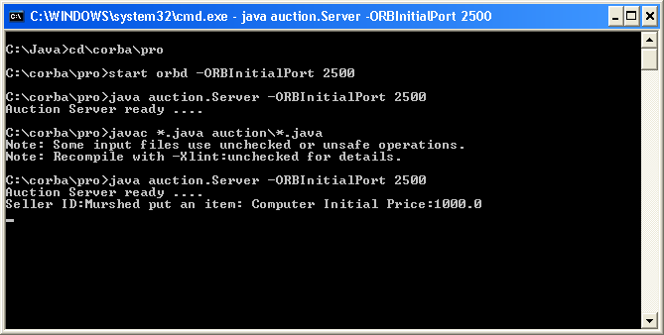

Seller Program
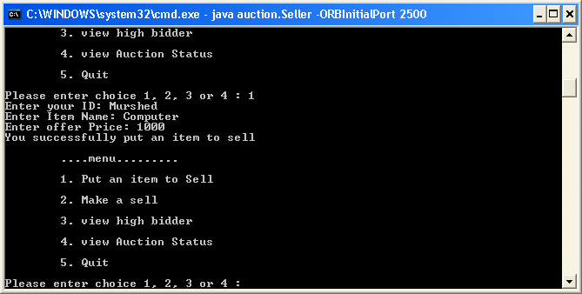

Client bid and offer price was less
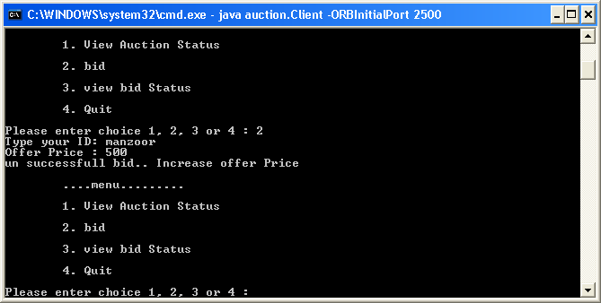

Successful bid

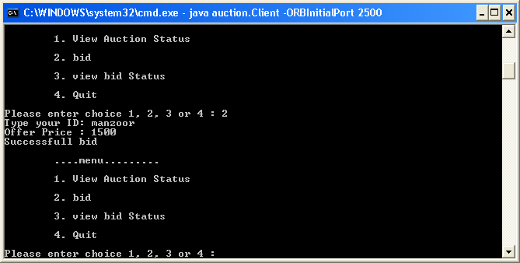

Another client is checking the auction

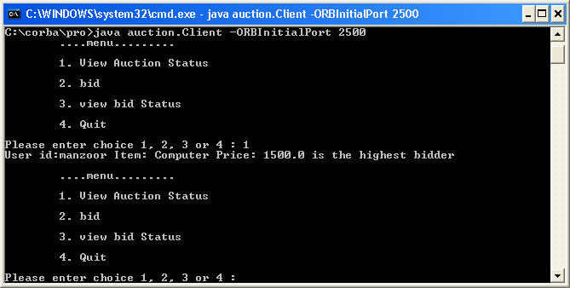

Client 2 make a successful bid

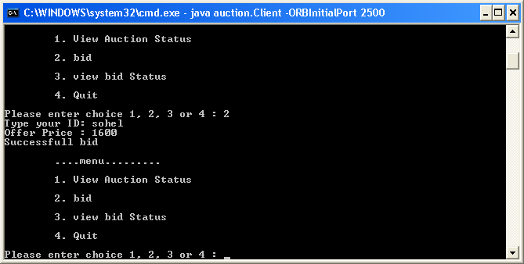

Client #1 is checking the auction status and found client #1 gave higher bid

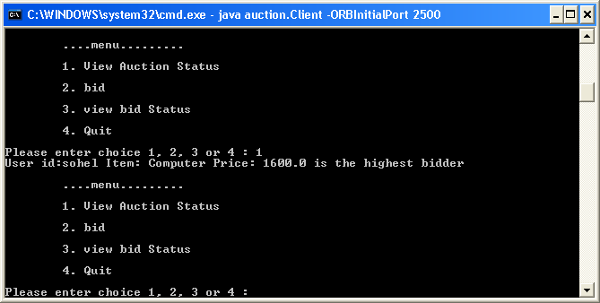

Client #1 still can see his/her offer by press option 3 and also current offer

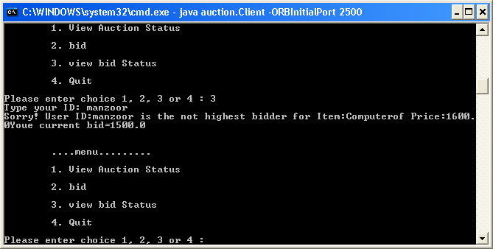

Seller can see the current high bidder by pressing 3

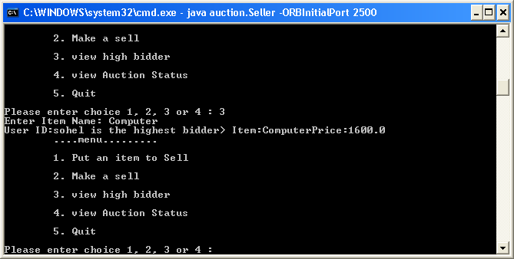

Seller can see the auction status by pressing 4

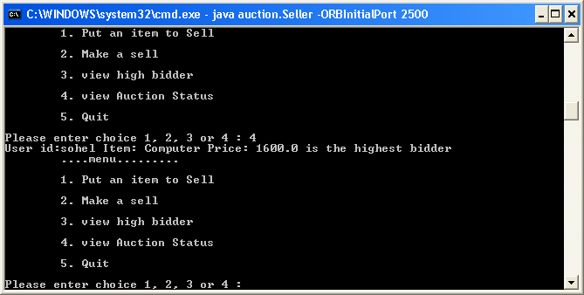

Seller can sell by using option 2

