1. Take a screenshot of Ghostery with the vendor tags and answer the following questions: 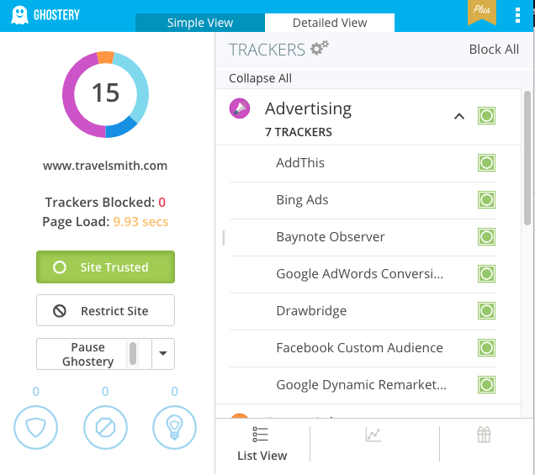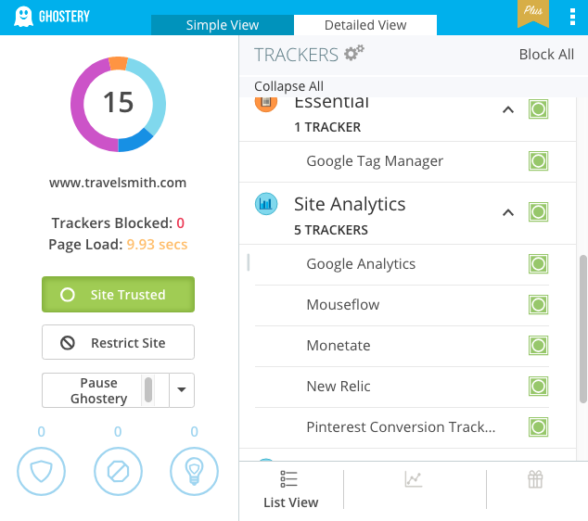
   1. What tag manager is being used?
      * Google Tag Manager
   2. What analytics platform is being used? Are there multiple?
      * Google Analytics and New Relic
   3. What testing tool is being used?
      * Monetate
   4. Is there a vendor we didn't cover? If so, briefly research and describe what service the vendor offers.
      * New Relic – Looks like a competitor to GA or Adobe. Creates a dashboard to track site visits and look at metrics.
      * Mouseflow – Mouseflow follows a users mouse around the screen to track clicks. It can also create heatmaps to see where visitors spend the most time on a page. They can record your activity on a webpage too.
      * Monetate – Helps build A/B tests. Can use the information to build customer segments and recommendations based on those segments.
      * Pinterest Conversion Tracker – Basically allows the tracking of converted Pinterest Pin clicks. The idea is you can gather information about a customer to build targeted audience profiles to customize your site for future visits.
2. Find an analytics call and provide a screenshot. Answer the following questions: 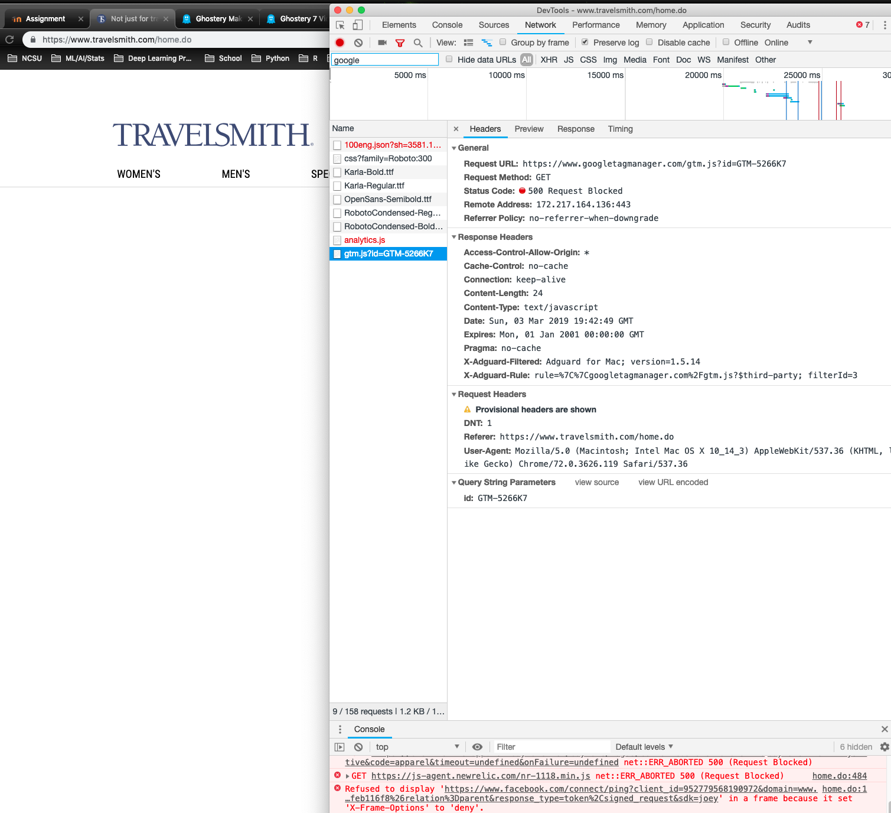
   1. What data do you think is being collected?
      * They can see that I am on a Mac computer and my OS version. They can also see that I’m using a modern version of the Chrome web browser. They can also see how I got to the page (i.e. where I clicked in from). They can tell that I use an ad blocker called Adguard for Mac. It appears they can see the resolution of my monitor and color depth. Also, they can see the language I need. They can see where I’m hovering my mouse.
   2. Click around the site, does it appear that any data is not collected? If so, describe the actions not collected.
      * I don’t think they can see what other tabs I have open. I also can’t tell if they know who I use for my ISP. It’s hard to see if they know whether I’m currently on their webpage or on a different tab. So I would say maybe they don’t know the actual amount of time I am looking at their webpage versus it just being opened.