**Online appendix**

**Online appendix A: English translation of the experimental instructions**

These are the instructions for the participants who participated in the treatment with incentives. Participants in the treatment without incentives received almost the same instructions, but without the information about the random selection of a choice to determine the donation and without the information about adding a fixed amount in case money could be lost. The participants were told they could think of the probabilities as if the lottery’s outcome is determined by drawing a stone from a bag with a 100 chips numbered from 1 up to and including 100.

The header of the page always read “Instructions part x” where x was 1, 2, or 3, depending on the order in which the participant was presented with the different parts.

***Instructions lottery choice part page 1***

In this part of the experiment you will be asked six times to choose between two lotteries. Below you can see what such a choice situation looks like. **This is only an example, you cannot make a choice yet.**

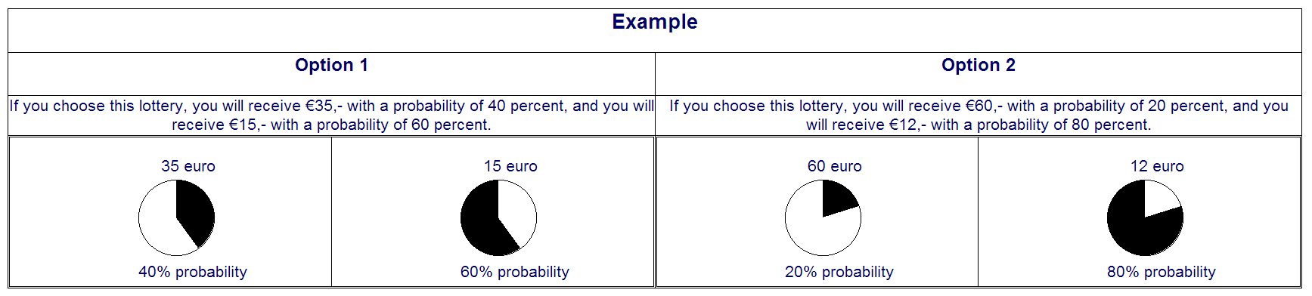

If this part is selected to determine what amount will be donated to the charity on your behalf, a dice determines which of the six choice situations determines the amount. The lottery you selected in that choice situation is played out.

The outcome is determined by drawing a chip from a bag of 100 chips numbered from 1 up to and including 100. The lower is the number on the drawn chip, the better is the outcome. If you chose the left lottery in the example above, a number from 1 till 40 would mean that €35 will be donated and a number from 41 till 100 that €15 will be donated.

You can reread these instructions later if required.

***Instructions lottery choice part page 2***

In some choice situations money can be lost. In that case the largest amount you can lose in either of the two lotteries is added to the amount that will be donated to the charity if this choice situation is selected, **independent of your choice or the outcome of the lottery.**

In the example below that means that €10 will be added to the amount donated to the charity, **also if you chose the left lottery.**

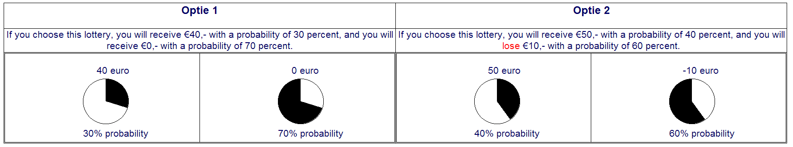

You can reread these instructions later if required.

***Instructions lottery valuation part page 1***

In this part of the experiment you will be asked to indicate for 3 lotteries for 9 amounts whether you prefer the amount *or* the lottery. Below you can see such a choice situation. **This is only an example you cannot make a choice yet.**

Every time you see the 9 amounts, one below the other, on the left and the lottery on the right. The amounts are listed in increasing order from the lowest to the highest amount. In between each amount and the lottery, there are two circles. By clicking on the left circle you choose the amount, by clicking the right circle you choose the lottery.

When you have made your choice for all of the amounts you can confirm these by clicking “Continue”. Up until that time you can adjust your choices.

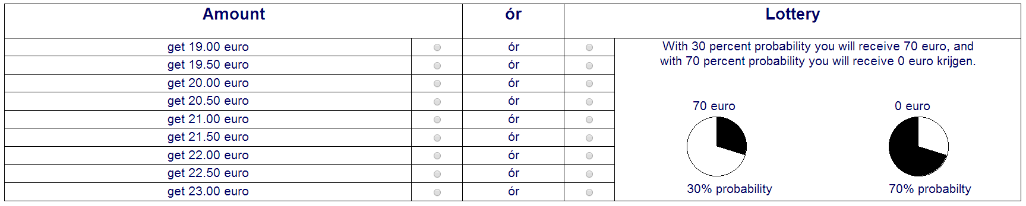

If this part is selected to determine what amount will be donated to the charity on your behalf a dice determines which of the 3 choice situations determines the amount. Next, a card is drawn to determine which of the nine amounts is looked at. If for that amount you chose the amount, that amount will be donated to the charity. If you chose the lottery, the lottery will be played out.

The lottery’s outcome is determined by drawing a chip from a bag of 100 chips numbered from 1 up to and including 100. The lower is the number on the drawn chip, the better is the outcome.

If you chose the lottery in the example above, a number from 1 till 30 would mean that €70 will be donated and a number from 31 till 100 that €0 will be donated.

You can reread these instructions later if required.

***Instructions lottery valuation part page 2***

In some choice situations money can be lost. In that case, the largest amount you can lose in the two lotteries is added to the amount that will be donated to the charity if this choice situation is selected, **independent of your choice or the outcome of the lottery**.

In the example below that means that €30 will be added to the amount that is donated to the charity, **also if you chose the fixed amount**.

You can reread these instructions later if required.

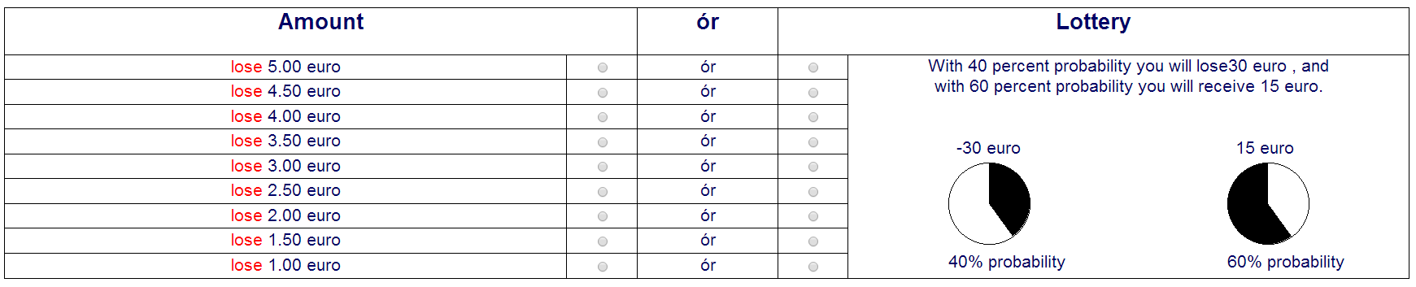

**Instructions hypothetical political scenarios part**

In this part of the experiment, we ask you to put yourself in the shoes of a Member of Parliament. We will present you with 4 hypothetical situations. Each time the question is whether you think your parliamentary caucus should vote in favor or against the proposal.

Every question is preceded by a description of the situation and the consequences of a vote in favor or against. These consequences are usually uncertain, but you do get information about the probability of possible consequences.

Please assume that:

1) the proposal has no other consequences than those mentioned in the question.  
2) there is no better alternative proposal available.  
3) your caucus is ideologically neutral towards the proposal.  
4) your vote choice is not affected by any potential coalition agreements.

**Online appendix B: Detailed discussion of lottery choice tasks**

## *Common ratio effect*

**Problem 1:**

**A)** €28 for sure or

B) €40 with 80% probability, €0 with 20% probability.

**Problem 2:**

C) €28 with 25% probability, €0 with 75% probability or

**D)** €40 with 20% probability, €0 with 80% probability.

*Prospect-theoretical prediction:* Majority choice: A and D. This prediction is not in accordance with expected utility theory (EUT) because the expected utility of C is ¼ that of A and that of D is ¼ of that of B. And because probabilities have a linear effect on an option’s expected utility, the ranking of the two options should be the same in the two decision problems. Prospect theory explains the deviation from EUT through probability weighting. The difference between 100% and 80% is seen as large because 80% probability is underweighted, which makes A relatively attractive. The difference between 25% and 20% is seen as small; both are pretty small probabilities, so they are not underweighted, or both are underweighted a little, making D relatively more attractive.

This decision problem is based on an example of Allais (1953). Kahneman and Tversky (1979) used a version of this problem with 3,000 and 4,000 Israeli pounds (result: 80% A, 35% C). And Kahneman and Tversky (1984) a version with $45 and $30 (result: 74% A, 42% C). Ballinger and Wilcox (1997) find evidence for this effect in a set of many different decision problems, which all have this same general structure. Loomes and Sugden (1998) find similar evidence.

## *Common consequence effect* (NB: not discussed in the paper, see note 9).

**Problem 3:**

**A)** €35 for sure or

B) €60 with 10% probability, €35 with 85% probability, €0 with 5% probability.

**Problem 4:**

C)€35 with 15% probability, €0 with 85% probability or

**D)** €60 with 10% probability, €0 with 90% probability.

*Prospect-theoretical prediction:*Majority choice: A and D. This prediction is not in accordance with EUT because the difference in the expected utility is the same between A and C and between B and D (0.85*U(€35)). Probability weighting explains this as follows: small probabilities are overweighed, so the 5% chance to earn nothing in B makes that option unattractive. Conversely, the difference between 15% and 10% does not get much weight, making D extra attractive compared to C.

This decision problem is an adaptation of the original Allais paradox as posited by Allais (1953). Many experiments (e.g., Conlisk, 1989; Kahneman & Tversky, 1979; Slovic & Tversky, 1974) show the existence of the Allais paradox with variants of this problem. An interesting recent paper is Huck and Müller (2012). They present the original Allais paradox (with amounts in the millions), a version with reduced amounts (€0, €5, €25), and the reduced amounts variant for real payoffs to a representative sample of the Dutch population. Huck and Müller found that violations are higher in the general population than in the lab; higher for large amounts; and the same for real or hypothetical incentives. Huck and Müller had 223 observations in the lab. Given the low level of deviations for low amounts, they needed that many to get significant results. In the field, they had 1,426 observations. Interestingly, many people already chose the risky option where getting the lower amount for sure is possible (cf. Conlisk, 1989).

## *Reflection effect*

**Problem 5:**

A) €60 with 33% probability or

**B)** €20 for sure

**Problem 6:** €60 for sure and

**C)** –€60 with 67% probability, €0 with 33% probability or

D) –€40 for sure

*Prospect-theoretical prediction:*Majority choice B and C. This prediction is not in accordance with EUT because, since participants get €60 for sure in addition to the amounts listed, these are in fact the exact same problems. Cumulative prospect theory explains this as follows: probability weighting is cumulative: it is the chance to get an outcome further from the reference point that is weighted, so in decision problem 5, the 33% chance to get €60 is weighted, while in 6 the 67% chance to get –€60 is weighted. Because both probabilities are of moderate size they are underweighted (especially the 67%) leading to risk aversion for gains and risk taking for losses. The curvature of the value function strengthens this effect. More generally, this is the reflection effect, i.e., the tendency to be risk taking for losses and risk averse for gains.

The decision problem we use is the original “Asian disease problem” (Tversky & Kahneman, 1981) with euros instead of lives; since in that case the only difference is in the framing. Tversky and Kahneman’s result was 72% B and 22% D. They confirmed the effect with a financial example as they did in their prospect theory paper (Kahneman & Tversky, 1979). Linde and Sonnemans (2011) sum up that the reflection effect is also present in less controlled conditions. An example is the stock market, where investors are more willing to sell winning stocks than they are to sell losing stocks – the so-called disposition effect (Odean, 1998). When a stock loses (gains) value, the investor is more (less) willing to take risks, i.e., hold (sell) the stock, because she perceives the situation as a loss (gain). McGlothlin's (1956) finding that racehorse gamblers bet more heavily at the end of the day, when they have usually lost money, also confirms the reflection effect. A meta-analysis corroborates the existence of the reflection effect (Kühberger, Schulte-Mecklenbeck, & Perner, 1999).

**Online appendix C: Detailed discussion of lottery valuation tasks**

The lottery valuation tasks test for the existence of prospect theory’s main qualitative features: the fourfold pattern and loss aversion. The design is similar to Tversky and Kahneman (1992). In total there are nine lotteries, but each participant is only presented with three different lotteries. These are either framed as gains, where outcomes are either €0 or €40; losses, where outcomes are either –€40 or €0; or mixed outcomes, –€20 or €20. Each participant gets one lottery where the probability of the best outcome is 10%, one where the probability of the best outcomes is 50% and one where the probability of the best outcomes is 90%. We compensate participants for their losses by adding the maximum amount that could be lost in the lottery to the amount donated to the charity, independent of their choices. Therefore the gain, mixed and loss treatments actually have exactly the same payoffs and the difference between the treatments is purely a difference in framing (which is exactly what we need).

Participants’ valuation for the lotteries is determined using a multiple-price list: for nine increasing amounts, participants indicated whether they preferred the fixed amount or the lottery. The lowest amount is the expected value of the lottery minus €2. The value rises by €0.50 at a time up to the expected value plus €2. If this part is selected to determine the donation to the charity, one lottery and then one of the fixed amounts in that lottery’s price list are randomly selected. If the participant chose the fixed amount, the fixed amount is her donation; if she chose the lottery, the lottery is played out to determine the donation. The multiple-price list elicitation method is a variant of the Becker–DeGroot–Marschak (BDM) mechanism (Becker, Degroot, & Marschak, 1964). The BDM is an incentive-compatible method to elicit a lottery’s certainty equivalent (CE), i.e., the fixed amount for which the decision maker is indifferent between receiving the amount and playing the lottery. In this method, a participant states her CE for a lottery after which a random amount is drawn (from a reasonable interval). If this amount is higher than the stated CE, the participant receives the amount; if it is lower, the participant plays the lottery. You can see the CE as the minimum amount for which you would be willing to sell the lottery. Although the BDM mechanism is transparent to economists, this is not always the case for participants. For example, participants may think of the situation as if it were a negotiation and therefore ask a high price, i.e., report a too high CE.

For these reasons, we approximate the BDM using the multiple pricelist. This method elicits an approximation of the participant’s CE of the lottery, because at some point she will switch from preferring the lottery to preferring the fixed amount. The lottery’s CE must then lie between the highest amount for which she prefers the lottery and the lowest amount for which she prefers the fixed amount. There is evidence that the multiple pricelist – which boils down to a binary choice format because at each price offer, the participant must be indicate whether or not she would “trade” (i.e., play the lottery) at that price – is a more reliable way of eliciting valuations than the BDM (Bardsley et al., 2010: 272).

We approximate the CE as the average of the highest amount for which a participant chooses the lottery and the lowest amount for which she chooses the fixed amount. If a participant always chooses the fixed amount (lottery), her valuation was set at the lowest (highest) possible value minus (plus) €0.25. To use this method, it must be the case that if a participant chooses the lottery (fixed amount), she also chooses the lottery (fixed amount) for all lower (higher) amounts; otherwise it is impossible to speak of a CE. We warn participants if they do not do this, but they can make such choices if they want. We exclude these choices from the results. There were only eight of such choices in the students’ sample and six in the politicians sample, about equally distributed of the gain, mixed and loss treatments.

The lotteries’ CE allows us to test prospect theory’s main qualitative predictions: loss aversion and the fourfold pattern of risk attitudes. Risk taking means that people prefer the lottery over the lottery’s expected value, so we would expect to see a CE above the lottery’s expected value for large and moderate probabilities in the loss treatment, and for small probabilities in the gain treatment. Risk aversion is equivalent to a CE below the lottery’s expected value, which we thus expect to find for low probabilities in the loss treatment and for large probabilities in the gain treatment. Loss aversion increases risk aversion, so we expect that the CE’s are lower in the mixed treatment than in the gain treatment.

**Online appendix D: Hypothetical political scenarios:**

**Asian disease, gain treatment**

The Netherlands is preparing itself for the outbreak of a disease, which is expected to kill 600 people. You are going to vote on the way to combat the disease. There are two alternatives with the following consequences:

If program A is implemented 200 people will be saved.

If program B is implemented there is a 1/3 probability that 600 people will be saved and a 2/3 probability that 0 people will be saved.

The vote is on implementing program A. If that is voted down program B will be implemented.

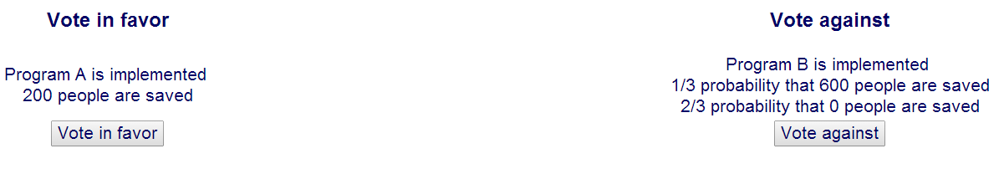

**Asian disease, loss treatment**

The Netherlands is preparing itself for the outbreak of a disease, which is expected to kill 600 people. You are going to vote on the way to combat the disease. There are two alternatives with the following consequences:   
If program A is implemented 400 people will die.   
If program B is implemented there is a 1/3 probability that 0 people will die and a 2/3 probability that 600 people will die.

The vote is on implementing program A. If that is voted down program B will be implemented.

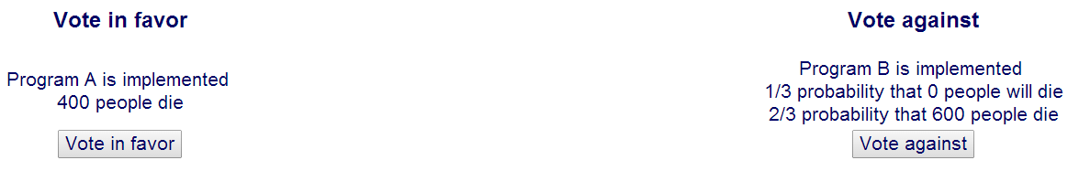

**Macro-economic policy outcomes, gain treatment**

The economy is doing better than expected. According to the CPB (Netherlands Bureau for Economic Policy Analysis), if policies do not change, unemployment will be 6% next year rather than the 6.5% expected earlier.

The budget deficit will be 2.6% instead of the 2.9% expected earlier.

You are going to vote on a proposal with the following consequences:   
with a probability of 50% unemployment will drop by 0.5 percentage points and the budget deficit will improve with 0.1 percentage points.   
With a probability of 50% unemployment will rise by 0.5 percentage points and the budget deficit will deteriorate with 0.1 percentage points.

Your caucus has the deciding vote.

The situation is also represented in the table below. The numbers represent changes compared to the earlier expectations.

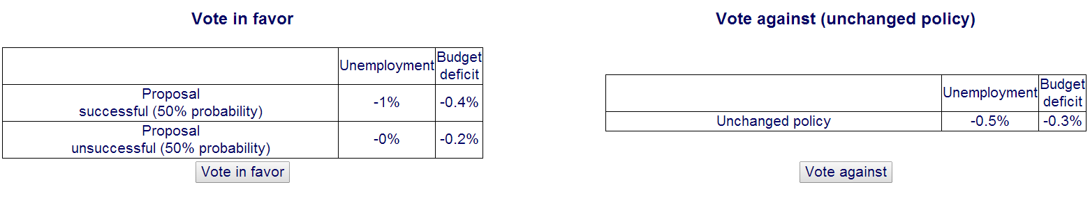

**Macro-economic policy outcomes, loss treatment**

The economy is doing worse than expected. According to the CPB (Netherlands Bureau for Economic Policy Analysis), if policies do not change, unemployment will be 6% next year rather than the 5.5% expected earlier.

The budget deficit will be 2.6% instead of the 2.3% expected earlier.

You are going to vote on a proposal with the following consequences:   
with a probability of 50% unemployment will drop by 0.5 percentage points and the budget deficit will improve with 0.1 percentage points.   
With a probability of 50% unemployment will rise by 0.5 percentage points and the budget deficit will deteriorate with 0.1 percentage points.

Your caucus has the deciding vote.

The situation is also represented in the table below. **The numbers represent changes compared to the earlier expectations.**

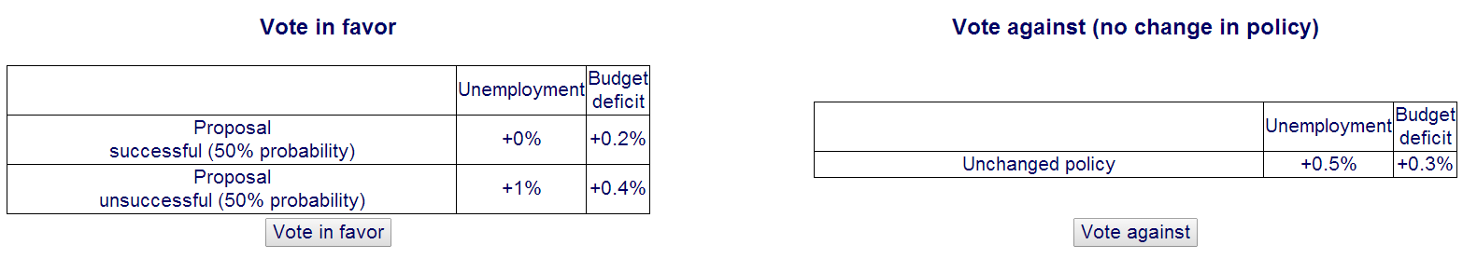

**Votes outcomes, gain treatment**

Your party is doing well in the polls: 10% more voters than in the previous elections.

You are going to vote on a proposal on which your party does not have a substantive opinion. It is unsure how this will work out electorally.

If you vote in favor some voters will appreciate it very much, and others will strongly disapprove. How this will turn out on balance is uncertain:   
with 50% probability the number of votes your party gets will increase by 5% and   
with 50% probability the number of votes your party gets will decrease by 5%.

If you vote against the proposal it is very probable that not much will change to the number of voters who will vote for your party.

The situation is also represented in the table below. **The numbers represent changes compared to the earlier expectations.**

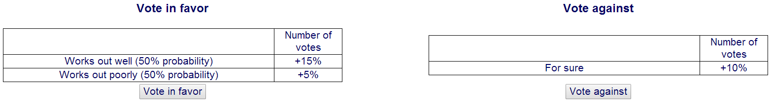

**Votes outcomes, loss treatment**

Your party is doing poorly in the polls: 10% fewer voters than in the previous elections.

You are going to vote on a proposal on which your party does not have a substantive opinion. It is unsure how this will work out electorally.

If you vote in favor some voters will appreciate it very much, and others will strongly disapprove. How this will turn out on balance is uncertain:   
with 50% probability the number of votes your party gets will increase by 5% and   
with 50% probability the number of votes your party gets will decrease by 5%.

If you vote against the proposal it is very probable that not much will change to the number of voters who will vote for your party.

The situation is also represented in the table below. **The numbers represent changes compared to the earlier expectations.**

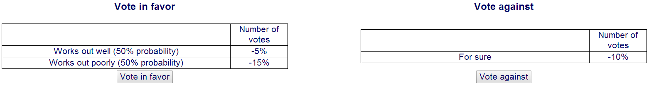

**Votes and economic policy outcomes, gain in votes**

The economy is doing worse than expected: according to the CPB (Netherlands Bureau for Economic Policy Analysis), if policies do not change, national income will rise by 1% instead of the 2% expected before.

At the same time, your party is doing well in the polls: 6% more votes than in the previous elections.

You are going to vote on a proposal that with 60% probability will increase economic growth by 0.3% and with 40% probability will decrease economic growth by 0.3%.

Your party has the deciding vote. The consequences of the proposal will influence the number of voters intending to vote for your party.

If economic growth decreases by 0.3% your party will lose 3% of its voters; if economic growth increases by 0.3% your party will gain 3% more voters.

The situation is also represented in the table below. **The numbers represent changes compared to the earlier expectations.**

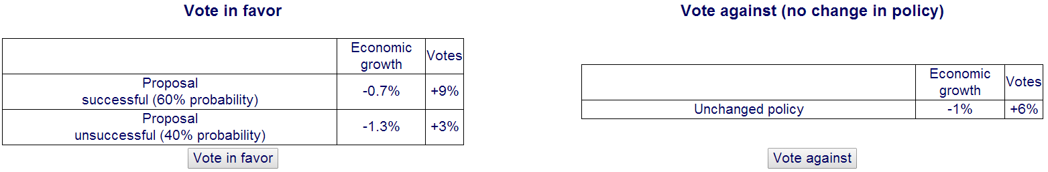

**Votes and economic policy outcomes, loss in votes**

The economy is doing better than expected: according to the CPB (Netherlands Bureau for Economic Policy Analysis), if policies don’t change, national income will rise by 1% instead of the 0% expected before.

At the same time your party is not doing well in the polls: 6% fewer votes than in the previous elections.

You are going to vote on a proposal that with 60% probability will increase economic growth by 0.3% and with 40% probability will decrease economic growth by 0.3%.

Your party has the deciding vote. The consequences of the proposal will influence the number of voters intending to vote for your party.

If economic growth decreases by 0.3% your party will lose 3% of its voters; if economic growth increases by 0.3% your party will gain 3% more voters.

The situation is also represented in the table below. **The numbers represent changes compared to the earlier expectations.**

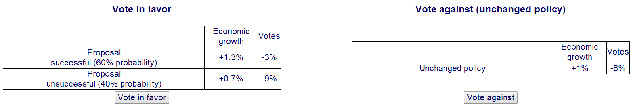

**Online appendix E: Results of the student-sample compared to the MP-sample**

The experiment with the student-sample was conducted on March 27 and 28, 2014 at the CREED laboratory at the University of Amsterdam. We thank CREED for the possibility to use their facilities and have abided to their research integrity standards (regarding, for instance, the storage of raw data and no deception). In total 176 people participated; 51% were male, and 53% studied economics.

The largest part of our student-sample (n=102) received the same incentive as the politicians did (see main text), in addition to a show-up fee of €4. These were all Dutch-speaking students. The remaining Dutch-speaking students (n=33) and non-Dutch speaking students (n=41) were assigned to a treatment without financial incentives. Like the politicians, the Dutch-speaking students received instructions in Dutch, the non-Dutch speaking students received instructions in English. The latter part of our sample is comparable to existing studies without incentives (such as Kahneman and Tversky’s work). We find no substantive differences in the finding for the student-samples with and without incentives

*Table E.1*. Common ratio problem

|  |  |  |  |  |
| --- | --- | --- | --- | --- |
| Task | % of students choosing risky option (Full sample) | % of students choosing risky option (Incentive treatment) | % of politicians choosing risky option | P-value ranksum test comparing politicians to students (with incentives) |
| €28 for sure  *or*  €40 with 80% probability and  €0 with 20% probability | 51.70% | 54.90% | 63.04% | 0.1704 (0.3555) |
| €20 with 25% probability and €0 with 75% probability *or*  €40 with 20% probability and  €0 with 80% probability | 81.82% | 83.33% | 71.74% | 0.1309 (0.1056) |
| Difference (percentage points) | 30.11% | 28.43% | 8.70% | 0.0316 (0.0632) |
| p-value binomial-test | <0.0001 | <0.0001 | 0.4545 |  |
|  | N=176 | N=102 | N=46 |  |

*Table E.2*. Common consequence problem

|  |  |  |  |  |
| --- | --- | --- | --- | --- |
| Task | % of students choosing risky option (Full sample) | % of students choosing risky option  (Incentive treatment) | % of politicians choosing risky option | P-value ranksum test comparing politicians to students (with incentives) |
| €35 for sure  *or*  €60 with 10% probability and €35 with 85% probability and €0 with 5% probability | 71.02% | 72.55% | 73.91% | 0.6993 (0.8632) |
| €35 with 15% probability and €0 with 85% probability *or*  €60 with 10% probability and €0 with 90% probability | 77.84% | 82.35% | 73.91% | 0.5737 (0.2388) |
| Difference | 6.82% | 9.80% | 0% | 0.4804 (0.3405) |
| p-value binomial-test | 0.1480 | 0.1102 | 1 |  |
|  | N=176 | N=102 | N=46 |  |

*Table E.3* . Reflection effect problem

|  |  |  |  |  |
| --- | --- | --- | --- | --- |
| Task | % of students choosing risky option (Full sample) | % of students choosing risky option (Incentive treatment) | % of politicians choosing risky option | P-value ranksum test comparing politicians to students (with incentives) |
| €60 with 33% probability and  €0 with 67% probability *or* €20 for sure | 14.77% | 13.73% | 39.13% | 0.0002 (0.0005) |
| €0 with 33% probability and –€60 with 67% probability *or* –€40 for sure | 79.55% | 72.55% | 76.09% | 0.6100 (0.6522) |
| Difference (in percentage points) | 64.77% | 58.82% | 36.96% | 0.0020 (0.0280) |
| p-value binomial-test | <0.0001 | <0.0001 | 0.0002 |  |
|  | N=176 | N=102 | N=46 |  |

*Table E.4*. Lottery valuation tasks, average difference between the valuation and the expected value of the nine different lotteries for the full student-sample (n=176).

|  |  |  |  |
| --- | --- | --- | --- |
| Probability of highest aamountamount | Gain treatment | Mixed treatment | Loss treatment |
| 10% | € 0.01 | € 0.48 | € 0.24 |
| 50% | –€ 0.44 | € 0.15 | € 0.49 |
| 90% | –€ 0.62 | € 0.33 | € 0.26 |

*Table E.5*. Lottery valuation tasks, average difference between the valuation and the expected value of the nine different lotteries for students with incentives (n=102).

|  |  |  |  |
| --- | --- | --- | --- |
| Probability of highest amountamount | Gain treatment | Mixed treatment | Loss treatment |
| 10% | –€ 0.17 | € 0.43 | € 0.31 |
| 50% | –€ 0.68 | € 0.25 | € 0.34 |
| 90% | –€ 0.68 | € 0.58 | € 0.34 |

*Table E.6*. Political decision scenarios for the full student-sample (n=176)

|  |  |  |  |
| --- | --- | --- | --- |
| Scenarios | Loss situation  % choosing risky option | Gain situations  % choosing risky option | p-value Fisher exact test |
| 1) Economic policy outcomes | 66.29% | 59.77% | 0.435 |
| 2) Votes | 73.03% | 39.08% | <0.001 |
| 3) Votes and economic policy outcomes (loss/gain in terms of votes) | 89.69% | 51.90% | <0.001 |
| 4) Asian disease | 84.52% | 36.96% | <0.001 |

**References**

Allais, P.M. (1953). Le comportement de l’homme rationnel devant le risque: Critique des postulats et axiomes de l'ecole Americaine. *Econometrica*, *21*(4), 503–546.

Ballinger, T.P., & Wilcox, N.T. (1997). Decisions, error and heterogeneity. *The Economic Journal*, *107*(443), 1090–1105.

Bardsley, N., Cubitt, R., Loomes, G., Moffatt, P., Starmer, C., & Sugden, R. (2010). *Experimental Economics: Rethinking the Rules*. Princeton and Oxford: Princeton University Press.

Becker, G.M., Degroot, M.H., & Marschak, J. (1964). Measuring utility by a single-response sequential method. *Behavioral Science*, *9*(3), 226–232.

Conlisk, J. (1989). Three variants on the Allais example. *The American Economic Review*, *79*(3), 392–407.

Huck, S., & Müller, W. (2012). Allais for all: Revisiting the paradox in a large representative sample. *Journal of Risk and Uncertainty*, *44*(3), 261–293.

Kahneman, D., & Tversky, A. (1979). Prospect theory: An analysis of decision under risk. *Econometrica*, *47*(2), 263–291.

Kahneman, D., & Tversky, A. (1984). Choices, values, and frames. *American Psychologist*, 341–350.

Kühberger, A., Schulte-Mecklenbeck, M., & Perner, J. (1999). The effects of framing, reflection, probability, and payoff on risk preference in choice tasks. *Organizational Behavior and Human Decision Processes*, *78*(3), 204–231.

Linde, J., & Sonnemans, J. (2011). Social comparison and risky choices. *Journal of Risk and Uncertainty*, *44*(1), 45–72.

Loomes, G., & Sugden, R. (1998). Testing different stochastic specifications of risky choice. *Economica*, *65*(260), 581–598.

McGlothlin, W.H. (1956). Stability of choices among uncertain alternatives. *The American Journal of Psychology*, *69*(4), 604–615.

Odean, T. (1998). Are investors reluctant to realize their losses? *The Journal of Finance*, *53*(5), 1775–1798.

Slovic, P., & Tversky, A. (1974). Who accepts Savage’s axiom? *Behavioral Science*, *19*(6), 368–373.

Tversky, A., & Kahneman, D. (1981). The framing of decision and the psychology of choice. *Science*, *211*(1), 453–458.

Tversky, A., & Kahneman, D. (1992). Advances in prospect theory: Cumulative representation of uncertainty. *Journal of Risk and Uncertainty*, *5*(4), 297–323.