Introduction to Numerical Analysis Project3

20120281김영은

Problem1.

(a) Plot with noise , and .

To generate noise , use built-in function ‘randn’ and ‘randsample’.

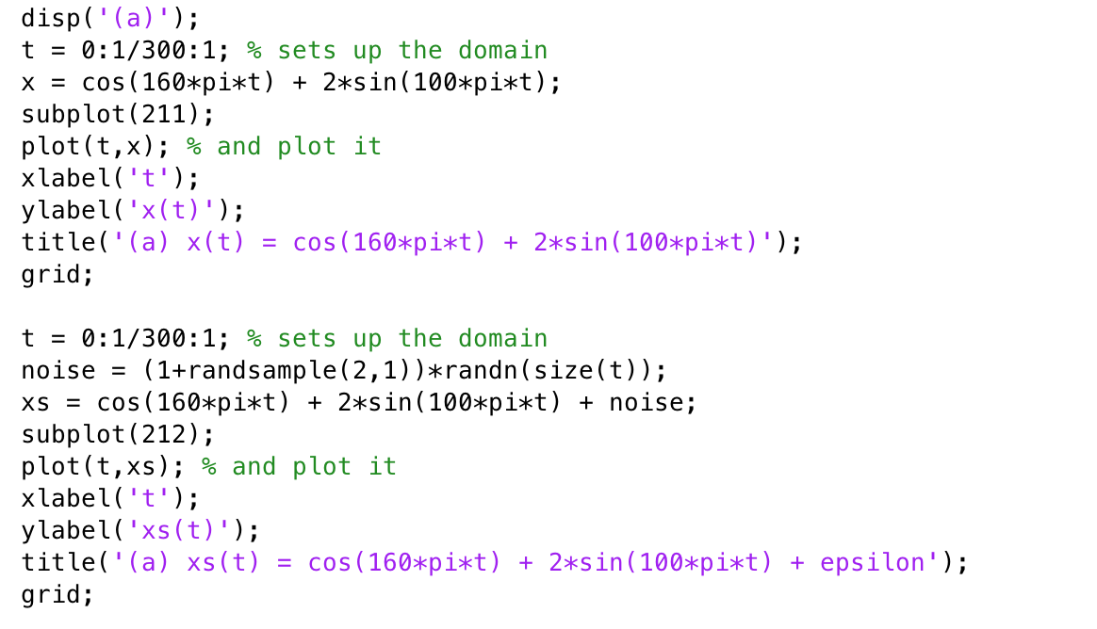

Code 1 (a) plot x(t) and x~(t)

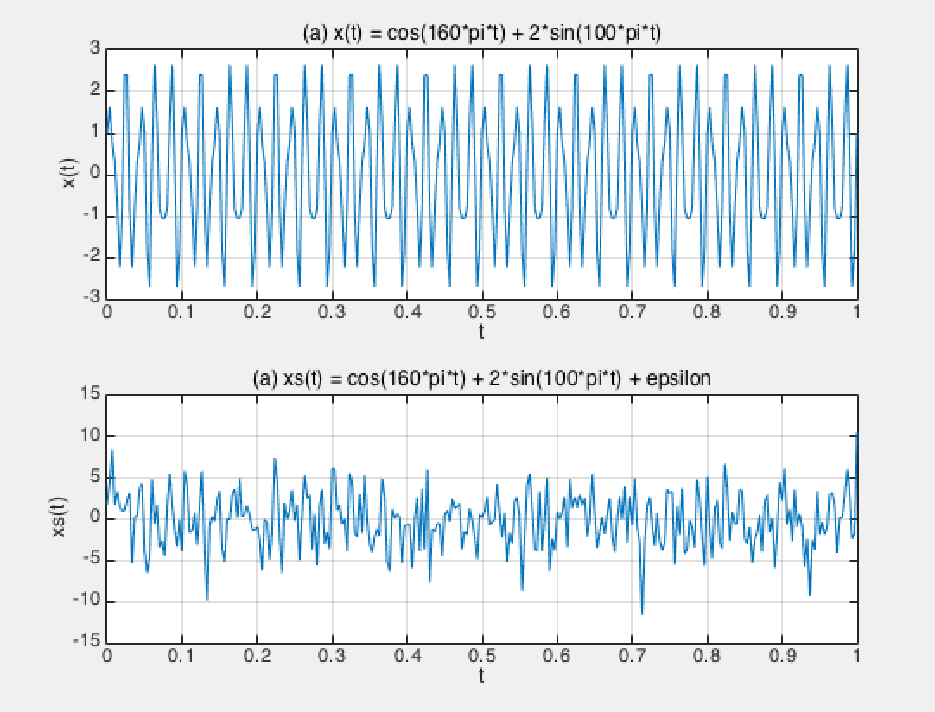

Graph 1 problem 1-(a)

와 의 그래프를 비교해보면, noise가 있을 때 원래의 파형과 상당히 다르게 나와서 그래프 만으로는 원래의 신호를 알기 어렵다.

(b) Generate the discrete time signal

Generate the discrete time signal with N=300 with using randn and randsample for noise.

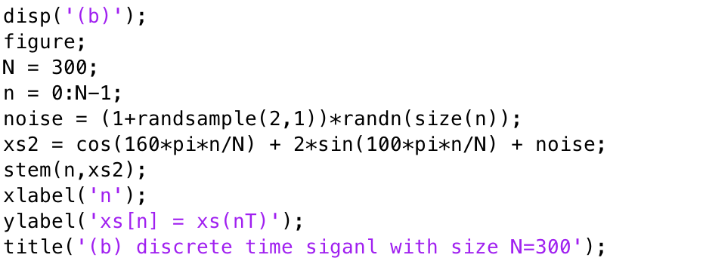

Code 2 Generate discrete time signal with N=300

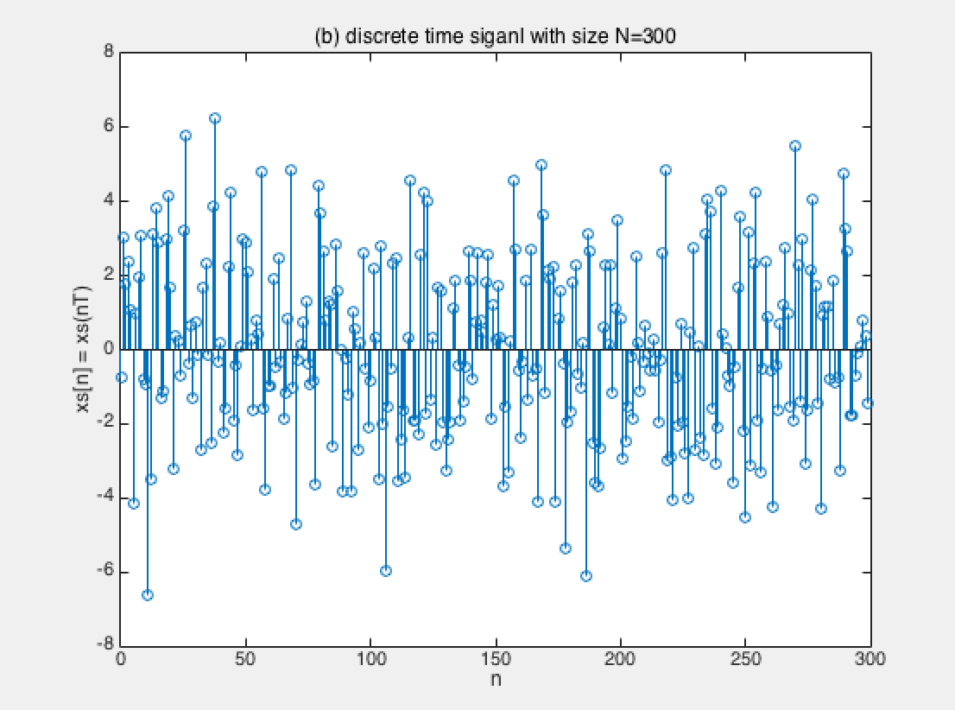

Graph 2 x[n] with discrete time signal

(c) Compute the DFT of

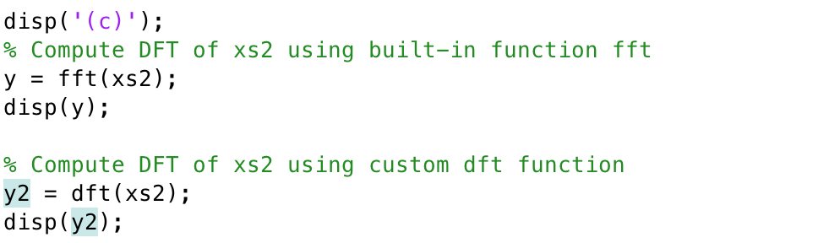

Code 3 calculate dft vector in two ways

Calculate dft vector of in two ways; first by using built-in function fft, and secondly by using custom dft function below.

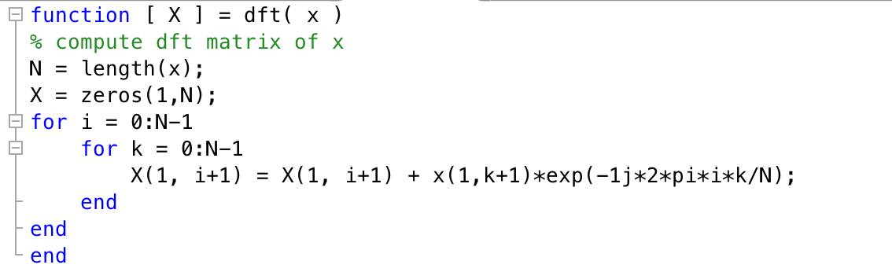

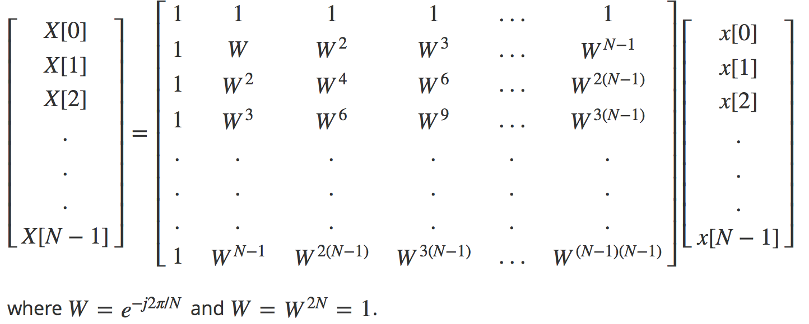

Figure 1 Computing dft vector

To compute dft vector, once get the x vector x[n] which is value calculated x(t) with discrete time signal. After that, calculate N = length of x[n] and generate X with length N, and calculate entries of X with using for loop according to Figure1.

(d) Plot the magnitude of spectrum and the phase spectrum.

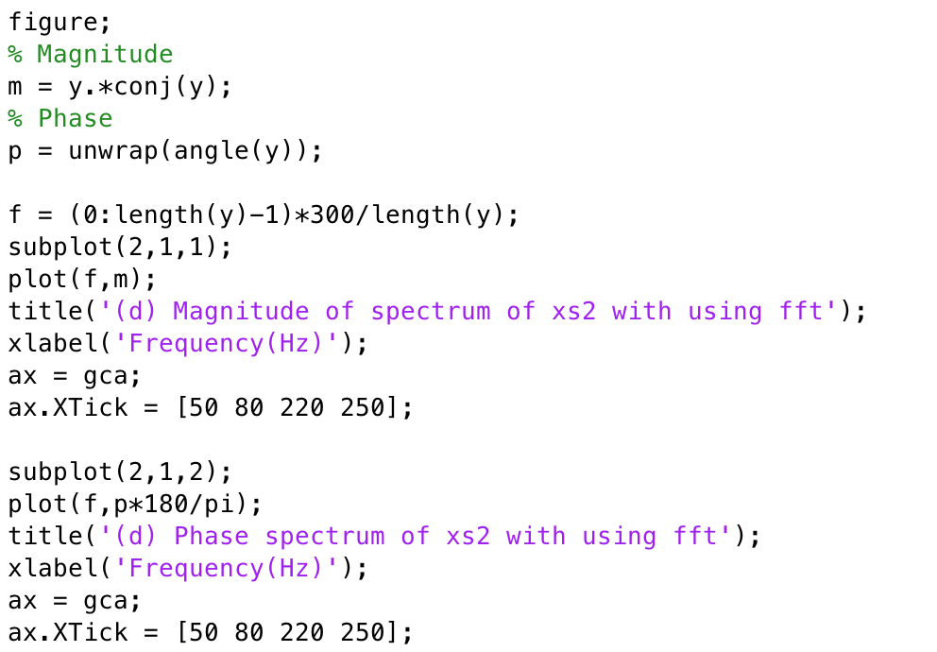

Code 4 Calculate and plot magnitude and phase

Calculate magnitude and phase with build-in function ‘conj’ and ‘angle’ and plot each values with x-axis frequency. In same way, get 3 graphs; First one is graph of magnitude and phase of dft of x(t). From the first graph, I can get exact phase. Second one is graph of magnitude and phase of dft of x[n] calculated with build-in function ‘fft’, and the last one is graph of magnitude and phase of dft of x[n] calculated with custom function ‘dft’. Since the dft vector is of size 1x300, too large, I inserted only the graph of magnitude and phase from each dft vector not the vector. The second and last graph display same phase and magnitude.

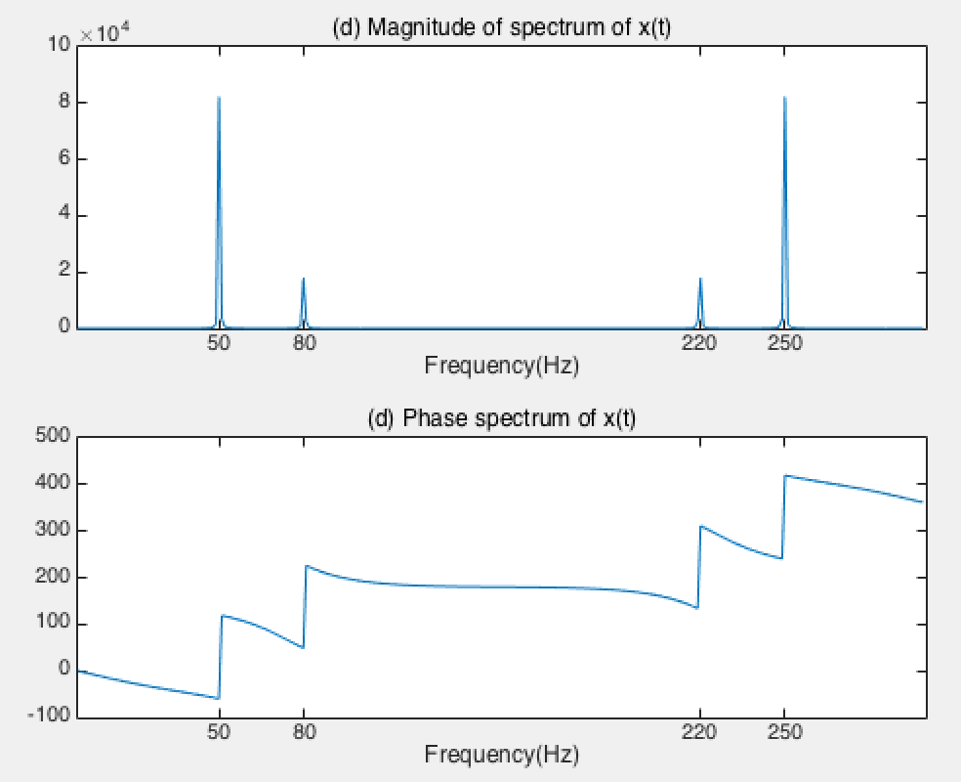

Graph 3 magnitude of spectrum and phase spectrum of x(t)

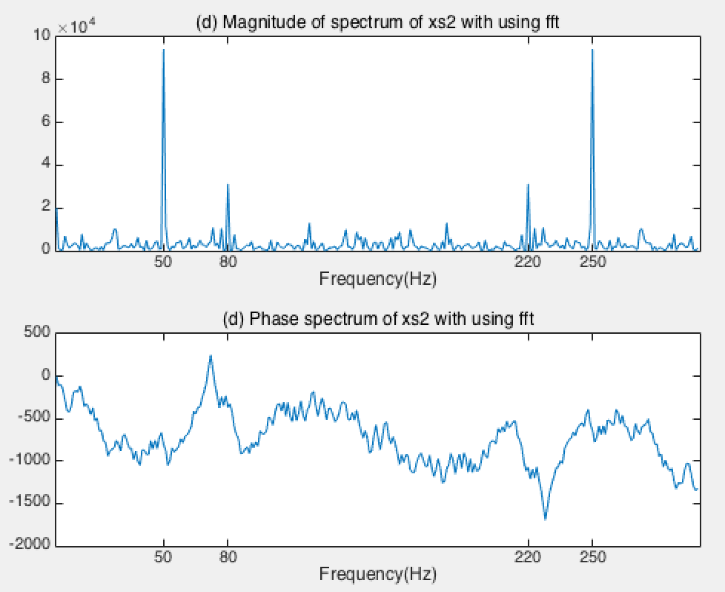

Graph 4 magnitude of spectrum and phase spectrum of x[n] calculated with 'fft'

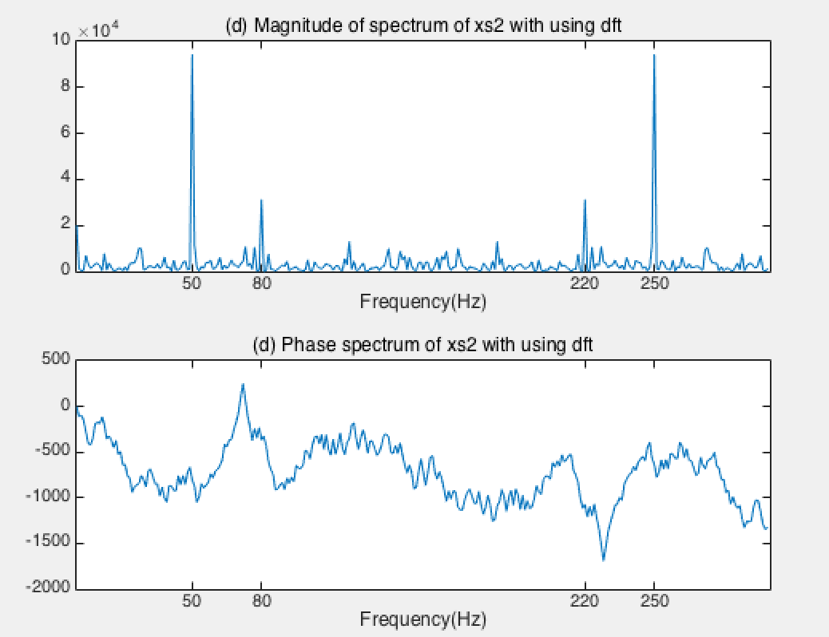

Graph 5 magnitude of spectrum and phase spectrum of x[n] calculated with 'dft'

(e) Construct an approximation of . High pass filter vs Low pass filter.

Order of filter is defined by number of active elements in the filter. As the filter order N increases, the actual frequency responses approach our ideal better and better.

Low-pass filter: used to cut unwanted high-frequency signals.

Set the sampling frequency to with , and cut-off frequency to 3Hz. Plot 3 graphs; first one is original signa, and the second one is which is x(t) with noise, the last one is filtered .

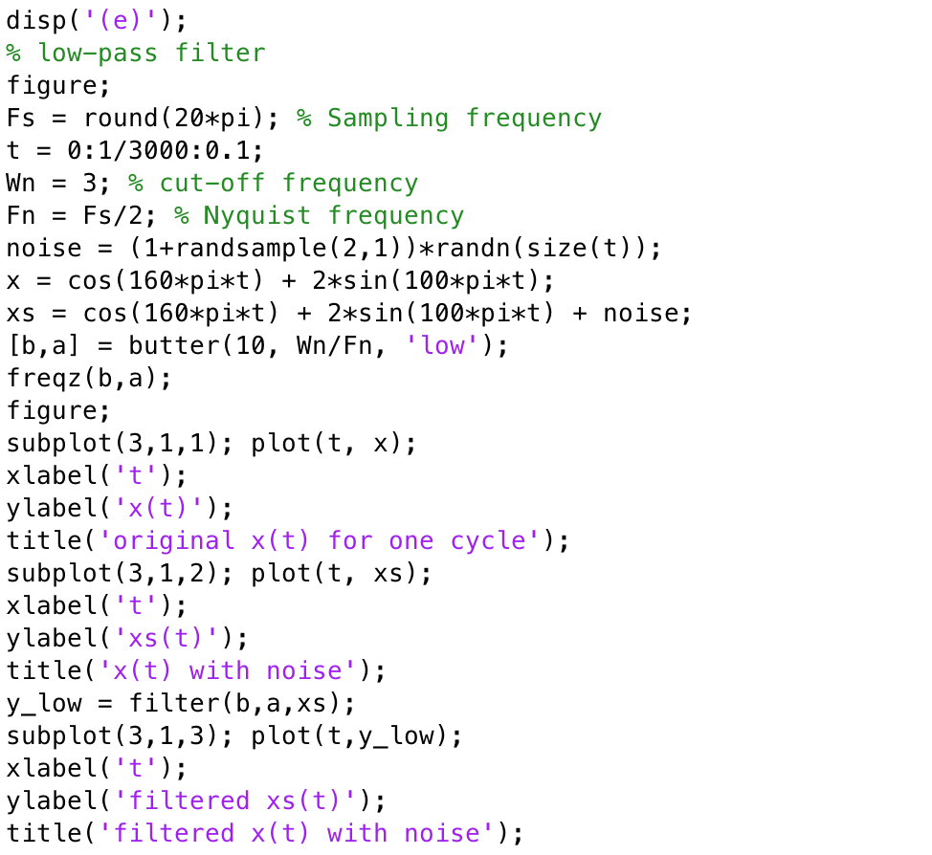

Code 5 low-pass filter

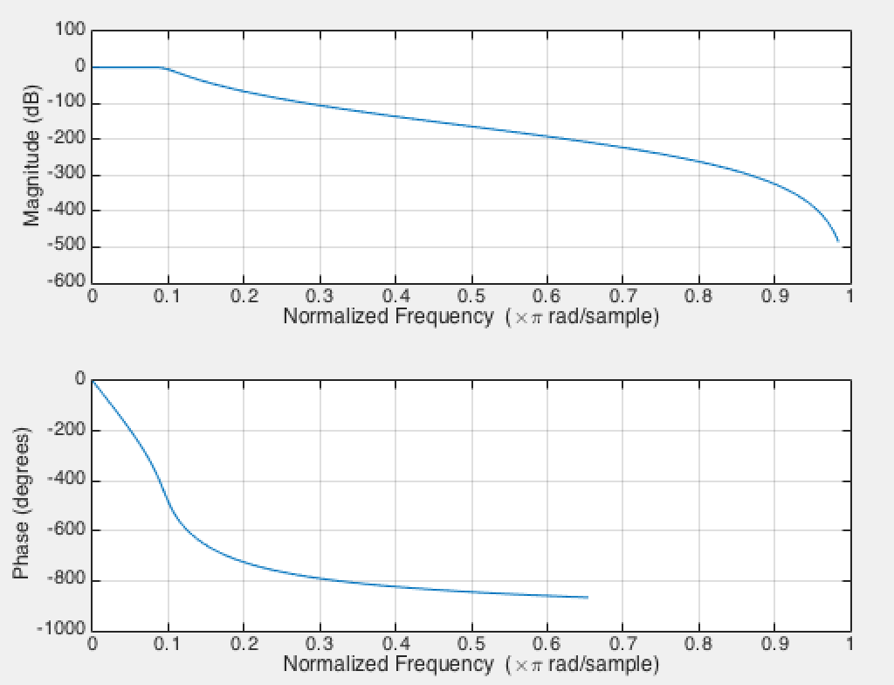

Graph 6 low-pass filter magnitude and phase

Magnitude and phase of generated low-pass filter with cut-off frequency 3Hz and order 10.

In the below graph, the filtered graph has similar phase to original signal.

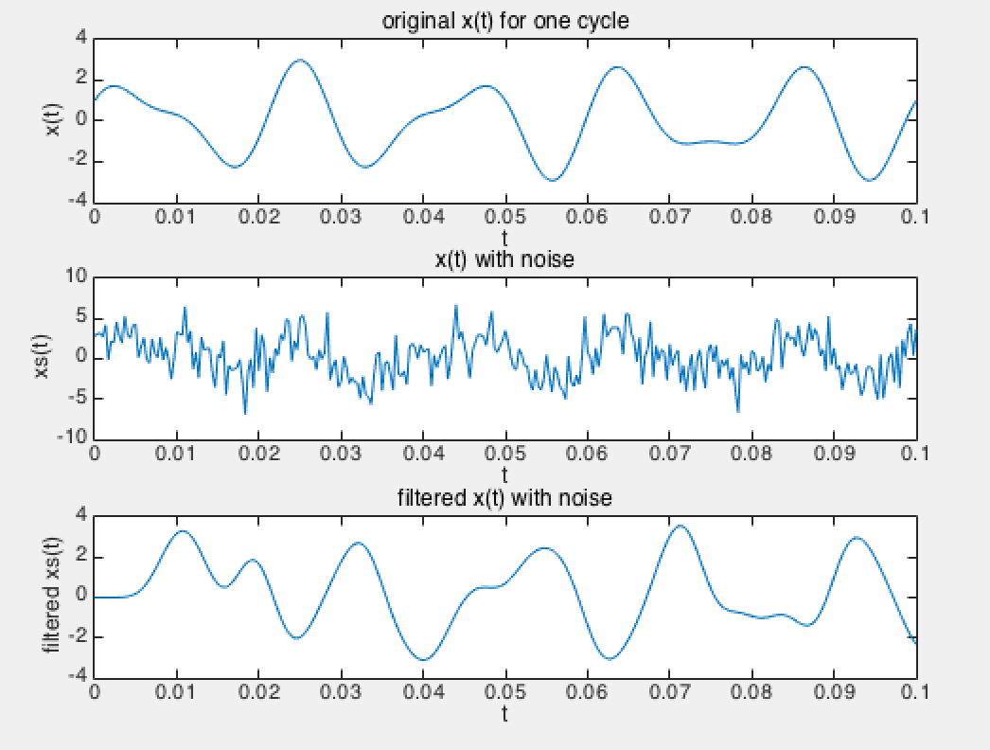

Graph 7 x(t), xs(t) and low-pass filtered xs(t)

High-pass filter: used to passes high frequencies fairly well; it is helpful as a filter to cut any unwanted low frequency components.

Set the sampling frequency to with , and cut-off frequency to 10Hz.

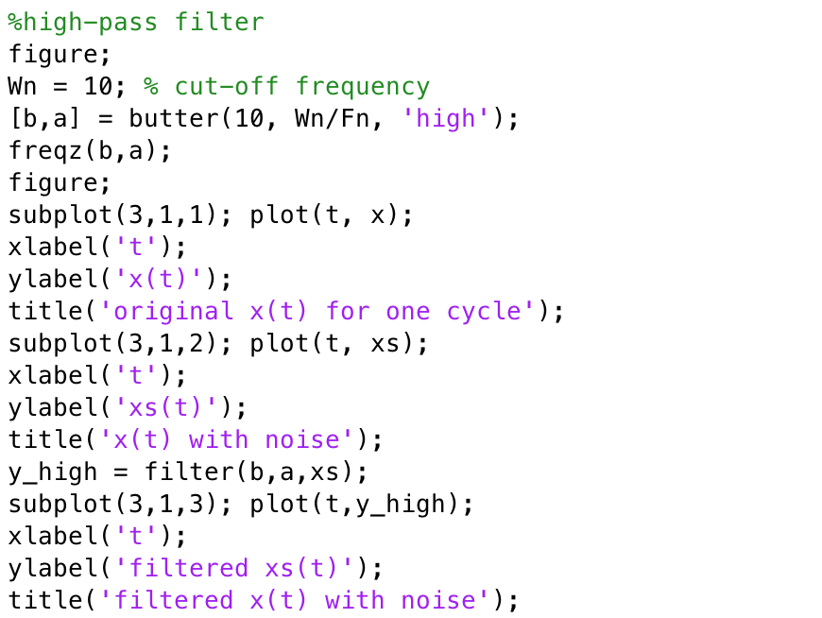

Code 6 high-pass filter

Magnitude and phase of generated high-pass filter with cut-off frequency 10Hz and order 10.

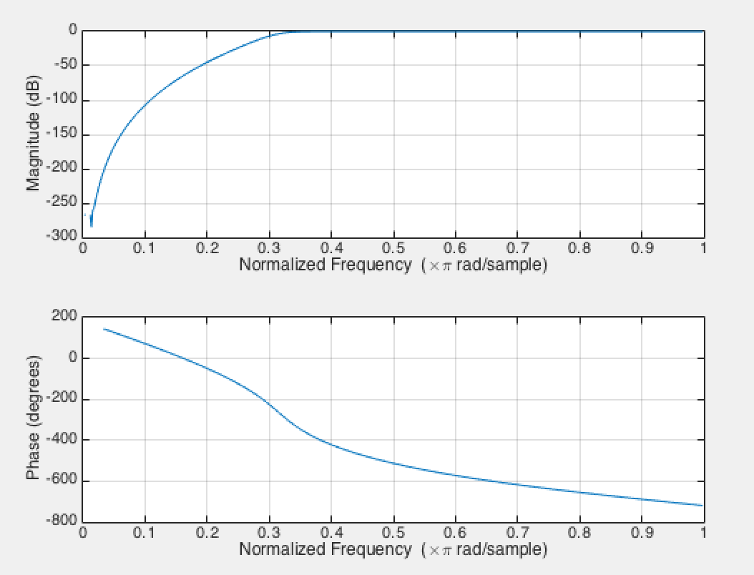

Graph 8 high-pass filter magnitude and phase

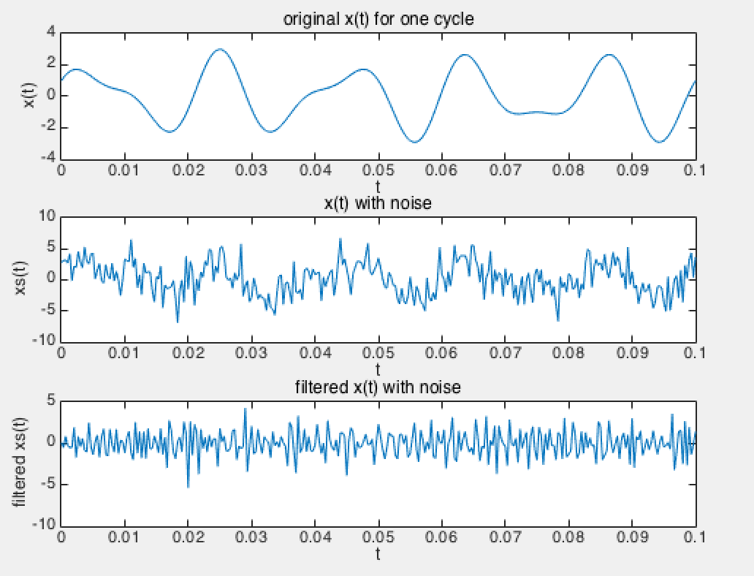

Graph 9 x(t), xs(t) and high-pass filtered xs(t)

Problem2.

(a) Perform the spectrum analysis of and (DFT and spectral analysis) and plot the magnitudes of and .

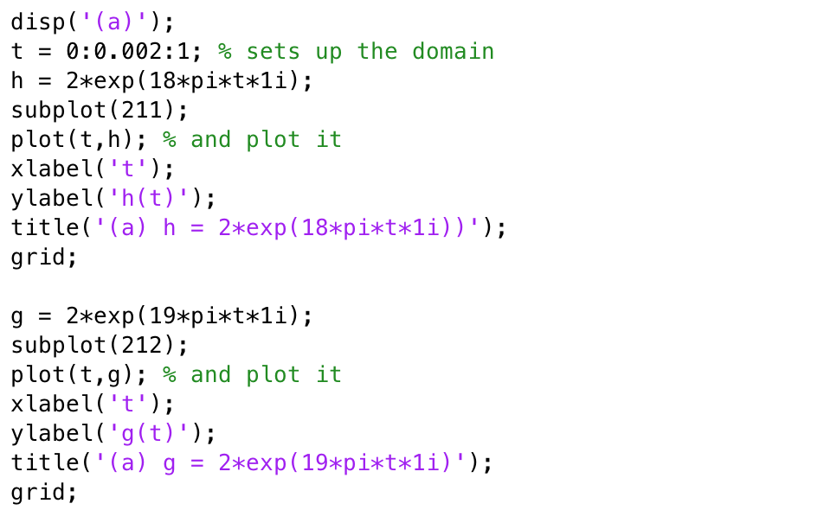

Code 7 plot h(t) and g(t)

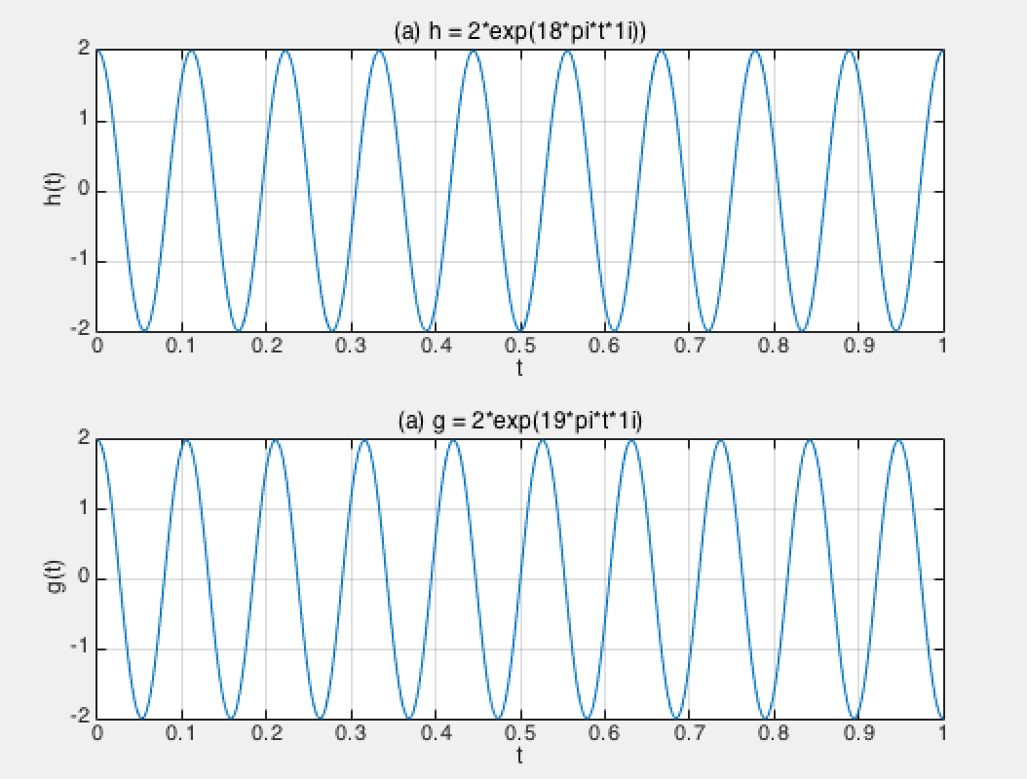

Graph 10 graph of h(t) and g(t) for 0<t<1

Compute magnitude and phase for spectral analysis by using build-in function ‘fft’, ‘conj’ and ‘angle’.

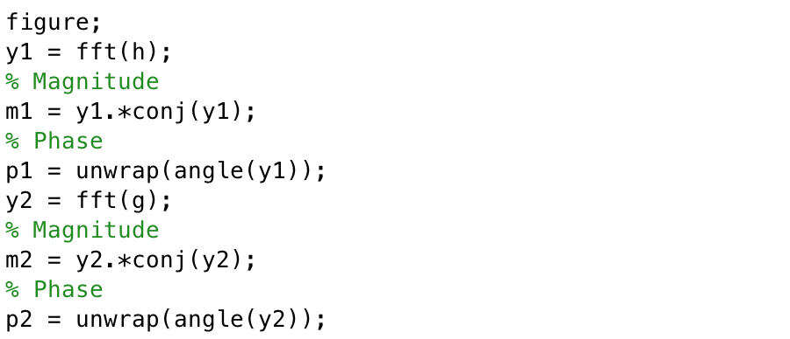

Code 8 Compute magnitude and phase of h(t) and g(t)

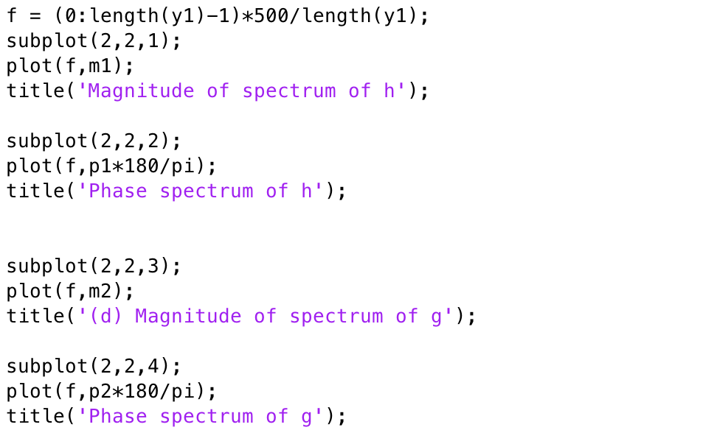

Code 9 plot magnitude and phase of h(t) and g(t)

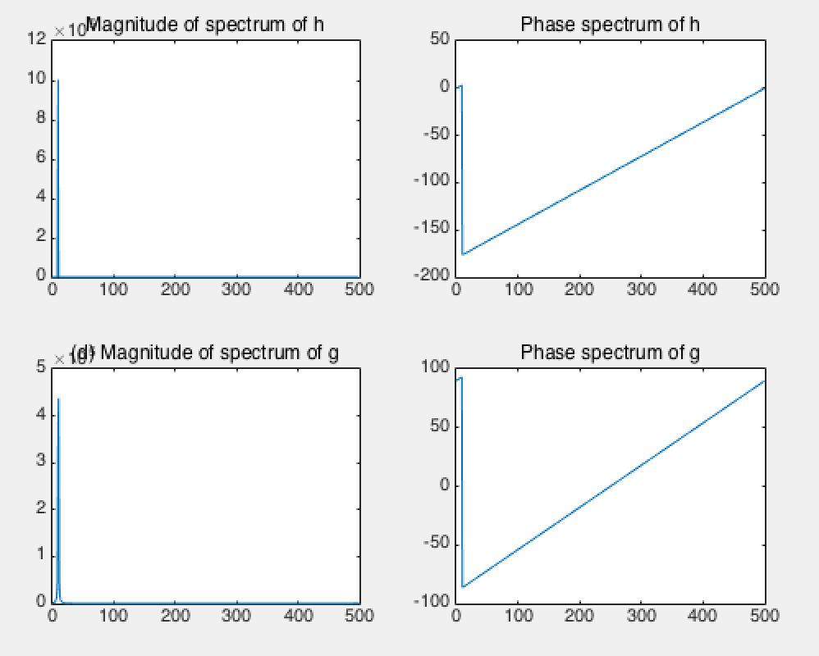

Graph 11 graph of magnitude and phase of h(t) and g(t)

(b) What difference do you see? Why? Discuss about better result.

The definition of dirac-delta function is given as below.



The fourier transform of is . So they has different frequency and phase. The h(t) has integer constant , and the g(t) has non-integer constant . Dirac-delta function with integer coefficient is better to analysis even it has noise, since it maintain its phase with transform.