This program can be used to Browse any table that can be accessed using a “connection string”.

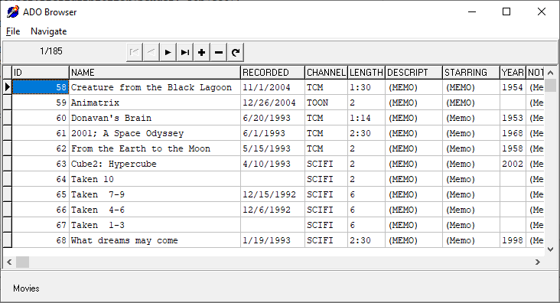

Any table that can be accessed via a *Connection String* can be opened.

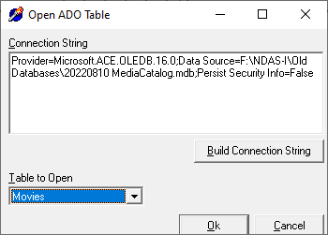

Records can be presented ordered by any available index.

Records can be searched for a string appearing in any field. Additional records can be added and any records can be hidden (i.e., marked as deleted).

Double-clicking on a “(MEMO)” field will open it in a separate window.

