This program can be used to Browse a dBase .DBF file (and associated index) using the shareware TDbf table driver.

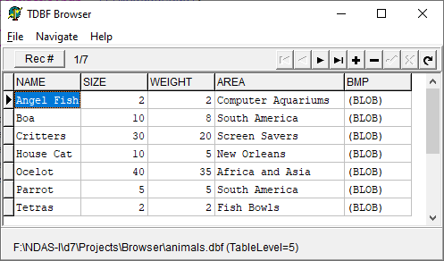

Records can be presented ordered by any available index.

Records can be searched for a string appearing in any field. Additional records can be added and any records can be hidden (i.e., marked as deleted).

Double-clicking on a “(Memo)” field will open it in a separate window.