This program can be used to unscramble letters to make words.

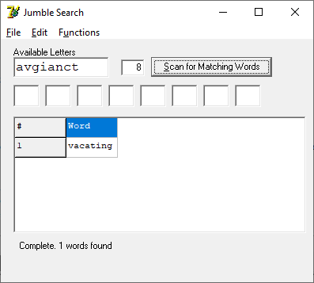

It can also be used to find words which match certain specified letters (ala *WordWiz*) and other games.

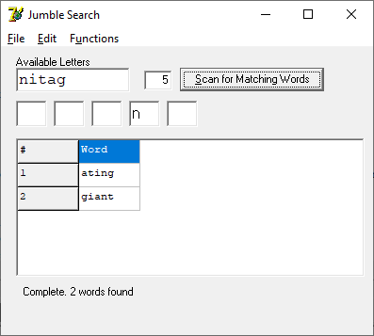

Simply fill in the given letters (*Available Letters)* and press “*Scan for Matching Words.*” If the matched words are constrained to match letters in certain positions, just enter the required letters in the needed positions.