*ListBinaryDifferences* will compare two binary files, byte by byte, and list each region of the two files that is different.

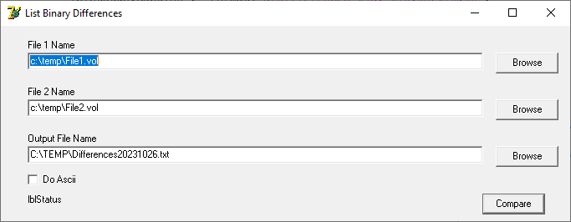

01. 725DE: 00 00 00 00 00 00 00 00 00 00 00 00 00 00 00 00 00 00 00 00 00 00

: 00 00 00 00 00 00 00 00 00 00 00 00 00 00 00 00 00 00 00 00 00 00

: 0F 00 4F 00 01 00 05 43 49 4E 46 4F 4D 2E 4D 49 53 43 49 4E 46 4F

: 0F 00 O 00 01 00 05 C I N F O M . M I S C I N F O