**MediaCatalog**

MediaCatalog was designed to help keep track of large collections (i.e., hundreds+ of locations, thousands+ of volumes and millions of files) of Media (diskettes, CDs, DVDs, HDDs).

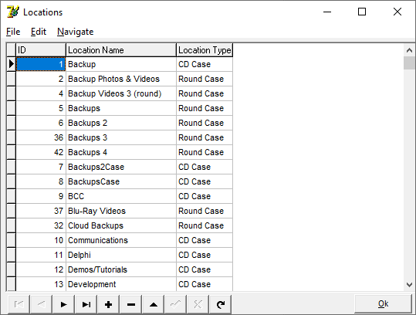

Each table can be sorted on any of its indexed fields.

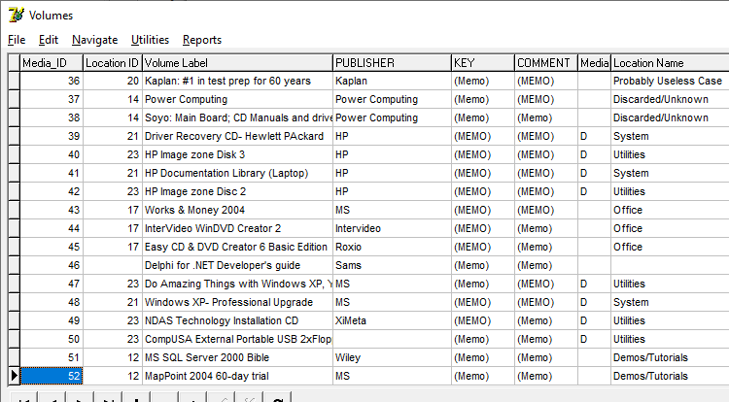

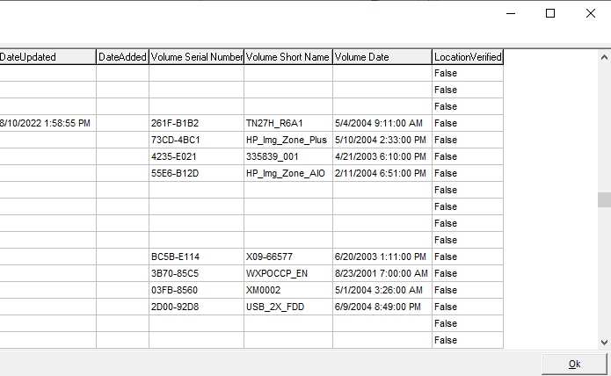

Double-clicking on a “(MEMO)” field will open a window to display its contents.

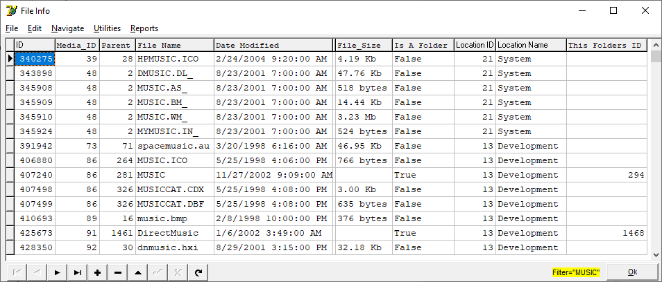

Each of the three tables (*locations, volumes, file info)* can be filtered on a string or on a Boolean expression.

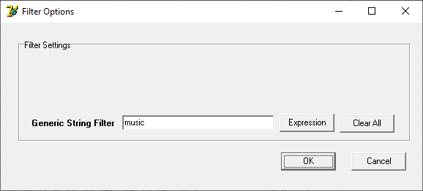

The *Navigate* menu can change which index the browse is sorted on or select the filtering to use.

Filtering on an expression:

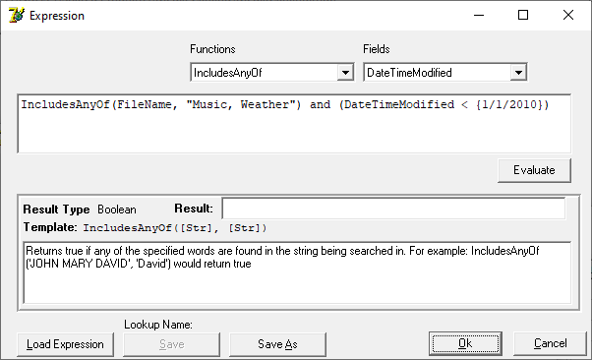

Expressions can be saved for future use.

When a CD or DVD is ejected, information will be provided to assist in labeling it:

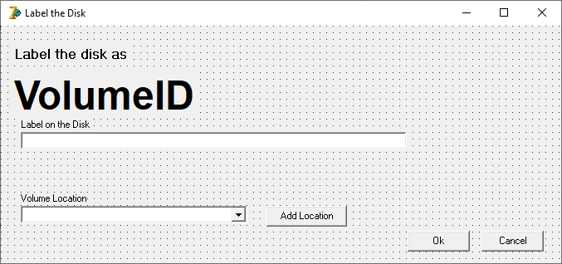

**File/Scan CD/DVD/HD Volume/Folder...”**

Can be used to scan all the files on a volume or folder (diskette, CD, DVD, HDD).

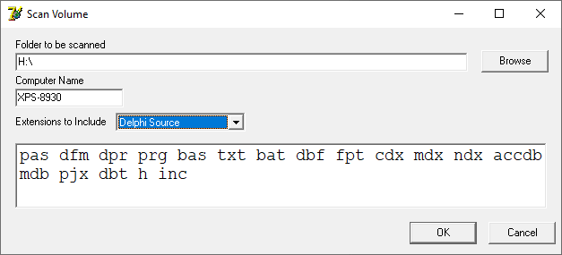

To build a media catalog that only includes certain file name extensions, the *Extensions to Include* can be set to “*Specified Below”* and then list the allowable extensions. Files with any other extensions will be ignored.

A record for each file that is found will be appended to the *Files* table. Records are never updated.

**Scan Single File**

There are sometimes CD/DVD volumes which cannot be scanned using the above command. An alternate way to scan a volume is to use the *Scan Single File* menu item. A single directory listing can be sent to a text file using the ordinary *DOS DIR* command and then imported to the database using the “*File/Import Single Directory Listing Text File...”* menu item. This will read and parse the previously generated directory listing. This sometimes is a better way to scan a volume than *“File/Scan CD/DVD/HD Volume/Folder...”*

To generate the text file of the files in a directory, in the CMD window, use a command like:

DIR *.* >"F:\NDAS-I\CD Contents\VOL0001.txt" /s

And the use the menu item: *“File / Import Single Directory Listing Text File...”* which will parse the directory listing line by line and import it into the database.

**Select this record – build tree**

When viewing records in the *File Info* browser, you can right-click on a record and then select *“Select this record – build tree”*. This will display the tree-structure leading to the selected record in the main window:

