**FILER-DEBUGGER OVERVIEW**

The Filer-Debugger is designed to enable high level debugging of p-System programs. Code can either be debugged at the p-Code level or at the Pascal source code level. Code can be single stepped either one p-Code opcode at a time or one source code line at a time. Breakpoints can be set on any p-Code location (and in effect on any source code line). Local and or global variables can be watched. Most different versions of the p-System (VI.4, VI.5, VII, V4.2.2) can be debugged.

TABSHEET: P-Code/Source

This Tabsheet shows many of the most import pieces of information when debugging including:

* *Source Code* (If available in the debugger database)
* *P-Code*
* The *Dynamic* call stack
* The *Static* call stack
* The *Parameters* call stack
* The *Watch* list – expressions or locations to be displayed

TABSSHEET: Breakpoint List

TABSHEET Syscom:

TABSHEET: CRT/Key Info

TABSHEET: History

TABSHEET: Messages:

TABSHEET: Profile

TABSHEET: Global Directory

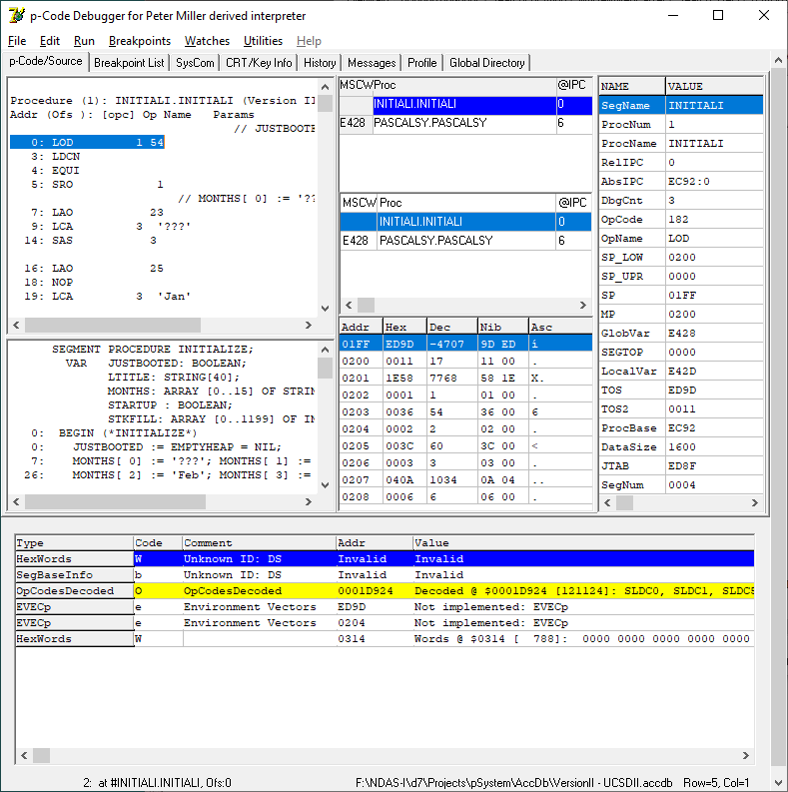

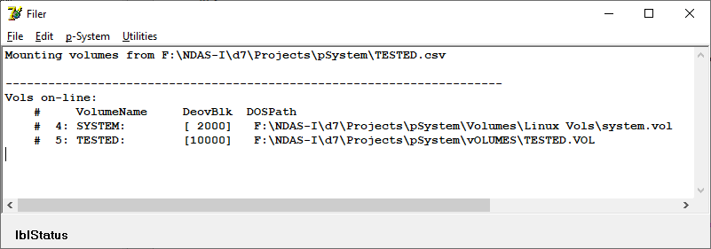

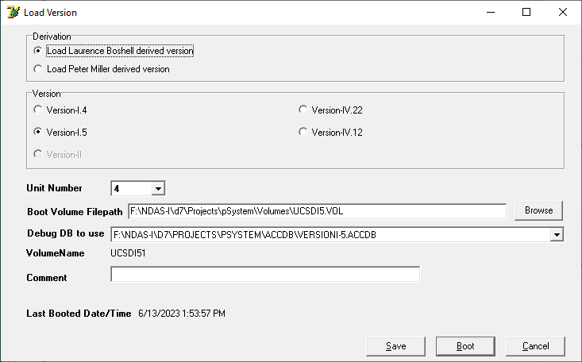

# **UTILITIES**

SegNames/ProcNames

This scans through the database and compares each record with the information that has been loaded into the memory structures to verify that they match. Possible problems include segment / procedure names that may be duplicates or which have the same segment name and procedure number but which do not have matching procedure names. Such problems probably will have to be manually corrected using MS Access.

Display CRT/Key Info from SYSCOM.MISCINFO

Given a Unit Number (#4) and filename (i.e., “SYSTEM.MISCINFO”) this function will display the CRT and Key info from the specified file.

Dump Debug Info

If {$IfDef DumpDebugInfo} was specified when the system was compiled, this function will close the dump file and open it for editing and/or printing. If If {$IfDef DumpDebugInfo} was not specified at compile time, this menu item will be disabled.

Catalog Debugger Databases...

This will scan through all of the debugger databases (*.ACCDB) in the specified *Root Folder and its sub-folders* and generate a report which lists the names of the databases, the file dates, the number of segments, the number of procedures, the date of the latest update, how many records contain p-Code, how many contain source code and the path to the database.