FILER

# Overview

The “Filer” can be used to access UCSD p-System volume (*.VOL) files and transfer DOS/Windows files to/from them and to transfer files from one p-System volume to another. Subsidiary volume files (*. SVOL) can be mounted and accessed. Volumes from as far back as Version I.4 (and probably even earlier) and as late as Version IV+ can be accessed.

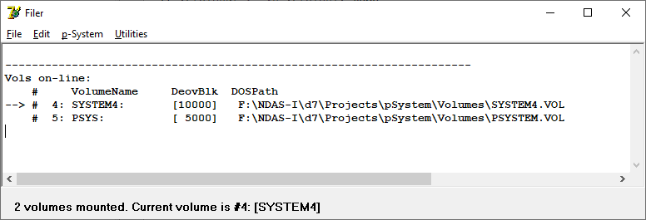

Directories can be listed.

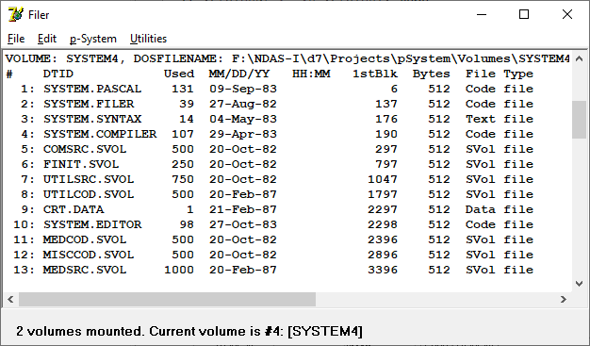

p-System volumes can be in standard *.VOL format or can be in other formats that have been used over the years such as Z-80 Emulator (*.RAW), HealthKit (.H8D), NorthStar (*.NSI), etc. Other unknown formats can be guessed at or specified by entering parameters such as Bytes/Sector, Sectors/Track, Base Track Number, Sector Interleave and Track to Track Skew. The volume is scanned using all permutations of the above parameters looking for valid files.

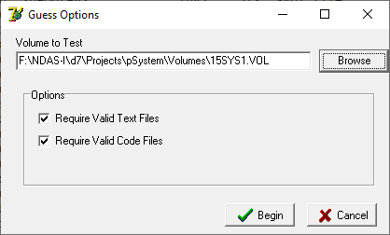

p-System volumes can be converted from one format to another.

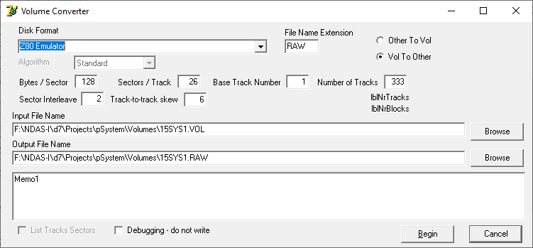

Two p-System volumes can be compared for mis-matched files.

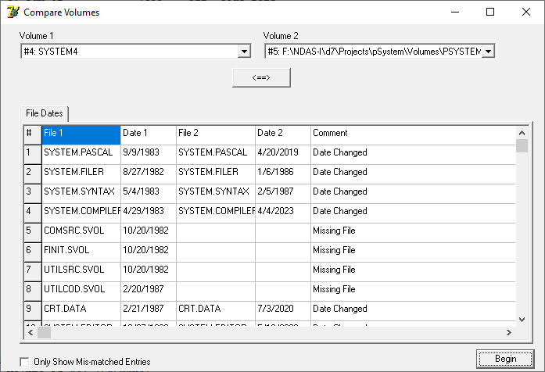

p-System files can be deleted or renamed.

Folders containing p-System volumes in a Windows directory or in a p-System volume can all be searched for a specified ASCII string or Hex string.

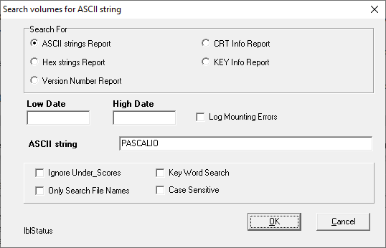

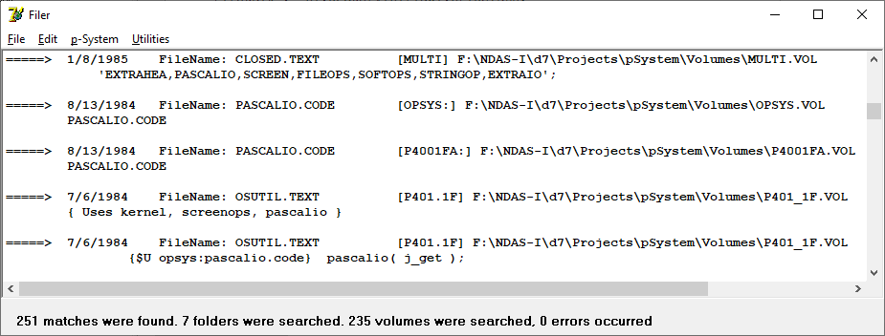

Reports can be generated listing the version numbers of .CODE files.

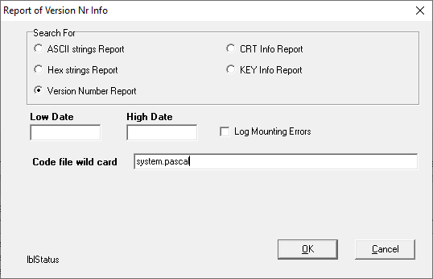

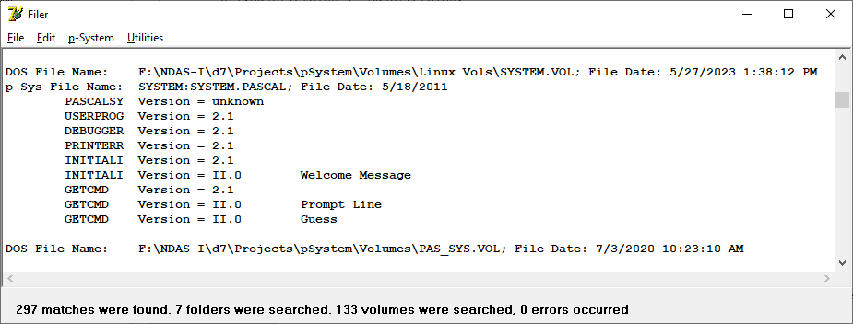

Reports can be generated listing the CRT info or Key codes for the volume (using SYSTEM.MISCINFO). Reports are generated to a .CSV file which can be opened by MS Excel or by LibreOffice Calc (or other spreadsheet tools).

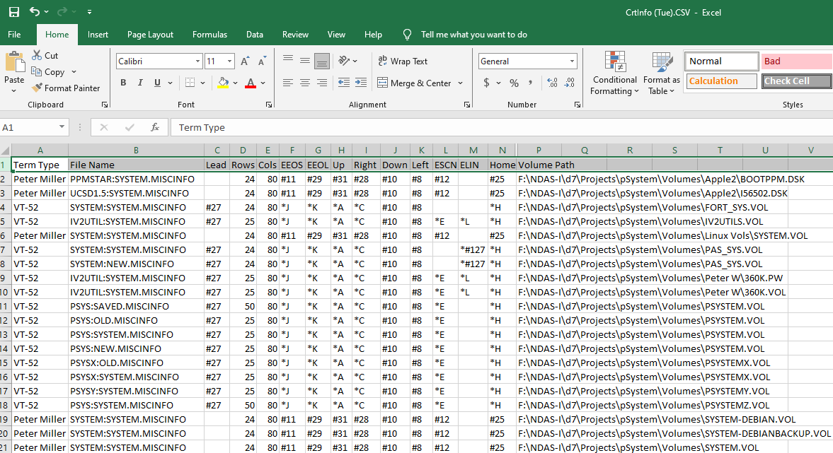

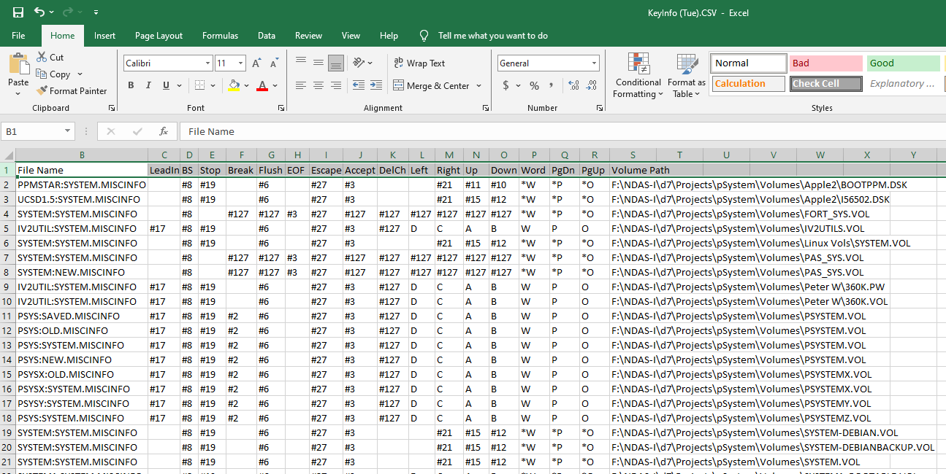

**Program Parameters**

The Filer.exe program can be passed filename parameter(s) when it is executed. This is the full file path and name of one or more .CSV files to be used to specify the volumes to be mounted.

*Testing.csv:*

UnitNumber,VolumeName,DOSPathName,ParentUnitNumber,VolStartBlockInParent,NonStandardFormat

4,"PSYSX","F:\NDAS-I\d7\Projects\pSystem\Volumes\PSYSTEMX.VOL",0,0

10,"UTILITY","F:\NDAS-I\d7\Projects\pSystem\Volumes\UTILITY.VOL",0,0

12,"OPSYS","F:\NDAS-I\d7\Projects\pSystem\Volumes\OPSYS.VOL",0,0

11,"P4021FA","F:\NDAS-I\d7\Projects\pSystem\Volumes\P4021FA.VOL",0,0

9,"JUNK","F:\NDAS-I\d7\Projects\pSystem\Volumes\JUNK.VOL",0,0

5,"DUMPSYS","F:\NDAS-I\d7\Projects\pSystem\Volumes\DUMPSYS.VOL",0,0

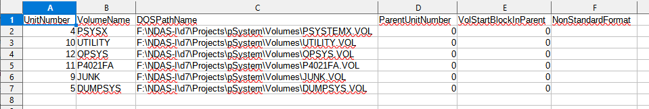

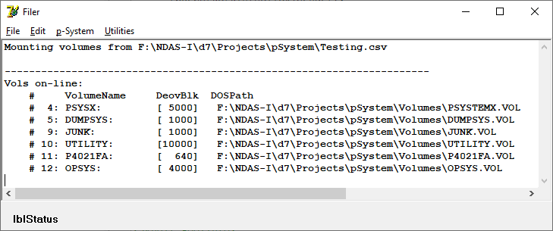

Filer Settings can be reached from the *File/Filer Settings* Menu item:

