The *Used Units* program can scan a Delphi program and/or units to construct a list of all units which are used by that program and/or unit. Once scanned, any one of the involved units can be selected to see what units *it* uses or is used by. In the *Used* Unit tab, specify the file path/name using the *Main Program* text box and browser:

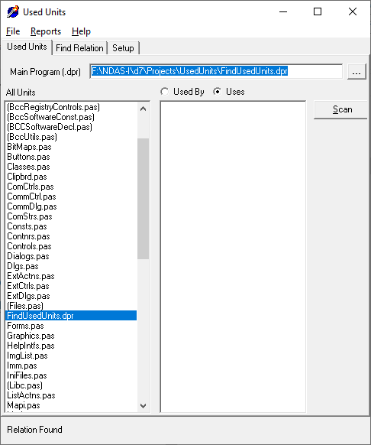

Once scanned it then becomes possible to find out how two units are connected. i.e., *“Why is this unit getting compiled?”.* This is done on the *Find Relation* page:

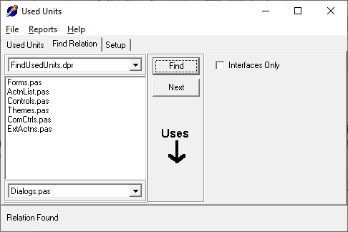

By default, directories associated with the project are scanned as are the .*DOF* paths. Additional paths to search for source code files can be added on the *Setup* Page:

