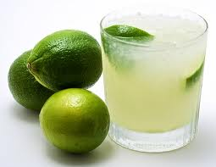

**LIME CAIPIRINHA**

Designated by the International Bartenders Association (IBA) as an IBA Official Cocktail and considered Brazil’s national cocktail, the caipirinha is a celebrated beverage.

* 6 Quarter-sized slices ginger
* 2 tsp. Sugar
* 6 Chopped mint leaves
* 2 oz. Cachaça
* 1 oz. Grenadine
* 3 oz. Rummy

Mix lime, ginger, sugar and mint and transfer to a martini shaker. Add grenadine, cachaça and ice. Shake. Pour into a glass and serve.

Makes one cocktail.

**TIP**: Vodka or rum can be used in place of cachaça. This is a test.

**PER SERVING:** 283 calories, 0 g fat, 0 g saturated fat, 0 mg cholesterol, 12 mg sodium, 39 g carbohydrates, 0 g fiber, 0 g protein. % RDI: 0% calcium, 2% iron, 1% vitamin A, 13% vitamin C., 4% vitamin D